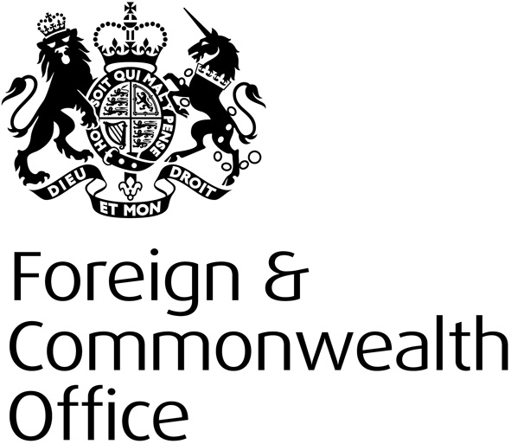
FCO Human Rights and Democracy Programme 2014-15: Guidance for Potential Implementers at Concept Stage
Human Rights and Democracy Department
January 2014

Overview

The Human Rights and Democracy Programme (HRDP) is the FCO’s dedicated fund supporting human rights and democracy work overseas. The Programme aims to make a difference to people’s lives, helping to build the capacity of governments and civil society to promote and protect human rights. In 2013/14, we supported over 80 projects worldwide.

Human rights, democracy and the rule of law are at the heart of the Government’s foreign policy. The HRDP targets areas that are both important to us and where we consider we can make the greatest impact in delivering the FCO’s overarching purpose to “pursue an active and activist foreign policy, working with other countries and strengthening the rules-based international system in support of our values”.

Please read all guidance and ensure that project proposals are designed and submitted in accordance with the guidance. Proposals that do not meet the criteria and guidance will be rejected. Before bidding you should also familiarise yourself with our strategy and terms and conditions (including monitoring and reporting requirements), available here.

HRDP FY2014-15 Bidding Round Time Table

31 January 2014 – Human Rights & Democracy Programme Bidding Round Opens. Potential Implementers are invited to submit concept bids only to the relevant UK Mission in the country they wish to work in.

28th February 2014 – Human Rights & Democracy Programme Bidding Round Closes (this deadline is subject to local conditions). After the bidding round closes UK Missions will assess all concept bids received. Selected bidders will be asked to work their concept up to a full proposal for submission.

28th March 2014 - Deadline for selected implementers to submit full proposals to Post (this deadline is subject to local conditions). Post will then submit the best bids to the HRDP Team in London.

April/May 2014 – Assessment of submitted projects by HRDP Team and Board.

End May 2014 – Successful bidders notified.

Project Applications

In a change to the procedures for implementers should submit a completed concept bid (form available here or at Annex A) to the relevant UK Mission. Selected bidders will be notified and asked to work up their bid into a full proposal once the bidding round has closed.

Concepts should be:

Concise – Post will receive a large number of concept bids. Concepts should be a maximum of 3 pages. If information is set out concisely it makes it much easier to assess. In addition, bids that do not include copious amounts of background or general information tend to be...
Clear – Is the proposal easy to read and does it follow a logical course. Such bids will more likely be...
Convincing – Does the bid convince us that this is the best way to spend UK public money.
HRDP is a strategic Programme and we assess every bid we receive to ensure it will achieve impact and that it fits with both the HRDP strategy and our local human rights strategy for the relevant country. Projects in individual countries overseas must have the support of the British Embassy or High Commission in the country and you should engage with them early on in the process. We will not assess concept bids submitted directly to the FCO in London. Projects must be submitted via the relevant British Mission. The exception is where a proposal covers more than one country, when it should be submitted via the relevant HRDD thematic desk officer in London (see below for contact details). You should still discuss your project with the local mission in each country you intend to work in and you will need the support of all local missions.

Implementers should note that the Human Rights and Democracy Programme Board will only accept a maximum of five full bids per Implementer but will not fund more than two. This includes an Implementer’s country offices.

Bidders selected to submit a full bid will be sent further guidance.

Please send any questions, comments or suggestions to HRDPF.Applications@fco.gov.uk . The HRDP welcomes feedback on its strategy, guidance and forms.

Project Funding
Projects should begin from June 2014 and must be completed by end February 2015.

Will there be a second round?
Funds will be committed during a single allocation round. We may, if needed, run a second allocation round later in the year with notification placed on our website.

How much funding is available?
We will fund projects up to a value of £200,000. Projects in excess of that amount may be considered exceptionally. You should bid for what you think the project will cost to deliver.

What about non-priority countries and non-ODA countries?
Projects are accepted from both non-priority and non-Official Development Assistance eligible countries, however the majority of funding will go to priority countries and only a very small percentage of the available funding can be spent in non-ODA eligible countries. Please see the OECD website for a list of ODA eligible countries.

Joint Funding
We welcome projects jointly funded with other donors as a way of increasing impact and enhancing co-ordination. All projects must demonstrate how they complement the efforts of other donors and bring added value. We strongly encourage projects that seek to secure future funding from other bodies (e.g. EU, UN) for follow-on work.

Can a project cover more than one thematic area?
While a project can cover more than one thematic area, you should pay particular attention to the link with the strategic aims. We have found that projects, which seek to cover more than one theme, can lose strategic focus and be unrealistic in their aims.

Can we run a researched based project?
While we’re happy to accept research based projects, the Programme Board would need to be convinced that such a project would actually have an impact on the issue in the timeframe available. Such projects should clearly explain how the research will be used or disseminated to create impact.

Litigation and legal aid
We do not fund general legal aid (e.g. where we are paying for large numbers of people to access legal advice or undertake litigation). We would only look to fund strategic litigation that has a wider precedent or impact on wider policy. We would also require a detailed explanation of why the litigation is particularly strategic and relevant to what the project is trying to achieve. Given litigation can take years, the project must consider what impact the litigation can have in the time available for the project and how the cases will be funded once FCO funds end.
Is the start date fixed?
We have asked that projects start in June because we cannot guarantee that the Board will have completed assessing projects by the end of May. We also need to allow time for logistics including signing the Grant Contract. Activities cannot start before the Grant Contract has been signed. If your Grant Contact is signed by both parties on 21st May 2013 then the earliest activities can start is the 22nd May 2013.

Is the end date fixed?
We have asked that projects end in February because this will provide us with time close down the project before the end of the financial year. If a project had an end date of the 31st March and project activities were delayed the project would have to end on 31st March without the activities being completed. As funding is only guaranteed for one financial year the Implementer would not be able to continue activities into April.

Thematic Lead Contacts

Name | Lead
Natalie Doherty | Global Torture Prevention | Natalie.Doherty@fco.gov.uk
Christopher Layden | Abolition of the Death Penalty | Christopher.Layden@fco.gov.uk
Nina Mason | Freedom of Expression | Nina.Mason2@fco.gov.uk
Jamie Mason | Freedom of Religion | Jamie.Mason@fco.gov.uk
Annie Eshelby | Women’s Rights | Annie.Eshelby@fco.gov.uk
Philip Gilbert | Business and Human Rights | Philip.Gilbert@fco.gov.uk
Emma Kouki | Democratic Processes | Emma.Kouki@fco.gov.uk
Jessica Jambert - Gray | Preventing Sexual Violence | Jessica.Jambert-Gray@fco.gov.uk

ANNEX A - PROJECT CONCEPT FORM
This form should be submitted prior to putting forward a full Project Proposal. The Post may accept or reject Project Concepts.

When the Post agrees a Concept, and invites implementers to put forward a full Project Proposal, it is not a guarantee that the full Project Proposal will be approved for funding. It signals the Post’s interest in receiving more details about the proposed project. Before you complete this form, check the website of the British Embassy/High Commission in the country in which you are proposing to work and/or speak to the Post’s Project Officers to find out about the Programme Strategy applicable for that country, and to check project viability.
Project Title
Purpose (This must be NO MORE than one sentence)
Implementing Agency
Name; Address; Telephone Numbers; Email; Website
What change will this project deliver?
Why do we need to run this project? And what will be the longer term impact?
Keep this short, you should be able to articulate why the project is needed in a couple of sentences
Background
In no more than 200 words, provide the background to the issue this project will change and why the UK is the best donor

Risks
Provide brief details of any serious risks to the success of the project and how these will be mitigated
Cost - What is the TOTAL cost of the Project  Please note, project funds are paid quarterly in arrears. UK Financial Year runs from April to March. | FY14/15 |  | £ | If co-funding has or is being sought, please also show the cost to the FCO and provide details of the co-funding organisations |  | FY 14/15 | £
Timing | Planned start date: |  |  |  | Planned completion  date:
Post Comments
Include which CBP Objective this project will help deliver.
Should this Concept now be worked up into a Full Proposal  If No, give explanation |  | Yes/No
Date

