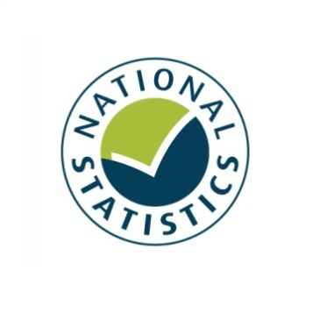

Entertainment Licensing Statistics 2013

England and Wales

Statistical Release

December 2013

Prior to 2012, *Alcohol, entertainment and late night refreshment licensing statistics* were produced by DCMS and designated as National Statistics under subsection 12(8) of the Statistics and Registration Service Act 2007. These entertainment licensing statistics (a subset of the previous statistics) have been produced and published by DCMS as a result of a machinery of government change. They have been produced to the same standard, and continue to be designated as National Statistics.

*The United Kingdom Statistics Authority has designated these statistics as National Statistics, in accordance with the Statistics and Registration Service Act 2007 and signifying compliance with the Code of Practice for Official Statistics.*

*Designation can be broadly interpreted to mean that the statistics:*

* *meet identified user needs;*
* *are well explained and readily accessible;*
* *are produced according to sound methods; and*
* *are managed impartially and objectively in the public interest.*

*Once statistics have been designated as National Statistics it is a statutory requirement that the Code of Practice shall continue to be observed.*

Contents

Chapter 1: Introduction and key findings 4

Chapter 2: Premises Licences for regulated entertainment 10

Chapter 3: Club Premises Certificates for regulated entertainment 15

Annex A: Background notes 19

Annex B: Interpretation of modelled estimates 22

1. Introduction and key findings

This release presents statistics on the number of premises licences and club premises certificates authorising regulated entertainment in England and Wales in force on 31 March 2013. All figures consist of a combination of actual returns and modelled estimates for non-response.

Subject to any conditions, definitions and exemptions that may apply, the types of regulated entertainment which may require a licence under the Licensing Act 2003 are as follows:

* A performance of a play
* An exhibition of a film
* An indoor sporting event
* Boxing or wrestling entertainment (both indoors and outdoors)
* A performance of live music
* Any playing of recorded music
* A performance of dance

The Licensing Act 2003[1] may require that some form of authorisation is obtained before one or more of these entertainment activities can lawfully be carried out – such as a premises licence or club premises certificate.

Premises may have a licence covering several forms of entertainment. This licence may also cover alcohol and late night refreshment.

**Figure 1:**

**Key findings**

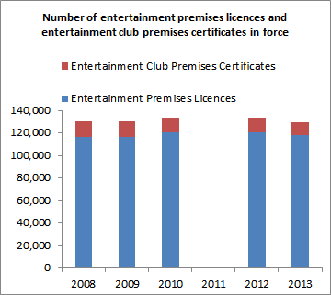

* There were 117,800 premises licences authorising regulated entertainment in force in England and Wales on 31 March 2013, a 2.5 per cent decrease compared to 120,800 licences on 31 March 2012. Between 31 March 2008 and 31March 2012, there has been a slight but steady increase in the number of premises licensed for regulated entertainment, before the decrease in the latest results.
* Premises licences accounted for 90.8 per cent of the total number of licences in force which authorised regulated entertainment on 31st March 2013. Club premises certificates accounted for the other 9.2 per cent. The combined total of premises licenses and club premises certificates covering entertainment increased gradually between 2008 and 2012, before decreasing over the past year by 2.8 per cent.
* The largest percentage increases in premises licences between March 2012 and March 2013 were for those covering boxing and wrestling (7.9%), plays (2.6%), and indoor sporting events (1.6%). To note, actual attendance figures over this time period, from the Taking Part Survey[2], did not show any significant change in attendance of plays or dramas.

**Club Premises Certificates**

* There were 11,900 club premises certificates authorising regulated entertainment in England and Wales on 31 March 2013, a 5.7 per cent decrease compared to 12,600 such licences on 31 March 2012. There has been a gradual but steady decrease in the number of these club premises certificates in force since 2008.
* The biggest percentage decrease was for the number of club premises certificates for recorded music and performance of dance, both of which decreased by 4.2 per cent between 31 March 2012 and 2013.
* The only entertainment type for which the number of club premises certificates increased between March 2012 and March 2013 was plays, a 2.0 per cent increase over this time period.

To note, the number of entertainment premises licences and entertainment club premises certificates in force do not provide a measure of the regulated entertainment which actually takes place. This is because a premises or club being authorised for a certain type of regulated entertainment does not mean that they necessarily provide it.

As context, Taking Part data shows the actual attendance rates for some of these types of regulated entertainment.

**Introduction**

The main purpose of this collection is to monitor the impact of the Licensing Act 2003. It provides information to help licensing authorities benchmark their position and provide an understanding in the context of the national picture.

These statistics are used by DCMS to provide a measure of the changing number of premises or club premises licensed to provide entertainment across its key policy areas. They are also used to inform deregulation proposals regarding the forms of entertainment which may require licences in the future.

Accompanying excel tables for the number of premises licences and club premises certificates authorising regulated entertainment are available at

<https://www.gov.uk/government/publications/entertainment-licensing-2013>

Excel tables which show the number of premises licences and club premises certificates authorising entertainment by individual Licensing Authority have been published and are available at <https://www.gov.uk/government/publications/entertainment-licensing-2013>

These data consist of the actual returns received from responding Licensing Authorities (88.0% and 85.4% of all licensing authorities for premises licences and club premises certificates authorising entertainment respectively) and have therefore not been modelled. Therefore, non-responding licensing authorities have been omitted from the main table but are listed within the same spreadsheet for information. The sum of the licences shown in these tables will be substantially less than the aggregated totals for England and Wales since the aggregated figures incorporate estimates for non-response.

It is important to note that the licensing authority tables do not, on their own, provide an insight into areas where particular forms of entertainment are most popular as they largely reflect the size of the population in each authority. Also, as with the aggregated national figures, a licence to provide a certain type of entertainment does not necessarily mean it is actually taking place. Figures on the number of entertainment premises licenses and entertainment club premises certificates per 100,000 population are available at <https://www.gov.uk/government/publications/entertainment-licensing-2013>

These allow for comparisons to be made between regions on a comparable basis but still do not provide an indication of the regulated entertainment which has actually taken place, rather an indication of the number of licences available for regulated entertainment per head of population.

**Definitions:**

**Premises licences** can be used for the sale or supply of alcohol, the provision of regulated entertainment or the provision of late night refreshment.

**Club premises certificates** allow a qualifying club to carry out activities specified under the Licensing Act 2003 (<http://www.legislation.gov.uk/uksi/2005/42/contents/made>)

Please note that this release deals only with premises licences or club premises certificates whichauthorise the provision of **regulated entertainment**. It also does not include data for regulated entertainment authorised by a Temporary Event Notice.

Figures in this publication (unless otherwise stated) relate to the number of premises licences or club premises certificates authorising entertainment in force on **31 March 2013** in **England and Wales**. There are no corresponding figures for Scotland[3] or Northern Ireland. Scottish liquor licensing statistics are available but these do not distinguish the provision of regulated entertainment.

The number of entertainment premises licences and entertainment club premises certificates in force do not provide a measure of the regulated entertainment which actually takes place. This is because a premises or club being authorised for a certain type of regulated entertainment does not mean that they necessarily provide it. For example a premises may have previously provided a form of regulated entertainment which it has now ceased to, but not had it removed from its licence.

Figures on participation in various entertainment types are available from the [Taking Part Survey](https://www.gov.uk/government/collections/taking-part). Where relevant these figures have been referred to in this release.

Complementing this release, data on licences authorising alcohol and late night refreshments are published by the Home Office in their publication *Alcohol and Late Night Refreshment Licensing England and Wales 2012/13 a*vailable at <https://www.gov.uk/government/publications/alcohol-and-late-night-refreshment-licensing-england-and-wales-31-march-2013>

The Home Office publication includes figures for the total number of premises licences and club premises certificates in force, not just those authorising the provision of regulated entertainment as in this release.

**Data response:**

98.9 per cent of the licensing authorities in England and Wales responded to the questionnaire. Of these 89.0 and 86.4 per cent provided the number of entertainment premises licences and entertainment club premises certificates in force respectively. Throughout this publication modelled estimates have been used to account for these missing data. Full information on response rates and the modelling procedure can be found in Annex A. Further information on interpreting the modelled data can be found in Annex B.

**Revisions:**

Figures from 2008, 2009, and 2010 referred to in this report have not been revised from previous publications. In a very few cases, figures from 2012 have been revised where Licensing Authorities provided more accurate information at a later date.

**Additional information:**

The Licensing Act 2003 defines the provision of regulated entertainment as a licensable activity. The Act brought together 6 existing licensing regimes including public entertainment, cinemas and theatres. Once granted, the license is valid until surrendered, subject to the payment of any annual licence fee due and any premises which held an old scheme licence was eligible to apply for it to be converted. The statistics presented in this report enable the Government to track the uptake of such licences throughout England and Wales and to gauge what impact the legislation has had and continues to have on the number of clubs or premises able to provide different entertainment types.

The Live Music Act 2012 came into force on 1 October 2012. The data reported on in this publication refer to licences in force on 31st March 2013 so this Act may have had an impact on these statistics.

The Act amends the Licensing Act 2003 (“the 2003 Act”) by partially deregulating the performance of live music and removing regulation about the provision of entertainment facilities. It may therefore be expected that licences authorising live music performances may decrease, as may applications for new licences. However as the Live Music Act only partially deregulated live music in defined circumstances, the live music category is likely to remain in place on most pre-existing licences.[4] These statistics do not provide an indication of whether the Act has increased the provision of live music itself. Full information on this Act is available at <http://www.legislation.gov.uk/ukpga/2012/2/enacted>

The Government is also committed to further deregulatory reforms to entertainment licensing. This is being implemented in phases. The first phase, by secondary legislation removed the requirement for a licence between 8:00-23:00 for performance of plays and exhibitions of dance (up to an audience limit of 500) and indoor sport up to audience limit of 1000 people. It also clarified the position on combined fighting sports such as Mixed Martial Arts, so that it is clear in law that such activities remain licensable as boxing or wrestling activities. This came into force on 27th June 2013. It may therefore be expected that the number of licences in force covering these entertainment types may decrease in future editions of these statistics. This legislative change will not have affected statistics in this publication which refer to licences in force on 31st March 2013. For more information see <http://www.legislation.gov.uk/uksi/2013/1578/contents/made>

The Government is currently consulting on a second phase of deregulatory changes that would be implemented through a Legislative Reform Order in 2014

<https://www.gov.uk/government/consultations/legislative-reform-order-changes-to-entertainment-licensing>

The Department has also consulted on a third phase - a limited deregulation for community film exhibition <https://www.gov.uk/government/consultations/licensing-act-2003-community-film-exhibition-consultation>

There was no data collection in 2011 as a result of the Machinery of Government change which reallocated policy responsibilities under the Licensing Act 2003 between the Home Office and the Department for Culture, Media and Sport. It was decided to keep the frequency of collection under review, with a plan to repeat the exercise following any forthcoming legislative changes. As such, the first collection following the Machinery of Government change was in 2011/12.

**Feedback:**

We would like to understand further the needs of our users and how this release meets them. Please email [sam.tuckett@culture.gsi.gov.uk](mailto:sam.tuckett@culture.gsi.gov.uk) to provide feedback on whether this release meets your needs and any suggestions as to how it could be improved.

1. Premises Licences for regulated entertainment

There were 117,800 premises licences authorising some form of regulated entertainment in England and Wales on 31 March 2013, a 2.5 per cent decrease compared to 120,800 premises licences on 31 March 2012.

Over the same period, the largest percentage increases have been in the number of premises licences authorising boxing or wrestling (7.9%), plays (2.6%) and indoor sporting events (1.6%).

There have been decreases in the number of premises licences authorising live music (-0.5%), recorded music (-0.2%) and performance of dance (-0.1%) The Live Music Act 2012, which partially removed the need for licences, may explain the decrease in premises licences for live music.

The statistics presented in this chapter relate to the number of premises licences authorising the provision of regulated entertainment issued by the licensing authorities in England and Wales that were in force on 31 March 2013.

All figures consist of a combination of actual returns and modelled estimates for non-response.

**Entertainment premises licences by entertainment type:**

There are 8 categories of regulated entertainment which premises licences can cover, a particular premises licence can cover multiple entertainment types.

The categories of entertainment are:

* Plays
* Films
* Indoor sporting events
* Boxing or Wrestling
* Live Music
* Recorded music
* Performance of dance
* Entertainment similar to live music, recorded music or dance (referred to as ‘similar to live music, recorded music or dance’ in figure 2 and 4)

Prior to the Live Music Act 2012 a licence was also required for the following.

* Facilities for making music
* Facilities for dancing
* Facilities for entertainment similar to making music or dancing

These types of entertainment are no longer licensable and this is the first publication not to report on licences for these facilities for providing entertainment as a result of the Live Music Act 2012 being implemented.

Information on exactly what constitutes each activity and what requires a licence as set out in The Licensing Act 2003 can be found at <http://www.legislation.gov.uk/ukpga/2003/17/schedule/1/enacted>

There is also the Guidance to Licensing Authorities https://www.gov.uk/government/publications/section-182-of-the-licensing-act-2003-amended-guidance

Figure 2 shows the number of premises holding licences for each licensable entertainment type.

* The most commonly authorised form of regulated entertainment was recorded music which was licensed in 100,600 premises. There has been a 0.2 per cent decrease since 2012 (100,800). Over four out of five (85.4%) of all premises licenses for entertainment covered recorded music.
* There have been decreases in the number of premises licences covering live music, recorded music and performance of dance, which fell by 0.5, 0.2 and 0.1 per cent respectively between data collections for March 2012 and March 2013. The decrease in licences for live music may have been as a result of the Live Music Act 2012. To note, there have not been any significant changes in attendance of live music or dance events (other than contemporary dance for which there was a significant decrease in attendance) over this period according to data from the Taking Part Survey.
* The largest percentage increases between March 2012 and 2013 have been in the number of premise licences authorising boxing and wrestling (7.9%), plays (2.6%) and indoor sporting events (1.6%). It could be the case that the increase for boxing and wrestling reflects the Government’s intention to partially deregulate indoor sporting events, but not the boxing and wrestling category (which also includes combined fighting sports). This policy was implemented in June 2013. This prior knowledge could have resulted in licence variations to ensure that such sports were correctly attributed in the boxing and wrestling category and not indoor sport, so that licence conditions could continue to apply to boxing and wrestling after the partial deregulation of indoor sport.
* To note data from the Taking Part Survey do not show any significant change in the rate or adults attending plays or dramas over this period.

**Figure 2: The number of entertainment premises licences in force in England and Wales on 31 March 2012 and 2013 by entertainment type.**

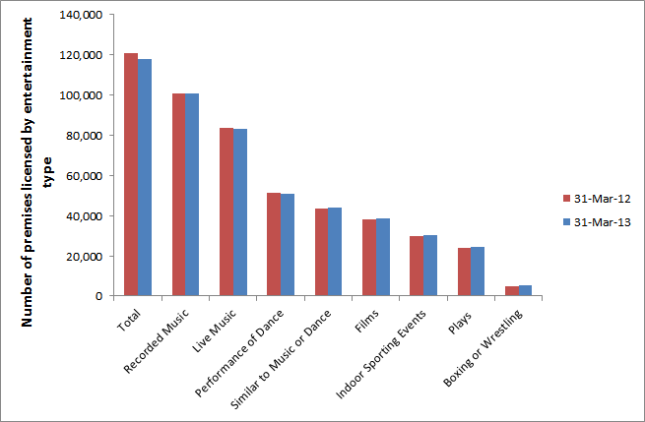

**Notes**

1) The sum of the number of licences covering each entertainment type will not equal the total number of entertainment premises licences in force since more than one form of entertainment can be covered by each licence.

2) Figures consist of a combination of actual responses and modelled estimates to account for non-response.

Excel tables for the number of entertainment premises licences in force can be found at <https://www.gov.uk/government/publications/entertainment-licensing-2013>

Figure 3 shows that London, South East and the North West had the greatest number of entertainment premises licences (over 12,500 licences each). Conversely the region with the least entertainment premises licences was the North East with fewer than 6,000.

**Figure 3: The number of entertainment premises licences in force on 31 March 2013 by region**

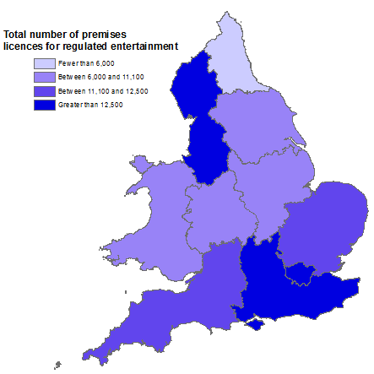

**Notes**

1. Figures consist of a combination of actual responses and estimates to account for non-response

Excel tables for the number of entertainment premises licences in force by region can be found at <https://www.gov.uk/government/publications/entertainment-licensing-2013>

**Figure 4: The number of entertainment premises licences in force on 31 March 2013 by region, per 1,000 population.**

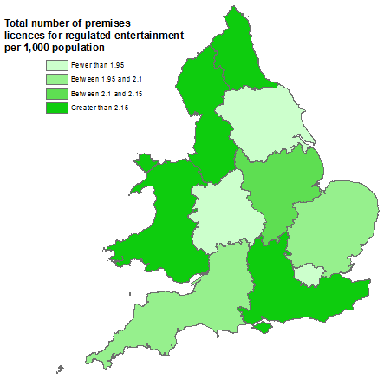

The regions with the most entertainment premises licences per head of population are different from the regions which have the greatest absolute number of these licences. For instance in figure 4, Wales is amongst the areas with the greatest entertainment premises licences per head of population, whilst figure 3 shows Wales to be amongst the areas with one of the lower absolute number of such licences. Similarly London has a high number of premises licences for entertainment but a lower rate of provision per head of population.

Excel tables for the number of entertainment premises licences per head of population are available at <https://www.gov.uk/government/publications/entertainment-licensing-2013>

1. Club Premises Certificates for regulated entertainment

There were 11,900 club premises certificates authorising regulated entertainment in England and Wales on 31 March 2013, a 5.7 per cent decrease compared to 12,600 club premises certificates on 31 March 2012.

The biggest percentage decrease was for the number of club premises certificates for recorded music and performance of dance, both of which decreased by 4.2 per cent between 31 March 2012 and 2013.

The only increases over this period have been for the number of club premises certificates for plays and entertainment similar to live music, recorded music or dance which increased by 2.0 and 1.8 per cent respectively.

The statistics presented in this chapter relate to the number of club premises certificates covering regulated entertainment issued by the licensing authorities in England and Wales that were in force on 31 March 2013. All figures consist of a combination of actual returns and modelled estimates for non-response.

A club premises certificate allows a qualifying club to carry out activities specified under the Licensing Act 2003 (<http://www.legislation.gov.uk/uksi/2005/42/contents/made>).

The categories of regulated entertainment which can be covered by club premises certificates are the same as those detailed in chapter 2 for premises licences. There are 8 categories of regulated entertainment and one particular club premises certificate can cover multiple entertainment types.

Figure 5 shows the number of entertainment club premises certificates in force on 31 March 2012 and 2013.

* The most commonly authorised form of regulated entertainment by club premises certificates was recorded music, with 10,600 club premises certificates in force. There has been a 4.0 per cent decrease from 2012 (11,000). 89.2% of all club premises certificates for entertainment covered recorded music.
* There has also been a decrease in the number of entertainment club premises certificates for live music and performance of dance, both of which decreased by 4.2 per cent between March 2012 and 2013.
* The least commonly authorised form of regulated entertainment by club premises certificates has been for boxing and wrestling, with just 700 such certificates in force on 31 March 2013. This represents a 1.2 per cent decrease from 2012.

**Figure 5: The number of entertainment club premises certificates in force in England and Wales on 31 March 2012 and 2013.**

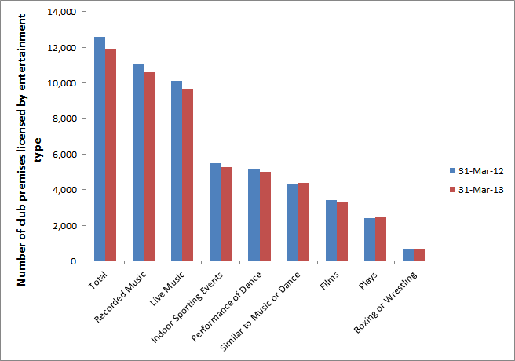

**Notes**

1) The sum of the number of club premises certificates covering each entertainment type will not equal the total number of entertainment club premises certificates in force since more than one form of entertainment can be covered by each such certificate.

2) Figures consist of a combination of actual responses and estimates to account for non-response.

Excel tables for the number of entertainment club premises certificates in force can be found at <https://www.gov.uk/government/publications/entertainment-licensing-2013>

Figure 6 shows that only three regions had over 1,150 entertainment club premises certificates in force on 31 March 2013 (South East, Yorkshire and the Humber and North West). Only one region had less than 800 entertainment club premises certificates in force on 31 March 2013 (North East).

**Figure 6: The number of entertainment club premises certificates in force on 31 March 2013 by region**

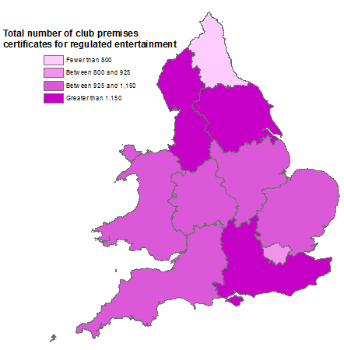

**Notes**

1) Figures consist of a combination of actual responses and estimates to account for non-response

Excel tables for the number of entertainment club premises certificates in force by region can be found at <https://www.gov.uk/government/publications/entertainment-licensing-2013>

**Figure 7: The number of entertainment club premises certificates in force on 31 March 2013 by region, per 1,000 population.**

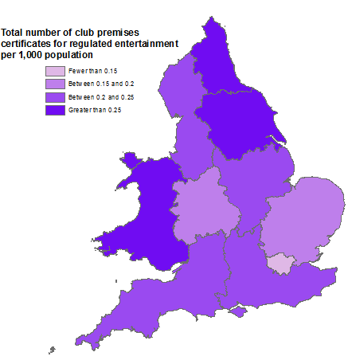

Figure 7 shows that the North East is amongst the regions with the greatest club premises certificates in force per head of population in contrast with figure 6 which shows that the North East is among the regions with the least absolute number of club premises certificates.

Excel tables for the number of entertainment club premises certificates per head of population are available at <https://www.gov.uk/government/publications/entertainment-licensing-2013>

Annex A: Background notes

1. The Entertainment licensing data collection is commissioned by the Home Office on behalf of the Department for Culture, Media and Sport, as part of their data collection for the *Alcohol, entertainment and late night refreshment licensing statistics*. See here for full details of The Licensing Act 2003 <http://www.legislation.gov.uk/ukpga/2003/17/contents>

Note that the Act has been partially amended by the Live Music Act 2012 <http://www.legislation.gov.uk/ukpga/2012/2/contents/enacted>

And the “2013 order” <http://www.legislation.gov.uk/uksi/2013/1578/contents/made>

1. *Entertainment licensing statistics 2013* is a National Statistic and has been produced to the high professional standards set out in the Code of Practice for Official Statistics. National Statistics undergo regular quality assurance reviews to ensure they meet customer needs and are produced free from any political interference. For more information, see <http://www.statisticsauthority.gov.uk/assessment/code-of-practice/code-of-practice-for-official-statistics.pdf>.
2. The latest results presented here are on the number of premises licences or club premises certificates authorising the provision of regulated entertainment in force in **England and Wales** on **31 March 2013**. The next release will be in Autumn 2014 and will cover entertainment premises licences and entertainment club premises certificates in forces on 31 March 2014.
3. The questionnaire covers all licensing authorities in England and Wales (350 licensing authorities).
4. Prior to 2012, these figures were reported on as part of the DCMS publication: Alcohol, Entertainment and Late Night Refreshment Licensing. This release from 2009/10 can be found at <http://www.culture.gov.uk/what_we_do/research_and_statistics/4865.aspx>. There was no entertainment licensing data collection in 2011 and it is not feasible to retrospectively collect this data reliably.
5. The total compliance cost of licensing authorities responding to the questionnaire (not just the regulated entertainment section) is estimated at £10,400.
6. Of the 350 Licensing Authorities in England and Wales, 346 (98.9%) responded to the questionnaire. Of these 308 (89.0%) and 299 (86.4%) provided the total number of premises licences and club premises certificates respectively authorising regulated entertainment in force in their authority on 31 March 2013. See table 1 on page 21 for a full breakdown of response rates for each entertainment type.
7. Estimates have been made for non-response (Non-response refers to a licensing authority either not returning a questionnaire or leaving a specific question in the questionnaire blank).

In cases where data were not provided for a category from the 2013 collection but were provided in the 2012 collection, an estimate was made by applying an adjustment to the 2012 figure for that licensing authority. This adjustment was the average percentage change from 2012 to 2013 for the relevant category of licensing authority (These are: District, London Borough, Metropolitan District, Unitary Authority, Welsh Unitary Authority or left unspecified)

If a figure had not been given in 2013 or 2012, the same procedure was followed using the 2010 entry.

However, if there was no figure for a particular licensing authority in 2013, 2012, or 2010 then an average figure for the relevant type of licensing authority was used. Excel sheets of modelled estimates can be found at

<https://www.gov.uk/government/publications/entertainment-licensing-2013>

1. Estimating for non-response allows changes to be compared on a comparable basis between years. There are some limitations to the estimation process, but the data are sufficiently robust for their intended use. These are discussed in Annex B. Data tables based only on actual returns for individual licensing authorities are also available.
2. We can also provide documents to meet the specific requirements of people with disabilities. Please call 020 7211 6000 or email [evidence@culture.gsi.gov.uk](mailto:evidence@culture.gsi.gov.uk)
3. The responsible statistician for this release is Sam Tuckett. For enquiries on this release, please contact Sam Tuckett on 0207 211 2382.
4. For general enquiries telephone: 0207 211 6200

Department for Culture Media and Sport  
100 Parliament Street

London

SW1A 2BQ

[enquiries@culture.gov.uk](mailto:enquiries@culture.gov.uk)

**Table 1: The percentage of licensing authorities which provided the number of premises licences and club premises certificates authorising the provision of each regulated entertainment type**

|  |  |  |  |  |  |  |  |  |  |  |
| --- | --- | --- | --- | --- | --- | --- | --- | --- | --- | --- |
|  |  | Total | a | b | c | d | e | f | g | h |
| Response rate as a percentage of licensing authorities that responded to the questionnaire (2) | Premises licences authorising provision of entertainment type | 89.0% | 73.4% | 73.4% | 73.4% | 73.4% | 73.7% | 73.7% | 73.4% | 72.5% |
| Club premises certificates authorising provision of entertainment type | 86.4% | 72.5% | 72.5% | 72.8% | 72.5% | 73.1% | 73.1% | 72.5% | 72.0% |
| Response rate as a percentage of all licensing authorities in England and Wales (3) | Premises licences authorising provision of entertainment type | 88.0% | 72.6% | 72.6% | 72.6% | 72.6% | 72.9% | 72.9% | 72.6% | 71.7% |
| Club premises certificates authorising provision of entertainment type | 85.4% | 71.7% | 71.7% | 72.0% | 71.7% | 72.3% | 72.3% | 71.7% | 71.1% |

Key:

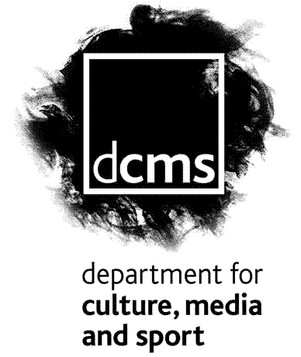

1. Plays
2. Films
3. Indoor sporting events
4. Boxing or wrestling
5. Live music
6. Recorded music
7. Performance of dance
8. Entertainment similar to live music, recorded music or dance

**Notes**

1. The sum of the number of premises licences and club premises certificates covering each entertainment type will not equal the total number in force since more than one form of entertainment can be covered by each such licence or certificate.
2. Response rates as a percentage of licensing authorities that responded to the questionnaire, refers to the percentage of Licensing Authorities which responded to that specific question, out of the 346 responding Licensing Authorities who submitted a return at all.
3. Response rates as a percentage of all licensing authorities in England and Wales, refers to the percentage of all 350 licensing authorities which answered each specific question.

Annex B: Interpretation of modelled estimates

As noted throughout the report, modelled estimates have been used where Licensing Authorities did not respond or provided incomplete returns. The method of calculating these estimates is described in Annex A.

There were no discernible trends as to which Licensing Authorities did not respond or provided incomplete returns. They were not for instance, mainly small Authorities likely to have few licences in force, nor were they mainly large authorities with a greater number of licences in force.

Modelled estimates are imperfect by nature; as such there is always a degree of error in the calculated estimates for individual Licensing Authorities. For this reason data for individual Licensing Authorities have only been published for those that provided actual returns. This represents 88.0% and 85.4% of all Licensing Authorities in England and Wales for premises licences and club premises certificates authorising entertainment respectively.

We model for Licensing Authorities which do not provide complete responses despite this error in the modelling. Implementing it reduces the extent of error that would have existed had it not been done. For most Licensing Authorities (97% and 97% for premises licences and club premises certificates authorising entertainment respectively) either, modelling was not required, or modelled estimates were based on returns that the Licensing Authority provided in previous years so are likely to accurately reflect the actual number of licences in force.

In the few cases where authorities which did not respond in 2013 and did not respond in any previous year of data collection since 2010, an average for the authority type has been used. This makes an assumption that similar authority types (e.g. London Boroughs) have a similar number of licenses in force. This subset of modelled estimates is therefore likely to be less accurate, but given they are only used for less than 4% of all Licensing Authorities, we believe this introduces little bias and that the national estimates are still robust. As such this modelling should not influence the way that these statistics are interpreted.

2-4 Cockspur Street

London SW1Y 5DH

www.culture.gov.uk



1. Information on the need for licences for regulated entertainment as set out in The Licensing Act 2003 is available at <http://www.legislation.gov.uk/ukpga/2003/17/contents>
2. Further information on the Taking Part Survey is available at https://www.gov.uk/government/collections/sat--2
3. Scottish liquor licensing statistics are available here <http://www.scotland.gov.uk/News/Releases/2013/04/liquor04042013> The operating plan under liquor licences would cover whether or not entertainment is offered, but these figures are not available.
4. https://www.gov.uk/entertainment-licensing-changes-under-the-live-music-act