27 June 2013
STATISTICAL RELEASE: EXPERIMENTAL STATISTICS
Domestic Green Deal and Energy Company Obligation in Great Britain, Quarterly report
Introduction
This first quarterly Green Deal (GD) and Energy Company Obligation (ECO) statistical release provides a range of further analysis and geographical breakdowns of published GD Assessments and Supply Chain activity for the period January to March 2013.The most up to data information on the GD and ECO can be found in the monthly statistical releases – available here. Future quarterly releases will also provide more detailed breakdowns on GD Plans and measures installed.

Key points (for the first quarter of 2013)
Of the 9,224 Green Deal Assessments in England and Wales completed in this period:

- Around 90 per cent of properties getting a GD Assessment had an energy efficiency band rating of D or lower compared to 85 per cent of the overall domestic building stock in England (Chart 1). This suggests properties where assessments are being taken out are generally those which could benefit from energy efficiency measures.

- There were 30,506 improvements recommended in Green Deal Advice Reports (around three improvements per assessment). The most common measure recommended was to upgrade the existing boiler with the same fuel which was recommended in 56 per cent of the assessments completed and accounted for 17 per cent (5,170) of all recommended measures. Other commonly recommended measures included different types of solid wall insulation (11 per cent of all recommended measures), solar PV, heating controls for wet central heating system and floor insulation (each accounting for 10 per cent of all recommended measures).

- 84 per cent of GD Assessments were in owner-occupied properties (7,667), with the remainder split equally between the private rented sector and the social rented sector. This compares to 65 per cent of the housing stock in England and Wales being owner occupied.

- 16 per cent of GD Assessments were in the North West (1,453), the highest in any region. 14 per cent were in each of the South West (1,325) the South East (1,300) and Yorkshire and The Humber (1,281). Four per cent of GD Assessments were in Wales (376) and one per cent were in Scotland (70).

Chart 1 – Percentage of GD Assessments lodged, up to 31st March 2013, by Energy Efficiency Band compared with Energy Efficiency Band ratings of all properties in England in 2011.

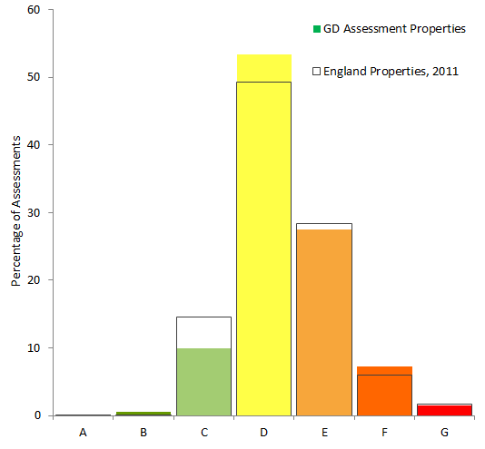

Charts
Chart 1 Percentage of GD Assessments lodged, by energy efficiency band
Chart 2 Number of GD Assessments lodged, by property type
Chart 3 Proportion of GD Assessments lodged, by built form

Maps
Map 1 Number of Green Deal Assessments lodged by Local Authority
Map 2 Number of Assessor organisations operating per Local Authority
Map 3 Number of Installers operating per Local Authority

Detailed Results
This section of the report provides detailed information on different elements of the Green Deal, including a geographic split of where GD Assessments took place, the characteristics of these properties and an overview of the supply chain. The Domestic Green Deal and Energy Company Obligation in Great Britain, Monthly report contains the latest headline results on GD Assessments and the supply chain.
Where the report refers to table numbers in brackets, these are the tables included in Annex A and separately in Excel here.

Green Deal Assessments, completed up to 31 March 2013
The Green Deal launched on 28 January 2013 in England and Wales and on 25 February in Scotland. ECO started on 1 January 2013 for Great Britain.

The first step in the Green Deal process involves a Green Deal Assessor coming to the home, talking to the owner/occupier about their energy use and seeing if they can benefit from making energy efficiency improvements to their property.

The main output from this process is that a Green Deal Advice Report (using information from an Energy Performance Certificate and Occupancy Assessment) will be produced and will be lodged on a national register. The householder is then able to view the energy efficiency measures which have been recommended and understand the potential costs and savings.

For more information on the GD assessment process see here or go to Annex B.

Geographic location (Table 1, Map 1)

GD Assessments have been taking place in properties throughout Great Britain.

16 per cent of GD Assessments were in the North West (1,453), the highest in any region; this is broadly comparable with the 14 per cent of dwelling stock in 2011 in England as reported by the Department of Communities and Local Government. 14 per cent were in each of the South West (1,325) the South East (1,300) and Yorkshire and The Humber (1,281), compared to 11 per cent, 16 per cent and 10 per cent of dwellings in England. Four per cent of GD Assessments were in Wales (376) and one per cent were in Scotland (70).

Map 1 shows the number of Green Deal Assessments lodged by Local Authority in England and Wales. The large majority of Local Authorities in England and Wales had at least one GD Assessment within their administrative area in the first quarter of 2013, showing that GD Assessments were spread across the country.

Thirteen Local Authorities (including three Unitary Authorities) had over 100 assessments in the first quarter of 2013; these are marked as dark green in Map 1 and were as follows (with their respective number of assessments):

Local Authority | Number of assessments up to 31st March 2013
Leeds | 396
Kirklees | 244
Liverpool | 200
Cheshire East UA | 168
Birmingham | 150
Manchester | 146
Teignbridge | 134
City of Kingston upon Hull, UA | 132
Mendip | 116
City of Bristol, UA | 113
South Kesteven | 106
Bolton | 105
Southwark | 105

Map 1 – Number of Green Deal Assessments lodged by Local Authority up to 31st March 2013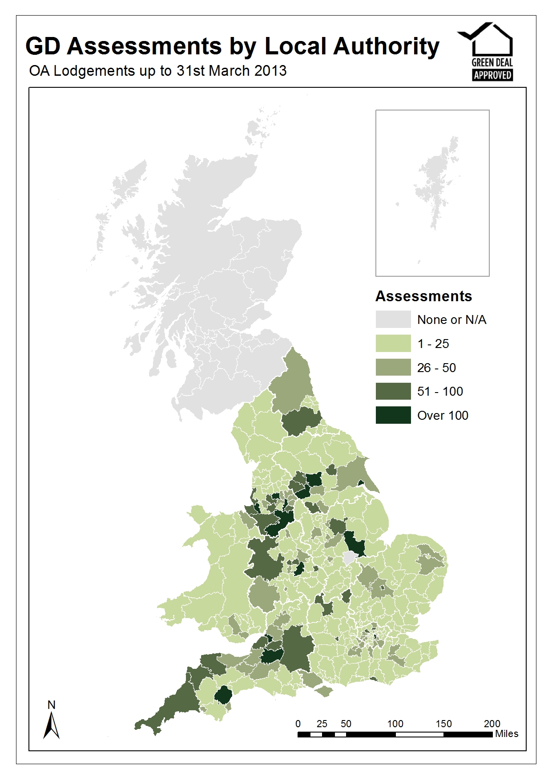

Energy Efficiency Rating (EER) Bands (Table 2, Chart 1)

The energy efficiency rating is presented in an A-G banding system for an Energy Performance Certificate, where Band A rating represents low energy costs (i.e. the most efficient band) and Band G rating represents high energy costs (i.e. the least efficient band).

Chart 1 compares properties that have had Green Deal assessments (coloured blocks) against the energy efficiency rating bands of properties in England in 2011 reported in the English Housing Survey (blocks with black outline).

A slightly higher proportion of Green Deal assessed properties were in the lower energy efficiency bands compared to all properties in England. Around 90 per cent of properties getting a GD Assessment had an energy efficiency band rating of D or lower, compared with 85 per cent of all properties in England.

Property Type (Table 3, Chart 2)

82 per cent of GD Assessments were in houses (7,550), 10 per cent were in bungalows (896), seven per cent were in flats (637) and two per cent were in maisonettes (141). This is shown in Chart 2. The housing stock in England (as reported in the English Housing Survey 2011-12) shows that 71 per cent of property types were houses, 16 per cent were flats, nine per cent were bungalows, and four per cent were maisonettes (purpose built flats).

Chart 2 - Number of Green Deal Assessments by Property Type up to 31st March 2013

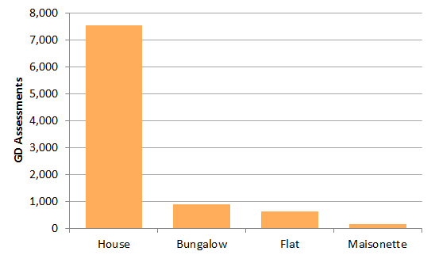

Built Form (Table 4, Chart 3)

The four main types of build are detached, semi-detached, end-terrace and mid-terrace. 37 per cent of GD Assessments (3,434) were semi-detached, followed by 28 per cent which were detached (2,587), 23 per cent were mid-terrace (2,107) and 12 per cent were end-terrace (1,096).

Chart 3 – Number of Green Deal Assessments by Built Form, up to 31st March 2013

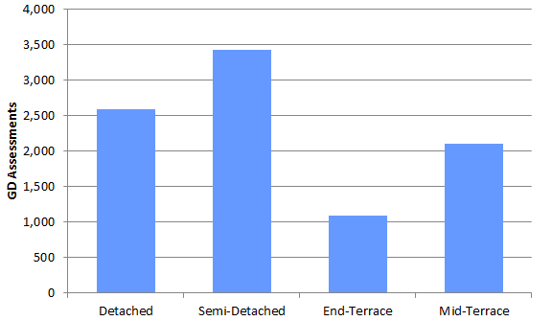

Tenure (Table 5)

84 per cent of GD Assessments were in owner-occupied properties (7,667), eight per cent were in the private rented sector (713) and the remaining eight per cent were in the social rented sector (694). In comparison, according to dwelling stock figures released by Department for Communities and Local Government, in England and Wales as of the 31 March 2012 there were 65 per cent owner-occupied, 18 per cent private rented sector and 18 per cent social rented sector properties. This suggests that a higher proportion of GD Assessments were in owner-occupied properties than would be expected.

On or off the Mains Gas Grid (Table 6)

In 2011 it was estimated 2.9 million households do not have mains-gas heating in England and Wales. This is around 12 per cent of all properties in England and Wales, and this is very similar to the 13 per cent of properties which had a GD assessment and were off the mains-gas grid.

Recommended measures (Table 7, 7a)

There were 30,506 improvements recommended in Green Deal Advice Reports, so on average there were around three recommended measures per GD Assessment. In 23 per cent of Assessments (2,111) one measure was recommended, in 21 per cent of Assessments (1,896) a package of two measures were recommended, in 16 per cent of Assessments (1,475) a package of three measures were recommended, and in 41 per cent of Assessments (3,742), packages of four or more measures were recommended.

The most common measure recommended was to replace the boiler. This accounted for 17 per cent (5,170) of all measures and this was recommended in 56 per cent of all GD assessments. Other commonly recommended measures included different types of solid wall insulation (11 per cent of all measures recommended), heating controls for wet central heating system (10 per cent of all measures recommended), and another 10 per cent of recommendations were for floor insulation. Photovoltaics (solar PV) were the most recommended micro-generation measure, also accounting for 10 per cent of recommendations and recommended in around a third of all GD assessments. Eight per cent of recommended measures were loft insulation.

The Supply Chain
To understand more about the organisations and infrastructure underpinning the Green Deal, this report also includes a section on geographical coverage of the number of Assessor organisations and Green Deal Installer organisations.
Supply chain operational coverage, as at end May (Maps 2 and 3)
The supply chain to support the Green Deal has been developing since October 2012. This includes individual Advisors (who carry out and produce Green Deal Advice Reports) and Assessor organisations (who employ authorised Green Deal Advisors), Green Deal Providers (who quote for and arrange Green Deal Plans with customers), and Installer organisations (who install energy efficiency improvements under the GD finance mechanism).

The Green Deal Oversight and Regulation Body (ORB) produces publically available information on the supply chain, and the latest figures are available by using the search tool on the ORB website. There is also information available on contacts in local areas.

These organisations operate in different geographical locations and provide a wide variety of offers to consumers. The maps below show the self-reported operational coverage of Assessor organisations and Installers by Local Authority. These maps are based on information submitted onto the ORB consumer search tool by a number of these participating organisations. 117 (60 per cent of 196) Assessor organisations and 450 (37 per cent of 1,223) Installers have submitted their information as at 30th May 2013.

These maps provide an indication of where these organisations are expecting to operate. However, businesses are flexible and may travel further to other areas as the market develops. Maps 2 and 3 indicate that there is good coverage of where these organisations are expecting to operate across all Local Authorities (LAs) in Great Britain. This publication does not report the operational coverage of Green Deal Providers, as only 11 (19 per cent of 60) had submitted their details onto the ORB consumer search tool.
There is some variation in the level of coverage in different administrative areas, with generally fewer Assessor Organisations and installers in Scotland and Wales compared to England. LAs in the North West have the most complete coverage of the GD supply chain out of all regions in Great Britain. For example, Manchester has at least 50 Assessor Organisations (54 report they operate in Manchester) and 110 installers (125 report they operate in Manchester).
Overall, all LAs are covered by at least 13 Assessor Organisations and 43 installers.

Map 2 – Number of Assessor organisations operating per Local Authority
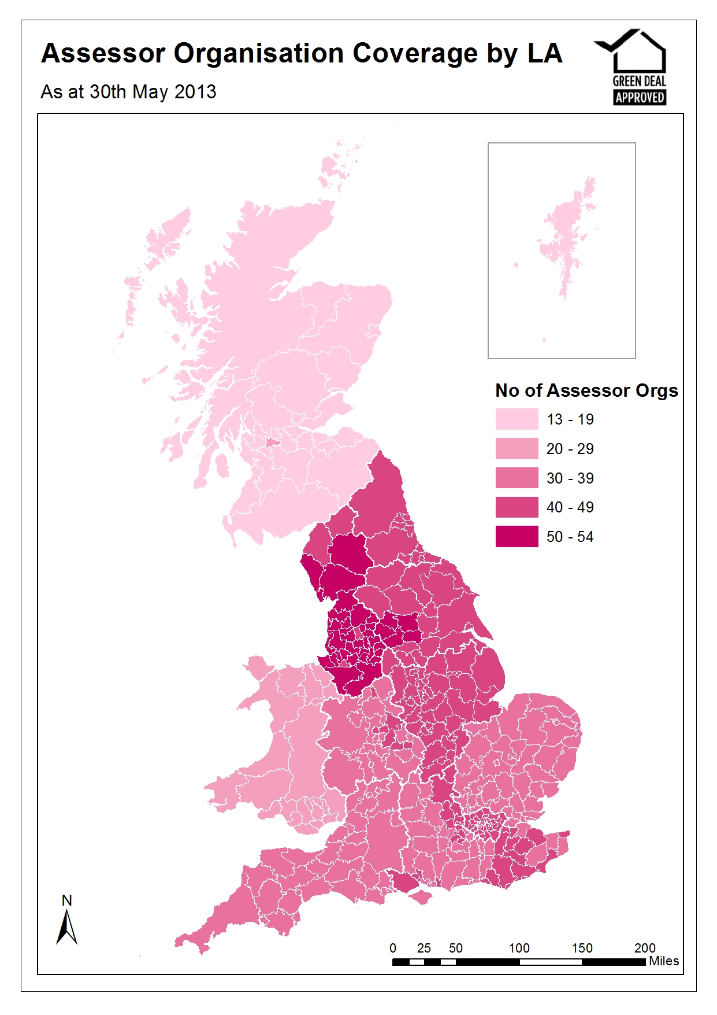
Map 3 – Number of Installers operating per Local Authority
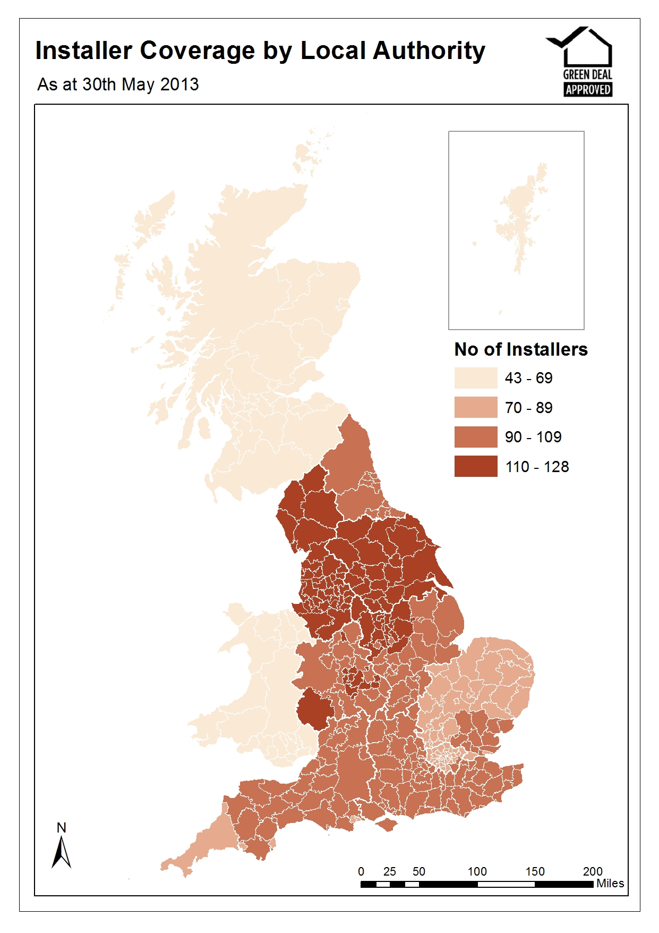

Annex A – Main Tables

Table 1: Number of Green Deal Assessments lodged by administrative area, up to 31st
March 2013 (Table available in Excel here).

Table 1a: Number of Green Deal Assessments lodged by region, up to 31st March 2013

Area names |  |  |  | Green Deal Assessments | Percentage of Assessments
Great Britain |  |  |  | 9,294 | 100
England |  |  |  | 8,848 | 95
North East |  |  |  | 327 | 4
North West |  |  |  | 1,453 | 16
Yorkshire and The Humber |  |  |  | 1,281 | 14
East Midlands |  |  |  | 705 | 8
West Midlands |  |  |  | 956 | 10
East |  |  |  | 611 | 7
London |  |  |  | 890 | 10
South East |  |  |  | 1,300 | 14
South West |  |  |  | 1,325 | 14
Wales |  |  |  | 376 | 4
Scotland |  |  |  | 70 | 1

Table 2: Number of Green Deal Assessments by Energy Efficiency Band, up to 31st March 2013, England and Wales
Energy Efficiency Band ¹ |  | Green Deal Assessments |  |  | Percentage of Assessments
A |  | 2 |  |  | 0
B |  | 49 |  |  | 1
C |  | 913 |  |  | 10
D |  | 4,926 |  |  | 53
E |  | 2,530 |  |  | 27
F |  | 664 |  |  | 7
G |  | 140 |  |  | 2
Total |  | 9,224 |  |  | 100

Table 3: Number of Green Deal Assessments by Property Type up to 31st March 2013, England and Wales
Property Type |  | Green Deal Assessments | Percentage of Assessments
House |  | 7,550 | 82
Bungalow |  | 896 | 10
Flat |  | 637 | 7
Maisonette |  | 141 | 2
Total |  | 9,224 | 100

Table 4: Number of Green Deal Assessments by Built Form, up to 31st March 2013, England and Wales
Built Form |  | Green Deal Assessments | Percentage of Assessments
Detached |  | 2,587 | 28
Semi-Detached |  | 3,434 | 37
End-Terrace |  | 1,096 | 12
Mid-Terrace |  | 2,107 | 23
Total |  | 9,224 | 100

Table 5: Number of Green Deal Assessments by tenure, up to 31st March 2013, England and Wales
Tenure |  | Green Deal Assessments | Valid Percentage of Assessments
Owner-occupied |  | 7,667 | 84
Rented (private) |  | 713 | 8
Rented (social) |  | 694 | 8
Total ¹ |  | 9,074 | 100
¹ Of the 9,224 Assessments, the tenure of 150 properties was unknown.

Table 6: Number of Green Deal Assessments by whether property is on or off the Mains Gas Grid, up to 31st March 2013, England and Wales
Properties on Mains Gas Grid |  | Green Deal Assessments | Percentage of Assessments
Off Gas |  | 1,179 | 13
On Gas |  | 8,045 | 87
Total |  | 9,224 | 100

Table 7: Number of improvements recommended in Green Deal Advice Reports by measure type (grouped), up to 31st March 2013, England and Wales
Measure Types |  | Number of Measures¹ | Percentage of Measures
Boiler |  | 5,752 | 19
Cavity Wall Insulation |  | 1,346 | 4
Loft Insulation |  | 2,590 | 8
Micro-generation |  | 4,835 | 16
Other Heating |  | 3,810 | 12
Other Insulation |  | 7,016 | 23
Solid Wall Insulation |  | 3,489 | 11
Window Glazing |  | 1,668 | 5
Total |  | 30,506 | 100
¹ More than one measure can be recommended per Assessment. On average there are around three recommendations per Assessment.

Table 7a: Number of improvements by measures recommended in Green Deal Advice Reports, up to 31st March 2013, England and Wales
Measure Type by Measures | Number of Measures¹ | Percentage of Measures
Boiler | 5,752 | 19
Change heating to gas condensing boiler (fuel switch) | 241 | 1
Change heating to gas condensing boiler (fuel switch), and flue gas heat recovery | 8 | 0
Change heating to gas condensing boiler (no fuel switch) | 103 | 0
Change heating to gas condensing boiler (no fuel switch), and flue gas heat recovery | 5 | 0
Condensing oil boiler | 58 | 0
Upgrade boiler, same fuel | 5,170 | 17
Upgrade boiler, same fuel, and flue gas heat recovery | 167 | 1
Cavity wall insulation | 1,346 | 4
Loft Insulation | 2,590 | 8
Loft Insulation | 2,353 | 8
Room-in-roof insulation | 237 | 1
Micro-generation | 4,835 | 16
Air source heat pump with radiators | 66 | 0
Air source heat pump with underfloor heating | 0 | 0
Biomass wood logs boiler | 22 | 0
Biomass wood pellets room heater with boiler | 11 | 0
Ground source heat pump with radiators | 12 | 0
Ground source heat pump with underfloor heating | 0 | 0
Micro-CHP | 4 | 0
Photovoltaics | 2,953 | 10
Solar water heating | 1,572 | 5
Wind turbine (on mast) | 0 | 0
Wind turbine (roof mounted) | 195 | 1
Other Heating | 3,810 | 12
Cylinder thermostat | 446 | 1
Heating controls for warm air system | 77 | 0
Heating controls for wet central heating system | 3,043 | 10
New or replacement storage heaters | 154 | 1
Replacement warm-air unit | 24 | 0
Waste water heat recovery | 66 | 0
Other Insulation | 7,016 | 23
Draughtproofing | 1,745 | 6
Flat roof insulation | 295 | 1
Floor insulation | 3,002 | 10
Hot water cylinder insulation | 994 | 3
Insulated doors | 980 | 3
Solid Wall Insulation | 3,489 | 11
External insulation with cavity wall insulation | 178 | 1
Solid wall insulation (pre 1967 England & Wales, pre 1965 Scotland) | 2,070 | 7
Solid wall insulation (from 1967 E&W, from 1965 Scotland) | 1,241 | 4
Window Glazing | 1,668 | 5
Double glazing | 1,527 | 5
Secondary glazing | 124 | 0
Triple glazing | 17 | 0
Total | 30,506 | 100
¹ More than one measure can be recommended per Assessment. On Average there are around three recommendations per Assessment.

Annex B – Background
Green Deal

The Green Deal (GD) was launched on 28 January 2013 in England and Wales (and on 25 February in Scotland) and will tackle a number of the key barriers to the take-up of energy efficiency measures.

Customers having Green Deal Assessments undertaken have the choice of how they proceed. They might take the view that their home is sufficiently energy efficient, or that they want to finance work through a Green Deal Plan or that they want to use alternative funding arrangements (e.g. use of savings).
The Green Deal process for households is briefly described below:

Step 1 – Assessment – A Green Deal assessor will come to the home, talk to the owner/occupier about their energy use and see if they can benefit from making energy efficiency improvements to their property.

Step 2 - Recommendations – The assessor will recommend improvements that are appropriate for the property and indicate whether they are expected to pay for themselves through reduced energy bills.

Step 3 – Quotes – Green Deal Providers will discuss with the owner/occupier whether a Green Deal Plan is right for them and quote for the recommended improvements, including the savings estimates, savings period, first year instalments and payment period for each improvement. A number of quotes can be obtained.

Step 4 – Signing a plan – The customer chooses to proceed with a given provider and package of measures. The owner/occupier needs to obtain the necessary consent to make improvements to the property before they can agree terms with the GD Provider of a Green Deal Plan, at which stage they enter a cooling-off period.

Step 5 – Installation – Once a Green Deal Plan has been agreed, the Provider will arrange for the improvements to be made by a Green Deal Installer. Once the installation has been completed a letter is sent to the Bill Payer and, at this stage, the Green Deal Plan goes ‘live’.

Repayments will be no more than what a typical household should save in energy costs.

Energy Company Obligation

The Energy Company Obligation (ECO) started on 1 January 2013 (although energy companies have been able to count against their targets measures delivered since 1 October 2012) and runs to 31 March 2015. It broadly takes over from two previous schemes (Carbon Emissions Reduction Target - CERT - and Community Energy Saving Programme - CESP) and focuses on providing energy efficiency measures to low income and vulnerable consumers and those living in 'hard-to-treat' properties. While ECO is not a financial target, DECC’s Impact Assessment estimated costs at around £1.3 billion a year.

There are three main ECO obligations – The Carbon Saving Obligation (CSO); Carbon Saving Communities (CSCO) and Affordable Warmth (HHCRO). The ECO Carbon Saving Obligation is estimated to be worth around £760 million per year. The Carbon Saving Community Obligation and ECO Affordable Warmth will together provide support worth around an estimated £540 million per year to low-income households and areas.

Carbon Saving Obligation - This covers the installation of measures like solid wall and hard-to-treat cavity wall insulation, which ordinarily can’t be financed solely through the Green Deal.

Carbon Saving Communities Obligation - This provides insulation measures to households in specified areas of low income. It also makes sure that 15 per cent of each supplier’s obligation is used to upgrade more hard-to-reach low-income households in rural areas.

Affordable Warmth Obligation - This provides heating and insulation measures to consumers living in private tenure properties who receive particular means-tested benefits. This obligation supports low-income consumers who are vulnerable to the impact of living in cold homes, including the elderly, disabled and families.

How do the Green Deal and ECO interact?

Following a GD Assessment there will be a range of measures which could improve the energy efficiency of the property. Some of these could be paid for through GD finance, up to the point where the expected annual cost will not exceed what a typical household should save in energy costs. However, depending on the measure or the property, other sources of finance may also be required. ECO funding could be one of these sources, for example for measures such as Solid Wall Insulation and hard-to-treat Cavity Wall insulation.

Annex C – Sources and Methodology

Data Sources
The estimates in this and future Statistical Release use administrative data generated as part of the Green Deal and Energy Company Obligation processes.
There are seven main sources of information:
- Landmark – who manage the national lodgement of Green Deal Assessments in England and Wales
- Energy Savings Trust (EST) – who manage the national lodgement of Green Deal Assessments in Scotland
- Green Deal Central Charge Database – which manages the recording and administration of Green Deal Plans
- Ofgem – who administer the Energy Company Obligation and collect information from energy companies on measures installed under ECO.
- The Green Deal Oversight and Regulation Body (ORB) – who administer the certification of GD organisations (including assessors, installers and providers)
- Data on ECO brokerage is publically available following each auction.
- Capita – who administer the Green Deal Cashback Scheme

This report uses data from Landmark and the Energy Savings Trust for numbers of lodged Assessments, and data from the ORB for the supply chain.

Property Characteristics

Information relating to the characteristics of properties getting GD Assessments is taken from the Energy Performance Certificate relating to the GD Assessment. Properties can be built in a large variety of configurations. A basic division is between free-standing or single-family houses and various types of attached or multi-user dwellings. Both sorts may vary greatly in scale and amount of accommodation provided. Many variations are purely matters of style rather than spatial arrangement or scale.

All property types have a built form. The four main types of build are detached, semi-detached, end-terrace and mid-terrace. Mid-terrace has external walls on two opposite sides; end-terrace has three external walls.

Energy Efficiency Rating

The Energy Efficiency Rating (EER) is presented in an A-G banding system for an Energy Performance Certificate, where Band A rating represents low energy costs (i.e. the most efficient band) and Band G rating represents high energy costs (the least efficient band).

The EER bands based on SAP are:

- Band A (92 plus)
- Band B (81-91)
- Band C (69-90)
- Band D (55-68)
- Band E (39-54)
- Band F (21-38)
- Band G (1-20)

Experimental Statistics

These estimates are released as Experimental Statistics which means they are official statistics undergoing an evaluation process prior to being assessed as National Statistics. They are published in order to involve users and stakeholders in their development, and as a means to build in quality assurance during development.
More information on the methodology is included here.
As with any new data collection, there are likely to be some data quality issues to resolve as the process beds in. Therefore data in the monthly reports should be treated as provisional and subject to revision.
Any revisions will be marked in the data tables and for any significant revisions we will provide an explanation of the main reasons.
Further Information and Feedback

Any enquiries or comments in relation to this statistical release should be sent to DECC’s Green Deal Statistics Team at the following email address:
EnergyEfficiency.Stats@decc.gsi.gov.uk

Contact telephone: 0300 068 5202

The statistician responsible for this publication is Matt Walker.

Further information on energy statistics is available at https://www.gov.uk/government/organisations/department-of-energy-climate-change/about/statistics

Next Releases

The next quarterly publication is planned for publication at 9.30am on 19 September 2013 and will contain more detailed information on activity up to the end of June, including geographic breakdowns of Green Deal Assessments and ECO measures.

Issued by:
Department of Energy & Climate Change
3 Whitehall Place
London SW1A 2AW
www.gov.uk/decc

Press Enquiries: 0300 068 5219
Out of hours: 020 7215 3505
General Enquiries: 0300 060 4000

At the time of publication DECC did not have record level information on GD Assessments which had taken place in Scotland. As record level information was not available for this publication, geographic breakdowns by Scottish Authority for the 70 Assessments which took place up to 31st March are not included in Map 1.
Live tables on dwelling stock 2012 (Table 109) , Department of Communities and Local Government https://www.gov.uk/government/uploads/system/uploads/attachment_data/file/192180/LiveTable109_FINAL_VERSION.xls
DECC intend to provide geographic breakdowns of GD Assessments within Scotland in the next quarterly release on 19 September.
Record level GD assessment information is not available for Scotland.
English Housing Survey, Headline Report 2011-12, Table 14 https://www.gov.uk/government/uploads/ system/uploads/attachment_data/file/88370/EHS_Headline_Report_2011-2012.pdf
The equivalent split is not available for Welsh properties, which make up around 5 per cent of the housing stock in England and Wales.
English Housing Survey, Headline Report 2011-12, Table 12
All property types have a built form.
Live tables on dwelling stock 2012 (Tables 104 and 106) , Department of Communities and Local Government https://www.gov.uk/government/statistical-data-sets/live-tables-on-dwelling-stock-including-vacants
Off-Grid Energy, An OFT Market Study, October 2011, Table A.1 http://www.oft.gov.uk/shared_oft/market-studies/off-grid/OFT1380annexes.pdf
Individual Installers within an installer organisation do not need to register.
GD accredited organisations are able to provide their operational coverage information onto the ORB consumer search tool on a voluntary basis. Some organisations have waited until they are ready to delivery GD services before providing their details. Separate entries have been submitted for each individual sub-division of an organisation which has its own certification ID.
This information is taken from the 30th May 2013 as there are lags resulting from the time it takes for organisations to provide their information. Earlier information provided may not be representative of delivery of services in Q1 2013.
NB, not all Installers are accredited to install all available domestic measures as part of the Green Deal. Please check the ORB website for further details.
The Plan is a contract between the owner/occupier and the Provider – it sets out the work that will be done and the repayments.
For example, in the case of a Green Deal Plan that is regulated by the Consumer Credit Act 1974, the consumer will have 14 days to withdraw from the part of the Green Deal Plan which provides credit.
This is both the EPC and Occupancy Assessment which make up a Green Deal Advice report. This quarterly report is based on data extracts from Landmark up to the end of April 2013.
Information on the Standard Assessment Procedure can be found here https://www.gov.uk/standard-assessment-procedure

