
Professor Neil Humphrey and Dr Garry Squires
Research Report DFE-RR028
Achievement for All Evaluation: Interim Report (May 2010)
This research report was written before the new UK Government took office on 11 May 2010. As a result the content may not reflect current Government policy and may make reference to the Department for Children, Schools and Families (DCSF) which has now been replaced by the Department for Education (DFE).
The views expressed in this report are the authors’ and do not necessarily
reflect those of the Department for Education

Principal Investigators

Professor Neil Humphrey (Lead Principal Investigator)
Dr. Garry Squires

Research Team

Dr. Alexandra Barlow
William Bulman
Judith Hebron
Jeremy Oldfield
Lawrence Wo

Academic Support

Professor Peter Farrell
Professor Daniel Muijs
Dr. Andy Howes

Administrative Support

Jane Mortimer

Acknowledgements

We gratefully acknowledge the support and contribution of each Achievement for All and comparison school, the Local Authority leads, and National Strategies regional advisors in providing the data described throughout this report.

Contents
Principal Investigators i
Research Team i
Academic Support i
Administrative Support i
Acknowledgements i
Acronyms used in this report i
Executive Summary 1
Chapter 1: OVERVIEW OF THE ACHIEVEMENT FOR ALL (AfA) NATIONAL EVALUATION PROJECT 1
Aims and objectives 1
Research design 1
Quantitative strand 1
Qualitative strand 1
Chapter 2: FINDINGS FROM OUR BASELINE SURVEY OF TEACHERS AND PARENTS 1
What we learnt about wider outcomes and parental engagement and confidence for pupils with SEND 1
The survey designs 1
Structure of the findings 1
The nature of our study sample 1
Defining the monitoring sample 1
Representativeness of the monitoring sample in terms of gender, age, SEND provision and primary need. 1
Comparability of AfA and comparison schools in the monitoring sample in terms of the wider outcomes. 1
Findings from the baseline teacher and parent surveys 1
Levels of agreement between teachers and parents 1
Behaviour 1
Positive relationships 1
Bullying 1
Parent survey - engagement and confidence 1
Parent survey – wider participation 1
Chapter 3: FINDINGS FROM THE BASELINE ACADEMIC ATTAINMENT DATA COLLECTED BY NATIONAL STRATEGIES 1
What we learnt about academic attainment for pupils with SEND 1
About the data 1
Patterns and trends in the academic attainment data 1
Chapter 4: FINDINGS FROM OUR INTERVIEWS WITH REGIONAL ADVISORS AND LOCAL AUTHORITY LEADS 1
What we learnt about strategic support and emerging models of practice in Local Authorities 1
Developing thinking about what how SEND is defined and understood 1
Promoting ‘joined up’ provision for children with SEND 1
Building on existing practice and other initiatives 1
Promoting communication and sharing of ideas and practice between schools 1
Supporting and challenging schools 1
Raising aspirations and expectations for children with SEND 1
Building in sustainability and transferability from the outset 1
Different models of practice 1
Chapter 5: FINDINGS FROM OUR INITIAL SCHOOL CASE STUDY VISITS 1
What we learnt about how schools are implementing AfA 1
General 1
Assessment, tracking and intervention 1
Structured conversations with parents 1
Provision for wider outcomes 1
Barriers and facilitators around successful implementation 1
Timescale and pressure 33
Initiative overload/malaise 1
Strong leadership 1
‘Fit in’ not ‘bolt-on’ 1
Chapter 6: FINDINGS FROM OTHER SOURCES OF DATA COLLECTION 1
Other sources 1
Workload Agreements 1
Training and skills 1
Empowering schools versus forcing schools 1
Appendices 1
Appendix 1 1
Table 1: Conversion chart for academic attainment data 1
Appendix 2 1
Figure 19: Mean point scores by year group 1
Figure 20: Mean point scores by year group and gender 1
Figure 21: Mean point scores by year group and SEND provision 1
Figure 22: Mean point scores by primary SEND type in year 1 1
Figure 23: Mean point scores by primary SEND type in year 5 1
Figure 24: Mean point scores by primary SEND type in year 7 1
Figure 25: Mean point scores by primary SEND type in year 10 1

Acronyms used in this report

AfA | Achievement for All
ASD | Autistic Spectrum Disorders
BECTA | British Educational Communications and Technology Agency
BESD | Behaviour, Emotional, Social Difficulties
DCSF | Department for Children, Schools and Families
HI | Hearing Impairment
IEP | Individual Education Plan
LA | Local Authority (Formerly local education authorities but now also referred to by many alternative names such as Children’s Services)
MLD | Moderate Learning Difficulty
MSI | Multiple Sensory Impairment
NS | National Strategies
OFSTED | Office for Standards in Education
PD | Physical Difficulties
PMLD | Profound and Multiple Learning Difficulty
SA | School Action
SA+ | School Action Plus
SCLN | Speech, Communication and Language Needs
SENCo | Special Educational Needs Co-ordinators
SEND | Special Educational Needs and Disabilities
SpLD | Specific Learning Difficulty (e.g. dyslexia)
VI | Visual Impairment

Executive Summary

The aims of this national evaluation project are to examine the impact of Achievement for All (AfA) on a variety of outcomesfor pupils with SEND and to find out what processes and practices in schools are most effective in improving these outcomes. Our research design comprises (a) a quantitative strand involving longitudinal assessment of outcomes for over 10,000 pupils with SEND (including a comparison group of pupils attending schools that are not involved in AfA) through teacher surveys, parent surveys and academic attainment data, and (b) a qualitative strand involving interviews with key strategic figures, longitudinal case studies of 20 AfA schools, ‘mini-case studies’ of 100 pupils/families, and ad-hoc data collection at a range of events relating to AfA. The findings presented in this report are derived from our baseline surveys and initial case study school visits. They therefore only represent an early ‘snapshot’ and should be interpreted in this context.

Our baseline survey of pupil outcomes yielded data on around 10,000 pupils in the teacher survey and over 2,000 pupils in the parent survey – making this the largest study of its kind to be conducted in England. Initial analysis suggests that this monitoring sample is representative of national trends among pupils with SEND. We found moderate levels of agreement between teacher and parent surveys – which emphasizes the need for further sharing of information between home and school. In terms of overall trends, we found that outcomes tended to be worse for pupils who are:
- males
- at School Action Plus or have a Statement of SEN
- attending secondary schools, and/or
- identified as having ASD or BESD.

The academic attainment data collected on our behalf by National Strategies also revealed some very interesting trends:
- pupils with SEND do make progress across year groups
- whilst females’ initial advantage in English increases over time, males’ initial advantage in Maths decreases over time
- the differences in attainment between pupils at different stages of SEND provision increases slightly as they get older
- pupils with certain primary needs (e.g. MSI) make differential progress across year groups.

Our qualitative data collected from key strategic figures suggested that AfA:
- is developing thinking about what we mean by SEND
- is promoting ‘joined up’ provision for children with SEND
- can be used as a tool to build upon and improve existing practice and other initiatives
- is promoting communication and sharing of ideas and practice between schools
- is raising aspirations and expectations for children with SEND

Our qualitative data collected during initial case study school visits suggested that:
- despite some early concerns, AfA has been embraced by most schools
- Strand 1 (assessment, tracking and intervention) is helping schools to make better use of data to improve outcomes for children with SEND
- Strand 2 (structured conversations with parents) is having a very positive impact on parental engagement and confidence
- Strand 3 (provision for wider outcomes) is promoting flexibility and creativity in school practice
- schools face difficult barriers to implementation in terms of timescales, pressure, and initiative overload/malaise (this is particularly true of secondary schools)
- key facilitators of effective implementation include strong leadership and assimilating AfA into existing structures and practices rather than seeing it as a ‘bolt on’

Finally, our ad-hoc data collected from a range of AfA events suggested that:
- there are concerns among teaching unions about the additional demands that AfA has placed upon teachers
- AfA resources have been used to develop training and skills of teaching staff and will therefore contribute to overall school development
- resistance to AfA has been most evident in LAs where schools were not given a choice of whether or not to participate

In summary, our baseline quantitative data suggests that there are significant numbers of pupils with SEND who need the kind of support offered within AfA – strengthening the original rationale for the project. Our qualitative data – even at this early stage in the evaluation - suggests that AfA is already beginning to have a positive impact upon processes and practices within LAs and schools.

Chapter 1: OVERVIEW OF THE ACHIEVEMENT FOR ALL (AfA) NATIONAL EVALUATION PROJECT

Aims and objectives
The main aim of the national evaluation project is to examine the impact of AfA on a variety of outcomes for children and young people with special educational needs and disabilities (SEND) in Years 1, 5, 7 and 10. We also aim to find out what processes and practices in schools are most effective in improving these outcomes.
We intend to meet these aims by addressing the following research questions:
- What is the impact of AfA on outcomes for pupils with SEND?
  - In relation to attainment in English and mathematics?
  - In relation to wider outcomes such as behaviour, attendance, and positive relationships?
  - In relation to parental engagement and confidence?
  - To what extent is any impact mediated by variation in regional, LA, school and pupil level factors?
- What processes and practices are most effective in improving the above outcomes?
  - In relation to activity at regional, LA, school and classroom levels?
  - What contextual and pupil factors influence the relative success of these processes and practices?
  - How sustainable and transferable are these processes and practices?
An additional factor that we have been asked to consider since the commissioning of the research has been the impact of the BECTA project to improve on-line reporting in some AfA schools. This being treated as a school level factor (RQ1) and a contextual factor (RQ2).

Research design
In order to address the above questions, our research project has been designed as follows:

Quantitative strand
This strand of the research primarily focuses upon Research Question 1. We are conducting online surveys of teachers and parents of children and young people with SEND in Years 1, 5, 7 and 10 (these are the target year groups for the project). These surveys focus upon key AfA outcomes. The teacher survey looks at behaviour, bullying and positive relationships. The parent survey covers these areas, and in addition, wider participation and parental engagement and confidence. In addition to these surveys, we will be collecting and analysing data on pupil attendance (this will be collected from participating Local Authorities) and academic attainment in English and Mathematics (this is being collected on our behalf by National Strategies).
The surveys are being conducted at three key time points – at baseline (Time 1 – the Spring term 2010), mid-point (Time 2 – Autumn term 2010) and at the end of the project (Time 3 – Summer term 2011) so that we can track changes in pupil outcomes. Approximately 455 AfA schools and 54 comparison schools (who are not part of the AfA project) are participating in this strand of the project. Our potential sample of pupils/families for this strand is approximately 14,500.
In addition to these pupil outcome surveys, we are also conducting surveys at the school level in order to determine what factors (such as the climate of the school and activity in each of the three key strands of AfA) impact most upon pupil outcomes. These surveys will be completed by the AfA lead in each school and will be conducted at two key time-points – in the Summer term 2010 (Time 1) and in the Spring term 2011 (Time 2).

Progress so far and next steps
At the time of writing, we have completed our baseline (Time 1) pupil outcome survey. We are currently in the process of developing the school level surveys so that the first of these (Time 1) can be conducted in June 2010.
The initial findings relating to this strand of the national evaluation project can be found in chapters 2 and 3 of this report.

Qualitative strand
This strand of the research primarily focuses upon Research Question 2. Our qualitative data collection comprises of the following:
- Interviews with National Strategies regional advisors, AfA project leads, and a representative sample of AfA lead/advisory teachers in each Local Authority. These interviews primarily focus upon strategic support for AfA implementation.
- Longitudinal case studies of 20 AfA schools (2 in each Local Authority), that primarily focus upon the process of AFA implementation and involving:
  - interviews with Special Educational Needs Co-ordinators, head teachers/senior managers, classroom teachers, support staff (e.g. teaching assistants) and pupils,
  - focus groups with parents,
  - observations and,
  - analysis of school documentation.
- ‘Mini case studies’ of 100 pupils/families (5 in each case study school). These mini case studies are designed to provide clear examples of how AfA is working to improve outcomes for individual pupils/families.
- Additional, informal data collection at a range of events – for instance, the launch and update conferences hosted by the National College for School Leadership in each Local Authority. These additional data collections opportunities provide us with a broader view of progress in AFA implementation, including some of the early challenges and successes.

Progress so far and next steps
At the time of writing, we have interviewed each National Strategies regional advisor and all 10 AfA project leads. Additionally, we have recruited and conducted our first data collection visits to our 20 case study schools. These schools are currently in the process of nominating pupils/families for our mini case studies. Members of the evaluation team attended all launch and update conferences and are also attending occasional events organised in each Local Authority.
Next steps in this strand of the project include interviews with advisory/lead teachers in each Local Authority, and second visits to each of our case study schools. These second visits will include initial data collection for our mini case studies of pupils/families. This data collection will take place in the summer term 2010.
The initial findings relating to this strand of the national evaluation project can be found in chapters 4, 5 and 6 of this report.

Chapter 2: FINDINGS FROM OUR BASELINE SURVEY OF TEACHERS AND PARENTS

What we learnt about wider outcomes and parental engagement and confidence for pupils with SEND

The survey designs
The findings presented in this chapter are based on the baseline surveys completed by teachers and parents of pupils with SEND in the spring term of 2009/10 (Time 1). A review of the literature on the wider outcomes targeted in AfA revealed that there were no suitable existing measures that could be used ‘off the shelf’, and so the evaluation team developed bespoke surveys for use in the project. These were piloted in late 2009 using teachers and parents that were not involved in the AfA project; initial analysis suggested that the surveys were fit for purpose.
The teacher survey covers the following outcomes:
- Positive relationships – a sample item is, “[Pupil name] has at least one good friend”
- Behaviour – a sample item is, “[Pupil name] gets in fights with other children”
- Bullying – a sample item is, “[Pupil name] is called names or teased by other children”
The parent survey also covers positive relationships, behaviour, and bullying, in addition to the following outcomes:
- Wider participation – a sample item is, “[Pupil name] often attends wider participation activities at his/her school”
- Parental engagement and confidence – a sample item is, “I feel that the school listens to me”.

Structure of the findings
The graphs and tables shown on the following pages are designed to give an idea of some of our initial findings from the surveys. In particular, we highlight patterns that we have found relating to factors such as:
- Year group – for instance, do older children behave better than younger children?
- Sex – for instance, do females have more positive relationships than males?
- Primary need – for instance, do pupils with autistic spectrum disorders (ASD) experience more frequent bullying than pupils with other SEND?
- SEND provision – for instance, is there greater engagement and confidence among parents of pupils at school action (SA) than those at school action plus (SA+) or with statements of special educational needs?

The nature of our study sample

In any large scale study there is always a concern about how well the schools involved represent the larger national picture and to what extent the findings can then be generalised beyond those schools involved in the AfA pilot.

Defining the monitoring sample
The target pupils are those with SEND in Y1, Y5, Y7 and Y10. Baseline academic data has been collected from LAs and schools by NS and passed to us (13,767 pupils). Teachers have logged onto our survey site and completed the baseline teacher surveys for 10,341 pupils (9,902 from AfA schools and 439 from comparison schools).
We have created a ‘monitoring sample’ for AfA schools, which includes all target pupils for which we have both baseline teacher surveys and academic data. We have added to this all pupils at comparison schools for which we have baseline teacher surveys. Our monitoring sample contains 9,824 pupils (9,385 from AfA schools and 439 from comparison schools).
The monitoring sample of pupils with SEND in Years 1, 5, 7 & 10
AfA schools 9,385
Comparison schools 439
For parent surveys, we received a total of 2,010 and these could be matched to the monitoring sample for 1,596 pupils (1,525 from AfA schools and 71 from comparison schools).

Representativeness of the monitoring sample in terms of gender, age, SEND provision and primary need.
In this section we report on teacher survey data only in the interests of brevity. However, it is worth noting that proportions of parent survey returns by gender, year group, SEND provision and primary SEND type for the monitoring sample are broadly comparable to the trends outlined below, despite a much lower response rate overall.
Figures 1 to 4 provide a breakdown of the monitoring sample for the AfA and comparison schools, by gender, year group, SEND provision and primary SEND type. These proportions are compared to national data produced by DCSF to demonstrate representativeness.
Figure 1: Gender ratio
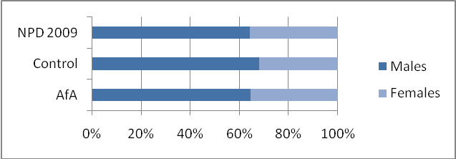
Twice as many males as females have SEND
Across all three samples, approximately two thirds of the pupils with SEND were males.

Figure 2: Year group ratio
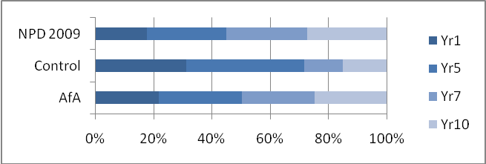
Levels of SEND remain the same across year groups in AfA schools and the national population
The AfA sample had an even spread of pupils per year group, as schools in AfA were selectively chosen to reflect this range. This mirrors national averages. There were less year 7 and 10 pupils in the comparison sample, because recruiting secondary schools not involved in the AfA pilot was particularly difficult.

Figure 3: SEND provision
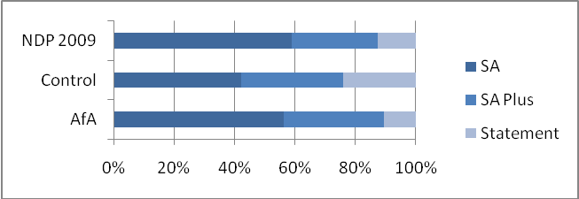
Levels of support for SEND are the same in AfA schools and the national population
There were similar proportions of children at the different stages of provision among the AfA and national sample. However, there were proportionately more pupils with Statements of SEND in the comparison sample, which is perhaps a reflection of comparison schools’ motivation to participate in the project.

Figure 4: Percentages of primary SEND types
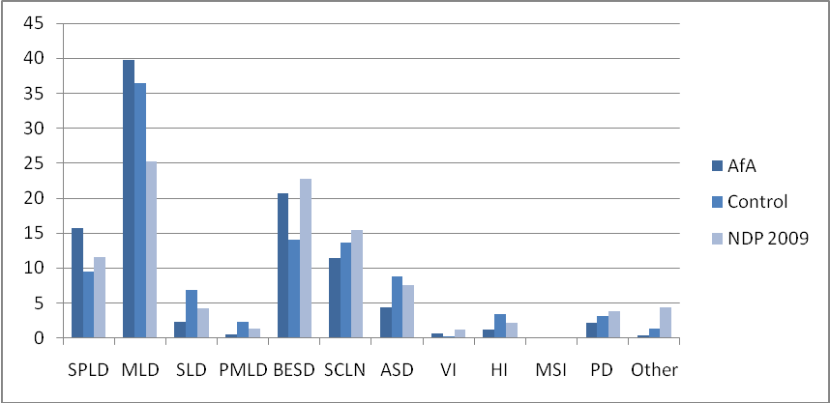
The proportion of SEND type to national data was very similar overall. For the AfA sample all but one category (MLD) (and for the comparison sample all but two categories - MLD and BESD) were within 4% of proportions in the national sample.
Reporting of primary SEND type is not required for pupils at School Action, and therefore the figures for primary SEND type for the national sample contain only information for pupils with SEND at School Action Plus and with Statements of SEN. This may explain some differences between the samples, particularly the higher percentage of MLD in the monitoring sample. The MLD category may be being used as a ‘catch-all’ category for children at School Action until further assessment has been undertaken involving outside professionals at School Action Plus.
The above comparisons demonstrate that our monitoring sample is representative of national trends among pupils with SEND in England in terms of gender, age, SEND provision and primary SEND type at the start of the AfA pilot. This strengthens the argument that any differences that emerge over the next two years can be attributed to the introduction of AfA.

Comparability of AfA and comparison schools in the monitoring sample in terms of the wider outcomes.

Teacher surveys (Strand 3)
The teacher surveys focused on:
- Behaviour with scores ranging from 0-27 and higher scores are indicative of greater behaviour problems.
- Positive relationships with scores ranging from 0-30 and higher scores are indicative of more positive relationships.
- Bullying scores range from 0-24 and higher scores are indicative of more frequent bullying.
Mean scores on these scales were calculated for the AfA and comparison schools (Figure 5).

Figure 5: Mean teacher-rated scores for behaviour, positive relationships and bullying for the AfA and comparison samples
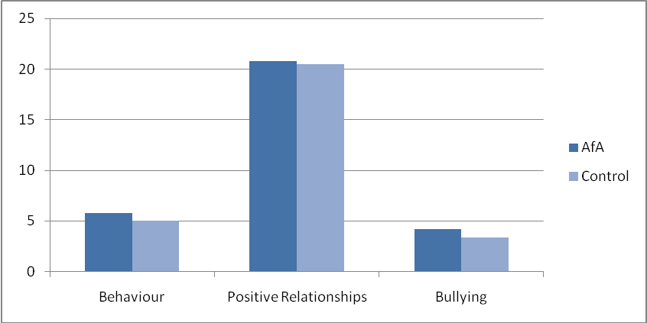

Overall the teachers in AfA and comparison schools reported similar levels of behaviour, positive relationships and bullying.

Parent surveys (Strand 2 and 3)
The parent surveys focused on
- Behaviour - scores range from 0-27; higher scores are indicative of greater behaviour problems. (Strand 3)
- Positive relationships - scores range from 0-30; higher scores are indicative of more positive relationships. (Strand 3)
- Bullying - with scores ranging from 0-24 and higher scores are indicative of more frequent bullying. (Strand 3)
- Wider participation activities - scores range from 0-24; higher scores are indicative of increased participation in wider activities. (Strand 3)
- Parental engagement and confidence - scores range from 0-24; higher scores are indicative of greater engagement and confidence. (Strand 2)
Mean scores on these scales were calculated for the AfA and comparison schools (Figure 6).

Figure 6: Mean parent-rated scores for behaviour, positive relationships, bullying, parental confidence and engagement and wider participation activities for the AfA and comparison samples
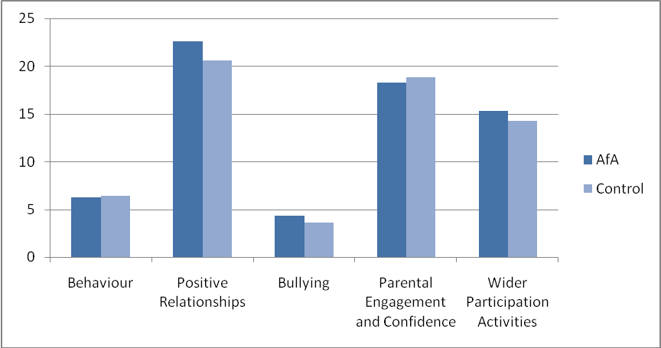
Overall the parents in AfA and comparison schools reported similar levels of behaviour, positive relationships, bullying, parental engagement and confidence and wider participation activities.

Findings from the baseline teacher and parent surveys

Levels of agreement between teachers and parents
Where we had teacher and parent survey responses for the same pupils, we were able to assess levels of agreement by calculating correlation coefficients. The correlation coefficients for teacher and parent survey responses were 0.39 for bullying, 0.36 for positive relationships and 0.51 for behaviour. These values indicate moderate levels of agreement, which is a very common finding in the measurement of these kinds of outcomes.
Teacher and parent views are different for many individual pupils and this emphasises the need to improve parental engagement and participation in partnership with teachers.
However, these findings also indicate that teachers and parents’ views are different for many pupils, and this emphasizes the need for sharing of information between home and school (e.g. in the structured conversations with parents).

Behaviour
The graphs in this section show how behaviour is reported to vary by gender, year group, SEND provision and primary SEND type. Figures 7 and 8 show the average teacher-rated and parent-rated scores.
Agreements between the parent and teacher data were that:
- Males had much greater reported behaviour problems than females.
- Pupils at School Action had much lower levels of reported behaviour problems than those at School Action Plus or with Statements of SEND.
- As would be expected, pupils identified as having BESD had the greatest incidence of reported behaviour problems. This is followed by PMLD and ASD.
Differences in the views of parents and teachers are evident:
- Teachers report a fairly consistent incidence of behavioural difficulties across all year groups, while parents report that there is an age-related decline in behavioural difficulties (with the exception of Year 10).
- Parents also reported high incidence of behavioural difficulties in children with PMLD which may be characterised by some of the more challenging behaviours associated with these children. Surprisingly, high incidences of behavioural difficulties are reported for children with hearing impairments.

Figure 7: Mean teacher-rated and parent-rated behaviour scores in the monitoring sample by gender, year group and position on SEND register
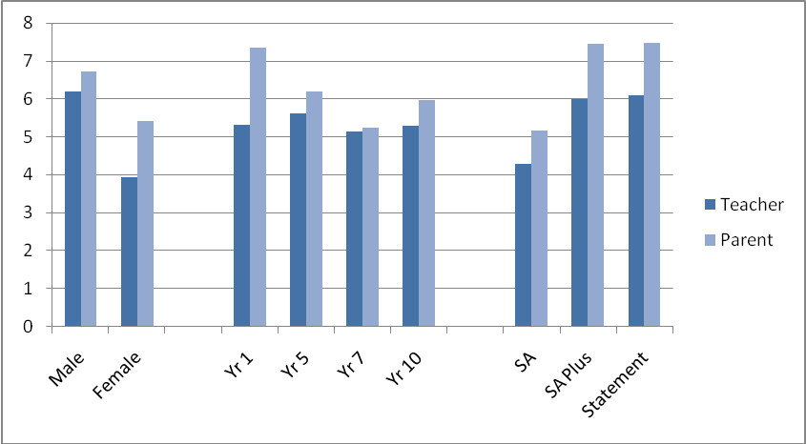

Figure 8: Mean teacher-rated and parent-rated behaviour scores in the monitoring sample by primary SEND type
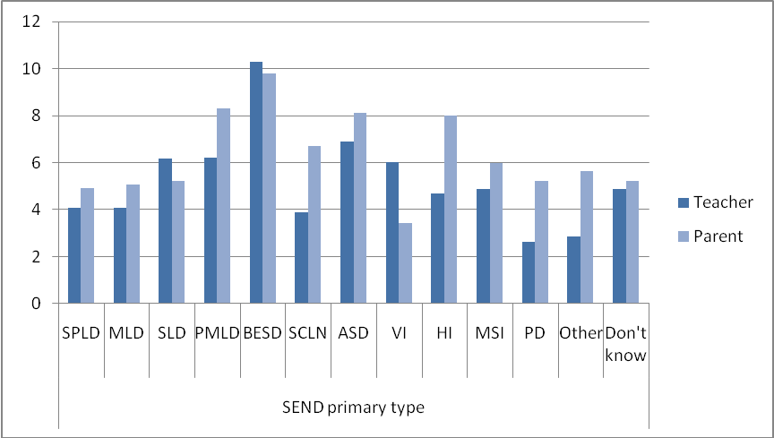

Positive relationships
The graphs in this section show how behaviour is reported to vary by gender, year group, SEND provision and primary SEND type. Figures 9 and 10 show the average teacher-rated and parent-rated scores.
Both teachers and parents reported that:
- Pupils with higher levels of SEND support have lower levels of reported positive relationships.
- Pupils identified as having ASD had lower reported levels of positive relationships than other groups of pupils. Teachers also identified pupils with PMLD as having lower reported levels of positive relationships than all other groups of pupils (including those with ASD).
Parents reported that positive relationships do not appear to vary as a function of gender or age. However, teachers reported that females had greater levels of positive relationships than males, and that positive relationships generally appear to increase with age (with the exception of pupils in Year 10).

Figure 9: Mean teacher-rated and parent-rated positive relationships scores in the monitoring sample by gender, year group and SEND provision
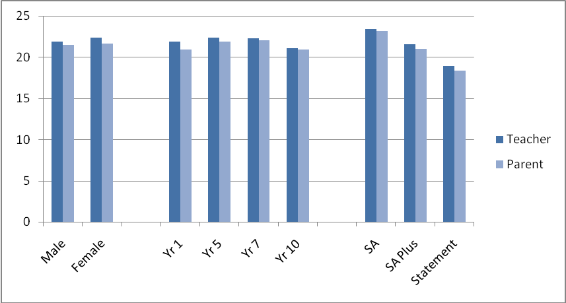

Figure 10: Mean teacher-rated and parent-rated positive relationships scores in the monitoring sample by primary SEND type
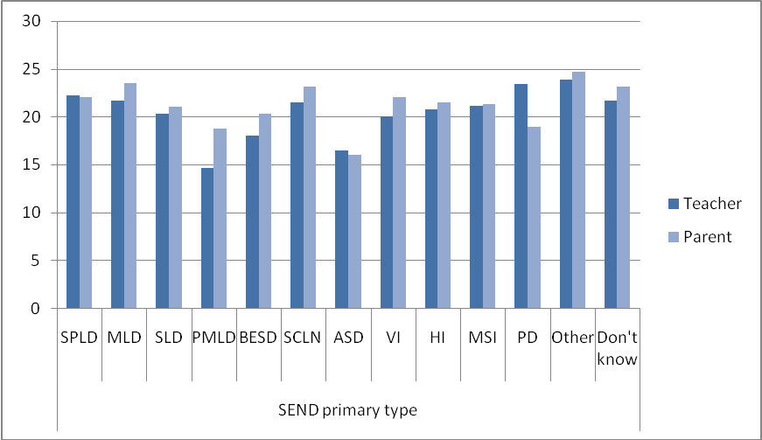

Bullying

Involvement in bullying
In both the teacher and parent survey, nearly two-thirds of the sample were reported as not being involved in incidents of bullying. Only a small proportion were involved in bullying on a daily basis. This finding contrasts with a report from MENCAP that found that 8 out of 10 pupils with a learning disability said that they had been bullied.
Teachers and parents reported that less than one in ten pupils were involved in bullying on a weekly basis. Over the time period of a term, the numbers remain small with teachers reporting just less than 1 in 5 and parents reporting around 1 in 6 (Figure 11).
Teachers and parents differed in their estimates of role for those involved in bullying with teachers describing around a third of pupils as both bullies and victims, while parents thought their children were more likely to be on the receiving end of bullying with nearly two-thirds described as victims (Figure 12).

Figure 11: Teacher-reported and parent-reported frequency of incidents of bullying in the monitoring sample
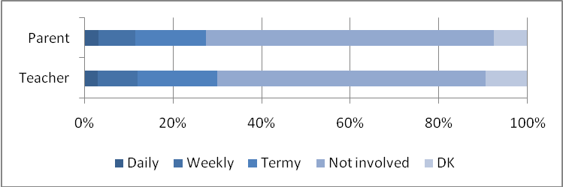

Figure 12: Teacher-reported and parent-reported role in incidents of bullying in the monitoring sample (of those pupils reported as being involved in bullying)
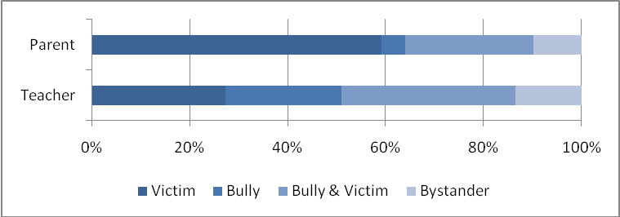

Extent of bullying
The graphs in this section show how bullying is reported to vary by gender, year group, SEND provision and primary SEND type. Figures 13 and 24 show the average teacher-rated scores and parent-rated scores.
Both teachers and parents indicate that:
- Females are less involved in bullying than males
- Pupils at School Action Plus experienced the most teacher and parent-reported bullying
- Pupils identified as having BESD and ASD are reported as experiencing more bullying than other groups of pupils
The effect of age on bullying is reported differently by parents and teachers. There is an age-related increase in parent reported bullying. Teachers reported less bullying as pupils get older (from Year 5 onwards). In both cases, Year 1 pupils were least involved in bullying.

Figure 13: Mean teacher-reported and parent-reported bullying scores in the monitoring sample by gender, year group and SEND provision
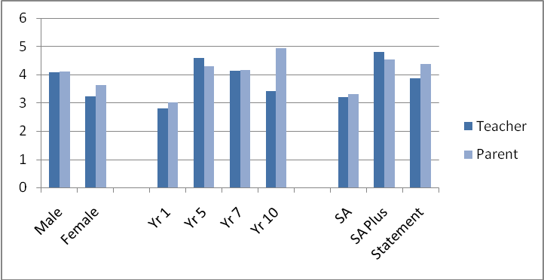

Figure 14: Mean teacher-reported and parent-reported bullying scores in the monitoring sample by primary SEND type
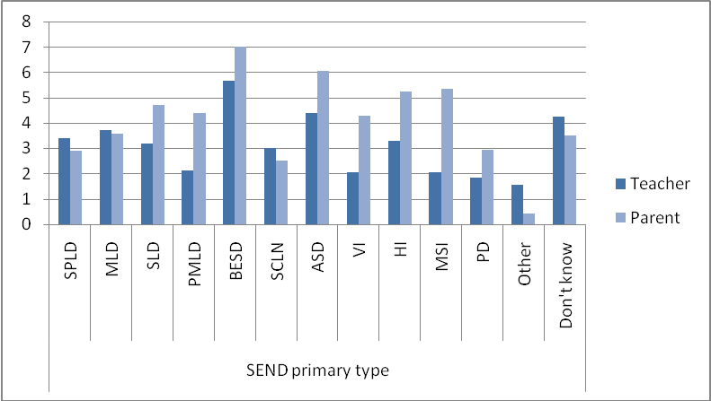

Parent survey - engagement and confidence
Figures 15 and 16 show the average scores for parental engagement and confidence by gender, year group, SEND provision and primary SEND type. The following trends were evident:
- There is an age-related decline in parental engagement and confidence.
- Parents of pupils at School Action Plus feel less engaged and confident than parents of pupils at the other two stages of SEND provision.
- Parental engagement and confidence does not appear to vary greatly according to primary SEND type.

Figure 15: Mean parent-reported engagement and confidence scores in the monitoring sample by gender, year group and SEND provision
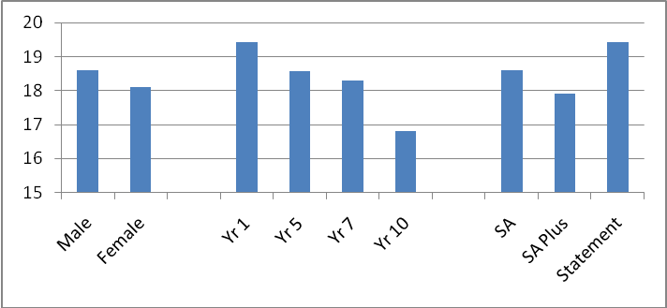

Figure 16: Mean parent-reported engagement and confidence scores in the monitoring sample by primary SEND type
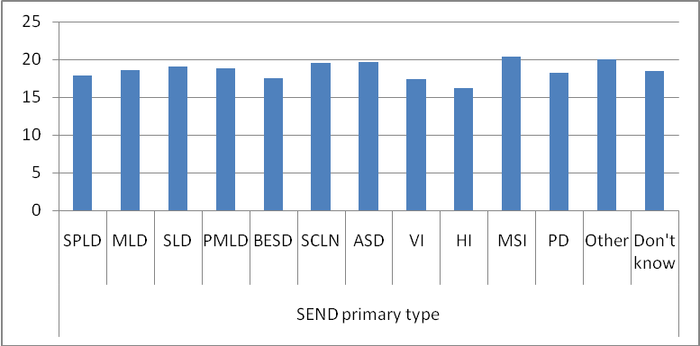

Parent survey – wider participation
Figures 17 and 18 show the average parent-reported wider participation scores by gender, year group, SEND provision and primary SEND type. The following trends were evident:
- Wider participation does not appear to vary greatly according to age or sex.
- Pupils with statements of SEND are reported as being less likely to take part in wider participation than pupils at the other two stages of SEND provision.
- Pupils identified as having an ASD and VI were reported as being the least likely to take part in wider participation activities.

Figure 17: Mean parent-reported wider participation scores in the monitoring sample by gender, year group and SEND provision
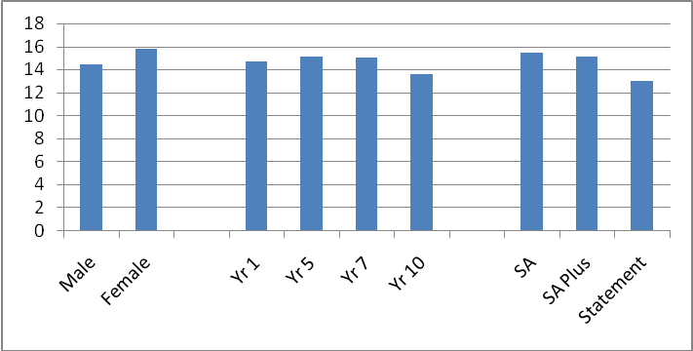
Figure 18: Mean parent-reported wider participation scores in the monitoring sample by primary SEND type
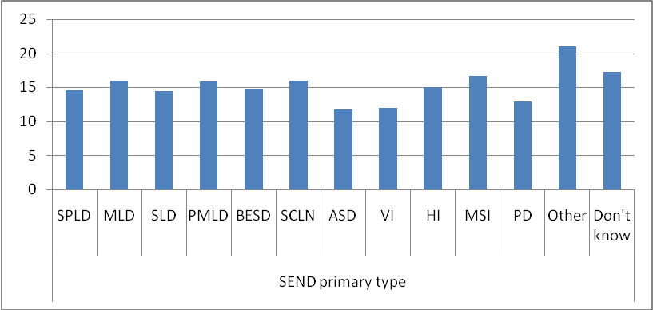
Overall our baseline survey reveals some interesting trends that may have implications for AfA implementation. For instance, the finding that pupils with Statements of SEND are the least likely to take part in wider participation activities is something that schools may address in their implementation of Strand 3 – perhaps by using AfA funding to ensure staffing is available to support such pupils if they choose (for example) to join after-school clubs.

Chapter 3: FINDINGS FROM THE BASELINE ACADEMIC ATTAINMENT DATA COLLECTED BY NATIONAL STRATEGIES

What we learnt about academic attainment for pupils with SEND
The findings presented in this chapter are based upon academic attainment data for pupils in AfA schools in the monitoring sample relating to the autumn term 2009/10. This data was collected on our behalf by National Strategies in December 2009. In the interests of brevity and clarity, the numerous figures relating to trends found in this dataset are not presented in this chapter – they can be found in the report Appendices (Figures 19 to 25).

About the data
Valid academic data was available for 7,838 pupils. This was presented in the form of P-levels, National Curriculum levels and GCSE grades. These data were converted into a ‘point score’ (PS) so that we have a continuous scale along which pupils’ progress can be measured during the project. This conversion process is detailed in the Appendices (Table 1). Separate point scores were calculated for English and Mathematics, and the average of these taken to arrive at an ‘average point score’ (APS).

Patterns and trends in the academic attainment data
As with our baseline survey (see previous chapter), we were able to examine our academic attainment data to see how it varies according to sex, year group, SEND provision and primary SEND type. As would be expected, there is a strong age-related increase in academic attainment. Academic attainment also varies as a function of sex and subject. In all but year 1, females outperform males in English. This sex difference widens with age. In maths, males have higher average scores than females across all year groups, but the gap narrows over time.
Pupils with SEND do make progress.

There were clear differences in academic attainment between pupils at School Action, School Action Plus and with a Statement of SEN, and as one might predict, attainment decreases with increased SEND provision. The gap in attainment between the three types of SEND provision widens slightly with age. When we begin to examine academic attainment in relation to primary SEND type, a couple of clear patterns emerge. Across all year groups pupils identified as having SLD and PMLD score much lower than other groups of pupils. Given the nature of difficulties experienced by such pupils, this was expected. Pupils with MSI score above average in year 1, but this is not sustained and they score below average in the years 5, 7 and 10.
There is a gap in attainment between pupils at different stages of SEND provision that widens with age.
The academic dataset collected on our behalf by National Strategies revealed some interesting trends that may have implications for AfA implementation. For example, the data clearly demonstrates the progress made across year groups by children with SEND. However, there is also a gap in attainment between pupils at different stages of SEND provision which widens slightly with age. Furthermore, there is some evidence that pupils with certain primary needs make differential progress across year groups. Schools may need to take such trends into account when setting academic attainment targets for individual pupils.

Chapter 4: FINDINGS FROM OUR INTERVIEWS WITH REGIONAL ADVISORS AND LOCAL AUTHORITY LEADS

What we learnt about strategic support and emerging models of practice in Local Authorities
The findings presented in this chapter are based on interviews with three regional advisors from the National Strategies and 10 Local Authority AfA Leads that were conducted in the period November 2009 – January 2010. All interviews were transcribed and examined for common themes. These themes are presented below and supported with extracts from the transcriptions.

Developing thinking about what how SEND is defined and understood
The legal definition of SEN comes from the 1944 Education Act and is replicated in many documents including the SEN Code of Practice (2001). This focuses around rather circular arguments that a child has special educational needs if the school does something different for them because they have significantly greater difference in their ability to learn than other children of the same age. But, it is unclear as to how much more difficulty the child would have for this to be considered a significant difficulty. It also raises the possibility that if the school had sufficient resources that they could do something different for many more children. A key finding in our initial interviews was that the introduction of AfA has led to something of a paradigm shift in thinking about what we mean when we talk about ‘special educational needs and disabilities’. This theme also emerged in our case study work with schools. Traditionally, there has been an expectation that schools know who their children with SEND are and can convey this information to others who need it. However, the introduction of AfA has challenged this notion, and highlighted some key issues. Firstly, the population of children with SEND is very fluid and open to change. This issue has become regularly debated within AfA. Secondly, SEND is contextual in nature – a pupil may have SEND in one school but when they move schools they are no longer considered to have SEND. This is because the definition of SEND is contextual and comparative rather than being objective and absolute. Identification of SEND at transition points (e.g. Year 6 to Year 7) can therefore be fraught with difficulties. One LA lead told us that there is a sudden rise in referrals for Statutory Assessments for Y5 and Y6 pupils (LA D). Thirdly, there are differing agendas related to definition of SEND (for instance, the way that funding is allocated by LAs may depend on how many pupils schools report as having SEND; the way that schools perceive OFSTED inspections as seeking out a quota of children who may have SEND). This tends to affect how many children in a given school are considered to have SEND. Fourthly, some schools are reluctant to tell parents that their children are following Code of Practice processes around SEND at the School Action and School Action Plus stages of provision. They prefer to not increase parental anxieties by saying that the children were just a little below expected levels of attainment than the others and needed a bit of extra help. Finally, deciding what constitutes each category of primary need can in itself be problematic without a comprehensive assessment that usually only occurs if a child is to receive a Statement of SEN. This means that the same child could be placed in two or more categories for effectively the same educational difficulties e.g. a child who does not achieve the expected level of attainment in writing may be classified as having general learning difficulties (MLD or SLD), dyslexia (SpLD), a language difficulty (SLCN), or their lack of progress may be due to emotional difficulties that would place them in the BESD category.
“What AfA is doing is actually thrashing some of this out and getting LAs and schools to reflect on [their definition and identification of SEND]” (NS Regional Advisor NS2)

Promoting ‘joined up’ provision for children with SEND
At the heart of AfA is the notion that provision for children with SEND needs to mirror the diverse range of outcomes targeted within the project. Effective provision covering a wide range of academic and non-academic outcomes is best facilitated by collaborative, ‘joined up’ work involving a number of key agencies, and LAs have been working hard to ensure that this is in place as part of AfA. In addition to the strategic support funded directly through the project (e.g. NS Regional Advisors, LA AfA Leads, LA Advisory/Lead Teachers), LA Leads have involved colleagues from school improvement, SEND, educational psychology, and other key services in their planning of AfA implementation. The project is being seen as a focal point for drawing such agencies together and triggering changes in practice regarding multi-agency working across the whole Local Authority. This means that the impact of AfA can reach beyond directly funded schools and provides a key example of one possible change that can be sustained after funding for the project finishes in 2011.
“There have been links with services… but little real strategic contact. But… we’re now moving forward and this has been triggered by AfA” (LA Lead I, 2)
“It’s certainly giving us the opportunity to… galvanise Local Authority services right across [the area]” (LA Lead C)

Building on existing practice and other initiatives
One of the challenges facing some schools involved in AfA is the perception that it is simply another new educational initiative launched by the DCSF (see Chapter 5 of this report). Schools sharing this view can be difficult to motivate because AfA is seen as a ‘bolt-on’ that places demands upon (often already stretched) resources. However, the strategic support for AfA is sending a clear message that the philosophy underpinning the project places a strong emphasis on building upon existing practice rather than attempting to ‘reinvent the wheel’. Schools are being asked to consider what relevant work they are currently undertaking that is relevant to the outcomes specified in AfA, and how they might use their funding to facilitate developments in these areas. Many schools are therefore using this as an opportunity to consider some of the key priorities outlined in the School Improvement Plans and think about how they might address them using the resources provided by AfA. In this way, AfA can become a ‘seed bed’ for creativity and flexibility in provision for SEND, and the project itself can be more easily assimilated into existing structures and practices within schools.
“We’re hoping that AfA will support us in … developing more coherence between strategies and projects”
(LA Lead E)
“[AfA] affords authorities the time through the funding to look at developing practices built upon good practice which could actually then become part of the embedded culture and ethos of the school”
(NS Regional Advisor NS3)

Promoting communication and sharing of ideas and practice between schools
One way in which the development of good practice in relation to improving outcomes for children with SEND is being facilitated within AfA is through support for school networks/clusters. In many LAs existing networks have been utilised, so this is not necessarily something ‘new’ that has come about as a result of AfA, but an example of how the project has built upon foundations that were already in place and provided the opportunity – through additional funding, resources and strategic support – to allow them to galvanise and flourish. In concrete terms, these networks provide opportunities for school leaders and key teachers to both learn from the practice of others and disseminate their outstanding work to colleagues. In one LA, a ‘placement school’ system has been developed where individual members of staff can spend time at another school that is considered to be at the forefront in the promotion of a key AfA outcome.
“Teachers from other schools can go… and feel part of an outstanding environment”
(NS Regional Advisor NS3)
“[AfA provides] the opportunity to… showcase some of the excellent work… but then also to learn from one another”
(LA Lead D)

Supporting and challenging schools
A fundamental element of the strategic support for AfA has been to ‘support and challenge schools’ in their implementation. In terms of support, every LA has provided (or has plans to provide) the basic training for school staff in the three strands of the project (e.g. training for the structured conversations with parents), and each LA has hosted two AfA conferences. However, in addition, some LAs have provided further opportunities for schools. For example, in LA A the project leader holds a weekly ‘surgery’ where school AfA leads can drop in and discuss progress, raise queries and seek advice. In terms of challenging schools, both the LA Leads and NS Regional Advisors play a crucial role in monitoring progress made by schools in relation to their implementation plans and holding them to account where agreed actions have not been followed through, or in providing an appropriate steer at key decision points in the project. In relation to the former, LA I prioritised school visits based upon perceived progress (with schools felt to be falling behind or becoming disaffected targeted for early visits). In relation to the latter, one NS regional advisor relayed an example of helping schools make more informed decisions about which wider outcomes to focus upon in Strand 3.
“We’re getting them to reflect back on what can be done differently” (NS Regional Advisor NS3)

Raising aspirations and expectations for children with SEND
Central to the challenge of narrowing the achievement gap for children and young people with SEND is changing aspirations and expectations held by the professionals who work with them. Strategic support for AfA has been working towards changing these expectations through challenging discussions with schools in relation to their monitoring, tracking and intervention for children (Strand 1). Early evidence suggests that the mandatory termly teacher assessments of children’s academic attainment in English and Mathematics is pushing schools to think much more closely about how such data is collected, how its accuracy and reliability are assured, and how it is used to set appropriate targets for children that can be supported by intervention in the classroom. Discussion with strategic support helps schools consider whether progress children are making is as good as it could be. If progress is not as expected, schools are asked to consider why that might be, and what interventions they may put into place to change a particular child’s trajectory.
“It’s about saying, is this progress as good as it should be? And if it isn’t, why isn’t it? And what are we doing about it?” (NS Regional Advisor NS2)

Building in sustainability and transferability from the outset
An initial concern about the AfA project that has been shared by a variety of stakeholders is that – whilst it presents a unique opportunity for participating schools – the funding is tied to a relatively short period of time. As such, progress made during the two-year period may not be sustainable or transferable in the longer term (for example, some schools expressed concern that the structured conversations with parents may not be feasible once there is no longer funding available to release key teachers from their teaching). In response to this, a key element of the strategic support for AfA has been helping schools to explore ways of sustaining changes in practice from the very beginning of the project. For example, in relation to the structured conversations with parents, schools can consider ways in which they might retain the ‘spirit’ of work undertaken during AfA in their future interactions with parents. At a general level, this might be in reviewing how the school might continue to encourage parental engagement and confidence. At a more specific level, it could be in making sure that key staff are in contact with parents at regular intervals and make use of the skills developed through the training held in each LA (for instance, attending, paraphrasing, use of silence, summarising, and giving information).
“It’s not about a set of materials, it’s about an approach and that’s where the sustainability aspect of it will come in” (NS Regional Advisor NS3)

Different models of practice
Although the 10 LAs involved in AfA are generally following the guidelines produced by DCSF closely, local circumstances in some have dictated that different models of practice be adopted. One particular issue has been the recruitment of advisory/lead teachers at LA level to work with schools. This has proven to be difficult because schools are understandably reluctant to allow their best practitioners to be seconded. In LA E the response to this challenge has been to adopt a different model of practice for this aspect of the project. Placement opportunities are to be offered to secondary schools on a pro-rata (size of school) basis, in accordance with numbers in targeted cohorts. For example, a school with a cohort of 300 Year 7 students would have 10 teacher placements across two terms and each placement would include 12 half-day sessions in a placement school in addition to one day of coaching/own school support. This means that the placement school would have some of their own coaching time to use in the AfA school.

Chapter 5: FINDINGS FROM OUR INITIAL SCHOOLCASE STUDY VISITS

What we learnt about how schools are implementing AfA
Case study schools were recommended to us by LAs and then selected to provide maximum variation across the whole project. We selected 20 schools in rural and urban areas, primary and secondary schools and mainstream and special schools. In this chapter we discuss our initial findings from case study visits across the 10 participating local authorities. These initial visits took place in the period January-March 2010. All interviews and field notes were transcribed and examined for common themes. These themes are presented below and supported with extracts from the transcriptions.

General
Participating schools began the project with an understandable feeling of trepidation. AfA sets a high benchmark in terms of expectations placed upon schools within a short period of time, and this was reflected in early concerns expressed by many staff. Nonetheless, schools do feel positive about the project, and see it as way to build upon good practice within their existing SEND provision. The resources provided through project funding and training opportunities have allowed them to put into practice ideas that they had previously not been able to bring to scale. It is worth noting, however, that some schools have struggled to deploy their allocated resources within the tight timescales prescribed within the project – for instance, small schools with limited staff capacity.
“AfA has taken the school to the next level… [as it] builds on what we are already doing.” (School 18, LA I)
A key facilitator for AfA implementation is drawing upon “eager staff who want to try out new ideas and are motivated”, and who are “willing and able to change or modify their practice” (School 18, LA I). Reactions from staff have on the whole been positive, although there are concerns about teachers being taken away from the classroom (for instance, to conduct structured conversations with parents). However, the role of lead teachers has been vital to getting a balance: “the kind of school we are, we are involved in a number of initiatives and things which sometimes take some of my staff outside school, you know, if you’ve got lead teachers for this and that then they are already out for things and therefore, you’ve got to balance that” (School 9, LA E).
“The fact that they can already see some quick wins and gains means… they’ve taken it on.” (School 9, LA E)

Assessment, tracking and intervention
Data is available at the school and LA level to help with the identification of SEND and the responses that teachers make in the classroom, at the whole school level and feeding into LA decision making. Several processes have been developed and AfA draws upon these (e. g. Progression Guidance, Assessing Pupil Progress, Personalised Learning, Professional Conversations, use of Management Information Systems such as Assessment Manager and Tracker).
“AFA has just given us another focus, just a different approach and it’s… added value… to people who were doing it anyway, it’s made them think about the practice… I had a lady doing numeracy before but she didn’t tie in much with me, with what I was doing in the classroom, but they all now use the same APP sheets, they record on the same APP sheets, we annotate it, we get together and we look and see where we’ve got to.
Today I found one of the more able males can’t do subtraction, he just didn’t know about subtraction, so we… put it down as one of his targets so he’s now going to be doing some subtraction because he’s quite a bright boy but there’s obviously a gap.” (School 4, LA B)

Class Level
The use of APP has been seen as building upon existing good practice and using assessment as a way of knowing where children are up to and using this to inform the planning of teaching (e.g. School 13, LA G). Some school staff have been disappointed with the way that APP training has been presented and have been left hearing mixed messages and feeling confused (e.g. School 15, LA H). Yet some staff in the same school indicated that it all seemed “straight forward”.
“…they might not move from a 2a to a 3c… but… you can see them blossoming and growing in confidence…” (School 3, LA B)
Some schools are still developing processes for sharing information more effectively between staff members and with parents. In one school there is still a tendency to place information for staff access on the notice board and hope that staff will access it. This school is now involved in trying to develop computerised systems and is looking to set up on-line reporting. There are some practical issues to deal with e.g. one teacher noted that a confidential e-mail accidentally created an Outlook message pop-up when she was using the computer with her class (School 3, LA B).
“The data measuring bit is pretty straightforward, so we set up folders for each child’s records, so we did it in detail of where they are now, so we’re measuring them on that, now you couldn’t really do that for every child… but we thought let’s see how manageable it is. So they’ve got their ‘I can’ targets and uploading that data termly is pretty straightforward because we assess them half termly anyway.” (School 15, LA H)
APP sheets are being used in the classroom to help co-ordinate and improve the communication about what different adults are doing with a child (School 4, LA B) There are concerns that progress is not always easily measurable even when APP is used and that more subtle indicators may be needed.
“[Provision mapping] works like an IEP as long as… the child’s got an intervention on there that’s target led and progress is measurable, so like… a child in Year 1 who’s doing fifteen minutes a day, I don’t need the teacher to have separate literacy targets for them because there’s very clear targets within that intervention and I’ll be monitoring them… well, I’ll be assessing them at the beginning and the end, I’ll be able to monitor progress so we can show that progress over a term.” (School 1, LA A)

School level
Provision mapping allows the SENCo to allocate resources and reduces the burden on teachers to fill in lots of IEP targets while still being able to monitor progress and make decisions about interventions (School 1, LA A).
“We’re looking at tracking of interventions, so that’s… something I’m focusing on for the special needs side of things. It’s looking at are the interventions we’re using effective? How can I use SIMS to support me in doing that?” (School 13, LA G)
The use of electronic data systems has been seen by some schools to be potentially useful both for monitoring and tracking within school and for when children transfer from one school to another, however it is not without its problems (e.g. requiring information to be input again).
“So on SIMS here, we’ve got all the provisions here for all the kids on what we call the ECM register, the primary schools will have that… but that will literally when it comes up from Year 6 to be inputted onto our system… one of the questions to ask… is ‘look, how can we set up this system so that there’s one input… and that information is used, not only in the SEN reporting side, but is also the side of SIMS that effectively I’d call a mark sheet. But as it stands at the minute we have to input provision information here twice into a system to make it come out. The primary schools have to put it in and our SIMS manager here.” (School 14, LA G)

Structured conversations with parents
This strand of AfA has been one of the early success stories. AFA leads within schools have suggested that the process of having several structured conversations over a school year will enable a healthy shift from parents of children with SEND primarily identifying with SENCos to seeing the class teacher as their main point of contact in the school. This enhanced relationship empowers teachers to use information and planning generated by the process and provides a point of reference for day-to-day parent contacts. Previously, there was a tendency for many class teachers to consider pupils with SEND as the specialism of another staff member and to include them less in lesson planning etc. Despite many schools already having good relationships with their pupils' parents, they have found Strand 2 is letting them “re-focus on the parents” (school 15, LA H), and the structured conversation is regarded as having strengthened this even further. Structured conversations are beginning to have an effect on schools’ assessment of children with SEND, as parents are able to provide insights into home life that were not possible in the traditional parental interview/IEP review. Some staff have begun to reflect on school strategies that may benefit home strategies in addressing SEND, especially with regard to BESD. A more shared approach seems to be emerging. The ethos of ‘teachers talking and parents listening’ is changing in some schools and has been welcomed. The pupils in question see their parent and teacher working collaboratively, which may also have positive effects.
"This will have the biggest impact in the project, at least for our school". (School 15, LA H)
“I […] can see the involvement with parents being a major improvement because our parents find it difficult. I think they will grow in confidence in how they can help their children and that’s what I would like to achieve.” (School 7, LA D)
“[structured conversations have been] absolutely brilliant, the best thing that the project has brought to the table.” (School 18, LA I)

Parents have found these conversations to be positive, feeling that their child’s school is listening to and engaging with them in a non-threatening way. School 18 found a key facilitator for engaging the harder to reach parents has been using other parents (who found the experience positive), to talk to non-engaged parents and get them involved. As these conversations are having a real impact already there is a hope that this model can be used across the whole school and with all parents. Staff have commented on how much more both parents and staff have benefited from the conversations and how they put the child in a context that helps to maximise the home-school relationship. One particularly positive example concerned a parent who was able to articulate his own difficulties at school, of which staff were unaware, but subsequently enabled them to suggest suitable ways for him to help address his own child’s specific needs. (School 9, LA E). However, there are concerns about issues of sustainability and weighing up the benefits of these conversations for SEND pupils versus the potential disadvantage of reducing the amount of time their teacher is present in the classroom (School 18, LA I).
[Structured conversations are the key for] “children feeling better about themselves and parents feeling better about how to support their child.” (School 18, LA I)

Provision for wider outcomes
At the outset it is important to note that this strand is still in its early stages in terms of implementation. Nonetheless, schools are welcoming the flexibility it provides and the opportunity to focus on in a very concrete way on key areas of concern. Schools can also use Strand 3 of the project as a guiding structure for other initiatives they are already involved in but have previously felt unable to embed fully because of resource or other constraints – for instance the Social and Emotional Aspects of Learning (SEAL) programme, which may help to promote positive relationships, better behaviour and reduce bullying. It also inciting schools to re-focus and tighten-up and enhance existing procedures.
[Strand 3 is something we can]… “take and run with” (School 15, LA H)
“We’ve already implemented a lot of attendance strategies but we’re just trying to enhance them. We’re also including punctuality. We’re having some punctuality panels where we’re inviting parents to come in to talk about what the issues are. We’ve also had the school health advisor in for children who are persistently absent ... so we actually got the parents to come in and talk to the health advisor. That was really successful. So we’re hoping to extend that as well.” (School 7, LA D)

School 15 (LA H) commented they are excited about the possibilities opened up through Strand 3. Their activity thus far provides an interesting example of the creative approaches taken by many AfA schools. School 15 have conducted a lot of independent research into appropriate materials and activities to tackle aspects of Strand 3, for example using the ‘I-Can’ tool as an audit to determine what behaviours should be focused upon in their work. School 15 have also developed innovative and subtle approaches, for example confidence building exercises for year 1 and 5 pupils. These interventions are already showing impact for some pupils. One teacher working on aspects of behaviour - such as confidence and self-esteem - claimed marked changes in a group of pupils who were now reading aloud in class and volunteering themselves for tasks, which they would never have done before (School 15, LA H). Other schools (School 18, LA I, School 8, LA D) believes that focusing on positive relationships will help decrease bullying and behavioural problems whilst enabling children to feel good about themselves – indicating the convergent nature of the themes addressed in Strand 3 (that is, the outcomes themselves are not mutually exclusive). Their second area of focus - wider participation - will broaden the provision available to SEND children and increase their confidence (School 18, LA I).
“We have chosen to look at bullying and building positive relationships and the reasons that we’ve chosen that is because we believe that the others, the attendance, participation in extended services, behavioural difficulties are inextricably linked to the above two and if we get those two right we can eliminate bullying… if we can develop positive relationships then hopefully that will go a long way to improving attendance, improving punctuality and so on.” (School 8, LA D)
Strand 3 of AfA is still very much in a process of development in schools. However, common schemes and approaches used by schools that feed into Strand 3 include; one-to-one tuition, mentoring schemes, SEAL and breakfast clubs. Schools in LA G are working in their clusters to find materials and approaches to tackle their chosen areas, with further support from the LA to provide training for these groups of schools. Schools in LA B are investing in 'Circle Time', which was demonstrated at their Spring Update Conference. This scheme helps children get to know new friends, helps role-model peers to help struggling peers, and all children to ask for help and raise their concerns as well as praising peers. Schools in LA H is focusing on attendance and are using breakfast/wide-awake clubs, which they have now been able to offer free of charge using AfA funding, and this has helped to improve attendance. One school in LA H has also used one-to-one assistance and nurture groups to work on positive relationships, and pupils have a contact book which can go between parents and teachers to write comments/messages to improve parental confidence and engagement.
“Like billing up our Wide Awake Club, that deals with [attendance]... this starts at twenty past eight, way before school starts, they attend it, well their attendance has got to be better hasn’t it?” (School 15, LA H)
“Behaviour instances that have gone in the behaviour record… we use a time out room, a time out book at lunch time, that can be for things like a bit of disruption or finishing work, but this is for you know, hurting children or being really rude, that kind of slightly more serious instances and that’s what we’re going to be monitoring at the moment.” (School 13, LA G)

Barriers and facilitators around successful implementation

Timescale and pressure
“Time, it’s the timeframe that is…nothing’s going to stop us getting up and running ‘cause we will get up and running… but whether we’re going to get up and running as quickly as… you would... we haven’t had time to do everything because being a small school the responsibility falls on less shoulders, you can’t spread the load.” (School 4, LA B)
An issue consistently raised by schools is the sheer pace of project and its associated timescales. There is a fast pace to get things going that is placing a high demand on schools and support materials are being developed ‘just in time’. Schools, in particular secondary schools, are not meeting deadlines. Although schools, staff and parents have been enthusiastic about AfA, there is widespread concern at the amount of unforeseen paperwork and administration that is standing in the way of the initial implementation and progress. There is a feeling among some teachers that everything should have been started earlier (e.g. project announced after schools had already completed planning cycles for 09/10, LA staff not in place in September, school packs not ready in time, some schools not appointing lead staff until late in the Autumn term). However, despite these early teething problems the vast majority schools now appear to be getting on track with things on the whole and committed to the project – although there are still notable concerns from Secondary schools.

Initiative overload/malaise
An initial barrier to early implementation in some schools has been the view that AfA is simply the latest in a long line of governmental initiatives that they are asked to implement. This mindset produces as resistance to investing time and energy because the belief is that another new initiative will take priority before AfA has become fully embedded. It is also worth noting that those that share this view have also focused upon the finite funding lifespan of the project and are already raising concerns about sustainability and transferability. Whilst this early concern has petered out in many schools, there a still a small but significant number for whom it is still a pressing issue.
“I suppose with everything else in school it’s time isn’t it? ... I think a lot of people get a lot of things thrown at them and you know, a lot to balance, you know, a lot to sort of juggle, I think that’s the big issue, I don’t think people are unwilling.” (School 13, LA G)

Strong leadership
Schools which are flourishing are highlighting the importance of a strong leadership team. In School 15 (LA H) the head teacher is the AfA project lead, the Year 1 teacher is the deputy head and SENCo, and the Year 5 teacher is a Key Stage 2 manager – meaning that AfA is being led by an experienced, influential core group of staff within the school. In contrast, in some schools the AfA lead is a class teacher. Typically, this has led to a slower start to the project in both planning and implementation. Although the majority of staff at such schools are very positive about AfA, there are still a few staff who see it as yet another scheme and extra workload for them (which of course relates to the previous theme of initiative overload/malaise). Without the influence yielded by being a school leader, AfA leads in these schools may struggle to convince such staff of the benefits of involvement and ‘get them on board’.
“I think our leadership team is pretty well sorted. But you see we’re fortunate in the sense that our Year 1 teacher who’s the deputy head and the Year 5 teacher who’s a Key Stage 2 manager, so you have experienced teachers straight away involved in it, in the leadership team. So when we met we were talking about it and we made it happen.” (School 15, LA H)

‘Fit in’ not ‘bolt-on’
Where early AfA implementation has gone well the project has been seen as something that can be assimilated into existing structures and practices rather than as a ‘bolt on’. As has already been discussed (see previous chapter) this involves thinking about the project as an opportunity to refocus on some of the most vulnerable learners in the school and work creatively to promote better outcomes for them by enhancing existing provision. For example, one head teacher spoke of using AfA funding to enhance provision under the Extended Services initiative, in which his school are also participating. In concrete terms it has meant that key staff could be paid to work outside of school hours to support pupils with SEND in after-school activities.

Chapter 6: FINDINGS FROM OTHER SOURCES OF DATA COLLECTION

Other sources
Throughout the pilot phase we have been welcomed by LAs to the Launch Conferences and to the Spring Update Conferences. We have been contacted by head teachers and others who have sought to share openly their concerns and successes. In many ways these additional sources of information were not planned in our original conceptualisation of the research process, but they have provided rich and useful data. In this section, we highlight a few of the issues brought to our attention.

Workload Agreements
Teaching unions have been particularly concerned about the additional demands that AfA has placed upon teachers. One secondary school (LA C) has taken an innovative approach to supporting teachers while also completing all of the associated tasks. For instance in order for the 36 key teachers involved in AfA to undertake the structured conversations funding has been used to provide teaching cover for those conversations taking place during the school day. Where teachers are able to work outside of school hours to meet with parents unable to make appointments during the school day then additional payments have made. The costings of the structured conversation have been based on 1 hour preparation, 1 hour for the actual meeting and 1 hour to follow-up. It is unclear whether this will be sustainable once the pilot phase finishes.

Training and skills
One school spoke at the Spring Update Conference about teacher training and skills prior to AfA. There had been a lack of confidence amongst teachers about meeting the needs of a wide range of children with AfA within their school. AfA had brought this into focus and staff worked together with training from the LA to contribute to the overall school development plan to:
- Improve Quality First Teaching
- Develop personalised interventions
- Improve children’s social skills
- Raise pupil self-esteem

Empowering schools versus forcing schools
Resistance has been evident at a number of conferences for schools. This seems to be more evident in those LAs that have insisted that all of the schools participate without taking into account the different school contexts (e.g. one headteacher talked about how it can be difficult in a small school with only a couple of teachers trying to juggle many roles). In LA C, head teachers were reluctant to release their best teachers from the classroom to take on LA lead teacher roles. The LA Lead proposed a different way of working involving clusters and local networks focussed around hub or partnership schools. Initially there was resistance to this, with many head teachers arguing that this would create additional meetings and networks to join (when there were already existing networks in place). The LA Lead asked schools to volunteer and enough did so to make the process work and move forwards.

Appendices

Appendix 1

Table 1: Conversion chart for academic attainment data
P levels | GCSE | NC | Point Score
1 |  |  | 1
2 |  |  | 2
3 |  |  | 3
4 |  |  | 4
5 |  |  | 5
6 |  |  | 6
7 |  | 1c | 7
8 |  | 1b | 9
 |  | 1a | 11
 |  | 2c | 13
 |  | 2b | 15
 |  | 2a | 17
 | G- | 3c | 19
 | G | 3b | 21
 | G+ | 3a | 23
 | F- | 4c | 25
 | F | 4b | 27
 | F+ | 4a | 29
 | E- | 5c | 31
 | E | 5b | 33
 | E+ | 5a | 35
 | D- | 6c | 37
 | D | 6b | 39
 | D+ | 6a | 41
 | C- | 7c | 43
 | C | 7b | 45
 | C+ | 7a | 47
 | B- | 8c | 49
 | B | 8b | 51
 | B+ | 8a | 53
 | A- | 9c | 55
 | A | 9b | 57
 | A+ | 9a | 59
 | A*- | 10c | 61
 | A* | 10b | 63
 | A*+ | 10a | 65

Appendix 2

Figure 19: Mean point scores by year group
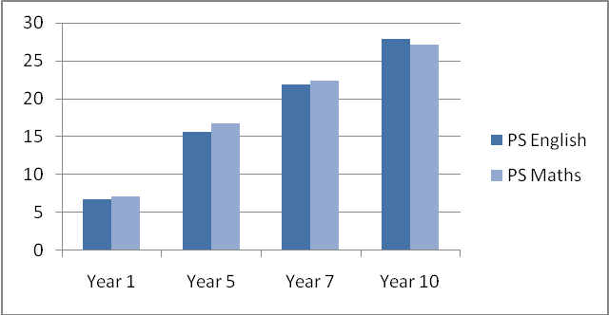

Figure 20: Mean point scores by year group and gender
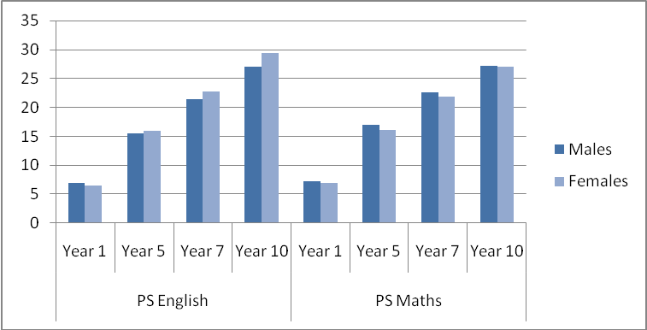

Figure 21: Mean point scores by year group and SEND provision
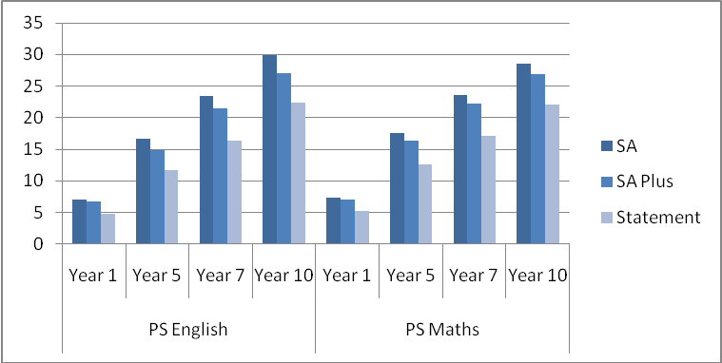

Figure 22: Mean point scores by primary SEND type in year 1
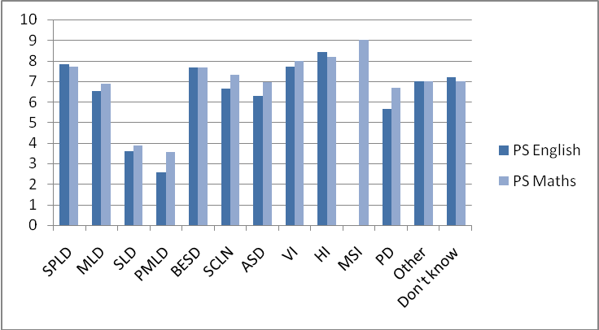

Figure 23: Mean point scores by primary SEND type in year 5
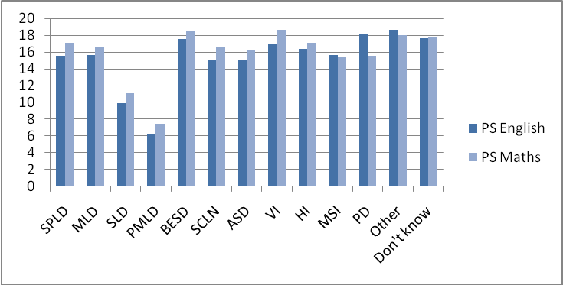

Figure 24: Mean point scores by primary SEND type in year 7
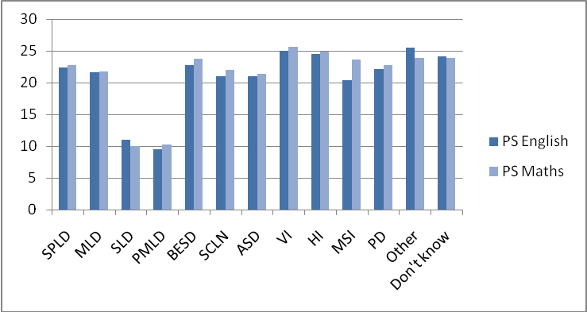

Figure 25: Mean point scores by primary SEND type in year 10
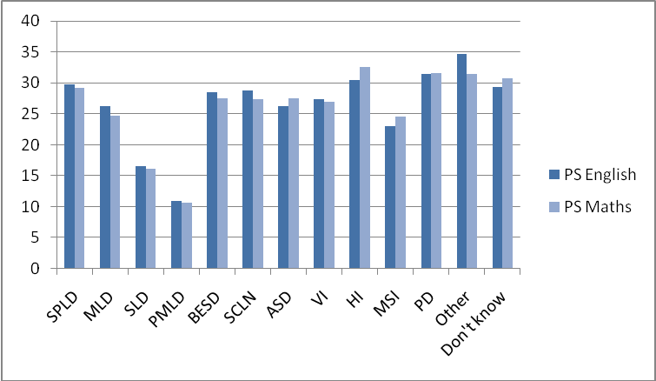

Ref: DFE-RR028
ISBN: 978-1-84775-789-0
© Manchester University
August 2010

These outcomes are: behaviour, bullying, positive relationships, attendance, wider participation, parental engagement and confidence, and academic attainment.
Hard-copy and telephone surveys have also been made available in order to ensure that people without access to the internet are able to participate in the research. Additionally, parent surveys have been translated into the nine most commonly spoken languages other than English across the 10 participating Local Authorities.
Further analysis will be conducted alongside the ongoing project work to ensure that the surveys are both reliable and valid.
A correlation co-efficient takes on a value between -1 and +1, with scores closer to +1 indicating higher levels of agreement. This analysis is done using data for pupils for whom there was both a teacher survey and a pupil survey of the same variable.
MENCAP (2007) Bullying Wrecks Lives: the experiences of children and young people with a learning disability retrieved from http://www.mencap.org.uk/ on 10th May 2010
This figure is lower than that reported for the monitoring sample in previous chapters primarily because many pupils in Year 1 were assessed using the Early Years Foundation Stage Profiles in the autumn term 2009/10. Data produced using this system is incompatible with the metric used for other pupils (P levels/NC levels/GCSE grades). However, we hope to use data collected in the winter term 2009/10 (which is compatible with our metric) as the baseline for these pupils so that they can be included in the final analysis.
See Squires, G., & Farrell, P. (2006). Educational Psychology in England and Wales. In S. R. Jimerson, T. D. Oakland & P. T. Farrell (Eds.), The Handbook of International School Psychology Thousand Oaks, California Sage Publications Inc.
GCSE grades in this table are allocated points based on a table sent by NS. These are different to the QCA charts (which have A* at 58 and give alternative courses). National Curriculum level conversion uses information from the National Strategies website.

