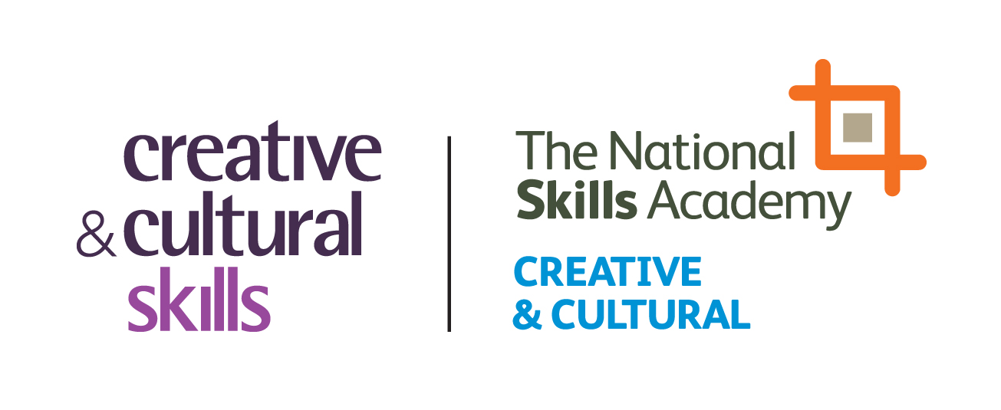

17 September 2012
Creative & Cultural Skills contribute to Inquiry into the role of Group Training Associations

Creative & Cultural Skills have contributed to the Inquiry into the role of Group Training Associations (GTAs), which published its final report last week. Creative & Cultural Skills welcome the report’s largely positive assessment of the role and capacities of Group Training Associations, which cited evidence provided on the potential of GTAs in the creative sector.

Creative & Cultural Skills share the view that GTAs should form a central part of the Government’s economic growth framework. We also support the recommendation that GTAs are established or developed in sectors and regions where they have not traditionally been prominent.
Group Training Associations are employer-driven bodies which help to find workforce and development solutions for small and medium-sized enterprises and provide larger employers with the training they need to build capacity. GTAs also play an important role in the provision of apprenticeships. Many operate from their own training centres and provide off-the-job training which businesses cannot provide in-house.
Although GTAs have historically served the needs of traditional areas of the economy such as manufacturing, the model is one which we believe can be applied readily to the creative and cultural sectors. In June this year, we announced the extension of the National Skills Academy for Creative & Cultural into the design, cultural heritage and jewellery Sectors. GTAs will play a key strategic role in supporting this extension and facilitating the uptake of higher level and technical apprentices within these sectors.

The final report can be viewed here.

Notes to editors

Creative & Cultural Skills supports the skills and training needs of the UK’s creative and cultural industries. We deliver through our Skills Academy, a growing network of employers and training providers who are committed to the provision of high quality, industry-relevant creative education and training, apprenticeships and careers advice. We are licenced as a Sector Skills Council by the UK Commission for Employment and Skills. For further information, please visit www.ccskills.org.uk
For more information on this press release please contact our press office on: 020 7015 1800 emma.diggory@ccskills.org.uk catherine.large@ccskills.org.uk

