Review of Lower Thames Crossing Capacity Options:
Model Status Report




Prepared by: Checked by:
Andrew Currall Mark Dazeley
Senior Consultant Associate Director


Approved by:
Paul Hanson
Regional Director

Review of Lower Thames Crossing Capacity Options:

Rev No | Comments | Checked by | Approved by | Date
1 | Draft for issue | MJD | PAH | 2012-04-04
2 | Draft for comment, including Chapter 7 (freight) | MJD | PAH | 2012-04-13
3 | Draft Chapter 9 for comment | MJD | PAH | 2012-04-26
4 | Final Draft | MJD | PAH | 2012-05-01
5 | Final Issue | GCP | MJD | 2012-05-09
6 | Final Issue with amended Chapter 2 | MJD | MJD | 2012-05-10

AECOM House, 63-77 Victoria Street, St Albans, Hertfordshire, AL1 3ER
Telephone: 01727 535000 Website: http://www.aecom.com

Job No 60249197 Reference 102 Date Created May 2012

This document has been prepared by AECOM Limited for the sole use of our client (the “Client”) and in accordance with generally accepted consultancy principles, the budget for fees and the terms of reference agreed between AECOM Limited and the Client. Any information provided by third parties and referred to herein has not been checked or verified by AECOM Limited, unless otherwise expressly stated in the document. No third party may rely upon this document without the prior and express written agreement of AECOM Limited.

Although this report was commissioned by the Department for Transport (DfT), the findings and recommendations are those of the authors and do not necessarily represent the views of the DfT. The information or guidance in this document (including third party information, products and services), is provided by DfT on an 'as is' basis, without any representation or endorsement made and without warranty of any kind whether express or implied.

/tmp/lo/0000.doc

Executive Summary 6
1 Introduction 9
1.1 Background 9
1.2 Report Scope 9
1.3 Report Structure 9
2 Transport Models in the Region 11
2.1 M25 Model 11
2.2 Thames Gateway South Essex Model 12
2.3 Kent Thameside Model 12
2.4 Medway Traffic Model 13
2.5 East London Highway Assignment Model 13
2.6 M25-A13 Corridor Relieving Congestion Scheme Model 14
2.7 Thurrock Model 14
2.8 Conclusions and Recommendations 14
3 Zoning 15
3.1 Overview 15
3.2 Defining the Study Area 15
3.3 Zonal Topography 16
3.4 Zonal Trip Density 17
3.5 River Crossing Trip Distributions and Densities 19
3.6 Zone Disaggregation 22
3.7 Zone Aggregation 25
3.8 Conclusions and Recommendations 26
4 M25 Highway Model: Network Detail 28
4.1 Introduction 28
4.2 Network Structure 28
4.3 Centroid Connectors 32
4.4 Time Periods 34
4.5 User Classes 35
4.6 Generalised Costs 35
4.7 Conclusions and Recommendations 35
5 M25 Highway Model Performance 37
5.1 Introduction 37
5.2 Existing Model Calibration / Validation 37
5.3 Paths and Routeing 38
5.4 River Crossing Select Links 43
5.5 2004 Independent Validation Check 45
5.6 2009 Independent Validation check 52
5.7 Conclusions and Recommendations 57
6 M25 Demand Model 59
6.1 Model History and Overview 59
6.2 Choice Models 59
6.3 Segmentation 59
6.4 Economic Parameters and Generalised Cost 60
6.5 Internal Supply Model 61
6.6 Runtime Optimisation 61
6.7 Calibration and Realism Testing 62
6.8 Conclusions and Recommendations 63
7 Freight Modelling 64
7.1 Introduction 64
7.2 Background On Freight Movements at the Crossing 64
7.3 Freight Impact Forecasting 64
7.4 Enhancements for Further Consideration 66
7.5 Potential Usage of GBFM 67
7.6 Limitations and Caveats on the use of the Strategic Corridor Data 68
7.7 Potential Usage of FiLM or BYFM 69
7.8 Other Data Sources 70
7.9 Conclusions and Recommendations 71
8 Toll Modelling Methodology 72
8.1 Overview 72
8.2 Previous Option A Testing 72
8.3 Demand Segmentation 73
8.4 Assignment Route Choice 74
8.5 Relevant Purposes 76
8.6 Local Resident Discounts 77
8.7 Other Considerations 78
8.8 Conclusions and Recommendations 78
9 Highway Model Calibration Approach 80
9.1 Overview 80
9.2 Model Calibration Process 80
9.3 Matrix Provenance and Local Update 81
9.4 Preparation of Prior Demand Matrices and Matrix Estimation 83
9.5 Count Data Availability 84
9.6 Journey Time Data Availability 85
9.7 Interaction with the Toll Demand Model 86
9.8 Documentation 86
Appendix A: Zones considered for disaggregation 87
Appendix B: Test of Zone Disaggregation Results 92

Do not delete the line below as you will remove the Bookmark TOT (Table of Tables)
Table 3.1: M25 Model zones identified for disaggregation 24
Table 4.1: Traffic count data across the peak periods in the vicinity of A282 Dartford Crossing 34
Table 5.1: Summary calibration statistics – M25 B602 model 37
Table 5.2: Screenline summary calibration, all time periods 38
Table 5.3: 2004 AM peak, independent validation assessment result 46
Table 5.4: 2004 interpeak, independent validation assessment results 47
Table 5.5: 2004 PM peak, independent validation assessment results 48
Table 5.6: Journey time validation, end-to-end routeing 51
Table 5.7: 2009 AM peak, independent validation assessment results 53
Table 5.8: 2009 interpeak, Independent validation assessment results 54
Table 5.9: 2009 PM peak, Independent validation assessment 55
Table 6.1: M25DM values of time, 2009 values, 2002 prices 60
Table 6.2: M25DM vehicle kilometre elasticities to fuel cost, matrix level, internal origins 62
Table 6.3: M25DM public transport trip elasticities to fare, matrix level, internal origins 62
Table 7.1: Summary of reports for which freight modelling aspects were reviewed 65
Table 7.2: Strategic national corridors significantly influenced by LTC 68
Table 8.1: M25 Model Dartford Crossing toll sensitivity, 300% toll 72
Table 8.2: Highway trip lengths (km) by income quintile, London and south east, NTS 2008 73
Table 8.3: M25 Model charges and values of time by vehicle type, 2009 77
Table A.1: Zones Considered For Disaggregation 87

Do not delete the line below as you will remove the Bookmark TOF (Table of Figures)
Figure ES1: Extent of modelled area classifications 7
Figure 3.1: Extent of modelled area classifications 16
Figure 3.2: Maximum number of trips (origin or destination) by zone. 2004, AM peak 18
Figure 3.3: Maximum of origins/destination loadings by zone in the Area of Detailed Modelling 19
Figure 3.4: A282 Dartford Crossing, southbound, origins (purple) and destinations (orange) 20
Figure 3.5: A210 Blackwall Tunnel, southbound, origins (purple) and destinations (orange) 21
Figure 3.6: Woolwich Ferry, southbound, origins (purple) and destinations (orange) 21
Figure 3.7: M25 Staines, southbound, origins (purple) and destinations (orange) 22
Figure 3.8: Area of detailed consideration for zone size 23
Figure 3.9: Zones identified for disaggregation 24
Figure 3.10: Zones identified for disaggregation 26
Figure 4.1: M25 Model simulation network 29
Figure 4.2: Junction coding, A13/A1012 30
Figure 4.3: ‘Dummy’ node coding in the study area 31
Figure 4.4: Centroid connector (red) loading in the vicinity of the proposed M2-M20 Link 33
Figure 5.1: St Albans to Gatwick 40
Figure 5.2: Harlow to Gatwick 40
Figure 5.3: Stevenage to Gatwick 40
Figure 5.4: Stratford to Longfield 42
Figure 5.5: Stratford to Bluewater 42
Figure 5.6: Hainault to Bluewater 42
Figure 5.7: Beckton to Charlton/Woolwich 42
Figure 5.8: A282 Dartford Crossing SLA (2-way) 43
Figure 5.9: A102 Blackwall Tunnel SLA (2-way) 44
Figure 5.10: Woolwich Ferry SLA (2-way) 44
Figure 5.11: 2004, AM peak validation to TRADS, south Essex area 49
Figure 5.12: 2004, AM peak validation to TRADS, Kent Thameside area 49
Figure 5.13: 2004, AM peak validation to TRADS, M2-M20 area 50
Figure 5.14: 2009, AM peak validation to TRADS, south Essex area 56
Figure 5.15: 2009, AM peak validation to TRADS, Kent Thameside area 56
Figure 5.16: 2009, AM peak validation to TRADS, M2-M20 area 57
Figure 8.1: Proposed Thames / M4 Screenline 75
Figure 8.2: Proposed toll choice model process 76
Figure 9.1: LATS Sites and M25 Model Matrix Build Sectors in South Essex and North Kent 82
Figure 9.2: Local RSI Sites and Screenlines used in the TGSE Matrix Build 83
Figure B.1: Effect of Illustrative Option C Coding on traffic flows, 1417 zone model 92
Figure B.2: Effect of illustrative Option C coding on traffic flows, 1121 zone model 93
Figure B.3: Core Scenario: Flow differences between 1417 Zone Model and 1121 Zone Model, Area of Interest 94
Figure B.4: Core Scenario: Flow differences between 1417 Zone Model and 1121 Zone Model, Wider Area 95
Figure B.5: Core Scenario: Delays at Junctions, 1417 Zone Model 96
Figure B.6: Core Scenario: Delays at Junctions, 1121 Zone Model 97

Executive Summary
Background
AECOM has been appointed by the Department for Transport (DfT) to undertake a study to provide strategic outline business cases for three alignment options (plus a variant) for providing additional river crossing capacity in the Lower Thames area. These options are the result of a previous study, the ‘Dartford River Crossing Study (2009)’.
As part of the Government’s Comprehensive Spending Review (CSR) 2010, the DfT committed to both short and medium term measures to address congestion on the crossing as well as to review the longer term capacity options. The focus of this study is to address and develop the longer-term capacity options.

Scope of this Report
This document forms the Model Status Report, which follows AECOM’s Inception Report.
The objective of this report is to undertake a review of the existing M25 Model (version B602) and to set out the necessary refinements to the model for this study. The refinements draw on other local models and their data, as appropriate. The review refers to and draws upon the current DfT WebTAG guidance, including the consultation highway modelling unit, WebTAG 3.19C.

Models in the Region
The M25 Model is clearly the best starting point for the development of a model suitable for assessing the Lower Thames Crossing options. The model was used in the 2010 study by Halcrow and Hyder to perform preliminary assessment. However, other models in and around the area of interest exist, namely the Kent Thameside Model, the Thames Gateway South Essex model, the Medway Traffic Model, and the East London Highway Assignment Model; have been reviewed to consider whether they might contain data useful to the study (networks, zone structure or demand). The owners of these models have provided their permission for the modelled data to be used for this study (Kent County Council, Essex County Council, Medway Council and Transport for London respectively).
We will also review the Thurrock Model when it has been received.
Most of these models are not useful, for various reasons (wrong focus, wrong software, zoning not consistent), but we consider that the Thames Gateway model may be useful in defining more disaggregate zoning in Thurrock and north of the existing and proposed crossings, and the Medway Traffic Model may contain some useful network coding that can be adopted in the area of the M2.

Zoning
We have divided the geography of the M25 Model into three area classifications, consistent with WebTAG 3.19C. The broad locations of these three areas are presented spatially in Figure ES1.
The M25 Model zone system has been examined with reference to the existing and proposed crossings, and a number of zones are suggested for disaggregation, either due to the high trip densities that exist within them in the Area of Detailed Modelling or based upon the analyses of the river crossing trip movements in the existing model. We expect to add around 15-20 zones to the model in this way.
The existing M25 Model zone system is overly detailed for the purposes of testing Lower Thames Crossing options, with significant unnecessary detail to the west of London. There is therefore potential for runtime and model efficiency savings by aggregating zones away from the Area of Detailed Modelling. Some sensitivity tests have been conducted and reported to assess the viability of aggregation.

Figure ES1: Extent of modelled area classifications
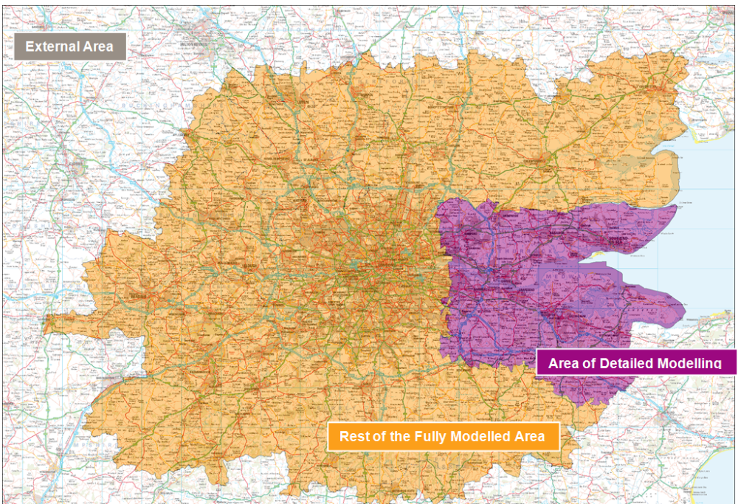

M25 Highway Model
The existing M25 highway model appears generally suitable for assessing the impacts of proposed capacity enhancement schemes in the Lower Thames area. The broad network coverage and extent of the simulation network is good, with all major routes covered.
Some of the arterial routes within the Area of Detailed Modelling have been simplified in some cases and are not representative of actual junction layouts, capacities or operations. Enhancement of these routes will be undertaken using a mixture of existing models and new coding.
Centroid connector usage and loading in Medway and Maidstone will be reviewed following network enhancements and zonal disaggregation. Some of the connectivity here may lead to unrealistic routeing around the proposed capacity enhancement schemes, particularly Option C and the M2-M20 Link variant.
Generalised cost assignment parameters will need to be updated in order to reflect the latest WebTAG 3.5.6 guidance, although the methods used in their formation seem appropriate.
The coding of tolls and generalised costs will be revised, because tolls are currently represented as time penalties in seconds and they will need to be processed in the demand model as monetary charges.

M25 Demand Model
We have reviewed the M25 demand model as it currently stands. We regard it as generally suitable for the assessment of this work and compliant with WebTAG guidance, provided that modelling of traveller response to tolls is improved, for example via income segmentation. This is discussed in the report. In addition, we intend to integrate the full SATURN-based M25AM assignment model in the demand model structure, removing model complexity and removing a simplifying assumption in the existing model.

Freight Modelling
We have reviewed the representation of freight demand in the existing M25 Model, and alternative potential data sources.
Due to the evolution of recent travel patterns, the updated 2001-based LGV and HGV matrices in current use in the M25 Model are not guaranteed to be an accurate representation of the current pattern of goods vehicle movements at the existing Dartford Crossing.
The use of a single RSI survey at the Crossing would in principle be an excellent and cost effective way of obtaining data on the current pattern of goods vehicle movements. However, the timescales and practical problems associated with this work preclude any surveys. Other RSI surveys located away from the Crossing itself, are highly unlikely to be a cost-effective approach to collection of adequate data on HGV movements.
In the absence of an effective RSI survey at the Crossing itself, the most suitable alternative source of OD goods vehicle matrices for the base year is through improving the procedure to apply freight growth. The most cost-effective approach would be to start from the validated 2004 matrices and for all ODs likely to use the Crossing replace their global growth factors instead by goods vehicle type and Crossing-specific growth factors from 2004. This should ensure no deterioration through the years in performance of the goods vehicle matrices at the Crossing. Improvements can also be made to the future year growth factors by using 2011-based factors that are segmented by goods vehicle type and region.
If the results from this approach prove unsatisfactory more resource intensive methods may be required. For example, a similarly updated version of the output vehicle matrices estimated by either GBFM or BYFM/FiLM could be generated, with the latter model having certain potential advantages.

Toll Modelling Methodology
The current M25 Model contains a three-way division of demand into “willingness to pay” categories, split by household income. This is applied only in the highway assignment model, not the demand model.
We have considered potential refinements to this process, and concluded that a pre-assignment choice (logit) model that divides travellers into “pay toll” and “don’t pay toll” categories is the most appropriate way to model route choice associated with one or more tolls.
We also believe that income-segmentation of the demand model matrices, to improve representation of demand-model responses (mainly redistribution and mode-choice) to tolls, is also likely to be beneficial.
The existing division of demand into income bands is quite simple, involving global factors applied to the matrices. We intend to refine this if we do decide to split by income, including at least a representation of the increased length of trips made by persons in higher-income households.

Conclusions and Recommendations
We regard the M25 Model as a generally suitable tool for the assessment of the Lower Thames Crossing scenario testing, but intend to undertake a number of refinements to improve its suitability, including refinement of the zones in the area of interest, improving the representation of the way traveller choices respond to tolls, and improving the representation of freight demand and growth in freight demand.
In addition to this, a few straightforward general improvements to the M25 Model, including use of the full SATURN model to supply travel costs to the demand model, and various minor runtime improvements, will be made before using the model.
Several other transport models exist covering the area of interest. These have been reviewed, and, where appropriate, data will be extracted from these to improve the representation of the area in the M25 Model.

  - Background
- Introduction
    - AECOM has been appointed by the Department for Transport (DfT) to undertake a study to provide strategic outline business cases for three alignment options (plus a variant) for providing additional river crossing capacity in the Lower Thames area. These options are the result of a previous study, the ‘Dartford River Crossing Study (2009)’.
    - The first Dartford Thurrock River crossing, the A282, was in the form of a single tunnel which opened in 1963. In line with growth in demand, a second bore was completed 1980 and the Queen Elizabeth II bridge opened in 1991.
    - As reported in the ‘Dartford River Crossing Study’, the existing crossing provision suffers from significant congestion; the study identified the issues caused by these constraints as well as proposing both short-term (toll plaza locations) and long-term (three options for additional crossing capacity) mitigation measures.
    - As part of the Government’s Comprehensive Spending Review (CSR) 2010, the DfT committed to both short and medium term measures to address congestion as well as to review the longer term capacity options. The focus of this study is to address and develop the longer-term capacity options.

  - Report Scope
    - This document forms the Model Status Report, which is the second deliverable of the ‘Output 1’ stage of works, following AECOM’s Inception Report.
    - The objective of this report is to undertake a review of the suitability of the existing M25 Model (version B602) and to set out the necessary refinements to the model for this study. The refinements will draw on other local models and their data, if appropriate. As part of this analysis, the model performance in the vicinity of the existing A282 Dartford Crossing and the proposed options has been assessed. The review refers to and draws upon the current DfT WebTAG guidance, including the consultation highway modelling unit, WebTAG 3.19C.
    - The M25 Model is comprised of two distinct sub-models:
- The M25 Highway Assignment Model, developed using SATURN software; and
- The M25 variable demand forecasting model, developed using EMME software.
    - This report is a critical review of the models, identifying any weaknesses in the defined ‘core’ model area and suggesting any immediate model updates that will be required prior to the application of the models in developing the strategic outline business cases for the crossing options.
    - Consideration is then given to the freight forecasting capability and to how the tolling of various scheme options should be implemented in the model.
    - The purpose of this report is to consider the modelling methodology, or capability required of the transport model for the strategic appraisal of options to provide additional Lower Thames capacity. Consideration of the use of the model outputs for this appraisal will be considered, in part, in Task 1.3 (Appraisal Methodology) and further in Output 3 (formulating the scenarios and defining the option tests).

  - Report Structure
    - Following this introduction, this report is structured into the following key chapters:
- Chapter 1: ‘Transport Models in the Region’, which provides a description of models that may be of potential use to this review;
- Chapter 2: ‘Zoning’, which reviews the geography and trip density of the zone system;
- Chapter 3: ‘M25 Highway Model’, which reviews the M25 highway assignment model component;
- Chapter 4: ‘M25 Highway Model Performance’;
- Chapter 5: ‘M25 Demand Model’ which reviews the variable demand forecasting model component;
- Chapter 6: ‘Freight Modelling’;
- Chapter 7: ‘Toll Modelling’; and
- Chapter 2: ‘Highway Model Calibration Approach’.

  - M25 Model
- Transport Models in the Region
    - The M25 Model was developed to assess the transport impacts of forecast traffic growth and for the assessment of transport interventions within and around London, with specific reference to the demand management strategies on and around the M25, requiring consideration of:
- the potential range of developments across the region and the consequential travel demands;
- the scale of development at Heathrow, Gatwick and Stansted Airports and the possible breadth of impacts on the regional transport infrastructure; and
- the credibility and robustness of the modelling suite to withstand detailed examination at Public Inquiry.
    - Recognising the then existing capabilities of modelling software and methods, a suite of linked models was developed, with each focused on specific issues. The key components of this M25 Model are:
- an M25 Assignment Model, M25AM, developed by Hyder Consulting from the existing M25 North of Thames Assignment Model (NoTAM) SATURN model, incorporating travel demand data derived from the 2001 London Area Travel Survey (LATS) data;
- a multi-modal M25 Demand Model (M25DM), developed by AECOM, providing demand model capability, covering trip generation and trip frequency, time period, mode and destination choice; and
    - Of relevance to this study, the M25 Model has been used in the recent past to assess Option A (HyderHalcrow JV) and is currently being used to assess free flow tolling on the existing Dartford Crossing. The most recent version of the model, the B602 version, has been enhanced to incorporate improved representation of the river crossings for the A282 at Dartford and the A210 Blackwall Tunnel, incorporating new speed-flow curves and coding at the crossings.
    - The detailed simulation model network covers the South East region and the southern parts of the East of England region. Away from these areas, the network provides more skeletal coverage of the rest of Great Britain, represented through the use of less detailed buffer-style network coding. The simulation network covers an area broadly from Reading in the west to just east of Medway and Rochester in the east, and from Stevenage in the north to Gatwick Airport in the south. With reference to the South East, which is to be the primary focus of this study, the network extends to Junction 5 on the M2 at Sittingbourne, some 20 miles west of Canterbury, and to Junction 8 of the M20 some 20 miles north-west of Ashford.
    - The M25 highway model has the following dimensions:
- 1,417 zones;
- 48,910 network links, of which 34,359 are simulation and 14,551 are buffer.
- 18,533 nodes, of which 14,841 are in simulation network and 3,692 are in buffer.
- 6 user-classes (low/medium/high income (non-work), employers’ business, LGV, HGV); and
- 3 time-periods (AM peak, interpeak, PM peak); no pre-peak (PASSQ) assignments;
    - The M25 demand model has the following dimensions:
- 1417 zones;
- 5 demand segments (commuting, other, employers’ business, LGV, HGV);
- 2 types of car availability (car and no-car available); and
- 4 time periods (AM period, interpeak period, PM period, off peak period).
    - The highway demand matrices used in the M25 Model were developed from LATS roadside interview data collected in 2001 and 2004 traffic count data. The age of these data add some uncertainty to the trip patterns, but there is no more recent comparable data set providing the scope and coverage of the 2001 LATS data.
    - The M25 Model demand matrices were rebuilt by AECOM during 2008, incorporating greater coverage of RSI survey data than previously used in the NoTAM donor model, the focus of which was to the north of the Thames. Synthetic demand data were used to represent unobserved trip movements and merged with observed data using variance-weighting techniques (essentially giving greater weight to data that has greater statistical confidence).
    - It should be noted that although the M25 Model uses 1417 zones, the highway demand matrices were developed in 2532 zones (NAOMI zoning), before being aggregated to M25 Model zones. These more disaggregate demand data will be of potential use if the disaggregation of M25 Model zones is considered necessary; this is discussed in Chapter 2. The NAOMI zones are particularly disaggregate to the south of the Thames Estuary.
    - The public transport demand matrices were developed synthetically, calibrated to TEMRPO trip ends and trip length profiles from the National Travel Survey.
    - Given the provenance of the model, its data and its structure, it is clear that the M25 Model is the most suitable basis with which to develop the strategic outline business cases for the crossing variants.

  - Thames Gateway South Essex Model
    - The Thames Gateway South Essex (TGSE) model consists of an upper-tier land-use, economic and transport interaction model (SETLUM), a middle-tier network assignment model coded in Omnitrans software and a lower-suite of operational models.
    - The area covered by TGSE covers the majority of the Thames Gateway region extending forty miles along the River Thames from the London Docklands area in the west to Southend-on-Sea in the east. The model is broadly bound by the A12 in the north and the River Thames in the south, and from the river Crouch in the east and the M25 in the west. The extent of the model allows for coverage of both the A13 and A127 in detail and the model should therefore be able to demonstrate the competing route choice in the area.
    - The model is comprised of 380 zones, 249 of which cover the internal study area to a relatively fine level of detail. These zones appear to be aligned with Census geographical and administrative boundaries to a good degree.
    - The highway demand matrices were developed by AECOM using a similar methodology to that used to develop the M25 Model matrices. Roadside interview data came from two sources: local RSIs undertaken in 2006 and LATS RSIs undertaken in 2001. Analyses of these locations shows a good degree of coverage in the Thurrock and Basildon areas, suggesting that the matrices may provide a useful basis for the disaggregation of M25 Model zones north of the Thames Estuary, if required.
    - In terms of application to the study, the TGSE model may be able to be used for the refinement of zoning to the north of the Thames, based on the RSI data that has been used in the model construction. As the highway model has been coded in Omnitrans, we cannot make direct use of any network coding within the M25 Model, which uses SATURN software.

  - Kent Thameside Model
    - The Kent Thameside Model (KTS) is multi-modal transport model that has been developed for the purpose of predicting the effects of development in the KTS area. The detailed model simulation area covers the highway network stretching from the boundary of the London Borough of Bexley in the east to Gravesend in the west, and bound by the River Thames in the north and the A2 in the south. Buffer network is modelled which encompasses in lesser detail most of the Greater London and Kent areas.
    - The model consists of 590 zones, the majority of which are located within the Kent Thameside area, with a good level of detailed zoning in the south Essex and Kent county areas and the remaining zones becoming progressively more aggregate away from the study area. The zones appear to be mostly defined based on geographical boundaries that match those of the 2001 census dataset, although it is noted that in a few instances KTS zoning is more disaggregate than, and appears to cross the boundaries of Output Areas.
    - The highway model appears to model two user-classes – light vehicles and HGVs, although matrices do exist for a more disaggregate set of purposes for use in demand mode choice modelling. The highway matrices primarily are based on observed data used in the original model build in 1993; a subset of these data were enhance in the model update to a 2005 base-year, making use of 2001 LATS survey data to replace the river crossing information only (Rotherhithe Tunnel, A102 Blackwall Tunnel and A282 Dartford Crossing) and use of some limited 2002 RSIs undertaken in the London Borough of Bexley.
    - In terms of application to the study, it is not recommended that the KTS model be used for the refinement of zoning based on the age of the RSI data that form the basis for the majority of movements within the matrices (preference is given to the NAOMI demand data). It might be possible to make use of the highway networks in order to enhance the coding in the KTS area of the M25 Model if required as a result of this review.

  - Medway Traffic Model
    - The Medway Traffic Model (MTM) covers a relatively restricted set of network and zone definitions primarily within the urban areas of Chatham, Gillingham and Rochester, bound to the south by the M2 motorway, with links to Gravesend in the west and the A249 in the east. Some detail of the A228 and on the Isle of Grain has also been included to the north.
    - There is very little detail in either the network or zone structure outside Medway, in recognition that sufficient data were not available in order to model traffic movements outside of the district. The trip matrices in the MTM have been created primarily from synthetic data, making use of pre-existing synthetic matrices and with no new roadside interview surveys undertaken.
    - Unlike the M25 Model, the Medway Transport Model zones do not appear to be built from aggregations of output areas or larger-aggregated recognised boundary datasets, with zone boundaries frequently bisecting those from the Census dataset. This is inconsistent with the M25 Model and WebTAG guidance (3.19C).
    - In considering that the highway matrices are primarily derived from synthetic data, the zoning system and networks are particularly focused on the urban areas of Chatham, Gillingham and Rochester and that the zoning system is not compatible with Census 2001 boundaries, we do not intend to make use of the MTM in order to enhance the M25 Model zone system or demand, particular as the NAOMI demand (discussed above) has greater spatial detail and consistency with the M25 Model matrices. There may be a requirement to review the network coding of the M2 and A249 in the MTM if this can be used to enhance the M25 Model.

  - East London Highway Assignment Model
    - The East London Highway Assignment Model (ELHAM) is one of five highway assignment models developed by TfL covering the Greater London area. These five models, together with the London Regional Demand Model (LoRDM) and Regional Railplan form the basis of TfL’s London regional modelling capability. This model is subject to on-going improvements, but the version available at the time is a 2009 validated model, released in early 2011.
    - ELHAM covers 10 boroughs as part of its area of detailed modelling, with parts of the M25 falling within the area of detailed modelling. Outside these 10 boroughs there is a detailed representation of network, albeit in buffer network coding in some cases, particularly in North, Central and parts of South London. In order to accurately represent this level of detailed network coding, the model contains a significant number of zones; in total there are 1,471 zones, of which 1,103 are within the area of detailed modelling. These zone boundaries are defined based on administrative boundaries in line with WebTAG guidance.
    - The prior matrices for this model were developed using a large number of RSI locations. The first set of data was from the Continuous Roadside Interview Survey Programme (CRISP) from 2008 / 2009 which focuses on RSI surveys for cordons, or enclosures, or areas within London. In addition to this there is a Thames Screenline of RSI surveys that has been used in the development of the prior matrices.
    - As part of the calibration / validation of the highway model, there is a good coverage of both counts and journey times within the East London area. In terms of counts, there are cordons for each of the matrix build enclosures and a number of screenlines inside the M25, including a Thames Screenline. In terms of journey times all significant routes within the area are covered by observed data. This includes the A12, A13, A2 and A20, as well as the M25, including the Dartford Crossing, and a route passing through the Blackwall Tunnel.
    - In terms of this application, ELHAM is a good source of observed data for 2009 both in terms of counts and journey times within the M25. The potential use of this data is discussed further in Chapter 2. The network coding has also been subject to rigorous standards and checking, and so the coding of the key routes inside the M25 of interest to this study should be considered for use in the Lower Thames modelling. This coding can be used as either a cross-check for the coding in the existing M25 model, or can be adopted if considered to be a better source of network coding.

  - M25-A13 Corridor Relieving Congestion Scheme Model
    - The incomplete M25-A13 Corridor study has a data collection report and associated data available for use. These have been provided, consisting of ANPR data, ATC and MCC count data and HATRIS journey time data extracts. Having reviewed these, ATC count data and journey time data will be used to augment the local calibration data set.

  - Thurrock Model
    - Data from the Thurrock Model will be considered when made available. In considering the data available from the other models discussed above, and bearing in mind the local scope of the model, we expect to make only limited use of traffic count and journey time survey data, if they can meaningfully augment the wider calibration/validation data set. We do not envisage taking network coding or demand data from the Thurrock Model.

  - Conclusions and Recommendations
    - The M25 Model provides an appropriate basis for the development of a model suitable for the assessment the longer-term crossing capacity options in the Dartford area.
    - As explained in subsequent chapters, there will be a need to disaggregate the zoning, and hence demand matrices, as well as the highway networks in the vicinity of Dartford and Thurrock. The models described above can help in this refinement process.
    - North of the Thames Estuary, the Thames Gateway South Essex model provides detailed zoning and demand data than that in the M25 Model, with observed (hence more reliable) data in the broad area in which disaggregation may be required.
    - There is no suitable source of coded SATURN highway networks in this area; therefore any new network coding will be developed from first principles.
    - South of the Thames Estuary, the use of demand data from Medway Traffic Model is discounted due to the synthetic nature of the data. The demand data developed for the M25 Model, in NAOMI zoning, is the most appropriate data source for spatial refinement. If this does not provide the required detail for a given area, demand data from the Kent Thameside Model can be used as a substitute.
    - The detailed network coding in the Kent Thameside Model and Medway Traffic Model will be considered for use in the updated M25 Model, as both provide detailed simulation network coding within Dartford, Gravesend and Medway.

  - Overview
- Zoning
    - This chapter presents the findings of our review of the M25 Model zoning system, which is used for both the highway assignment model (M25AM) and demand model (M25DM).
    - WebTAG 3.19C §2.3, provides guidance on the derivation of highway model zoning systems, emphasising the importance of zone size in the primary area of interest and appropriate loading to the highway network to ensure realistic routeing and assigned network performance. This model review has been undertaken with reference to this guidance.
    - The zone system adopted for the demand model (M25DM) has always been consistent with that of the highway model (M25AM), not least to reduce model complexity. The presumption is that this consistency will be retained, and so this zoning review is by implication also a review of the demand model zone system.
    - The focus of this chapter is primarily on what has been classified as the ‘Area of Detailed Modelling’, as defined in WebTAG 3.19C §2.2.5. This is the area over which significant impacts of the proposed interventions are certain to occur; how this area has been defined is presented below.
    - An appreciation of the zoning system is required in order to ensure that it is suitable for use in the assessment of providing additional crossing capacity of the Lower Thames area. The zoning system needs to ensure that its spatial resolution is sufficient to represent both the performance of the network and the effects of new crossing options upon it; the analysis in this chapter explores this.
    - As stated in WebTAG 3.19C §2.3.10, there is a degree of interdependence between the definitions of the zoning system and the network; if zones are significantly larger than the level of network detail implies, for instance, then it may lead to the unrealistic location of centroid connectors thus distorting traffic flows across the network.
    - This chapter concludes with recommendations for zone system enhancements that are considered necessary for the requirements of this study.

  - Defining the Study Area
    - The M25 Model has been divided into the three study area classifications, consistent with WebTAG 3.19C §2.2.5: the broad locations of these three areas are presented spatially in Figure 3.1. The three study area classifications are the ‘Area of Detailed Modelling’, the ‘Rest of the Fully Modelled Area’ and the ‘External Area’.
    - The focus of the zoning review is primarily on the ‘Area of Detailed Modelling’, which is the area over which significant impacts of interventions are certain. As defined, our broad ‘Area of Detailed Modelling’ covers some 2,190 square kilometres of the area surrounding the Thames Estuary, extending between 40-50km north-south and between 30-60km east-west.
    - The basis for the ‘Area of Detailed Modelling’ has been drawn from the extent of the simulation network in Kent and south Essex. In addition to the areas directly surrounding the existing Dartford Crossing and the proposed capacity enhancement schemes, the ‘Area of Detailed Modelling’ has been defined to include those key areas/routes which, in our judgement and as defined in preliminary discussions with stakeholders, are likely to be significantly affected by the introduction of additional capacity enhancement schemes in the Lower Thames area. This includes the M25 north of junction 5 (M26) and south of junction 28 (A12), the A13 and A127 between the M25 and Benfleet, the A2 from the M25 to the M2 at Sittingbourne and the M20 and M26 from the M25 to Maidstone.
    - Furthermore, the ‘Area of Detailed Modelling’ has been extended to the east within Kent in order to ensure that all decision points are encompassed.
    - The definition of the ‘Rest of the Fully Modelled Area’ and the ‘External Area’ is to some degree more arbitrary, although has been undertaken in consideration of both the simulation network and granularity of the zoning system. The ‘Rest of the Fully Modelled Area’ has been defined as the rest of the simulation network that is not contained within the ‘Area of Detailed Modelling’; the M25 Model has a significant expanse of simulation network that – with respect to the definitions provided in WebTAG – has speed/flow modelling and the representation of strategically important junctions. Our definition of this area is perhaps larger than required in order to cover the area over which the impacts of the proposed schemes may be felt (WebTAG 3.19C §2.2.5), but the coding within the area is much more detailed than required in the ‘External Area’.
    - The ‘External Area’ has simply been defined by those areas of the network that are coded with less detailed buffer-style coding within the model; this covers the rest of Great Britain. This area is consistent with our interpretation of where the impacts of the proposed schemes are likely to be negligible.
    - There is an interface in Kent between the ‘Area of Detailed Modelling’ and the ‘External Area’, whereas elsewhere, the ‘Area of Detailed Modelling’ is surrounded by the ‘Rest of the Fully Modelled Area’. The reason for this anomaly is due to the provenance of the M25 Model, which had a requirement for a much larger area to be covered by simulation network within SATURN. To reduce technical risk and time inputs, this large simulation area is to be retained. For the purposes of this study, an extension of the fully modelled area was considered (eastward towards Canterbury), but discounted following consideration of viable routeing choices i.e. enhancing the network in this part of the external network was not considered to be worthwhile in the context of this study.
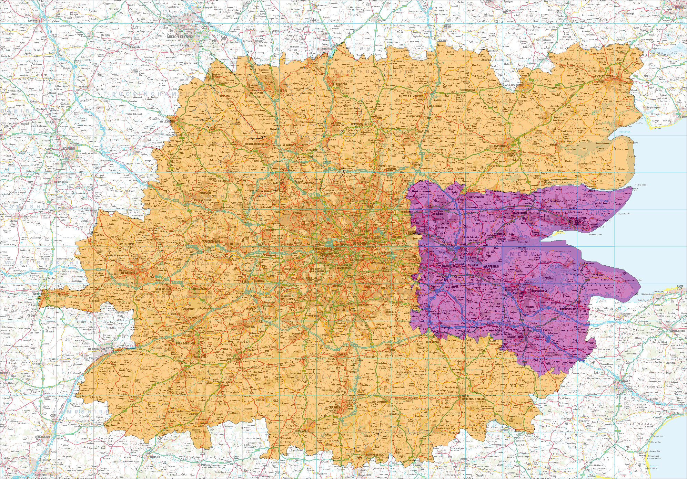
Figure 3.1: Extent of modelled area classifications
Area of Detailed Modelling
Rest of the Fully Modelled Area
External Area

  - Zonal Topography
    - The M25 Model was not developed with assessment of the Lower Thames Crossing capacity options in mind. However, the close proximity of the M25 and the linkage that the A282 Dartford Crossing provides mean that the model and thus zoning system tend to be reasonably detailed in the area. As recommended in WebTAG 3.19C §2.3.1, the zoning system should follow the convention of smallest zones in the Area of Detailed Modelling progressively becoming larger for the External Area. This generally is the case for the M25 Model with respect to the Area of Detailed Modelling required for this study. It is notable, however, that particularly within the south Essex area, zones are not as detailed as desired and some form of disaggregation may be required. This is discussed below.
    - As set out in WebTAG 3.19C §2.3.2, model zones should ideally be formed along the boundaries of Census and other administrative geographies. In the case of the M25 Model, this generally appears to be the case within both the Area of Detailed Modelling and the Rest of the Fully Modelled Area, where the zones are typically aligned with 2001 Census Output Areas. This will simplify the linkage between planning data (either local data or TEMPRO forecasts) and the model zones.
    - It is noted however, that the district boundary between the Gravesham and Medway (both Kent) does bisect a larger M25 Model zone in the north Kent area; it is suggested that this zone be disaggregated, along Output Area boundaries, in order to provide consistency between zones and district boundaries within the Area of Detailed Modelling. This should lead to the more accurate compilation of forecast planning data, better zone loading and thus better forecast model results.
    - The zoning system in its current state is compliant with WebTAG 3.19C §2.3.4, 2.3.5 and 2.3.6 in that zones have been defined making use of natural barriers in the Area of Detailed Modelling, most obviously the Thames Estuary. It is also built up from Output Area Census geography.

  - Zonal Trip Density
    - WebTAG 3.19C §2.3.12 provides guidance as to the number of trips that should ideally be loaded onto the highway network by a zone in the Area of Detailed Modelling, noting that the number should be small and tend not to exceed 300 PCUs per hour. This is in order to prevent implausibly high loads from appearing at single points within the network. Outside the Area of Detailed Modelling, the guidance suggests that this constraint on trip numbers be relaxed owing to the increased sizes of zones in-line with the guidance on modelled area types (§2.2.5). This is particularly relevant in the case of the M25 Model which is a strategic model with a zone structure covering the whole of Great Britain.
    - Analysis of the base year M25 Model matrices has been undertaken to demonstrate the number of interzonal trips (i.e. those that are loaded onto the network) by zone in the model. Figure 3.2 shows these results in spatial form for the morning peak hour (08:00-09:00) matrices, which have the highest number of trips of each of the three modelled time periods.
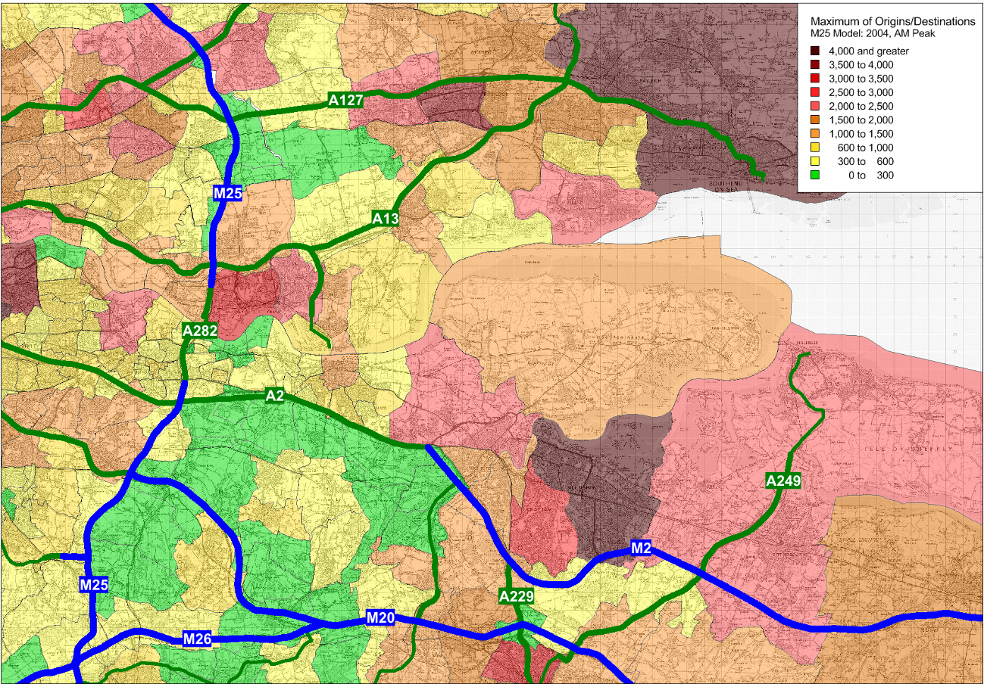
Figure 3.2: Maximum number of trips (origin or destination) by zone. 2004, AM peak
Contains Ordnance Survey data © Crown copyright and database right 2012
    - As the figure demonstrates, there are a number of zones within the vicinity of the scheme options that have greater than 300 interzonal trips either to or from them in the morning peak hour. Whilst it should be borne in mind that the M25 Model is primarily a strategic model covering the entire country and thus it is not practical to have zones small enough to generate a maximum of 300 trips in all cases, there does appear to be the need for some zonal disaggregation in the vicinity of the proposed schemes.
    - There will be a requirement to disaggregate zones particularly where route-choice is likely to exist between each of the three options that are to be modelled and the existing A282 Dartford Crossing (and, to a lesser extent, the A210 Blackwall Tunnel). For instance, there is a clear grouping of zones in the south Essex area between Thurrock and Grays that have a high density of trips and will have clear route choice between the new options and existing crossing. Similarly, there is a grouping of zones in north Kent (Medway) that also demonstrate high densities of either origins or destinations.
    - Figure 3.3 presents a plot showing the maximum number of trips (either origin or destination) for zones within the Area of Detailed Modelling. These highlight that whilst there is a significant proportion of zones that have a number of trips greater than 300 (represented by the red bar), around a quarter of these have a maximum of origins or destinations trips greater than 1,500 PCUs. Having such a large number of trips entering/exiting the network to zones can be problematic.
    - As discussed in more detail in the highway network review section, the majority of zones are connected to the network in the study area through a single centroid connector; the result of this means that trips from across a large area are all loaded through a single junction and therefore turning movements at the downstream junctions are likely to be unrealistically high. Likewise, junctions elsewhere in the nearby network may have unrealistically low turning movements as traffic will be being loaded elsewhere in the zone.
    - This results in a particularly ‘lumpy’ representation of traffic from these large, generally urban zones that may unrealistically influence routeing across the network sub-area. As such, all zones with a number of trips greater than 1,500 PCUs have been analysed with respect to the network density within them and the element of route choice that is likely to be afforded to them. This has resulted in a selection of zones being recommended for disaggregation.
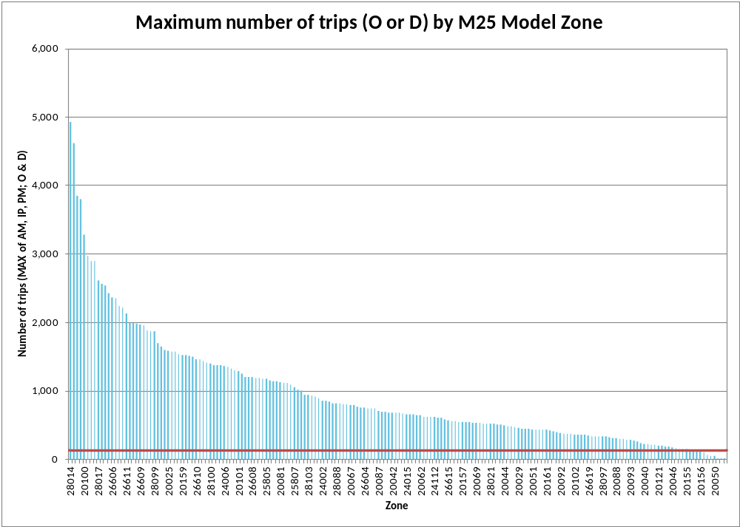
Figure 3.3: Maximum of origins/destination loadings by zone in the Area of Detailed Modelling

  - River Crossing Trip Distributions and Densities
    - Select link assignments have been undertaken within the existing M25 base year model for the A282 Dartford Crossing and for the nearest competing crossings, namely the Woolwich Ferry and the A210 Blackwall Tunnel.
    - Analyses of these select link assignments have been undertaken within MapInfo GIS software in order to understand and to display spatially those zones that are either the origin or destinations of trips that cross the river and are thus likely to be in scope. This provides further clarification as to those zones that have high densities of trips that cross the river and may require some zonal disaggregation due to overall strategic route choice within the model.
    - Figure 3.4 to Figure 3.7 demonstrate the origins and destinations for trips making use of the three crossings in the southbound direction in the AM peak hour model. Analysis has also been undertaken for the northbound direction and these have also been used to inform the likely scale of zonal disaggregation required.
    - As the figures demonstrate, there are a significant number of trips outside the Area of Detailed Modelling which use the existing Dartford Crossing that originate in Norfolk and in northern Cambridgeshire. Trips from the western side of this shaded region might have strategic route-choice between the M11 and the A505/A1(M) for travel to the M25, which may ultimately affect their routeing decisions around the M25 itself. As such, it is recommended that these zones be disaggregated in order to ensure that more accurate routeing be allowed within the model.
    - The figures demonstrate that trips making use of Woolwich Ferry are, as might be expected, limited in scope to areas of east and central London and no further disaggregation is required. Similarly, no disaggregation is likely to be needed based on the analyses of the Blackwall Tunnel origins/destinations, which, in respect to zones with high densities of trips, tend to be limited to north and east London.

Figure 3.4: A282 Dartford Crossing, southbound, origins (purple) and destinations (orange)
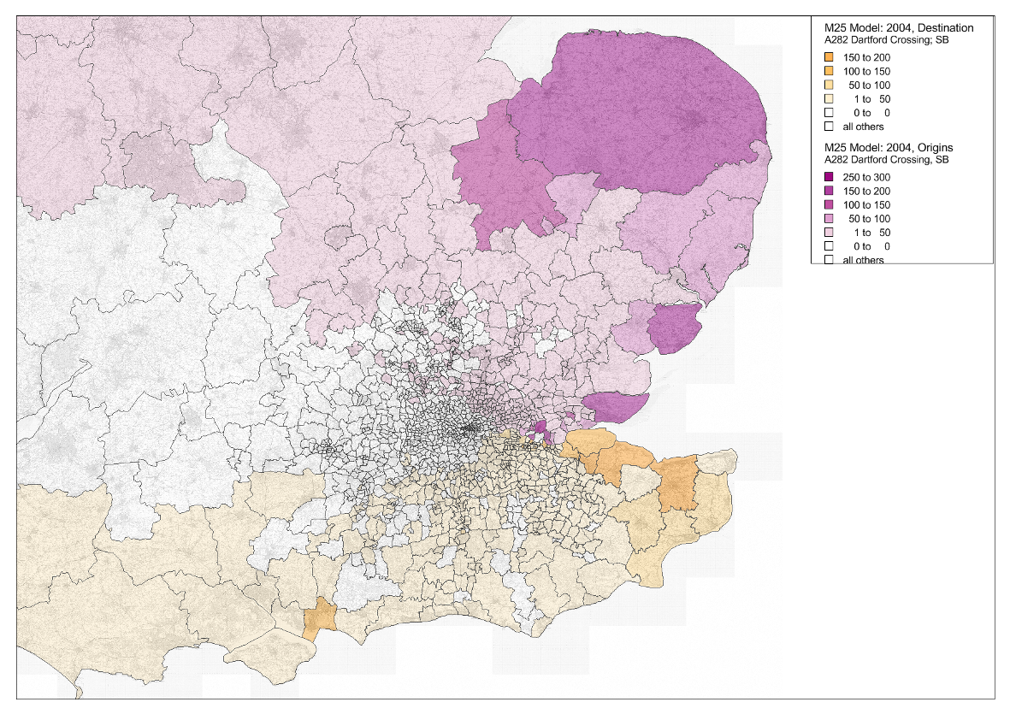
Contains Ordnance Survey data © Crown copyright and database right 2012

Figure 3.5: A210 Blackwall Tunnel, southbound, origins (purple) and destinations (orange)
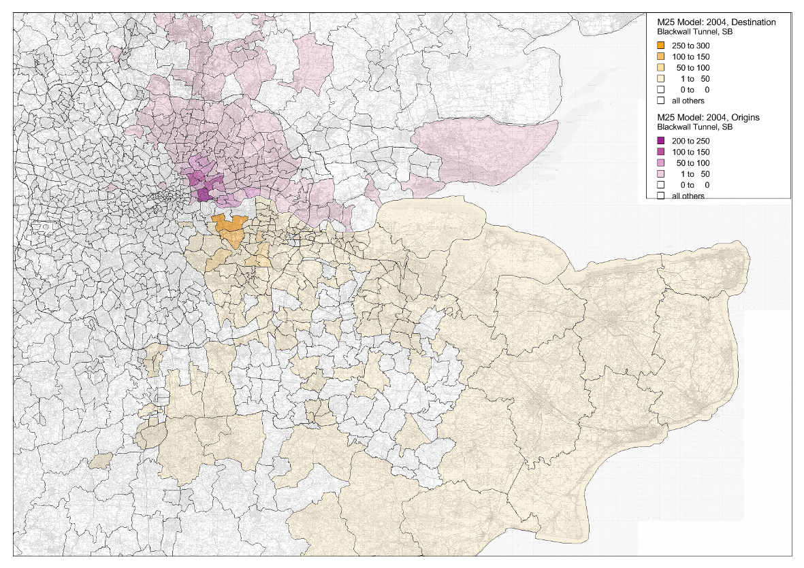
Contains Ordnance Survey data © Crown copyright and database right 2012
Figure 3.6: Woolwich Ferry, southbound, origins (purple) and destinations (orange)
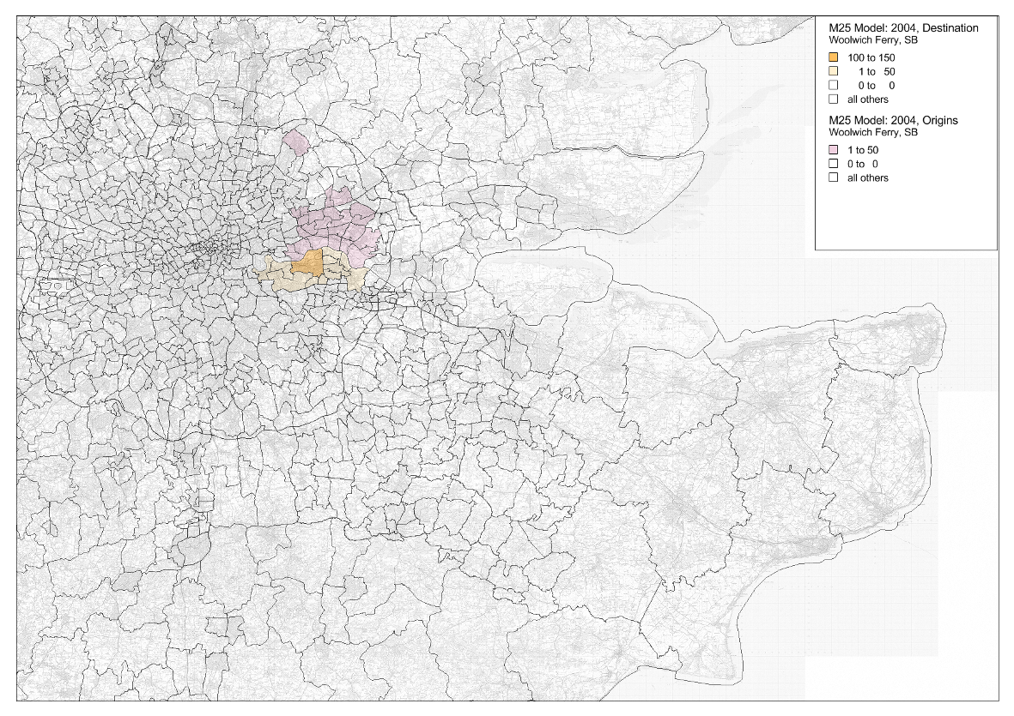
Contains Ordnance Survey data © Crown copyright and database right 2012
Figure 3.7: M25 Staines, southbound, origins (purple) and destinations (orange)
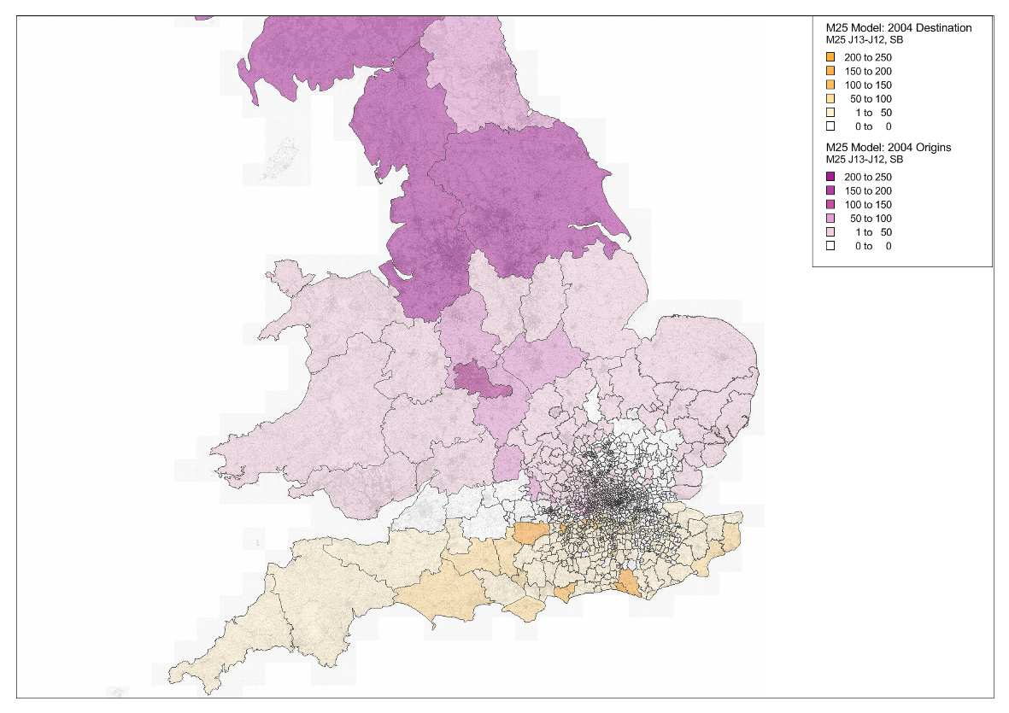
Contains Ordnance Survey data © Crown copyright and database right 2012

  - Zone Disaggregation
    - In addition to the trip density-based consideration of zone disaggregation candidates, all zones in the shaded area Figure 3.8 have been considered for disaggregation. A list of these local zones and the reasoning for disaggregating or not disaggregating is provided in Appendix A.
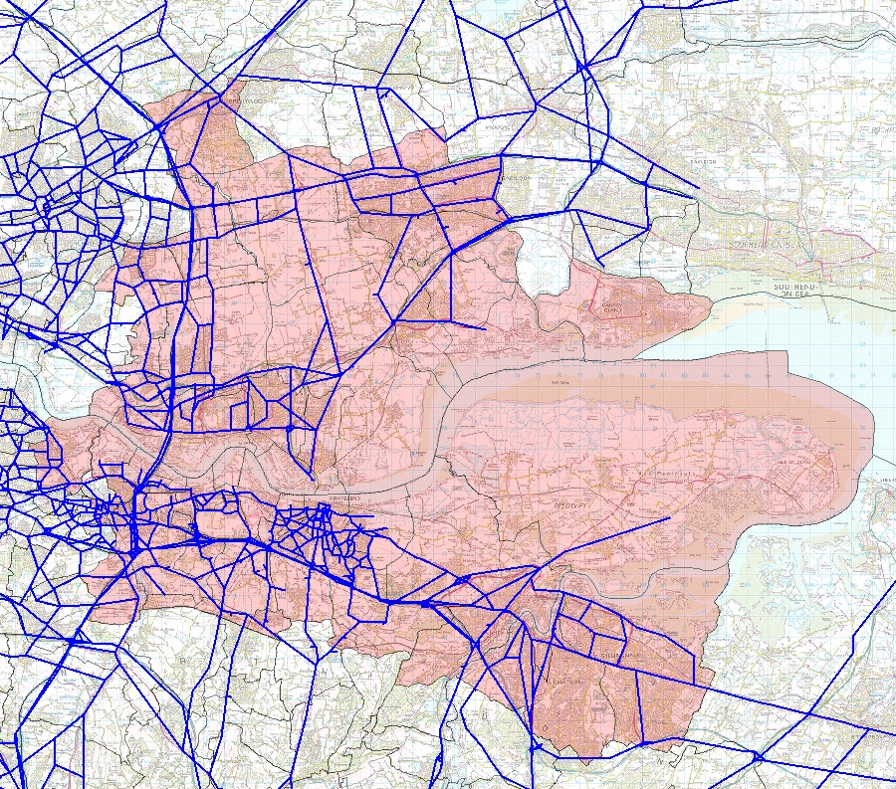
Figure 3.8: Area of detailed consideration for zone size
Contains Ordnance Survey data © Crown copyright and database right 2012

    - In summary, 19 zones in total have been identified as being worth disaggregating due to either an obvious choice of strategic routeing, which may vary depending on where within a zone a trip originates/destinates, or a high level of travel activity to/from them. Table 3.1 provides a list of these 19 zones, including zone number, description and location (district and county).
Table 3.1: M25 Model zones identified for disaggregation
Zone | Description | District | County
20020 | Lower Higham | Gravesham | Kent
20026 | New House & Perry Street | Gravesham | Kent
20041 | Dartford (Central) & New Town | Dartford | Kent
20049 | St Mary's Isl& & Ocelet Submarine | Gillingham | Kent
20061 | Dartford (Central) & New Town | Dartford | Kent
20062 | Dartford (Central) & New Town | Dartford | Kent
20095 | Chatham & Luton | Rochester Upon Medway | Kent
20098 | Snodl& (N) | Tonbridge & Malling | Kent
28016 | Orsett & Horndon on the Hill | Thurrock | Essex
28017 | Grays & Little Thurrock | Thurrock | Essex
28018 | West Thurrock | Thurrock | Essex
28059 | Purfleet | Thurrock | Essex
28061 | Tilbury & Chadwell St Mary | Thurrock | Essex
28080 | Brentwood (S) & Warley | Brentwood | Essex
35001 | Cromer & the Norfolk Coast | Cromer & the Norfolk Coast | Norfolk
37004 | Ely Soham & Littleport | Ely Soham & Littleport | Cambridgeshire
20100 | Stockbury & Hill Green | Maidstone | Kent
28098 | Basildon | Basildon | Essex
28070 | Basildon | Basildon | Essex

    - We have reviewed all zones in the immediate area of the existing and proposed crossings, and considered disaggregation of each. In the majority of cases, either there was no route choice at all (single access point to zone) or essentially no strategic route choice (only one strategic exit in any given direction).
    - The zones assessed as in need of disaggregation are identified spatially in Figure 3.9.

Figure 3.9: Zones identified for disaggregation
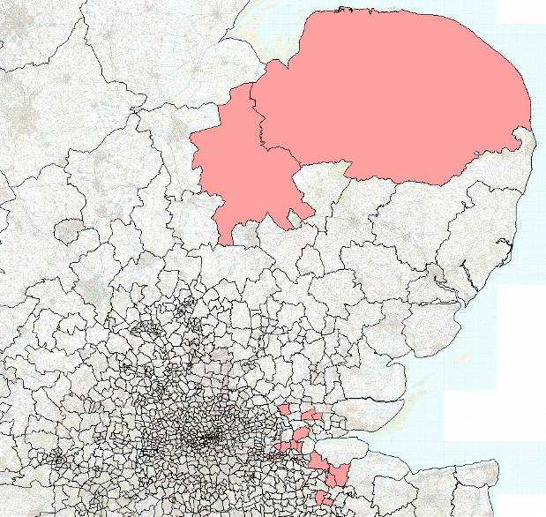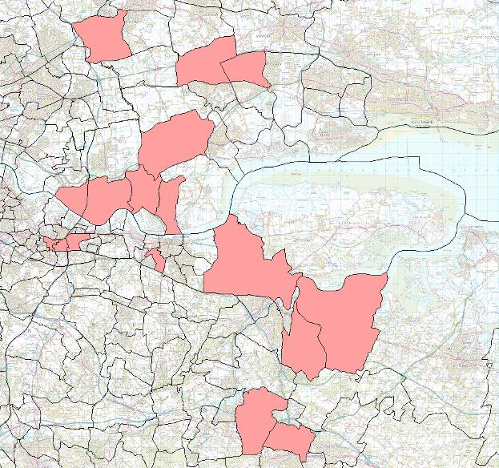

    - By disaggregating these zones within the model, it should be possible to achieve a better representation of the loading and routeing of trips within the ‘Area of Detailed Modelling’, and better matching the zone density to the highway network.

  - Zone Aggregation
    - In addition to the consideration of the disaggregation of zones in the vicinity of the Thames Estuary, the aggregation of potentially superfluous zones elsewhere in the model has also been considered.
    - The primary motivation in identifying zones that can be aggregated is to reduce model run times, discussed in Section 1.39. In summary, the run time of the M25 Model broadly increases, or decreases, more than linearly with the number of zones. That is, reducing the number of zones by 20% will reduce runtimes by more than 20%. Sizes of matrix-based files will decrease with the square of the number of zones.
    - The existing model is estimated to have a run time of approximately 24 hours. In order for this to significantly improve productivity, this could possibly be reduced to 12-16 hours, allowing runs to be started in late afternoon and completed the following morning.
    - We have examined the relationship between the zoning and the network detail, specifically the extent of the simulation network. There is a clear trend for relatively disaggregate zoning in the simulation area and relatively coarse zoning in the buffer network. There are possibly 25-50 zones that could be aggregated in the buffer network area; aggregation in the simulation area requires more analysis.
    - Having considered the implications of aggregating model zones, there was a concern that there is some risk that aggregating zones, even at some distance from the study area, would adversely affect route-choice, especially if carried out in central London. There was also some concern that aggregating zones might adversely affect convergence or create congestion hotspots, but some preliminary sensitivity testing suggested that this may not be the case; in limited testing, zonal aggregation actually tended to reduce congestion, provided aggregated zones inherit all centroid connectors from their parent zones.
    - If model representation were simplified in some areas of the model in terms of zoning, further savings in runtime could be generated by removing the junction simulation in these areas and re-coding them as SATURN “buffer” network. This would be a more significant task in terms of person time.
    - There would seem therefore appear to be three available options:
- Aggregate zones within the simulation area without refining the highway network; as discussed. The main effort involved would be in defining the new aggregated zones; re-coding the network would then be a largely automatic task. Some testing and iterative improvement of the new zone layer would most usefully be involved, however.
- Aggregate zones within the simulation area and refine the highway network, by removing excessive detail and re-coding network with link speed-flow curves instead of junction simulation, or with fixed speeds adjusted over time. Further effort would be involved in network re-coding. Simplification, via removing superfluous links, would be very difficult to automate and would have to be done manually.
- Leave the zoning as is (notwithstanding the recommended zone disaggregation (Section 1.17)), eliminating any risk associated with aggregating zones, but accepting longer runtimes.
    - We have experimented with aggregating zones in the existing M25 Model without refining the highway network (i.e. the first option). In doing this, we have aggregated zones where:
- they are distant from the area of interest; and
- loading onto the strategic network is identical or very similar; or
- one or more zones have negligible demand.
    - The zones aggregated for these tests are shown in Figure 3.10.
Figure 3.10: Zones identified for disaggregation
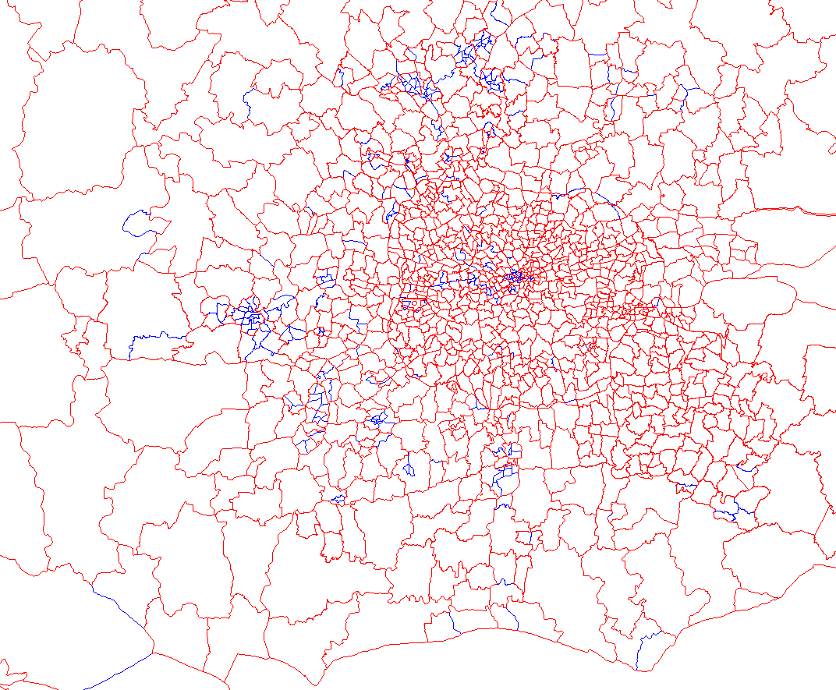
gregrehrehhre

    - In doing this, we have reduced the number of zones from 1417 to 1121, a reduction of 296 zones, or 21%. This translates to a ~30% reduction in assignment time and a ~38% reduction in matrix storage requirements and processing time, which includes the demand model calculations within the model and TUBA post-processing analysis. The overall anticipated effect on total model runtimes is a reduction of approximately one third.
    - We note also that the assignment convergence improved marginally following the aggregation of zones.
    - These performance improvements come with little effect on model performance in the vicinity of the Lower Thames area. Appendix B illustrates this with plots showing:
- the changes in traffic flow following the introduction of Option C, in both 1121 and 1417 zoning;
- differences in ‘core scenario’ traffic flow in 1121 and 1217 zoned models; and
- modelled delays in a ‘core scenario’ in 1121 and 1217 zoned models.
    - In considering the performance gains of zone aggregation and the minimal effect on model performance in the Lower Thames area, we recommend that this approach be adopted.
    - There are other measures that can be adopted to help reduce model run times; these are discussed in Section 1.39.

  - Conclusions and Recommendations
    - The M25 Model zones are broadly suitable for the assessment of the longer-term crossing capacity options in the Dartford area. They do need some limited refinement however.
    - The M25 Model zones are broadly consistent with 2001 Census geography; this should be retained in any modification to the zone system, providing consistency with other data sources, not least planning data.
    - There are a number of zones in the vicinity of the Dartford Crossing that have been identified as requiring disaggregation, on the basis of the density of trips to/from these zones and because the routeing choices of trips from these zones will be uncertain when the various capacity options are evaluated.
    - Two zones in Norfolk/Cambridgeshire have been identified for disaggregation on the basis of the pattern of demand using the existing Dartford Crossing. Trips originating/destinating to the west of these zones have a viable routeing alternative around the western side of the M25.
    - In disaggregating the model zones we will draw, where suitable, on data available from local models. Should the data be unsuitable the alternative approaches we will adopt, in order of preference, are:
- Use of the NAOMI prior matrices (which were constructed at a finer level of detail before aggregating to the M25 Model zone system; and
- Where these finer zones are not consistent with our requirements use of planning data (residential postcodes to indicate population distribution and, if available, Valuation Office data to indicate employment distribution).
    - The aggregation of zones to reduce the model size and run times has been considered and is considered to be worth pursuing. Other run time saving measures will also be considered, discussed in Section 1.39

  - Introduction
- M25 Highway Model: Network Detail
    - This chapter sets out our review of the highway component of the M25 Model, with a specific focus on the network detail in the vicinity of the proposed capacity enhancement options and the performance of the model in the same locations.
    - It is important to have an appreciation of the performance of the model prior to undertaking any assessments relating to additional capacity enhancement options: understanding the current network structure, and its strengths and weaknesses will be key to the specification of any model enhancements that may be required to ensure that the model is suitable for use in this Study.
    - The model has been assessed against the acceptability criteria and guidelines contained within WebTAG 3.19C ‘Highway Assignment Modelling’ (November 2009). This document, whilst in consultation, reflects the DfT’s latest guidance and supersedes the Design Manual for Roads and Bridges (DMRB) Volume 12, Section 2. We have structured our analysis as follows:
- Network Structure, discussing the network coverage, density and coding with respect to area definitions as set out in WebTAG 3.19C section 2.2.5;
- Centroid Connectors, reviewing the zone loading within the model, with a particular focus in the Lower Thames area;
- Time Periods, discussing the modelled time periods in respect to WebTAG 3.19C section 2.5 guidance;
- User-Classes, discussing the sub-division of the demand matrices; and
- Generalised Costs, covering the time and distance coefficients used as the basis for route choice within the highway model.
    - The outcome of this chapter is a set of concise conclusions and recommendations for model enhancements that are required to provide a robust basis on which to undertake forecasting and assessment relating to the provision of additional crossing capacity.

  - Network Structure
    - The M25 Model network covers the South East region and the southern extents of the East of England region in a reasonably detailed way, primarily with simulation coding throughout its extent. Away from these areas, the network provides a more skeletal coverage of the rest of Great Britain, represented through the use of less detailed buffer-style network coding.
    - As part of the study, we have broadly divided the M25 network into three specific regions, aligned with that of the model area approach specified in WebTAG 3.19C §2.2.5, these being: the Area of Detailed Modelling; the Rest of the Fully Modelled Area and the External Area. These areas, as described in WebTAG, were devised with the modelling objective in mind and have different characteristics dependent upon said objective.
    - Given that this study will make use of the existing M25 Model, this verification task determines which aspects of the network are applicable to the three area types and assess the network against the relevant criteria; it is likely that there will be a need to undertake some network enhancements to achieve a fit with the WebTAG definitions.

Area of Detailed Modelling
    - Figure 4.1 provides an overview of the network structure in both the Area of Detailed Modelling and the Rest of the Fully Modelled Area; simulation coding is shown as green links, with the less detailed buffer coding highlighted red.
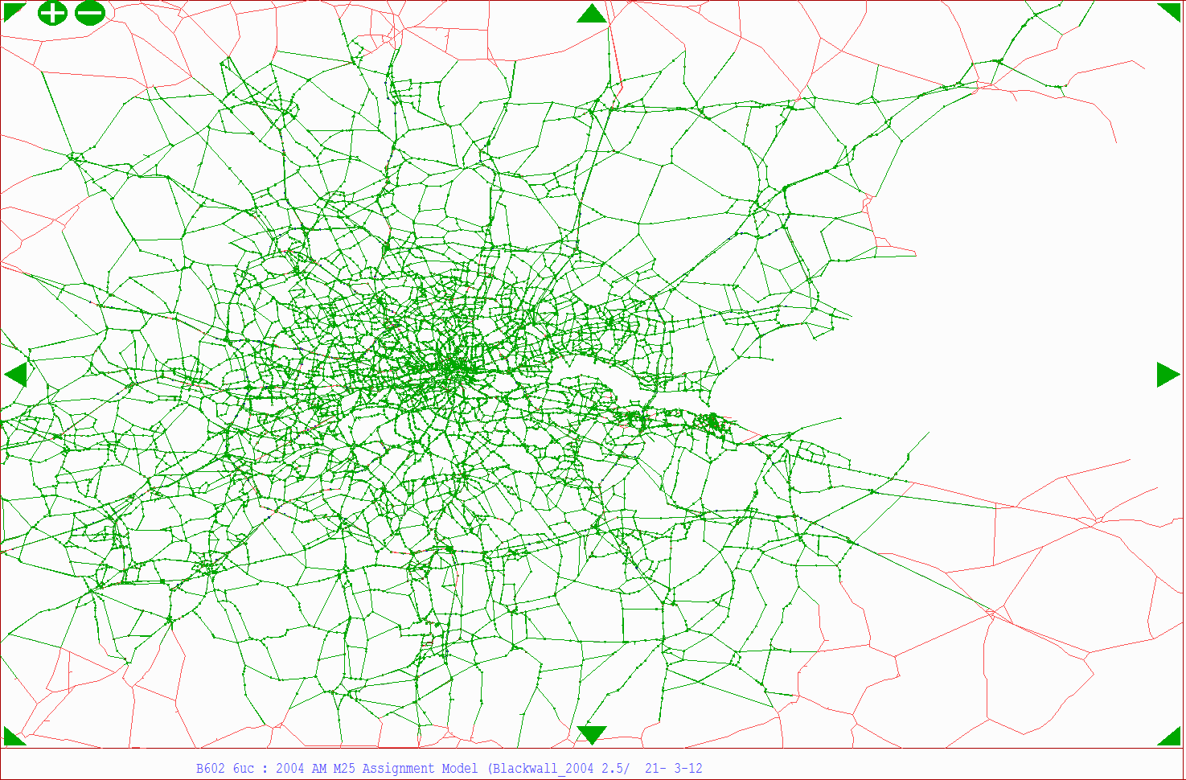
Figure 4.1: M25 Model simulation network

Coverage of Simulation Coding
    - As the plot demonstrates, the model detail is in-line with that expected by WebTAG 3.19C. As Section 2.4.2 of the guidance states, the network should include all main roads as well as those secondary routes that are likely to carry traffic movements that could use the scheme being assessed. The level of detail both in south Essex and north Kent area is reasonable, with a good coverage of the M25, A13 and A2 provided as well as for parallel routes including the A127, M20 and M26.
    - Whilst the extent of the simulation network throughout south Essex and Kent is considered to be generally suitable. It is noted that there are a few locations where buffer links are embedded within the simulation network coding; this applies to two or three small areas of the network in north Kent. These will need to be converted to simulation links prior to any enhancement or testing being undertaken, in order to ensure that all modelled links and junctions within the study are represented in accordance with WebTAG 3.19C. This is a relatively straightforward task that would involve the re-coding of around 15 links and their associated junctions and would ensure that detailed coding is prevalent throughout the Lower Thames area.

Quality of Junction Coding
    - Whilst the extent of the simulation area appears to be broadly suitable, the quality of the network coding in the area has also been checked. Analysis of junction coding along key corridors pertaining to the capacity enhancement options to be tested has been undertaken, with analyses of network structure, saturation flows and lane definitions being undertaken at the junctions; the corridors that have been most closely scrutinised are the A13, A2/M2, M20 and M26.
    - Analyses of these corridors has demonstrated that, in some cases, some very basic coding exists in places that does not accurately enough reflect junction layouts, geometries and/or capacities; an example of this is shown in Figure 4.2 for the junction of the A13 with the A1012 at Chafford Hundred, north of Grays. In reality, this junction is a grade-separated gyratory with on-slips and off-slips to/from both carriageways of the A13. However, as can be seen from Figure 4.2, the junction has been simplified to be represented as a single roundabout node, with ‘dummy’ nodes coded at either side on the A13 to allow for traffic to leave the carriageway, in some cases having to cut across the mainline. Coding such as this is quite clearly incorrect and will not model traffic flows or delays along the corridor correctly.
    - Given that the locations of some examples of this coding are close enough to the proposed crossing options to have a potential impact on traffic movements that may make use of them, it is recommended that at least the key corridors mentioned above are reviewed and, if necessary, junctions along them that are likely to be impacted by the introduction of the proposed capacity enhancement options recoded.
    - Examples of such simplified coding are found on the A13, M2, M20. For the M2, it is recommended that coding be based on the existing Medway Traffic Model which has a reasonable representation of this route and the junctions along it. The A13 and the M20 will however need to be recoded directly; the Thames Gateway South Essex model is built in the Omnitrans software package meaning that direct use of coding information is not possible; with regards to the M20, we are not aware of any traffic models that model this route in detail, and any coding updates will therefore be derived from first principles.

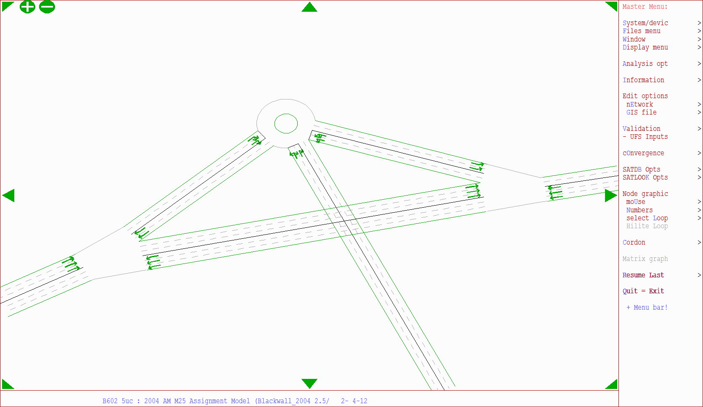
Figure 4.2: Junction coding, A13/A1012

Dummy Nodes

    - Figure 4.3 shows the location and use of ‘dummy’ node coding within the study area; ‘dummy nodes’ allow for unlimited capacity through them and do not represent any form of priority at the junctions that they are used at. As the plot demonstrates, their use is widespread in south Essex and north Kent. Whilst the use of ‘dummy’ nodes is reasonable in some cases, particularly at zone loading locations where a large volume of trips are loaded onto the network at a single location, their use can lead to issues with accurately modelling delay in the network.
    - As ‘dummy’ nodes represent unlimited capacity through them, their use prevents the propagation of ‘blocking back’ throughout the network in areas of high congestion, thus leading to a potential under-representation of delays, which could have a significant potential impact on regional routeing. In the case of the M25 Model, with relation to the study, it is suggested that ‘dummy’ nodes on the key strategic routes of importance (A13, A2/M2, M20) are recoded, as well as on any routes that provide a means of access to any of the proposed capacity enhancement options (e.g. the A1089 in the case of Option B). This will ensure that travel conditions across the study area are more accurately represented.

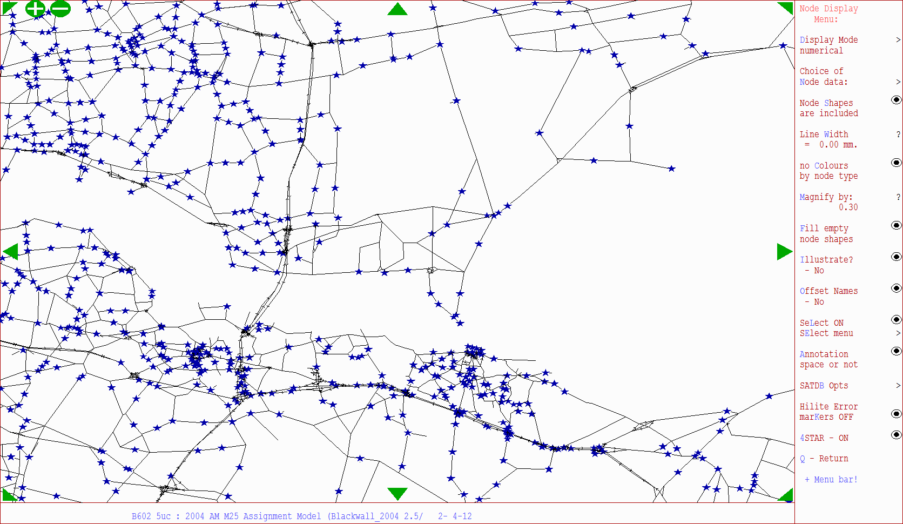
Figure 4.3: ‘Dummy’ node coding in the study area

Rest of the Fully Modelled Area
    - WebTAG 3.19C §2.4.3 states that the Rest of the Fully Modelled Area should be large enough to cover the area where impacts of interventions from the scheme to be assessed may occur, albeit at a relatively weak magnitude. The M25 Model, due to its original intended use and hence specification, has a significantly large area that, with regards to this Lower Thames Crossing study, would be considered as the Rest of the Fully Modelled Area. In fact, the simulation area is much larger than that required to represent even those impacts that are of weak magnitude. The simulation area, as shown in Figure 4.1, covers an area broadly from Reading in the west to east of Medway and Rochester in the east, and from Stevenage in the north to Gatwick Airport in the south.
    - The level of network detail in this area is analogous to that in the Area of Detailed Modelling; and in some cases, particularly the M25, the model coding is better than would be expected due to the model having been developed for use in studies all around the M25. Within this area, the majority of all links (apart from a few in central London) have capacity restraints modelled by the use of speed/flow curves, whilst all major junctions are also coded. Although a large number of ‘dummy nodes’ (unlimited capacity) have been coded throughout this model area, their use appears to be appropriate, either at locations of zone loading or at junctions within central London where network detail is lacking.
    - Previous Option A testing by the Hyder-Halcrow Joint Venture (HHJV) involved the tripling of the toll charge on the A282 at Dartford Crossing. Analyses of the results from this exercise noted that the two key routes that traffic re-routed to were the Blackwall Tunnel (cars) and the western sections of the M25 (HGVs). It is worth noting that the ‘Rest of the Fully Modelled Area’ contains both the A102 Blackwall Tunnel and all sections of the M25, including the western sections, both of which are modelled to a good level of detail. The inclusion of these within the ‘Rest of the Fully Modelled Area’ will allow for the full impacts of any future tolling options in the east to be assessed.

External Area
    - WebTAG 3.19C §2.4.7 states that the level of detail in the external area should be less than that in the Fully Modelled Area. This is the case within the M25 Model which models the external area in skeletal form for the rest of the country; the model reports that there are a total of 48,910 links within the model, 34,359 (~70%, the majority) of which are within the simulation area. This shows that the level of detail within the External Area is reasonable and proportional.
    - Analysis of the M25 Model shows that no capacity constraint mechanism (speed-flow curves) has been coded in the external area and that, instead, fixed speeds have been coded. WebTAG 3.19C §2.4.10 states that the use of fixed speeds in the external area should be based on time-period specific cruise-speeds as opposed to speed limits. Analyses of the models show that free-flow speeds in the external area tend not to be equal to posted limits (although not in all cases). Additional analyses also demonstrate that these fixed speeds vary by time period, suggesting that the M25 Model generally meets the requirements of DfT guidance for the External Area.
    - Given the fixed speeds in the external area, it will be necessary to alter these over time to reflect additional congestion due to regional and national growth in the external area. Altering the fixed speeds should make use of data from the DfT’s Road Traffic Forecasts 2011 (RTF11) which is the latest guidance available, formed from recent runs of NTM. This is the approach that has been adopted in the application of the M25 Model to date (using previous versions of the RTF).

  - Centroid Connectors
    - Centroid connectors are the mechanism used to load trips onto the highway network. Trips from a modelled zone can be loaded onto the network via one or more centroid connectors dependent upon a number of different zone characteristics, but often reflective of zone size and land-use. As WebTAG 3.19C §2.4.12 states, the positioning of centroid connectors is critical to achieving realistic results from the assignment model, especially within the Fully Modelled Area.
    - Within the Area of Detailed Modelling (south and north of the Dartford Crossing) the M25 Model tends to make use of both spigot-style and link spanning-style centroid connector loading in order to represent a means of access to and egress from the network. As recommended by WebTAG 3.19C §2.4.14, this tends to have been mindful of barriers to vehicular movement (e.g. land-use, major roads).
    - Whilst the centroid connectors appear to generally be well connected to the network within the ‘Area of Detailed Modelling’, the zone loading in the vicinity of each of the three proposed capacity enhancement schemes has been subject to further scrutiny. It is important to ensure that trips enter and exit the network as realistically as possible in order to generate the correct levels of congestion in order to realistically influence routeing.
    - The majority of centroid connectors in zones adjacent to the proposed capacity enhancements options appear to suitably connected to the highway network. It is noted however, that there are a number of locations where some remedial coding to centroid connectors may be required in order to correct positioning that may impact upon the proposed scheme options.
    - In the south Essex area, directly in the vicinity of Thurrock and Grays, some of the centroid connector positioning appears to be unrepresentative of the zone boundaries; analyses of the zone system within GIS software demonstrates that some of the zone loading occurs away from the population-based centres of gravity, which will result in more trips entering the network and more remote locations than they otherwise should, potentially skewing locations of congestion. This is due in part to the fact that the zones in this area are larger than would be expected for the ‘Area of Detailed Modelling’, which may be remedied by suggested zonal disaggregation. Careful consideration of centroid connector loading following zonal disaggregation in the area (as recommended in Chapter 2) should resolve these issues however, and help to achieve more realistic traffic movements (WebTAG 3.19C, §2.4.12).
    - Analysis of the zone loading has also shown that there a number of issues in the area surrounding the Borough of Medway, to the southern end of Option C and around the M2-M20 Link Road enhancement variant. As Figure 4.4 demonstrates, there are a number of instances in the vicinity of the proposed M2-M20 Link where the centroid connectors from adjacent zones are connected at the same node.
    - WebTAG 3.19C §2.4.16 states that centroid connectors from adjacent zones should not be connected to the network at the same location as this will lead, at worst, to movements between the zones not appearing on the network. Numerous zones loading into the same node can also cause problems for the demand model (M25DM), as they can result in zero travel costs between zones which need to be corrected to prevent the calculation of erroneous generalised costs.
    - It is recommended therefore that, at least in the Medway area, the network be examined and if any key links are missing that these be added in. Centroid connector loading in the area should be reassessed in light of any network enhancement or zone disaggregation.
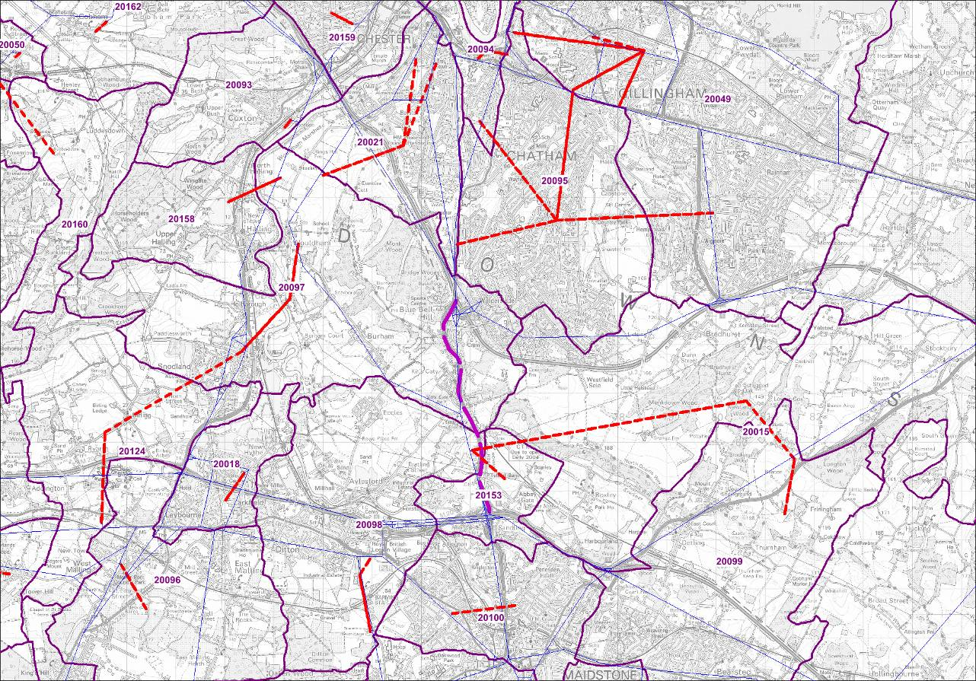
Figure 4.4: Centroid connector (red) loading in the vicinity of the proposed M2-M20 Link

  - Time Periods
    - WebTAG Unit 3.19C §2.5.1 states that, at a minimum, three time periods should be modelled in the highway assignment model: the morning peak, evening peak and the interpeak period.
    - For the M25 Model, the interpeak period has been modelled as the average interpeak hour (average 10:00-16:00), which is in accordance with WebTAG 3.19C §2.5.3. The morning peak and evening peak hour model are peak hour models (08:00-09:00 and 17:00-18:00 respectively), as recommended in §2.5.5.
    - It is unclear whether or not the peak hours modelled for the AM and PM have been derived through the use of ATC data as suggested in Section 2.5.2 of WebTAG 3.19C, although generally accepted standard definitions of the peak hours have been used. Analysis of some TRADS data in the vicinity of the A282 Dartford Crossing has been undertaken to understand when the morning and evening peak hours fall, these are presented in Table 4.1 for each of the three hours of the morning and evening peak periods.

Table 4.1: Traffic count data across the peak periods in the vicinity of A282 Dartford Crossing
Site Location | Dir. | 07:00-08:00 | 08:00-09:00 | 09:00-10:00 | 16:00-17:00 | 17:00-18:00 | 18:00-19:00
A282, Junction 1b Onslip | ACW | 506 | 434 | 402 | 737 | 639 | 397
M25, Junction 29 – 30 | CW | 4,107 | 3,772 | 4,106 | 4,029 | 3,976 | 3,568
M25, Junction 30 – 29 | ACW | 3,901 | 3,625 | 3,393 | 4,784 | 4,704 | 4,110
A2, Tollgate nr Singlewell | WB | 4,235 | 4,120 | 3,921 | 3,618 | 3,634 | 2,963
A13, NW of Sandy Lane Wennington | WB | 1,239 | 1,063 | 691 | 965 | 1,071 | 811
A13, NW of Sandy Lane Wennington | EB | 783 | 858 | 781 | 1,065 | 1,183 | 1,157
M20 eastbound between J5 and J6 | EB | 2,309 | 2,512 | 2,153 | 3,466 | 3,702 | 3,217
M20 westbound between J6 and J5 | WB | 2,994 | 2,902 | 2,582 | 2,715 | 2,737 | 2,242

    - Table 4.1 demonstrates that traffic levels are broadly similar across the current morning pre-peak and peak hours. It is noted that there appears to be a reduction in traffic on the M25 in the 08:00-09:00 hour compared with the two peak shoulder hours – this could be due to traffic queuing prior to the crossing and thus leading to reduced traffic flows through the M25 in the peak hour. The evening peak demonstrates more traffic across all sites in the 17:00-18:00 hour, although traffic levels are similar overall between the pre-peak and the peak hour. Overall, the analysis appears to demonstrate that the currently represented peak hours of 08:00-09:00 and 17:00-18:00 are sufficient for analyses and appraisal purposes.
    - Overall, the time periods that have been modelled appear to be acceptable and in-line with DfT guidelines and should be acceptable for the purposes of the assessment of the crossing options. It is unlikely that there is a need to expressly model the off-peak or weekend time periods, as the use of annualisation factors during the appraisal process, as per WebTAG Unit 3.5.3, should prove appropriate.
    - We note that the M25 Model does not use the SATURN 'PASSQ' process to represent the build up of traffic and queues before the modelled (peak) hour. The effect of this is unclear as the model is calibrated, based on its processes to reproduce the observed pattern of traffic and delay. We would consider it desirable to represent queuing using this function, particularly for urban modelling. However given the work undertaken to date to calibrate the model, we have concerns that there would be significant risks in terms of cost and timescale of changing the model operation in this respect. We would also note that our assessment of impacts for the strategy level analysis required will be focused on the strategic rather than urban network. Furthermore there would be a significant increase in model run times. We have concluded, therefore, that, while desirable, we should not seek to enhance the M25 Model in this respect.

  - User Classes
    - The B602 version of the M25 Model has six separate user classes, to represent the varying operating costs and values of time by trip purposes and income group. This ensures that routeing through the highway network is based on differing distance coefficients by vehicle and user type. The user classes within the M25 Model are as follows:
- car business;
- car other (non-work) low value of time;
- car other (non-work) medium value of time;
- car other (non-work) high value of time;
- LGV; and
- HGV.

  - Generalised Costs
    - The generalised cost coefficients used within the M25 Model have been based on DfT guidance as set out in WebTAG 3.5.6. There will be probably be a need to update the value of time and operating cost assumptions due to change in guidance, with WebTAG tending to be updated during April of each year, although we note that the 2012 update will be later than anticipated.
    - The latest LMVR available to us states that in deriving the value of time for HGVs an adjustment was made in order to reflect the operators’ value of time as opposed to the drivers’ value of time. The adjustment factor of 2.303 that has been derived is the ration of operators’ and drivers’ value of time as quoted in ‘Advice on Modelling of Congestion Charging or Tolling Options for Multi-Modal Studies’ (DfT, 2002). This is something that AECOM favours and is now substantiated in WebTAG 3.19C §2.8.8, that states that the appropriate factor to use should be around twice the standard WebTAG 3.5.6 values.
    - The same LMVR also states that a further adjustment has been made to HGV generalised costs, in respect to the distance-based coefficient. In the highway assignment model, the distance coefficient has been set to equal that of ‘car other’ user classes in order to ensure that HGVs route on Motorways and A-roads in preference to lower quality routes, the reason being that the high vehicle operating costs associated with HGVs results in a high distance-based generalised cost coefficient leading to the use of shorter, slower routes (such as B-roads) as opposed to longer but faster routes (such as motorways). This method is not reflected nor acknowledged in WebTAG guidance – it would be prudent to undertake a sensitivity test during any model enhancement to assess the level of impact that this change to the distance coefficient is having within the assignment.
    - We note that WebTAG 3.19C §2.9.14 expresses a preference for separate speed/flow curves for light and heavy vehicles. An approximation of this is represented in the existing M25 Model, with HGV speeds limited to 90kph. We intend to retain this methodology.
    - It is noted that generalised costs are currently presented within the model as ratios of pence per minute (ppm) and pence per kilometre (ppk), as opposed to absolute values. This will need to be changed in light of the proposed tolling methodology (see Chapter 7) to reflect absolute values, which will then enable actual matrices of toll charges to be skimmed from the highway assignment (not currently possible).

  - Conclusions and Recommendations
    - Overall, the M25 Model provides a sound basis that can be enhanced in order to ensure that it is suitable for assessing the impacts of proposed capacity enhancement schemes in the Lower Thames area. The broad network coverage and extent of the simulation network is good, with all major routes covered.
    - Some of the arterial routes within the Area of Detailed Modelling, including the A13, M2 and M20, have been simplified in some cases and are not representative of actual junction layouts, capacities or operations. Enhancement of these routes should be undertaken using a mixture of the Medway Traffic Model from which to extract coding for the M2 and by undertaking new coding ourselves for the A13 and M20 where no suitable models exist that we are aware of. Dummy node use on the strategic road network should also be reviewed and, where not appropriate, recoded using the same methodology.
    - Centroid connector usage and loading in Medway and Maidstone should be reviewed following network enhancements and zonal disaggregation. Some of the connectivity here is not sufficient to meet WebTAG 3.19C requirements and may lead to unrealistic routeing around the proposed capacity enhancement schemes, particularly Option C and the M2-M20 Link variant.
    - Generalised costs within the model will need to be updated in order to reflect the latest WebTAG 3.5.6 guidance, although the methods used in their formation appear to be appropriate. It is proposed that the 2.303 factor applied to HGV values of time in order to reflect the operators’ values of time; however, a sensitivity test will be required on the current usage of ‘car other’ distance coefficients for HGVs in order to assess the impact that this is having, as this is a move away from DfT guidance. The generalised cost parameter values used within the highway assignment model will need to be revised to absolute values, reflecting the toll modelling methodology proposed later in this report.

  - Introduction
- M25 Highway Model Performance
    - This chapter of the report summarises our analyses of the performance of the existing M25 Model. Whilst the previous chapter focused solely on the network development and structure, this chapter considers the result of assignments on those networks. This analysis reviews the goodness of fit of the modelled flows with observed data and the responsiveness of the model, both through network coding and assignment parameters.
    - In comparing modelled traffic flows with observed counts, validation of the model has been assessed to the criteria presented in WebTAG 3.19C. Where routeing and path checks have been made, subjective analysis of the paths has been undertaken to ascertain whether the model is behaving logically and as expected.

  - Existing Model Calibration / Validation
    - We have been provided with spreadsheets detailing the results of the original calibration undertaken for the existing B602 2004 base-year model. These help to give an overview of the model performance in general and also the performance of the model in the vicinity of the Dartford Crossing. We have not been presented with any calibration information concerning journey times and our review is therefore limited in this respect.
    - Individual link flow validation results for the three time periods are presented in Table 5.1. This table has been summarised based on data contained within the model LMVR and the calibration spreadsheets. Performance is provided both in terms of GEH values and the DMRB % flow difference criteria. These data are presented as the results across all links within the model, including those that are used in the calibration process.

Table 5.1: Summary calibration statistics – M25 B602 model
Time Period | GEH <5.0 | DMRB
AM Peak | 81% | 83%
Interpeak | 87% | 88%
PM Peak | 82% | 83%

    - The overall results show a reasonable level of model calibration for the existing model as it stands, at a strategic level. WebTAG 3.19C states that 85% of all modelled links in the calibration process should meet the two criteria, being either a GEH value of less than 5.0 or meeting the flow difference ‘DMRB’ criteria. The M25 Model performs reasonably well, meeting both criteria in the interpeak and only just failing to meet the criteria in the morning and evening peak. Overall, the morning peak hour shows the worst calibration of the three modelled time periods. Further, more detailed analysis of individual link flow validation in the Lower Thames area is presented in the independent validation analyses later on in this chapter.
    - The calibration spreadsheet can also be used to focus on specific areas of the model; the calibration counts have been divided into a set of cordons and screenlines. By analysing the data at this lower level, we can understand how the model performs locally, in relevance to the Lower Thames area. Those areas directly within the vicinity of the Lower Thames area as reported in the calibration/validation spreadsheets have been identified as follows:
- Screenline 10: A13 / A127, between central London and the A130 near Benfleet; and
- Screenline 11: M20, from south London, Orpington and onwards to the A228.
    - Calibration results for the sub-areas are presented in Table 5.2 for the screenline summaries.

Table 5.2: Screenline summary calibration, all time periods
M25 Section | Direction | Number of Links | Observed Flow | Model Flow | % Diff | Within 5%?
AM Peak
Screenline 10 | Clockwise | 20 | 16,698 | 16,626 | -0.4 | 
Screenline 10 | Anti-Clockwise | 20 | 15,495 | 14,817 | -4.4 | 
Screenline 10 | Both Direction | 40 | 32,193 | 31,442 | -2.3 | 
Screenline 11 | Clockwise | 7 | 9,855 | 9,429 | -4.3 | 
Screenline 11 | Anti-Clockwise | 7 | 10,269 | 9,685 | -5.7 | ❒
Screenline 11 | Both Direction | 14 | 20,124 | 19,113 | -5.0 | ❒
Interpeak
Screenline 10 | Clockwise | 20 | 14,196 | 13,899 | -2.1 | 
Screenline 10 | Anti-Clockwise | 20 | 13,937 | 13,210 | -5.2 | ❒
Screenline 10 | Both Direction | 40 | 28,133 | 27,109 | -3.6 | 
Screenline 11 | Clockwise | 7 | 8,115 | 8,049 | -0.8 | 
Screenline 11 | Anti-Clockwise | 7 | 8,472 | 8,397 | -0.9 | 
Screenline 11 | Both Direction | 14 | 16,587 | 16,446 | -0.9 | 
PM Peak
Screenline 10 | Clockwise | 20 | 16,475 | 16,308 | -1.0 | 
Screenline 10 | Anti-Clockwise | 20 | 16,005 | 15,278 | -4.5 | 
Screenline 10 | Both Direction | 40 | 32,480 | 31,586 | -2.8 | 
Screenline 11 | Clockwise | 7 | 9,807 | 9,588 | -2.2 | 
Screenline 11 | Anti-Clockwise | 7 | 10,206 | 9,744 | -4.5 | 
Screenline 11 | Both Direction | 14 | 20,013 | 19,332 | -3.4 | 

    - For screenlines 10 and 11 which represent the A13/A127 and the M20 respectively, the calibration tends to be reasonable. In the morning peak, only the anti-clockwise (westbound) movements fail to meet the flow criteria, being just outside of the 5% threshold. The interpeak displays similarly good overall calibration, with only the anti-clockwise movements on screenline 10 failing to meet the requirement being just 0.2% outside of the tolerance threshold. In the evening peak, all directions of the screenlines are represented to be within 5% of observed flows demonstrating a good level of calibration.
    - The individual link flow results presented above provide some confidence that, across the whole model, routeing is likely to be reasonable given the compliance of the model against the WebTAG acceptability criteria. Screenline results in the Lower Thames area show that overall, the model performs well against the WebTAG criteria for screenlines in all time periods, suggesting that the matrices are of sufficient quality. With enhancement and refinement of both the network and the zoning in the Lower Thames area as previously discussed, it should be possible to achieve a better calibrated model within the area.

  - Paths and Routeing
    - Logic checks have been undertaken on the existing M25 Model network in order to ensure that the model is coded in such a way that traffic routeing is likely to be logical. In order to assess this, a number of ‘trees’ have been assessed graphically within the model.
    - The term ‘tree’ refers to the set of routes from one zone (origin) to another (destination) within the highway network. By analysing trees to assess whether or not the model appears to be calculating what are expected to be the lowest cost routes between zones, we can have confidence in the network coding and (to some extent) performance as a whole. This does not discount the fact that individual network coding issues may still be within the model, however, and these will need to be assessed on a case-by-case basis.
    - Figure 5.1 to Figure 5.3 present a number of plots showing the calculated trees between various zones north of the M25 (St Albans, Stevenage and Harlow) to Gatwick, south of the M25. These plots demonstrate the sensitivity of traffic routeing either anti-clockwise (via Heathrow) or clockwise (via the Dartford Crossing) round the M25. Obviously routeing via the A282 Dartford Crossing incurs a toll fee as part of the overall cost. Overall, the paths demonstrated by the model appear to be logical, suggesting that the sensitivity of the M25 coding and the toll as coded in the model are plausible.

Figure 5.1: St Albans to Gatwick
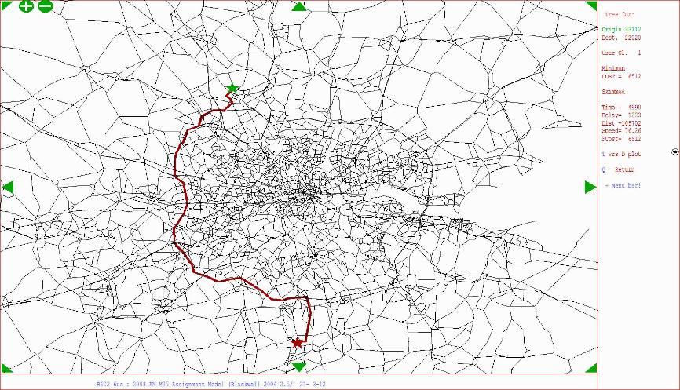
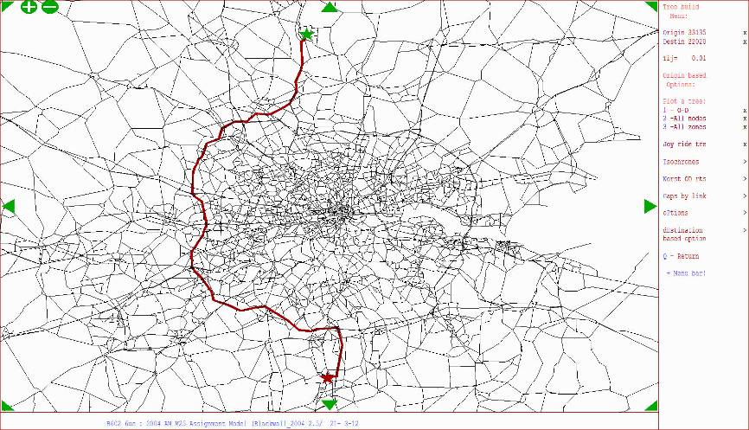

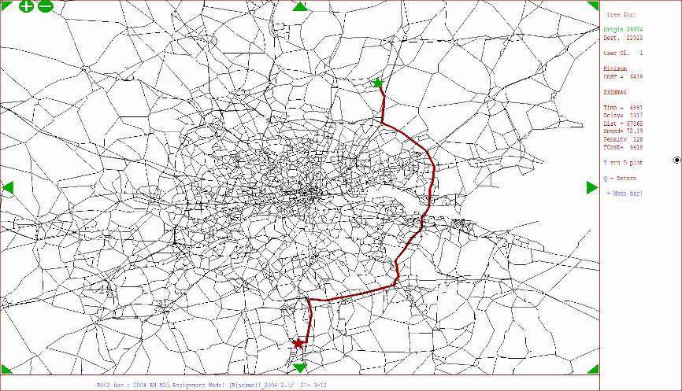
Figure 5.2: Harlow to Gatwick

Figure 5.3: Stevenage to Gatwick

    - Figure 5.4 to Figure 5.7 presents a number of plots showing the calculated trees between various zones north and south of the existing A282 Dartford Crossing and the two nearest other river crossings that are included within the model, namely the Woolwich Ferry and the Blackwall Tunnel. These plots demonstrate the sensitivity of traffic routeing via each of these river crossings (the only one of which that is tolled being the A282) and the minimum-cost paths associated with these movements.
    - The plots demonstrate reasonable minimum cost routes within the model for the movements that have been selected. For those trips whereby the trip end is close to the Blackwall Tunnel (i.e. the routes from Stratford) then the un-tolled route via the A102 Blackwall Tunnel is shown to have the lowest cost. For those movements whereby the trip-end is either to the east of the M25 or between the Blackwall Tunnel and the A282 Dartford Crossing, then the A282 seems to provide the lowest cost option for travel, possibly associated with the dense junction coding and congestion within London.
    - For the Beckton to Charlton plot (Figure 5.7), both of the selected zone trip ends are closer to the Woolwich Ferry than to the Blackwall Tunnel, yet the minimum cost route is the longer distance trip via the A102 at Blackwall instead. This is reflective of the low capacity of the ferry route and the wait times and slow speeds involved with making this movement within the M25 Model. As such, the ‘tree’ for this movement appears to be plausible; further information on trip distributions for the Woolwich Ferry is provided later on in this report.

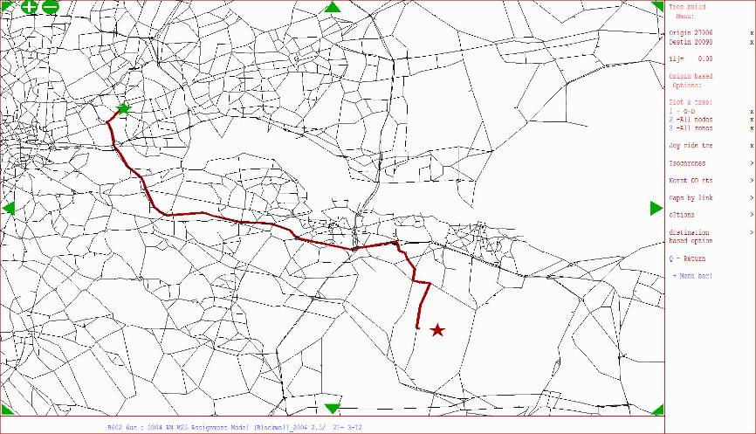
Figure 5.4: Stratford to Longfield

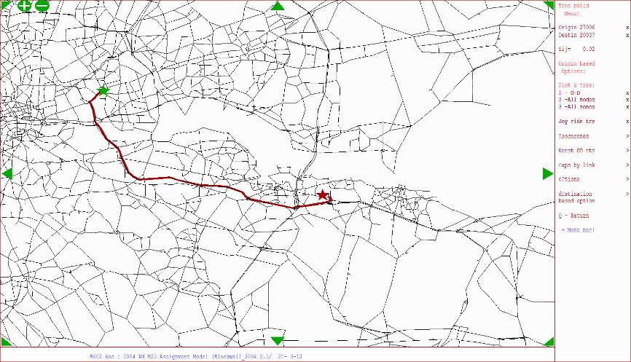
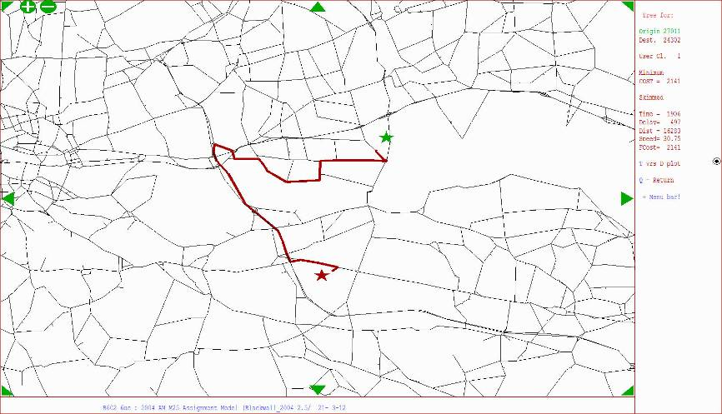
Figure 5.5: Stratford to Bluewater

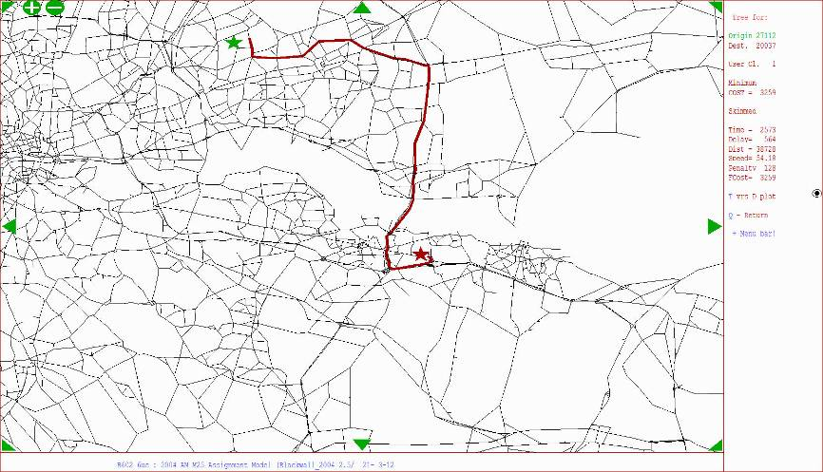
Figure 5.6: Hainault to Bluewater

Figure 5.7: Beckton to Charlton/Woolwich

  - River Crossing Select Links
    - Figure 5.8 to Figure 5.10 demonstrate the distributions of trips making use of the A282 Dartford Crossing and the more westerly river crossings of the Woolwich Ferry and the A102 Blackwall Tunnel. These plots identify the distribution of traffic in both directions for the morning peak hour.
    - Whilst we have no observed trip distribution information to compare the select links with, the overall distributions – both when assessed individually and in comparison with each other appear to be sensible. It is demonstrated that the A282 Dartford Crossing has the greatest catchment area, with traffic from across both the East of England and the South East regions making use of the crossing. Blackwall Tunnel, meanwhile, demonstrates much less of a regional catchment area, primarily servicing movements to/from north and east London and northern Kent; this appears to be sensible as most traffic movements entering the central London area are unlikely to do so as through trips. Woolwich Ferry shows even more localised trip-catchment, primarily servicing only those movements making short distance crossings of the river between Beckton and Greenwich/Woolwich, with only a few medium-distance trips; this is a reflection of the low service frequencies and slow journey times of the ferry that make the crossing unattractive and higher cost to the majority of traffic wishing to traverse the river.

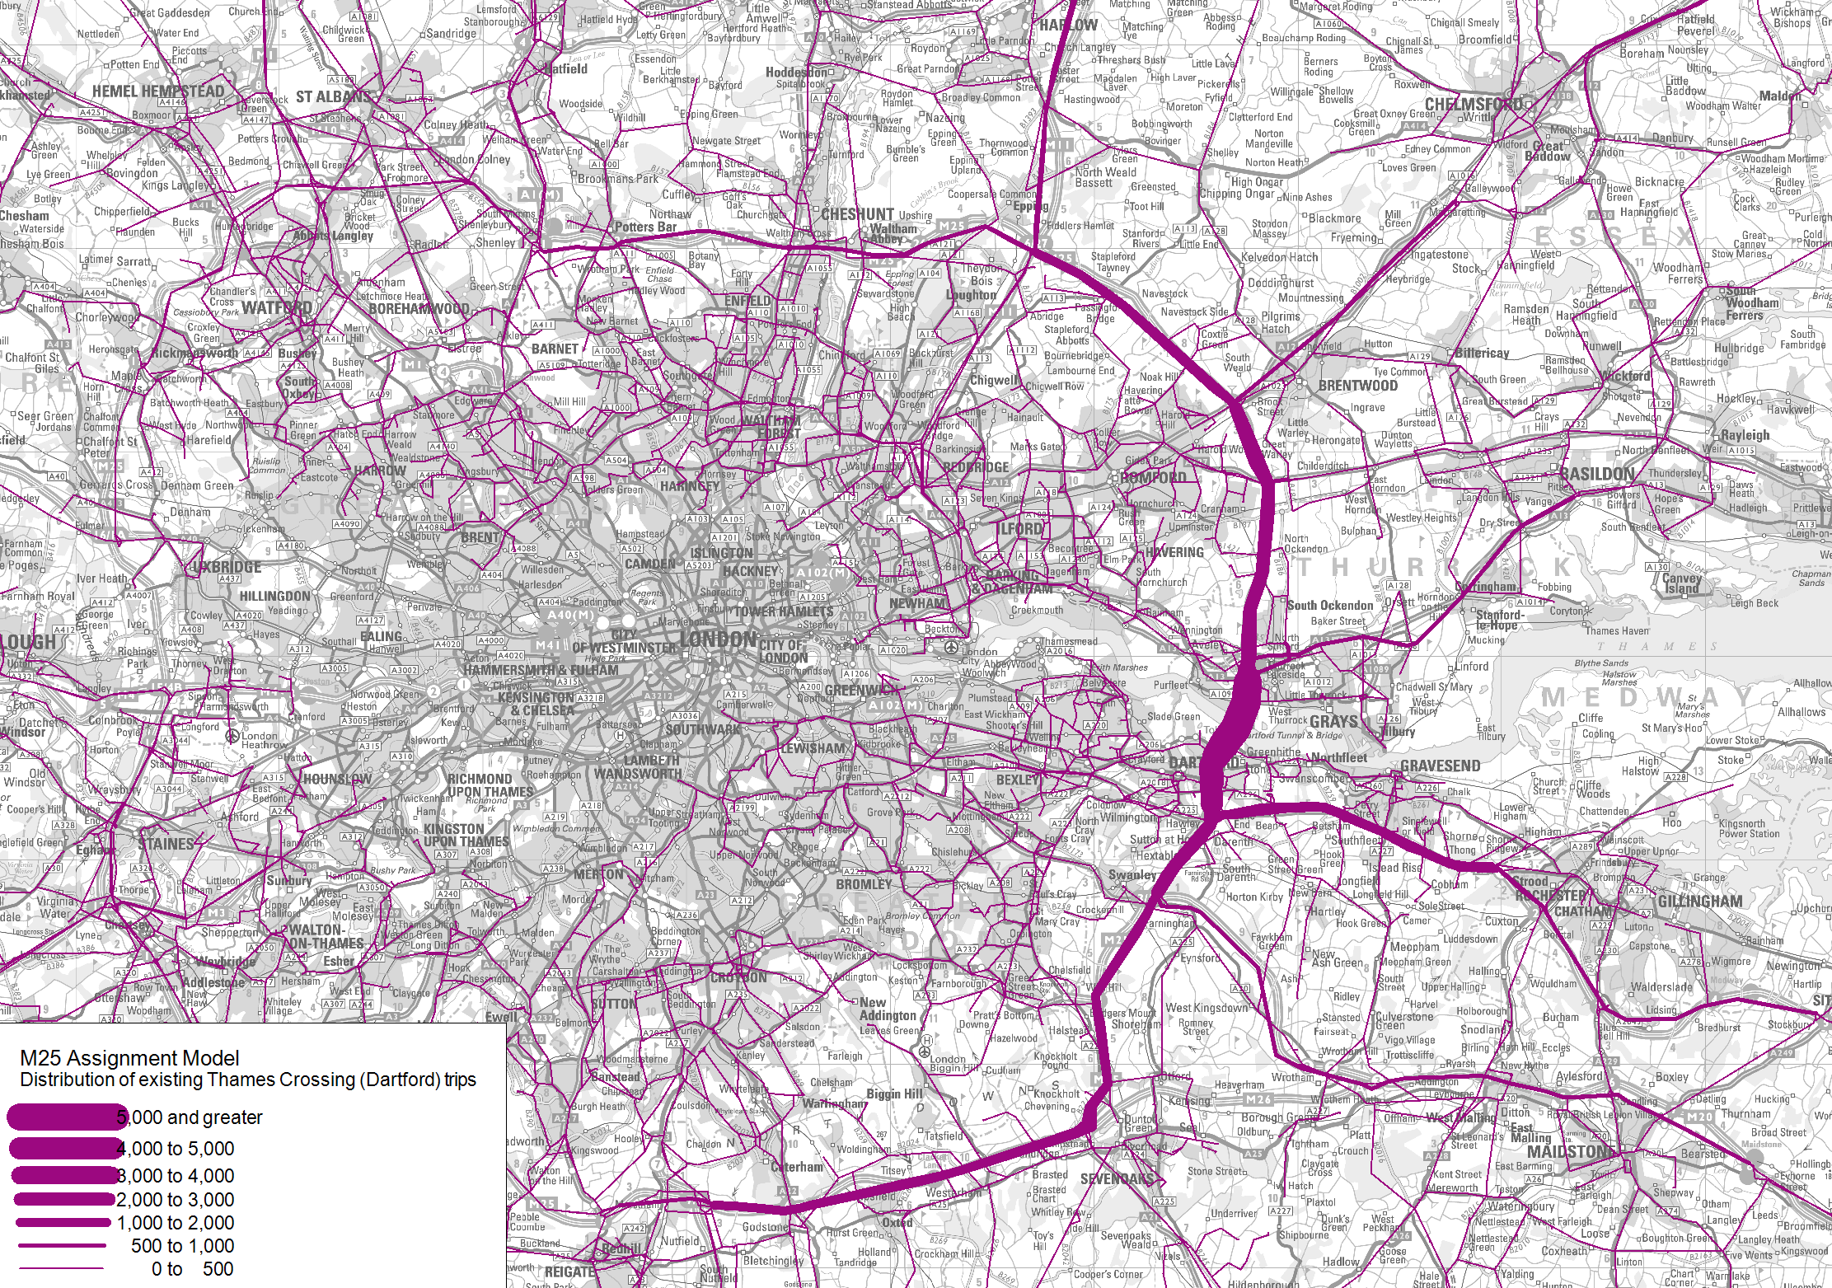
Figure 5.8: A282 Dartford Crossing SLA (2-way)

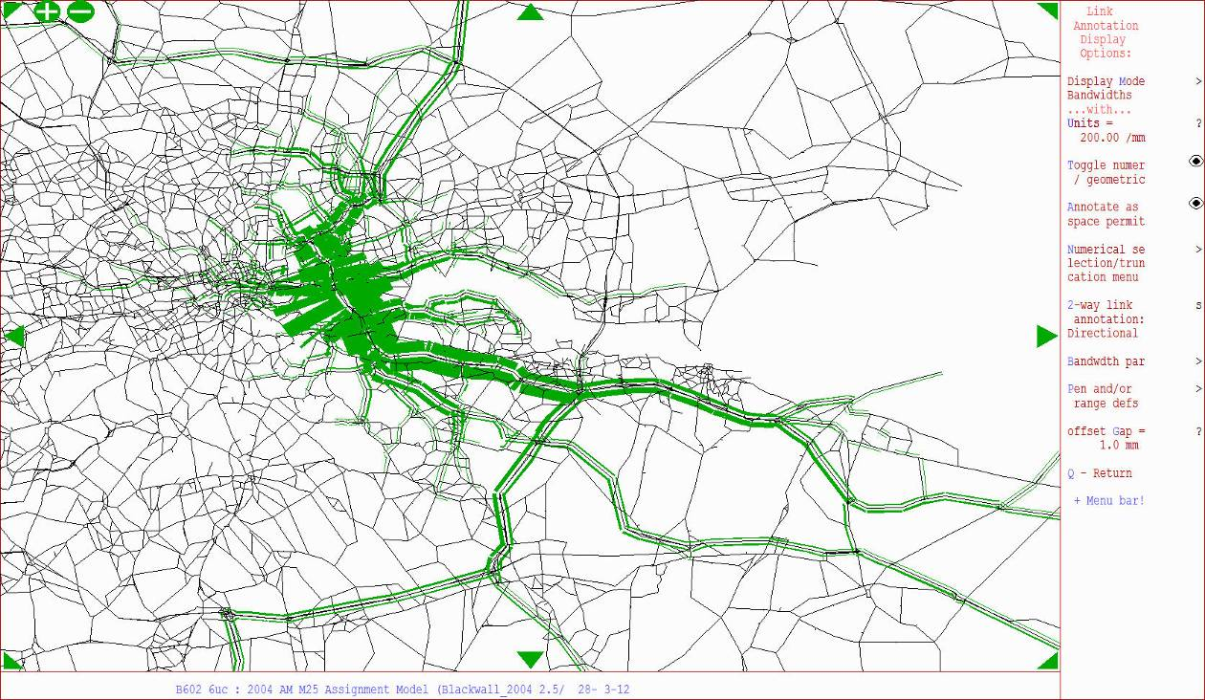
Figure 5.9: A102 Blackwall Tunnel SLA (2-way)

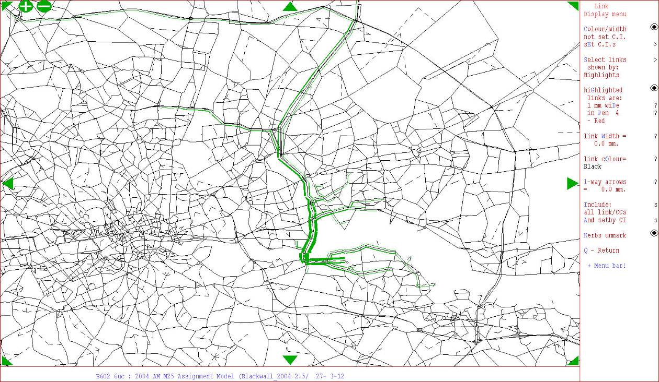
Figure 5.10: Woolwich Ferry SLA (2-way)

  - 2004 Independent Validation Check
    - To assess the quality of the coded network and its assignment, the performance of the individual links within the area of interest has been examined. This involved obtaining observed counts from the Highway Agency’s Traffic Database (TRADS) and comparing these against modelled traffic flows on a link by link basis. To correspond with the existing calibrated base-year model matrices, the data was extracted for the average Monday to Friday weekday in October 2004. AECOM has reviewed the link flow validation against the criteria and acceptability guidelines set out in WebTAG 3.19C §3.2.8.
    - Figure 5.11 to Figure 5.13 show a graphical representation of the 2004 link flow validation performance area of interest and illustrate the options for new crossings to provide context. The highway network is presented as thin blue lines, whilst green, yellow and red lines indicate GEH values of less than 5; between 5 and 10; and over 10 respectively. Tables demonstrating the validation statistics against WebTAG 3.19C acceptability criteria are also included, with Table 5.3, Table 5.4 and Table 5.5 presenting results for the AM peak, interpeak and PM peak respectively.
    - Overall the validation of the 47 sites within the area of interest is relatively poor. Only 47%, 51% and 40% of the links in the AM peak, Interpeak, and PM peak respectively are within the GEH threshold value of 5.
    - Closer analysis of the validation of individual links shows that for each time period, the area of the network north of the possible intersection between the M25 and Option C exhibits mixed validation, showing reasonably good validation in the AM peak and poorer validation in the IP and PM. South of this, the A13 also demonstrates a varied performance between the time periods, with the eastbound flow generally performing better. Most sites within this area that fail to meet the acceptability criteria are due to the M25 Model understating traffic flows. Modelled flows along the A1089 ‘Dock Approach Rd’ are consistently lower than the observed flow for each time period, with GEH values amongst the worst of all links analysed; this is particularly of note given the connectivity of capacity enhance scheme Option B, which connects at the southern end of this route.
    - Only limited observed data exists within TRADS between Junction 30 of the M25 and the Dartford Crossing. From the one site available, the validation is only within the GEH value threshold in the PM peak hour. A similar situation can be seen south of the crossing, between the crossing and M25 Junction 2, where only the slip roads off the A282 are available. Again these show poor validation results in each of the three modelled time periods.
    - The M25’s intersection with the A20 at junction 3 has a poor level of validation, in particular on the main A20 carriageway. Here the modelled flow is more than double the observed in each time period, with GEH values of greater than 20 in each period.
    - The A2 generally has a better level of validation than other sections in the model. However once the road changes into the M2 just east of Chatham, the validation does not meet the acceptability criteria in any of the three modelled time periods.
    - The validation of westbound flows perform relatively well on the M20, south of the Option C variant, in the westbound direction, although it is noted that there is an underestimation of traffic volumes in the eastbound direction within the model, with validation falling short of the acceptability guidelines.
    - Overall the count validation of the model in the area of interest does not meet the acceptability guidelines set out in WebTAG 3.19C §3.2.5. Modelled flows are generally lower than the observed counts; in some cases, particularly with regard to the M20, this understatement by the model can be significant. The independent validation also demonstrates that the A2 calibration tends to be good closer to the M25, but that this deteriorates farther east once the A2 becomes the M2.
Table 5.3: 2004 AM peak, independent validation assessment result
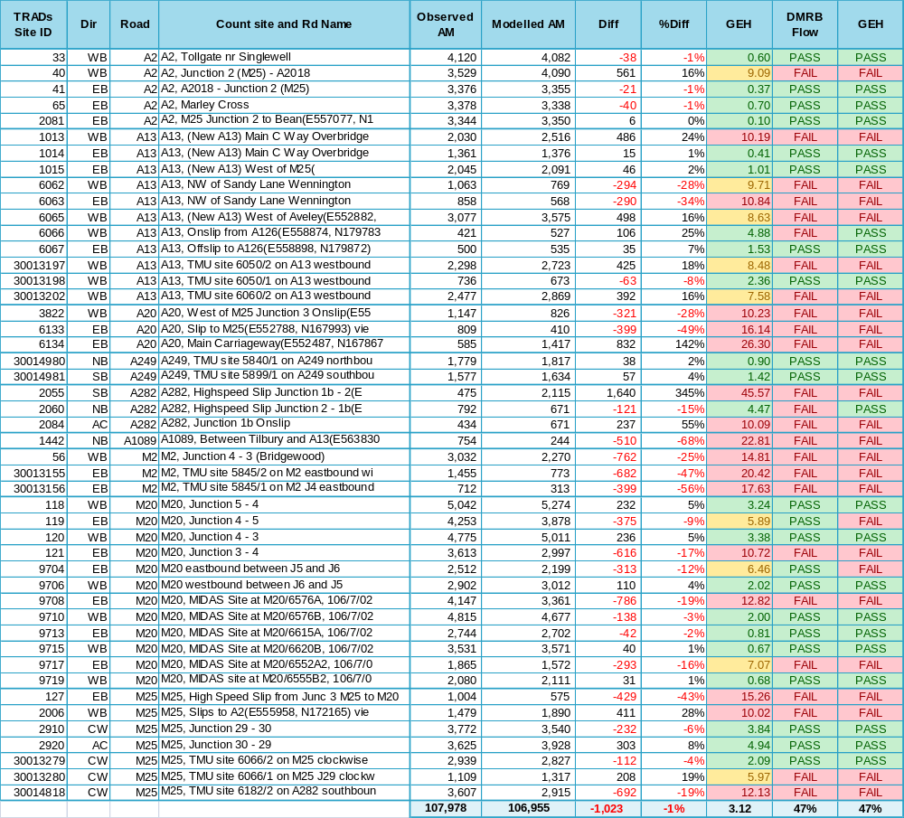
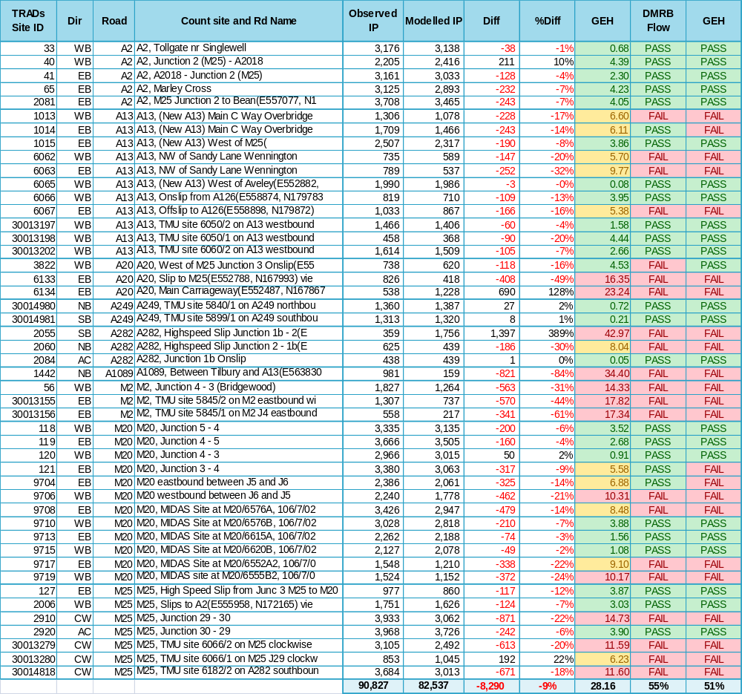
Table 5.4: 2004 interpeak, independent validation assessment results

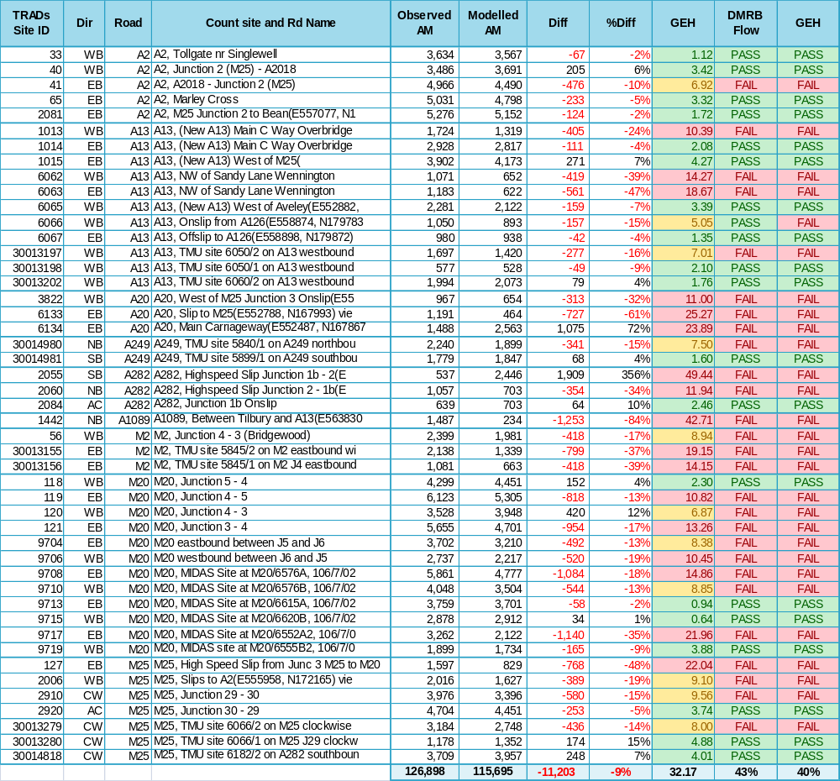
Table 5.5: 2004 PM peak, independent validation assessment results

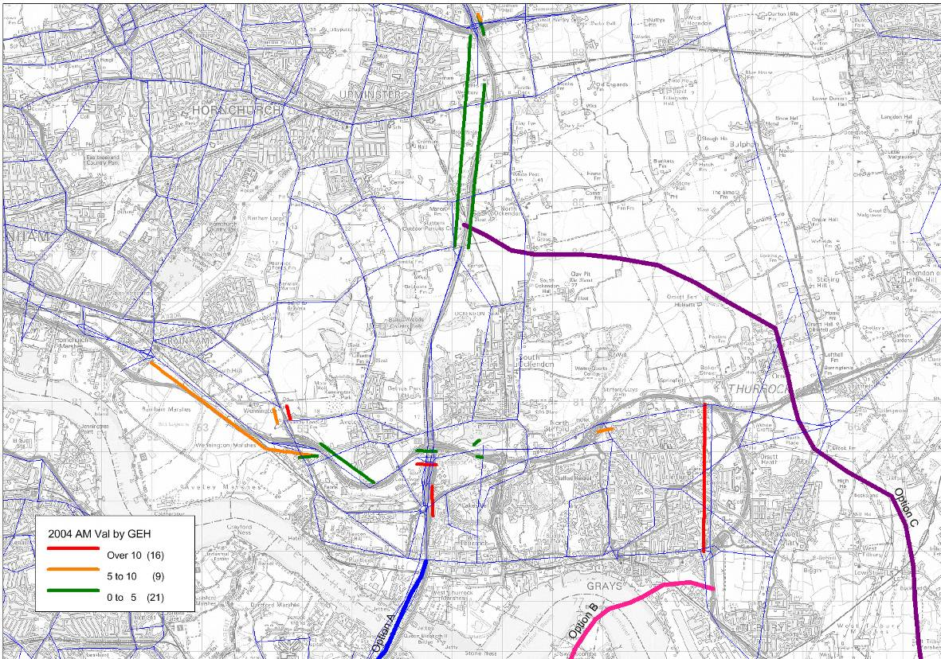
Figure 5.11: 2004, AM peak validation to TRADS, south Essex area

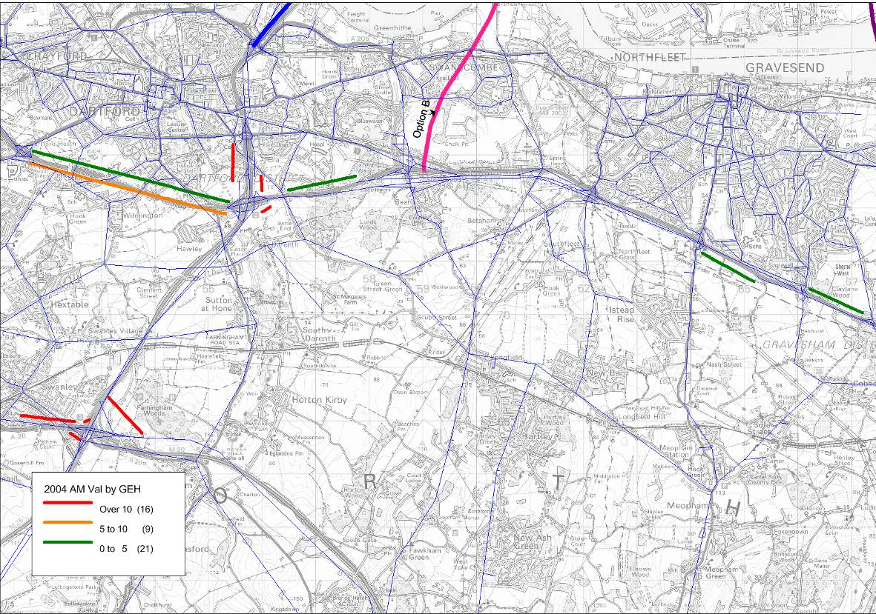
Figure 5.12: 2004, AM peak validation to TRADS, Kent Thameside area

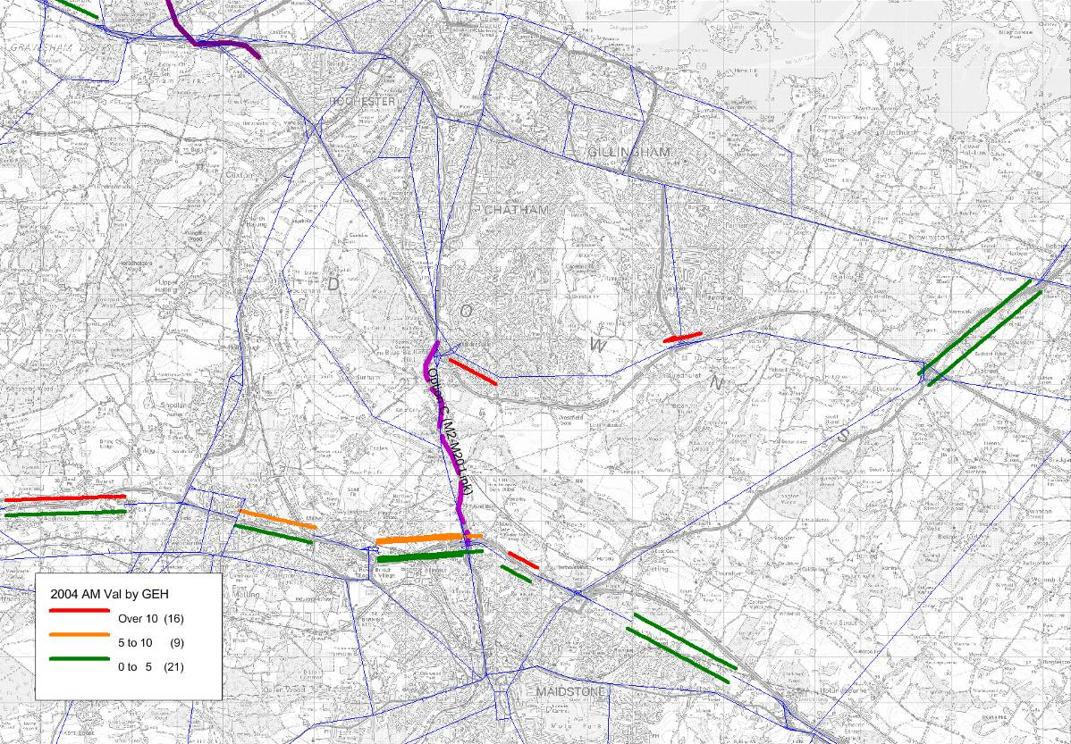
Figure 5.13: 2004, AM peak validation to TRADS, M2-M20 area

    - Journey time validation has also been undertaken across a number of routes in the study area. The observed data were taken from the Highways Agency’s Traffic Information Systems (HATRIS) database for those routes that had data available for October 2004. The routes for which data were available were the M25 (J28 – J5), M20 and A13. Journey times were then extracted from the model for the length of the route; a comparison is presented in Table 5.6.

Table 5.6: Journey time validation, end-to-end routeing
Route | Direction | Observed Time | Modelled Time | Difference | % Difference
AM Peak
M25 (J28 – J5) | Clockwise | 33:57 | 31:17 | -02:40 | -7.9%
M25 (J5 – J28) | Anti-Clockwise | 31:15 | 31:37 | 00:22 | 1.2%
A13 (A1306-A1089) | Eastbound | 07:59 | 06:07 | -01:54 | -23.4%
A13 (A1089-A1306) | Westbound | 10:37 | 06:29 | -04:08 | -39.0%
M20 (J1 – J7) | Eastbound | 19:31 | 18:05 | -01:26 | -7.4%
M20 (J7 – J1) | Westbound | 23:04 | 21:01 | -02:03 | -8.9%
Interpeak
M25 (J28 – J5) | Clockwise | 31:01 | 27:08 | -03:53 | -12.5%
M25 (J5 – J28) | Anti-Clockwise | 31:49 | 30:41 | -01:08 | -3.5%
A13 (A1306-A1089) | Eastbound | 07:58 | 06:07 | -01:51 | -23.3%
A13 (A1089-A1306) | Westbound | 07:17 | 06:04 | -01:13 | -16.7%
M20 (J1 – J7) | Eastbound | 19:12 | 18:08 | -01:04 | -5.6%
M20 (J7 – J1) | Westbound | 19:06 | 18:03 | -01:03 | -5.5%
PM Peak
M25 (J28 – J5) | Clockwise | 37:07 | 35:42 | -01:25 | -3.8%
M25 (J5 – J28) | Anti-Clockwise | 39:01 | 38:31 | -00:30 | -1.3%
A13 (A1306-A1089) | Eastbound | 07:08 | 06:30 | -00:38 | -8.9%
A13 (A1089-A1306) | Westbound | 07:54 | 06:08 | -01:46 | -22.4%
M20 (J1 – J7) | Eastbound | 19:41 | 20:14 | 00:33 | 2.8%
M20 (J7 – J1) | Westbound | 19:31 | 19:03 | -00:28 | -2.4%

    - The above table demonstrates that the M25 Model has a tendency to underestimate journey times on the strategic road network for those routes analysed; this is consistent with the modest under-modelling of traffic volumes on the M25.
    - Across each of the time periods, both the M25 and the M20 sections that have been analysed fall within the 15% acceptability guidelines for journey times as defined within WebTAG 3.19C. The M25 in the anti-clockwise direction in particular exhibits a good level of validation, ranging from within between -3.5%to +2.8% of the observed journey times. The M20 shows good levels of validation in the interpeak and evening peak.
    - Modelled journey times on the A13 generally fail to meet the acceptability guidelines, with the exception being the eastbound direction in the PM peak hour. The corridor in general sees faster journey times within the model when compared with the observed data. This is possibly due to the poor representation of junctions along this route which, in conjunction with the generally lower traffic volumes, may mean that not enough congestion is being forecast by the model.
  - 2009 Independent Validation check
    - AECOM has also conducted an independent validation check on a forecast 2009 model in order to assess the performance of the model at a close forecast year; this test is in part to test the accuracy of the forecasting methodology, although it is noted that given the poor level of link flow validation in the 2004 model in the Lower Thames area, it is unlikely that we will be able to draw any definitive conclusions as to the forecasting process. Again, the average Monday to Friday weekday traffic counts were extracted for October 2009 from the Highway Agency’s TRADS database and compared against modelled traffic flows on a link by link basis where available. The model was analysed using the same method as described above.
    - As the 2009 forecasts are used for this check, and the counts used for the comparison are focussed in the Lower Thames area (which was not the focus of the original M25 Model calibration), it can be expected that there will be more variation in quality at the local level, possibly poor in places.
    - A graphical representation of the area of interest and the various possible options is provided in Figure 5.14 to Figure 5.16. A total of 68 sites were used for this analysis. Overall, the compliance of the model with the acceptability criteria is demonstrated to be 43%, 49% and 38% in the AM peak, Interpeak and PM peak respectively, which is similar to that of the independent 2004 validation. Results are presented in tabular format in Table 5.7 through Table 5.9.
    - Between junctions 29 and 30 of the M25, where capacity enhancement Option C is likely to connect at its northern end, the modelled flows generally meet the acceptability guidelines, as per the 2004 model. One exception to this is in the clockwise direction in the Interpeak period, where modelled flows are underestimated.
    - Unlike the base year model, there is a wide range of observed count data available at junction 30, giving a good indication of the model performance in this area. With the exception of the PM peak hour, the clockwise flow along the M25, at and within junction 30, performs quite poorly. The anti-clockwise flow however appears to meet the criteria in the majority of cases.
    - The A13 performs well in the AM peak hour, with most links meeting the required criteria. However the Interpeak and PM peak models tend to underestimate traffic flow, again as per the 2004 base-model. Also as per the base year model, the A1089, ‘Dock Approach Road’ underestimates traffic flow when compared with the observed data, failing to meet the acceptability criteria in each time period. The underestimation of traffic on the A13 affects both options B and C, which have connectivity with the route (either indirectly via the A1089 in the case of option B, or directly via a new grade-separated junction in the case of option C). As per the 2004 validation, traffic volumes on the A1089 are significantly underestimated by the model; given the connectivity of the Option B scheme, this will need to be addressed through a model re-calibration.
    - Modelled flows along the A2 appear to be overestimated in the eastbound direction in the morning peak hour with westbound flows underestimated by the model; A2 validation is good in the interpeak although mixed in both the AM and PM peaks. The model appears to be underestimating traffic flow in all time periods at the M2 close to Chatham. The possible intersection between the A2 and Option C appears to validate reasonably, only just failing to meet the GEH validation criteria, but meeting the ‘Flow’ acceptability criteria. However, given the issues on the M2 validation, this area of the model will again need to be addressed through a re-calibration exercise.
    - As per the base-year model, traffic flows on the M20 tend to be underestimated within the 2009 model when compared with the observed traffic count data for the eastbound direction. Volumes in the westbound direction are mixed, with some over and some under-estimation by the model.
    - Overall the validation of the forecast model in our area of interest does not match the acceptability guidelines with the 2009 forecast model tending to – as per the 2004 base-year - under estimating traffic across the area.
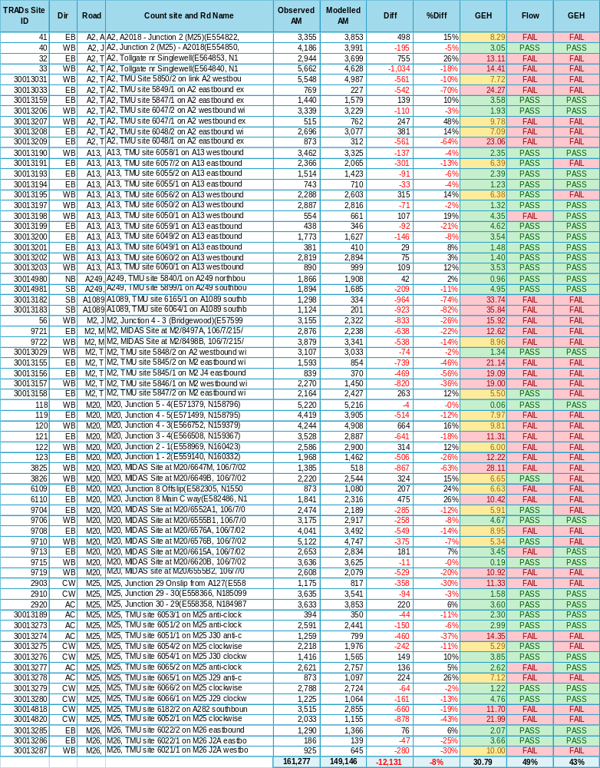
Table 5.7: 2009 AM peak, independent validation assessment results

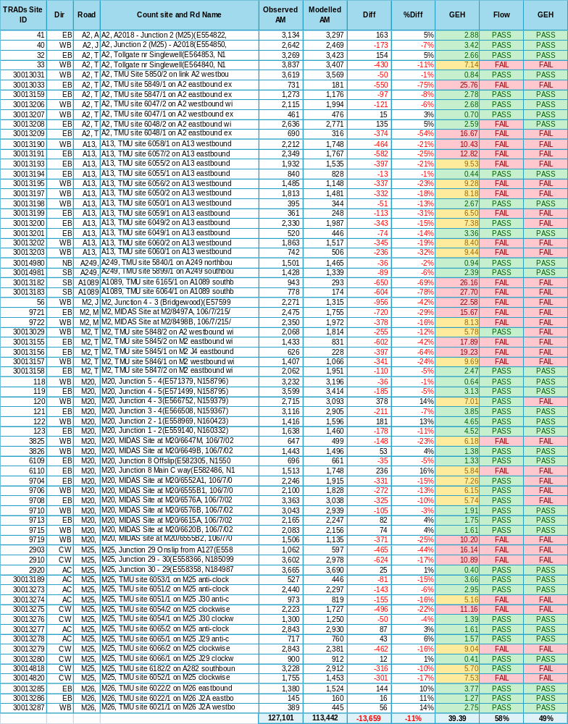
Table 5.8: 2009 interpeak, Independent validation assessment results

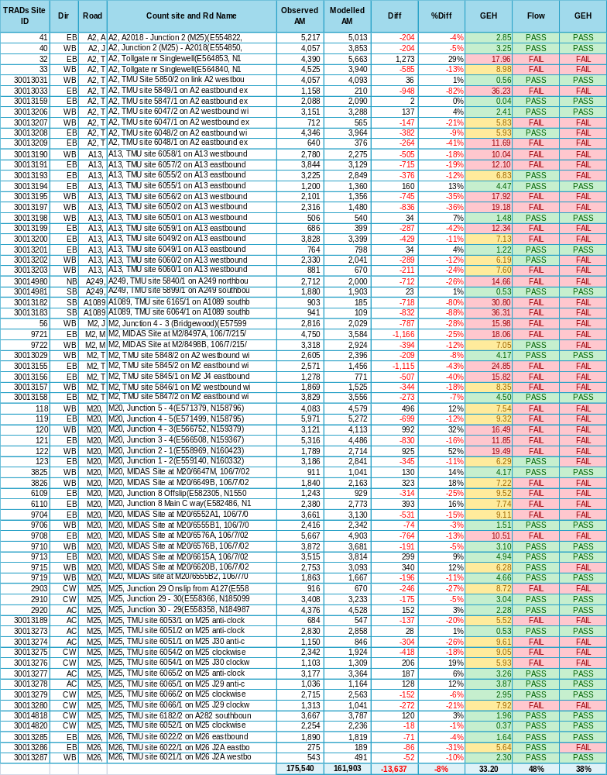
Table 5.9: 2009 PM peak, Independent validation assessment

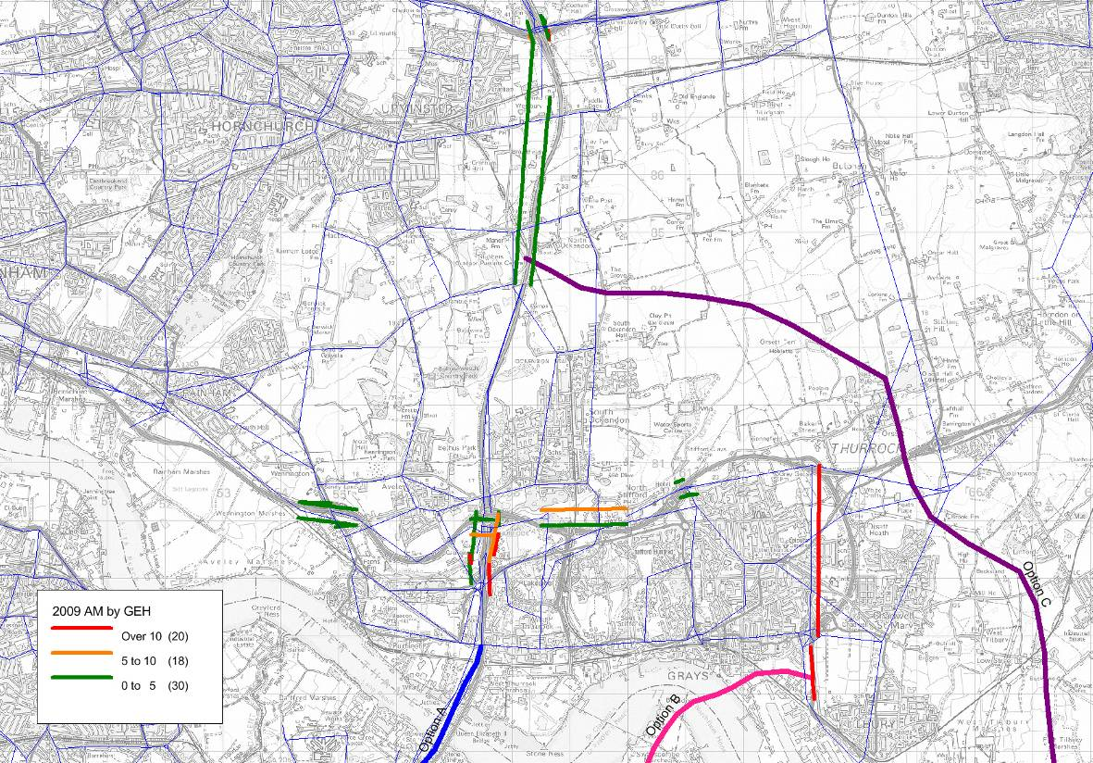
Figure 5.14: 2009, AM peak validation to TRADS, south Essex area

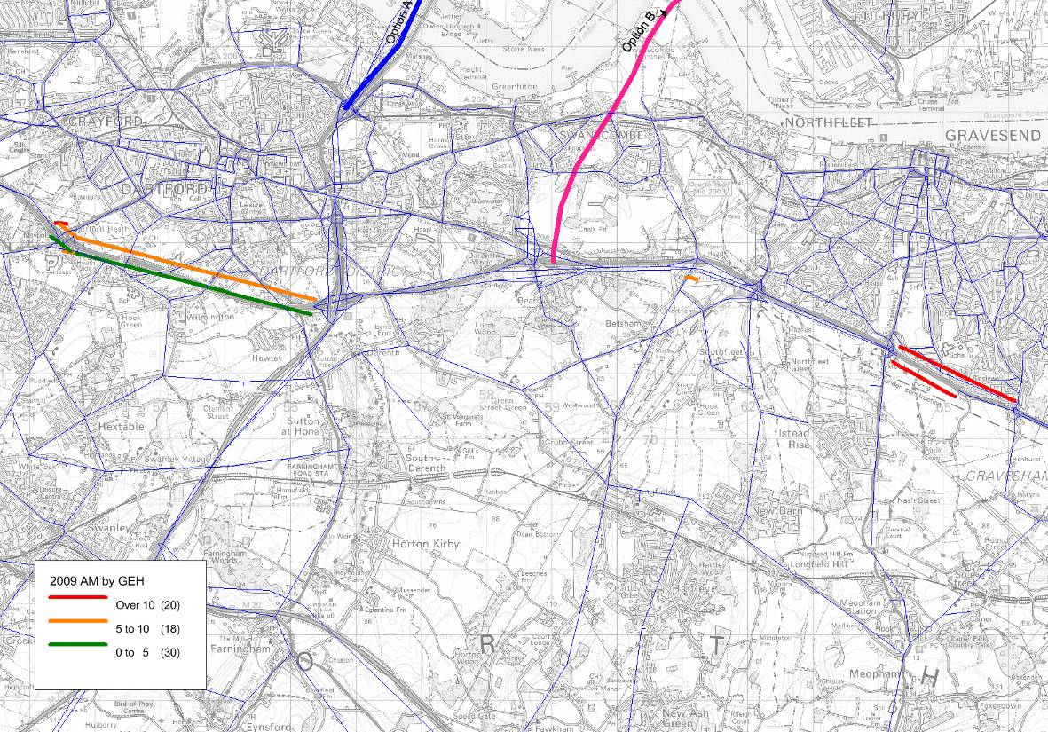
Figure 5.15: 2009, AM peak validation to TRADS, Kent Thameside area

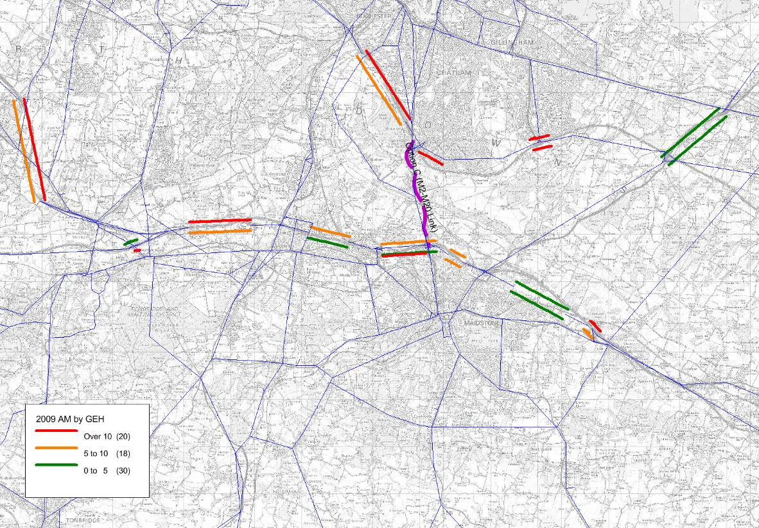
Figure 5.16: 2009, AM peak validation to TRADS, M2-M20 area

  - Conclusions and Recommendations
    - The preceding chapter concluded that the network construction and structure of the M25 Model provides a sound base that can be enhanced. This chapter draws the same conclusions; in that the model performance requires enhancement in order to make a model that is fit for assessing options for additional crossing capacity in the Lower Thames area.
    - The existing M25 Model has been accepted by the Highways Agency for the purpose of strategic M25-based studies. The inference is therefore that the strategic model performance is reasonably good. The focus of this Chapter has been on the performance of the model in the Lower Thames area, where the performance is more varied, with areas of weakness identified.
    - With regards to the network in the Lower Thames area, two forms of assessment have been undertaken: the first looking at information contained within the original model calibration process and the second undertaking some independent validation using 2004 data extracted from the Highways Agency’s TRADS database. With regards to the M25, the sections both north and south of the existing Dartford Crossing show that the model generally under-represents traffic volumes. This is particularly noticeable in the morning and evening peak hours where the majority of sections/directions fail to meet model validation acceptability criteria.
    - Model performance has also been assessed with regards to the routeing that is contained within the model, both analysing minimum-cost paths through the network and through analyses of assignment-level select links at river crossings. Minimum-cost path analyses (trees) have been conducted between zones north of the M25 and Gatwick south of the M25; origin zones selected to the north are those that are likely to be sensitive to routeing either via the A282 Dartford Crossing or the M25 via Staines.
    - Analyses of these paths demonstrate logical results. Trees have also been checked in the vicinity of the Crossing, analysing paths from north-east London to north-west Kent; these demonstrate the network performance in terms of the choice between the A282 Dartford Crossing and the A102 Blackwall Tunnel. Again, the trees produced by the model show logical minimum-cost path routes, suggesting the network coding and setup are reasonable.
    - Assignment level select links conducted on river crossings in the east (A282 Dartford, A102 Blackwall, Woolwich Ferry) demonstrate logical routeing by the assignment algorithm. The A282 is shown to have the largest catchment area for trips primarily servicing movements to/from the East of England, South East and beyond; the A102 Blackwell Tunnel is shown to primarily service movements between north and east London and the South East (Kent), with Woolwich Ferry catering solely to those shorter distance cross river trips in east London. These appear to be reasonable and suggest sensible route choice.
    - In summary, the model is demonstrated to be performing reasonably overall: minimum-cost paths and route-choice across the river appear to be logical, whilst traffic volumes on radial routes in the Lower Thames area compare reasonably well with observed traffic counts. Nevertheless, there are local issues, particularly in the peak hours in the vicinity of the existing A282 Dartford Crossing.
    - These will require, and would reasonably be addressed, by an improved representation of the network and zoning detail in this area, as discussed in the preceding chapter.
.
  - Model History and Overview
- M25 Demand Model
    - The M25 demand model (M25DM) is a logit-based, incremental, hierarchical choice model, developed originally based upon Variable Demand Modelling Advice (VaDMA) published by the Department for Transport. This has since become WebTAG 3.10, and M25DM has been kept reasonably up-to-date with releases of WebTAG 3.10, especially with respect to economic parameters (WebTAG 3.5.6).
    - AECOM developed M25DM for Hyder using EMME software. It is based on a model structure also used in several other AECOM demand models, among them the East of England Regional model (EERM) and the Thames Gateway Demand Model. It uses a production to attraction trip-based representation of demand, that is, tours are not used.
    - The M25 Model is a model with a highway focus. Although it contains a representation of public transport demand, this is quite simplistic: the demand is wholly synthetic, there is no passenger crowding for rail trips or highway congestion for bus trips, and no assignment model or models for public transport.

  - Choice Models
    - M25DM has five choice models, all of them incremental logit-based, applied in the following order:
- Trip frequency, applied only for non-work purposes, which adjusts total demand up or down by production zone and purpose.
- Time period choice, which adjusts proportions of demand allocated to each time period, by production zone and purpose.
- Main mode choice, which adjusts the split of demand by highway and public transport, by time period, production zone and purpose.
- Trip Distribution, which adjusts trip attractions, by mode, time period, production zone and purpose.
- Public transport sub-mode choice, which adjusts the split of public transport demand into rail and bus, by origin-destination movement, time period and purpose. This is relevant only in the construction of composite costs for public transport.
    - Logit-based composite costs are used to transfer cost up the hierarchy.
    - Parameters to control sensitivity are taken largely from WebTAG 3.10.3. The London Transportation Study (LTS) model has been used as a source of trip distribution parameters within London.

  - Segmentation
    - Seven demand segments are used in M25DM:
- Home-based work (commuting);
- Home-based business (in employer’s time);
- Home-based other;
- Non-home-based business;
- Non-home-based other;
- Light Goods Vehicles (LGVs); and
- Heavy Goods Vehicles (HGVs).
    - The five non-freight segments are further divided into car-available and no-car-available demand for public transport. However, the no-car-available demand is not processed by the model, as it is irrelevant to highway travel.
    - There is currently no segmentation by value of time or household income. This will probably need to be addressed before using the model to assess the lower-Thames crossing options; this is discussed further in Chapter 7.
    - The model represents four time periods:
- AM peak period (7am to 10am);
- Interpeak period (10am to 4pm);
- PM peak period (4pm to 7pm); and
- Off-peak period (7pm to 7am).
    - Three of these correspond, via an adjustment to three or six hours, to time periods in the highway assignment model; the off peak period is treated approximately, using the interpeak highway network and demand that is estimated based on survey data from the other periods.
    - These time periods will provide the basis upon which data can be extracted from the model and used for appraisal. To do this, careful consideration of suitable annualisation factors will be required; for the Crossing(s), the HGV annualisation factor will probably differ. This subject is discussed further in the Appraisal Specification Report.

  - Economic Parameters and Generalised Cost
    - M25DM follows the guidance in WebTAG 3.5.6 to derive economic parameters. All parameters in the model are taken from the most recently published live version of 3.5.6. The consultation version of this document with electric vehicles considered has not been used.
    - Generalised cost for highway trips includes trip time, fuel cost, non-fuel cost for business travel, and highway tolls. For public transport trips it includes only fares. Monetary charges applied to highway vehicles, including operating costs and tolls, are assumed to be distributed equally among the vehicle occupants.
    - Values of time, of particular interest to this project, are quoted for 2009 in the table below.
Table 6.1: M25DM values of time, 2009 values, 2002 prices
Vehicle/Person Type | Person Value of Time (p/min)
Car (commuting) | 8.74
Car (leisure) | 7.73
Car (business) | 36.56
Light Goods Vehicles | 13.79
Heavy Goods Vehicles | 33.95

    - Vehicle values of time, used in the highway model (see Section 1.25), are consistent, via average vehicle occupancies, with the demand model values.
    - M25DM includes two mechanisms to “damp” generalised cost changes for long distance trips. This concept is discussed in WebTAG 3.10.2, §1.11. Firstly, total generalised cost is multiplied by a factor derived from the free-flow base year highway distance skim, equal to 1 for trips less than 35km long, decreasing to around 0.25 for trips 500km long. Secondly, values of time are varied around the central values quoted in the table above based on the same distance skim, with values increasing with distance.
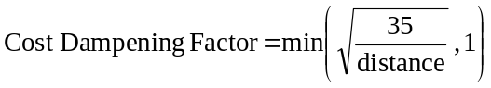
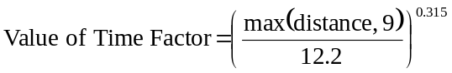
    - The combined effect of these two mechanisms is never sufficient to result in lower costs at higher distance, assuming linear cost-distance relationship, as 0.315+0.5, the powers of distance used, is still less than 1.

  - Internal Supply Model
    - Due to its size, the current version of M25DM does not use the full SATURN model to assign and provide cost skims to the demand model. Runtimes for this SATURN model, at the time of M25DM’s development, were too high to make this practical given the need to run 5-15 demand-supply iterations. Instead it uses a topologically identical network in EMME, which duplicates SATURN link-speed flow curves but uses a considerably more simple method for simulating junctions. The full SATURN model is then used at the end of the model run, when the final demand has been created.
    - This setup is known as a “tiered” model, and is cautiously accepted in WebTAG (3.12.2C §6.1) and WebTAG 3.19C §2.10.18-29.
    - However, more recent developments in SATURN, especially the “SPIDER” parameter, as well as advances in computer processing capability, have significantly reduced runtimes for the M25 SATURN assignment model. Consequently, we intend to embed this directly in the demand-supply structure, abandoning the simplified EMME model.
    - In unifying the M25 Model, we will use the M25AM as validated i.e. a peak hour assignment within the demand model (which strictly requires period hour travel costs). This approximation was made in the existing M25 Model on the grounds that the traffic levels (and hence travel costs) in the model do not vary much throughout the peak periods; this will be maintained.

  - Runtime Optimisation
    - M25 is a large model, currently with 1417 zones. It thus takes considerable time to run, with current runtimes estimated at around 24 hours for a single future year forecast test once the model has been unified. Switching the internal assignment to the full M25AM, given the SPIDER functionality, is likely to increase this only slightly, by around 20%, whilst removing the approximation of the simplified EMME highway assignment model. This increase in runtime is considered to be a worthwhile penalty for the unification of the model into an untiered system.
    - An obvious means of reducing runtimes is to reduce the number of zones in the model (in particular reducing assignment time). The merits of zone aggregation are discussed in Section 1.18.
    - Some savings in runtimes could be achieved by a other methods, such as:
- Optimising the demand model code to avoid existing EMME modules more than necessary (this adds a small overhead). This is expected to reduce the 24 hour runtime by ~20 minutes.
- Adjusting SATURN assignment parameters, such as the method of skimming costs and number of assignment iterations associated with skimming. This would need some experimentation, trading off runtime against accuracy.
- Accepting slightly less rigorous convergence both the highway and demand models for preliminary testing and using the most tightly converged runs only for “final” model runs to be used for economic appraisal or the comparison of closely competing scheme options.
    - It is the last approach that offers most promise. The demand model currently converges to a demand-supply gap (%Gap) of 0.05% which is half that required by WebTAG 3.10. It is therefore the demand model convergence that should be first considered for loosening (loosening highway assignment convergence can be a false economy as demand model convergence suffers as a consequence).
    - Accepting that the demand-supply convergence may be affected by unifying the model structure, some statistics from an existing 2030 M25DM forecasting test provide context. The demand model converged to a %Gap of 0.05 in 19 iterations. The same model would have converged to 0.10% in 9 iterations and 0.15% in 8 iterations. The WebTAG criterion of 0.10% would be a sensible starting point.
    - Any decisions on runtime optimisation will be deferred until we understand the actual runtimes of the enhanced model – the 24 hour estimate is a reasonable cautious estimate. We will test the sensitivity of the economic benefits to model convergence in reaching a conclusion on the most appropriate balance between model convergence and run time.
    - We note that previous users of the existing M25 Model have experienced spurious economic benefits using TUBA, possibly due to the benefits being close to the %Gap (WebTAG 3.10.4 §1.5). Good model convergence will clearly be required, and so for the purposes of appraisal, the models will be allowed to run to full convergence.

  - Calibration and Realism Testing
    - The realism tests required by WebTAG 3.10.4, fuel cost and public transport fare sensitivity, have been carried out for the M25 Model. These will be repeated as part of the development of the new version of the model. The most recent results are quoted in the tables below. They have been calculated only for trips originating in the “internal area”, within and within about 30 km outside of, the M25.
    - The calibration was originally performed by minor adjustments to the cost damping parameters (e.g. the 35km cut-off). The logit sensitivity parameters, taken from WebTAG 3.10.3 and LTS, were not themselves adjusted.
Table 6.2: M25DM vehicle kilometre elasticities to fuel cost, matrix level, internal origins
 | +10% Car Fuel Cost
Segment | AM | IP | PM | OP | 16 hour
HBW | -0.26 | -0.33 | -0.28 | -0.37 | -0.29
HBEB | -0.13 | -0.24 | -0.16 | -0.25 | -0.19
HBO | -0.31 | -0.33 | -0.27 | -0.33 | -0.33
NHBEB | -0.10 | -0.15 | -0.03 | -0.15 | -0.12
NHBO | -0.31 | -0.28 | -0.28 | -0.27 | -0.29
Overall | -0.26 | -0.29 | -0.25 | -0.32 | -0.29

Table 6.3: M25DM public transport trip elasticities to fare, matrix level, internal origins
 | -10% PT Fare Elasticities
Segment | AM | IP | PM | OP | 16 hour
HBW | -0.56 | -0.18 | -0.62 | -0.17 | -0.48
HBEB | -0.19 | -0.10 | -0.20 | -0.10 | -0.16
HBO | -0.69 | -0.54 | -0.56 | -0.56 | -0.58
NHBEB | -0.32 | -0.19 | -0.35 | -0.18 | -0.24
NHBO | -1.05 | -0.60 | -0.60 | -0.60 | -0.64
Overall | -0.59 | -0.43 | -0.59 | -0.35 | -0.52

    - These values satisfy the main WebTAG criteria, namely that the fuel cost elasticity should be between -0.25 and -0.35, and the fare elasticity between -0.2 and -0.9. The breakdown by time period and purpose is generally logical; with business elasticities to fuel cost being perhaps a little higher than expected. We will recalculate these following updates to the model and consider further adjustment of parameters.
    - Car journey time elasticities were also calculated. However, these were produced prior to the most recent version of WebTAG 3.10.4 in which it is made clear that trip elasticities are required here, rather than vehicle kilometre ones, and that the response should be measure without demand-supply feedback (i.e. only for a single demand-supply iteration).
    - We will calculate journey time elasticities as part of the development of the new version of the model following the latest guidance. Based on experience with other models, we are very confident the WebTAG 3.10.4 criteria (negative and not greater in magnitude than 2) will be satisfied without the need for any adjustments to model parameters

  - Conclusions and Recommendations
    - We regard the M25 demand model as generally suitable for the assessment of this work and compliant with WebTAG guidance, provided that the modelling of traveller response to tolls is improved; this is discussed further in Chapter 7.
    - In addition, we intend to embed the full SATURN-based M25AM assignment model in the demand model structure, as the former simplification of using a simpler model without junction simulation is no longer necessary, given advances in hardware technology and SATURN software.
    - We have identified potential ways of optimising model runtimes; a decision on what, if anything, is necessary will be deferred until the runtimes of the revised model are better understood.

  - Introduction
- Freight Modelling
    - Freight demand is generally modelled relatively less robustly than personal travel in conventional general-purpose transport models. The M25 Model is no exception to this rule. Freight demand matrices are constructed using roadside interview data, generally with relatively small sample sizes; freight demand growth over time is applied globally, without reference to location of developments, and freight speeds and routeing are largely derived from car data. The model does contain functionality to encourage heavy goods vehicles to use the motorways and major roads, however.
    - This Chapter discusses ways in which the modelling of goods vehicle traffic might be improved given that LGVs and HGVs comprise about 30% of all vehicles using the existing Dartford-Thurrock Crossing.

  - Background On Freight Movements at the Crossing
    - The national economic importance of road freight movements at the Crossing is high, with around a third of the HGV traffic (Parsons Brinkerhoff, 2009) carrying mainly higher value goods between areas north of the Thames and the continent, via roll-on/roll-off services at the Kent ports and the Channel Tunnel. The majority of this traffic is over long distances to/from the Midlands and North West. Another 40% of the HGV movements through the Crossing are to/from Kent itself, many of which are over shorter distances to North London or South Essex. The remaining crossing movements for HGVs comprise 12% for South London and 8% for the rest of the South of England.
    - The Crossing has increasingly been subject to traffic delays due to congestion and to the associated complexity of the toll operations. These delays do not exhibit the more typical UK pattern of being concentrated in a few peaks but tend to occur across the whole day from 06:00 to 19:00 hours, on all days of the week and in most months of the year (PB, 2009). This implies that there is very limited scope for goods vehicles to re-time their travel so as to avoid this risk of a costly delay due to congestion.
    - PB (2009) presents AADT data from Le Crossing (the then toll operator) since 1964 for all traffic at the Crossing, as well as annual data for 2003-08 for the AADT of HGVs by direction. This indicates that between 2003 and 2008 the proportion of light vehicles has decreased by 9-10% and that of HGVs increased by 11-12%. It is argued there that this change has in part been caused by the capacity restrictions on the total vehicle movements coupled with the growth in HGVs, which have few alternative routeing options, displacing in the busier hours some of the passenger car trips that would otherwise have occurred.

  - Freight Impact Forecasting
    - The key steps required in order to forecast the impacts of the LTC options on freight movements are as follows.
- First, determine the broad magnitudes of each of the main movements of future year freight traffic that may benefit directly from use of the LTC.
- Second, for each main movement, determine what volume would be diverted through the LTC. This requires spatially disaggregated OD matrices of HGV volumes in order to assign the HGV traffic to the road network.
- Third, other road movements that do not use the LTC will be affected indirectly by LTC as a result of changes in the location and scale of road congestion created by road capacity either being freed up or being used up by the traffic diverting through the LTC. This vehicle operating cost impact can be quantified through traffic assignment, with and without the LTC and associated road schemes.
    - The following paragraphs critically examine the existing approach that has been used to analyse the freight impacts of a Lower Thames Crossing (LTC), followed by a discussion of the potential for use of goods vehicle matrices from the Great Britain Freight Model (GBFM) developed by MDS Transmodal. The conclusions and recommendations are summarised at the end of this chapter.

Reports Reviewed
    - The reports by HyderHalcrow JV (HHJV 2010a to 2010e) describing the Lower Thames Crossing Capacity Study that have been reviewed are listed in Table 7.1, along with reports from a number of other recent studies that include the area around the Crossing. For each report there is a brief summary of the extent of their relevance to freight modelling topics, and the more significant aspects related to freight demand analysis and forecasting are discussed further in later Sections.
Table 7.1: Summary of reports for which freight modelling aspects were reviewed
Report | Freight related content
Lower Thames Crossing Capacity Study - HyderHalcrow JV (2010)
Analysis of Impact on Freight | Only provides information regarding the split of benefits between HGVs and non-HGVs for the options that had been tested
Traffic Impact at Dartford Crossing by User Class | Presents information on the impact of the various charge levels by user type (inc. HGV), including the use of the Crossing and trip distribution
Better Use Option Development: Inception Report | Not directly relevant
Option A | Chapters 1-3 provide useful background on the Study  Chapter 9 outlines the traffic models used and the changes introduced into the M25 Assignment Model (version B330).  Chapter 10 outlines the economic appraisal.  Chapter 11 outlines potential model and data enhancements.  Section 12.7 has conclusions on traffic modelling.
Welfare and Revenue Maximising | Lists economic benefit values for freight (TEE) for various options
Dartford River Crossing Study – Parsons Brinkerhoff (2009)
Dartford River Crossing Study into Capacity Requirement | Chapter 4 outlines the use of GBFM for freight  Appendix 4A recommends future modelling enhancements
M25 Model Development
M25 Demand Model, Model Development and Validation Report – AECOM (2009) | Chapter 4 describes the creation of the demand matrices for HGVs and LGVs

Dartford River Crossing Study (2009)
    - The final report of the 2009 Dartford River Crossing Study (PB, 2009) describes in its Chapter 4 the reasons for the selection of the modelling approach adopted in that study. It did not undertake any new modelling work but was based instead on making effective use of a combination of the three most suitable existing models, using the:
- East of England Regional Demand Model (EERDM) to identify the strategic changes in passenger traffic demand;
- South Essex Transport/Land Use Model (SETLUM) for more localised changes in passenger traffic demand adjacent to the Crossing; and
- Great Britain Freight Model (GBFM) to identify the changes in goods vehicle demand.
    - Appendix 4A (PB, 2009) provides further information on lessons learned and on PB’s recommendations for the next stages of modelling work and its associated data collection. In particular, para 4A.32 onwards contains recommendations for freight modelling based on continuing the use of GBFM, which if necessary could be rebased from 2004 to a more current base year using observed count data collected at and around the Crossing.

Lower Thames Crossing Capacity Study: M25 demand model (2010)
    - Following on from the 2009 study, freight demand modelling was also included in the subsequent Lower Thames Crossing Capacity Study by HHJV in 2010. The rest of this Section reviews the freight related component of the M25 Model that was used.
    - The M25 Model includes both LGV and HGV user classes. It has a base year of 2004 and forecast years 2009, 2015, 2025 and 2040.
    - A check was made of the 2009 forecast flows at the Dartford Crossing which indicated that the forecast two-way 16 hour weekday flows of LGVs and HGVs were below the observed flows by -17% overall, although the car flows were closer with a 6% overestimate, leading in total to a -2% underestimate of total vehicles. The goods vehicle forecasts are complicated by differences in categorisations of vehicles as discussed in para. 12.7.21 of HHJV (2010d):
“The M25 Models have three vehicle classes, Car, LGV and HGV but the Dartford Crossing charges are defined in three different classes, Car, 2-Axle Goods, Multi-Axle Goods. It has been necessary to assume these two definitions are consistent in applying charging in the traffic models. There is likely to be some overlapping of definitions, in particular 2-axled rigid trucks would be modelled as HGVs and therefore assumed to pay the Multi-axle Goods rate when at the plaza they would pay the lower 2-Axle Goods rate. Further work would be required to identify whether the level of complexity that may be required to match the vehicle classes in the model with the charging classes is justified relative to the corresponding increase in accuracy of the financial or economic appraisals.”
    - Para. 1.9.1 of HHJV (2010d) states that “The M25AM has a Base Year of 2004 and the model uses trip matrices based on 2001 O&D patterns.” More detail is provided in Section 4.2 of AECOM (2009) on the creation for a typical weekday in 2004 of the base year 16-hour production-attraction (PA) vehicle matrices, including those for LGVs and HGVs. They are based on a combination of observed 2001 LATS data, 2004 traffic count data and synthetic demand data used to represent unobserved trip movements. These matrices for passenger and goods vehicles were assembled to create the M25AM demand matrices, which were then adjusted through matrix estimation to create base year (2004) validation matrices.
    - For future years, global freight traffic growth factors are then applied to the LGV and the HGV matrices based on DfT’s published NTM growth factors.
    - Because in 2001 the collection of LATS RSI data for goods vehicles was not without problems, it is likely that the quality of the goods vehicle matrices is poorer than that of car matrices. Furthermore, because LGV traffic has grown much more rapidly than other vehicle types, there is no guarantee that the 2001 LGV matrix pattern would be a good representation of the current pattern of LGV trips.
    - For these reasons and because these matrices essentially are constructed from observed matrix data from back in 2001, a strategy for model enhancement has been outlined in Chapter 11 of HHJV (2011d), coupled with supporting traffic surveys.

  - Enhancements for Further Consideration
    - This Section discusses various improvements to the existing approach to modelling goods vehicles and assessing benefits that it may be worthwhile to implement.
    - It is not ideal to retain the awkward mismatch in vehicle categories between the model matrices and the toll charges for 2-axle goods vehicles. Over the last decade on the national trunk road network, LGV traffic has grown much more rapidly than either car traffic or HGV traffic so it would be advantageous to avoid combining LGVs implicitly with either of these other categories. In particular at the Crossing itself, the AADT data collected by DfT suggest that LGVs were the only category of vehicle that grew strongly in the period since 2003.
    - There are two alternative methodological improvements that should be considered to address this mismatch.
    - For base year and future year forecasting, the Freight in London Model (FiLM discussed below in Section 1.48) can provide individual OD matrices for LGVs and for HGVs. The latter are sub-divided into 2-axle vehicles and into three other goods vehicle types. These matrices if introduced in the M25AM as three separate user classes for LGVs, for 2-axle HGVs and for all other larger HGVs combined, would facilitate an improved representation: of toll revenue estimates; of PCU factors for use in measurements of congestion; and of future forecast rates of growth differentiated by goods vehicle type. However, this approach would require significant data assembly and model development resources, which would increase model run times and so should not be adopted unless there is a demonstrable need for this set of model enhancements. Various other advantages and disadvantages from the use of GV matrices from FiLM or of HGV matrices from the broadly similar BYFM model are discussed further in Section 1.48 below.
    - A simpler but coarser alternative approach would be to make use of DfT’s AADT data for LGVs and 2-axle HGVs to provide improved estimates of the current vehicle type split at the Crossing. Further adjustments based on the counts from the toll operator would be needed to extend this split to the full 24-hours since the daily pattern at the Crossing is not necessarily the same as the standard pattern used for national AADT calculations. For only those OD movements likely to use the Crossing, the factors applied to the original 2004 OD vehicle matrices to update them to current year could be changed to now be based on the growth by vehicle type since 2004 observed at the Crossing. This current year split could then be combined with growth trends by detailed goods vehicle type in order to provide an adjustment factor to correct the future revenue estimates from tolls. This would provide a fairly simple revenue correction, while avoiding the need for a major revision to the goods vehicle categories used within the assignment procedure in the M25AM. The growth factors by goods vehicle type that are adopted could be derived from:
- Regional growth factors from DfT’s 2011-based Road Transport Forecasts for each of LGVs, rigid and articulated HGVs for motorways in the South East region; or
- Crossing-specific growth factors from existing forecasting models such as GBFM for rigid and articulated HGVs or from FiLM for rigid and articulated HGVs and for LGVs.
    - The values of the factors in Table 10.4 of HHJV (2010d) that are used to disaggregate matrices of LGVs into the sub-categories: personal and business, and of HGVs into the sub-categories: OGV1 and OGV2, prior to the benefit calculations in TUBA should be recalculated to make sure that they are representative of the actual pattern of vehicles using the Crossing. The use of goods vehicle matrices from FiLM would aid in this revision because these already are segmented in a form that is consistent with the TUBA categories. Alternatively, data from AADTs or the toll operator could be used to provide such factors.
    - Para. 9.11.13 of HHJV (2010d) states that “that the 2040 (Design Year) forecast flows on the Crossing are 122,000 northbound and 104,000 southbound.” It appears surprising to have such a pronounced 17% asymmetry in direction for future traffic movements, when there appears in recent years, either from DfT’s or from Le Crossing’s AADT data (PB, 2009), to be no significant difference between directions in daily flow totals. The source of this forecast asymmetry should be investigated to determine how much of it is due to goods vehicle movements and whether the revised approaches discussed above would alleviate it.
  - Potential Usage of GBFM
    - The Great Britain Freight Model (GBFM) is owned and managed by MDS and has been used by DfT for a number of years in various studies to provide estimated base year and future year OD matrices of freight tonnes by mode and of HGV traffic by road link.
    - As part of the background to the Delivering a Sustainable Transport System (DaSTS) process of 2009/10, the Department commissioned a study (MDST, 2009) to provide detailed freight traffic flow data on 14 strategic national network corridors for road and rail, disaggregated by link, commodity, length of haul, port origins and port destinations. An extension to that study (MDST, 2010) provided similar data for coastal shipping traffic and also analysed freight movements across the network in terms of length of haul by commodity. It was designed to give the Department an evidence base to better understand how freight is using the network.
    - Freight traffic along 6 of these 14 strategic national network corridors is likely to be significantly influenced by a Lower Thames Crossing, as indicated in Table 7.2.

Table 7.2: Strategic national corridors significantly influenced by LTC
No. | Corridor description
1 | London – Dover / Channel Tunnel
5 | London – Orbital routes
10 | London – East Midlands & North East
12 | London – Haven ports
13 | London – Cambridge
14 | London – Thames ports

    - We have assumed that the impacts on the other strategic national corridors radiating from London would be limited. For example, the natural routeing on Corridor 6 (Bristol/ Wales / South West to London) would be south of the Thames for Kent related movements but would be North of the Thames for Essex so that impacts of LTC would mainly be indirect results due to differential congestion levels between routes north and south of the Thames. For Corridor 4 (London to Southampton / South Coast ports) the freight traffic related to the eastern coast of East Anglia might benefit from use of the LTC but this traffic volume is likely to be small in total.
  - Limitations and Caveats on the use of the Strategic Corridor Data
    - The freight data supplied from GBFM for ODs and for the numbers of HGVs on the road links of the strategic national corridors are for the base year 2007. These data do not include LGV movements, whether used for goods or for personal transport.
    - These data are subject to a number of caveats listed in DfT (2010), of which the most important in the context of their possible use in this study are:
- “The onus is on you as a user of the data to satisfy yourself from the technical information provided that these data are fit for your intended purpose. In particular we consider that disaggregations of these data may not be robust. We urge caution in the use of fine detail from the datasets.
- The provision of data in no way implies that these data are suitable for later modelling to support business case development. It should not be assumed that use of the data in modelling to support a major scheme, or other, business case will meet with the approval of DfT officials.”
    - Section 6 of MDST (2010) provides further detail on the limitations and caveats that need to be considered when using the highway data that have been output from GBFM. Some aspects of particular note for the needs of this LTC study are reproduced below.
    - The assignment method in use to allocate vehicles to the links of the road network does not represent standard current practice.
“The assignment methodology uses an all-or-nothing algorithm. i.e. the lowest generalised cost is found between the origin and the destination and all traffic is assigned to that route. … Inevitably there are particular origin-to-destination flows where the assigned route may not represent the route taken in reality by the majority of traffic. …
Some examples of this case are:
Between Dover and the M25, there are 2 similar routes: the A2 / M2 and the M20 where this all-or-nothing problem can occur. The assignment routine routes all of this traffic via the M20, which corresponds to what the majority of traffic (around 80%) does in reality. …”
    - The assignment does not take account of road congestion
“Ideally a road assignment algorithm would take account of congestion – and assign less traffic to congested routes at busy times of day. However GBFM is a freight-only model. As most of the traffic on the roads is cars and vans, there is little point in having any congestion-based feedback to the assignment routine without including car and van traffic.”
    - Because of these simplifications it is unlikely that the assigned HGV flows on the links of the network are suitable for direct use within this study. Instead it would be more appropriate to make use of the OD matrices of HGVs that were adopted as input to the GBFM network assignment procedure in 2007. These matrices could then be used as a foundation for the goods vehicle matrices for assignment within the M25AM, though this would first require a zone matching procedure between models to enable their use.
    - Although the particular study commissioned by DfT from MDST did not entail forecasting future matrices, such future forecast matrices exist through other studies that have been carried out by MDST and so are potentially available from GBFM. They could be used either as full matrices or alternatively to provide zonal trip-end growth factors.

  - Potential Usage of FiLM or BYFM
    - The Freight in London Model (FiLM) was developed by WSP (2010) for Transport for London. It is a multi-stage freight transport model that includes generation, distribution, mode choice and assignment of goods vehicles, based on a spatial input-output modelling framework. It was originally constructed as a London-focused version of the Base Year Freight Matrices (BYFM) model of Great Britain which was developed for DfT also by WSP. FiLM is now owned and managed by TfL and is implemented in WSP’s MEPLAN software.
    - FiLM has 399 zones within the M25 and a further 222 zones covering the rest of GB, with increases in zone size as a function of distance from London. In the vicinity of the Crossing the zones outside the M25 are at the district level or finer, while inside the M25 they are much smaller than districts. It has a very detailed road and rail network throughout GB. It estimates all-day OD matrices for all LGV movements, segmented by whether for carriage of goods, for service trips or for commuting or other personal trip purposes. It estimates OD matrices of HGV movements, which are segmented by commodity type, logistic stage and vehicle type (5 vehicle sizes). It has a base year of 2006 and forecast years of 2016 and 2031.
    - The traffic assignment to the road network is based on a multi-path assignment using congested link times. These congested link times were produced by the LTS model within the M25 and by DfT’s NTM in the rest of GB. The model calibration and validation details are documented in the FiLM reporting, which also provides an overview of the Reference Case forecasts to 2031 and of results from policy test runs.
    - In the past, all areas within London have shown a higher growth rate in LGV traffic than that for cars or HGVs. Nevertheless, the growth rate for LGVs in London is a fraction of the high rate exhibited in the rest of the country, There might be a need to revisit the London-specific LGV passenger (i.e. commuting and service purposes) traffic forecasts in FiLM to consider whether they may need to be increased somewhat to better match to expectations on future LGV traffic growth, However, this revision should be to a level no higher than the past growth rate within London, which implies that it would remain much lower than that within DfT’s current NTM 2011-based forecasts of London’s LGV traffic. This further revision would be a relatively straightforward task to implement within FiLM as the LGV passenger trip forecasts have already been revised upwards in Spring 2011.
    - There would also be a requirement to analyse the FiLM modelling and forecasts for those LGV passenger movements that both start and end outside London, as many of the trips over the Crossing will fall in this category. These LGV passenger movements though included within FiLM (but not in BYFM), were not in scope for the FiLM study and so have never been scrutinised in detail. It is expected that their future growth rate should be substantially greater than that for London-oriented trips, so that the LGV growth rate from DfT’s NTM 2011-based forecasts for the South East region should be appropriate.
    - FiLM provides an alternative source to GBFM for base year and future year goods vehicle OD matrices or for zonal growth factors for vehicle trip ends. Its main advantages are:
- It has full modelling of all LGV movements;
- It has a well calibrated split by vehicle type that distinguishes 2-axle goods vehicles from larger HGVs;
- The zonal OD matrices have been constructed by making detailed use of primary, secondary and tertiary logistics information for its zonal trip productions and attractions as well as on CSRGT and other freight data sources; and
- As well as 24-hour daily matrices, it has time period matrices for the AM 7-10, interpeak 10-16 and PM peak 16-19 periods.
    - However, it would be necessary to obtain agreement from TfL to enable the model or its resulting output vehicle matrices to be used for this study. As is the case with GBFM, the FiLM OD vehicle matrices would first require a zone matching procedure between models to enable their direct use for congested equilibrium assignment within the M25AM.
    - The BYFM model is similar in methodology and content to FiLM, but the main differences are that BYFM:
- does not include non-goods LGV movements (e.g. commuting or service trip purposes);
- has a more detailed zoning system distant from London but a less detailed zoning system within the M25; and
- only has a base year (2006) model but without representation of future year forecasts.
    - Accordingly, in the base year the HGV matrix outputs from BYFM would be a suitable substitute for those from FiLM for use in updating the HGV matrix of the M25 Model. They would first however, need to be checked against observed counts in the vicinity of the Crossing to confirm that they are broadly suitable. Note that because these FiLM/BYFM outputs are synthetic matrices that have not been through any network based matrix estimation procedure, it is unlikely that they would initially meet rigorous GEH requirements for validation. It is however expected that they should provide a good prior matrix for use as input to such a procedure.
    - Great care is need in interpretation when comparing the FiLM/BYFM output matrices against RSI-based OD data. For LGVs and 2-axle HGVs a significant proportion of all observed movements are multi-stop trips, which in some instances may have 50 or more short legs per day. The OD matrices in FiLM/BYFM represent journeys rather than their individual component legs. This allows them to be long enough to reroute in order to take account of improvements in road provision. At RSI surveys, normally it is the OD characteristics of the leg rather than the journey that is requested, so that the trip lengths around the crossing measured from RSI data might appear to be rather short. This in turn would artificially limit the benefit to rerouting across a more distant new crossing. This is less of an issue for artics and large rigids, which are less likely to have a large number of legs per journey. The calibration of the FiLM/BYFM trip lengths was based on DfT surveys (CSRGT and LGVS) of vehicle use and not on RSI intercept data because the two sources of trip length data are not mutually consistent.

  - Other Data Sources
    - The main data sources that are typically used in constructing strategic freight transport models include:
- AADT data from DfT’s AADF site and/or the HA TRADS database for trunk roads;
- CSRGT data for OD matrices of tonnes and vehicles – because the CSRGT is necessarily subject to substantial local sampling errors it is unsuitable for use at a detailed spatial level but is used instead as a key ingredient when synthesising demand matrices;
- Zonal data on employment, households, floorspace, etc. to estimate the detailed zonal pattern of freight production and attraction volumes.
    - These data items have already been combined and used in detail in the construction and calibration of both GBFM and FiLM so that in general the output vehicle matrices from these models themselves are likely to be more suitable for use in this study than the raw data items listed above would be.
    - The main exception to this would relate to the use of current AADT data in and around the Crossing in order to check the accuracy of the vehicle flow estimates by these models and if required to update their OD matrices from their earlier base year to provide a closer match to the current observed level of goods vehicle movements on the crossing.
    - Because of the large proportion of HGVs making long distance trips and because of the impossibility of carrying out RSIs on the motorway network itself, it would be outside the scope of the current study to set up a rigorous set of RSIs that covered the movements of articulated HGVs. This set of RSIs would need to extend across the whole motorway network either throughout the Midlands and North or to the whole area south of the Thames and including access to the Kent ports to guarantee unbiased coverage. The Crossing itself is the only location at which an RSI might be cost-effective and comprehensive for HGV traffic.

  - Conclusions and Recommendations
    - Based on this short initial review the following broad conclusions have emerged regarding the creation of suitable demand matrices for goods vehicles.
    - Due to the evolution of recent travel patterns, the updated 2001-based LGV and HGV matrices in current use in the M25 Model are not guaranteed to be an accurate representation of the current OD pattern of goods vehicle movements at the Crossing.
    - The use of a single RSI survey at the Crossing would in principle be an excellent and cost effective way of obtaining data on the current pattern of goods vehicle movements, provided that multi-stop journeys are appropriately measured. However, the timescales and practical problems associated with this work preclude any surveys.
    - Other RSI surveys located away from the Crossing itself, are highly unlikely to be a cost-effective approach to collection of adequate data on HGV movements.
    - In the absence of an effective RSI survey at the Crossing itself, the most suitable alternative source of OD goods vehicle matrices for the base year is through improving the procedure to apply freight growth. The most cost-effective approach would be to start from the validated 2004 matrices and for all ODs likely to use the Crossing replace their global growth factors instead by goods vehicle type and Crossing-specific growth factors from 2004. This should ensure no deterioration through the years in performance of the goods vehicle matrices at the Crossing. Improvements can also be made to the future year growth factors by using 2011-based factors that are segmented by goods vehicle type and region. There are benefits to using differentiated HGV growth factors throughout between rigid and artics because they have exhibited different past growth trends, require different factors for scaling from 12 to 24 hours and are subject to different charge rates at the crossing. This differentiated should be implemented in a simplified fashion that does not require the major burden of creating an extra HGV matrix that would be included as an extra user class within the assignment model.
    - If the results from this approach prove unsatisfactory more resource intensive methods may be required. For example, a similarly updated version of the output vehicle matrices estimated by either GBFM or FiLM/BYFM could be generated, with the latter model having certain potential advantages.
    - Both of these models also could provide future year forecast matrices, or perhaps zonal or OD-based growth factors by vehicle type that could be applied to existing base matrices.
    - We intend to investigate a more refined source of freight growth from one of these models, and consider updates to the base demand, though our current view is that the base (2004) matrices in M25 need not be updated.

- Toll Modelling Methodology
  - Overview
    - In considering the provision of an additional crossing there may be a need to consider tolls for two reasons.
- First, the revenue stream from the tolls will be an important consideration in the financial case for the new crossing; and
- Secondly, there may be a desire to manage demand through differential tolls, better to utilise the capacity of alternative crossing points.
    - Given the presence of toll charges, both on the existing Dartford Crossing and on any new crossing, it is necessary for a robust and reliable assessment of options for expanding the river crossing capacity, that the M25 Model accurately reflects the routeing and demand responses of the range of travellers using the crossings.
    - It is generally accepted that a single value of time for, say, all car non-work vehicles, is inadequate for predicting responses to tolls in assignment modelling (choice of route), and probably also unsuitable for predicting demand responses. We have reviewed the DfT’s consultation WebTAG guidance on the topic (3.12C), considered the scale of charges to be tested and existence of alternative routes, and considered the runtime implications of each option for revising the M25 Model to better predict responses to tolls.
    - As part of the preliminary assessment of Option A, undertaken by Hyder and Halcrow, the car non-work demand matrices in the SATURN model were split three-ways by income group. This disaggregation was not carried into the demand model. Our starting position in this review was that this three-way assignment segmentation represents the minimum reasonable level of detail for the project, and that at least some refinement to this process is likely to be required.

  - Previous Option A Testing
    - Hyder and Halcrow ran some tests of the sensitivity of Dartford Crossing demand to the level of toll in 2025 as part of the previous programme of modelling. In particular, a test was carried out in which the level of toll charged was tripled, and the effect on flows was recorded. Results are quoted in the table below. The “Re-routeing %” is an estimate of the proportion of the suppression that re-routes elsewhere, based on the suppression across the entire Thames screenline. For example, the bottom row indicates that 64% of suppressed HGV demand chooses an alternative route, while the remaining 36% chooses an alternative destination (as mode-choice and trip-frequency do not apply to HGV in M25DM).
Table 8.1: M25 Model Dartford Crossing toll sensitivity, 300% toll
User Class | Effect on flow |  | Re-routeing %
Car Business | -25% |  | 81%
Car Non-work Low Income | -48% |  | 80%
Car Non-work Med Income | -45% |  | 80%
Car Non-work High Income | -44% |  | 76%
LGV | -24% |  | 79%
HGV | -11% |  | 64%

    - Of particular interest is the fact that car non-work trips have a much higher sensitivity to tolls than business or freight demand, even in the highest “willingness to pay” category. This suggests that improvements to the modelling of traveller choices in response to tolls should focus on the car non-work segments. Heavy Goods Vehicles are particularly insensitive.
    - The main alternative route appears to be the Blackwall Tunnel, except in the case of HGVs, for which the west side of the M25 is the main option.
    - The following Sections 1.53 to 1.57 present a detailed technical consideration of the issues and options available to represent the effects of tolls on route and other choices within the M25 model. The conclusions are summarised in Section 1.58.

  - Demand Segmentation
    - We have considered three possible approaches to segmenting the demand matrices by income:
- No segmentation. This is unlikely to be adequate alone (WebTAG 3.12.2C suggests that some income-segmentation is a core requirement for modelling any sort of road pricing or tolling), but alternative approaches to dealing with the issue could render it unnecessary (e.g. a logit model to make the decision of whether to pay the toll).
- Split existing matrices simply into three or more bands, using global proportions, probably from WebTAG 3.12.2 Appendix A; perhaps with reference to the National Travel Survey (NTS) to confirm suitability for London and environs.
- Split existing matrices using a more complex method, taking into account some or all of, trip length, trip mode and trip production zone.
    - We have also considered three ways in which the segmentation could be applied:
- Apply the segmentation both at the assignment level and within the demand model.
- Apply the segmentation only at the assignment level, aggregating the matrices for the demand model. This is the method used in the preliminary assessment of Option A. Evidence in Table 8.1: suggests that re-routeing is the primary effect, so this may be justifiable.
- Apply the segmentation only at the demand-model level, aggregating the matrices for the assignment model. This would be used only if an alternative method for deciding whether travellers do or do not pay the toll at the assignment level was created.

    - Any segmentation will have an effect upon runtime linear with respect to the total number of segments. Given that current model runtimes are strongly weighted towards SATURN assignments, increasing segmentation at the assignment level has a substantially higher runtime “cost” than increased demand model segmentation. However, demand-model segmentation would have a higher cost in terms of file sizes. We assume in the following that some sort of income-segmentation will be needed.
    - WebTAG suggests three-way income segmentation as a starting point, and we propose that this is adopted given the runtime implications of more detail.
    - Average household income correlates positively and non-negligibly with average trip-length, as shown below. We regard this effect as potentially significant and accordingly intend to account for trip-lengths in deriving factors to split existing car non-work demand matrices
Table 8.2: Highway trip lengths (km) by income quintile, London and south east, NTS 2008
Quintiles | 1 | 2 | 3 | 4 | 5
Trip Length, km | 11.458 | 12.127 | 12.756 | 14.832 | 17.496

    - We intend to use NTS and Annual Survey of Hours and Earnings (ASHE) data to split the M25 base year matrices into three income bands, probably those used in NTS. ASHE data will enable the derivation of appropriate household proportions by production zone using its income decile information. NTS will then be used to establish trip-rates by income band, mode and purpose, allowing trip ends to be split by income band. Finally, functions representing income-proportions by different trip-lengths, given that longer trips tend to have higher proportions of high-income trips, will be fitted to further adjust the splits by trip-length so that the higher income trips have appropriately longer distributions.
    - It will then be necessary to estimate values of time by income band. Guidance in WebTAG 3.10.12C, Appendix A, which provides elasticities of value of time to household income, will be used to create factors for the central values of time implied by WebTAG 3.5.6 and currently used in the M25 Model. We will also refer to other documentation, as we have done in previous studies, provided by John Bates.
    - If income-segmentation is used, we intend to apply it only in the demand model, for reasons discussed in the following section.

  - Assignment Route Choice
    - Three options have been considered:
- Use of a standard assignment procedure, including some income segmentation as discussed in the previous section.
- Use of a parameter in SATURN called “STOLL” that allows values of time by origin zone to be randomly generated from a distribution supplied to the model.
- Use of an external logit model to split demand into “don’t pay”, “pay toll” and possibly “pay lower toll only” segments, which can be assigned separately with different sets of banned links in SATURN.
    - All of these options have runtime implications. 1 and 3 involve increased segmentation of the assignment model, probably at a similar level to each other (3 income segments versus 2-3 pay-categories), though option 3 is probably slightly better in this respect, as it will be possible for at least some tests to apply this with only two pay-categories.
    - Option 2 does not involve increased segmentation as such. However, testing has demonstrated that the runtime implications of this option are extremely large; runtimes will increase for a single assignment in excess of a factor of 40. There are a number of reasons for this: STOLL is incompatible with SPIDER and MULTIC, two SATURN options that significantly reduce runtime (the former by internally simplifying the network; the latter by distributing processing across multiple processor cores); the STOLL assignment algorithms are significantly slower in any case; and the STOLL assignments converge much more slowly than standard assignments.
    - Option 3 may well increase the number of demand-supply iterations required to achieve convergence between demand and supply, as it will increase the overall sensitivity of the demand model. This effect on model runtime is likely to be relatively small (perhaps 10%-50%, considerably less than STOLL).
    - Given previous AECOM experience of modelling toll roads and competing routes with variable, or no, prices, we have decided to adopt a pre-assignment logit model, option 3, rather than income-segmenting the assignment demand. This will ensure a “smoother” response to changes in tolls and insertion of new toll roads. Significant problems have been encountered in the past when the choice of tolls is left to the highway assignment; subtle changes in either congestion or differential tolls can result in ‘flip-flopping’ in the model forecasts, with step-changes in forecast demand for tolled infrastructure resulting from minor changes in congestion or charges.
    - This pre-assignment logit model will, firstly, take the non-work assignment demand and allocate demand to “pay” and “don’t’ pay” options. The “don’t pay” demand will then be banned from using any tolled Thames crossings, whereas the “pay” demand will only have tolled Thames crossings available. In the cases where there are more than one tolled Thames crossings, a further logit model will be undertaken to allocate “pay” demand to between toll options, and therefore to a specific crossing point.
    - This allocation will be implemented in the SATURN highway model through the addition of multiple non-work SATURN user classes. One will represent the “don’t pay” demand, and then a further non-work assignment user class for each tolled Thames crossing in a given scenario will be used. There will then be a series of bans in order to ensure that these non-work assignment groups use only the crossing points they have chosen through the pre-assignment logit model.
    - This process will define the method by which the demand chooses to cross the Thames. In the case of tolled options, the crossing point is defined by the toll options chosen, whereas demand in the “don’t pay” category has all non-tolled crossing available. The route choice to / from these crossing points, and between non-tolled crossing points for “don’t pay”, is then made within the SATURN assignment.
    - For freight and business assignment demand, the choice of crossing point, in terms of location and between tolled and non-tolled options, will be undertaken in the SATURN assignment itself. The pre-assignment logit model will only be applied to non-work car demand.
    - Demand for which the choice of using the Dartford Crossing, or another tolled crossing point, is not applicable will not be subjected to this pre-assignment logit process. That is, demand between, say, Norfolk and Wales will be allocated to the “don’t pay” category without entering the logit model.
    - As part of the setup of the SATURN model to represent the crossing choices, a series of links stretching east-west following the Thames and continuing west along the M4 corridor will be defined. It is these links which will be available to different “pay” and “don’t pay” options. Trips with both an origin and destination to the north of this screenline, or to the south, will be excluded from the pre-assignment logit process. An illustrative example of this screenline is given in Figure 8.1.
Figure 8.1: Proposed Thames / M4 Screenline
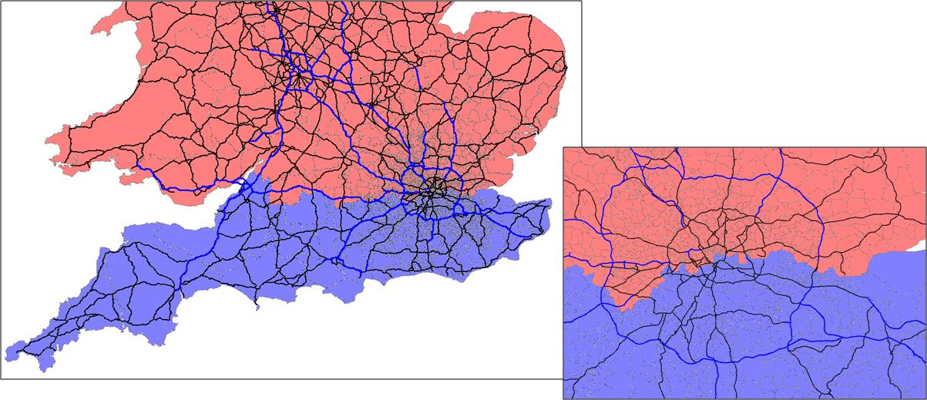
    - In summary, the procedure would be as follows:
- Demand with both an origin and destination to the north or south of the Thames Crossing Screenline will be allocated directly to the “don’t pay” category.
- An absolute logit model will be run for the remainder of demand based on the highway assignment skims to allocated non-work between “don’t pay” and “pay” categories.
- In the cases where there are more than one tolled Thames crossing options, a further absolute logit model will be undertaken between the available toll options.
- Demand will then be reassigned onto the highway network, producing revised cost skims. This will feed into a further round of demand model choice calculations, producing revised assignment demand for the toll choice model.

This process will then be repeated until the demand and supply models are fully converged. This will be measured in accordance with the demand-supply %Gap as defined in WebTAG Unit 3.10.4.
    - The remainder of the demand model, i.e. mode choice, time period choice, etc, is then calculated based on composite costs over toll options, and between “pay” and “don’t pay”. The toll choice model is performed after these main demand model processes, prior to the assignment.
    - This proposed process is illustrated in the figure below.
Figure 8.2: Proposed toll choice model process
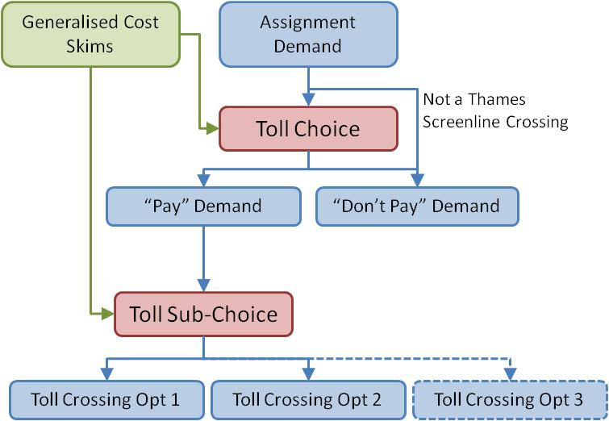
    - An area worth noting on in this methodology is the source of the costs from the highway model in the first iteration. In order to undertake the toll-choice process, the process requires costs from the highway model, but to generate costs an assignment of demand is required. An initial assignment with zero demand will be performed to generate initial costs for the toll-choice model, though costs from this initial assignment will not be used in the incremental choice models, only to provide an initial pay/don’t pay split for the toll-choice model so that a reasonable starting point for full assignment can be obtained.
    - The toll choice process will have to be an absolute model as it will be necessary to deal with new toll options that did not exist in the base year. It will therefore be necessary to iterate the base model to convergence, something that wasn’t previously required.
    - Parameters will be required for the toll-choice process. This will mean:
- a sensitivity “lambda”, in units of inverse time, which controls the scale of response of “pay” and “don’t pay” proportions to any change in cost;
- a choice-constant, in units of time, which calibrates the base level of toll paying, applied to toll-payers without loss of generality (this may be assumed zero depending on the results of the analysis); and
- in principle, a second choice-constant used to calibrate the choice between two tolls (this may be assumed to be zero).

    - We will assume the value of these parameters. One unknown at least will be implied by the current usage of the Dartford Crossing. We will also inspect other evidence for appropriate sensitivities, such as historic changes in Dartford Crossing usage following price increases, and data from the M6 Toll, and route choice parameters calibrated for estuary crossings. We will then estimate constants that replicate demand using the existing Dartford Crossing.

  - Relevant Purposes
    - It is considered essential, based on previous AECOM toll forecasting experience discussed in Section 1.54.5, that some refinement to the M25 Model to represent routeing choice in response to tolls be made. The choice of river crossing made by each traveller is central to this study, and a single value of time, certainly for car non-work, the largest segment, is almost certainly too crude. WebTAG 3.10.2, Table 3 suggests that some segmentation is likely to be necessary.
    - Segmenting business trips is considered unnecessary, since they have a high value of time and would be likely to pay any reasonable toll in practice.
    - Segmenting freight demand is possible; however sensitivity results in Table 8.1 demonstrate that freight demand is insensitive to tolls, even by comparison with business, so this too is considered unnecessary.
    - In addition, both freight and business demand segments, even across the existing Dartford Crossing, are still small by comparison with the car non-work segment: as an illustration, Light Goods Vehicles (LGV) flow represents about one-third of the car non-work vehicle flow, i.e. is of similar size to the car non-work demand following three-way income segmentation. On this basis, there is less need for freight or business segmentation.
    - Furthermore, following DfT guidance, HGVs are modelled as having a relatively high value of time to account for the value of goods carried (2.303 times the driver value of time – see Section 1.25). They are therefore likely to pay tolls, even accounting for the higher tolls charged for HGVs. The HGV value of time in 2009 in the model is 4.3 times that of car non-work persons, while the toll is only 2.4 times. Even LGVs experience lower perceived tolls than car other demand.
Table 8.3: M25 Model charges and values of time by vehicle type, 2009
Vehicle Type | Value of Time (p/min) | A282 Toll (pence) | A282 Toll (minutes)
Car (non-work) | 7.73 | 139 | 18.0
Light Goods Vehicles | 13.79 | 190 | 13.8
Heavy Goods Vehicles | 33.95 | 335 | 9.9

    - Accordingly, we have decided not to segment freight or business demand by income. Both the income segmentation and the pre-assignment logit model will be applied only to car non-work trips, which represent the majority of the demand. Note that “non-work trips” includes commuters.

  - Local Resident Discounts
    - Significant discounts are available for residents on the Dartford Crossing, and similar discounts may need to be modelled for at least some of the new options to be tested.
    - Applying these discounts in the demand model and for cost skims used to calculate benefits is relatively simple; since the demand is already at a production-attraction level and cost skims can easily be converted to production-attraction level using factors from the prior demand matrices, tolls can be factored down for movements within the “resident” area. Where there are two crossings and two “resident” areas, tolls can be skimmed separately for each crossing to enable this. We therefore intend to model the discounts within the demand model and for the purpose of calculating economic benefits.
    - Applying the discounts within the SATURN assignment model to reflect effects upon routeing is considerably more difficult, since it would necessitate having separate “residents” user-classes. We have decided not to model the discounts at an assignment level as:
- it was originally reported that only 4% of total Dartford-crossing demand was by residents;
- increasing the number of assignment user classes has significant runtime implications; and
- as these trips are produced locally, little route-choice is likely to exist as regards crossing the river:.

  - Other Considerations
    - It is suggested in WebTAG 3.12.2 that changes in proportions of car driver and car passenger (i.e. car occupancy) is a potentially significant response to tolls. The M25 Model does not currently have any internal facility to model such an effect.
    - There is no evidence or guidance in WebTAG concerning how sensitive such a response should be.
    - It is considered that given the length of trips using the existing river crossing and likely to be using the proposed crossings, opportunities for car-sharing or would be minimal in the context of the overall forecast traffic, and that the evidence regarding how sensitive such a response should be is in any case so limited as to make robustly modelling it unlikely. Accordingly, no provision for occupancy response in the demand model is proposed. A sensitivity test could be undertaken to assume an occupancy change, but the effects are assumed to be small.
    - It is also suggested in WebTAG 3.12.2 that the interaction of toll schemes with public transport demand be considered carefully, including congestion-related effects on public transport costs.
    - The M25 Model contains no explicit representation of public transport networks or travel costs, except that it does estimate rail and bus fares and their change over time. Developing any sort of public transport supply model to account for, for example, the effect of changing highway congestion on bus journey times, or the effect of overcrowding on rail services, would involve considerable work on model enhancement. Furthermore, as all public transport demand in the M25 Model is wholly synthetic, any demand response would be uncertain, especially in the case of overcrowding which is intrinsically linked with demand.
    - Bus mode-shares for movements crossing the Thames are very small, probably less than 5%. The National Travel Survey bus mode share for London and the South East, for trips longer than 10 miles is about 4%, and this is probably an overestimate, since some of this is derived from the high frequency bus services of central London; around the Dartford Crossing and to the east, provision is less comprehensive.
    - The likely effect of bus demand and costs upon highway flows will be at least an order of magnitude less than this. We will seek to check the modal-choice effect of scenarios tested and demonstrate this to be small.
    - Although rail mode-shares are higher, with around 15% of trips using rail for journeys longer than 10 miles in London and the South East, the demand is dominated by radial trips into London rather than the orbital movements predominantly served by the crossing. The demand model represents the impacts of car time and cost changes on mode choice, and given that the effects on rail demand are expected to be modest, we would judge that any changes in rail crowding would be minimal.
    - Accordingly, no enhancement to the representation of public transport supply is proposed.

  - Conclusions and Recommendations
    - The current M25 Model contains a three-way division of demand into “willingness to pay” categories, split by household income. This is applied only at the assignment level, not in the demand model.
    - We have considered potential refinements to this process, and concluded that a pre-assignment logit model that divides travellers into “pay toll” and “don’t pay toll” categories is the most appropriate way to model route choice associated with one or more tolls. This implies the following:
- a ‘route choice’ decision will be included within the demand model to allocate highway trips between those that use the tolled Dartford Crossing and those that route across the Thames elsewhere (possibly distinguishing current and new Lower Thames crossings) ;
- the assignment model will assign trips, conditional on the predetermined choice of crossing, i.e. identifying the access route to and egress from the crossing; and
- iteration between the demand and network models using updated travel times and costs, will reach an equilibrium between supply and demand.

    - We believe that income-segmentation of the demand model matrices, to improve representation of demand-model responses (mainly redistribution and mode-choice) to tolls, is also likely to be useful.
    - The existing division of demand into income bands is simplistic, involving global factors applied to the matrices. We intend to refine this reflecting variations in income (trip ends) and a representation of the increased length of trips made by persons in higher-income households.
    - The value of time for business and freight purposes is relatively high. This means that at modest tolls (e.g. the levels likely to reflect maximum revenue or maximum user benefits) the routeing decisions will be relatively insensitive and segmentation of these trips would have relatively little effect on model performance. The income / value of time segmentation will therefore be limited to non-work private car trips.

  - Overview
- Highway Model Calibration Approach
    - Chapters 2 and 3 concluded that as part of the refinement of the M25 Model for the purposes of assessing additional Lower Thames Crossing capacity, the highway model is to be updated in the local area. The aim of this task is to improve the model performance in the key study area, both in terms of link flows and journey times.
    - Given the constraints of this study, it will not be possible to undertake a complete model development programme, taking into account recalibration of the entire model for a more recent base year and potentially revisiting the prior matrices. Due to this, the reporting output from the highway model calibration will be an addendum to the existing LMVR, as opposed to a new LMVR for the model.
    - The development of the network and zone system is discussed elsewhere in this report, and this section focuses on the calibration of the highway model based on the updated network and zoning.

  - Model Calibration Process
    - There are three possible methodologies that have been considered for the calibration of the highway model. These are:
- Option 1: a full recalibration of the 2004 base year model using the existing count dataset with the addition of further counts in the key study area;
- Option 2: a local calibration of the 2004 base year model using additional counts in the key study area, and fixing movements in the demand matrix away from this area; and
- Option 3: a local recalibration of the existing 2009 forecasts using additional counts in the key study area, and fixing movements in the demand matrix away from this area.
    - With Options 2 and 3, we would seek to minimise the impact of the local calibration on longer distance, more strategic movements, as these will potentially have been adjusted in the original 2004 model calibration. Furthermore, the focus of the 2009 recalibration is on local movements and so should be primarily affecting trips with one or both trip ends in the ‘Area of Detailed Modelling’. We note however that some adjustment of more strategic trips may be required during the calibration process. We will therefore seek to minimise the impact of the local calibration on the strategic traffic using SATURN’s capabilities in this area.
    - Considering these options in more detail, Option 1 would involve a full recalibration of the 2004 base year model from the prior matrix using the full set of calibration counts as used in the existing calibration. This count dataset would be supplemented with additional count data in the key study area from other models and data sources.
    - This revised base year would then be forecast to 2009 using the demand model, and the performance of this 2009 forecast would be demonstrated against counts and journey times in this year. It is likely that the performance of the forecast model might deteriorate slightly in comparison to the 2004 base year; however, forecast assumptions would need to be considered in order to improve this performance if necessary.
    - Option 2 is similar to Option 1; however the starting point for this approach would be the existing calibrated 2004 base year model. The estimated matrices from this process would be further estimated using a smaller set of additional counts in the key study area. It is not recommended practice to matrix estimate matrices that have already been subject to matrix estimation; nevertheless the finer local detail sought here is to a large extent complementary to the overall M25 Model calibration. Movements away from the area where additional count data is located would be fixed during the second round of matrix estimation, so that matrix adjustments are largely confined to the local trips which were not adjusted in the original matrix calibration.
    - As with Option 1, this version of the base year model would then need to be forecast to 2009 and compared with observed data in this year. Similarly, the forecast assumptions may need to be revised in order to retain the performance of the 2004 base year model in the 2009 forecast.
    - Option 3 removes the need to undertaken a review of a model forecast by matrix estimating in 2009. This approach would take the existing 2009 forecast model, and perform a local calibration exercise similar to that detailed in Option 2 i.e. with matrix estimation intended to be complementary to the existing 2004 calibration.
    - A model performance review would be needed of the calibrated 2009 forecast model to ensure that the flows on the key routes in the model correspond with 2009 observed data. This would consider some of the key strategic routes in the key study area, both in terms of link flows and journey times.
    - There are run time savings in Option 2 and Option 3 compared to Option 1 as the smaller number of counts in matrix estimation will reduce processing time. The run times for matrix estimation extend into days rather than hours and these advantages are therefore material.
    - There is additional complexity on a number of counts with Option 1 and Option 2. Firstly, the process of forecasting from a revised 2004 base year to a 2009 forecast may not produce a suitable performance of the 2009 model compared against observed data. The process of refining the forecasting assumptions to better replicate the 2009 conditions would be an iterative process, and potentially time consuming.
    - Also, this methodology would require the processing of two sets of count and journey time data: one for the 2004 recalibration exercise; and one for the 2009 performance review. With the exception of TRADS data, data taken from other models will require factoring from the base year of the given model to both 2004 and 2009. These factors would be based on long-term count data in the area, reflecting road and area type, but this process reduces the quality of count data, reducing the ability to judge model performance.
    - Given the timescale constraints, Option 3 is the preferred approach. This requires the development of one set of counts and journey time for the 2009 modelled year. However, the count dataset developed for this approach should cover a larger area to ensure that the performance of the 2009 model away from the area of further calibration is suitable for this application.
    - It is intended that there are two sets of count data for this process: one for the further calibration of the model in the local area; and a separate validation dataset for the performance of the existing 2009 forecast flows and journey times. Depending on the performance of the model against these validation counts, it may become necessary to include these counts in the matrix estimation process. If so, the changes to the wider matrix would be reviewed.
    - With a calibrated 2009 model, this would become the base year not only of the highway model but also of the demand model. Data from the existing 2004 demand model would be imported into this revised demand model, with adjustments made as appropriate to represent the change in base year. This would be required, for example, for the car occupancy matrices which would be adjusted in line with WebTAG guidance.

  - Matrix Provenance and Local Update
    - The original M25 Model matrix development used RSI data based entirely upon the 2001 LATS surveys. The locations of these LATS sites in the vicinity of the local area (outside London) are shown in Figure 9.1 (LATS sites in yellow, matrix building sectors in red).
Figure 9.1: LATS Sites and M25 Model Matrix Build Sectors in South Essex and North Kent
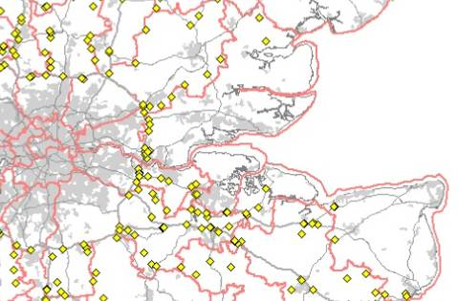
Reproduced from the M25 Model matrix build report

    - The red boundaries in the figure define the sectors that were used to develop the demand matrices from the 2001 LATS data (RSI sites should ideally be located on the sector boundaries; this will have been borne in mind during the original matrix build).
    - The red sectors are larger than M25 Model zones, and any trip movements within these sectors will not have been observed as part of the RSI surveys. Trip patterns for these movements will therefore have been synthesised.
    - The implication of this is most stark in south Essex, where a single sector covers the area between the M25, the A12 and north-east towards Braintree. This area includes Grays, Tilbury, Southend, Brentwood and Basildon. Trips within and between these towns will have been entirely synthesised.
    - As discussed in Chapter 1, data from some of the local models will be used to augment local movements; these are thought to be generally understated in the existing M25 Model, as discussed in the assessment of modelled traffic flows discussed in Chapter 4.
    - The TGSE model will be used to provide detail in the south Essex area; these demand data were derived from a mixture of observed and synthetic data, incorporating RSI data in Grays, Basildon and Southend, as shown in Figure 9.2.
Figure 9.2: Local RSI Sites and Screenlines used in the TGSE Matrix Build
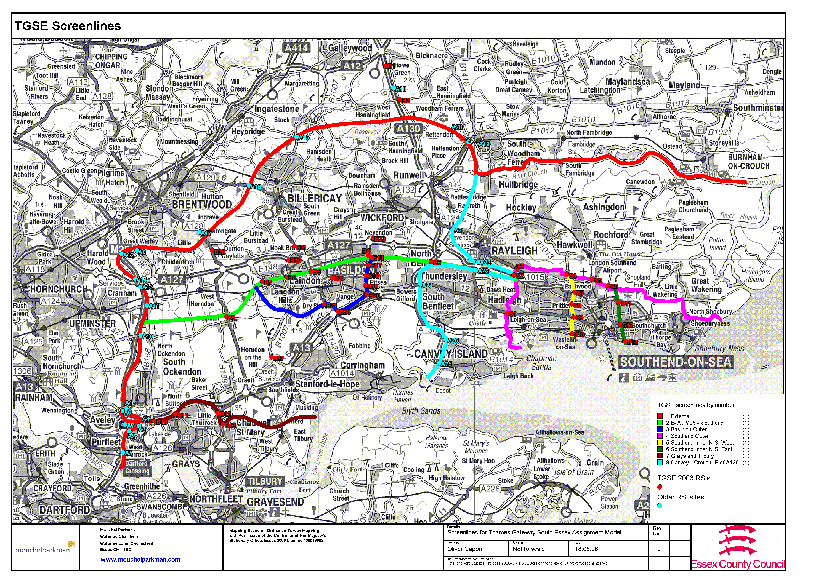
Reproduced from the TGSE matrix build report

    - In the north Kent area, the KTS model will not be used in augmenting the local data, as the KTS model is primarily based on RSI data dating to 1993. These data were partially updated using 2001 LATS data, but the LATS data have already been used in the M25 Model matrix build, and so the KTS model has little to offer regarding LATS movements. Some more recent RSI data was used in Bexley, but this is outside the main area of interest.
    - The Medway model has been developed from synthetic data taken from a donor model, and therefore is unsuitable for use in this study.
    - In north Kent, the existing synthetic demand data used in the M25 Model will therefore be retained, and adjusted using new local counts as discussed below.
    - There will clearly be some uncertainty in the demand data with this approach, and so this should be borne in mind when appraising the model forecasts; some sensitivity testing may be required. It would be possible to attempt a re-synthesis of demand data in north Kent and elsewhere using up-to-date trip-end data and trip-cost profiles; however, timescales preclude this: constructing and calibrating a gravity model would require at least a couple of months of work. The value of undertaking such synthesis is also unclear given the need to rely on and apply assumptions to estimate the trip ends and trip length distributions by purpose which drive the synthesis for which there are no recent local data. It will therefore be appropriate to consider sensitivity analysis as part of the model testing to assess the uncertainties in the model outputs.

  - Preparation of Prior Demand Matrices and Matrix Estimation
    - Prior highway demand matrices will be required as inputs to the matrix estimation process. The intended procedure is as follows.

- The 2009 forecast M25 demand matrices, at a production-attraction level, will be taken from the existing M25 Model.
- These matrices will be converted to the new zoning system, using appropriate trip-end data to disaggregate zones where appropriate. Preference will be given to trip-ends from the original NAOMI matrix build. Where this is too aggregate north of the river, trip-ends from the Thames Gateway South Essex (TGSE) model will be used instead. Failing both of these, address point data will be used.
- The 2006 base year final TGSE matrices wholly within the South Essex LATS cordon will be converted to the new M25 zoning. This is essentially a pure aggregation, so no disaggregation factors will be required.
- The TGSE matrices will be factored up to 2009 level using growth factors implied by the existing M25 Model forecast matrices, and then used to replace the existing M25 prior demand wholly within the South Essex LATS cordon.
- The overall demand following the merging of TGSE prior demand will be split into “Willingness to Pay” bands by household income using the methodology set out in Chapter 7.
- The resulting production-attraction level demand matrices will be converted to origin-destination and vehicles, and aggregated across assignment user classes to create assignment matrices to be used in matrix estimation. The production-attraction matrices will be retained to allow the final estimated matrices to be converted back to P-A people demand at the full demand-model segment level.
- Matrix estimation will then be undertaken using a count data set intended to cover local movements in the vicinity of the crossing options in north Kent and south Essex. Limited counts that affect more strategic movements may be required, most notably for Dartford Crossing traffic. We will seek to validate the Crossing traffic, but an element of calibration may be required.
- So as to reduce the impact of the local matrix estimation on the parts of the M25 Model that were matrix estimated by Hyder in the 2004 calibration, we will seek to limit the extent to which matrix estimation can influence these parts of the matrix; the highway software allows constraints to be applied to limit the matrix cells adjusted.

  - Count Data Availability
    - Within the existing model calibration process there are a large number of link counts across the simulation area, both inside and outside the M25. The aim of this section of the report is to look at other sources of count data to supplement this count dataset, in particular in the key study area.
    - Count data in the key study area have in part been incorporated in the local models. These have been discussed in Chapter 1, so this section will solely consider the count data used in the calibration and validation of these models. Other data sources of potential count data are TRADS and the DfT Count Database, as well as the transaction data from the Dartford Crossing.
    - The East London Highway Assignment Model (ELHAM) has a 2009 base year, and contains a number of screenlines and cordons in the model link flow calibration / validation. Cordons, or enclosures, are located throughout East London, including cordons of Harold Hill, Hornchurch and Swanley which may be of interest to a model calibration exercise. In addition to this ELHAM also contains a number of screenlines which may be of interest to this study. Four of these that may be most of interest to this study are the North-East Orbital, Sidcup, Thames and River Rom screenlines.
    - The Kent Thameside Transportation (KTS) Model has a base year of 2005. The count data used in the calibration / validation of the model are concentrated in and around Dartford and Gravesend. A cordon of these two urban areas and a number of screenlines capturing east-west movements in the area may be of use in supplementing the existing traffic count data.
    - The Medway Traffic Model (MTM) has a base year of 2007, and the count data used in this model are focused in and around Rochester, Chatham and Gillingham. There is a significant amount of local count data, including turning counts within the urban area; there are also a number of counts on key strategic routes in this area of Kent.
    - The Thames Gateway and South Essex (TGSE) Model has a validated base year of mid-2006. The majority of the counts used in the calibration and validation of the model are to the east of the M25 broadly forming a screenline to the south of the A12, a screenline to the east of the M25, and a series of counts along the A13 and A127 corridors.
    - In terms of other data sources, TRADS data cover the trunk road network in the key study area, with good coverage of data over recent years. These data should be used in preference to data from other models where multiple data sources are available. This is due to the fact that the processing and source of some of the count data in other models is not known, and therefore there is much tighter control on data directly sourced from TRADS.
    - There are also other data collected for the ‘M25-A13 Corridor Relieving Congestion Scheme’. These have been provided and will be used where appropriate.
    - A consideration when sourcing count data is the quality of the survey. Long-term ATC data is the referred source of data, with one-day manual counts containing the largest variation. In developing a count dataset for the local calibration of the model, the count type will need to be defined, where possible, in order to source the most reliable data.
    - In addition to this there is the DfT’s count database. This is primarily manual count data, although there is a good coverage of count sites in the key study area. Due to the manual nature of these traffic surveys, as opposed to automatic traffic counts such as TRADS, this count data would only be used to supplement the count data set where ATC data are not available from another source.

  - Journey Time Data Availability
    - As with the count data, the existing M25 Model contains a number of journey time surveys as part of the journey time validation. This section will look at supplementing this data with either new routes or more recent surveys, in particular in the key study area. Similarly, supplementary journey time data may be available from other models in the area or from other sources such as HATRIS.
    - The 2009 ELHAM validation contains a number of journey time routes inside the M25, and also includes journey time route along the M25 between Junction 26 and Junction 3 across the Dartford Crossing. The key radial routes in East London are also covered by journey time routes, including the A12, A127, A13, A207, A2 and A20.
    - The KTS model contains journey time data covering the majority of major routes between Dartford and Gravesend, including the A2 and the A226.
    - The Medway Traffic Model contains journey time surveys on all the key routes of this model, including the M2 between Junction 1 and Junction 5. There is journey time information on the A229 to the north of the junction with the M2, but not to the south.
    - The TGSE Model contains journey time data along the A13 and A127, as well as along potentially competing routes to the M25 including the A128 which may be important with some of the proposed additional capacity options.
    - HATRIS data are available for all the main routes in the model, including the M25, A2 / M2 and M20. There are also journey time data along the A1089 which should be included in the model validation due to the location of the proposed Option B crossing. There are limited HATRIS data within the M25; however this area of the model can be supplemented with data from ELHAM.
    - When supplementing the journey time data for validation of the highway model, HATRIS data should be used where available, and supplemented within data from the existing models. Experience of using HATRIS data in other applications has shown that this data can be volatile, and so data for a number of months, if not a couple of years, should be extracted to provide confidence in the observed data. Also, where possible, this data should be cross-checked within data in other models to provide further confidence in the data.

  - Interaction with the Toll Demand Model
    - As the demand model will contain a pre-assignment logit model to define route choice between “toll” and “no toll” Thames crossings, and as this element of the demand model is an absolute model, this process will need to be run in the base year. This means that the results of the calibrated highway model will need to be installed in the demand model, and a 2009 base year demand model run.
    - This process will create revised highway demand, dividing non-work car demand between the Dartford Crossing and the free Thames crossings. This could potentially produce different assignment results from that in the 2009 calibrated model. There will be parameters within the toll-choice model that can then be adjusted based on the results of this process to best replicate the calibrated model flows. However; the sensitivity of the toll-choice to changes in toll prices should be retained.
    - Focus during this process will be given to the flow on the Dartford Crossing, but will also look to minimise the effect of this on the flows elsewhere in the key study area. The results of the assignment of this revised demand will be assessed against the 2009 counts and journey times used in the local calibration to ensure that the model performance has not been reduced through this process.

  - Documentation
    - Following implementation of the model updates in Tasks 1.4 and 1.5, Tasks 1.6 (base year validation) and 1.7 (realism / sensitivity testing) will assess and report the performance of the refined model.

Appendix A: Zones considered for disaggregation
Table A.1: Zones Considered For Disaggregation
Name | Number | MaxTrips | Conclusion | Comment
New House & Perry Street | 20026 | 520 | Split | Odd-shaped zone. Some possibility of route-choice to west. Consider splitting.
Dartford (Central) & New Town | 20041 | 390 | Split | Clear strategic route choice to the east. Consider splitting.
Dartford (Central) & New Town | 20061 | 473 | Split | Clear strategic route choice to the east. Consider splitting.
Dartford (Central) & New Town | 20062 | 452 | Split | Clear strategic route choice to the east. Consider splitting.
Orsett & Horndon on the Hill | 28016 | 471 | Split | Possibly should be split. Two urban areas, with potential different routing northbound (though not south).
Lower Higham | 20020 | 1,837 | Split | Route choice between A228 and A229 southbound. Consider splitting.
Grays & Little Thurrock | 28017 | 1,836 | Split | Route choice between A13 and A126. Consider splitting.
West Thurrock | 28018 | 2,482 | Split | Route choice between A13 and A126. Consider splitting.
Purfleet | 28059 | 1,039 | Split | Route choice between A13 and A126. Consider splitting.
Tilbury & Chadwell St Mary | 28061 | 904 | Split | Route choice between A13 and A126. Consider splitting.
St Mary's Isle & Ocelet Submarine | 20049 | 3,462 | Split | Clear route choice to both west and east and very large amount of demand. Should be split.
Chatham & Luton | 20095 | 2,319 | Split | Clear route choice to east (possibly some to west as well). Should be split.
Brentwood (S) & Warley | 28080 | 1,701 | Split | Some route choice southbound. Possibly of significance for model; consider splitting.
Basildon | 28098 | 2,588 | Split | Clear choice of route east and west (three way in the westerly direction). Should be split.
Basildon | 28070 | 1,776 | Split | Clear three-way route choice east and west. Should be split.
Norfolk | 35001 | 4,450 | Split | External zone. Strategic route choice southbound that could affect modelled area along with significant demand in that direction. Consider splitting.
Cambridgeshire | 37004 | 5,421 | Split | External zone. Strategic route choice southbound that could affect modelled area along with significant demand in that direction. Consider splitting.
Snodle (N) | 20098 | 1,404 | Split | Route choice westbound that could affect area of interest. Consider splitting.
Stockbury & Hill Green | 20100 | 2,484 | Split | Route choice westbound that could affect area of interest. Consider splitting.
Basildon | 28101 | 963 | Recode CC | Urban area highly focussed in the west, where no strategic routing choices exist. Oddly, centroid connector loads into east. Consider moving.
St Mary Hoo | 20019 | 883 | No action | A228 is only major road out of zone, and only road usable for main urban area and ports.
Gravesend | 20022 | 486 | No action | Strategic routing likely fairly static across zone; travellers can either head to Gravesend centre north or to A2 south.
Gravesend | 20023 | 455 | No action | Routing into Gravesend identical across zone. Routing south onto A2 by either of two local roads, but makes no strategic difference.
Gravesend | 20024 | 309 | No action | Little demand. Travel east by one route only. Travel west differs only up to local road level.
Gravesend | 20025 | 1,024 | No action | Radial hub (town centre). Only three major radial routes at widely separated angles. No likely variation in strategic routing.
New House & Perry Street | 20027 | 331 | No action | No strategic route choice.
Northfleet | 20028 | 429 | No action | No strategic route choice.
Northfleet | 20029 | 251 | No action | Urban area in one corner of the zone; no variation in routing on any modelled network.
Northfleet | 20030 | 435 | No action | Urban area all along main road; no conceivable variation in routing on any modelled network.
Northfleet | 20031 | 348 | No action | Urban area concentrated in north. No obvious route choice.
Bluewater Retail Development & John's | 20036 | 410 | No action | Odd-shaped zone. Urban area concentrated in west, where no significant route choice.
Bluewater Retail Development & John's | 20037 | 555 | No action | Shopping centre. One access point.
Dartford (Central) & New Town | 20038 | 333 | No action | Possible strategic route choice to the west, but urban area is concentrated and would suggest northern route.
Greenhithe & Stone | 20042 | 274 | No action | One access point. Aggregate with 20044?
Greenhithe & Stone | 20044 | 260 | No action | Tiny zone. One access point. Aggregate with 20042
Hawley | 20045 | 283 | No action | Urban area concentrated, with one access point.
Joyce Green | 20059 | 708 | No action | Sewage works; one access point. Nil route choice.
Joyce Green | 20060 | 451 | No action | No obvious strategic route choice.
Dartford (Central) & New Town | 20063 | 281 | No action | Little demand. Three urban areas with clearly distinct local route-choice. Could be disaggregated three ways, or bits of it combined with nearby zones (latter possibly more sensible).
Dartford Power Station | 20064 | 229 | No action | Nil route choice. Single access to power station.
Gravesend | 20069 | 312 | No action | No significant route-choice issues. Some possibility of an A226/A2 split eastbound, but these come together soon anyway, and most of zone would likely select A2.
Chatham & Luton | 20094 | 728 | No action | Demand likely focussed on college and hospital, which are close together. Not much in the way of strategic route choice anyway.
Swanley & Hextable | 20102 | 236 | No action | Only one major road; urban area concentrated. Vague possibility of route-choice westbound, but not very strategic in any case.
Aveley (N) | 28019 | 885 | No action | Most of area quite concentrated, with no obvious strategic decisions. Smaller urban area to the west; could conceivably be split, but even including this there don't seem to be any distinct strategic route choice changes.
South Ockendon | 28020 | 1,102 | No action | Urban area very concentrated. No obvious strategic routing decisions; one exit in each cardinal direction.
Aveley (S) | 28021 | 374 | No action | Urban area all on one road; no strategic route choice.
Coryton Oil Terminal | 28040 | 169 | No action | Only one strategic exit west and only one east. Could actually be aggregated with 28088 and 28089.
East Tilburry | 28058 | 531 | No action | Urban area very concentrated. No network coded in this zone.
Tilbury Docks | 28060 | 523 | No action | No strategic route choice; docks only.
Corringham (E) & Fobbing | 28088 | 562 | No action | Only one strategic exit west and only one east. Could actually be aggregated with 28089 and 28040.
Stanford-le-Hope | 28089 | 937 | No action | Only one strategic exit west and only one east. Could actually be aggregated with 28040 and 28088.
Chatham & Luton | 20159 | 1,133 | No action | Only one major road through zone (A228) and most traffic likely to leave via it. Some possibility of departure north via A, but this would only make a difference for a short stretch of road and urban area mostly in south.
Hodsoll Street & Ash | 20092 | 239 | No action | Only one major road through zone (also only road coded).
Basildon | 28100 | 925 | No action | No strategic route choice. Only one exit in each direction.
Upminster Corbets Tey & Hacton | 26619 | 270 | No action | Urban area all in west of zone; no strategic route choice.
Upminster Corbets Tey & Hacton | 26617 | 346 | No action | Urban area all in north of zone; no strategic route choice.
North Ockendon Stubbers Lodge & Hobbs | 26615 | 398 | No action | Urban area all in north of zone; no route choice.
Canvey Island | 28002 | 1,497 | No action | Island. All demand leaving zone must pass through A130, B1014 roundabout, so no variation in routing.
Darenth & Fleet Downs | 20039 | 269 | No action | Very little demand
Greenhithe & Stone | 20040 | 128 | No action | Very little demand
Greenhithe & Stone | 20043 | 78 | No action | Very little demand
Betsham & Bean | 20046 | 105 | No action | Very little demand
Betsham & Bean | 20047 | 170 | No action | Very little demand
Swanscombe Marshes & Greenhithe | 20052 | 183 | No action | Very little demand
Swanscombe Marshes & Greenhithe | 20053 | 222 | No action | Very little demand
Istead Rise | 20068 | 171 | No action | Very little demand
Hodsoll Street & Ash | 20091 | 111 | No action | Very little demand
Upminster Trading Park Fairplay Farm | 26614 | 129 | No action | Very little demand
Belhus Park (W) & Little Brickkiln Wo | 28053 | 166 | No action | Very little demand
Chatham & Luton | 20093 | 186 | No action | Very little demand
Hodsoll Street & Ash | 20163 | 137 | No action | Very little demand
Meopham | 20050 | 37 | No action | Very little demand
Meopham | 20162 | 84 | No action | Very little demand
Stanford-le-Hope | 28097 | 218 | No action | Very little demand
North Ockendon Stubbers Lodge & Hobbs | 26620 | 73 | No action | Very little demand
Chatham & Luton | 20021 | 1,167 | No action | No strategic route choice for any distance away from zone.
Slade Green | 24001 | 1,862 | No action | Considerable choice to route to east, but this is outside scope of the project. No route choice to west, where we are primarily concerned.
Stanford-le-Hope | 28022 | 291 | No action | Very little demand
Northfleet | 20070 | 1 | Combine | No demand. Combine with adjacent zone.

Appendix B: Test of Zone Disaggregation Results
Figure B.1: Effect of Illustrative Option C Coding on traffic flows, 1417 zone model
(flows on Option C are not shown due to SATURN display limitations)
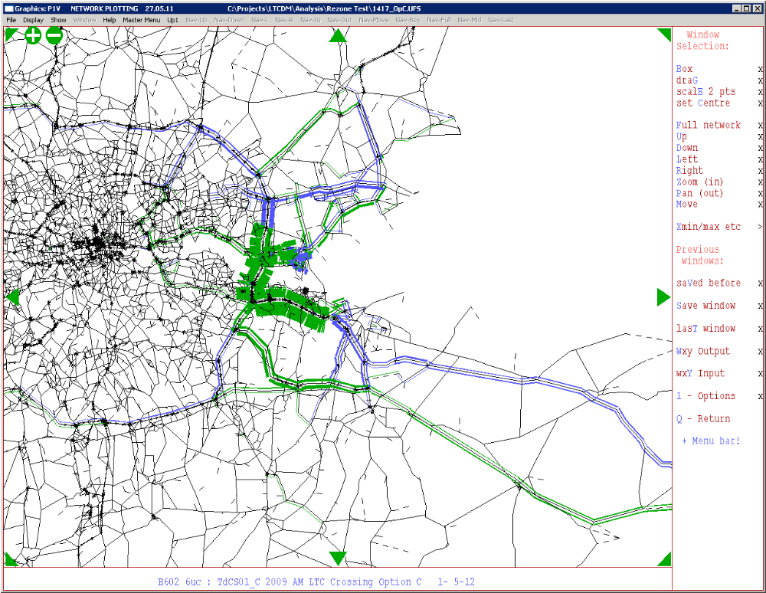

Figure B.2: Effect of illustrative Option C coding on traffic flows, 1121 zone model
(flows on Option C are not shown due to SATURN display limitations)
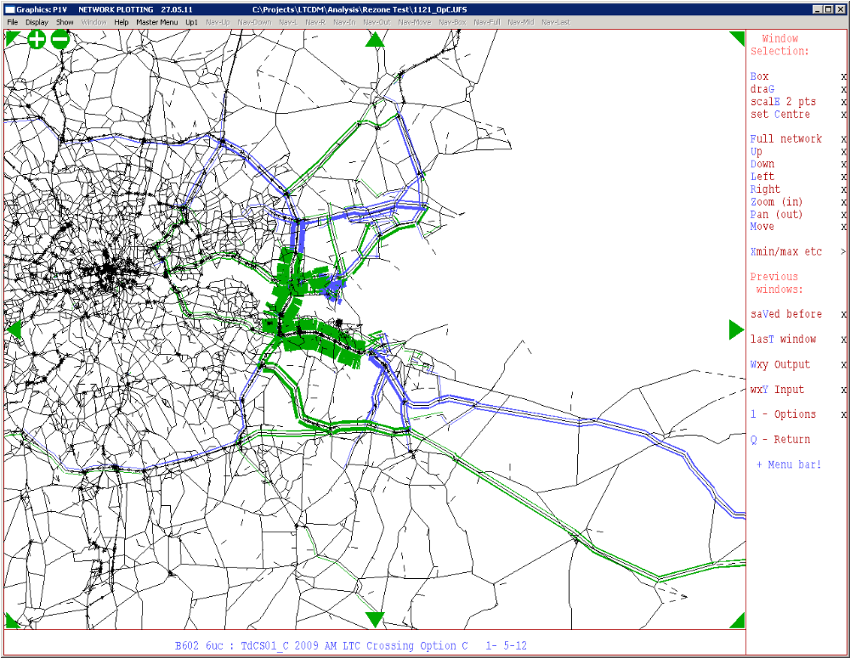

Figure B.3: Core Scenario: Flow differences between 1417 Zone Model and 1121 Zone Model, Area of Interest
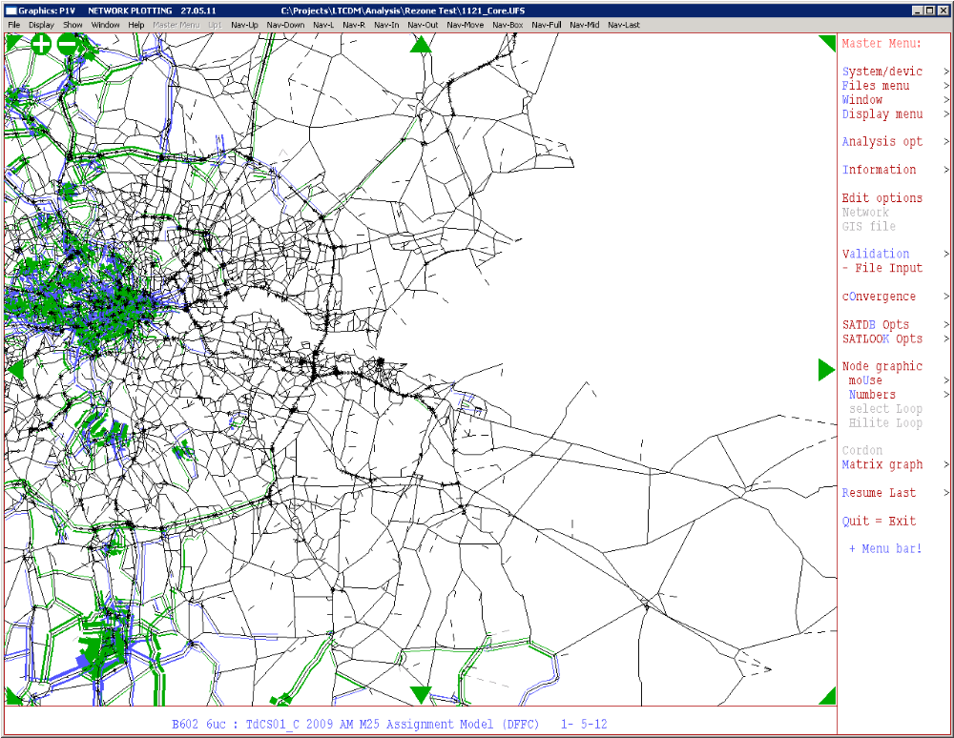
Flows are shown at 300 PCUs per mm. The difference on the north section of the M25 between the A1(M) and A10, for example, is around 150 PCUs.
Figure B.4: Core Scenario: Flow differences between 1417 Zone Model and 1121 Zone Model, Wider Area
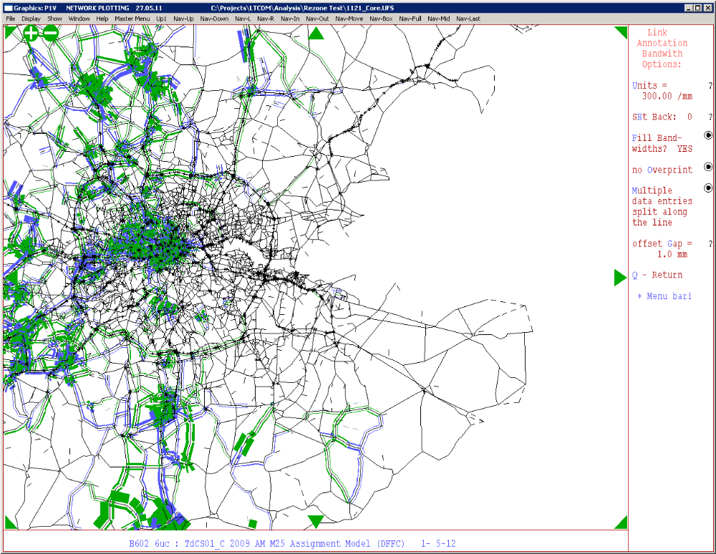

Figure B.5: Core Scenario: Delays at Junctions, 1417 Zone Model
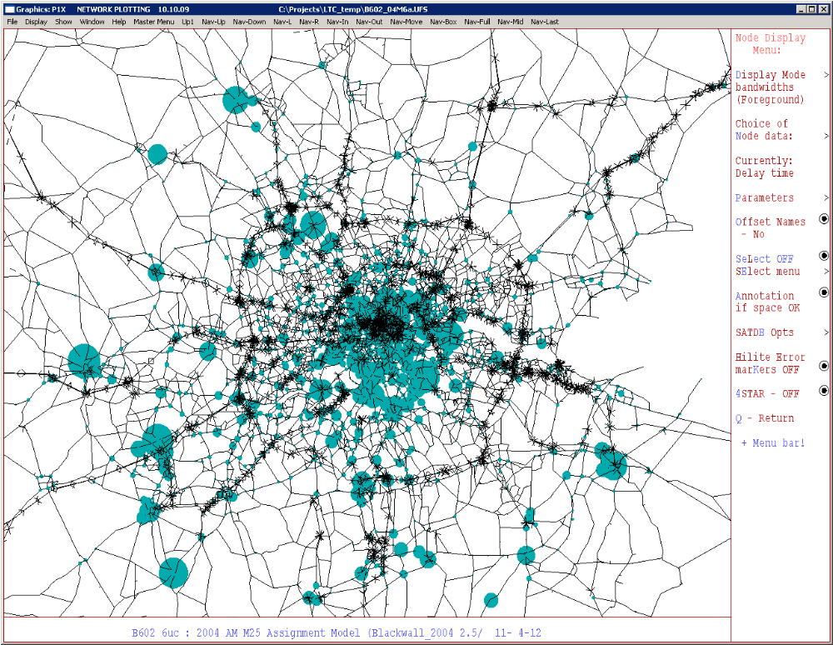
Figure B.6: Core Scenario: Delays at Junctions, 1121 Zone Model
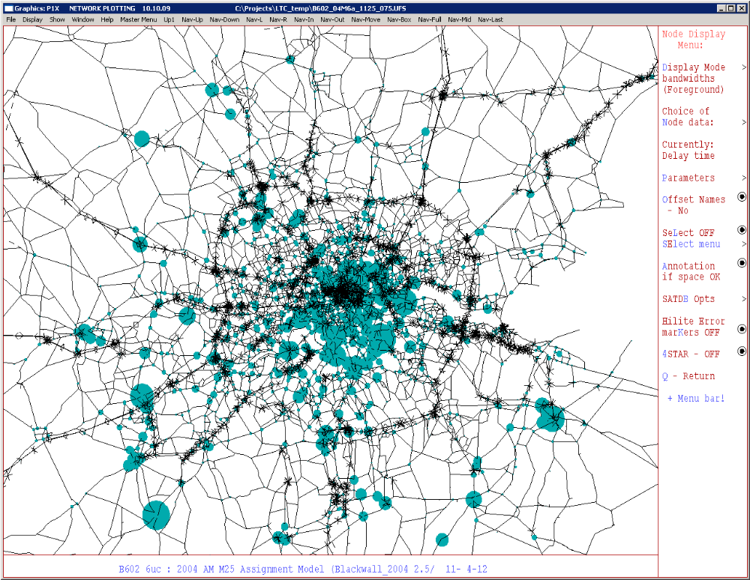

Tower Hamlets, Newham, Hackney, Redbridge, Barking & Dagenham, Havering, Bexley, Greenwich, Lewisham and Waltham Forest.
Spigot centroid connectors are where a zone feeds onto the end of a given link. This link then joins the main highway network via standard junction coding. It is possible for a zone to be connected to one or more spigots.
Link spanning centroid connectors as those where the demand from a zone feeds onto the mid-point of the link. The flow from the zone appears in the SATURN assignments at the junctions at the end of the link onto which is loaded.
M25 LUS – Sections 2&5 Traffic & Economics. Local Model Validation Report, version 3.0. Atkins. November 2011.
WSP (2010) Freight in London Model — FiLM: Draft Final Report. For Transport for London

