
Government
Shared Services:
A Strategic Vision - July 2011
Introduction
When the Coalition Government came to office it was a stated priority to reduce the deficit and ensure critical front-line services were protected. Over the past year, rigorous controls have been put in place to reduce wasteful and inefficient spend such as travel and the buying of consultancy. In procurement alone, savings of over £1bn have been achieved and we intend to build upon this over the Spending Review Period.

To ensure we maintain our trajectory to reduce the deficit, by achieving sustainable savings and making Government efficient, we must simplify and standardise back office services and functions. We estimate that in 2009/10, around £2.5bn was spent on HR, Finance and Procurement functions across Central Government organisations, with considerable variation in expenditure and levels of service delivered.

This document is a summary of the proposed strategic vision and future operating model for Government Shared Services. The scope of this work is to consolidate back office transactional services – HR, Finance, Payroll and Procurement - between and across Central Government organisations and Arms Length Bodies (ALBs).
History of Government Shared Services
Since the Gershon Review in 2004, Government has recognised the potential benefits of shared services to:

- Reduce the cost of back office corporate services via asset sharing (IT, buildings, resources, management) and minimised process cost.  - Drive service excellence by freeing the department to focus on core objectives and professionalising corporate service functions.  - Increase operational efficiency through better MI, improved benchmarking, comparable between organisations which in turn could potentially drive up performance. | “The CBI believe the business case for shared services is evident – economies of scale, better sharing of information across function and organisational boundaries, aggregation of buying power for the purchase of leading edge solutions, greater opportunities for staff specialisation a framework for continuous improvement and process innovation.”  Transformation Through Shared Services, CBI, June 2006

Departments have acted strongly and positively over the last five years in response to this; a number have delivered Shared Services Programmes which have enabled them to take a joined-up approach to managing their corporate functions, within and across Departments. As a result, a number of Shared Services Centres (SSCs) have emerged, with Departments and ALBs clustered around these (see figure 1).

Figure 1: Government Shared Back Office Services: The Current Landscape
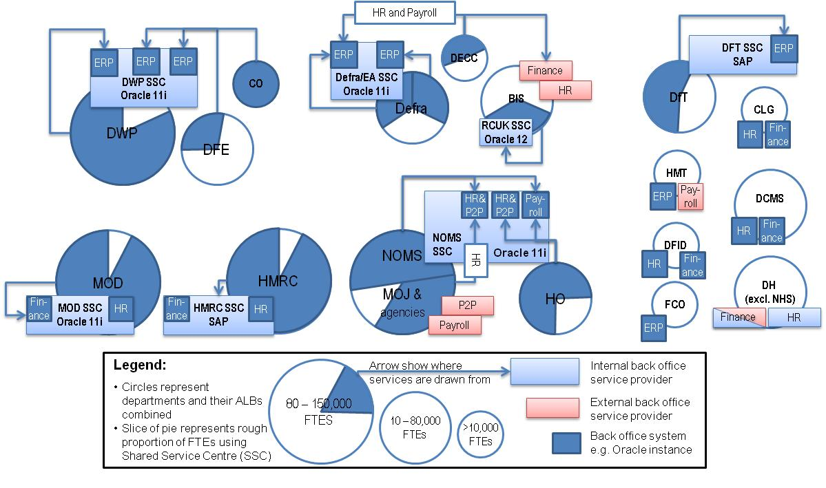

This activity has realised significant benefits. For example, the Home Office and the Ministry of Justice are both ahead of the benefit realisation forecast to be delivered through their relationship (Home Office currently reporting savings of £13m per annum and the Ministry of Justice report £20m per annum) and Department for Work and Pensions reported savings of approximately £35m in 2009/10 delivered through their back office shared service centre.

However, the current landscape is complex – in many cases services are joined up rather than truly shared, lines between providers and customers are blurred; there is scope to improve. The process of getting to this landscape has driven out some clear lessons about the cost and barriers to sharing services effectively.

Lesson 1: Independence is important to incentivise a better quality of services at a lower cost.

Lesson 2: Delivery of shared services is not a core Government skill and bringing in operational and commercial expertise is vital to improving current capability.

Lesson 3: On-boarding to a bespoke service can be expensive and issues on charging between public organisations can act as a barrier, e.g. smaller organisations need an affordable solution.

Lesson 4: Shared Services comprises a range of key components that influence cost and require standardisation – infrastructure, IT platform, ERP solution, business change, business processes.

Lesson 5: Strong governance is essential and efficiency gains are proportional to the level of mandation in the use of shared services.
Strategic Vision
The Current Opportunity
In addition to the Coalition Government’s focus on driving efficiency, reform programmes within Central Government are already under way in Finance, HR and Procurement. These programmes will drive towards standardised and simplified corporate processes across Government. These have the potential to be a valuable enabler for future back office corporate shared services, specifically through reducing the need for customised processes which have, from experience, proven to be a significant driver of cost.

At the same time, a number of Departments are due to upgrade their supporting IT systems for back office corporate services in the coming years. A co-ordinated management approach by Government will lower the cost of reinvestment whilst enabling a rationalisation of the current landscape. For example, a number of large Departments who have implemented and operate an Enterprise Resource Platform (ERP) solution need to plan for the expiration of support to the current instance by 2013. This presents an opportunity for UK Government to source a “vertical” solution for a “cloud based” ERP standard platform which Departments could buy into and from.
Government Shared Services
The Cabinet Office has developed a two part strategy for provision of Government back office corporate services.

Firstly, we will ensure Central Government Departments and their ALBs have access to cost effective, fit for purpose shared back office corporate services:

“We will reform how Central Government procures and manages consolidated back office corporate services - by establishing an equitable market of a small number (circa 2) of accredited Independent Shared Service Centres (ISSCs) and enabling Departments and their ALBs to choose between these – in order to drive up quality and reduce costs of these services, in support of Governments cost reduction targets.”

A Central Government oversight function will lead a new governance structure which will accredit ISSCs, establish benchmarks and set customer service standards. It will also approve Departmental and ALB strategies and provide support as they migrate into this model.

Approved ISSCs will operate independently from any customer organisation. They will provide outcome based services, using standardised simplified processes, with the expectation to regularly publish performance data against established benchmarks. They will be able to make use of different business models (i.e. public, mutual, private) in order to leverage capability and the financial investment needed to deliver this service and may operate virtually or from a small number of fully integrated delivery centres.

Figure 2: Government Shared Services: Future Model
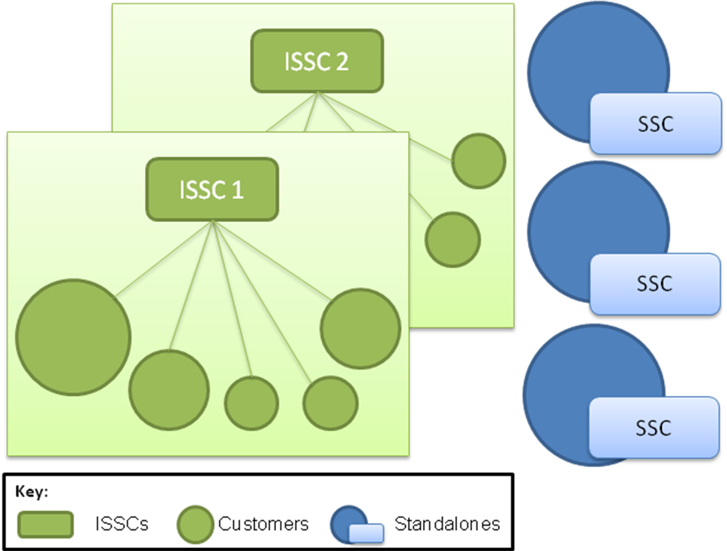
Note: Cabinet Office and Department for Transport (DfT) have agreed that the SSC owned and run by the DfT on behalf of itself and its ALBs, which is currently being divested to the private sector, will become one of a small number of centres within the planned governance structures.

Secondly, where they are large enough, Departments will be able to make a case to continue to use their own “standalone” back office corporate service provision. Performance of these Standalone Service Centres (SSCs) will still be monitored against agreed benchmarks by the central oversight function. Over time, if they are able to show better performance than the ISSCs, they may be able to begin offering services to others. Conversely if an ISSC demonstrates better value for money than a Standalone Service Centre, the Department may be compelled to become a customer of an ISSC, or at the least be held accountable for achieving the standards set by the central oversight function.

Next Steps

Over the next three months, the Cabinet Office ERG Shared Services team will work with Departments to conduct a due diligence exercise, to develop the plan to migrate to the future shared services model, together with an estimation of projected costs and benefits that will form the basis of a strategic outline business case. This work will be reported in November 2011.

Cabinet Office
70 Whitehall
London
SW1A 2AS.
www.cabinetoffice.gov.uk
July 2011

In this context ‘Independent’ means that the organisation is not managed by a customer of the services provided by the centre. Customers will have representation within the governance of any ISSC.
In this context a ‘Centre’ can mean more than one building or application, but is managed as a single operation.

