
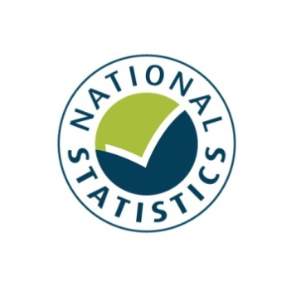

This Cultural and Sporting Life: The Taking Part 2010/11 Adult and Child Report
Statistical Release
August 2011





Our aim is to improve the quality of life for all through cultural and sporting activities, support the pursuit of excellence, and champion the tourism, creative and leisure industries.

Taking Part is a National Statistic and has been produced to the standards set out in the Code of Practice for Official Statistics

Contents

Introduction 5
Key findings 7
Chapter 1: Free time activities 9
Chapter 2: Child engagement 14
Chapter 3: The influence of childhood participation on adult participation 23
Chapter 4: Sport and active recreation 29
Chapter 5: Attitudes to the 2012 Olympic and Paralympic Games 35
Chapter 6: Digital engagement 40
Chapter 7: The big society 50
Chapter 8: Cycling and swimming proficiency 57
Chapter 9: Archives 64
Chapter 10: Participation in culture 66
Chapter 11: Looking ahead 72
Annex A: Background note 73
Annex B: Demographics 75
Annex C: Sector definitions - Child 81
Annex D: Sector definitions - Adult 86

Introduction

This report
This report presents findings from the sixth year of the Taking Part survey, expanding on and complementing the Statistical Release published in June 2011 that presented headline findings from the survey. The sixth year covers the 12 month period from April 2010 to March 2011 and includes participation in culture and sport, volunteering, digital participation, and cycling and swimming proficiency. Where observations are made over time, the latest data are compared with earliest available data (typically 2005/06).

Where previous reports have focused on participation levels in DCMS sectors and what are considered as the more traditional ways in which people engage, this report uses the wider range of data available from Taking Part to look at how digital engagement is starting the change the picture of participation in our sectors. In addition, it also considers the role our sectors play in the big society and attitudes towards the 2012 Olympic and Paralympic Games.

This release reports findings for both adults and children. While the fifth year of Taking Part was carried out on a reduced sample size, this sixth year reinstated a full sample and, as such, supports a much wider range of analysis of the adult and, particularly, child datasets. Taking Part users are encouraged to contribute their views on the content of this release and areas of interest for analysis to the Taking Part team at the Department for Culture, Media and Sport (DCMS): TakingPart@culture.gsi.gov.uk

Taking place on the same day as this release is the second Taking Part User Event, which will present findings from this report along with further research and discussion of the new longitudinal element of the survey. Material from the day will be made available on our site at: http://www.culture.gov.uk/what_we_do/research_and_statistics/7394.aspx

The next release, scheduled for the end of September 2011, will present data from the first quarter of the seventh year of the survey (April 2011 to June 2011) along with updated rolling annual estimates combining the latest year six and seven estimates.

The Taking Part Survey
The Taking Part survey is commissioned by the Department for Culture, Media and Sport (DCMS) in partnership with a number of our arm’s length bodies. For 2005 to 2011 these were Arts Council England, English Heritage, Sport England, and the Museums, Libraries and Archives Council (MLA). As part of the Government wide review of arm’s length bodies, some of the responsibilities of the MLA will transfer to Arts Council England including the representation for their sectors on the Taking Part board. With this release, we would like to thank the MLA for their valuable contribution to the management, content and analysis of the survey over the past six years.

The survey covers both adults and children in England and collects a wide range of data about engagement and non-engagement in culture, leisure and sport as well as more diverse measures that support a range of Government objectives. Taking Part is the key evidence source for DCMS, providing reliable national estimates of participation and supporting the Department’s aim of improving the quality of life for everyone by providing people with the chance to get involved in a variety of these opportunities. The survey also aims to support the DCMS Structural Reform Priorities and Business Plan through the provision of data for DCMS input and impact indicators and the broader information strategy. The latest DCMS indicators are available at: http://www.culture.gov.uk/about_us/8192.aspx

Taking Part is a continuous face-to-face survey with adults aged 16 and over living in private households in England. It is conducted on behalf of DCMS by TNS-BMRB. The survey has run since mid-July 2005. A child interview was added to the survey in January 2006, interviewing a randomly selected child in those households containing at least one child aged 11-15. This is also a continuous face-to-face survey. In 2008/09, the child survey was broadened to include children aged 5-10. Interviews with children aged 11-15 are carried out directly, for those aged 5-10 an interview is conducted with the adult respondent.

The Taking Part Survey contributes to the evidence base across a wide range of topics including participation in culture and sport, satisfaction and enjoyment with culture and sport, social capital, volunteering and barriers to participation. It also collects an in-depth range of socio-demographic information on respondents. This report presents a range of data across these subjects but is by no means a complete picture of what is available. A wider range of measures are included in the spreadsheets accompanying this release, while analysis of 2005/06 to 2010/11 adult data can be conducted through NetQuest, our on-line analytical tool:
http://www.culture.gov.uk/what_we_do/research_and_statistics/6762.aspx

Key findings

Child engagement
- In 2010/11, the majority of children had engaged with the arts in the last year, including 98.2 per cent of 5-10 year olds and 99.0 per cent of 11-15 year olds.

- 72.6 per cent of 5-10 year olds and 69.3 per cent of 11-15 year olds had visited a heritage site in the last 12 months. In 2010/11, 75.6% of children had visited a library in the last 12 months. This has remained steady since 2008/09.

- 89.7 per cent of children had done sport in the last 4 weeks; 85.4 per cent of 5-10 year olds and 94.5 per cent of 11-15 year olds. This is unchanged from 2008/09.

- In January to March 2011, 79.5 per cent of 5-15 year old children had done some form of competitive sport in the last 12 months. Almost three quarters (74.9%) had taken part in competitive sport in school, whilst 40.6 per cent had taken part outside of school.

The influence of child participation
- Adults who participate in culture and sport tend to be more likely to have done the same activities as a child. However, the influence of childhood participation is stronger in some sectors.

- In general, adults were more likely to participate in culture and sport when they were children than as adults, e.g. while 86.0 per cent of adults had played sport when they were children, far fewer (53.0%) had done so in the last 4 weeks. The exception is heritage – 56.8 per cent of adults had visited a heritage site as a child while 70.7 per cent had visited in the last 12 months.

Sport and active recreation
- In 2010/11, 54.1 per cent of adults had done some sport or recreational physical activity in the last 4 weeks while 71.7 per cent had done so in the last 12 months.

- Men are more likely to have done sport or recreational physical activity than women. This is true for the 4 week measure (61.8% of men; 46.7% of women) and the 12 month measure (77.7% of men; 65.9% of women).

- The majority of adults enjoyed the sporting activity they participated in, with 88.5 per cent of adults rating their enjoyment as 6 or more.

- Three-quarters of adults have recommended sporting activity to a friend or family member.

The 2012 Olympic and Paralympic Games
- People are generally supportive of the UK hosting the 2012 Olympic and Paralympic Games, with 66.7 per cent expressing some degree of support in 2010/11.

- Attitudes to the 2012 Games vary somewhat by region and people who live in London, the East of England and the South East have more favourable views.

- Attitudes to the 2012 Games also vary by disability, and people with a limiting illness or disability are more supportive than those without a limiting illness or disability.

Digital engagement
- In 2010/11, the highest combined actual and digital participation is found in the heritage sector – 71.2 per cent of adults participated in person or took a virtual historical tour.

- The greatest discrepancy in percentages of adults participating in person and those participating digitally is found in the heritage sector. Only 0.5 per cent of adults had attended through digital only means compared to 63.6 per cent who had only attended in person (7.1% had attended both in person and digitally).

- Archives are the only sector where the percentage of adults participating by digital means only exceeds the percentage participating in person. In 2010/11, 2.3 per cent of adults visited an archive in person only and 7.6 per cent participated by digital means only (1.7% had attended both in person and digitally).

- The sport sector had the highest percentage of digital-only participants; with 11.6 per cent of adults only participating in sport using a Wii Fit or similar exercise device (including adults who also did active sport in the last 4 weeks, then 34.3% of adults had virtually participated in sport).

Big society
- In 2010/11, 24.2 per cent of adults had volunteered and, of these, 31.8 per cent had volunteered within DCMS sectors.

- In 2010/11, 88.4 per cent of adults had donated money in the last 12 months with 33.0 per cent donating to any DCMS sector.

- The DCMS sectors with the highest proportion of charitable giving were heritage, with 16.0 per cent of people donating to this sector and museums and galleries with 15.2 per cent.

- Charitable giving to DCMS sectors was significantly higher for white people (34.9%) compared to Black or minority ethnic groups (17.9%). Also a significantly higher proportion of males (35.3%) donated than females (30.8%), likely due to men having higher incomes than women.
.
- Free time activities

Taking Part asks respondents about the types of activities they undertake in their free time. In this way it can give a picture of the range of interests people hold and how these may fit with our sectors. It also asks a range of questions around the types of media people engage with and their use of technology.

Key findings

- In 2010/11, 87.6 per cent of adults reported watching TV as their main free time activity, followed by spending time with friends or family (83.5%) and listening to music (73.7%). Almost a third of adults (30.7%) watch 4 or more hours of television per day.

- News programmes were the most watched type of TV programme for both men and women (70.0% and 66.7% respectively). The second most popular programming type was live sport coverage (68.6%) for men and films (64.0%) for women.

- The vast majority of adults (92.5%) have a television that allows them to watch additional channels (other than BBC1, BBC2, ITV, C4 and Channel 5) and of those who own a radio, 57.2 per cent own a digital radio.

Free time activities

In 2010/11, 87.6 per cent of adults reported watching TV as their main free time activity, followed by spending time with friends or family (83.5%) and listening to music (73.7%) (Table 1.1).

Table 1.1: Free time activities

Activity | % | +/-
Watch TV | 87.6 | 0.6
Spend time with friends/family | 83.5 | 0.7
Listen to music | 73.7 | 0.9
Shopping | 72.1 | 0.9
Eat out at restaurants | 67.4 | 0.9
Read | 65.8 | 0.9
Days out or visits to places | 62.6 | 0.9
Internet/emailing | 60.8 | 1.0
Sport/exercise | 51.8 | 1.0
Gardening | 48.1 | 1.0
Go to cinema | 47.7 | 1.0
Go to pubs/bars/clubs | 47.4 | 1.0
Theatre/music concerts | 42.3 | 1.0
DIY | 38.5 | 1.0
Visits to historic sites | 35.1 | 0.9
Visit museums/galleries | 32.6 | 0.9
Play computer games | 26.2 | 0.9
Arts and crafts | 19.0 | 0.8
Play a musical instrument | 10.5 | 0.6
Other answers | 1.0 | 0.2

The same top three activities are reported by men (87.4%, 80.2% and 73.0% respectively). For women listening to music is the fourth most popular activity (74.4%) while shopping is the third (a top three of 87.8%, 86.7% and 81.4% respectively).

TV programme types

News programmes were the most watched type of TV programme for both men and women (70.0% and 66.7% respectively). The second most popular programming type for men was live sport coverage (68.6%), followed by films (68.5%) and comedy (63.8%). The second most popular type of programming among women was films (64.0%), followed by soaps (53.9%) and comedy (53.8%) (Table 1.2).

Table 1.2: Types of television programmes watched by adults

Programme type | % | +/-
News (national or local) | 68.3 | 1.1
Films | 66.2 | 1.1
Comedy | 58.6 | 1.1
Live sport coverage | 51.2 | 1.1
Wildlife | 47.5 | 1.1
Soaps | 40.7 | 1.1
Food & Cookery | 40.0 | 1.1
History | 37.6 | 1.1
Quiz Shows | 35.9 | 1.1
Contemporary or period drama | 35.9 | 1.1
Current affairs or politics (e.g. Panorama, Question Time) | 31.3 | 1.1
Reality TV programmes or observational documentaries | 31.0 | 1.1
Other sport programmes | 29.4 | 1.0
Science (e.g. Horizon) | 28.2 | 1.0
Home & DIY | 27.7 | 1.0
Gardening | 24.0 | 1.0
Consumer programmes (e.g. Watchdog) | 21.6 | 0.9
Chat shows | 21.5 | 0.9
Investigative programmes (e.g. The Secret Policeman) | 21.2 | 0.9
Popular music programmes | 20.7 | 0.9
Children's programmes and animation | 13.2 | 0.8
Arts (e.g. The South Bank Show) | 12.9 | 0.8
Education (e.g. Open University programmes) | 11.5 | 0.7
Classical music programmes | 10.3 | 0.7
Religious programmes | 9.2 | 0.7
Business (e.g. Trouble at the Top) | 7.9 | 0.6
Don't know | 0.1 | 0.1

TV Hours

The survey asks respondents about how many hours, on average, they watch television per day. Table 1.3 shows the breakdown by number of hours.

Table 1.3: Hours of television watched by adults

Hours watching TV | % | +/-
Never watch TV or don't have one | 2.2 | 0.3
Less than 1 hour | 8.2 | 0.6
About 1 hour | 11.1 | 0.7
About 2 hours | 25.7 | 1.0
About 3 hours | 22.0 | 0.9
About 4 hours | 15.5 | 0.8
About 5 hours or more | 15.2 | 0.8

In 2010/11, the majority of adults watched around 2 or 3 hours of TV per day. This was the case for both male and female viewers. The number of hours watched is highest among those aged 75+ and generally lower among those aged 25-44 years old (Figure 1.1).

Figure 1.1: Hours of TV watched, by age, 2010/11

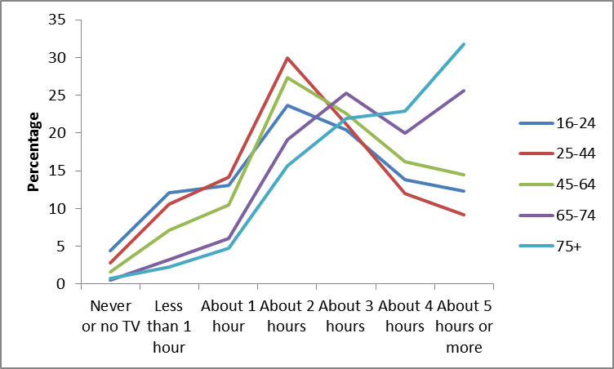
Notes
- Confidence intervals range between +/.04 and +/-3.2
- Values may not round to 100 per cent due to rounding

Television and radio technology

The vast majority of adults in England (92.5%) have a main television in the household that allows the watching of additional channels (other than BBC1, BBC2, ITV, C4 and Channel 5). Satellite systems are the most popular ways to receive these channels (46.3%), followed by Freeview systems (38.2%) and cable (14.6%). Of those who do not have access to additional channels (7.1% of households), 20.3 per cent had plans to access additional channels on their main television in the next 12 months.

Over a third of people (37.7%) reported that they watched video-on-demand television. Of those that don’t, only 8.8 per cent said they were very or fairly likely to watch it in the next 12 months.

Most people (90.4%) have a radio in their household. Of those who have a radio, 57.2 per cent had a digital radio. In the next 12 months, 11.2 per cent of all those surveyed had plans to buy a digital radio or an additional one.

Almost a third of people (32.4%) have used a Wii Fit or similar computer based exercise device with 29.8 per cent of men and 34.9 per cent of women having used one. Over half (52.1%) of 16-24 year olds have used one while 15.7 per cent of 65-74 year olds and 5.0 per cent of those aged 75 and over have also used one.

Cinema attendance

Taking Part asks a range of questions on cinema visiting. Almost half (47.7%) of adults say they go to the cinema in their spare time. More specifically, 53.2 per cent of people report that they have been to see a film at a cinema or other venue in the last 12 months.

Of those who have been to the cinema in the last 12 months, 3.0 per cent of people go at least once a week, 25.2 per cent go less often than this but at least once a month, and 44.9 per cent of people go at least 3-4 time a year. Meanwhile, 26.9 per cent of people had been once or twice in the last 12 months (Figure 1.2).

Figure 1.2: Frequency of cinema visits in the last 12 months, by age, 2010/11

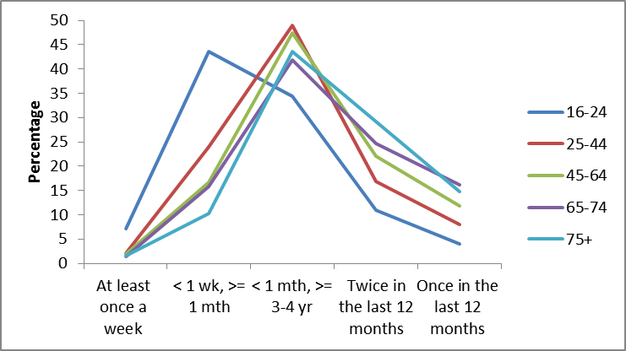
Notes
- Confidence intervals range between +/-0.6 and +/-7.1.

Newspapers

Over half of respondents (55.4%) read a daily newspaper on at least three occasions in the week before interview. The daily newspaper read the most often was The Sun (17.8%), followed by the Daily Mail (15.9%) and local daily newspapers (9.3%).

- Child engagement

The Taking Part child questionnaires cover children aged 5-15 years.

The 11-15 child survey was added in January 2006, interviewing a randomly selected child in those households containing at least one child aged 11-15. In 2008/09, the child survey was broadened to include children aged 5-10. Interviews for those aged 5-10 are conducted with the adult respondent by proxy and, due to this, the 5-10 survey is limited to asking about activities undertaken out of school (with the exception of some questions on competitive sport). For 11-15 year olds, the questionnaire is asked directly and covers both in and out of school activities.

This chapter provides headline figures on child participation in culture and sport alongside new data on participation in competitive sport.

Key findings

- In 2010/11, the majority of children had engaged with the arts in the last year, including 98.2 per cent of 5-10 year olds and 99.0 per cent of 11-15 year olds.

- 72.6 per cent of 5-10 year olds and 69.3 per cent of 11-15 year olds had visited a heritage site in the last 12 months. In 2010/11, 75.6% of children had visited a library in the last 12 months. This has remained steady since 2008/09.

- 89.7 per cent of children had done sport in the last 4 weeks; 85.4 per cent of 5-10 year olds and 94.5 per cent of 11-15 year olds. This is unchanged from 2008/09.

- In January to March 2011, 79.5 per cent of 5-15 year old children had done some form of competitive sport in the last 12 months. Almost three quarters (74.9%) had taken part in competitive sport in school, whilst 40.6 per cent had taken part outside of school.

Arts

In 2010/11, most children (98.6%) had engaged with the arts in the last year. This includes 98.2 per cent of 5-10 year olds and 99.0 per cent of 11-15 year olds. These figures have remained steady since 2008/09.

In 2008/09, a greater proportion of 5-10 year old girls (98.4%) than boys (96.1%) had engaged with the arts in the last year. In 2010/11, the difference between boys and girls no longer existed, largely due to a rise in the percentage of boys engaging with the arts (Figure 2.1).

Figure 2.1: The percentage of 5-10 year old children who engaged with the arts in the last 12 months, by age, 2008/09 and 2010/11

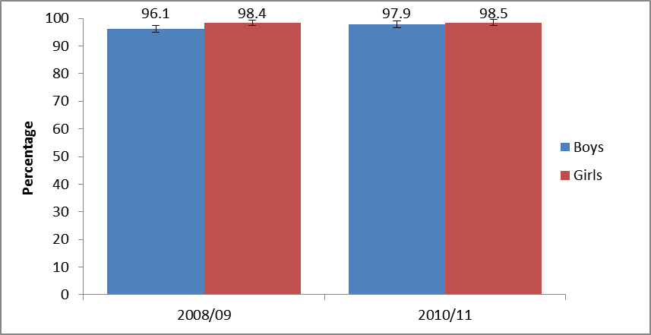
Notes
- Confidence intervals range between +/-0.9 and +/-1.5
- Data for 5-10 year olds relates to out of school participation only. Data for 11-15 years olds relates to participation both in and out of school

The proportion of 5-10 year olds who had engaged with the arts in the last week has increased from 2008/09 (81.1%) to 2010/11 (84.8%).

Compared to 2008/09, the proportion of 5-10 year olds doing reading and writing activities and film or video activities increased in 2010/11, whilst the proportion doing music activities fell. Amongst 11-15 year olds the percentage doing dance activities and computer activities fell while participation in other activities remained steady (Table 2.1).

Table 2.1: Changes in the percentage of children doing various arts activities from 2008/09 to 2010/11

 | 2008/09 | 2009/10 | Percentage point change
5-10 year olds
Reading and writing activities | 87.7 | 90.5 | 2.8
Film or video activities | 49.0 | 58.5 | 9.5
Music activities | 55.3 | 50.7 | -4.6
11-15 year olds
Dance activities | 51.9 | 45.4 | -6.5
Computer activities | 70.8 | 66.5 | -4.3
Notes
- Confidence intervals range between +/-1.6 and +/-3.6
- Data for 5-10 year olds relates to out of school participation only. Data for 11-15 years olds relates to participation both in and out of school
- All changes statistically significant

Amongst both 5-10 and 11-15 year olds, activities such as dance, theatre and drama, reading and writing, and arts and crafts are more popular with girls than boys. Amongst 5-10 year olds, girls were also more likely to have done music activities than boys.

Heritage

In 2010/11, 71.6 per cent of children had visited a heritage site in the last 12 months, including 72.6 per cent of 5-10 year olds and 69.3 per cent of 11-15 year olds.

The percentage of children who visited a heritage site in the last week was higher in 2010/11 (8.4%) than in 2008/09 (5.0%). This increase is seen across both the 5-10 (from 5.7% to 9.0%) and 11-15 (from 4.2% to 7.8%) year old age groups.

When 11-15 year olds were asked who they had done heritage activities with (in the last week), over three quarters (80.6%) said parents/guardians while 63.1 per cent said they had been with a sibling or other relative. Smaller proportions had done these activities with friends (12.5%) or on a school trip (5.4%).

Libraries

In 2010/11, 75.6% of children had visited a library in the last 12 months. This has remained steady since 2008/09.

Since 2008/09, the proportion of 5-10 year olds who had visited a library increased from 72.2 per cent to 76.4 per cent. However, during the same period, the proportion of 11-15 year olds who had visited a library fell from 78.6 per cent to 74.4 per cent (Figure 2.2).

Figure 2.2: The percentage of children who visited a public library in the last 12 months, by age, 2008/09 and 2010/11

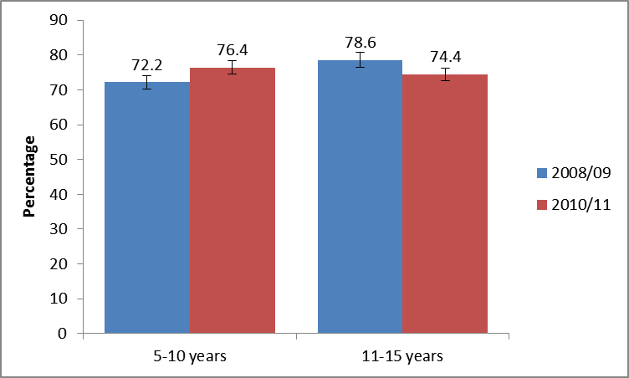
Notes
- Confidence intervals range between +/-2.3 and +/-2.8
- Data for 5-10 year olds relates to out of school visits only. Data for 11-15 years olds relates to visits both in and out of school

The decrease in the number of 11-15 year olds visiting libraries appears to be largely driven by a decrease in the proportion of girls in this age group visiting (from 82.0% in 2008/09 to 75.9% in 2010/11).

When 11-15 year olds were asked who they had done library activities with outside school, just over two-thirds (68.8%) said they had visited with their parents, whilst 14.2 per cent had visited alone, and about one in five (19.2%) had visited with friends (Figure 2.3).

Figure 2.3: Who 11-15 year olds visit public libraries with, 2010/11

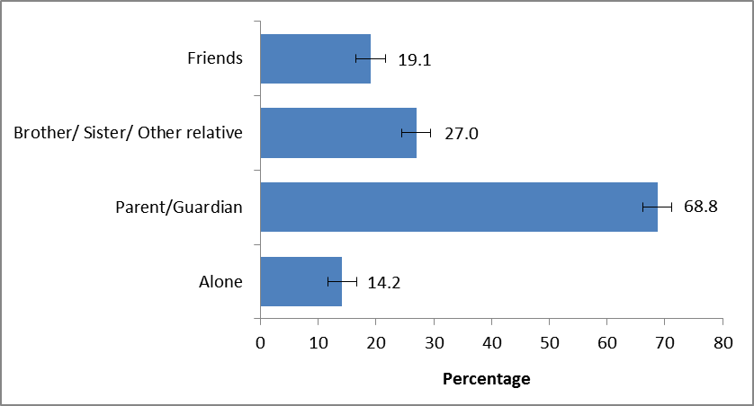
Notes
- Confidence intervals range between +/-4.6 and +/-6.1

Museums

In 2010/11, 64.7 per cent of children had visited a museum in the last 12 months; 67.6 per cent of 5-10 year olds and 60.7 per cent of 11-15 year olds. This has remained steady since 2008/09.

Sport

In 2010/11, 89.7 per cent of children had done sport in the last 4 weeks; 85.4 per cent of 5-10 year olds and 94.5 per cent of 11-15 year olds. This is unchanged from 2008/09.

In both the 5-10 and 11-15 age groups, boys were more likely to have done sport in the last 4 weeks than girls (Figure 2.4).

Figure 2.4: The percentage of children who did sport in the last 4 weeks, by age and sex, 2010/11

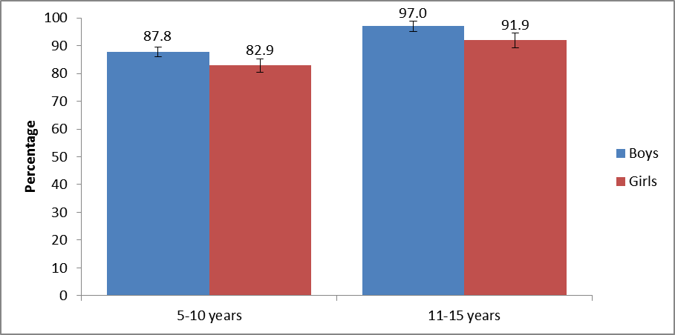
Notes
- Confidence intervals range between +/-1.4 and +/-3.0
- Data for 5-10 year olds relates to out of school participation only. Data for 11-15 years olds relates to participation both in and out of school

Children with a limiting long-term illness/disability were significantly less likely to have done sport in the last 4 weeks than those who did not have one (78.5% compared to 90.4%).

When asked who they did sport with outside school in the last 7 days, over half of 11-15 year olds had done sport with friends (52.2%), whilst almost a third had done it with a parent/guardian (32.6%) or a sibling/other relative (30.1%). Meanwhile, 16.5 per cent had done sport at an after school club (Figure 2.5).

Figure 2.5: Who 11-15 year olds play sport with, 2010/11

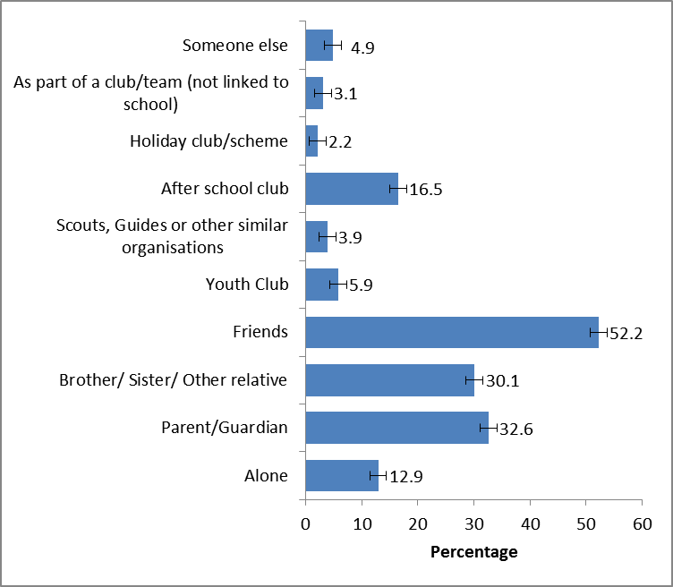
Notes
- Confidence intervals range between +/-0.8 and +/-2.9

Individual sports

Swimming, diving or lifesaving was the most common sport amongst 5-10 year old children, with almost half (48.3%) of all children in this age group doing this in the last 4 weeks. More than a third had played football (35.9%), and more than a quarter (28.0%) had been cycling (Table 2.2).

Table 2.2: The top ten sports done by 5-10 year olds in the last 4 weeks, 2010/11

Sport | % | +/-
Swimming, diving or lifesaving | 48.3 | 2.8
Football (include five-a-side) | 35.9 | 2.7
Cycling or riding a bike | 28.0 | 2.5
Walking or hiking | 23.1 | 2.4
Gym, gymnastics, trampolining or climbing frame | 15.2 | 2.0
Tenpin bowling | 9.6 | 1.7
Martial arts - Judo, Karate, Taekwondo and other Martial Arts | 7.2 | 1.5
Tennis | 6.9 | 1.4
Cricket | 6.6 | 1.4
Rounders | 6.2 | 1.4
Notes
- These figures only include activities done outside of school only

Football was the most common sport amongst 11-15 year olds, with half (50.0%) of all children this age having played in the last 4 weeks. Basketball (27.3%) was the second most common, followed by swimming, diving or lifesaving (26.6%) (Table 2.3).

Table 2.3: The top ten sports done by 11-15 year olds in the last 4 weeks, 2010/11

Notes
Sport | % | +/-
Football (include five-a-side) | 50.0 | 3.1
Basketball | 27.3 | 2.8
Swimming, diving or lifesaving | 26.6 | 2.8
Gym, gymnastics, trampolining or climbing frame | 24.8 | 2.7
Walking or hiking | 22.5 | 2.6
Rounders | 20.9 | 2.6
Cycling or riding a bike | 20.4 | 2.5
Netball | 19.3 | 2.5
Badminton | 18.9 | 2.5
Rugby | 17.9 | 2.4
- These figures include sports activities done both in school and outside of school

Competitive sport

To support the aim of increasing the opportunities to participate in competitive sport among children, questions have been developed on this topic that now form a continuing part of the child questionnaires. This section presents the first results for this topic, based on the questions introduced in January 2011.

In January to March 2011, 79.5 per cent of 5-15 year old children reported they had done some form of competitive sport in the last 12 months. Almost three quarters (74.9%) had taken part in competitive sport in school, whilst 40.6 per cent had taken part outside of school.

In school

In January to March 2011, almost two thirds (63.9%) of 5-10 year olds played sport at school in organised competitions (such as a sports day). Meanwhile, 44.1 per cent of 11-15 year olds had participated in competitive sport in this way.

For 11-15 year olds, playing sport against others in PE and games lessons (74.9%) was the most common way of doing competitive sport, whilst being a member of a club that plays sport (31.9%) was the least common (Figure 2.6).

Figure 2.6: The percentage of 11-15 year olds who did competitive sport in school, January to March 2011

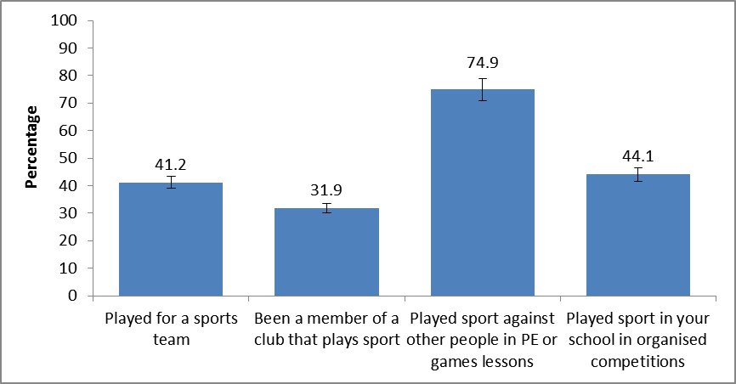
Notes
- Confidence intervals range between +/-5.2 and +/-6.0
- Competitive sport questions were introduced to Taking Part in January 2011.

Among 11-15 year olds, boys were more likely than girls to participate in competitive sport in school. The exception is playing sport against other people in PE or games lessons (Figure 2.7).

Figure 2.7: The percentage of 11-15 year olds who did competitive sport in school, by sex, January to March 2011

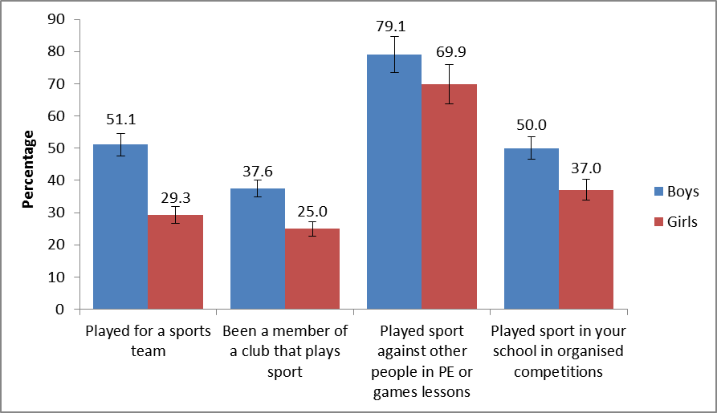
Notes
- Confidence intervals range between +/-6.2 and +/-9.1
- Competitive sport questions were introduced to Taking Part in January 2011.

Outside school

In January to March 2011, almost a third (30.3%) of 11-15 year olds belonged to a sports club, making this the most common means of doing competitive sport outside school. Over a fifth (22.5%) played for a sports team (Figure 2.8).

Figure 2.8: The percentage of 5-15 year olds who did competitive sport outside school, January to March 2011

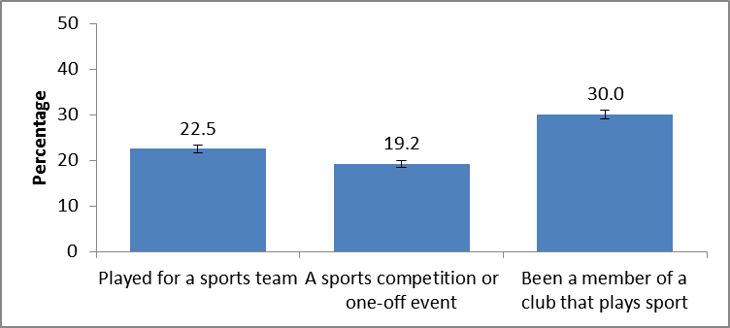
Notes
- Confidence intervals range between +/-3.2 and +/-3.7
- Competitive sport questions were introduced to Taking Part in January 2011.

Boys were also more likely than girls to participate in competitive sport out of school. For all three of the activities described above, fewer than half as many 11-15 year old girls did the activities compared to 11-15 year old boys (Figure 2.9).

Figure 2.9: The percentage of 5-15 year olds who did competitive sport outside school, by sex, January to March 2011

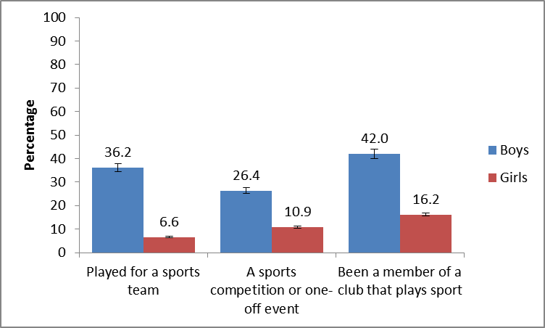
Notes
- Confidence intervals range between +/-3.0 and +/-4.9
- Competitive sport questions were introduced to Taking Part in January 2011.

- The influence of childhood participation on adult participation

This chapter examines the extent to which childhood participation in culture and sport influences adult participation. Analysis presented here is supported by multivariate analysis of Taking Part which demonstrates that childhood participation is a strong driver of adult participation.

Key findings

- Adults who participate in culture and sport tend to be more likely to have done the same activities as a child. However, the influence of childhood participation is stronger in some sectors.

- In general, adults were more likely to participate in culture and sport when they were children than as adults, e.g. while 86.0 per cent of adults had played sport when they were children, far fewer (53.0%) had done so in the last 4 weeks. The exception is heritage – 56.8 per cent of adults had visited a heritage site as a child while 70.7 per cent had visited in the last 12 months.

The relationship between childhood and adult participation in culture and sport
The relationship between childhood and adult participation is well established (e.g. Buraimo et al. 2010 and 2011) and, in general, adults who participate in culture and sport are more likely to have done the same activities as a child.
The influence of childhood participation is stronger in some sectors. For example, only a very small proportion (3.7%) of adults who paint or draw did not do this activity when they were a child. Meanwhile, 59.0 per cent of adults who had visited a heritage site in the last 12 months had not visited a heritage site as a child.

Child participation
In general, adults were more likely to participate in culture and sport when they were children than as adults, e.g. while 86.0 per cent of adults had played sport when they were children, far fewer (53.0%) had done so in the last 4 weeks. The exception is heritage – 56.8 per cent of adults had visited a heritage site as a child while 70.7 per cent had visited in the last 12 months (Figure 3.1).

Figure 3.1: Adult and childhood participation in culture and sport, 2010/11
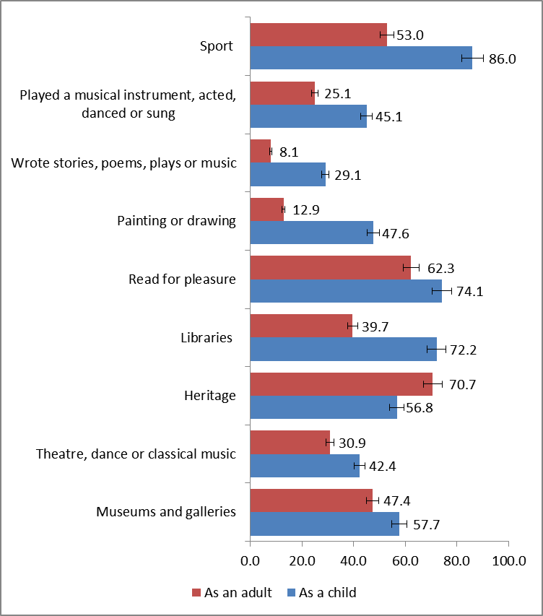
Notes
- Confidence intervals range between +/-0.5 and +/-1.4.

Museums and galleries
In 2010/11, 47.4 per cent of adults had visited a museum or gallery in the last 12 months; 57.7 per cent had visited as a child (aged 11-15). Among those who had visited a museum or gallery as a child, 58.0 per cent also visited as an adult. Meanwhile, among those adults who had not visited a museum or gallery as child, a smaller proportion (33.3%) had visited as an adult (Figure 3.2).

Figure 3.2: The percentage of adults who visited a museum or gallery in the last 12 months, comparison between those who visited as a child and those who did not, 2010/11
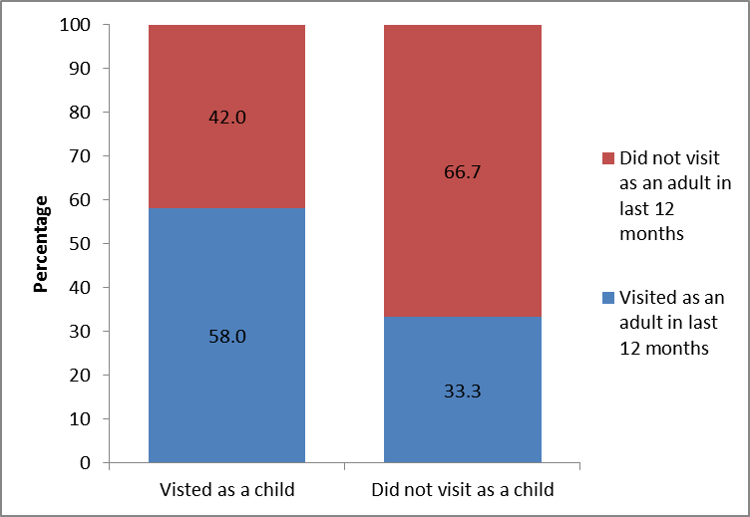
Notes
- Confidence intervals range between +/-1.8 and +/-2.0

Heritage
In 2010/11, over two-thirds (70.7%) of adults had visited a heritage site in the last 12 months. A smaller proportion (56.8%) had visited as a child.
For heritage, the influence of childhood participation is less marked than it is for other sectors. Among those adults who had visited a heritage site as a child, 82.3 per cent also visited as an adult. However, a still sizeable proportion of adults – 59.0 per cent –who did not visit a heritage site as a child, had visited as an adult (Figure 3.3).

Figure 3.3: The percentage of adults who visited a heritage site in the last 12 months, comparison between those who visited as a child and those who did not, 2010/11

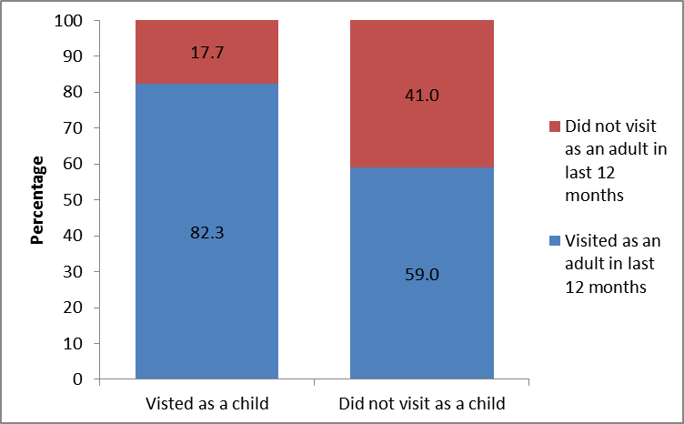
Notes
- Confidence intervals range between +/-1.4 and +/-2.0

The arts
In 2010/11, 30.9 per cent of adults has been to the theatre or seen a dance or classical music performance in the last 12 months; 62.3 per cent had read for pleasure; 12.9 per cent had done painting or drawing; 8.1 per cent had written stories, plays, poetry or music; and 25.1 per cent had played a musical instrument, acted, danced or sung.
Adults were more likely to have taken participated in all these arts activities when they were children: 42.4 per cent went to the theatre; 74.1 per cent read; 47.6 per cent painted or drew; 29.1 per cent wrote stories etc.; and 45.1 per cent played a musical instrument etc.
For the arts, the influence of childhood participation is greater than it is for other sectors. For example, among those adults who had seen theatre, dance or classical music as a child, 43.5 per cent had also done so as an adult in the last 12 months (Figure 3.4).

Figure 3.4: The percentage of adults who went to see theatre, dance or classical music in the last 12 months, comparison between those who did the same activities as a child and those who did not, 2010/11
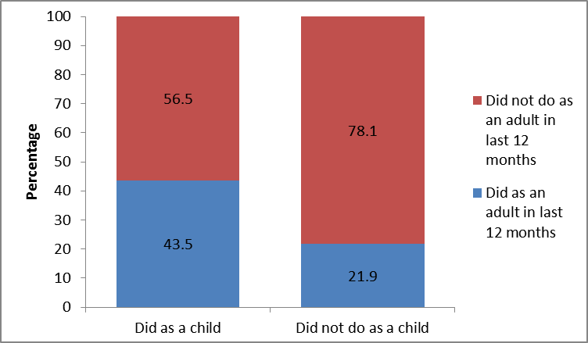
Notes
- Confidence intervals range between +/-0.6 and +/-2.7

Sport
In 2010/11, 53.0 per cent of adults had done sport in the last 4 weeks; 86.0 per cent had done so as a child. Among those who had done sport as a child, 56.4 per cent had also done sport in the last 4 weeks. Meanwhile, among those adults who did not play sport as child, a smaller proportion (36.3%) had done so in the last 4 weeks (Figure 3.5).

Figure 3.5: The percentage of adults who played sport in the last 4 weeks, comparison between those who played sport as a child and those who did not, 2010/11

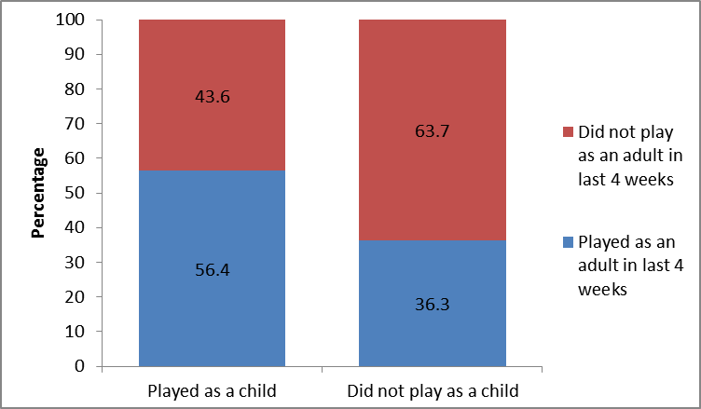
Notes
- Confidence intervals range between +/-1.5 and +/-3.5.

Libraries
In 2010/11, 39.7 per cent of adults had visited a public library. Meanwhile, almost three-quarters (72.2%) had visited as a child. Among those adults who had visited a library as a child, 47.0 per cent also visited as an adult. A smaller proportion (24.8%) of adults who had not visited a library as a child, visited as an adult (Figure 3.6).

Figure 3.6: The percentage of adults who visited a library in the last 12 months, comparison between those who visited as a child and those who did not, 2010/11

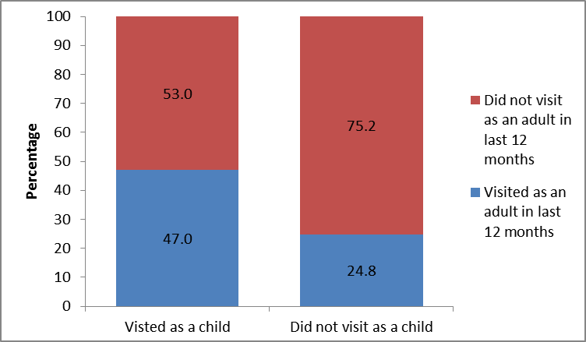
Notes
- Confidence intervals range between +/-1.6 and +/-2.3.

- Sport and active recreation

This chapter examines sport and active recreation. In particular, it examines the extent to which people have played sport, the most popular sport and recreational activities, enjoyment and barriers to sport participation. In looking at the overall amount of activity reported, it extends upon the narrower definition of sport presented in the regular quarterly reports. The results for sport are summarised at the close of this chapter.

Key findings

- In 2010/11, 54.1 per cent of adults had done some sport or recreational physical activity in the last 4 weeks while 71.7 per cent had done so in the last 12 months.

- Men are more likely to have done sport or recreational physical activity than women. This is true for the 4 week measure (61.8% of men; 46.7% of women) and the 12 month measure (77.7% of men; 65.9% of women).

- The majority of adults enjoyed the sporting activity they participated in, with 88.5 per cent of adults rating their enjoyment as 6 or more.

- Three-quarters of adults have recommended sporting activity to a friend or family member.

Participation in sport or recreational physical activities in the last 4 weeks

In 2010/11, 54.1 per cent of adults had done some sport or recreational physical activity in the last 4 weeks while 71.7 per cent had done so in the last 12 months.

Men are more likely to have done sport or recreational physical activity than women, both in the last 4 weeks (61.8% compared with 46.7%) and in the last 12 months (77.7% compared with 65.9%) (Figure 4.1).

Figure 4.1: Percentage of adults who have participated in sport or recreational physical activities during the last 4 weeks and 12 months, by sex, 2010/11

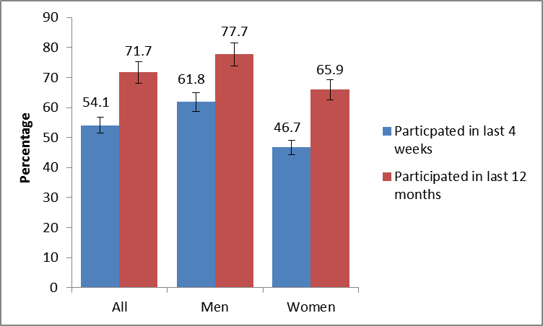
Notes
- Confidence intervals range between +/-0.9 and +/-1.5

The most popular activities sport or recreational physical activities are health, fitness, gym or conditioning activities (14.6%) and indoor swimming or diving (14.4%). The second most popular activity is cycling for health, recreation, training and competition purposes (10.6%). Joint third are jogging, cross-country, road running (7.6%), keepfit, aerobics, dance exercise (7.1%) and outdoor football (7.1%) (Table 4.1).

Table 4.1: Top 5 sport or recreational physical activities in the last 4 weeks, 2010/11

Activity | % | +/-
Health, fitness, gym or conditioning activities | 14.6 | 0.7
Swimming or diving [indoors] | 14.4 | 0.7
Cycling [health, recreation, training, competition] | 10.6 | 0.6
Jogging, cross-country, road running | 7.6 | 0.5
Keepfit, aerobics, dance exercise (include exercise bike) | 7.1 | 0.5

Three of the top 5 sport or recreational physical activities also appear in the top 5 list for men, namely health, fitness, gym or conditioning activities (done by 15.5% of men), indoor swimming or diving (12.4%) and cycling for health, recreation, training and competition purposes (14.0%). Football is the third most popular sport among men (13.2% had played in the last 4 weeks while snooker, pool and billiards is the fifth most popular sport (10.9%) (Table 4.2).

Table 4.2: Top 5 sport or recreational physical activities that men participated in during the last 4 weeks, 2010/11

Activity | % | +/-
Health, fitness, gym or conditioning activities | 15.5 | 1.1
Cycling [health, recreation, training, competition] | 14.0 | 1.1
Football (include 5-a-side and 6-a-side) [outdoors] | 13.2 | 1.1
Swimming or diving [indoors] | 12.4 | 1.0
Snooker, pool, billiards (exclude bar billiards) | 10.9 | 1.0

The top 5 sport/recreation physical activities undertaken by people in the last 4 weeks, also appear in the top 5 list for women, albeit in a different order. For women, the most popular activity undertaken in the last 4 weeks was indoor swimming or diving (16.2%), second most popular was health, fitness, gym or conditioning activities (13.7%), third most popular was keepfit, aerobics, dance exercise (including exercise bikes) (10.4%), fourth most popular was cycling for health, recreation, training and competition purposes (7.4%) and fifth most popular was jogging, cross-country, road running (5.2%) (Table 4.3).

Table 4.3: Top 5 sport or recreational physical activities that women participated in during the last 4 weeks, 2010/11

Activity | % | +/-
Swimming or diving [indoors] | 16.2 | 0.9
Health, fitness, gym or conditioning activities | 13.7 | 0.9
Keepfit, aerobics, dance exercise (include exercise bike) | 10.4 | 0.8
Cycling [health, recreation, training, competition] | 7.4 | 0.6
Jogging, cross-country, road running | 5.2 | 0.6

Participation in sport or recreational physical activities in the last 12 months

In 2010/11, 71.7 per cent of adults had participated in sport or recreational physical activities in the last 12 months.

The top 3 sport or recreational physical activities that adults participated in during the last 12 months, namely indoor swimming or diving, health, fitness, gym or conditioning activities and cycling for health, recreation, training and competition purposes also appear in the top 3 activities that adults participated in during the last 4 weeks, albeit in a different order. However, indoor swimming or diving is still the most popular activity with almost a third of people (31.6%) having participated. Second most popular is health, fitness, gym or conditioning activities (21.8%), third most popular is cycling for health, recreation, training and competition purposes (18.0%). In joint fourth place is outdoor swimming or diving (13.6%), snooker, pool, billiards (13.5%) and Tenpin bowling (13.0%). This indicates that activities such as snooker, pool, billiards and Tenpin bowling are popular but not undertaken on such a regular basis as indoor swimming or diving, health, fitness, gym or conditioning activities and cycling (Table 4.4).

Table 4.4: Top 5 sport or recreational physical activities that adults participated in during the last 12 months, 2010/11

Activity | % | +/-
Swimming or diving [indoors] | 31.6 | 0.9
Health, fitness, gym or conditioning activities | 21.8 | 0.8
Cycling [health, recreation, training, competition] | 18.0 | 0.8
Swimming or diving [outdoors] | 13.6 | 0.7
Snooker, pool, billiards (exclude bar billiards) | 13.5 | 0.7

The top 5 activities for men in the last 12 months are the same as those for men in the last 4 weeks, albeit in a different order.

The most popular activity for men in the last 12 months was indoor swimming or diving (28.2%). This is followed by health, fitness, gym or conditioning activities (22.5%), cycling [for health, recreation, training, or competition] (22.3%), snooker, pool, billiards (21.4%), and outdoor football (19.1%) (Table 4.5).

Table 4.5: Top 5 sport or recreational physical activities that men participated in during the last 12 months, 2010/11

Activity | % | +/-
Swimming or diving [indoors] | 28.2 | 1.4
Health, fitness, gym or conditioning activities | 22.5 | 1.3
Cycling [health, recreation, training, competition] | 22.3 | 1.3
Snooker, pool, billiards (exclude bar billiards) | 21.4 | 1.3
Football (include 5-a-side and 6-a-side) [outdoors] | 19.1 | 1.2

The top 5 activities undertaken by women in the last 12 months match those undertaken by women in the last 4 weeks. Indoor swimming or diving is the most popular (34.7%), second most popular is health, fitness, gym or conditioning activities (21.1%), while third most popular is keepfit, aerobics, dance exercise (16.5%). In joint fourth place is cycling for health, recreation, training or competition purposes (14.0%) and outdoor swimming or diving (13.4%) (Table 4.6).

Table 4.6: Top 5 sport/recreational physical activities that women participated in during the last 12 months, 2010/11

Activity | % | +/-
Swimming or diving [indoors] | 34.7 | 1.2
Health, fitness, gym or conditioning activities | 21.1 | 1.0
Keepfit, aerobics, dance exercise (include exercise bike) | 16.5 | 0.9
Cycling [health, recreation, training, competition] | 14.0 | 0.9
Swimming or diving [outdoors] | 13.4 | 0.8

Enjoyment of activities and recommendation to friends and family

The majority of people enjoyed the sporting activities they participated in – 88.5 per cent of adults rated their enjoyment as 6 or more. This does not vary by sex (Figure 4.2).

Figure 4.2: Percentage of adults rating their enjoyment of the sporting activities they participated in, by sex, 2010/11

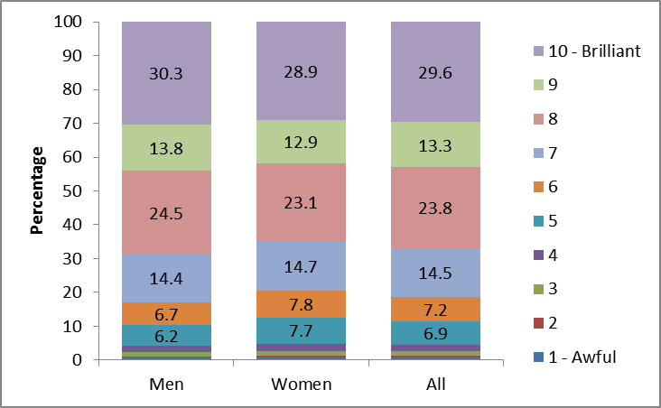
Notes
- Confidence intervals range between +/-0.2 and +/-1.7

When asked how likely is that they will participate in sport or active recreation again, men were more likely to answer ‘definitely’ (88.3%) than women (84.7%), however women (12.9%) were more likely than men (10.0%) to answer ‘probably’.

In 2010/11, 75.0 per cent of adults had recommended sporting activities to a friend or family member (74.6% of men and 75.4% of women).

Barriers to sport participation

The most common reasons for never playing sport include ‘I didn’t think I was healthy enough’ (22.0%) and ‘there are other things I prefer to do in my leisure time’ (21.8%). Table 4.7 shows the top five barriers cited for not playing sport.

Table 4.7: Reasons for not playing sport, 2010/11

Barrier | % | +/-
I didn’t think I was healthy enough | 22.0 | 2.6
There are other things I prefer to do in my leisure time | 21.8 | 2.6
I had too many responsibilities | 17.8 | 2.4
I didn’t think I would enjoy it | 14.4 | 2.2
I was worried that my health would suffer if I did this | 8.8 | 1.7

Participation in sport:

The following section summarises the key findings for sport participation reported in the June 2011 Taking Part Statistical Release.

In 2010/11, over half (53.0%) of adults had done active sport in the last 4 weeks, unchanged from 2005/06 (53.7%).

Between 2005/06 and 2010/11, the proportion of adults doing three or more 30 minute sessions of moderate intensity sport increased – from 23.3 per cent to 26.0 per cent.

Area-level factors

Those who live in the least deprived areas (59.6%) are more likely than those in the most deprived areas (46.1%) to take part in active sport. Meanwhile, the participation rate in the South East (57.4%) is higher than it is in the North East (47.4%), the North West (51.5%), the West Midlands (49.0%) and the South West (51.4%). Sports participation rates across the regions have not changed since 2005/06.

Socio-demographic factors

Between 2005/06 and 2010/11, there was an increase in the proportion of people aged 65-74 doing active sport (from 33.5% to 36.9%) and a corresponding decrease in the proportion of young people, aged 16-24, doing active sport (from 76.8% to 71.9%). Sports participation rates among the other age groups have remained steady across that period.

Men (60.4%) are more likely than women (45.9%) to have done active sport in the last 4 weeks. Sports participation rates among women have declined since 2005/06 (47.7%) while rates for men have remained steady.
- Attitudes to the 2012 Olympic and Paralympic Games

This chapter examines the extent to which people in England support the UK hosting the 2012 Olympic and Paralympic Games. It covers the reasons why people are either supportive of or against the UK hosting the 2012 Games, and provides analysis by a range of area level and socio-demographic variables.

Key findings

- People are generally supportive of the UK hosting the 2012 Olympic and Paralympic Games, with 66.7 per cent expressing some degree of support in 2010/11.

- Attitudes to the 2012 Games vary somewhat by region and people who live in London, the East of England and the South East have more favourable views.

- Attitudes to the 2012 Games also vary by disability, and people with a limiting illness or disability are more supportive than those without a limiting illness or disability.

Attitudes to the 2012 Olympic and Paralympic Games
In England, people are generally supportive of the UK hosting the 2012 Olympic and Paralympic Games. In 2010/11, 42.6 per cent of people said that they were ‘very supportive’ while 23.6 per cent said that they were ‘slightly supportive’. Since 2005/06, there has been an increase (from 22.5%) in the proportion who said they were slightly supportive of the 2012 Games and a decrease (from 48.4%) in the proportion who said they were strongly supportive.
Reasons for being strongly supportive of the UK hosting the 2012 Olympic and Paralympic Games vary widely and have changed considerably since 2006/07, when the question was first asked. For example, 32.3 per cent think that the 2012 Games will be good for the economy (up from 22.3% in 2006/07), 28.2 per cent think they will be good for the country more generally (down from 34.7% in 2006/07), and 9.7 per cent think that the 2012 Games will be good for tourism (up from 6.8% in 2006/07) (Table 5.1).

Table 5.1: Reasons for being strongly supportive of the UK hosting the 2012 Olympic and Paralympic Games, 2006/07 to 2010/11

 | 2006/07 | 2007/08 | 2008/09 | 2010/11
 | % | % | % | %
Good for London | 6.8 | 6.7 | 6.2 | 6.0
Good for the country | 34.7 | 32.6 | 33.2 | 28.2
Promotes sport and fitness | 20.1 | 19.8 | 17.7 | 18.0
Good for children and young people | 14.1 | 15.3 | 13.3 | 13.8
I want to go and see it | 8.1 | 9.9 | 12.0 | 10.8
National pride | 5.9 | 4.9 | 5.5 | 4.3
Regeneration of the east end of London | 8.6 | 7.9 | 6.4 | 5.2
I like athletics/sport | 8.2 | 8.4 | 8.2 | 9.7
Good for tourism | 6.8 | 7.4 | 6.8 | 9.7
Good for the economy | 22.3 | 25.2 | 22.2 | 32.3
Good for athletes | 2.6 | 4.6 | 4.1 | 3.2
Notes
- Confidence intervals range between +/-0.7 and +/-1.7.
- Question not asked in 2005/06 or 2009/10.
- Bold figures indicate a significant change from 2006/07.

In 2010/11, 5.1 per cent of people said that they were strongly against the UK hosting the 2012 Olympic and Paralympic Games, unchanged from 2005/06 (5.2%). Reasons for being strongly against the UK hosting the 2012 Olympic and Paralympic Games vary widely and have changed considerably since 2006/07. Between 2006/07 and 2010/11, the proportion of people who said that they thought the 2012 Games cost too much fell from 48.8 per cent to 21.1 per cent. However, there was an increase in the proportion of people who thought that the 2012 Games was a waste of money (from 18.6% to 24.7%) (Table 5.2).

Table 5.2: Reasons for being strongly against the UK hosting the 2012 Olympic and Paralympic Games, 2006/07 to 2010/11

 | 2006/07 | 2007/08 | 2008/09 | 2010/11
 | % | % | % | %
Costs too much | 48.8 | 42.2 | 42.1 | 21.1
Money better spent elsewhere | 19.3 | 20.4 | 15.8 | 14.4
Should be elsewhere in country | 12.6 | 8.5 | 6.6 | 6.5
Waste of money | 18.6 | 21.2 | 21.6 | 24.7
Security fears | 2.2 | 3.4 | 2.2 | 1.6
Don't think UK will do a good job | 6.5 | 4.3 | 4.0 | 1.2
Don't like sports or athletics | 2.2 | 2.6 | 2.5 | 2.8
It will only benefit London | 6.7 | 3.8 | 2.7 | 3.5
Notes
- Confidence intervals range between +/-0.5 and +/-2.0.
- Question not asked in 2005/06 or 2009/10.
- Bold figures indicate a significant change from 2006/07.

Area level factors
Overall, 66.7 per cent of people are supportive of the UK hosting the 2012 Olympic and Paralympic Games. While people who live in the most deprived neighbourhoods of England are less supportive of the 2012 Games than those who live in the least deprived neighbourhoods (64.3% compared with 69.3%), there is relatively little variation in attitudes between the extremes of deprivation (Figure 5.1).

Figure 5.1: Attitudes to the 2012 Olympic and Paralympic Games, 2010/11, by deprivation
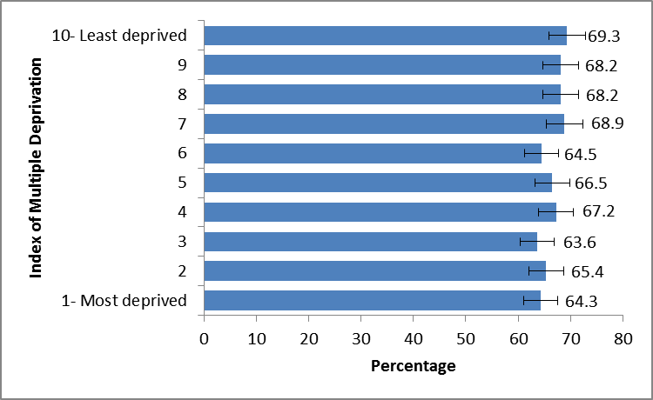
Notes
- Confidence intervals range between +/-2.8 and +/-3.2.

Attitudes to the 2012 Games vary somewhat by region and people who live in London, the East of England and the South East have the most favourable views. For example, people who live in London (69.3%) are more supportive of the 2012 Games than people who live in the North East (63.7%), Yorkshire and Humberside (62.8%), the East Midlands (62.6%) and the South West (63.4%) (Figure 5.2).

Figure 5.2: Attitudes to the 2012 Olympic and Paralympic Games, 2010/11, by region
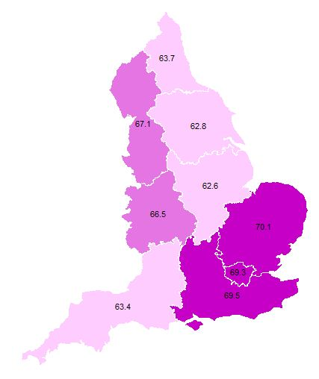
Notes
- Confidence intervals range between +/-2.3 and +/-4.1

Within London, there are further variations in people’s attitudes to the 2012 Olympic and Paralympic Games. In particular, people who live to the east of the six host boroughs (in Redbridge, Havering and Bexley) tend to be less supportive of the 2012 Games while people in the far west of London tend to be more supportive (Figure 5.3).

Figure 5.3: Attitudes to the 2012 Olympic and Paralympic Games, 2010/11, London

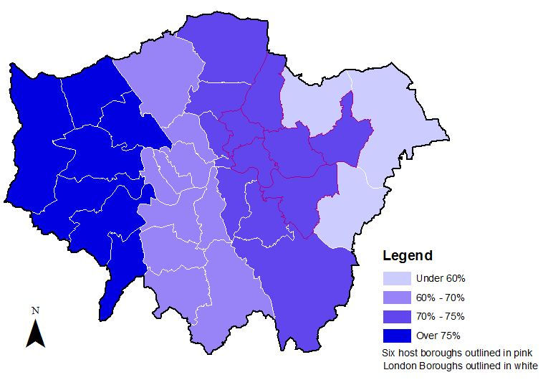
Notes
- Due to small sample sizes, percentages are indicative only

Socio-demographic factors
Younger people are generally more supportive of the 2012 Olympic and Paralympic Games than older people. In 2010/11, those aged 16-24 (69.2%), 25-44 (69.3%) and 67.1%) are more likely than those aged 65-74 (61.7%) and 75+ (57.9%) to be supportive of the 2012 Games.
Men (69.9%) have more favourable views than women (63.7%) and BME people (77.6%) are more supportive of the 2012 Games than white people (65.4%).
There is also a fairly clear socio-economic divide in attitudes to the 2012 Games. For example, those in the upper socio-economic groups (68.9%) are more supportive than those in the lower socio-economic groups (62.5%), those who are working (70.1%) have more favourable views than those who are not in paid employment (61.7%), and people who live in social housing (59.8%) have less favourable views than those who are owner occupiers (67.7%) or who rent privately (68.6%).
Attitudes to the 2012 Games also vary by disability, and people with a limiting illness or disability (68.6%) are more supportive than those without a limiting illness or disability (59.8%) (Figure 5.4).

Figure 5.4: Attitudes to the 2012 Olympic and Paralympic Games, 2010/11, by disability
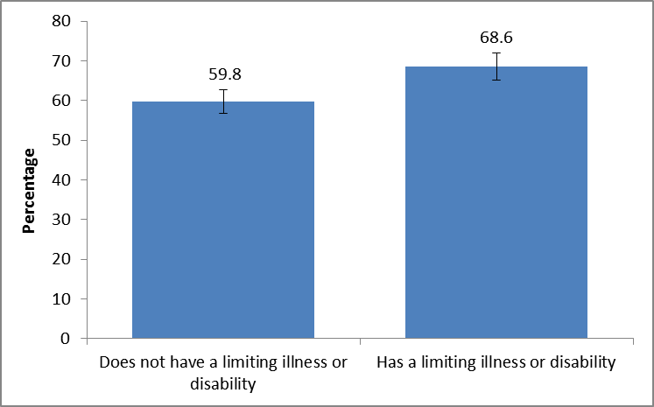
Notes
- Confidence intervals range between +/-1.2 and +/-1.5.

- Digital engagement

The focus of the Taking Part survey through its first six years has been participation in the traditional sense, that is, generally defined by making physical visits to actual sites or doing traditional activities such as drawing or playing an instrument. This chapter looks at the increasingly broad range of data collected by Taking Part on digital engagement and, in particular, how those participating in this way overlaps with the more traditional forms of participation. Throughout, we refer to these traditional forms as ‘actual’ participation by way of shorthand.

Key findings

- In 2010/11, the highest combined actual and digital participation is found in the heritage sector - 71.2% of adults participated in person or took a virtual historical tour.

- The greatest discrepancy in percentages of adults participating in person and those participating digitally is found in the heritage sector. Only 0.5 per cent of adults had attended through digital only means compared to 63.6 per cent who had only attended in person (7.1% had attended both in person and digitally).

- The lowest combined actual and digital participation is found in the archive centres/record offices sector (11.6%).

- Archives are the only sector where the percentage of adults participating by digital means only exceeds the percentage participating in person. In 2010/11, 2.3 per cent of adults visited an archive in person only and 7.6 per cent participated by digital means only (1.7% had attended both in person and digitally).

- The sport sector had the highest percentage of digital-only participants; with 11.6 per cent of adults only participating in sport using a Wii Fit or similar exercise device (including adults who also did active sport in the last 4 weeks, then 34.3% of adults had virtually participated in sport).

Digital participation

Digital participation for museums and galleries, archives, libraries, heritage and theatres/concerts, is defined as visiting websites for purposes such as viewing an online gallery collection, taking a virtual tour of a historic site or viewing an arts performance, but excluding web visits for information on opening hours or to buy tickets. The full list of activities included can be found in Annex B. For sport, digital participation is defined as using a Wii Fit or similar exercise device to take part in sport or active recreation.

The majority of respondents (82.0%) have access to the internet at home or have another member of the household who has access. Almost three quarters (74.8%) have accessed the internet at home on a computer, while 33.5 per cent have accessed the internet at work, and 23.4 have done so on a mobile device (such as a smartphone, palmtop or PDA). 22.2 per cent have accessed the internet from a friend or relative’s house.

Comparisons have been made with 2008/09 as that is the first year for which a comparable set of variables are available.

Overall digital participation

Findings presented in the June 2011 Taking Part Statistical Release showed that, in 2010/11, 35.3 per cent of adults had digitally participated in culture, an increase from 2008/09 (25.1%).

Those living in rural areas were just as likely as those in urban areas to have digitally participated in culture but there are variations by region. In 2010/11, digital participation was highest in London (42.1%) and lowest in Yorkshire and Humberside (28.6%). Between 2008/09 and 2010/11, there were increases in the proportion of people participating digitally in all nine English regions.

Meanwhile, those in the least deprived areas (based on the Index of Multiple Deprivation) have almost double the digital participation rate (45.7%) of those in the most deprived areas (24.8%). People in the higher ACORN groups such as Wealthy Achievers (41.5%) and Urban Prosperity (47.2%) had higher digital participation rates than the Hard-Pressed (24.0%).

Men had similar participation rates to women with 36.1 per cent and 34.6 per cent respectively. In 2010/11, those aged 25-44 had the highest digital participation rates (42.5%) and those aged 75+ the lowest (9.1%) (Figure 6.1).

Figure 6.1: Percentage of adults who have digitally participated in culture, 2010/11, by age

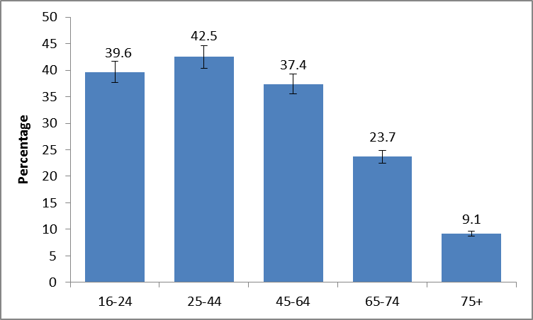
Notes
- Confidence intervals range between +/-1.4 and +/-3.6.

Types of website visited

Figures to visits to websites include visits that were for any purpose, for example to find out about an exhibition or opening hours, which are excluded from the overall measure of digital participation used later. These questions are consistent from the first year of the survey (2005/06) onwards.

Across the various types of websites, in 2010/11, theatre and concert websites were the most popular (42.6%), followed by sport (36.4%), heritage (26.7%), museums or gallery (25.0%), libraries (15.5%) and archives or records office (10.9%) websites. Between 2005/06 and 2010/11, the proportion of people visiting all types of culture and sport websites increased (Figure 6.2).

Figure 6.2: Percentage of adults who have visited a cultural or sport website, 2005/06 to 2010/11

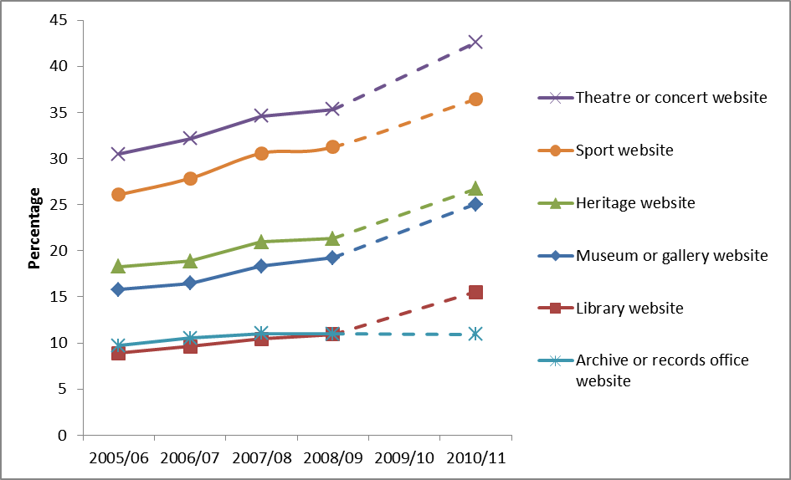
Notes
- Confidence intervals range between +/-0.6 and +/-1.1
- The question on websites visited was not asked in the 2009/10 survey.

The percentage of people visiting museum and gallery websites to find out about or order tickets for an exhibition or event increased from 47.9 per cent in 2005/06 to 54.5 per cent in 2010/11, whereas the percentage looking at items from a collection dropped from 33.7 to 22.3 per cent during the same period.

Museums and galleries

In 2010/11, 47.4 per cent of adults had been to a museum or gallery, whereas 49.9 per cent of adults had been in person or participated digitally. Just 2.5 per cent of adults had only digitally participated in museums and galleries (Figure 6.3).

Figure 6.3: Percentage of adults who have visited museums and galleries in person or digitally participated or both, 2010/11

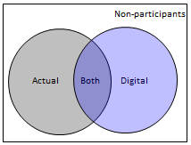
34.3
13.1
50.1
2.5

Notes
- Confidence intervals range between +/-0.3 and +/-1.0

There was a significant increase in the percentage of adults who had been to a museum or gallery from 43.9 per cent in 2008/09 to 47.4 per cent in 2010/11.

Likewise, there was a significant increase in the percentage of adults who had been to a museum or gallery in person or participated digitally, from 45.9 per cent in 2008/09 to 49.9 per cent in 2010/11, and a corresponding increase in the percentage participating digitally only (from 2.0% to 2.5%).

The breakdown by sex was similar (46.8% of men; 48.0% of women). However, men (2.9%) are significantly more likely to participate digitally only than women (2.0%).

In 2010/11, although the percentage of adults with a non-limiting disability or no disability who participated in museums or galleries in person or digitally (52.7%) was significantly higher than the corresponding percentage for adults with a limiting disability (39.5%), the corresponding percentages for adults participating by digital means only were not significantly different (2.5% and 2.3%, respectively).

Archives

Archives are the only sector where the percentage of adults participating by digital means only exceeds the percentage participating in person. In 2010/11, 2.3 per cent of adults visited an archive in person only and 7.6 per cent participated by digital means only (1.7% had attended both in person and digitally) (Figure 6.4).

Figure 6.4: Percentage of adults who have visited archive centres/record offices in person or digitally participated or both, 2010/11

7.6
88.4
1.7
2.3

Notes
- Confidence intervals range between +/-0.3 and +/-0.6

Levels of visits to archives remained steady between 2008/09 and 2010/11 at 4.0 per cent. However the percentage of adults visiting an archive or participating digitally with an archive increased significantly from 8.6 per cent to 11.6 per cent. This increase was driven by the percentage of adults who participated digitally only with archives (an increase from 4.6% to 7.6%).

Men (13.4%) are more significantly more likely to visit archives in person or engage with them digitally than women (9.9%). Men (9.4%) are also more likely to engage with archives by digital means only than women (5.9%) (Figure 6.5).

Figure 6.5: Percentage of adults who have visited archive centres/record offices in person or digitally participated, 2010/11, by sex

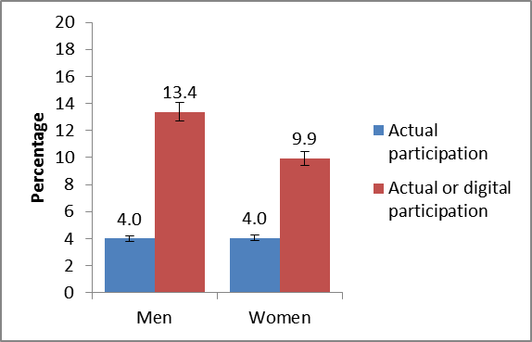
Notes
- Confidence intervals range between +/-0.5 and +/-1.1

Libraries

Levels of actual visits to public libraries remained steady between 2008/09 and 2010/11, at around 40 per cent. Likewise, percentages of adults who made actual visits to public libraries or participated digitally also remained steady around that period. However there was a small but significant increase in the percentage of adults who participated digitally only, from 2.4 per cent to 3.6 per cent (Figure 6.6).

Figure 6.6: Percentage of adults who have visited public libraries in person or digitally participated or both, 2010/11

11.5
56.7
3.6
28.2

Notes
- Confidence intervals range between +/-0.4 and +/-1.0

In 2010/11, women (44.8%) were more likely to visit a library in person than men (34.3%). Likewise, women (47.8%) were more likely to visit a library in person or participate digitally than men (38.5%). However men (4.2%) were significantly more likely than women (3.1%) to participate digitally only (Figure 6.7).

Figure 6.7: Percentage of adults who have visited public libraries in person or digitally participated, 2010/11, by sex

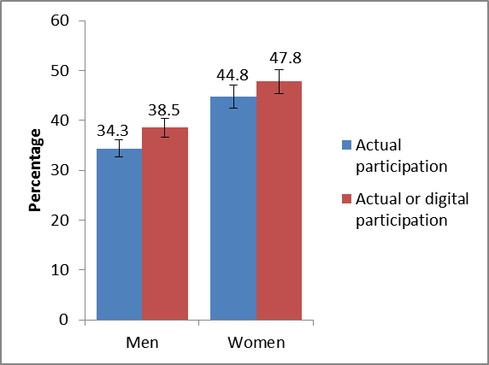
Notes
- Confidence intervals range between +/-0.4 and +/-1.5

In 2010/11, adults with a non-limiting disability or no disability who attended a library in person or participated digitally (44.4%) had significantly higher participation rates than adults with a limiting disability (39.1%). They also had significantly higher digital only participation rates (4.1% compared with 1.8%).

Heritage

The greatest discrepancy in percentages of adults participating in person and those participating digitally is found in the heritage sector. Only 0.5 per cent of adults had attended through digital only means compared to 63.6 per cent who had only attended in person (7.1% had attended both in person and digitally) (Figure 6.8).

Figure 6.8: Percentage of adults who have visited heritage sites in person or digitally participated or both 2010/11

63.6
7.1
0.5
28.8

Notes
- Confidence intervals range between +/-0.1 and +/-0.9

During 2008/09 to 2010/11, the percentage of adults visiting heritage sites significantly increased from 68.5 per cent to 70.7 per cent. Adults who visited a heritage site or heritage website increased from 69.1 per cent to 71.2 per cent. The percentage of adults participating digitally only remained steady during that period.

In 2010/11, although the percentage of adults with a non-limiting disability or no disability who participated in heritage in person or digitally (73.4%) was significantly higher than the corresponding percentage for adults with a limiting disability (63.2%), the corresponding percentages for adults participating by digital means only were not significantly different (0.5% and 0.8%, respectively).

Theatres and concerts

Between 2008/09 and 2010/11, the percentage of adults attending theatres and concerts remained steady (from 56.4% to 57.3%), whereas the percentage of adults visiting theatres and concerts in person or digitally increased from 57.0 per cent to 58.7 per cent. In that same period, the percentage of adults participating digitally only increased significantly from 0.6 per cent to 1.4 per cent (Figure 6.9).

Figure 6.9: Percentage of adults who have attended theatres and concerts in person or digitally participated or both 2010/11
51.3
5.9
41.3
1.4

Notes
- Confidence intervals range between +/-0.2 and +/-1.0

In 2010/11, women (59.3%) were significantly more likely to attend theatres and concerts in person than men (55.2%). Likewise, women (60.6%) were more likely to attend in person or participate digitally than men (56.8%). The difference in digital participation only in between males and females is not statistically significant.

In 2010/11, adults with a non-limiting disability or no disability who attended these sectors in person or digitally (62.5%) had significantly higher participation rates than adults with a limiting disability (44.6%). They also had significantly higher digital only participation rates (1.5% compared with 1.0%) (Figure 6.10).

Figure 6.10: Percentage of adults who have attended theatres and concerts in person or digitally participated, 2010/11, by limiting disability

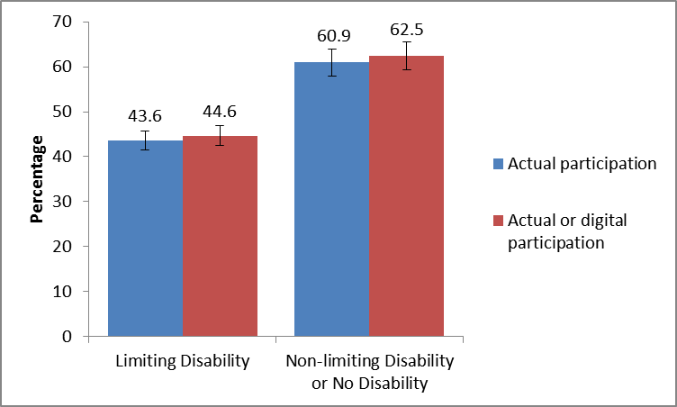
Notes
- Confidence intervals range between +/-0.3 and +/-1.8

Sport

The sport sector had the highest percentage of digital-only participants. In 2010/11, 53.0 per cent of adults had done active sport in the last 4 weeks, 64.6 per cent of adults had done active sport or used a Wii Fit or similar exercise device. 11.6 per cent of adults had virtually participated in sport (Figure 6.11).

Figure 6.11: Percentage of adults who have done active sport in the last 4 weeks or used a Wii Fit or similar exercise device or both, 2010/11

11.6
20.8
35.4
32.2

Notes
- Confidence intervals range between +/-0.6 and +/-1.0

In 2010/11, men (60.4%) had a higher percentage of active sport participation than women (45.9%). When we look at active sport participation versus virtual sport participation, the difference between the sexes, although statistically significant, is smaller (68.7% of men; 60.7% of women). Women (14.7%) are more likely to exercise virtually than men (8.3%) (Figure 6.12).

Figure 6.12: Percentage of adults who have done active sport in the last 4 weeks or used a Wii Fit or similar exercise device, 2010/11, by sex

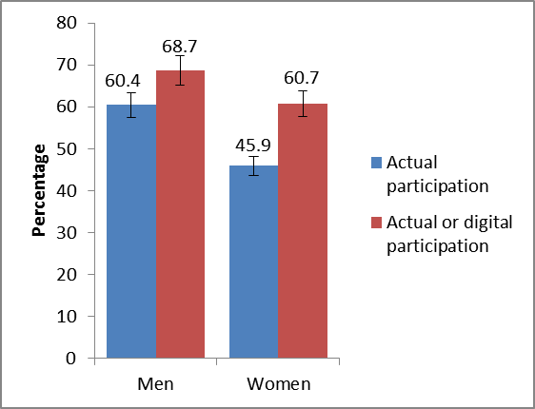
Notes
- Confidence intervals range between +/-0.9 and +/-1.5

The percentage of adults with a non-limiting disability or no disability who did active or virtual sport in the last 4 weeks (71.3%) was significantly higher than the corresponding percentage for adults with a limiting disability (39.5%) (Figure 6.13).

Figure 6.13: Percentage of adults who have done active sport in the last 4 weeks or used a Wii Fit or similar exercise device 2010/11, by limiting disability

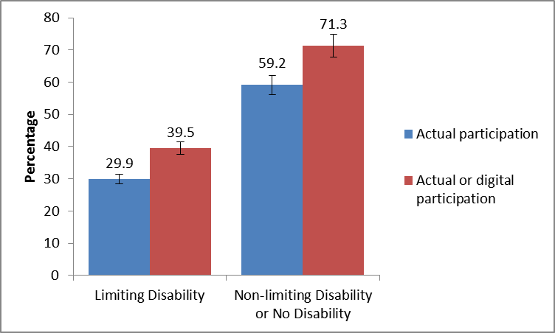
Notes
- Confidence intervals range between +/-0.8 and +/-1.8

Adults with a non-limiting disability or no disability (12.1%) are significantly more likely to participate virtually than adults with a limiting disability (9.6%).

- The big society

For a number of years, the Taking Part survey has included a range of questions on social capital and cohesion. Recently the survey has developed and included a range of questions to analyse charitable giving, presented here alongside data on volunteering and civic participation.

Key findings

- In 2010/11, 24.2 per cent of adults had volunteered and, of these, 31.8 per cent had volunteered within DCMS sectors.

- In 2010/11, 88.4 per cent of adults had donated money in the last 12 months with 33.0 per cent donating to one of the DCMS sectors.

- The DCMS sectors with the highest proportion of charitable giving were heritage, with 16.0 per cent of people donating to this sector, and museums and galleries with 15.2 per cent.

- Charitable giving to DCMS sectors was significantly higher for white people (34.9%) compared to Black or minority ethnic groups (17.9%). Also a significantly higher proportion of males (35.3%) donated than females (30.8%), likely due to men having higher incomes than women.
.

Overall volunteering

Taking Part asks about whether respondents have done any volunteering work in the last 12 months and whether this relates to any of the DCMS sectors.

In 2010/11, the DCMS sector with the most volunteering was sport, with 20.7 per cent of people having volunteered in this sector. The next most common was the arts with 8.1 per cent of people having volunteered. Libraries and archives saw the lowest rates of volunteering with 0.8 per cent and 0.6 per cent respectively. Museums and galleries had a volunteering rate of 1.4 per cent.

The proportion of volunteers in each DCMS sector was significantly higher if they had also participated in that sector. Just 3.1 per cent of adults had volunteered in more than one DCMS sector.

Between 2005/06 and 2010/11, there was a statistically significant increase in the proportion of people volunteering in the arts sector, from 6.3 per cent to 8.1 per cent (Figure 7.1).

Figure 7.1: Volunteering in culture and sport sectors, 2005/06 to 2010/11

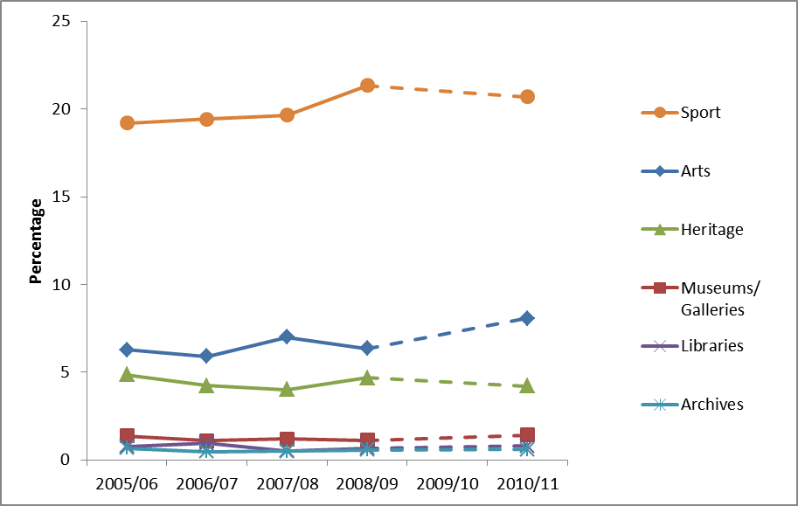
Notes
- Confidence intervals range between +/-0.2 and +/-2.0
- Questions on volunteering were not asked in the 2009/10 survey.

The heritage sector had the highest average amount of time spent volunteering during the last 4 weeks (over 10 hours). On average 9 hours 16 minutes was spent by volunteers in museums and galleries, followed by 8 hours 18 minutes in the arts sector.

Further analysis of volunteering can be found in the 30 June 2011 Taking Part release.

Overall charitable giving

Taking Part asks about whether respondents have donated money in the last 12 months and whether this was to any of the DCMS sectors.

In 2010/11, 88.4 per cent of adults had donated money (including any donations into a collection box) in the last 12 months. The highest frequency of charitable giving was less often than once a month but at least 3 or 4 times a year (35.1%), and 32.8 per cent donated less often than once a week but at least once a month.

A third of adults had donated to one of the DCMS sectors. The DCMS sectors with the highest proportion of charitable giving were heritage, with 16.0 per cent of people donating to this sector, and museums and galleries with 15.2 per cent. 7.4 per cent of adults had donated to the sports sector, 6.9 per cent to the arts, and 0.6 per cent to libraries.

On average, adults who donated to DCMS sectors donated less than £20 in the last 12 months. This varies by sector: 48.6 per cent of those who gave to the sport sector donated more than £20, compared with 42.8 per cent to heritage, 29.1 per cent to the arts, 21.2 per cent to museums and galleries and 17.0 per cent to libraries.

When asked what their giving intentions to DCMS sectors were in the next 12 months, the majority said they would give the same amount (76.8%) or less (10.2%). Just 5.2 per cent said they would donate more next year.

Types of charitable giving

Donations in last 12 months came through a variety of means, with the most common form being buying a raffle ticket (46.1%), followed by giving money to collecting tins (42.6%) and buying goods from a charity shop or catalogue (37.4%). In addition, over half of all adults had donated goods or prizes in last 12 months (50.9%) and 3.1 per cent had allowed the use of their possessions or facilities.

Attitudes to charitable giving

The main reason stated for giving more to DCMS sectors, was “I have more money/I can afford to give more” (26.3%). The opposite (having less money/I can't afford to give) was the main reason stated for giving less to DCMS sectors (43.3%).

The majority of adults thought it was fair to pay an entry fee to public museums and galleries (62.5%). Over 60 per cent of adults agreed or strongly agreed that they would be happy to donate money to their local arts, cultural or sporting organisations in order to keep them running. Over half of adults would be prepared to pay a small top-up fee on top of an entry fee if that money went towards the upkeep of the attraction or organisation they were visiting. Also, 51.9 per cent agreed or strongly agreed that the arts and cultural sector is a worthy cause to give money to. Only slightly more adults agreed (38.4%) than disagreed (34.5%) that giving money to charities in the arts, culture and sporting sectors won't make any difference to the facilities available to them.

Knowing the money would be spent or used locally was the main reason stated as encouraging donations to DCMS sectors, with 33.6 per cent of adults stating this would encourage them a lot, and 44.1 per cent stating this would encourage them a little. Other key reasons were “confidence that the arts, cultural or sporting charity uses the money efficiently” and “being asked by a friend or family member” (74.5% and 72.6% respectively).

Area-level factors

The extent to which people donate to DCMS sectors varies according to where people live, and the type of area they live in.

People who live in rural areas are significantly more likely than people in urban areas to have donated to DCMS sectors, 40.0 per cent have done so compared to 31.3 per cent in urban areas.

People in the least deprived areas (43.8%) were significantly more likely to have donated than people in the six most deprived decile areas (between 22.8% and 31.6%). Using odds ratios, we can report that moving from the most 8 deprived areas to the least 2 deprived areas, people are 61.4 per cent more likely to donate.

Charitable giving to DCMS sectors in 2009/10 was highest in the South East (39.7%) and East of England (37.2%) and lowest in the West Midlands (22.8%) and the East Midlands (28.2%) (Figure 7.2).

Figure 7.2: Percentage of adults who have donated to any DCMS sector in the last year, 2010/11, by region

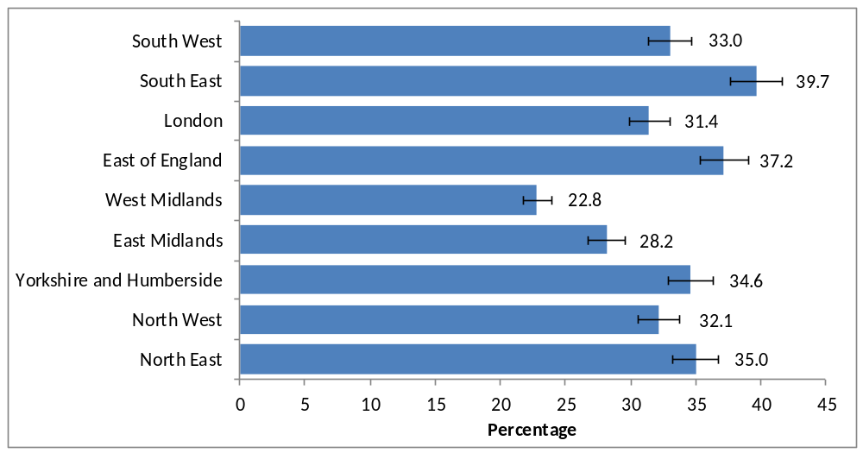
Notes
- Confidence intervals range between +/-4.7 and +/-7.4 for 2010/11.

Socio-demographic factors

In 2010/11, those aged 45-74 were the most likely to have donated to DCMS sectors (38.0%). A significantly lower proportion of adults aged 16-24 and 75+ donated to DCMS sectors (Figure 7.3).

Figure 7.3: Percentage of adults who have donated to any DCMS sector in the last year, 2010/11, by age

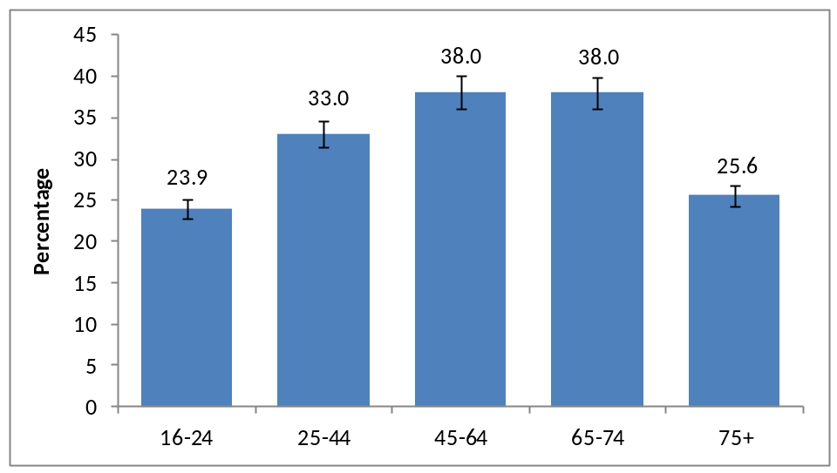
Notes
- Confidence intervals range between +/-3.1 and +/-6.2

Charitable giving rates to DCMS sectors were higher among those adults with a higher personal income. Only 23.5 per cent of adults with a total personal income in the last year below £5,000 (including adults with no personal income) donated. More than half (57.2%) of top earners earning more than £50,000 per year donated to DCMS sectors. Grouping together some of the income groups, and splitting by sex, we can see how charitable giving is higher for higher income groups for both men and women (Figure 7.4).

Figure 7.4: Percentage of adults who have donated to any DCMS sector in the last year, 2010/11, by personal income and sex

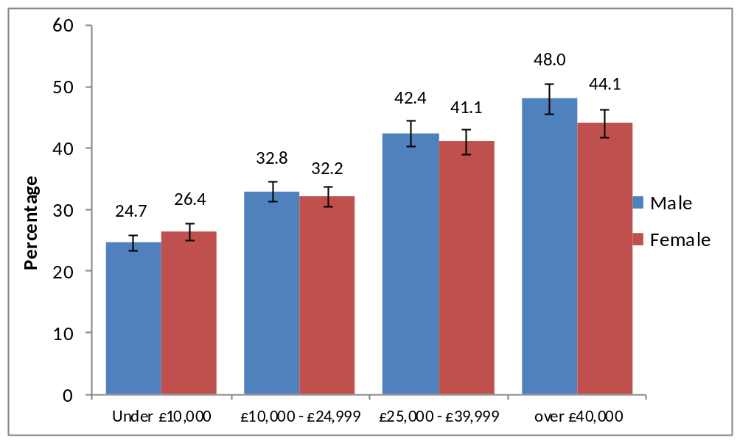
Notes
- Confidence intervals range between +/-3.6 and +/-11.1

Men were significantly more likely to have donated to DCMS sectors than women, 35.3 per cent having done so compared to 30.8 per cent of women. This is again likely to be due to higher incomes for males, as males who donated to DCMS sectors had an average salary around £22,000 compared to £13,000 for females.

This is also reflected with a higher proportion of charitable givers in higher socio-economic groups (39.8%) and those who own their own home (36.8%) (as opposed to being in the social and private rented sectors).

Volunteers in DCMS sectors were significantly more likely to have donated to DCMS sectors. Of those who volunteered, 55.2 per cent also donated, compared with 44.8 per cent who hadn’t donated. Even though a significantly higher proportion of women (26.0%) volunteered than men (22.4%), of those men who volunteered, a significantly higher proportion of them also donated to a DCMS sector (58.2%) than women (51.3%).

Overall civic participation

Taking Part asks a series of questions on sporting and cultural facilities in the respondent’s local area.

In 2010/11, over three quarters of adults (77.1%) had not taken any actions to try to get something done about sporting and cultural facilities in their area. The most common action that had been taken was to contact the council, with 12.0 per cent of adults having done so. Also 4.8 per cent of adults had contacted their local councillor or MP.

For adults that had taken no action in last 12 months, the first thing they would do to get something done about the sporting or cultural facilities in their local area would be to contact the council (50.8%).

45.7 per cent of adults had been involved in groups, clubs or organisations in the last 12 months. Of those adults, the most popular type of group was sports/exercise groups, taking part/coaching/watching (52.2% of adults who had attended a group), followed by hobbies/social clubs (34.5%).

In the last 12 months, 13.0 per cent of adults had been asked by any organisation what they thought of the environment, whereas only 5.3 per cent of adults had been asked their thoughts on local sporting facilities and 3.5 per cent on local cultural facilities.

- Cycling and swimming proficiency

In 2010/11, questions were added to Taking Part to investigate swimming and cycling proficiency among adults and children. In the June 2011 report, estimates were presented showing that 81.2 per cent of adults could swim, and 85.3 per cent could cycle. With the completion of a full survey year, the estimates can now be extended to cover cycling and swimming proficiency amongst children. These are presented in this chapter.

Key findings

- In 2010/11, 81.2 per cent of adults reported that they were able to swim, while 85.3 per cent said that they can cycle.

- Meanwhile, 91.2 per cent of 5-10 year olds, and 96.4 per cent of 11-15 year olds reported that they were able to cycle and 80.1 per cent of 5-10 year olds and 92.3 per cent of 11-15 year olds said they could swim.

Adult proficiency

In 2010/11, 81.2 per cent of adults reported that they were able to swim with 30.5 per cent reporting that they could swim continuously for more than 250 metres, 24.1 per cent for between 26 and 250 metres and 26.6 per cent for up to 25 metres. A greater proportion of men than women reported being able to swim (85.4% compared to 77.2%).

A greater number said they were able to cycle (85.3%) with 38.4 per cent saying they were confident to ride a bike on paths and cycle ways, 30.2 per cent being confident riding roads in their local area while 36.2 per cent are confident riding for longer distances. The difference between men and women was greater for cycling (92.5% compared with 78.5%) than it was for swimming.

Child cycling proficiency

In 2010/11, 93.5 per cent of all children (aged 5-15) reported that they could cycle. This includes 91.2 per cent of 5-10 year olds, and 96.4 per cent of 11-15 year olds. These figures are considerably higher than the proportions of adults (85.3%) who can (Figure 8.1).

Figure 8.1: The percentage of adults and children who can cycle, 2010/11

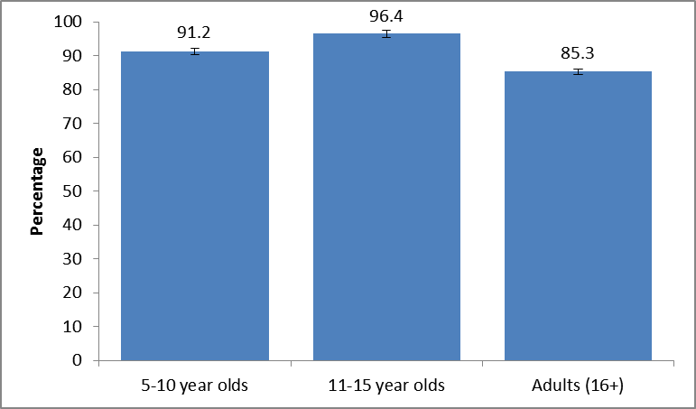
Notes
- Confidence intervals range between +/-0.7 and +/-1.5.

Over two thirds (69.5%) of 5-10 year olds can ride a bike without the need for stabilisers, with just over a fifth (21.6%) being able to ride with the aid of these. The remainder (8.8%) could not ride a bike.
Of those that could ride without the aid of stabilisers, more than three quarters (81.3%) said they would be comfortable riding on paths and cycleways; under a quarter (23.5%) said they would be comfortable riding on roads.

Area level factors

The way in which cycling proficiency varies by area for children closely reflects the story seen for adults. Children in the most affluent areas are more likely to be able to cycle than those in the most deprived areas, and children in rural areas (96.9%) were also more likely to be able to cycle than those in urban areas (92.7%). In addition, a smaller proportion of children are able to cycle in London (87.2%) than all other regions apart from the West Midlands. This may reflect the rural/urban trend mentioned above (Figure 8.2).

Figure 8.2: The percentage of children (5-15) who can cycle, 2010/11, by
region
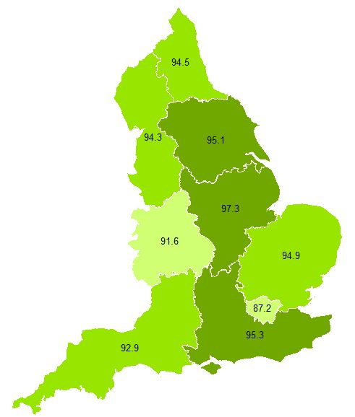

Notes
- Confidence intervals range between +/-2.2 and +/-4.1.

Demographic factors

There is no difference between the percentage of boys and girls that are able to cycle. This differs to the picture for adults, where men (92.5%) are significantly more likely to be able to cycle than women (78.5%) (Figure 8.3).

Figure 8.3: The percentage of children (5-15) and adults (16+) who can cycle, 2010/11, by gender

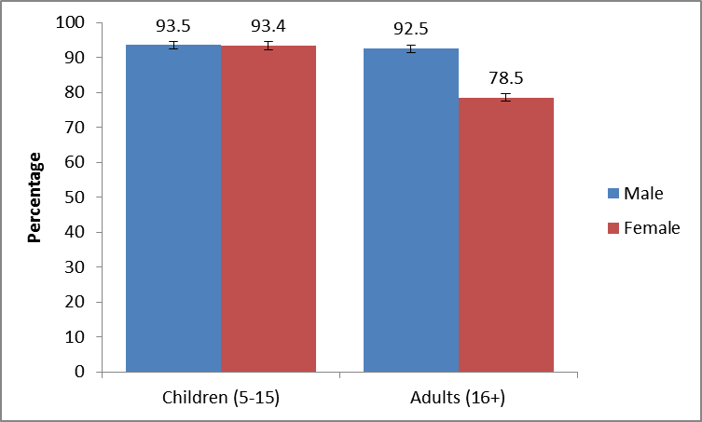
Notes
- Confidence intervals range between +/-0.8 and +/-1.5.

The story for other demographic groups more closely matches that seen for adults. White children (95.0%) are significantly more likely to be able to cycle than Black and minority ethnic children (87.2%), and children who do not have a limiting disability or illness (94.2%) are significantly more likely to be able to cycle than those that do (81.8%).

Child swimming proficiency

In 2010/11, 85.6 per cent of all children (aged 5-15) reported that they could swim. This includes 80.1 per cent of 5-10 year olds and 92.3 per cent of 11-15 year olds. Significantly more 11-15 year olds are able to swim compared to adults (81.2%) (Figure 8.4).

Figure 8.4: The percentage of adults and children who can swim, 2010/11

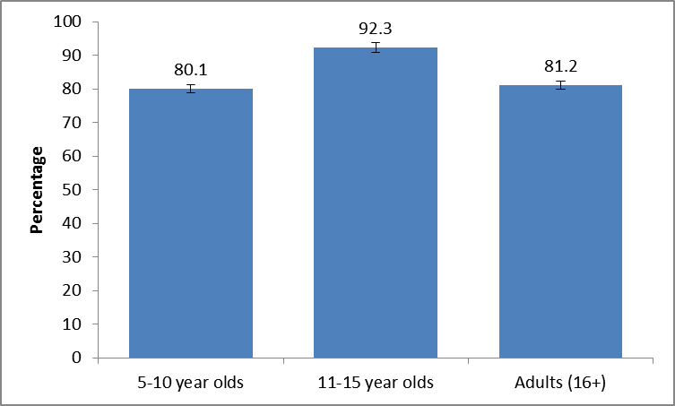
Notes
- Confidence intervals range between +/-0.8 and +/-2.2.

Of the 5-10 year olds that cannot swim (19.9%), more than three quarters are happy to go into the water with floats/armbands, with only a small proportion of all 5-10 year olds afraid of going into water (4.3%). Over half of all 5-10 year olds (57.2%) can swim without the aid of floats/armbands.

Area level factors

As with cycling proficiency, variation in swimming proficiency amongst children by area largely reflects the findings for adults. Children in the most affluent areas are more likely to be able to swim than those in the most deprived areas. Children in rural areas (92.2%) are also more likely to be able to swim than those in urban areas (84.1%). In both of these cases, the difference is greater than that seen for adults London again fares poorly, with children in London (77.8%) less likely to be able to swim than children in all other areas except for the West Midlands. Children in the South West (92.0%) and South East (90.3%) have the highest levels of swimming proficiency (Figure 8.5).

Figure 8.5: The percentage of adults and children who can swim, 2010/11, by region
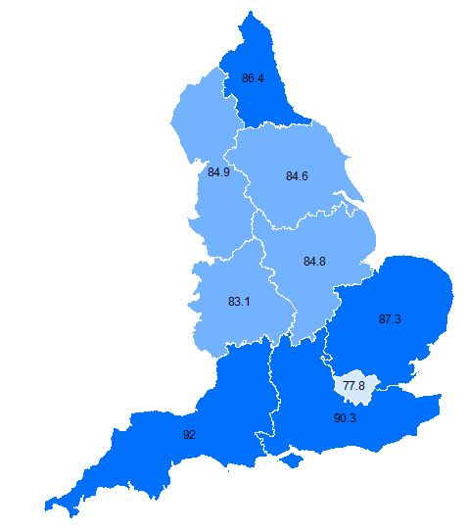
Notes
- Confidence intervals range between +/-3.1 and +/-6.1.

Demographic factors

As with cycling proficiency, the proportion of children who are able to swim does not vary by gender, despite it varying considerably for adults (Figure 8.6).

Figure 8.6: The percentage of adults and children who can swim, 2010/11, by sex

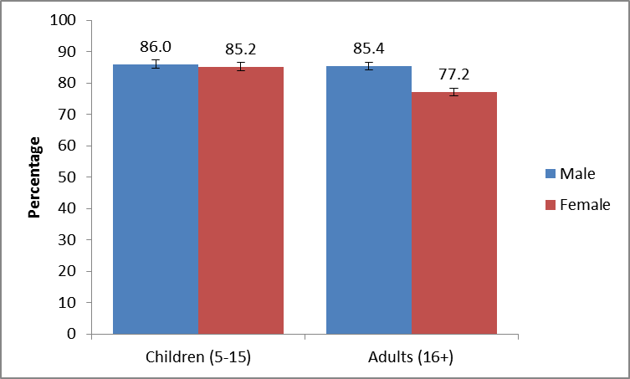
Notes
- Confidence intervals range between +/-1.0 and +/-2.1.

The same differences can be seen for swimming as cycling in terms of disability and ethnicity, with white children (88.4%) significantly more likely to be able to swim than Black and minority ethnic children (73.7%). Children with no disability (86.2%) are also significantly more likely to be able to swim than those with a disability (78.1%). It is worth noting, however, that this gap is not as wide as it is for cycling.

- Archives

Archives have been routinely presented alongside data on museums and galleries in previous releases. This report takes the opportunity to present analysis on this sector individually.

Key findings

- Between 2009/10 and 2010/11, the proportion of people visiting an archive (in their own time and voluntary) in the last year remained steady (from 3.8% to 4.0%)

- In 2010/11 archive visiting rates were significantly higher in 65-74 year olds, and among those in the upper socio-economic groups.

- Visiting rates at archives are similar across government office regions. However, visiting was significantly higher among those in rural areas compared to urban areas.

Overall participation in archives

In 2010/11, 4.0 per cent of adults had visited an archive in the last year in their own time or as part of voluntary work. Including paid work visits and academic study visits, this increases to 5.0 per cent of all adults. The percentage of adults visiting an archive in 2005/06 was 5.9 per cent, significantly higher than every year since.

In 2010/11, the vast majority of archive visits (80.1%) were in their own time, followed by 15.7 per cent visiting for paid work, and 7.3 per cent for academic study (Figure 9.1).

Figure 9.1: Percentage of adults visiting an archive or records office, 2005/06 to 2010/11

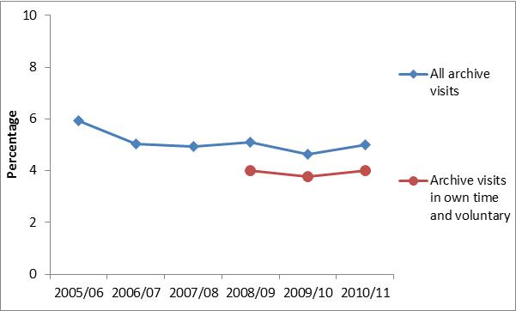
Notes
- Confidence intervals range between +/-0.3 and +/-0.8
- Questions on archive visits in own time and for voluntary purposes were not asked prior to the 2008/09 survey.

For those visiting in their own time and for voluntary work, just over half of adults visited just once in the last year (50.9%). 18.3 per cent visited twice a year, 20.8 per cent visited less often than once a month but at least 3-4 times a year. 7.2 per cent visited less often than once a week but at least once a month, with just 2.7 per cent visiting at least once a week (Figure 9.2).

Figure 9.2: Frequency of visits to an archive centre or records office, 2010/11

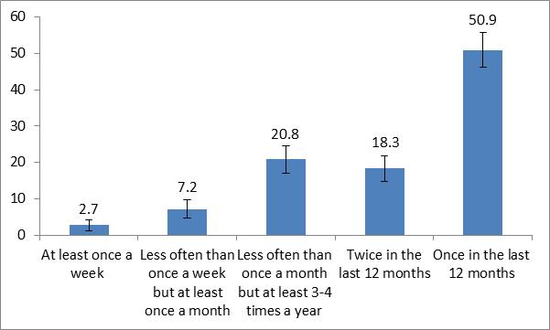
Notes
- Confidence intervals range between +/-1.5 and +/-4.7.

Area level factors

A significantly higher proportion of adults in the North West (5.1%) visited an archive at least once in 2010/11 than in London (3.3%), East Midlands (3.3%) and the South West (3.3%).

In 2010/11, 4.9 per cent of adults in rural areas had visited an archive which was significantly higher than the proportion of adults visiting in urban areas (3.8%).

Socio-demographic factors

In 2010/11, archive visiting rates were significantly higher among 65-74 year olds (8.0% compared to 3.6% for all other age groups). This equates to 65-74 year olds being more than twice as likely to visit an archive at least once in the last year. This is also reflected in those not working (4.6%) having a significantly higher visiting rate than the working population (3.6%).

Archive visiting rates were also significantly higher among those in the upper socio-economic groups (5.1%) and white adults (4.2%).

- Participation in culture

This chapter presents the key findings for cultural sectors as presented in the June 2011 release along with a few additional findings on library and arts participation.

Key findings

- Between 2005/06 and 2010/11, the proportion of people visiting a museum, gallery or archive in the last year increased (from 42.3% to 47.5%). The proportion visiting heritage sites and engaging with the arts remained steady.

- Over the same period, the proportion of people visiting a public library declined (from 48.2% to 39.7%). The majority (92.5%) of people described themselves as fairly or very satisfied with the service they received at their library.

- Cultural participation tends to be higher among certain groups. Participation rates continue to be significantly higher among those in the upper socio-economic groups and in the least deprived areas of England.

Overall participation in culture

In 2010/11, 47.5 per cent of adults had visited a museum, gallery or archive in the last year, an increase from 2008/09 (44.5%) and a continuation of the steady upward trend since 2006/07 (41.5%).

Meanwhile, 39.7 per cent of adults had visited a public library in the last year, a decrease from 2005/06 (48.2%). However the steady decline in library visits observed between 2005/06 and 2008/09 has now stabilised, with no significant change observed between 2008/09 (41.1%) and 2010/11 (39.7%)

In 2010/11, 70.7 per cent of adults had visited a heritage site in the last year, unchanged from 2005/06 (69.9%) while 76.2 per cent of adults had engaged with the arts at least once in the last year, unchanged from 2005/06 (76.3%) (Figure 10.1).

Figure 10.1: Proportion who have visited a museum, gallery or archive, a public library, a heritage site or engaged with the arts in the last year, 2005/06 to 2010/11

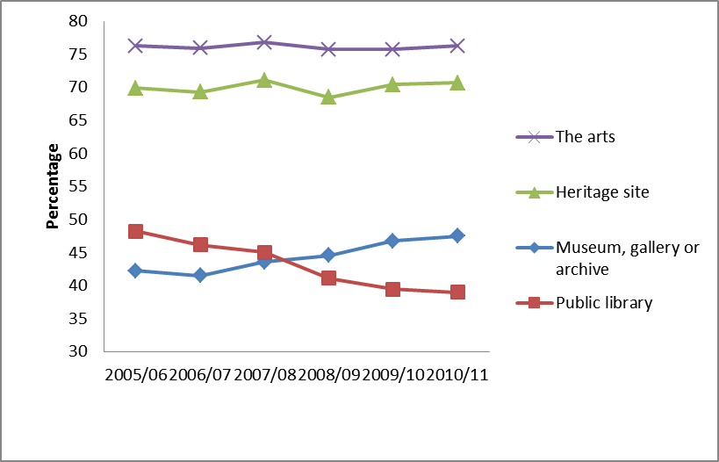
Notes
- Confidence intervals range between +/-0.7 and +/-2.4.

Museums, galleries and archives

While people who live in rural areas are just as likely as people in urban areas to have visited a museum, gallery or archive in the last year, there are variations by region.

In 2010/11, people in London (54.2%) and the South East (50.6%) had the highest levels of participation, while those in the East Midlands (41.1%) and the West Midlands (41.8%) had the lowest levels of participation. Since 2005/06, the proportion of people visiting museums, galleries and archives increased in the North East (from 42.0% to 48.4%), the North West (40.4% to 50.1%), Yorkshire and the Humber (38.8% to 45.2%), the West Midlands (35.3% to 41.8%), London (50.9% to 54.2%) and the South East (43.8% to 50.6%).

Between 2005/06 and 2010/11, the proportion of those visiting at least once a week (0.3% to 0.5%), at least once a month (3.2% to 3.6%) and 1-2 times a year (25.6% to 27.4%) have increased significantly The proportion of those never visiting fell from 57.7 per cent in 2005/06 to 53.7 per cent in 2010/11 (Figure 10.2).
Figure 10.2: Frequency of attendance at a museum, gallery or archive in the last year, 2010/11

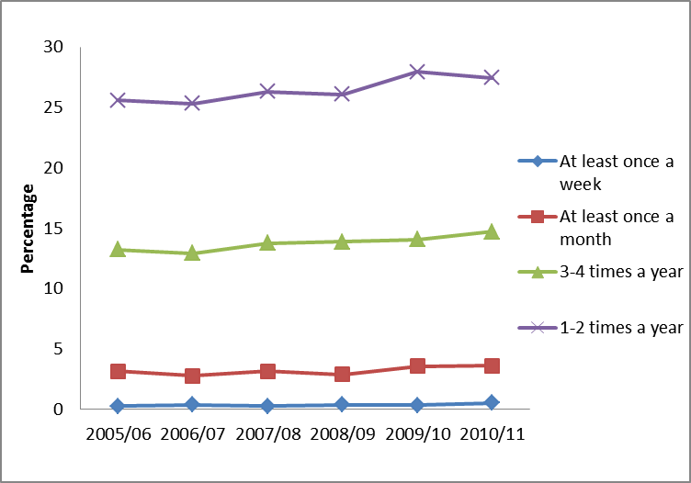
Notes
- The proportion of those who never attend has been omitted for reasons of clarity.
- Confidence intervals range between +/-0.8 and +/-2.2.

The extent to which people visit museums, galleries and archives varies by age, with younger (16-24 years) and older (75+ years) adults generally less likely to have visited a museum, gallery or archive in the last year than those aged 25-74 years. There have been significant increases in those visiting a museum, gallery or archive for those aged 25-44, 45-64 and 65-74 between 2005/06 and 2010/11.

While people in the upper socio-economic groups (57.5%) were considerably more likely than those in the lower socio-economic groups (33.7%) to have visited in the last year, both groups are now more likely to have visited a museum, gallery or archive than in 2005/06.

Libraries

In 2010/11, people who lived in the least deprived areas of England were more likely than those in the most deprived areas to have visited a library in the past 12 months (43.5% compared with 39.8%). However, the difference is not as stark as it is for the other cultural sectors.

People in rural areas (38.2%) are just as likely as people in urban areas (40.0%) to have visited a library in the last 12 months. Participation levels in both areas have declined since 2005/06.

Between 2005/06 and 2010/11, the proportion of people visiting a public library declined in all regions. The decline in library visits has been consistent across all socio-demographic groups with the exception of those aged 65-74 where the decline is not statistically significant.

The majority of people who use library services are satisfied with the service they receive with 65.2 per cent saying they are very satisfied and 27.3 per cent saying they are fairly satisfied. Those who were very dissatisfied accounted for 0.5 per cent of users.

Among those who were dissatisfied (3.6% were slightly or very dissatisfied), the main source of dissatisfaction was with the choice and physical condition of the resources available (54.0% reporting this). Other sources of dissatisfaction included staff assistance (28.5%) and computer facilities (13.9%) though it must be noted that these are proportions of a very small group.

Among those who reported that they used to use a library service but that this had now lapsed (that is, they had not used one in the past year), the main reason given was that the respondent had left school or university (28.2%) with moving home the next most likely cause (14.2%). The birth of a first child was given as a reason by 4.8% of those who had lapsed.

Heritage

The extent to which people visit heritage sites varies with where they live, and the type of area they live in. In particular, people who live in rural areas (78.1%) are more likely than people in urban areas (68.7%) to have visited a heritage site in the last year. The proportion visiting a heritage site is lowest in London (65.7%) and highest in the South East (76.5%). Between 2005/06 and 2010/11 the proportion visiting a heritage site has remained steady across the regions.

In 2010/11, people aged 75+ were the least likely to have visited a heritage site (Figure 10.3). However, since 2005/06 the proportion of people in this age group visiting heritage sites increased from 52.2 per cent to 57.0 per cent.

Figure 10.3: Proportion who have visited a heritage site in the last year, 2010/11, by age

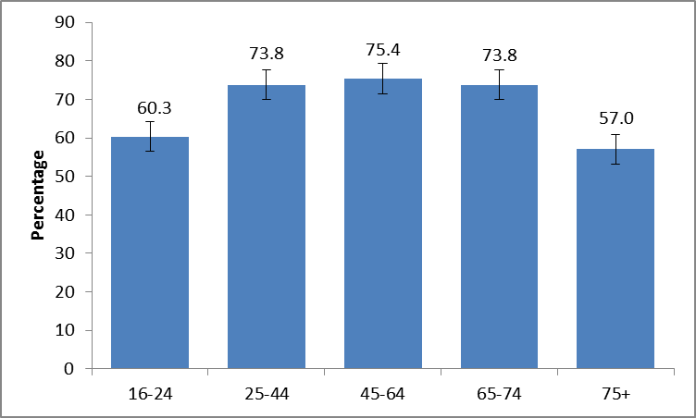
Notes
- Confidence intervals range between +/-1.5 and +/-3.6.

The arts

The extent to which people engage with the arts varies according to where people live, and the type of area they live in.

The effect of area level deprivation is considerable. In 2010/11, people who lived in the least deprived areas of England were far more likely than those who lived in the most deprived areas to have engaged with the arts in the last year (84.8% compared with 63.3%).

While people who live in rural areas (79.2%) are more likely to have engaged with the arts in the last year than people in urban areas (75.5%), between 2005/06 and 2010/11, the proportion of people in rural areas engaging with the arts decreased from 81.8 per cent to 79.2 per cent. Since 2005/06, the proportion of the people engaging with the arts remained steady across all the regions.

Looking at the frequency of engagement with the arts, between 2005/06 and 2010/11, there was an increase in those reporting participation once in the last 12 months (7.2% to 8.8%) and a decrease in those reporting three or more times in the last 12 months (62.5% to 61.2%) (Figure 10.4).

Figure 10.4: Frequency of engagement with the arts, 2005/06 to 2010/11

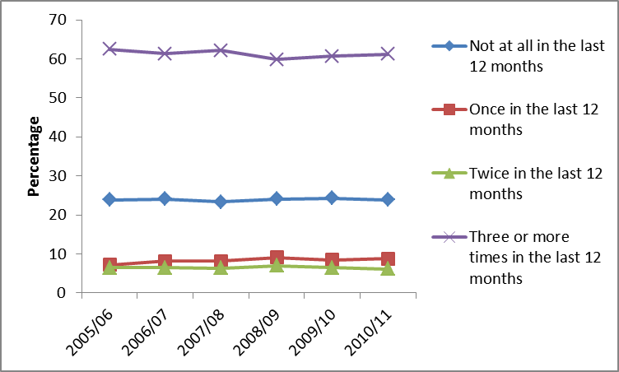
Notes
- Confidence intervals range between +/-0.4 and +/-2.2.

Between 2005/06 and 2010/11, the proportion of those aged 65-74 engaging in the arts increased from 70.7 per cent to 74.1 per cent. Engagement rates in the other age groups remained steady.

People in the upper socio-economic groups (83.8%) are considerably more likely than those in the lower socio-economic groups (64.5%) to have engaged with the arts in the last year

Among those who participated in an arts activity, over two thirds (68.5%) rated their enjoyment of the activity as 8 or higher out of 10. The majority (80.7%) said that it is definitely likely that they would do it again with only 3.7 per cent saying they would definitely or probably not do it again.

Among those attending arts events, 69.7 per cent rated they enjoyment of the activity as 8 out of 10 or higher and the majority (77.2%) said they would definitely do it again. The arts activities attended with the highest proportion of respondents rating their attendance as 10 out of 10 were ballet (49.2% scoring their enjoyment as 10) and musicals (46.0% scoring their enjoyment as 10).

- Looking ahead

Next steps
Funding for the next 4 years of Taking Part has been secured, and following a competitive tendering exercise, TNS-BMRB will continue to conduct survey fieldwork on behalf of DCMS and its partners (Arts Council England, Sport England and English Heritage).

The 2011/12 Taking Part Survey is currently in the field. The content of the questionnaire has changed to reflect the changing needs of DCMS, its partners, and the wider Taking Part user group. In particular, the survey now contains additional questions relevant to the 2012 Olympic and Paralympic Games and on the extent to which people feel able to get involved in local decisions (related specifically to the heritage sector). To make room for these new questions, the social capital module of the questionnaire was removed. The survey content is now being managed through a modular approach so, as with other removed sections, there remains the options for this to be added back in at a later date.

The 2011/12 adult and child questionnaires and a report outlining the process of testing undertaken to develop the new questions are published alongside this report. This is available at: http://www.culture.gov.uk/what_we_do/research_and_statistics/7387.aspx

The most notable change to the next wave of Taking Part is the addition of a longitudinal panel of adults and children. One of the primary benefits from this will be an improved ability to monitor the extent to which the 2012 Games inspires a generation of children into sport. It will also be used more generally to map engagement with the culture and sport sectors across life stages and support further work by the CASE research programme.

Forthcoming releases
The next release of data from Taking Part will take place at the end of September and include data from the first quarter of the seventh year of the survey. It will update rolling time series as well as presenting a first look at data from the new question topics within the survey. Future releases will follow a similar schedule, being released ahead of the Quarterly Data Summaries that will be produced by all departments. Taking Part forms part of the wider DCMS data strategy as well as supporting it’s impact and input indicators. Details of these are available at: http://www.culture.gov.uk/about_us/8192.aspx

If you would like further information on the Taking Part Survey, please contact the Taking Part team at DCMS on TakingPart@culture.gsi.gov.uk. Additional contact details are contained within Annex A.

Annex A: Background note

- The Taking Part survey is commissioned by the Department for Culture, Media and Sport (DCMS) and its partner arm’s length bodies (ALBs). For 2005 to 2011 these comprised Arts Council England, English Heritage, Sport England, and the Museums, Libraries and Archives Council. From the 2011/12 survey year onwards, the Museums, Libraries and Archives Council are no longer part of this group with Arts Council England representing these interests on the Taking Part board.

- Taking Part is a National Statistic and as such has been produced to the high professional standards set out in the Code of Practice for Official Statistics. National Statistics undergo regular quality assurance reviews to ensure they meet customer needs and are produced free from any political interference. For more information, see http://www.statisticsauthority.gov.uk/assessment/code-of-practice/code-of-practice-for-official-statistics.pdf

- Stringent quality assurance procedures have been adopted for this statistical release. All data and analysis has been checked and verified by at least two different members of the team to ensure the highest level of quality.

- The results presented here are based on interviews issued between April 2010 and March 2011. The total sample size for this period is 14,102.

- The survey measures participation by adults (aged 16 and over) and children (5-10 and 11-15) living in private households in England. No geographical restriction is placed on where the activity or event occurred.

- The median adult sample interview length was 40 minutes 42 seconds (mean 42 minutes 36 seconds). The median survey length for the 5-10 year old child interview was 14 minutes 3 seconds (mean 14 minutes 58 seconds) and for 11-15 year olds it was 24 minutes 16 seconds (mean 25 minutes 41 seconds).

- Participation in these activities must be for the purpose of recreation or leisure, including voluntary work. It excludes involvement in activities where the prime motivation is paid work or academic studies. The exceptions to this are attendance at historic environment sites which includes visits made for academic study, and sports participation which exclude volunteering, teaching, coaching and refereeing.

- The range has been calculated using a 95% confidence interval. This means there is a 95% probability the true percentage lies in the range given. All estimates have been rounded to one decimal place. An overall design factor of 1.188 has been applied to the dataset for the period April 2010 to March 2011. Individual design factors have been calculated for each sector in this period, ranging from 0.890 to 1.442. Statistical significance tests have been run at the 95% level. This means the probability that any given difference happened by chance is low (1 in 20).

- All differences and changes reported are statistically significant at the 95% confidence level unless otherwise stated.

- This release complements the Taking Part Statistical Release published on 30 June 2011 which presented headline finding for year 6 of the survey. Some figures may have been revised from previous releases, in which case the figures in this release supersede those from previous statistical releases. For more detailed information on the DCMS revisions policy and how revisions are handled for the Taking Part survey, please see the DCMS statement of compliance on our website.

- The data are weighted to ensure the representativeness of the Taking Part sample. There are two types of weighting: i) to compensate for unequal probabilities of selection; and ii) to adjust for differential non-response. Weighting is based on mid-2009 population estimates from the Office for National Statistics.

- For more information about the Taking Part survey, including previous publications, see http://www.culture.gov.uk/reference_library/research_and_statistics/4828.aspx

Versions of the questionnaire from all years of the survey are available, see http://www.culture.gov.uk/what_we_do/research_and_statistics/7387.aspx

- The fieldwork for the survey is being conducted by TNS-BMRB. For more information, see http://www.tns-bmrb.co.uk

- Where any trademarks are used this does not imply any affiliation, endorsement, or sponsorship between DCMS and the owners of these trademarks.

- We can also provide documents to meet the specific requirements of people with disabilities. Please call 020 7211 6000 or email takingpart@culture.gsi.gov.uk

- This report has been produced by Reannan Rottier, Yun Wong, Chris McKee, Peter Antoniades and Neil Wilson. Acknowledgement goes to colleagues within the DCMS, partner ALBs and TNS-BMRB for their assistance with the production and quality assurance of this release.

- The responsible statistician for this release is Neil Wilson. For enquiries on this release, telephone: 0207 211 6968

- For general enquiries telephone: 0207 211 6200
Department for Culture Media and Sport
2-4 Cockspur Street
London
SW1Y 5DH
enquiries@culture.gov.uk

Annex B: Demographics

This annex presents supporting data for the survey, showing a range of the key demographic breakdowns of those surveyed to assist in the understanding and interpretation of presented findings. Further breakdowns and base counts can be produced using the on-line NetQuest data tool.

Household numbers:

Number of adults in household | Frequency | %
One | 4626 | 18.3
Two | 7254 | 53.7
Three | 1477 | 16.6
Four | 574 | 8.6
Five or more | 171 | 2.9

Number of children in household | Frequency | %
None | 10130 | 69.3
One | 1834 | 14.7
Two | 1539 | 11.6
Three | 448 | 3.4
Four | 116 | 0.8
Five or more | 26 | 0.2

Gender, marital status and age:

Gender | Frequency | %
Male | 6074 | 48.8
Female | 8028 | 51.2

Harmonised marital status | Frequency | %
Married | 6322 | 50.9
Civil partnered | 26 | 0.2
Co-habiting | 1210 | 10.6
Single | 3166 | 24.4
Separated | 456 | 2.1
Divorced | 1272 | 5.5
Widowed | 1484 | 6.3

Age | Frequency | %
16-19 | 570 | 6.4
20-24 | 761 | 8.4
25-34 | 2019 | 16.0
35-44 | 2504 | 18.1
45-54 | 2256 | 16.6
55-64 | 2375 | 14.5
65-74 | 1968 | 10.4
75-84 | 1257 | 7.6
85+ | 387 | 2.0

Age by sex | Frequency | %
Male 16-24 | 627 | 7.6
Male 25-34 | 829 | 8.1
Male 35-54 | 2016 | 17.2
Male 55+ | 2600 | 15.9
Female 16-24 | 704 | 7.2
Female 25-34 | 1190 | 7.9
Female 35-54 | 2744 | 17.5
Female 55+ | 3387 | 18.6

Accommodation type and time spent living in the area

The survey asked respondents in which of the following ways did they occupy the accommodation where they reside:

Status | Frequency | %
Owners | 9414 | 66.7
Social rented sector | 2471 | 15.1
Private rented sector | 2213 | 18.2

The survey then follows up by asking tenants who their landlord is:

Landlord | Frequency | %
Local authority /council /new town development | 1514 | 27.5
A housing association or charitable trust | 1015 | 18.2
Employer (organisation) of a household member | 46 | 1.0
Another organisation | 92 | 2.0
Relative /friend of a household member | 358 | 11.0
Employer (individual) of a household member | 23 | 0.5
Another private landlord | 1721 | 39.7

Using the ONS harmonised length of time at address, the survey asks how long they have been resident:

Time at address | Frequency | %
Less than 12 months | 400 | 6.7
12 months or more but less than 2 years | 308 | 4.7
2 years or more but less than 3 years | 361 | 5.4
3 years or more but less than 5 years | 540 | 7.9
5 years or more but less than 10 years | 908 | 13.2
10 years or more but less than 20 years | 1401 | 21.4
20 years or longer | 3008 | 40.8

Education, work and qualifications

The survey asks people to identify the highest level of qualification they hold:

Highest level of qualification | Frequency | %
Higher Education & professional/vocational equivalents | 3292 | 30.1
Other Higher Education below degree level | 1421 | 12.7
A levels, vocational level 3 & equivalents | 2176 | 21.2
Trade Apprenticeships | 574 | 5.0
5 or more GCSE/O Level grades A* -C and L2 equivalents | 2026 | 18.6
GCSE/O Level grade A* -C(< 5 A*-C) and L1 equivalents | 865 | 7.8
Other qualifications: level unknown | 554 | 4.7

We ask the respondent about their economic status in the last week:

Economic status | Frequency | %
Paid work | 7256 | 56.7
Government training scheme | 26 | 0.2
Away from job / waiting to take up job | 245 | 1.8
Unpaid work | 79 | 0.6
Looking for work | 578 | 4.5
Student | 403 | 4.3
Looking after family/home | 877 | 5.9
Temporarily sick/ill | 76 | 0.5
Long-term sick/ill | 568 | 3.4
Retired | 3993 | 22.2

Whether respondent is working full or part time:

Status | Frequency | %
Full time | 5351 | 42.9
Part time | 2239 | 16.3
Not working | 6496 | 40.7
Total | 14086 | 100.0

Respondents are asked to identify the appropriate category for their personal earnings in the last year before tax and other deductions:

Personal earnings | Frequency | %
Under 2,500 | 778 | 6.4
2,500 - 4,999 | 1062 | 7.4
5,000 - 9,999 | 2137 | 13.7
10,000 - 14,999 | 1714 | 11.9
15,000 - 19,999 | 1264 | 9.3
20,000 - 24,999 | 974 | 7.0
25,000 - 29,999 | 729 | 5.3
30,000 - 34,999 | 576 | 4.2
35,000 - 39,999 | 377 | 2.8
40,000 - 44,999 | 353 | 2.6
45,000 - 49,999 | 264 | 2.0
50,000 or more | 625 | 4.8
SPONTANEOUS: Nothing/ No work or scheme | 644 | 5.1

They are asked about access to a vehicle and, below, whether they are the owner of a vehicle:

Ownership | Frequency | %
Non-vehicle owner | 3257 | 19.2
Vehicle owner | 10844 | 80.8

A range of geographic data is used to classify UK postcodes into the ACORN breakdown – A Classification of Residential Neighbourhoods – showing five headline categories:

ACORN06 | Frequency | %
Wealthy Achievers | 3567 | 26.2
Urban Prosperity | 1413 | 10.7
Comfortably Off | 4223 | 29.3
Moderate Means | 1978 | 14.4
Hard-pressed | 2892 | 19.2

Health, disability and well-being

Based on the standard ONS Harmonised long-standing illness questions, respondents are asked if they suffer from a long standing illness:

Harmonised illness | Frequency | %
No long standing illness | 9532 | 71.7
Long standing illness | 4527 | 28.3

It is also established whether they are suffering from longstanding illness, disability or infirmity:

Longstanding | Frequency | %
No long standing | 10631 | 78.9
Long standing | 3421 | 20.9

Geographical information

The interview can be assigned to one of nine Government Office Regions, based on the location it has taken place. Location of interview is also used to determine whether the area is classified as urban or rural:

GOR9 | Frequency | %
North East | 741 | 5.2
North West | 1862 | 13.3
Yorkshire and Humberside | 1422 | 10.2
East Midlands | 1317 | 8.6
West Midlands | 1418 | 10.4
East of England | 1612 | 11.1
London | 2033 | 14.9
South East | 2204 | 16.2
South West | 1493 | 10.2

Area type | Frequency | %
Urban | 11070 | 79.3
Rural | 3032 | 20.7

Ethnicity

Ethnicity (grouped) | Frequency | %
White | 12617 | 88.9
Mixed | 204 | 1.4
Asian | 796 | 6.8
Black | 423 | 2.5
Other / Refused / Don’t Know | 62 | 0.4
Total | 14102 | 100.0

Religion

Religion | Frequency | %
No religion | 3619 | 27.7
Christian | 9255 | 62.4
Buddhist | 77 | 0.5
Hindu | 178 | 1.5
Judaism | 48 | 0.4
Muslim | 452 | 4.0
Sikh | 83 | 0.7
Spontaneous: atheist/agnostic | 264 | 1.9
Other answers / Refused / Don’t Know | 126 | 0.9
Total | 14102 | 100.0

Annex C: Sector definitions - Child

For those aged 5-10 and 11-15, the following definitions apply from the Taking Part child survey:

Libraries
The respondent will be asked if they have visited a library to do activities such as the ones on the show card. The interviewer will ask the following.
“By this we mean visiting a library to do activities like the ones on this card.
- Read or taken out books
- Taken out CDs, DVDs etc
- Used computer services, photocopiers etc
- Used study areas
- Used reference materials or information services
- Attended an event in the library”
Children aged 5-10 are asked to “include any helping out with these types of activities”; those aged 11-15 are asked to “include any helping out or volunteering”.

Museums
The respondent will be asked if they have visited a museum.
“By this we mean visiting a museum to do activities like the ones on this card.
- Visited exhibitions
- Attended an event held at the museum
Children aged 5-10 are asked to “include any helping out with these types of activities”; those aged 11-15 are asked to “include any helping out or volunteering”.

Archive
For those aged 11-15, the respondent will be asked if they have visited an archive. This question is not asked of those aged 5-10.
“By this we mean visiting an archive to do activities like the ones on this card.
- Searched records at the archive
- Used computer or microfilm services, photocopiers etc
- Used study areas
- Used reference materials
- Attended an event held at an archive
Respondents are asked to “include any helping out or volunteering”.

Arts
The respondent will be asked if they have done any of the activities on the cards shown to them. Activities and events are as follows.

Dance activities
- Taken part in a dance club
- Taken part in a dance performance
- Created a new dance routine
- Attended a dance event
- Taken part in a dance lesson
Include any helping out with these types of activities (5-10)
Include any helping out or volunteering (11-15)
Do not include: Danced at a disco or party

Music activities
- Sang to an audience or rehearsed for a performance
- Practiced and rehearsed a musical instrument
- Played a musical instrument to an audience
- Written music (includes writing lyrics or music)
- Attended a live music event
- Taken part in a music lesson
Include any helping out with these types of activities (5-10)
Include any helping out or volunteering (11-15)

Theatre and drama activities
- Rehearsed or performed in a play/drama or drama club
- Taken part in a drama lesson
- Attended theatre performances such as:
- Plays
- Pantomime
- Opera
- Musicals
- Comedy
Include any helping out with these types of activities (5-10)
Include any helping out or volunteering (11-15)

Reading and writing activities
- Written stories, plays or poetry (include adults helping/writing on behalf of child for 5-10)
- Read books for pleasure
- Taken part in a reading club (where people meet up to discuss and share books)
- Listened to authors talk about their work
- Taken part in an English Literature lesson (11-15)
Include any helping out with these types of activities (5-10)
Include any helping out or volunteering (11-15)
Do not include: Reading textbooks which are required for school (5-10)
Do not include: Reading textbooks which are required for school (except those required for English Literature lessons) (11-15)

Arts, crafts and design
- Painting, drawing, printmaking, sculpture or model making
- Photography as an artistic activity
- Crafts such as pottery or jewellery making (woodwork and metal work also included for 11-15)
- Attended exhibition of arts, photography or other craft work
- Taken part in an arts, crafts, design or photography lesson
Include any helping out with these types of activities (5-10)
Include any helping out or volunteering (11-15)

Film and video activities
- Made or appeared in films or videos for artistic purposes
- Watched and discussed film or videos in a lesson or film society (to know more about how films are made as well as the stories they tell)
- Attended the cinema or an outdoor film screening
Include any helping out with these types of activities (5-10)
Include any helping out or volunteering (11-15)
Do not include: Watching films on television, DVD or the internet; Talking about films with family and friends

Other media activities (5-10 only)
Computer based activities such as:
- Made, revised or wrote their own blog, website or podcast
- Made or revised their own computer game
- Used a computer to create original artworks or animation

Radio activities such as:
- Made radio broadcasts or programmes
Do not include: Playing computer games, Surfing the internet, Listening to the radio

Computer based activities (11-15 only)
- Made, revised or wrote your own blog, website or podcast
- Made or revised your own computer game
- Used a computer to create original artworks or animation

Do not include: Playing computer games; Surfing the internet

Radio activities (11-15 only)
- Made radio broadcasts or programmes
Include any helping out or volunteering
Do not include: Listening to the radio

Street arts, circus, carnival or festival activities
Taken part in or been to any of the following:
- Street arts (art in everyday surroundings like parks, streets or shopping centres)
- Outdoor sculptures and art works
- Circus
- Carnival
- Festivals
Include any helping out with these types of activities (5-10)
Include any helping out or volunteering (11-15)

Historic environment
The respondent will be asked if they have visited any historic or important modern, places, buildings or public spaces.
“By this we mean visiting the places or doing the activities on this card.
- Visited a historic building, garden or landscape open to the public
- Visited historical monuments or sites of archaeological interest
- Visited a city or town with historic character
- Visited important modern buildings or public spaces
Children aged 5-10 are asked to “include any helping out with these types of activities”; those aged 11-15 are asked to “include any helping out or volunteering”.

Sport and active recreation
The respondent will be asked about their participation in sports. Eligible activities are as follows.

GAMES (include mini-sports and mini-games)
- Football (include five-a-side)
- Netball
- Hockey (include unihoc but not ice, roller and street hockey)
- Cricket (include kwik cricket, soft-ball cricket)
- Rugby (include League, Union, touch rugby or new image rugby)
- Rounders
- Basketball (include mini-basketball)
- Volleyball (include mini-volleyball)
- Baseball or softball
- Dodgeball
- Tennis (include racquet ball, short tennis, swingball)
- Badminton and other shuttlecock games
- Table tennis
- Golf, putting, pitch and putt
- Tenpin bowling
- Snooker, pool or billiards (11-15 only)
- Darts (11-15 only)
- Other games such as American Football (11-15 only), Squash (include mini-squash), Lacrosse (11-15 only), bowls (carpet, lawn etc), street, ice or roller hockey (Specify)

SWIMMING
- Swimming, diving or lifesaving

ATHLETIC AND GYMNASTIC ACTIVITIES
- Cross country, jogging or road running
- Athletics – track and field events, running races or jumping
- Gym, gymnastics, trampolining or climbing frame
- Other game skills (e.g. hoops, hopscotch, throwing and catching, bean bags, frisbee)
- Aerobics, keep fit (include skipping, dance exercise, exercise bike)
- Weight-training (11-15 only)
- Martial arts – Judo, Karate, Taekwondo and other Martial Arts
- Boxing or wrestling
- Other athletic and gymnastic activities such as yoga or pilates (Specify)

SKATING
- Ice skating
- Roller skating/blading or skate boarding

OUTDOOR AND ADVENTUROUS ACTIVITIES
- Orienteering
- Walking (only include walking non-stop for more than 30 minutes for leisure purposes) or hiking
- Climbing (include indoor climbing), abseiling or potholing
- Cycling or riding a bike (include BMX and mountain biking)
- Horse riding or pony trekking
- Rowing or canoeing
- Angling or fishing
- Other outdoor an adventurous activities such as skiing (on snow or on artificial surface; on slopes or grass), fencing, motor-sports or karting (11-15 only), waterskiing, sailing, windsurfing or boardsailing (Specify)

To count towards the indicators reported, respondents must have participated in these activities within the last 4 weeks. In measuring participation during the last week to obtain measure of time spent, the respondent must have participated in the activity for at least 30 minutes.

Annex D: Sector definitions - Adult

Libraries
The respondent is asked if they have used a public library service. If the respondent is unsure what is in scope, the interviewer has the following definition to refer to.
“Use of a public library can include:
- A visit to a public library building or mobile library to make use of library services (including to print/use electronic resources or to take part in an event such as a reading group or author visit)
- The use of on-line library resources or services remotely (i.e. used a computer outside the library to view the website, catalogue or databases)
- Access, and receipt, of the library service by email, telephone, fax or letter
- Receipt of an outreach service such as home delivery or library events outside a library building
Use of other libraries and archive services is excluded.”

Museum, gallery or archive
The respondent is asked if they have attended a museum, gallery or archive. If the respondent is unsure what is in scope, the interviewer has the following definition to refer to.
“Archives are documents that have been created by families, individuals, businesses or organisations and have been specially chosen to keep permanently. They can be written papers such as letters or diaries, maps, photographs or film or sound recordings. Archives are historical documents but do not have to be very old. Places that keep archives are usually called a record office or archive centre.
Registering a birth, death or marriage happens at a registry office, not at an archive centre/record office.”

Arts
The respondent is asked if they have participated in a given list of arts activities, or attended a given list of arts events. Eligible activities and events are as follows.
Participation:
- Dance – ballet or other dance (for fitness and not for fitness)
- Singing – live performance or rehearsal/practice (not karaoke)
- Musical instrument – live performance, rehearsal/practice or played for own pleasure
- Written music
- Theatre – live performance or rehearsal/practice (e.g. play or drama)
- Opera/musical theatre – live performance or rehearsal/practice
- Carnival (e.g. as a musician, dancer or costume maker)
- Street arts (art in everyday surroundings like parks, streets, shopping centre)
- Circus skills (not animals) – learnt or practised
- Visual art – (e.g. painting, drawing, printmaking or sculpture)
- Photography – (as an artistic activity, not family or holiday ‘snaps’)
- Film or video – making as an artistic activity (not family or holidays)
- Digital art – producing original digital artwork or animation with a computer
- Craft – any craft activity (e.g. textiles, wood, metal work, pottery, calligraphy etc)
- Creative writing – original literature (e.g. stories, poems or plays)
- Book club – being a member of one

Attendance:
- Visual art exhibition (e.g. paintings, photography or sculpture)
- Craft exhibition (not crafts market)
- Event which included video or digital art
- Event connected with books or writing
- Street arts (art in everyday surroundings like parks, streets or shopping centre)
- Public art display or installation (an art work such as sculpture that is outdoors or in a public place)
- Circus (not animals)
- Carnival
- Culturally specific festival (e.g. Mela, Baisakhi, Navratri)
- Theatre (e.g. play, drama, pantomime)
- Opera/musical theatre
- Live music performance (e.g. classical, jazz or other live music event but not karaoke)
- Live dance event (e.g. ballet, African People’s dance, South Asian, Chinese, contemporary or other live dance)

Historic environment
The respondent is asked if they have visited the following list of historic environment sites.

- A city or town with historic character
- A historic building open to the public
- A historic park, garden or landscape open to the public
- A place connected with industrial history or historic transport system
- A historic place of worship attended as a visitor
- A monument such as a castle, fort or ruin
- A site of archaeological interest
- A site connected with sports heritage

Active sport
The respondent is asked about their participation in active recreation and a range of sports. Eligible activities are as follows.

- Recreational walking
- Recreational cycling
- Swimming or diving (indoors and outdoors)
- BMX, cyclo-cross, mountain biking
- Bowls (indoors and outdoor lawn bowls)
- Tenpin bowling
- Health, fitness, gym or conditioning activities
- Keepfit, aerobics, dance exercise (includes exercise bike)
- Judo
- Karate
- Taekwondo
- Other martial arts (includes self-defence, tai chi)
- Weight training (includes body building)
- Weightlifting
- Gymnastics
- Rugby League
- Rugby Union
- American football
- Football (includes 5-a-side and 6-a-side) [indoors and outdoors]
- Gaelic sport (e.g. camogie, Gaelic football, hurling, Irish handball and shinty)
- Cricket
- Hockey (excludes ice, roller and street hockey, but included in ‘other’)
- Baseball/softball
- Netball
- Tennis
- Badminton
- Squash
- Basketball
- Table tennis
- Track and field athletics
- Jogging, cross-country, road running
- Yachting or dingy sailing
- Canoeing
- Windsurfing or boardsailing
- Ice skating
- Curling
- Golf, pitch and putt, putting
- Skiing (on snow or on artificial surface; on slopes or grass)
- Horse riding
- Climbing/mountaineering (includes indoor climbing)
- Hill trekking or backpacking
- Motor sports
- Volleyball
- Orienteering
- Rounders
- Rowing
- Triathlon
- Boxing
- Waterskiing
- Lacrosse
- Fencing
- Other types of sport, e.g. rollerblading, street hockey, skateboarding, water polo, surfing, scuba diving, gliding, hang/paragliding, parachuting or parascending

Moderate intensity sport
To be counted as ‘moderate intensity’, the respondent must have participated in at least one 30-minute session of any of the sports (with the exception of bowls) listed above on at least three separate days in the past week. In addition, the effort put into the activity needs to be of moderate intensity, i.e. raises their breathing rate (or for walking it needs to be done at a brisk or fast pace).

The only exception to this is for those adults aged 65 and over, where some light activities are in also scope – indoor and outdoor bowls, yoga, Pilates, croquet and archery.

Digital Participation
Digital Participation includes visiting websites for at least one of the following reasons:

- Museum or gallery website – To look at items from a collection.
- Museum or gallery website – To find out about a particular subject.
- Library website – To complete a transaction (e.g. reserve or renew items, pay a fine).
- Library website – To search and view online information or make an enquiry.
- Heritage website – To take a virtual tour of a historical site.
- Theatre or concert website – To download music.
- Theatre or concert website – To view or download an arts performance or exhibition.
- Theatre or concert website – To discuss the arts or share artworks.
- Archive or records office website – To complete a transaction.
- Archive or records office website – To view digitized documents online.
- Archive or records office website – To search a catalogue.

Volunteering
The respondent is asked about any voluntary work they have done, including:

- Raising or handling money / taking part in sponsored events
- Leading a group
- Being a member of a committee
- Organising or helping to run an activity or event
- Visiting people
- Befriending / mentoring people
- Coaching or tuition
- Giving advice/ information/ counselling
- Secretarial, administrative or clerical work
- Providing transport or driving
- Representing – e.g. addressing meetings, leading a delegation
- Campaigning – e.g. lobbying, canvassing, letter writing
- Conservation/restoration
- Officiating – e.g. judging, umpiring or refereeing
- Other practical help - e.g. helping out a school, religious group, with shopping/refreshments

The respondent is also asked whether this activity was connected to any of the following areas:

- Arts
- Museum or gallery
- Heritage
- Libraries
- Archives
- Sport
- Any other sector

2-4 Cockspur Street
London SW1Y 5DH
www.culture.gov.uk

June 2011 statistical release available at: http://www.culture.gov.uk/publications/8253.aspx
http://www.culture.gov.uk/what_we_do/research_and_statistics/6602.aspx
http://www.culture.gov.uk/what_we_do/research_and_statistics/6602.aspx
Includes donations into a collection box.
Excludes national lottery
Includes income from all sources, before tax and other deductions.
‘Arts engagement’ refers to activities covering both participating in, and attending, an arts event. A full listing of these activities and events can be found in the annex to this report.

