June 2010

Evaluation of the Impact of Free Swimming

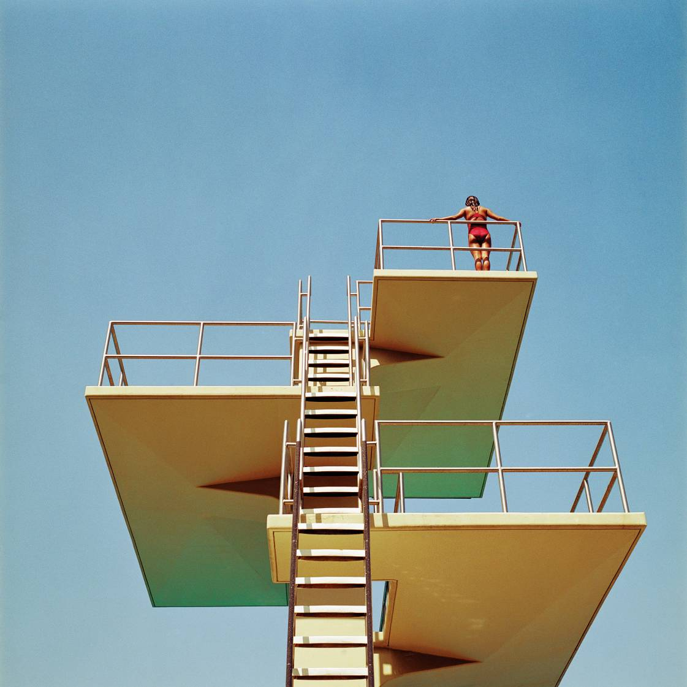
Year 1 report – main report


This is an independent evaluation report carried out by PricewaterhouseCoopers LLP and commissioned by the funders of the Free Swimming Programme:
Department for Culture, Media and Sport
Department of Health
Department for Children, Schools and Families (now Department for Education)
Department for Work and Pensions
Communities and Local Government
Sport England
Amateur Swimming Association

Contents
List of tables i
List of figures ii
Glossary of terms iii
1 Introduction 1
2 Context 4
3 Approach and methodology 12
4 Impact of the Free Swimming Programme 18
5 Lessons learned 33
6 Benefits and value for money of the Free Swimming Programme 42
7 Conclusions 47

List of tables
Table 4.1: Number of free swims undertaken by people aged 60 and over in participating pools 20
Table 4.2: Comparison of swimming frequency in the 60 and over age group pre and post April 2009 20
Table 4.3: Estimation of leakage to ineligible areas amongst those aged 60 and over 21
Table 4.4: Estimation of deadweight amongst those aged 60 and over 22
Table 4.5: Swimming participation rates amongst non-target groups (17-59 age group) based on APS data (Q1 of each wave) 22
Table 4.6: Estimation of displacement/substitution of swimming for other physical activities amongst those aged 60 and over 23
Table 4.7: Sensitivity analysis of displacement of swimming for other physical activities 23
Table 4.8: Estimation of wider effects (multipliers) amongst free swimmers aged 60 and over 24
Table 4.9: Estimation of sustainability amongst those aged 60 and over (all areas) 24
Table 4.10: Sustainability and willingness to pay when the FSP ends 25
Table 4.11: Estimation of net impact of free swimming for those aged 60 and over 25
Table 4.12: Estimation of net number of free swimmers amongst those aged 60 and over 26
Table 4.13: Number of free swims undertaken by people aged 16 and under in participating pools 27
Table 4.14: Comparison of swimming frequency in the 16 and under age group pre and post April 2009 27
Table 4.15: Estimation of leakage to ineligible areas amongst those aged 16 and under 28
Table 4.16: Estimation of deadweight amongst those aged 16 and under 28
Table 4.17: Estimation of displacement/substitution of swimming for other physical activities amongst those aged 16 and under 29
Table 4.18: Sensitivity analysis of displacement of swimming for other physical activities 29
Table 4.19: Estimation of wider effects (multipliers) amongst free swimmers aged 16 and under 29
Table 4.20: Estimation of sustainability amongst those aged 16 and under 30
Table 4.21: Sustainability and willingness to pay when the FSP ends 30
Table 4.22: Estimation of net impact of free swimming for those aged 16 and under 30
Table 4.23: Estimation of net number of free swimmers amongst the 16 and under age group 31
Table 5.1: Examples of good practice marketing 34
Table 5.2: lessons learned 38
Table 5.3: Conclusions and lessons learned 41
Table 6.1: Framework for assessing potential cost savings from increased physical activity 43
Table 6.2: Change in physical activity levels amongst free swimmers between 2009 and 2010 44
Table 6.3: Costs per net unit output 45
Table 6.4: Costs and benefits of free swimming 46

List of figures
Figure 2.2: FSP and the Legacy Action Plan 5
Figure 2.2: Pot 1 & 2 funding by region 9
Figure 3.1: Logic model for the Free Swimming Programme 12
Figure 3.2: Evaluation approach 14
Figure 3.3: Analytical framework 17
Figure 4.1: Proportion of people aged 60 and over aware that can swim for free in public pools 19
Figure 4.2: Proportion of adults living with children aged 15 and under and children aged 16 aware that can swim for free in public pools 26
Figure 4.3: Planned and actual delivery of free swimming lessons by region 32
Figure 5.1: Challenges to providing free swimming lessons 37
Figure 5.2: Expected and actual outcomes 38

Glossary of terms
APS | Active People Survey
ASA | Amateur Swimming Association
BME | Black Minority Ethnic
CLG | Department for Communities and Local Government
CSC | County Swimming Coordinator
DCMS | Department for Culture, Media and Sports
DCSF | Department for Children, Schools and Families
DH | Department of Health
DWP | Department for Work and Pensions
FSP | Free Swimming Programme
GDP | Gross Domestic Product
HR | Human Resources
KPI | Key Performance Indicator
LA | Local authority
MP | Member of Parliament
NHS | National Health Service
PCT | Primary Care Trust
PR | Public Relations
PwC | PricewaterhouseCoopers LLP
Q1 | Quarter 1
Q2 | Quarter 2
Q&A | Question & Answer
SE | Sport England
TCPS | Taking Part Children’s Survey

Executive Summary

Introduction

Terms of reference
Following the announcement of the Free Swimming Programme (FSP) in June 2008, PricewaterhouseCoopers LLP (PwC) was commissioned by Sport England in April 2009 to undertake a two year evaluation of the FSP in England. The aim of the evaluation is to assess:
- The impact of the FSP, specifically the extent to which it has increased the number of swims and the number of swimmers;
- The lessons learned, in particular evidence of what works, how, in what context and for whom; and
- The benefits and value for money of the FSP, focusing on the health and consequent economic benefits of swimming participation.
This executive summary assesses the impact of the FSP during its first year between April 2009 and March 2010.

Background
The FSP is one of the ways in which the Government plans to deliver the objectives of its Legacy Action Plan (LAP) for the London 2012 Olympic and Paralympic Games. Specifically, it focuses on the objectives of getting more adults active and providing young people with more physical education and sporting opportunities.
The Programme is funded by five government departments: the Department for Culture, Media and Sport (DCMS), the Department of Health (DH), the Department for Children, Schools and Families (now the Department of Education (DfE)), the Department for Work and Pensions (DWP) and the Department for Communities and Local Government (CLG). It also benefits from investment and resource from Sport England (SE) and the Amateur Swimming Association (ASA), which manages a team of County Swimming Coordinators (CSCs).
The £140m funding for the FSP over the two year period is divided into four ‘pots’. These consist of revenue funding for those aged 60 and over (£15m per year), revenue funding for those aged 16 and under (£25m per year), capital funding for dissemination in Year 1 (£10m) and further capital funding for dissemination through a bidding process in the two year period (£25m per year). In addition, some local authorities (LAs) have contributed additional funding to ensure delivery of the FSP.
Over the first year of the Programme, 261 LAs took up the Programme, including five which have no pools: 197 LAs have offered free swimming to those aged 60 and over and to those 16 and under, and a further 64 LAs have offered free swimming only to those aged 60 and over.

Context
Evidence from the Active People Survey (APS) shows that, whilst swimming remains the most popular sport with 3.2 million adults (7.6% of the population) taking part in at least one 30 minute session of at least moderate intensity per week, the level of participation has tended to decline over the last three waves of the APS, which started in October 2005. This is despite evidence from the APS showing that latent demand for swimming is the highest of all sports: around 5.4 million adults (12.9%) said that they would like to participate in swimming, or participate more often.
The DH recommends that adults undertake 30 minutes of physical activity a day on five days of the week to unlock the health benefits of physical activity and that children and young people should spend at least 60 minutes a day, every day of the week. Evidence from the Health Survey for England 2008 suggests that the level of physical activity undertaken by both age groups falls short of this: only 39% of men and 29% of women aged 16 and over reach the recommended level and only 32% of boys and 24% of girls aged between 2 and 15 achieve the Department’s recommended level of physical activity.

Approach
Our approach to the evaluation has involved collection and analysis of evidence through a range of mechanisms:
- Collation of monitoring data on the number of free swims undertaken in each LA at each participating centre by those aged 60 and over and those aged 16 and under;
- Analysis of data from the APS;
- Two waves of an online survey (undertaken by Research Now) of 4,000 members of the population in the two target age groups to assess participation in and attitudes towards swimming and free swimming;
- Two rounds of case study visits, based on LAs and CSCs throughout England, which explored four themes: marketing of the FSP, the financial impact of the Programme, the impact of CSCs and free swimming lessons;
- A programme of interviews with non-participating local authorities to understand the reasons behind their decision not to participate and their views of the FSP; and
- A literature review to assess the health impacts of exercise and the associated economic impacts.

Impact of the Free Swimming Programme

Awareness of the Programme
Levels of awareness of the FSP play a role in driving participation in the FSP and, therefore, its net impact. Figure 1 shows levels of awareness of the FSP. Those aged 60 and over were most aware of the FSP whilst those aged 16 were least aware of the Programme.

Participation in the Programme
Evidence from the monitoring data submitted monthly by each LA shows the number of free swims which have been taken throughout England. The APS also provides a basis for estimating the overall number of free swims undertaken as well as the number of (free) swimmers. The results of both analyses are summarised in Table 1. Despite differences between the two sources, they show a similar seasonal pattern, and that more free swims have been undertaken by people aged 16 and under than by those aged 60 and over.
Figure 1: Levels of awareness of the Free Swimming Programme
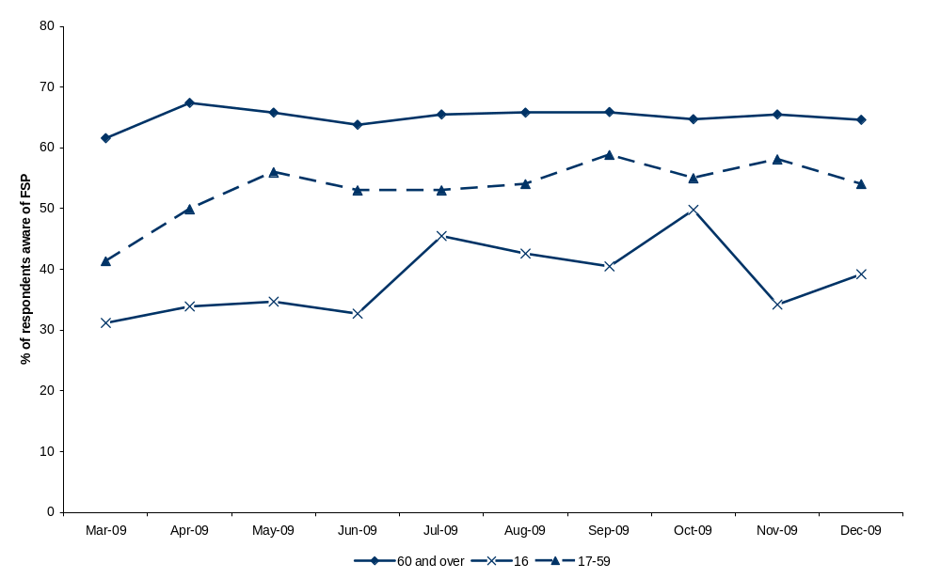
Source: Analysis of data from APS 3 and APS 4
Table 1: Number of free swims undertaken in participating pools (millions)
 | APS 3 (Q3) | APS 3 (Q4) | APS 4 (Q1) | APS 4 (Q2)
60 and over
Number of free swims (monitoring data) | 1.65 | 1.95 | 1.66 | 1.73
Number of free swims (APS data extrapolated to population level) | 1.43 | 2.26 | 2.07 | n/a
16 and under
Number of free swims (monitoring data) | 2.99 | 4.06 | 1.74 | 2.29
Number of free swims (APS data extrapolated to population level) | 3.73 | 6.75 | 5.48 | n/a
Source: Local authority monitoring data/APS

Net impact of the Free Swimming Programme
Our assessment of the net impact of the Programme uses the findings from the two waves of the online survey to assess the scale of each element of additionality. Our findings are summarised in Table 2 for each of the two target age groups. Our analysis shows that the level of additionality varies between age groups: for those aged 60 and over, we estimate additionality at 21.4% whereas for those aged 16 and under additionality is greater (49.8%). The main reason for the difference is that free swimmers aged 16 and under are more likely to be accompanied by other (paying) swimmers, although these swimmers are not all in the target age groups. In both age groups, nearly 90% of free swimmers indicated their intention to continue swimming.
Table 2: Estimated elements of additionality associated with the Free Swimming Programme
 | 60 and over age group |  | 16 and under age group
 | Nov / Dec 2009 | April / May 2010 | Nov / Dec 2009 | April / May 2010
Deadweight | 53.5% - 79.3% | 82.5% | 56.2% - 84.8% | 72.9%
Displacement / substitution | 8.7% | 6.3% | 14.5% | 8.2%
Wider effects (multipliers) | 22.8% | 30.4% | 76.4% | 100.0%
Net effect | 19.8%-44.6% | 21.4% | 24.2%-69.8% | 49.8%
Sustainability | 89.6% | 89.6% | 84.8% | 88.6%
Source: Analysis of online survey data
Using the results in Table 2, we have estimated the number of net additional swims and swimmers for each of the target age groups (see Table 3). For those aged 60 and over, we estimate that there have been around 1.5 million net additional swims over the first year of the FSP by about 23,000 net additional swimmers. For those aged 16 and under, there have been around 5.5 million net additional swims and just under 115,000 net additional swimmers.
Table 3: Estimated net number of free swims and free swimmers
 | 60 and over | 16 and under
Number of free swims reported from local authority monitoring data (million, Q1 – Q4) | 6.99 | 11.09
Number of free swims undertaken per month (‘000, Q1 – Q4) | 582.3 | 923.9
Average number of free swims undertaken per swimmer per month based on online survey | 5.42 | 4.03
Number of net additional swimmers based on online survey | 21.4% | 49.8%
Number of net additional swimmers per month (‘000) | 23.0 | 114.1
Number of net additional swims (million) | 1.49 | 5.52
Source: Analysis of online survey data and monitoring data

Impact of Free Swimming Lessons
There is limited evidence of the impact of the free swimming lessons offered as part of the FSP. Data provided by the ASA show that, to date, applications have been received to deliver 48,661 new swimmers via free swimming lessons, including 20,000 swimmers from schools delivering Key Stage 3. By March 2010, 18,399 new swimmers were recorded as having taken part in free swimming lessons across the nine regions in England. Further swimmers are thought to have taken part over the first year of the Programme, but the monitoring data for these lessons have not yet been returned.

Lessons learned
We have summarised the key conclusions and lessons learned from our qualitative research in Table 6.
Table 4: Key lessons learned
Thematic area | Conclusion or lesson learnt
Awareness of the FSP | - All LAs had a good level of awareness of the free swimming aspect of the Programme  - Non-participating authorities were not always aware of the availability of capital grants and grants for free swimming lessons when they made their decision on participation  - The timing of the initial decision making process was difficult and, in some cases, was adversely affected by non-availability of key staff over the summer holiday period
Decision making process | - The financial impact tended to be the key factor in the LA decision to participate in the FSP, although it was not the only factor  - Many LAs would have preferred an approach whereby grant funding was based on a targeted approach or on swimming pool usage figures  - Some non-participating LAs felt they would have participated if the requirements of the FSP could have been tailored further to suit local circumstances (e.g. being able to offer the FSP to those aged 16 and under only or to specific populations from deprived areas within the LA)
Marketing activities | - LAs highlighted a lack of specific guidance from central government departments with regard to promotion and marketing – this has led to a mixed approach to marketing and, in some areas, minimal activities  - There were some examples of good practice in marketing activities, including some that could be considered low cost options, however, this was not widespread. Consideration should be given to spreading such approaches to encourage further increases in participation in free swimming amongst the target groups by learning from good practice already developed by LAs to date  - In general, in areas where high levels of marketing activities had taken place, the increase in uptake of the FSP has been more pronounced  - Few LAs have specific plans for future marketing activities, although many would appreciate further guidance
Dealing with unanticipated outcomes | - LAs have experienced a range of unanticipated outcomes as a result of participating in the FSP which they have had to be overcome  - These include higher than expected administration costs (including the cost of re-issuing free swimming cards), reduced demand for paid swimming lessons and some negative reports about children’s behaviour
Impact of CSCs | - Time is required in order to allow CSCs to build effective relationships with partners  - There is a need to focus on key areas in Year 2 where performance is behind target  - There is a desire to share best practice amongst CSCs and operators and also to plan effective exit routes from lessons to encourage ongoing participation
Impact of free swimming lessons | - Substantial time is required for planning and project management  - Lack of pool capacity for lessons can be an issue – in some areas demand has outstripped supply and waiting lists have developed  - A friendly approach is important to new learners
Perceptions of the FSP | - CSCs, LAs and operators rated free swimming lessons higher (average of eight or nine out of ten) than the overall FSP (average of seven out of ten)  - Free swimming lessons were seen as providing a more effective method for targeting and increasing participation
Source: PwC analysis

Benefits and value for money of the Free Swimming Programme

Changes in levels of physical activity
The findings from the latest online survey showed positive changes in the level of physical activity undertaken by those who had participated in free swimming: amongst those free swimmers aged 60 and over, the proportion of respondents who undertook at least 30 minutes of activity a day increased from 66.2% before the start of the FSP to 78.4% since the FSP was introduced whilst amongst those aged 16 and under, the proportion of free swimmers undertaking more than 60 minutes of physical activities increased from 20.7% to 32.9%.
Whilst the increase in activity levels amongst these respondents may not be entirely attributable to the FSP, it is likely that some of it is.

Cost effectiveness and cost benefits of free swimming
Table 5 sets out the cost effectiveness of the FSP over the first year. Our analysis compares the inputs from central government with the associated outputs and outcomes. Thus, it assesses the impact of the resources committed to funding free swimming for each of the two target age groups in Year 1 with the estimated net outputs presented in Table 5. Neither the costs of free swimming lessons and the capital funding programme nor any additional costs incurred by LAs (and other stakeholders) are included in the estimates.
Table 5: Costs per net unit output
 | Number of net outputs delivered | Programme cost (£m) | Cost per unit of output (£)
60 and over
Swims | 1.49 million | 12.3 | 8.23
Swimmers | 22,971 | 12.3 | 535
16 and under
Swims | 5.52 million | 19.6 | 3.55
Swimmers | 114,068 | 19.6 | 172
Source: PwC analysis
Estimating the potential economic benefits of the FSP is fraught with a series of methodological difficulties. We have, nevertheless, sought to assess the potential benefits from Year 1 of the free swimming element of the FSP. We have focused on estimating the avoided costs to the health service and loss of productive days. The results of our analysis suggest that the benefit cost ratio of the programme for those aged 60 and over is in the region of 0.53:1 and for those aged 16 and under is in the region of around 0.82:1. These results do, however, need to be treated with caution.

Areas for improvement
Our evidence to date suggests that although the FSP has made some progress towards its objectives in terms of generating both net additional swims and swimmers, there is scope to build on this success in Year 2. We have identified a number of ways in which improvements could be made to the FSP:
- Put in place initiatives to reduce the level of deadweight experienced to date: this may include targeting non-swimmers through free swimming lessons and also making facilities more attractive to lapsed swimmers through the delivery of capital improvement projects;
- Provide clear, concise guidance (with regards to what works well) to LAs and CSCs on a timely basis, including where there are expectations in terms of marketing activities and any other expectations so as to drive growth in swimming on a year on year basis;
- Share good practice amongst LAs and CSCs (including non-participating LAs) by encouraging sharing and adoption of good practice universally to further drive uptake of swimming inter and intra-regionally;
- Ensure support is provided for CSCs in terms of additional training where required, and that materials and information is provided to them on a timely basis;
- Continue to provide free swimming lessons on a scale that will enable key growth targets to be met, ensuring that mechanisms used for marketing and promotion of these lessons (and follow-on activities) are undertaken locally, regionally and nationally where possible; and
- Consider how the impact of the FSP should be sustained beyond the two year funding period set, communicating details on a timely basis to LAs to allow local plans to be developed in time for the current scheme ending in March 2011.

Introduction

Introduction
This Section introduces the report of Year 1 of the evaluation of the Free Swimming Programme (FSP). It provides an overview of the terms of reference for the evaluation and explains the links between this evaluation and wider evaluation activities being undertaken as part of the London 2012 Olympic and Paralympic Games. It also sets out the structure of the remainder of this evaluation report.

Terms of reference
PwC was commissioned by Sport England in April 2009 to undertake a two year evaluation of the impact of the FSP. The aim of the evaluation is to assess the impact of the FSP by looking at three areas:
- The impact of the FSP, specifically the extent to which the FSP has increased the number of swims and the number of swimmers in the two target age groups;
- The lessons learned, in particular evidence of what works, how, in what context and for whom; and
- The benefits and value for money of the FSP, focusing on the health and consequent economic benefits of swimming participation.
PwC has worked with Research Now on this evaluation, combining PwC’s experience of evaluation and knowledge of the policy context with the ability of Research Now to conduct online surveys with the communities targeted by the Programme.
This report provides an assessment of the impact of the FSP between April 2009 and March 2010 (Year 1 of the programme).

Context – position of the Free Swimming Programme in relation to the London 2012 Olympic and Paralympic Games
The Department for Culture, Media and Sport (DCMS) has committed to creating a sustainable legacy for London and the UK following the hosting of the Olympic Games in 2012. The following five promises have been made:
- Make the UK a world-leading sporting nation;
- Transform the heart of East London;
- Inspire a generation of young people to take part in local volunteering, cultural and physical activity;
- Make the Olympic Park a blueprint for sustainable living; and
- Demonstrate the UK is a creative, inclusive and welcoming place to live in, visit and for business.
An Action Plan was put in place to help realise these objectives. With respect to the first objective, namely making the UK a world-leading sporting nation, the following goals were set:
- Two million more adults more active by the London 2012 Olympics and, in so doing, halt the recent decline in participation;
- Provide five hours (per week) of physical education and sport for 5 to 16 year olds and three hours of sporting opportunities for 16 to 19 year olds; and
- Offer three hours (per week) of sporting opportunities for young people aged 16 or under, beyond the school day.
The Action Plan stated that this would be delivered through:
“A range of new and planned programmes to increase sports participation; encourage swimming, walking and cycling.”
Swimming is seen as particularly important in the efforts to promote greater participation in physical activity and sport. Swimming is the most popular sport in England in terms of participation. Results from the Active People Survey (APS) show that in the period January 2009 to January 2010 over 5.5 million adults aged 16 and over (13.14%) went swimming at least once a month and over 3 million (7.63%) participated once a week. When the APS asked respondents “Which one sport or recreational physical activity would you most like to do, or to do more often?” the most common answer was swimming, with 5.4 million adults aged 16 and over (13%) wanting to participate more frequently. Swimming is, therefore, one of the sports for which there is the greatest latent demand.
In addition, swimming appeals to women and older age groups who are underrepresented in many other forms of sport and physical activity and it is seen as accessible to some groups for whom other, higher impact activity would be inappropriate, for example those with certain disabilities, pregnant women, those just starting physical activity and those who are frail or unsteady.
The FSP was announced in June 2008 as a £140 million programme which is funded by five government departments - the Department for Culture, Media and Sport (DCMS), the Department of Health (DH), the Department for Children, Schools and Families (now the Department of Education/DE), the Department for Work and Pensions (DWP) and the Department for Communities and Local Government – with investment and resource from Sport England (SE) and the Amateur Swimming Association (ASA), which has managed a team of County Swimming Coordinators (CSCs).
The FSP offers revenue grant funding to LAs to encourage them to offer free admission to publicly owned swimming pools for people aged 60 or over and 16 and under. It also offers capital grant funding to LAs participating in both the 60 or over and the 16 or under elements of the FSP to rejuvenate publicly accessible swimming pools in local authority or maintained school ownership. Finally, funding is also available (through the CSCs who are also funded by the Programme) for the provision of free swimming lessons for people across all age groups who are not able to swim or who are not confident in the water.

Report structure
This report summarises the key findings from our research and consultation at the end of Year 1. It is structured as follows:
- Section 2: describes the context for the evaluation, specifically the background to the launch of the FSP, its rationale, objectives and resources and its links to other similar swimming initiatives;
- Section 3: explains our approach and methodology;
- Section 4: analyses the evidence of the impact of the FSP;
- Section 5: discusses the lessons learned from the first year of the FSP;
- Section 6: assesses the benefits and value for money of the FSP;
- Section 7: summarises our key conclusions and assesses their implications.
This report is supported by the following Annexes:
- Annex 1: Local authority monitoring data
- Annex 2: Active People Survey results;
- Annex 3: Online survey results;
- Annex 4: Case study evidence – non-participating authorities;
- Annex 5: Case study evidence – participating authorities;
- Annex 6: Online survey questionnaire.
- Annex 7: Topic guide for case study visits; and
- Annex 8: Topic guide for interviews with non-participating LAs.

Context

Introduction
This Section of the report explains the background and context to the FSP with a focus on:
- Its role within the 2012 Olympics Legacy Action Plan;
- Historic trends in swimming participation and evidence of latent demand; and
- The potential health benefits of more physical activity.

Background

The 2012 Olympic Legacy Action Plan and the FSP
As outlined in the previous section, the Government has made a number of promises to assist in creating a sustainable legacy for London and the UK: These were further developed within a Legacy Action Plan (LAP) which provided detail on each of the five legacy promises and showed the headline ambitions behind each promise and the delivery programme that supported the delivery of those ambitions. Free swimming was cited in the LAP as one of the means of delivering the headline ambitions of inspiring young people through sport and getting more people more active. The Action Plan stated:
“We want to extend the considerable benefits of swimming and encourage providers to take a more user-focused approach. We will shortly announce plans for a new initiative to increase the number of people who swim and swim regularly. This will include measures to support local authorities to develop free swimming programmes and initiatives designed to improve the experience of swimming and to encourage adults who cannot swim, or cannot swim well, to take-up swimming… These new incentives will help many people become more active by 2012.”
Figure 2.1 illustrates how the FSP links to the relevant Government targets and headline ambitions:
Figure 2.2: FSP and the Legacy Action Plan
Legacy Promise
Headline Ambition
Targets
Delivery Programme
Make the UK a
world leading
sporting nation
Inspire young
people through
sport
Offer all 5 to 16 year
olds five hours of
high
-
quality sport a
week by 2012
Free Swimming
Programme
Get people more
active
Offer all 16 to 19
year olds three hours
of high
-
quality sport
a week by 2012
Help at least two
million more people
in England be more
active by 2012

Swimming participation and latent demand
The APS is a continuous annual survey undertaken by Sport England which examines how participation in sport varies between the range of different sports, people and places throughout England. To date, there have been three waves of the APS and the fourth wave commenced in October 2009. APS 1 began in October 2005 and was completed on 14 October 2006; APS 2 began on 15 October 2007 and was completed on 14 October 2008; and APS 3 began on 15 October 2008 and was completed on 14 October 2009. The results from Q1 of APS 4 have also been published and provide data covering the last four quarters (i.e. a rolling 12 months from January 2009 to January 2010). Findings from specific questions within these surveys, as they relate to swimming and the FSP, are outlined in more detail in Annex 2 of this report.
The results for once a week sports participation (which is one of Sport England’s strategic goals) across the range of funded sports from the latest Active People Survey (APS 4 Q1) show that:
- Swimming is the most popular sport with 3,219,900 adults (7.63%) taking part in at least one 30 minute session of swimming (or another associated activity as defined by the ASA) at least moderate intensity per week; and
- Over a million more people take part in swimming each week than the next most popular weekly sport of football which has 2,146,100 participants per week.
The fact that swimming is so popular reflects several reasons. In particular, it is seen as accessible to some groups for whom other, higher impact activity would be inappropriate, for example those with certain disabilities, pregnant women, those just starting physical activity and those who are frail or unsteady.
Although the APS shows that swimming remains the most popular sport, the level of participation has tended to decline over the last three waves of the APS. In particular:
- Swimming participation experienced a statistically significant decline from APS 1 to APS 2 from 3.27 million adults (8.04%) to 3.24 million adults (7.83%), a decrease of 29,500 participants.
- Between APS2 and APS3 there was a statistically significant decrease in the number of people swimming at least once a week. The results of APS 3 show that 81,900 fewer people swam once a week than during APS 2 (3,244,300).
- This fall in swimming participation was driven by a statistically significant decrease in female participation while male participation showed a small (not statistically significant) growth over the same period.
- The number of people swimming who were aged between 16 and 34 decreased and the decline was concentrated in the 16-19 and 25-29 age groups.
- There has been a statistically significant decline in swimming participation amongst those from lower socio-economic backgrounds and students. The participation of individuals from a higher socio-economic background has also decreased, but not significantly.
- Amongst those who swim the proportion participating once a week is lower for APS3 than for APS2 levels. .
APS2 showed that latent demand for swimming is the highest of all sports. About 5.4 million adults (13%) said that they would like to participate in swimming, or participate more often. This represents 24.2% of all 22.3 million adults who would like to do more sport and active recreation. Swimming is the one sport that 8.7% of males would like to do, or do more often, whilst the equivalent figure for females is 17.1%.

Links to improved health outcomes
The health benefits of physical activity are well documented and have been highlighted most recently in the Chief Medical Officer’s report for England. The following part of this Section examines the link between physical activity and physical and mental health and then briefly reviews the evidence of the physical and mental health benefits that swimming can provide.

Physical activity and physical health
There is a body of evidence that suggests a strong link between physical activity and the reduced risk of so called lifestyle diseases such as coronary heart disease and obesity, hypertension, cancer and osteoporosis.
The World Health Organisation has reported that physical inactivity is responsible for the following proportions of ‘disability-adjusted life years’ in developed countries:
- 23% of cardiovascular disease for men and 22% for women;
- 16% of colon cancer for men and 17% for women;
- 15% of type 2 diabetes;
- 12% of stroke for men and 13% for women; and
- 11% of breast cancer.
The Chief Medical Officer’s report also highlights the benefits of physical activity and states that those that are physically active reduce their risk of chronic diseases such as coronary heart disease, stroke and type two diabetes by up to 50%, and the risk of premature death by about 20-30%.

Physical activity and mental health
In addition to improved physical health, physical activity can have positive effects on people’s mental health. The Chief Medical Officer’s report states that:
“Physical activity is effective in the treatment of clinical depression and can be as successful as psychotherapy or medication, particularly in the longer term; and it may also help people with generalised anxiety disorder, phobias, panic attacks and stress disorders, and can have a positive effect on psychological well-being in people with schizophrenia.”
The report goes on to say that rhythmic forms of exercise, such as swimming, are the most effective in terms of delivering mental health benefits.

Levels of physical activity in the UK
A report from the Department of Health recommends that adults need to undertake 30 minutes of physical activity a day on five days of the week to unlock the health benefits outlined above. The report recommends that children and young people should spend at least 60 minutes a day, every day of the week. The existing level of physical activity of many English residents in both age groups falls short of this. The Health Survey for England 2008 showed that only 39% of men and 29% of women aged 16 and over reach these levels (based on self-reported levels of activity) and only 32% of boys aged between 2-15 and 24% of girls in the same age group achieved the Government’s recommended levels of physical activity.
The FSP aims to increase participation in sport and move the population closer to the Government’s recommended guidelines for physical activity.

Swimming and physical health benefits
Almost all physical activity can be considered to deliver health gains but swimming provides unique benefits. Swimming is a low impact exercise because the water supports the swimmer’s weight; individuals weigh 10% less in water and this makes it an accessible form of exercise for those with mobility difficulties, for example those who are obese. The buoyancy of the water also helps relax stiff muscles and reduces strain on joints and tissues thus lowering the risk of injury compared to other sports.
While the buoyancy of water makes it a low impact sport, the pressure and resistance of the water makes the body work harder. The DCMS states that for this reason 30 minutes of activity in the water is worth 45 minutes of the same activity on land. This makes swimming a suitable form of exercise for those that cite limited available time as the reason for being physically inactive.
Swimming has been found to be a good method for preventing cardiovascular disease as it strengthens the heart. Swimming reduces blood pressure, thereby lowering the risk of heart disease and stroke. Other organs of the body to benefit include the lungs – length swimming requires swimmers to breathe in a deep and rhythmic way, meaning that swimming provides a good workout for the lungs.

Swimming and mental health
Swimming can also be good for mental wellbeing: the rhythmic breathing required when length swimming allows more oxygen to flow to muscles which can make the swimmer feel more relaxed and less anxious. It has been suggested that simply being in the water can be relaxing.

The Free Swimming Programme

Rationale
The FSP is expected to contribute to the Government’s LAP by increasing physical activity amongst adults and children, whilst also halting the recent decline in participation. The Programme was designed to attract new participants as well as to encourage existing swimmers to swim more often, and to focus on sustaining increases in participation.
The DCMS website states:
“We’ve made swimming free because it’s the most popular physical recreation for adults, with around 17% of females and 10% of males swimming at least once a month. It has universal appeal, low barriers to participation and well-documented health benefits. According to the 2002 General Household Survey and confirmed by data from Active People 2, swimming is the most popular choice of activity for those who want to take part in sport but don’t currently do so.”
In addition, swimming is a particularly attractive sport for those aged 60 and over as it is a low impact activity. As this age group is one of the least active groups of people within the population, targeting them and encouraging them to become more active, along with those aged 16 and under, helps the Government to fulfil its goal of getting two million more adults more active by the London 2012 Olympics.

Objectives
The objectives of the FSP are to contribute to the Government’s targets of:
- Providing five hours of physical education and sport for 5 to 16 year olds, beyond the school day;
- Providing three hours of sporting opportunities for young people aged 16 or under, beyond the school day; and
- Helping at least two million more people in England be more active by 2012.

Participation
Over the first year of the Programme, 261 out of 326 LAs have taken up the Programme in some way:
- 197 LAs offer free swimming for those aged 60 and over and those 16 and under; and
- 64 LAs offer free swimming only for those aged 60 and over.
Two of these LAs joined the FSP after 1st April 2009: Surrey Heath and Wokingham, who are now providing free swimming to both age groups. In addition, six LAs extended their offer to include those aged 16 and under, after initially joining the programme in April 2009 and offering free swimming only to those aged 60 and over only. These LAs were Barnet, Broxtowe, East Hampshire, Mansfield, Reading and Warwick. Two LAs have downgraded their offer since April 2009 and now solely provide free swimming to those aged 60 and over.

Resource allocation
The FSP’s funding is divided into four ‘pots’ as follows:
- Pot 1: Revenue funding for the provision of free swimming for those aged 60 and over - £15 million per year;
- Pot 2: Revenue funding for the provision of free swimming for those aged 16 and under - £25 million per year: LAs can only access funding in this pot if they agree to provide swimming for those within Pot 1);
- Pot 3: Capital funding for dissemination in 2008/09 - £10 million: this can be accessed by those providing free swimming for those within Pot 2; and
- Pot 4: Capital funding for dissemination in 2009/10 and 2010/11 - £25 million per year.
Besides the funding from central government departments and agencies, some LAs have also contributed additional funding to ensure delivery of the FSP.

Pot 1 & 2 funding
To date, £12.3 million has been provided to LAs through Pot 1 Funding. Of this, the LAs in the North West region have received £2.0 million and those in the North East £0.8 million. To date, £19.6 million has been provided to LAs through Pot 2 Funding. LAs in the West Midlands have received the most (£2.8 million) and those in the South West have received the least (£0.8 million). The funding allocation by region is shown in Figure 2.2.
Figure 2.2: Pot 1 & 2 funding by region
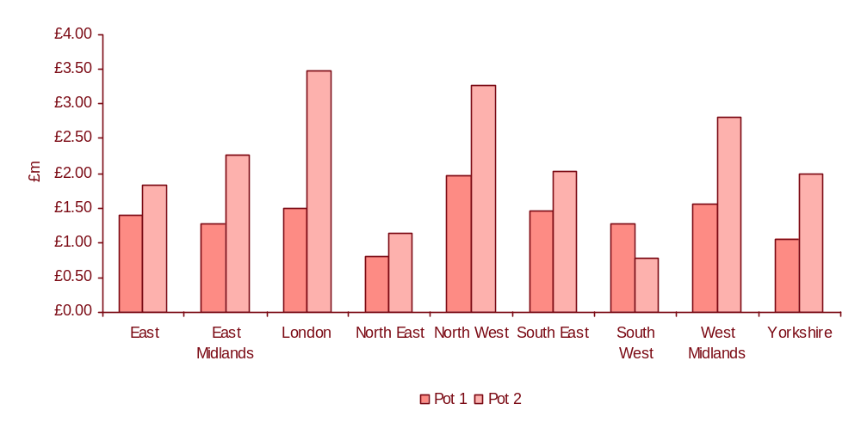
Source: PwC analysis

Pot 3 & 4 funding
Through Pot 3, £10 million of capital funding was provided to LAs in 2008/09 to support their capital modernisation programmes. A further £25 million of capital funding was awarded to LAs via a competitive bidding process in 2009/10 and a further £25 million of capital funding is due to be disseminated in 2010/11.

Other swimming initiatives
Various other initiatives to encourage swimming participation and exercise have been undertaken throughout the UK. We consider four of the key ones:
- The Free Swimming Programme in Wales;
- The Change4Life programme in England;
- The Kids Swim Free programme in London; and
- The Everyday Swim initiative.

The Free Swimming Programme in Wales
The Free Swimming Programme in Wales provided free entitlement to swimming from the summer of 2003 to those aged 16 and under during school holidays and free swimming to those aged 60 and over outside the school holidays. This initiative is still ongoing although is based around a number of criteria set by the Welsh Assembly Government.
We summarise the main findings of the evaluation of the programme in Wales below:
- The initiative was viewed as successful in increasing the number of juvenile swims through ‘free splash’ although the LAs have now shifted their focus to provision of quality swimming experiences and structured activities;
- Structured activities were found to increase long term usage to a greater degree than free splash although some pool managers indicated that structured sessions were under-utilised;
- Some leisure centre managers thought that the initiative had been successful in increasing the number of female swimmers as well as those from disadvantaged areas, however 40% of leisure centre managers stated that participation levels in swimming had either declined or remained the same as a result of the initiative; and
- The part of the scheme focused on those aged 60 and over was also found to have increased the number of new swimmers as well as increasing the attendance of existing users. Other programmes, such as Fit Swim Wales, lessons and activities such as Aqua Fit were provided as part of the programme for those aged 60 and over.

The Change4Life Programme
The Change4Life was launched in January 2009 with the aim of helping families in England to eat well, move more and live longer. It should be noted that the strategic objectives for this programme differ from those of the FSP, in that it is aimed at increasing people’s awareness of aspects of a healthy lifestyle, rather than providing any specific economic or financial benefits to do so.
An evaluation of the Campaign during the first year was conducted in November 2009. The headline findings of the evaluation include:
- Advertising awareness reached 85% in May 2009, with logo recognition at 86% (compared to a baseline recognition level of 9%);
- 71% of general practitioners and practice managers are aware of the campaign;
- 85% of mothers agreed that Change4Life “made me think about my children’s health in the long term”, 81% agreed it “made me think about the link between eating healthily and disease” and 83% “made me think about the link between physical activity and disease”. The monitoring survey indicates that a quarter of all parents already claim that they have taken action as a direct result of seeing Change4Life communications;
- Over 320,000 families have joined Change4Life. 260,000 families completed How Are The Kids? questionnaires. 77% of the responses have come from postcodes where it was estimated that at-risk families are most likely to reside, indicating that at-risk families are responding in greater numbers than the total population (64% of English families fall into the at-risk clusters);
- The Central Office of Information (COI), the centre of excellence for marketing and communications within government departments, found that the Change4Life website was the stickiest in Government (“stickiness” being a measure of the time people spend on a site and depth of engagement they have with the content); and
- COI’s analysis of How Are The Kids? concluded that the programme is the best performing direct response campaign in its database of previous government campaigns.
Swim4Life was then launched as part of the Change4Life offer. Swim4Life promotes the message that swimming is a great activity for the family and also promotes the FSP by highlighting areas that are participating in the programme.

Kids Swim Free
The Kids Swim Free (KSF) programme was launched in 2004 with the aim of increasing the number of children swimming during the Easter holidays in five East London Boroughs, and to provide an opportunity to promote physical activity amongst children and their families. The number of swims taken by children during this period (75,406) was more than double that of the previous year (32,178).
We summarise the key findings of the evaluation below:
- The overall cost to the central partners of the scheme was just under £140,000 and the cost per swim £1.28. This increased to £1.84 when marketing and research/evaluation costs were also included. Compared with individual entry costs at the time, this suggested that the scheme could be good value for money. However it should be noted that these figures are based on gross costs per swim, in that calculations are based on total operational costs divided by the total attendance for free swimming;
- The scheme was successful in attracting groups that are underrepresented in many other forms of sport and physical activity: older children, girls and unskilled social groups.
- The scheme demonstrated the inability/unwillingness of unskilled social groups to pay to swim and that if the financial barrier is removed, unskilled social groups increase uptake; and
- The scheme attracted parents to leisure centres, providing opportunities for physical activity promotion.
The recommendations from the evaluation included:
- Sufficient time should be given for the preparation of promotional materials and to take leisure centre views into consideration;
- Schools need to be “on board”;
- Sufficient lead-in time is required for considering and publicising the pool timetable;
- Consideration should be give to whether supervised sessions should be provided for unaccompanied children; and
- Consideration should be given to running free non-swimming physical activities or promotions simultaneously to Kids Swim Free scheme (this approach was successful in two Boroughs).

The Everyday Swim initiative
The Everyday Swim initiative ran in nine LAs in England, each of which chose to focus on a different group of non-traditional swimmers within their local population from 2006 to 2009. The LAs shared funding of £3 million and were set a target of increasing the swimming participation rate by 3% in the final 18 months of the pilot, between October 2007 to March 2009.
The evaluation of the initiative found that:
- Five of the nine pilot areas noted a positive change in participation based on data collated as part of APS 1 and APS 2. These changes ranged between 0.81% and 3.84% although only one LA area achieved a statistically significant increase in swimming participation;
- Collation of monitoring data as part of this evaluation was problematic. The evaluation concluded that accuracy was not always of the standard required for monitoring and decision making purposes;
- Three areas of good practice were identified, each of which was viewed as helpful in encouraging more people to swim: structured sessions (rather than access to ‘free splash’), culture change (more customer focus) and marketing (understanding who customers are, what they want, and how to reach them and particularly non-users);
- Five critical success factors were identified: good information, effective consultation with partners, dynamic leadership and support networks, continuity and perseverance and a long-term vision; and
- The evaluation concluded that provision of free splash sessions alone was likely to have more of an effect on ‘market penetration’ (existing swimmers taking part more often) than on ‘market development’ (new swimmers). It also found that initial increases in participation may not be sustained over time. This led to the conclusion that greater benefits are likely to arise from other elements of the programme such as free swimming lessons, capital investment and creative marketing than from simply removing the price barrier.
In summary, the evaluation programmes showed the success that free swimming initiatives can have in increasing participation levels, particularly from groups that are underrepresented in other sports and activities. In addition, they have shown that structured sessions (which either teach non-swimmers to swim or rebuild the confidence of those who have not been swimming in a number of years) are more effective than ‘free splash’ sessions in maintaining participation over the longer term.

Approach and methodology

Introduction
This Section explains the logic chain we have used to structure the identification of the key research questions and provides a summary of each phase of the research over the two year period, along with an update on changes which have been made to the approach over the first year of the evaluation (in particular to the online survey and approach to identifying case studies). It also explains the analytical framework that we have used to assess the net impact of the FSP.

Approach - logic model underpinning evaluation
Crucial to the successful delivery of any evaluation is the creation of an appropriate framework within which to identify and define the key evaluation questions. We have developed a logic model for this purpose which provides a structure for the evaluation and guides our research. The logic model considers the situational background to the FSP, inputs, activities, outputs and outcomes as shown in Figure 3.1.
Figure 3.1: Logic model for the Free Swimming Programme
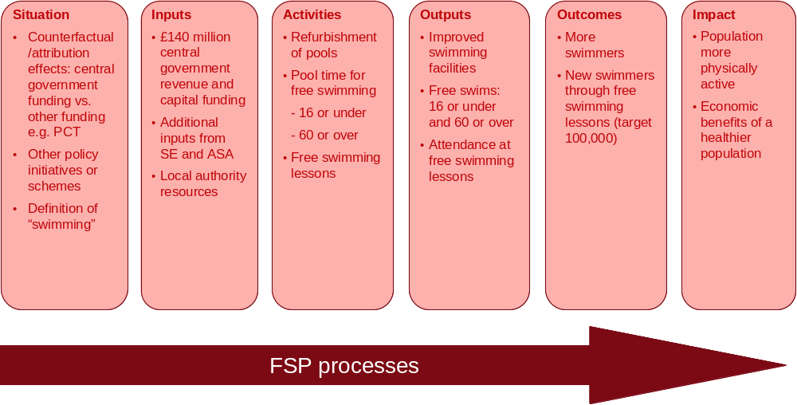
Source: PwC evaluation framework
As shown in the logic model above, each area which is being examined (such as situational understanding, inputs, activities and so on) can be measured in a number of different ways. For example, the outputs which the evaluation seeks to measure are not just the number of free swims that have been undertaken within each age group, but also attendance at free swimming lessons as these are developed and implemented across England and the improvements made to swimming facilities. In Year 1, the key aspects which we have focused on measuring are the outputs (the number of free swims and attendance at free swimming lessons) and the outcomes (the number of swimmers and new swimmers through free swimming lessons).
In Year 1, we also consider the evidence as to whether the FSP is beginning to deliver the expected impacts in terms of a more physically active population and the economic benefits that are associated with such a population. In Year 2 we will continue to focus on measuring these areas, along with expanding the evaluation to include other areas as outlined in Figure 3.1 above. For example, capital grants have not explicitly been explored as part of the evaluation to date as much of the work funded by the FSP is still in progress and, thus, it is too early to assess the full impact. Likewise, there is as yet limited evidence on the effect of providing free swimming lessons to attract new swimmers.

Methodology for Year 1 Report
Based on the logic model approach described above, the evaluation has been divided into four phases over the two year research period. The phases, which are shown diagrammatically in Figure 3.2, can be summarised as follows:
- Phase 1: this phase included our preparatory work which culminated in the agreement of an ‘Initiation Stage Working Paper’ which defined our approach to the evaluation;
- Phase 2: this phase included initial research, including baseline research, and concluded with preparation of an ‘Interim Report’ which provided an initial assessment of the impact of the FSP between April 2009 and September 2009;
- Phase 3: this phase included a second wave of research and analysis to track the impacts of the FSP and inform this Year 1 Report which analyses and summarises our emerging findings at the end of Year 1 of the Programme (from April 2009 to March 2010); and
- Phase 4: this phase will include a further, third wave of research and analysis to update and extend the evidence and enable us to prepare a ‘Final (Year 2) Report’ which analyses and summarises our findings at the end of the FSP.
Within each Phase completed to date, we have undertaken a series of activities which fall into one of three broad categories: information gathering (where we will gather and review secondary relevant data), survey and case study research (where we will undertake various forms of primary data collection) along with analysis and reporting. Each Phase, along with the research activities being undertaken, is shown in Figure 3.2 and is explored in further detail later in this Section in relation to the current phase of work (Phase 3) culminating in this Year 1 report.
Work on Phase 1 of the evaluation was completed between April and September 2009. Initial work was undertaken to develop a series of key performance indicators (KPIs) for each area being measured through the evaluation, along with definitions in order to assist with data collation. In turn, a secure online system for LAs to submit monthly performance monitoring data was developed and implemented, allowing secure storage of data and prompt collation of reports for the purposes of the Official Statistics, which are published on a quarterly basis. The Official Statistics provide the basic throughput data in terms of the number of free swims which are undertaken by the two target age groups on a monthly and quarterly basis, along with the total number of free swims by region and an indication of performance in terms of number of free swims per capita of the population in the two target age groups.
This Phase also included further refining our approach to the evaluation with our partners Research Now (who are responsible for administering the online survey to a nationally representative sample of people aged 16 and under and 60 and over in England). This primarily involved the development of the questions to be included within the online survey and piloting of it. The pilot survey was administered in October 2009 and 250 complete responses were received. Beyond this, each follow-on wave of the full online survey has achieved 4,000 completed responses, based on the approach and sample quotas designed to ensure that a sufficiently representative sample of swimmers is found in each wave.
Work to inform the development of the Interim Report (Phase 2) was undertaken from October 2009 to January 2010. This involved gathering information related to the first six months of the Programme (from April 2009 to September 2009) including monitoring data and evidence from APS3. Findings from the Active People Survey were used as a source of additional data which could be compared with the LA monitoring data, in terms of the total number of swims and swimmers, and frequency of participation. Additionally, the first wave of the online survey was administered between 23rd November and 3rd December, whilst case studies with 12 participating LAs and telephone interviews with a sample of non-participating LAs were undertaken in November and early December 2009. This Phase culminated in the production of the Interim Report for the Steering Group, the findings from which are also incorporated in this Year 1 report.
Figure 3.2: Evaluation approach
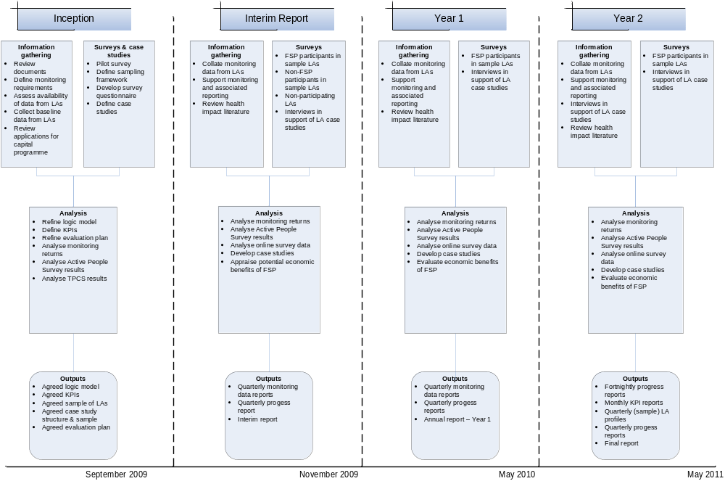

Work undertaken in Phases 1 and 2 of this evaluation have been used as the basis for the approach taken to Phase 3. The work undertaken in Phase 3 is outlined in more detail below:

Secondary research – information gathering
Several information gathering activities have been undertaken to inform the Year 1 report including:
- Collation of monitoring data from each of the participating LAs via a secure online system. This monitoring data is based on the number of free swims undertaken in each LA each month from April 2009 to March 2010 by those aged 60 and over and those aged 16 and under;
- Production of quarterly statistical reports on the number of free swims undertaken for publication on the DCMS website following validation of the monthly LA data; and
- A review of secondary literature to assess the health impacts of exercise, and swimming specifically, along with the estimated economic impact generated by increased physical activity amongst the general population.

Primary research - surveys & case studies
Two strands of primary research were also undertaken to inform the Year 1 report:
- An online survey (undertaken by Research Now) of the general population aged 6-16 and 60 and over in England between 26th April and 5th May 2010 to assess participation in swimming and free swimming amongst the two relevant age groups. The survey covered both adults living in LAs which are participating in the FSP and those which are not. In total, 4,012 responses were received, of which 1,469 were from children aged 6-16 and 2,543 were from adults aged 60 and over. These results, combined with those from the first wave of the online survey used to inform the Interim Report, form part of our evidence base for the Year 1 report; and
- Case studies to examine the impact of County Swimming Coordinators (CSCs) and the impact of free swimming lessons were undertaken in April and May 2010. The areas selected for case studies spanned across the nine English regions (as defined by the ASA) where each Senior CSC is based. Each Senior CSC or other CSC who participated in the case study discussion to examine the impact of their roles was asked to nominate a pool or LA in their region where they had undertaken work to promote free swimming lessons and which could be used to understand the impact of free swimming lessons. The findings from this round of case studies, combined with the 12 case studies previously undertaken to inform the Interim Report, form part of our evidence base for the Year 1 report. It should be noted, however, that the 12 LAs which participated in the first round of case studies were selected to ensure broadly proportional representation in terms of the nature of the FSP on offer (whether just for those aged 60 and over or for both groups), regional spread and the demographic/deprivation profile of each LA.
This Section is supported by two Annexes: Annex 3 summarises the findings from each round of the online survey and Annex 6 provides the online survey questionnaire(s). In addition, Annexes 7 and 8 provide details of the topic guides used for case study visits and interviews with non-participating LAs.

Analysis
We have analysed the findings from each of the sources described to inform the following sections of this report along with the conclusions and implications.
Our quantitative analysis is based on three main data sources:
- Monitoring data on the number of free swims collated from information provided by each local authority on a monthly basis (to provide an estimate of gross outputs);
- Findings from the online survey across England undertaken in April/May 2010 (to provide an estimate of additionality); and
- Secondary analysis of findings from each of the four consecutive waves of the APS of adults across England (to provide a point of comparison for the outputs and outcomes observed amongst those who have undertaken a free swim and who were aged 16 or 60 and over).
Over the course of the information gathering activities to inform the development of the Year 1 report, a number of issues have been noted with regards to the consistency and quality of the different data sources. Whilst steps have been taken to maximise both the consistency and quality of the data, there are some inherent difficulties which should be considered in the interpretation and analysis of findings presented within this report:
- Monitoring data provided by LAs are based on information gathered at pool level. In most instances, free swims are monitored using computerised systems although a small number of pools and LAs rely on manual systems. Data for several LAs have been affected by a data review exercise which has been undertaken by the national provider organisation following the identification of discrepancies between the monitoring data previously submitted and the actual number of attendances for free swims. Whilst this discrepancy has now been addressed by the provider and the majority of LAs affected, DCMS are presently conducting further investigations to ensure that the reporting of all free swims in authorities operated by SLM are as accurate as possible.
- Data have not been systematically collated on the resources committed to the FSP by parties other than central government. Indeed, there are conceptual challenges in determining the additional resources that have been invested, for example by LAs. Thus, the cost-benefit analysis reported later does not take into account these resources. Furthermore, this analysis has been undertaken at an aggregate level across England. As such, it does not show any differences which may exist between LAs.
- Whilst the online survey provides a robust way to gather views on swimming from a large group of respondents in a short timescale, the nature of such online surveys may mean that certain groups (such as those without access to the internet) are excluded from responding. We have set quotas for responses for both those aged 16 and under and those aged 60 and over to ensure that an adequate number of responses are gathered for both age groups. We have also set quotas to ensure adequate responses from those in different regions of England and in different social groups. These were all regularly monitored throughout the survey process. Analysis of the survey findings shows that responses have been received from a spectrum of age groups from those aged six to those aged 89.
- Analysis of data from the APS is also restricted to national level when results are disaggregated on a monthly basis. Unfortunately monthly results cannot be disaggregated at local authority level due to the small base sample sizes in each area in each month.

Analytical framework
A key focus of the evaluation of the FSP has been to understand how the gross and net impact of the FSP compare. Specifically, the analysis aims to assess how the pattern of swimming has changed compared with what it would have been if the FSP had not been launched. In order to do this, it is necessary to consider the various elements of additionality (see Figure 3.3). Additionality can be considered separately for both age groups in terms of both swims and swimmers.
For the purposes of this evaluation, the key factors that impact on the estimation of additionality are the following:
- Reference case/counterfactual: the change in the pattern of participation in swimming that would have happened anyway in the absence of the Programme;
- Leakage: the extent to which the benefits of the FSP have impacted on residents from non-participating LAs. It should, however, be noted that, whilst leakage is estimated and discussed in terms of generating an impact for residents of non-participating LAs, it is not factored into the estimation of net impact overall. This is because the FSP is a national initiative and thus open to all English residents (including those in non-participating LAs who are willing to travel outside of their own area to swim). Hence, it would be incorrect to deduct a percentage for leakage within the additionality estimations;
- Deadweight: the extent to which those individuals who swam for free would have swum anyway because they were willing to pay;
- Displacement/substitution: the extent to which the FSP has:
- displaced existing swimmers and swimmers from outside the two target groups;
- led to swimmers switching to public pools from private pools: such displacement/substitution has the potential to undermine the viability and, thus, the sustainability of commercial swimming pools although it has not been factored into our analysis in Year 1;
- impacted upon participation in other sports;
- Wider effects: the impact of the FSP on the uptake of paid swims by wider friends and family members, linked to free swimmers; and
- Sustainability: the likelihood that those who swam for free as a result of the FSP will continue swimming beyond the lifespan of the FSP.
Figure 3.3: Analytical framework
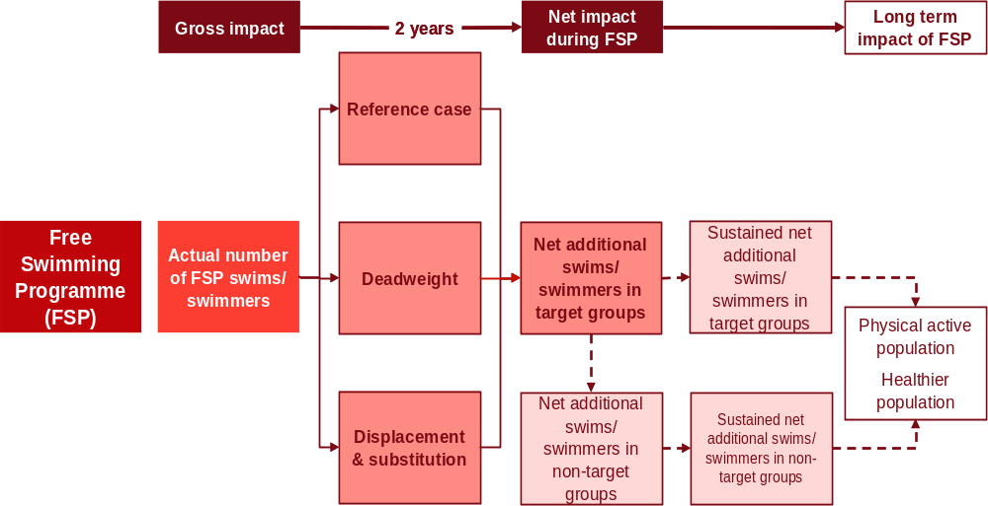
Source: PwC

Links between this evaluation and the evaluation framework for the London 2012 Olympic and Paralympic Games
The evaluation of the FSP is being conducted in line with the “London 2012 Olympic and Paralympic Games Impacts and Legacy Evaluation Framework” produced by DCMS. This evaluation framework highlights a number of indicators associated with sport and physical activities and other outcomes which should be achieved through the Olympic and Paralympic Games, which should also be delivered upon through the FSP. These indicators and outcomes include:
- Percentage of 5-16 year olds participating in at least two hours per week of high quality PE and sport at school;
- Percentage of 5-19 year olds participating in at least three further hours per week of sporting opportunities;
- Additional years of healthy life; and
- Economic and social participation by disadvantaged groups.
In addition, the approach used to evaluate the impact of the FSP is consistent with the methods recommended in the DCMS Framework. These include use of logic chains, clear indicators and reporting mechanisms and use of additionality estimates in the overall assessment of impact. Therefore, this evaluation will be useful to DCMS in evaluating the overall impact associated with the London 2012 Olympic and Paralympic Games.

Impact of the Free Swimming Programme

Introduction
This Section of our report analyses the impact of the FSP on the pattern of swimming and other physical activity, in particular of the two target age groups. Using the analytical framework explained in Section 3, it considers the gross and net impact of the FSP on each of the target age groups separately by examining the available evidence about:
- awareness of the FSP;
- levels of participation in the FSP as measured by the number of free swims and free swimmers – the gross impact;
- the extent to which the FSP has changed the number of swims undertaken and the number of swimmers within them, including how far the FSP has increased the overall level of physical activity after allowing for displacement and substitution – the net impact; and
- the likely sustainability of the impact.
The primary source of data for estimating the net impact is the online survey, however, we also use data on the gross number of swims obtained through monitoring data and APS 3/4.
The final part of the Section assesses the influence of the free swimming lessons provided as part of the FSP.

Awareness of the Free Swimming Programme – 60 and over
The level of awareness of the FSP has a role in driving the gross impact and, therefore, the net impact of the Programme since awareness is a pre-condition for behaviour change.
Figure 4.1 shows the variation in levels of awareness of the FSP amongst those aged 60 and over based on analysis of data from a set of additional questions which were asked of respondents to the APS from March 2009 onwards to coincide with the introduction of the FSP. It shows that awareness was highest amongst this age group in April 2009 (when 67.4% of the APS 3 sample was aware of the Programme), although it has remained relatively constant between July and December 2009.
Figure 4.1: Proportion of people aged 60 and over aware that can swim for free in public pools
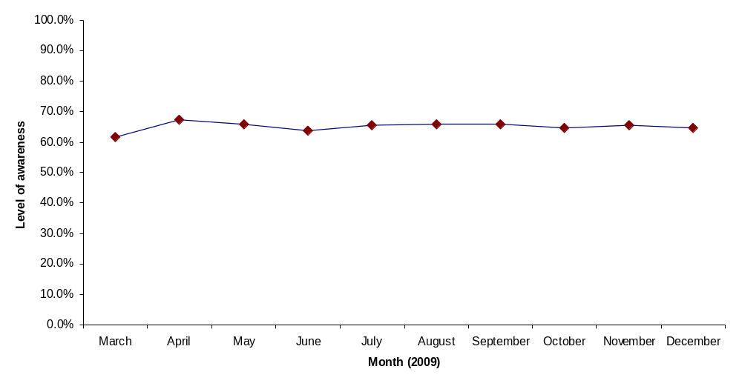
Source: Active People Survey

Scale of free swimming - 60 and over
The gross impact of the FSP can be gauged by considering the total number of free swims undertaken by those aged 60 and over. This can be measured in two different ways:
- the monitoring data submitted by each participating local authority on a monthly basis provide a source of the number of free swims that have been taken by those aged 60 and over throughout England; and
- data from the APS can also be used by extrapolating the number of free swims per swimmer across the population in the target age group.
The monitoring data are, however, less helpful in assessing the number of swimmers who have taken up swimming within the FSP. In order to assess the number of free swims undertaken by each swimmer, it is necessary to use survey data. We have used two such sources: the APS and the online survey set up specifically for this evaluation.
Table 4.1 shows the scale of free swimming using the two approaches. It is evident that the number of free swims recorded in the monitoring data was higher than that estimated through extrapolation of the APS data in the first quarter of the FSP (April to June 2009). In the subsequent two quarters, the numbers based on the extrapolated APS data were greater than the monitoring data. Several reasons may explain this difference:
- the APS is a sample survey and, as such, there are margins of error around estimates based on it;
- the APS may be capturing free swims not undertaken as part of the FSP: as noted, there are various other free swimming initiatives running concurrently with the FSP;
- the APS does not enable a distinction to be made between swims in LAs eligible for the FSP and those which are not; and
- there may be inaccuracies in the monitoring data.
Table 4.1: Number of free swims undertaken by people aged 60 and over in participating pools
 | APS 3 (Q3)  April to June 2009 | APS 3 (Q4)  July to September 2009 | APS 4 (Q1)  October to December 2009
Number of free swims (APS data extrapolated to population level) | 1.43 million | 2.26 million | 2.07 million
Number of free swims (monitoring data) | 1.65 million | 1.95 million | 1.66 million
Extrapolated APS data as a % of monitoring data | 86.6% | 116.3% | 125.1%
Source: Local authority monitoring data/Active People Survey

Impact of the Free Swimming Programme – 60 and over
The net impact of the FSP on those aged 60 and over can be assessed in terms of the additional number of swims, swimmers and participants in physical activity by estimating the extent to which the observed activity is additional (i.e. it would not have happened but for the FSP). As discussed in the previous Section, this involves adjusting for several different factors.

Reference case
The first step is to establish the reference case (or the counterfactual). This is the change in the pattern of participation in swimming that would have been expected to happen anyway in the absence of the FSP. This is difficult to determine because there are many other related initiatives across the UK at present which encourage the population to become more physically active. These include initiatives such as Everyday Swim.
There are two potential approaches: the online survey asks a direct question to participants in eligible and ineligible areas whereas the APS enables trends over time to be compared in all LA areas across England.
The online survey conducted as part of this evaluation asked respondents in the 60 and over age group the following question:
“Comparing your swimming now and your swimming before April 2009, are you swimming more often now, less often now, or about as often as you did before April 2009?”
Analysis shows that the proportion of respondents aged 60 and over swimming more frequently now than before April 2009 (when the FSP was introduced) is greater than the proportion which is swimming less often. Comparing swimmers in eligible and ineligible areas, there is no statistically significant difference.
Table 4.2: Comparison of swimming frequency in the 60 and over age group pre and post April 2009
Change in swimming frequency since April 2009 | November/December 2009 |  | April/May 2010
Change in swimming frequency since April 2009 | Swimmers aged 60 and over in eligible areas | Swimmers aged 60 and over in ineligible areas | Swimmers aged 60 and over in eligible areas | Swimmers aged 60 and over in ineligible areas
More often | 87  (28.1%) | 16  (24.2%) | 82  (27.2%) | 22  (29.7%)
About as often as before | 167  (53.9%) | 37  (56.1%) | 166  (55.0%) | 33  (44.6%)
Less often | 56  (18.1%) | 12  (18.2%) | 53  (17.5%) | 19  (25.7%)
Not sure | 0  (0.0%) | 1  (1.5%) | 1  (0.3%) | 0  (0.0%)
Total | 310  (100.0%) | 66  (100.0%) | 302  (100.0%) | 74  (100.0%)
Source: Online survey
As noted (see Annex 2), evidence from the APS provides a picture of how the pattern of swimming has changed over time, before and after the launch of the FSP. For example, for those aged 60 and over, APS 3 shows that 8.0% of respondents in Q3 had swum at least once in the last month, compared with 7.4% of respondents in Q3 of APS 2. Similarly, 9.0% of those aged 60 and over in Q4 of APS 3 had swum at least once in the last month compared to 8.1% of respondents in the same period of APS 2. In turn, 8.0% of those aged 60 and over had swum at least once in the last four weeks in Q1 of APS 4, compared with 7.0% of this age group in Q1 of APS 3. In addition, changes in once a week swimming participation based on each swim being of at least 30 minutes at a moderate intensity increased when the findings from APS 3 Q3 and Q4, and APS 4 Q1 are compared with figures from before the FSP was introduced (one year prior).

Leakage
Leakage is defined as the extent to which the benefits of the FSP impact on residents from non-participating LAs. As discussed in the previous Section, leakage is of less significance from a national perspective but is more important from a local perspective because of its potential effect on the ability of LAs affected to deliver the Programme successfully. The estimation of the level of leakage in terms of those aged 60 and over moving from non-participating to participating LAs to swim is set out below for information.
The online survey conducted as part of this evaluation asked respondents in the 60 and over age group the following question:
“When you swam most recently, can you recall what admission charge, if any, you paid to swim?”
Findings from this question showed that leakage amongst those aged 60 and over has fallen across the two waves of the survey from 7.6% in November/December 2009 to 5.4% in April/May 2010.
Table 4.3: Estimation of leakage to ineligible areas amongst those aged 60 and over
Element of estimation | November/December 2009 survey | April/May 2010 survey
Number of free public swims undertaken by those resident in ineligible areas | 11 | 8
Number of free public swims undertaken by those resident in eligible areas | 134 | 140
Total number of free public swims | 145 | 148
% of free public swims undertaken by residents of ineligible areas | 7.6% | 5.4%
Source: Online survey

Deadweight
Deadweight is defined as the extent to which those individuals who swam for free would have been willing to pay. The online survey conducted as part of this evaluation asked respondents in the 60 and over age group the following question:
“How likely is it that you would have gone swimming at this pool even if you had not been able to swim for free?”
In the first wave of the survey undertaken in November/December 2009, a four point scale of responses was used ranging from “very likely to have swum anyway” to “very unlikely to have swum anyway”. Interpretation of the responses to this question presented some inherent difficulties because it was hard to assess how likely it was that those responding in different ways would have gone swimming anyway. For example, it was not clear how many of those who stated that they were “very likely to have swum anyway” would actually have gone swimming. As a result, we undertook sensitivity analysis to assess the implications of different interpretations. We used a number of scenarios as follows:
- Scenario 1: 100% of those who stated that they were ‘very likely’ to have swum plus 100% of those who stated that they were ‘quite likely’ to have swum;
- Scenario 2: 100% of those who stated that they were ‘very likely’ to have swum plus 75% of those who stated that they were ‘quite likely’ to have swum; and
- Scenario 3: 80% of those who stated that they were ‘very likely’ to have swum plus 50% of those who stated that they were ‘quite likely’ to have swum.
Using these assumptions, it was found that the level of deadweight for those aged 60 and over at between 53.5% and 79.3%
In order to reduce the uncertainty regarding the ‘true’ level of deadweight, we amended the response scale within the online survey administered in April/May 2010. We gave respondents the opportunity to respond on a sliding scale according to the likelihood that would have gone swimming anyway.
Table 4.4 shows our estimates of deadweight based on the two waves of the online survey. The level of deadweight amongst those aged 60 and over is estimated at 82.5% based on the responses to the survey in April/May 2010. This is slightly higher than the upper limit of the range we estimated via the online survey in November/December 2010 (53.5% to 79.3%).
Table 4.4: Estimation of deadweight amongst those aged 60 and over
Response scale | November/December 2009 |  |  | Response scale | April/May 2010
Response scale | Number of respondents | Estimated number of swimmers | Level of deadweight | Response scale | Number of respondents | Estimated number of swimmers | Level of deadweight
Very likely | 67 | Between 100% of ‘very likely’ and 100% of ‘quite likely’ and 80% of ‘very likely’ and 50% of ‘quite likely’ | Between 53.5% and 79.3% | Very likely to have gone swimming (100% likely) | 85 | 85 | 100%
Fairly likely | 48 |  | Between 53.5% and 79.3% | Fairly likely to have gone swimming (75% likely) | 37 | 27.8 | 75%
Not sure | 5 | 0 | Between 53.5% and 79.3% | Neither likely or unlikely have gone swimming (50% likely) | 14 | 7 | 50%
Fairly unlikely | 19 | 0 | Between 53.5% and 79.3% | Fairly unlikely to have gone swimming (25% likely) | 9 | 2.3 | 25%
Very unlikely | 6 | 0 | Between 53.5% and 79.3% | Very unlikely to have gone swimming (0% likely) | 3 | 0 | 0%
Total | 145 | - | Between 53.5% and 79.3% | Total | 148 | 122.1 | 82.5%
Source: Online survey

Displacement /substitution
As noted in the previous Section, there are potentially two elements of displacement/substitution related to the FSP which need to be considered:
- displacement of existing swimmers and swimmers from outside the two target groups; and
- displacement of participation in other sports (i.e. whether participation in the Programme has been at the expense of participation in other activities).
It is difficult to measure whether the FSP has displaced existing swimmers from those outside of the target groups. The online survey does not include respondents outside the target groups (i.e. those aged 17-59) and, therefore, the effect of the Programme on non-target groups cannot be assessed in this way.
An alternative approach is to use data from the APS and examine trends across each wave. Table 4.5 shows swimming participation rates (based on once per month participation) amongst those aged 17-59 in Q1 of each wave of APS which has been undertaken (given that the most recently available data from APS 4 is for Q1). It suggests that swimming participation has declined over the last 12 months. Whilst the FSP only commenced during the time when APS 3 was being undertaken, the data from previous waves show that:
- between Q1 of APS 2 and Q1 of APS 3 swimming participation amongst the 17-59 age group remained static at 13.7%;
- between Q2 of APS 2 and Q2 of APS 3 swimming participation amongst the 17-59 age group declined from 14.4% to 13.4%;
- between Q3 of APS 2 and Q3 of APS 3 swimming participation amongst the 17-59 age group declined from 15.5% to 15.1%; and
- between Q4 of APS 2 and Q4 of APS 3 participation amongst those aged 17-59 increased from 18.5% to 18.6%.
Given the uncertainty in longer term trends in swimming participation in this age group and the fact that any decline may be due to factors other than the existence of the FSP, it is difficult to accurately assess displacement in this way.
Table 4.5: Swimming participation rates amongst non-target groups (17-59 age group) based on APS data (Q1 of each wave)
 | APS 1  (2005 to 2006) | APS 2  (2007 to 2008) | APS 3  (2008 to 2009) | APS 4  (2009 to 2010)
% of 17-59 year olds who undertook any swimming in the previous four week period | 12.7% | 13.7% | 13.7% | 13.3%
Source: Active People Survey data
The extent of displacement/substitution arising from the FSP can also be considered in terms of the swimmers who, despite swimming more often, now spend less time or have stopped participating in other sports or recreational activities. Our online survey asked respondents in the 60 and over age group the following question:
“Has swimming more often meant that you are spending less time these days on other sports or recreational physical activities than you did before April 2009?”
Table 4.6 below shows the level of displacement/substitution of swimming for other activities amongst those who have participated in free swimming. In the most recent wave of the online survey, over 85% of free swimmers had not reduced the time they spent on other physical activities. In contrast, less than 3% had stopped their other activities altogether and 9.6% of free swimmers stated that they were now spending less time on other physical activities although they did not indicate by how much.
Table 4.6: Estimation of displacement/substitution of swimming for other physical activities amongst those aged 60 and over
Element of estimation | November/ December 2009 | April/May 2010
Number of respondents who stated that they were not spending less time on other activities | 91  (88.3%) | 89  (85.6%)
Number of respondents who stated that they were spending less time on other activities (despite swimming more often) | 9  (8.7%) | 10  (9.6%)
Number of respondents who stated that they completely stopped doing these other activities | Question not asked | 3  (2.9%)
Number of respondents who were unsure | 3  (2.9%) | 5  (4.8%)
Source: Online survey
Table 4.7 shows the level of displacement based on an assumption that on average half of swimmers who spend less time on other activities have stopped other activities as a result of swimming more often. This shows that the level of displacement associated with swimmers spending less time on other physical activities is likely to be 6.3% for those aged 60 and over.
Table 4.7: Sensitivity analysis of displacement of swimming for other physical activities
Element of estimation |  | Level of displacement | 60 and over
 |  | Level of displacement | November/December 2009 | April/May 2010
Number of respondents who stated that they have completely stopped doing these other activities |  | 100% | Question not asked | 3 of 104  (2.9%)
Number of respondents who stated that they were spending less time on other physical activities |  | At 100% | 9  (8.7%) | 7  (6.7%)
 |  | At 50% | Question not asked | 3.5  (3.4%)
 | Level of displacement |  |  | 6.3%
Source: Online survey

Wider effects
For the purposes of this evaluation, the wider effects are defined in terms of multiplier or knock-on effects whereby the benefits of the Programme are spread beyond the two target groups (for example, by children being accompanied by parents while swimming, thus increasing the activity levels of the family as a whole). This can be measured by the impact of the FSP on uptake of paid swims by wider friends and family members, linked to free swimmers.
The online survey asked respondents in the 60 and over age group the following questions:
“When you swam most recently, did you go with anyone else, such as a group of friends or a member of your family?”
“Of the people you went swimming with most recently, how many, apart from yourself, paid an admission fee to swim?”
The online survey showed that within the 60 and over age group the wider effect was 30.4% in April/May 2010 compared with 22.8% in November/December 2009, an increase of over seven percentage points . It should be noted that our estimate of the multiplier effect does not take into account the number of people accompanying the free swimmer where the respondent has stated that two or more people accompanied them (we have assumed in such instances that they were accompanied by only two people). In addition, a number of these additional swimmers who accompanied the ‘free swimmer’ may have swum anyway (i.e. there would be a level of deadweight associated with this). As our survey only asked questions directly of those who had swum in the previous four weeks (and did not include any friends or family members who may have swam with them), this could not be assessed. Therefore, these responses suggest that wider effect in terms of multipliers amongst the 60 and over age group stands at 30.4%.
Table 4.8: Estimation of wider effects (multipliers) amongst free swimmers aged 60 and over
Element of estimation | November/December 2009 | April/May 2010
Number of those who swam for free and who also swam with someone else | 74  (51.0%) | 76  (51.4%)
Number of respondents who swam with someone who paid an admission fee to swim | 23  (31.1%) | 31  (40.8%)
Number of respondents who swam with one other person who paid an admission fee to swim (A) | 13 | 17
Number of respondents who swam with two other people who paid an admission fee to swim (B) | 10 | 14
Total number of additional swims through wider effects (A+(Bx2)) | 33 | 45
Multiplier effect (additional swims through wider effects divided by the number of free swimmers) | 22.8% | 30.4%
Source: Online survey

Sustainability
Whilst sustainability has not been included in our estimate of additionality (and, thus, in the net impact of the FSP), it is relevant to the longer term success of the Programme. The online survey asked respondents in the 60 and over age group the following questions as an indicator of sustainability of their swimming over the past 12 months (April 2009 to March 2010) and also their plans over the next 12 months (April 2010 to April 2011):
“Comparing your swimming now (November 2009) and your swimming before April 2009, are you swimming more often now, less often now, or about as often as you did before April 2009?”
“Comparing your swimming now (April 2010) and your swimming since April 2009, are you swimming more often now, less often now, or about as often as you did in April 2009?”
“During the next 12 months, do you expect to spend at least as much time taking part in sports and recreational physical activities as you do now?”
Responses to these questions showed that a broadly similar number of those aged 60 and over were swimming more often in November/December 2009 than prior to April 2009, when compared to those swimming more often in April/May 2010. In addition, the same proportion of respondents (89.6%) aged 60 and over in both waves of the survey expect to spend at least as much time taking part in sports and recreational physical activities over the next twelve months (see Table 4.9).
Table 4.9: Estimation of sustainability amongst those aged 60 and over (all areas)
Element of estimation | November/December 2009 | April/May 2010
Number of swimmers who are swimming more often than before April 2009 | 103  (27.4%) | 104  (27.7%)
Number of respondents who expect to spend at least as much time taking part in sports and recreational physical activities over the next 12 months | 337  (89.6%) | 337  (89.6%)
Source: Online survey
Two questions were added to the online survey in April 2010 to assess likely future behaviour in relation to swimming once the FSP ends (in March 2011).
The following questions were then asked in relation to sustainability and willingness to pay:
“In future, how much would you be prepared to pay per session to swim in your local public swimming pool?”
“Would you still swim as often if you could not swim for free?”
The findings from the online survey are shown in Table 4.10. They highlight that the vast majority (95.9%) of those aged 60 and over who had swum in the previous four weeks would be willing to pay a fee to swim in their local public pool in the future. Few of those aged 60 and over (8.1%), however, indicated that they would maintain the same or a greater level of swimming frequency once the FSP had ended.
Table 4.10: Sustainability and willingness to pay when the FSP ends
Element of estimation | April/May 2010
Number of swimmers aged 60 and above who would be willing to pay a fee per session to swim in their local public swimming pool | 603  (95.9%)
Number of swimmers who would not be willing to pay a fee per session to swim in their local public swimming pool | 26  (4.1%)
Number of swimmers who would swim less often or not at all once the FSP ends | 106  (71.6%)
Source: Online survey

Net impact
In order to estimate the overall level of additionality for those aged 60 and over in percentage terms, it is necessary to combine data from the online survey for each factor of additionality with data on the level of swimming uptake. Table 4.11 sets out the estimation of the overall level of additionality for those aged 60 and over, using findings for each element of additionality as described above to reach an overall figure for net impact in this age group. We estimate that the number of net additional swimmers in the 60 and over age group to date is 21.4%.
Table 4.11: Estimation of net impact of free swimming for those aged 60 and over
 | November/December 2009 |  | April/May 2010
 | % | Number | % | Number
Number of respondents aged 60 and over in eligible areas who were free swimmers in the last four weeks (gross impact) | - | 145 | - | 148
Deduction for leakage | - | 145 | - | 148
Deduction for deadweight | 53.5% - 79.3% | 30.0 - 67.4 | 82.5% | 25.9
Deduction for displacement/substitution | 21.9% | 23.4 – 52.7 | 6.3% | 24.3
Addition of wider effects (multipliers) | 22.8% | 28.7 – 64.7 | 30.4% | 31.6
Net additional swimmers (estimated by dividing the net impact after wider effects by the gross impact) | 19.8% - 44.6% | - | 21.4% | -
Source: Online survey
These data can then be combined with the LA authority monitoring data to estimate the net number of additional swims and swimmers. Our estimates are shown in Table 4.12. They indicate that the FSP offer to those aged 60 and over has delivered 1.49 million net additional swims (over the first year of the Programme) and over and 23,000 net additional swimmers per month.
Table 4.12: Estimation of net number of free swimmers amongst those aged 60 and over
 | Number of swims/swimmers
Number of free swims reported from local authority monitoring data (Q1 – Q4) | 6.99 million
Number of free swims undertaken per month (‘000, Q1 – Q4) | 582.3
Average number of free swims undertaken per swimmer per month based on online survey data | 5.42
Number of net additional swimmers based on analysis of online survey data | 21.4%
Number of net additional swimmers per month (‘000) | 23.0
Number of net additional swims | 1.49 million
Source: Analysis of FSP monitoring data and online survey data

Awareness of the Free Swimming Programme – 16 and under
Levels of awareness of the FSP have a role in driving the gross impact and, therefore, the net impact of the Programme.
Figure 4.2 shows awareness of the FSP amongst adults aged 17-59 sharing a household with children aged 15 and under, and also levels of awareness amongst those aged 16. This shows that, amongst both groups of respondents, the level of awareness has risen in the first nine months of the FSP, although is higher amongst parents of those aged 15 and under than amongst those aged 16.
Figure 4.2: Proportion of adults living with children aged 15 and under and children aged 16 aware that can swim for free in public pools
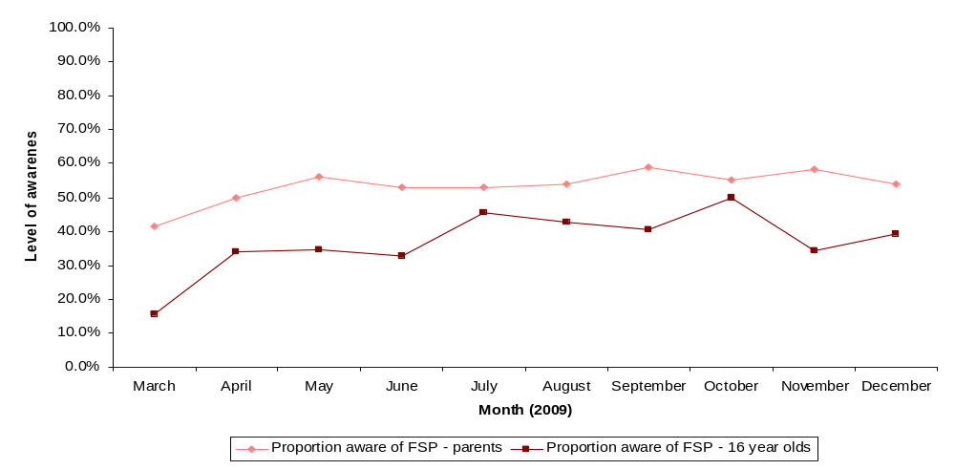
Source: Active People Survey

Scale of free swimming – 16 and under
We have measured the level of participation in free swimming amongst those aged 16 and under in broadly the same way as for those aged 60 and over. The significant difference is that the APS only covers children aged 16. It does, however, seek the views of adults living in households with children aged 15 and under.
Our analysis, whereby the number of free swims undertaken by those aged 16 and under is compared between the two sources, is shown in Table 4.13. It is evident that the number of swims recorded in the monitoring data is lower than that estimated through extrapolation of the APS data in all three quarters where data are available. Many of the reasons for the differences between the monitoring data and the extrapolated APS data for this age group are likely to be similar to those for adults aged 60 and over. In addition, for this age group, the question within the APS asked adults aged 17-59 who share a house with children aged 15 or under. Parents, therefore, are being asked to account for the number of swims taken by their children with the results that the levels reported may not be entirely accurate as they are essentially reported by a third party. Furthermore, respondents may share a household with more than one child and these respondents are expected to report the total number of free swims taken by the children in their household. Both factors potentially contribute to the differences between the APS based estimates and the monitoring data.
Table 4.13: Number of free swims undertaken by people aged 16 and under in participating pools
 | APS 3 (Q3)  April to June 2009 | APS 3 (Q4)  July to September 2009 | APS 4 (Q1)  October to December 2009
Number of free swims (APS data extrapolated to population level) | 3.73 million | 6.75 million | 5.48 million
Number of free swims (monitoring data) | 2.99 million | 4.06 million | 1.74 million
Extrapolated APS data as a % of monitoring data | 124.7% | 166.3% | 314.9%
Source: Local authority monitoring data/Active People Survey

Impact of the Free Swimming Programme – 16 and under
This part of the Section analyses and estimates the net impact of the FSP on those aged 16 and under in terms of the additional number of swims, swimmers and participants in physical activity. It follows a very similar approach to that used to estimate the impact on those aged 60 and over.

Reference case
We have used two different approaches to assess the reference case (or the counterfactual): the online survey asks a direct question whereas the APS enables trends over time to be compared in ineligible areas although it only covers those aged 16 (and excludes those aged 15 and under).
Analysis of the online survey shows that the proportion of swimmers who reported that they were swimming more often since the introduction of the FSP in April 2009 was slightly more in areas eligible for the FSP than those living outside these areas (see Table 4.14). The difference, however, is not statistically significant.
Table 4.14: Comparison of swimming frequency in the 16 and under age group pre and post April 2009
Change in swimming frequency since April 2009 | November/December 2009 |  | April/May 2010
Change in swimming frequency since April 2009 | Swimmers aged 16 and under in eligible areas | Swimmers aged 16 and under in ineligible areas | Swimmers aged 16 and under in eligible areas | Swimmers aged 16 and under in ineligible areas
More often | 145  (38.6%) | 83  (33.1%) | 168  (42.1%) | 88  (38.3%)
About as often as before | 168  (44.7%) | 127  (50.6%) | 181  (45.4%) | 109  (47.4%)
Less often | 60  (16.0%) | 40  (15.9%) | 46  (11.5%) | 30  (13.0%)
Not sure | 3  (0.8%) | 1  (0.4%) | 4  (1.0%) | 3  (1.3%)
Total | 376  (100.0%) | 251  (100.0%) | 399  (100.0%) | 230  (100.0%)
Source: Online survey
As noted (see Annex 2), evidence from the APS provides a picture of how the pattern of swimming has changed over time, before and after the launch of the FSP. For example, for those aged 16 and under, APS 3 showed that 13.7% of respondents in Q3 of the survey had swum at least once in the previous month, compared to 16.8% of respondents in Q3 of the APS 2 survey. Similarly, 18.5% of those aged 16 and under in Q4 of APS 3 had swum at least once in the last month compared to 22.8% of respondents in the same period of the APS 2 survey. However, 14.4% of those aged 16 and under had swum at least once in the last four weeks in Q1 of APS 4, compared with 13.6% of this age group in Q1 of APS 3. In addition, changes in once a week swimming participation based on each swim being of at least 30 minutes at a moderate intensity also showed very slight increases when the findings from APS 3 quarters 3 and 4, and APS 4 Q1 are compared with figures from before the FSP was introduced.

Leakage
Although leakage is excluded from the assessment of the overall impact of the FSP, it is nonetheless useful to understand where those responding to the free swimming offer live. The online survey enables us to analyse whether or not free swimmers lived in LAs eligible for the FSP. Table 4.15 summarises the results. It shows that leakage amongst those aged 16 and under increased across the two waves of the survey from 13.9% in November/December 2009 to 17.9% in April/May 2010.
Table 4.15: Estimation of leakage to ineligible areas amongst those aged 16 and under
Element of estimation | November/December 2009 survey | April/May 2010 survey
Number of free public swims undertaken by those resident in ineligible areas | 23 | 37
Number of free public swims undertaken by those resident in eligible areas | 142 | 170
Total number of free public swims | 165 | 207
% of free public swims undertaken by residents of ineligible areas | 13.9% | 17.9%
Source: Online survey

Deadweight
Our analysis of deadweight amongst those aged 16 and under uses the same approach as the one we have used for those aged 60 and over.
Table 4.16 shows the estimated level of deadweight in the two waves of the online survey. The level of deadweight amongst those aged 16 and under is 72.9%. This is within the range estimated via the first online survey in November/December 2009 (56.2% to 84.8%).
Table 4.16: Estimation of deadweight amongst those aged 16 and under
Response scale | November/December 2009 |  |  | Response scale | April/May 2010
Response scale | Number of respondents | Estimated number of swimmers | Level of deadweight | Response scale | Number of respondents | Estimated number of swimmers | Level of deadweight
Very likely | 76 | Between 100% of ‘very likely’ and 100% of ‘quite likely’ and 80% of ‘very likely’ and 50% of ‘quite likely’ | Between 56.2% and 84.8% | Very likely to have gone swimming (100% likely) | 74 | 74 | 100%
Fairly likely | 64 |  | Between 56.2% and 84.8% | Fairly likely to have gone swimming (75% likely) | 84 | 63 | 75%
Not sure | 6 | 0 | Between 56.2% and 84.8% | Neither likely or unlikely have gone swimming (50% likely) | 13 | 6.5 | 50%
Fairly unlikely | 14 | 0 | Between 56.2% and 84.8% | Fairly unlikely to have gone swimming (25% likely) | 29 | 7.3 | 25%
Very unlikely | 5 | 0 | Between 56.2% and 84.8% | Very unlikely to have gone swimming (0% likely) | 7 | 0 | 0%
Total | 165 | - | Between 56.2% and 84.8% | Total | 207 | 150.8 | 72.9%
Source: Online survey

Displacement /substitution
Our assessment of displacement/substitution related to the FSP amongst those aged 16 and under has focused on displacement of participation in other sports (including whether the Programme has encouraged existing swimmers to swim more often).
Table 4.17 shows the level of displacement/substitution of swimming for other activities amongst those who have participated in free swimming. In the most recent wave of the online survey, over 80% of free swimmers had not reduced the time they spent on other physical activities. In contrast, less than 5% had stopped their other activities altogether and 11.3% of free swimmers stated that they were now spending less time on other physical activities although they did not indicate by how much.
Table 4.17: Estimation of displacement/substitution of swimming for other physical activities amongst those aged 16 and under
Element of estimation | November/December 2009 | April/May 2010
Number of respondents who stated that they were not spending less time on other activities (despite swimming more often) | 182  (79.8%) | 209  (81.6%)
Number of respondents who stated that they were spending less time on other activities | 33  (14.5%) | 29  (11.3%)
Number of respondents who stated that they completely stopped doing these other activities | Question not asked | 12  (4.9%)
Number of respondents who were unsure | 13  (5.7%) | 18  (7.0%)
Source: Online survey
Table 4.18 shows the level of displacement based on the assumption that on average half of the swimmers who spend less time on other activities may have stopped other activities as a result of swimming more often. This shows that the level of displacement/substitution associated with swimmers spending less time on other physical activities is likely to be 8.2% for those aged 16 and under.
Table 4.18: Sensitivity analysis of displacement of swimming for other physical activities
Element of estimation |  | Level of displacement | 16 and under
 |  | Level of displacement | November/December 2009 | April/May 2010
Number of respondents who stated that they have completely stopped doing these other activities |  | 100% | Question not asked | 12  (4.9%)
Number of respondents who stated that they were spending less time on other physical activities |  | At 100% | 33  (14.5%) | 17  (6.6%)
 |  | At 50% | Question not asked | 8.5  (3.3%)
 | Level of displacement |  |  | 8.2%
Source: Online survey

Wider effects
Our approach to the assessment of the wider effects of the FSP on the 16 and under age group is similar to that we have used to assess the impact on those aged 60 and over.
Table 4.19 summarises the results. The online survey shows that the wider effects were 100% in April/May 2010 compared with 76.4% in November/December 2009, an increase of over 23 percentage points.
Table 4.19: Estimation of wider effects (multipliers) amongst free swimmers aged 16 and under
Element of estimation | November/December 2009 | April/May 2010
Number of those who swam for free who also swam with someone else | 155  (93.9%) | 198  (95.7%)
Number of respondents who swam with someone who paid an admission fee to swim | 76  (49.0%) | 118  (59.6%)
Number of respondents who swam with one other person who paid an admission fee to swim (A) | 26 | 29
Number of respondents who swam with two other people who paid an admission fee to swim (B) | 50 | 89
Total number of additional swims through wider effects (A+(Bx2)) | 126 | 207
Multiplier effect (additional swims through wider effects divided by the number of free swimmers) | 76.4% | 100.0%
Source: Online survey

Sustainability
Whilst sustainability is not a factor which contributes to our assessment of additionality and, thus, to our estimate of the net impact of the FSP, it is an important factor in the longer term success of the Programme. Specifically, it has an important bearing on thee likely impact on swimmers’ physical wellbeing and, hence, the benefits of the FSP. This is discussed further in Section 6.
Table 4.20 shows that a broadly similar number of those aged 16 and under were swimming more often in November/December 2009 than prior to April 2009 (36.4%), when compared to those swimming more often in April/May 2010 (40.7%). In addition, the proportion of respondents aged 16 and under who expect to spend at least as much time taking part in sports and recreational physical activities over the next twelve months has increased, from 84.8% in November/December 2009 to 88.6% in April/May 2010.
Table 4.20: Estimation of sustainability amongst those aged 16 and under
Element of estimation | November/December 2009 | April/May 2010
Number of swimmers who are swimming more often than before April 2009 | 228  (36.4%) | 256  (40.7%)
Number of respondents who expect to spend at least as much time taking part in sports and recreational physical activities over the next 12 months | 532  (84.8%) | 557  (88.6%)
Source: Online survey
In our online survey, we also asked about likely future behaviour in relation to swimming once the FSP ends (March 2011). Our findings are presented in Table 4.21. They show that the majority (90.4%) of those aged 16 and under who had swum in the previous four weeks (including those who had swum for free and those who had paid to swim) would be willing to pay a fee per session to swim in their local public pool in the future. Few of those swimmers aged 16 and under (11.6%) indicated that they would maintain the same or a greater level of swimming frequency once the Programme had ended.
Table 4.21: Sustainability and willingness to pay when the FSP ends
Element of estimation | April/May 2010
Number of respondents who would be willing to pay a fee per session to swim in their local public swimming pool (Base: all swimmers aged 16 and under) | 340  (90.4%)
Number of respondents who would not be willing to pay a fee per session to swim in their local public swimming pool (Base: all swimmers aged 16 and under) | 36  (9.6%)
Number of respondents who would swim less often or not at all once the FSP ends (Base: all free swimmers aged 16 and under) | 139  (67.1%)
Source: Online survey

Net impact
In order to estimate the overall level of additionality amongst those aged 16 and under, we have brought together our analysis of the online survey results for each element of additionality.
Table 4.22 sets out the results. It shows that the proportion of free swimmers in the 16 and under age group who are additional is estimated at 49.8% April/May 2010. This compares with a range of 24.2% to 69.8% in November/December 2009.
Table 4.22: Estimation of net impact of free swimming for those aged 16 and under
 | November/December 2009 |  | April/May 2010
 | % | Number | % | Number
Number of respondents aged 16 and under in eligible areas who were swimmers in the last four weeks (gross impact) | - | 165 | - | 207
Deduction for leakage | - | 165 | - | 207
Deduction for deadweight | 56.2% - 84.8% | 25.1 - 72.3 | 72.9% | 56.1
Deduction for displacement/substitution | 9.6% | 22.7 - 65.3 | 8.2% | 51.5
Addition of wider effects (multipliers) | 76.4% | 40.0 - 115.2 | 100.0% | 103.0
Net additional swimmers (estimated by dividing the net impact after wider effects by the gross impact) | 24.2% - 69.8% | - | 49.8% | -
Source: Online survey
We have analysed these data alongside the LA monitoring data to estimate the net number of additional swimmers. Our estimates are shown in Table 4.23. They indicate that the FSP offer to those aged 16 and under has generated 5.52 million net additional swims in its first year amongst and 114,100 net additional swimmers per month.
Table 4.23: Estimation of net number of free swimmers amongst the 16 and under age group
 | Number of swims/swimmers
Number of free swims reported from local authority monitoring data (million, Q1 – Q4) | 11.09
Number of free swims undertaken per month (‘000, Q1 – Q4) | 923.9
Average number of free swims undertaken per swimmer per month based on online survey data | 4.03
Proportion of net additional swimmers based on analysis of online survey data | 49.8%
Number of net additional swimmers per month (‘000) | 114.1
Number of net additional swims (million) | 5.52
Source: Analysis of local authority monitoring data and online survey data

Influence of free swimming lessons
Free swimming lessons are an integral part of the FSP. The aim of lessons is to bring non swimmers into the pool, teach them to swim and encourage them to take up swimming as part of a healthy lifestyle. Lessons are available to anyone over the age of 11, with 15 to 17 year olds and those aged 60 and over identified by the ASA as target age groups. The funding available consists of three pots:
- Pot A funding for lessons delivered between July and September 2009 - £1,500 was available for the delivery of six sets of lessons within this time period;
- Pot B funding for lessons delivered between September 2009 and March 2010 - £250 per set of lessons (six hours minimum) was available throughout this period; and
- Pot C funding which is a specific pot of funding for targeting hard to reach target groups – around £350 is available for lessons targeting hard to reach groups.
The key target is to deliver 100,000 lessons to non-swimmers by 2011.
There is limited evidence thus far of the impact of the free swimming lessons offered as part of the FSP. Data provided by the ASA show that, to date, applications for funding have been received to deliver lessons to a total of 48,661 participants in England. This is comprised of lessons for participants located throughout the nine regions set out by the ASA (as shown in Figure 4.3), along with a total of 20,000 pupils in schools delivering Key Stage 3.
Figure 4.3: Planned and actual delivery of free swimming lessons by region
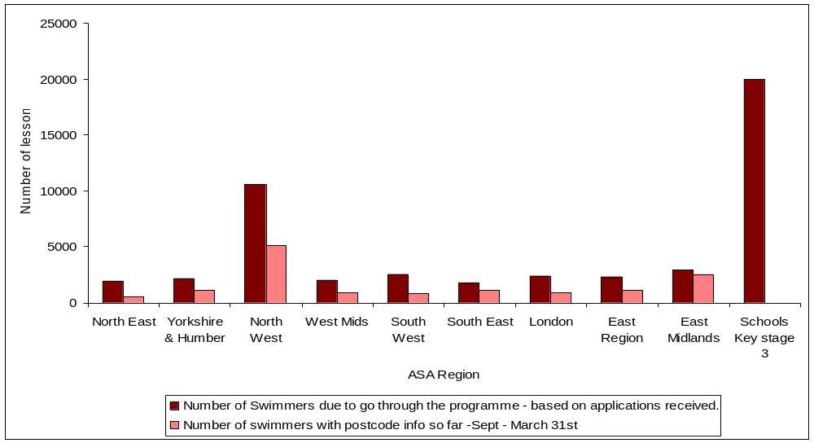
Source: ASA
Of the 48,661 participants from whom applications for lessons have been received, 18,399 are reported to have received their lessons between September 2009 and March 2010 across the nine regions. Further monitoring information is awaited for the remaining 30,262 lessons at the time of this report. It is expected that all learners will receive their lessons by July 2010.
Whilst the expected number of learners in each region varies (for example, lessons are planned for 10,600 learners in the North West region compared to 1,784 in the South East region, and 5,105 have been delivered in the North West region compared with 506 delivered in the North East region), those who have learnt to swim also vary in terms of their social and demographic characteristics. Data were available for 14,308 of the 14,345 learners reported as having been delivered to date although not all social and demographic data were available for each learner. The points below illustrate the key characteristics of the beneficiaries to date:
- 63.5% of those who have received free swimming lessons to date have been female whilst 31.5% were male: gender was not recorded for the remaining 5% of participants;
- In terms of overall number, the most free swimming lessons have been received by those aged 60 and over (33.0% of lessons were provided to this age group), whilst those aged 11 to 15 have received a significant proportion of the free swimming lessons (17.9%);
- Expressed in relation to the eligible population, most learners are planned to be in the 11 to15 age group (0.0829% of the population) whilst the smallest proportion of learners is planned for those aged 18 to 21 (0.0150%);
- Where data were available, 6.2% of those who had participated in free swimming lessons were classed as having a disability; and
- 22.1% of the free swimming lessons were provided to those classified as “beginners” whilst 44.4% of lessons were provided to those classified as “non-swimmers” and a further 27.3% of lessons were provided to “weak swimmers”: the swimming ability of the remaining participants was not recorded.

Lessons learned

Introduction
This Section examines the key lessons learned during the first year of the FSP. It is based primarily on two rounds of case studies in participating areas and a series of interviews with non-participating LAs. The findings are presented under the following headings:
- Awareness and understanding of the FSP, especially amongst non-participating LAs;
- Factors affecting decision whether to participate in the FSP;
- Marketing the FSP;
- Impact of the CSCs;
- Impact of free swimming lessons;
- Outcomes and impact of the FSP; and
- Overall perceptions of the FSP.
Full details of the findings from our interviews with non-participating LAs and the two rounds of case studies in participating areas can be found in Annexes 4 and 5 respectively.

Awareness and understanding of the Free Swimming Programme
Our interviews with non-participating LAs sought to gauge their level of awareness and understanding of the FSP. We found that all of the non-participating LAs who were interviewed as part of the evaluation were aware of the FSP although less than half were aware of the availability of support for swimming lessons and capital grants.
“We understand that it (the FSP) is the provision of free swimming for 16 and unders and 60 and overs and its aim is to increase physical activity in the run up to the 2012 Olympics”. (Interview with non-participating LA)
“I have heard of the capital grants but not about the free swimming lessons”. (Interview with non-participating LA)
The majority of non-participating authorities received letters or circulars from the DCMS informing them of the FSP and several interviewees also mentioned seeing or hearing reports in the media.
Some difficulties were highlighted in relation to the information received about the FSP. For example, one local authority received the letter from the DCMS over the summer holiday period when staff were on holiday and found it difficult to make an informed decision whether or not to participate in the FSP and others found it difficult to get a response to queries within the timeframe specified by the DCMS.
Overall, however, understanding of the FSP was consistently good across LAs.
“We understood that the Programme had to be completely free and could not be limited in any way (e.g. until the funding was exhausted or for certain months of the year).” (Interview with non-participating LA)

Factors affecting the decision whether or not to participate in the Free Swimming Programme
We also asked participating and non-participating LAs about the factors which influenced their decision whether or not to participate in the FSP.
The evidence from these discussions showed that the expected financial impact tended to be the key consideration in the decision-making process. Most LAs weighed up the potential loss in revenue from offering free swimming against the revenue grant offered and assessed the affordability of participating in the Programme. Where the grant was expected to cover, or almost cover, the anticipated cost of participating in the FSP, LAs were generally happy to participate. Four of the case study LAs had opted not to offer the FSP to those aged 16 and under largely because the grant from central government was not expected to cover the loss in revenue. For example, in Guildford, the potential loss in revenue was estimated to be £250,000 whereas the grant offered under the FSP was £60,000, a shortfall of £190,000.
While the financial effect of the FSP was a key factor in the decision making process, it was not the only factor. Some LAs were keen to participate in the FSP because its objectives aligned closely with their own objectives: eight of the 12 LAs cited social reasons for the decision to participate.
“The FSP ties in with the positive quality work that the council aims to achieve and in getting people more physically active within the council area which is part of the councils corporate and community strategy.” (Interview with participating LA)

Marketing the Free Swimming Programme
We asked participating LAs about how they had marketed the FSP and what had worked well and not so well.
We found that LAs’ marketing approach varied in terms of the scale of activities undertaken. About half had undertaken an extensive marketing approach using a mix of traditional techniques (such as leaflet distribution) and more innovative methods (such as targeted marketing of certain groups and online advertising using social networking sites). Table 5.1 identifies good practice marketing techniques which were found.
Table 5.1: Examples of good practice marketing
Marketing campaign | Local authority examples
Carnival entry | Gloucester Borough Council entered a Free Swimming ‘float’ in the local carnival parade during the summer. During this event the council dropped 4,000 leaflets to the public which was felt to have a good impact in attracting new members.
Social networking sites | Chorley Borough Council has advertised the FSP on social networking sites such as Facebook and Twitter. Through these sites, the Council highlighted the FSP and issues regular reminders to the public about the Programme.
Letter distribution using Council distribution network | The Leisure Trust within the Mid Suffolk Borough Council area made use of the Council’s distribution methods. The Council were issuing a letter to all households in the area about Council tax changes. The Trust asked the Council to include a leaflet about free swimming. This was sent to approximately 42,000 households in order to raise awareness of the FSP.
‘Beach’ in city centre | Birmingham City Council built a ‘beach’ in an area of the city centre over the summer period and used this event to promote the FSP and water safety to members of the public.
Publish information in multiple languages and Braille | Lambeth Borough Council produced marketing information for Free Swimming in Braille, large print and multiple languages including Spanish, Portuguese, French, Bengali, Twi and Yorbu so that all members of the community could access the Programme.
Pool parties | Birmingham Council held a series of pool parties which were sponsored by the local radio station. It held four such parties in total and the radio station played a series of trailers in the week preceding each event. It advertised each party at the pool concerned and brought along the radio presenters and promotional staff.
Source: Case study interviews
Evidence from the case studies (and the monitoring data provided by LAs) suggests that the level of marketing activity has impacted positively on the uptake of the FSP. It also shows that other factors, for example season factors, have had an important influence on the pattern of free swimming.
Most LAs concentrated their marketing investment around the launch of the Programme in April 2009. Looking forward, just over half of the case study LAs indicated that they plan to spend less on marketing as they feel that the public has been well informed of the Programme. They expect to focus on reinforcing earlier messages. Some LAs, however, plan to continue to invest in marketing the Programme, in some cases using innovative marketing initiatives: for example, Warrington Borough Council had plans to run a ‘Bluetooth Proximity Marketing’ campaign targeting anyone going past the leisure centre.

Impact of County Swimming Co-ordinators (CSCs)
As part of the second wave of case studies, we investigated the impact of the County Swimming Co-ordinators (CSCs).
As part of the FSP, the ASA recruited a network of 49 CSCs across the country. Many had a background in the sports industry, some had a prior interest in swimming and aquatics and some had worked for the ASA prior to a recent restructure. The CSCs felt that they had been provided with a comprehensive training programme which brought them to a similar level of knowledge given their different backgrounds. A couple of areas for improvement were identified: some CSCs felt that they needed further product training now, not least because of the wider range of products that they are expected to deliver, and some thought it would be helpful to vary the location of the training.
Overall, the CSCs were clear about their five key targets:
- Delivering free swimming lessons;
- Growing swimming participation;
- Enhancing education/ workforce development (based on the number of people going on coaching courses);
- Promoting Learn to Swim (based on the number of awards/ badges sold); and
- Increasing the number of Swim 21 club accreditations;
Many CSCs noted that their targets (and budgets) were not finalised until late into Year 1 and, as a result, they found themselves ‘chasing their tail’. Looking forward, most CSCs were confident that they could achieve their targets for Year 2.
“With respect to the targets around free swimming lessons there is ultimately a national target that we are all feeding into. Our targets have been based on the number of pools within the participating LAs but there has been a bit more negotiation with our senior CSC in agreeing our local targets. I don’t feel like they have been given to me without any negotiation – I feel I have input into the targets and will deliver against them.” (Interview with CSC)
Based on our discussions with CSCs, most felt that the impact of their work would be more evident and even greater in Year 2 of the Programme for several reasons:
- Partner relationships would be better developed;
- The full team would be in place;
- They would be better able to plan what they will do; and
- They had been able to change their approach to gain stronger commitment from LAs, especially with regard to swimming lessons.
Nonetheless, the CSCs felt that they had already made an impact:
- More people were learning how to swim and participating in swimming: most CSCs identified an increase in the uptake of swimming lessons and a general increase in swimming participation which had been achieved by encouraging LAs to take part and by getting them to reflect on their current pool programming (some had not re-examined their current offer for years);
- Greater partnership working: CSCs had encouraged LAs to join up with their key partners; and
- They had ‘kept the LAs honest’ by ensuring that they met their commitments.

Impact of free swimming lessons
We have investigated the impact of free swimming lessons.
Prior to free swimming lessons being offered through the FSP, most swimming pools provided swimming lessons which were taught in line with the ASA National Plan for Teaching Swimming (NPTS) and were generally geared towards babies (parent and baby session) or young children. Demand for them was typically high. In some LAs, lessons were also provided for adults although these were typically low volume and high price.
From our discussions with CSCs and pool operators, a typical set of free swimming lessons involved either six hours worth of lessons or six 30-40 minute lessons over a six week period (one hour sessions) or a twelve week period (half hour sessions). They were also provided by a Level 2 Swimming Coach, but in cases where the group was large or consisted of difficult groups to teach (e.g. disabled non-swimmers) an additional Level 1 teacher was on hand to provide assistance.
All CSCs viewed six hours as insufficient for anyone to become a competent swimmer, but the lessons were seen as ‘taster/starter sessions’ which would get people involved in taking more. The groups that have been targeted have been dependent on the profile of the area where the lessons are being provided.
“We have a large BME community, a lot of work was done to target these groups and there have been many success stories in terms of, for example, delivering lessons to Asian ladies.” (Interview with participating LA)
“There are pockets of deprivation in our LA. We have targeted people from lower income and have got them in swimming.” (Interview with participating LA)
Our case studies suggested that limited effort had been devoted to marketing swimming lessons. The main methods used included advertising through the local press, on the radio, in papers and by placing banners/ posters inside and outside the leisure centre. Word of mouth was cited as one of the most effective methods of promotion, particularly amongst the older age groups. Some of the national operators had launched larger advertising campaigns but these were mostly at the outset and had not been sustained. Both the London region and Bolton had been particularly successful with their marketing campaigns.
“GLL developed a press release (London wide and also Borough specific) with regards to the free swimming lessons and encouraged potential participants to sign up online via their own website. They used with signposting to the GLL website via LA partner websites to allow potential participants to register interest and highlighted the scheme within an LA newsletter. They attracted 3,500 expressions of interest online within the first 10 days of the scheme. This is in contrast to a previous marketing approach, whereby GLL used the Metro newsletter (at a cost of £7,500 per advert), with a much lower rate of success. (Interview with CSC)
The Bolton area ran a three week marketing campaign costing £4,000. It included a four page spread in the ‘Bolton Scene’ the local newspaper; advertising on billboards; and printing leaflets that were available in leisure centres. Within ten days of the marketing campaign, the Bolton pool operators had 1,000 people signed up to take swimming lessons. (Interview with participating pool operator)
Although the CSCs had provided promotional and marketing material to LAs and pools directly, it was felt that this was delivered too late and there were issues with downloading the material to distribute. The general view was that the swimming lessons would benefit from a more co-ordinated national marketing campaign delivered by the ASA in Year 2.
The LAs and pool operators we spoke to during the case studies thought that the CSCs were excellent in terms of providing support for getting lessons underway. In terms of financial support, most operators indicated that they had received funding for the successful completion of swimming lessons, with a higher level of funding provided for hard to reach groups. The CSCs through the ASA have also provided free CPD training for some of the teaching staff who provide sessions.
“We (the Pool Operator) were having a meeting with the PCT about free lessons. Our SCSC was willing to come to the meeting and make a presentation on the lessons. This was really helpful.” (Interview with participating pool operator)
The CSCs felt that the support they had received from the LAs was generally good, albeit variable. There were, however, some important challenges (see Figure 5.1).
Figure 5.1: Challenges to providing free swimming lessons
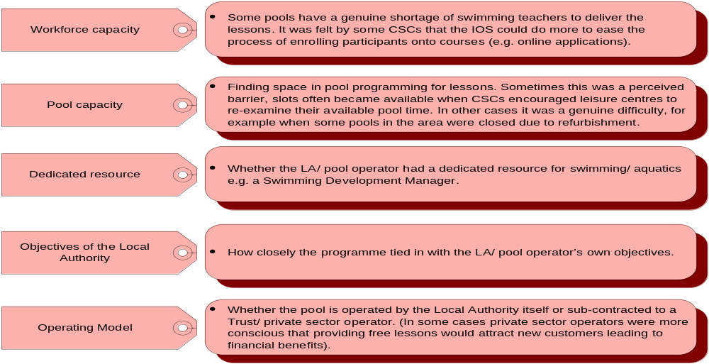

Overall, the CSCs had found that it had taken longer than expected to get lessons up and running: LAs did not get on board as quickly as they had anticipated and, once on board, CSCs found that it did not necessarily translate into delivery of swimming lessons.
“We had supported a lot of LA bids for free swimming lessons, such as for Asian girls and Chinese older people which, although approved for funding, didn’t actually get underway In the future, it will be important to keep up the contact with the LA or a spokesperson within the target group on a regular basis.” (Interview with CSC)
The CSCs felt that having worked with the partners for a year, they understood their issues better and having shared best practice stories with their colleagues, they were in a better position to know how to overcome these.
“We have learnt from those that have been delivering the lessons about what works best, for example, one LA pool found that it was hard to fill lessons offered to groups of 11-17 year olds. When they split the lessons so that lessons were provided to 11-14’s, and 15-17’s the take up was higher.” (Interview with CSC)
In terms of future plans, a number of areas were highlighted in discussions with CSCs:
- Increased focus on those areas where performance against target has been lower to date;
- Promotion of an ‘industrialised’ approach based on the benefits of this approach in some regions already and the desire to reach a mass audience of potential participants;
- Reviewing time invested in working with hard to reach groups, as time spent was felt to be significant, and attracts a smaller number of people than may be possible otherwise; and
- Development of best practice case studies to share with all other CSCs: this will help identify a few targeted initiatives that can be implemented, such as around sustaining participation (i.e. sign-posting those currently enrolled in lessons on to another exit routes).

Impact of free swimming lessons
On the whole, (anecdotal and other) evidence suggests that there is a strong demand for free swimming lessons and that they are having a very positive impact, especially in terms of attracting hard to reach groups and new customers, particularly those who have never swum before.
In addition to completing the course, pool operators and CSCs said that participants were swimming in between lessons and that incentives like discounted future lessons have meant that people are coming back and swimming more regularly – pools are busier. CSCs and pool operators have said that in addition to improving their swimming skills, the lessons have played an important social role for the participants as the following comment shows:
“Enjoying the lessons. I have made new friends and overcome my fear of the water.” (Participant – North East)

Feedback from the case study visits is that CSCs, LAs and operators are still learning about the best approach to take to the delivery of lessons. The main lessons learnt thus far are summarised below.
Table 5.2: lessons learned
Provide greater time for planning | “Operators should plan to allow time for marketing; time to inform staff about the scheme; and time to set up tracking mechanisms to monitor the progress and outcomes from those that take part.”
Appoint a project manager | “The reports we have conducted to date indicate that the most pro active providers and the highest deliverers are the organisations with a swimming development officer, the relationship between the CSC’s in these areas are also the most productive. The recommendation to the facilities in our region is to develop/introduce these posts and they will have a financial return.”
Manage expectations re: capacity | “What has worked not so well is the fact that the demand is too high for our level of capacity in terms of pool space and also the number of instructors. The centre has a waiting list of 150 people. If you offer something that is free to your community and then are unable to deliver it you will have issues.”
A friendly approach is important | LAs and pool operators learnt that a personal/ friendly approach was key to the success of the lessons. Approaches adopted to generate a ‘safe/ friendly’ environment included sending out a letter to the participants in advance, the instructor meeting the participants at the front of leisure centre/ reception, the instructor getting into the water with the group and following up by arranging to have tea/ coffee with the group after the lesson. Smaller class sizes for nervous adults were also recommended by some of the CSCs we spoke to.
Need evidence to monitor impact | Most CSCs, LAs and operators that we spoke to thought it was important to track participants more closely to see whether they completed their course, enrolled on another course and were swimming more regularly. Some operators followed up with participants that did not complete the course to find out why they had missed lessons. This provided valuable feedback for them.
Carefully consider marketing when trying to attract new customers | “Areas should carefully consider marketing, particularly who, how, what and where they want to target, and move away from just targeting existing customers.”  “There is no point putting leaflets up in the leisure centre if we want to attract new customers.”
Source: PwC analysis

Outcomes
Finally, we used the case studies to provide insights into the outcomes of the FSP.

Participating LAs
Overall, we found that the actual outcomes were largely felt to mirror those that LAs had expected prior to the FSP being launched (see Figure 5.2).
Figure 5.2: Expected and actual outcomes
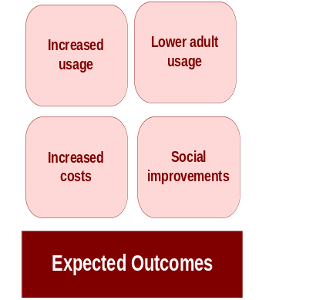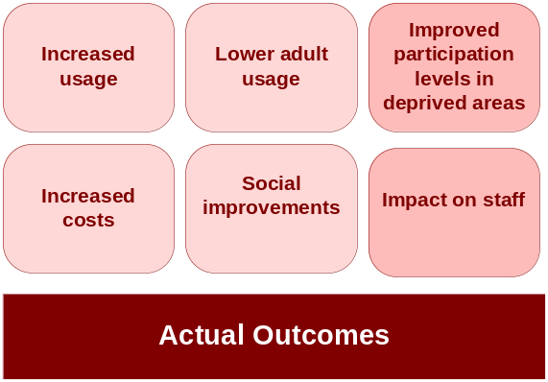

Increased usage
Generally, the LAs that had decided to participate indicated that the impact of the FSP had been positive in the first year of the Programme. Almost all of the LAs in the first wave of case studies had experienced an increase in participation rates and the Programme had attracted people to pools that would never have come to a leisure centre before.
When the LAs were asked about the impact they felt the Programme might have in the longer term, most felt that this would depend on the sustainability of the Programme. Other LAs were more hopeful that if people have started to swim and be more active, they would continue to use the leisure centre even after funding is withdrawn. They expected that the number of swimmers would fall back slightly if swimming was no longer free, but the FSP would leave a legacy of increased swimming participation.
“In the longer term, the participation levels will depend upon the Programme being sustained by the Government after the two years. If funding is withdrawn after two years we’d expect swimming rates will go down.” (Interview with participating LA)
”In the short to medium term it is my gut feeling that initially there will be a significant increase which will then plateau off and the initial high numbers will not be sustained. However, there will be a general increase in the number of swimmers.” (Interview with participating LA)
Some LAs had experienced a decrease in the number of adult swims by those aged 17 to 59 although, as LAs are not required to monitor usage amongst this age group, this is difficult to demonstrate.

Increase participation in deprived areas
Some LAs experienced an increase in non-swimmers from deprived areas within the authority. Within Gloucester, for example, the FSP has reached some of the city’s most deprived areas with 64% of people aged 16 and under in the Westgate ward registering to swim. Mid Suffolk also found that many children were coming into the centre from deprived areas. Birmingham has successfully targeted BME communities and areas of deprivation (through targeted outreach by the FSP co-ordinator).

Impact on staff
Almost all LAs felt that the FSP had adversely impacted their staff during the launch period. Most stated that since the initial launch, the burden on staff had decreased substantially and staff are now coping well with the increased numbers of swimmers. In some areas, the FSP had actually had a positive impact on staff.

Social improvement
A number of case study LAs (including Corby and Gloucester) had noticed reductions in crime which they attributed, in part, to the FSP.

Cost increases
Three LAs indicated that they have experienced an increase in costs ranging from an increase in staffing costs to an increase in chemical and cleaning costs. For example, Warrington experienced an increase of 15% in pool chemical and cleaning costs and an increase of 8% in staffing costs.

Unanticipated outcomes
Participating LAs have experienced a range of unanticipated outcomes:
- Administration costs were higher than expected: for example, due to the need take account of the costs of producing free swimming cards, application forms, postage, production time and staff time to register free swimmers;
- The cost of re-issuing cards was higher than expected, especially where they were issued for free with the result that they were not always valued;
- A reduction in the number taking paid swimming lessons: in some cases, free swimmers substituted a free swim for a lesson; and
- Disruptive behaviour by children which deterred others doing lane swimming sessions.

Non participating LAs
Where LAs had decided not to participate, they had generally experienced little adverse reaction from local stakeholders. Moreover, the majority of these LAs stated that they would still make the same decision not to participate in the FSP if they were asked again today. Only two non-participating LAs interviewed have since chosen to join the Programme.

Perceptions of the Free Swimming Programme
Finally, we asked LAs for their overall perceptions of the FSP and how it might be improved.

Non participating authorities
Non participating LAs identified several things which would need to change to encourage them to take part.
Most non-participating LAs felt that there should be increased funding on offer so that it would more closely align with the costs that would be incurred as a result of participating in the FSP. In addition, they also suggested that making other sports/activities available on a free or reduced price basis as part of a wider FSP would encourage greater participation in physical activity as some individuals have a fear or are self-conscious when it comes to swimming.
We received a number of suggestions about the scope of the FSP. Some LAs suggested that clarity on whether and how the Programme would be sustained would provide LAs with greater confidence to participate in the Programme. It was also suggested that the eligibility criteria for the Programme should be more flexible to meet local needs. This requires consideration of:
- Location – some coastal authorities did not participate as they would have experienced an influx of non-residents during holiday periods and the funding did not take seasonal factors into account;
- Target groups – target groups which would benefit most from free swimming provision (e.g. areas of deprivation); and
- Greater flexibility – it was suggested that the Programme currently adapts a ‘one size fits all’ approach, whereas a more flexible approach (e.g. by allowing free swimming in selected sessions) would encourage greater uptake across LAs.
“…Increase the deadline for decision making – The Council first became aware of the Programme in July and had to make a decision on it by 1st September. Given the summer holidays this was a very short period in which to make a decision on whether to participate – as a result local authorities will decide just not to go for it.” (Interview with non-participating LA)

Participating authorities
We also asked LAs in the first wave of case study visits to rate the FSP on a scale of one to ten (where one is poor and ten is excellent). The vast majority of LAs were very positive about their experience of the Programme to date: the average score was seven out of 10. Some LAs indicated that they would attribute a higher score to the Programme if there was more certainty regarding the future of the Programme beyond the current two year funding period.
When undertaking the second wave of case study visits, we asked CSCs, LAs and operators the same question. The ratings ranged from two to eight, but most continued to rate the FSP at around seven out of 10. CSCs, LAs and operators in the second wave of case studies were also asked to rate free swimming lessons on a scale of one to ten (where one is poor and ten is excellent). The ratings received were generally better than for the FSP as a whole.
“It provides new opportunities and allows operators to be creative and do new things with their existing programme. Lessons will mean that hundreds more people will be active, and thus will generate health and social benefits. This will have a quite good, positive impact and this should be sustainable.” (Interview with pool operator)
“Lessons will have a bigger impact over the longer term than free swimming. Swimming lessons have brought in new people. Some people are swimming for the first time – free swimming cannot do this.” (Interview with CSC)

Conclusions and lessons learned from case study visits and interviews
Based on the evidence from the first two waves of case studies and the telephone interviews with non-participating LAs, a number of conclusions can be drawn and lessons learned (see Table 5.3 below).
Table 5.3: Conclusions and lessons learned
Thematic area | Conclusion or lesson learnt
Awareness of the FSP | - All LAs had a good level of awareness of the free swimming aspect of the Programme  - Non-participating authorities were not always aware of the availability of capital grants and grants for free swimming lessons when they made their decision on participation  - The timing of the initial decision making process was difficult and, in some cases, was adversely affected by non-availability of key staff over the summer holiday period
Decision making process | - The financial impact tended to be the key factor in the LA decision to participate in the FSP, although it was not the only factor  - Many LAs would have preferred an approach whereby grant funding was based on a targeted approach or on swimming pool usage figures  - Some non-participating LAs felt they would have participated if the requirements of the FSP could have been tailored further to suit local circumstances (e.g. being able to offer the FSP to those aged 16 and under only or to specific populations from deprived areas within the LA)
Marketing activities | - LAs highlighted a lack of specific guidance from central government departments with regard to promotion and marketing – this has led to a mixed approach to marketing and, in some areas, minimal activities  - There were some examples of good practice in marketing activities, including some that could be considered low cost options, however, this was not widespread. Consideration should be given to spreading such approaches to encourage further increases in participation in free swimming amongst the target groups by learning from good practice already developed by LAs to date  - In general, in areas where high levels of marketing activities had taken place, the increase in uptake of the FSP has been more pronounced  - Few LAs have specific plans for future marketing activities, although many would appreciate further guidance
Dealing with unanticipated outcomes | - LAs have experienced a range of unanticipated outcomes as a result of participating in the FSP which they have had to be overcome  - These include higher than expected administration costs (including the cost of re-issuing free swimming cards), reduced demand for paid swimming lessons and some negative reports about children’s behaviour
Impact of CSCs | - Time is required in order to allow CSCs to build effective relationships with partners  - There is a need to focus on key areas in Year 2 where performance is behind target  - There is a desire to share best practice amongst CSCs and operators and also to plan effective exit routes from lessons to encourage ongoing participation
Impact of free swimming lessons | - Substantial time is required for planning and project management  - Lack of pool capacity for lessons can be an issue – in some areas demand has outstripped supply and waiting lists have developed  - A friendly approach is important to new learners
Perceptions of the FSP | - CSCs, LAs and operators rated free swimming lessons higher (average of eight or nine out of ten) than the overall FSP (average of seven out of ten)  - Free swimming lessons were seen as providing a more effective method for targeting and increasing participation

Benefits and value for money of the Free Swimming Programme

Introduction
One of the objectives of the evaluation of the FSP is to assess the impact of the Programme in terms of its ability generate health and consequent economic benefits and the associated value for money of the Programme. This Section summarises the available evidence. We start by elaborating the framework we have used to identify and assess the potential health and economic benefits. We then consider the evidence of the value for money to date of the FSP by examining its cost-effectiveness and the relationship between the costs and expected benefits.

Framework for assessing the benefits of the Free Swimming Programme
As noted in Section, 2, there is a body of evidence that suggests a strong link exists between physical activity and reduced risk of so called lifestyle diseases such as coronary heart disease and obesity, hypertension, cancer and osteoporosis. The Chief Medical Officer’s Report highlights the benefits of physical activity and states that those that are physically active reduce their risk of chronic diseases such as coronary heart disease, stroke and type two diabetes by up to 50%, and the risk of premature death by about 20-30%.
To the extent that the FSP can stimulate the level of physical activity across the target population, it has the potential to generate economic benefits in different ways:
- By reducing the incidence of disease and ill health in the population and so reducing costs to the NHS;
- By improving the quality of life of participants, again with the potential to reduce NHS costs and bring about wider social benefits;
- By improving health and thus contributing to improved attendance at school/work and contributing to fewer days lost through sickness absence; and
- By stimulating the economic development of the sports sector.
There are various pieces of evidence of the scale of these benefits:
- According to the Department for Culture, Media and Sports, physical inactivity in England costs £8.2 billion per annum in terms of the cost to the NHS and lost productive days from work. In addition, obesity is estimated to cost the NHS a further £0.5 billion and employers £2 billion due to lost days because of sickness.
- The Chief Medical Officer’s report also estimated the costs of specific health problems that could be reduced through a more active lifestyle: for example, it estimated that diabetes costs approximately £5.2 billion a year, osteoporosis costs approximately £1.8 billion a year and the treatment of mental illness costs the NHS £3.8 billion and personal social services costs £0.7 billion.
- Conversely, in the UK, the annual direct and indirect costs of sport and exercise-related injuries have been estimated at up to £991 million.
In addition to the positive economic benefits from improving the health of the population, the FSP has the potential to impact on the sport and leisure industry. Sport England's “Economic Importance of Sport” report, published in December 2007, assessed the economic value of sport across England. It showed that sport-related economic activity generated added value of £15,471 million in 2005 (based on current prices) whilst consumer expenditure on sport was £16,580 million in 2005. Furthermore, sport-related employment was estimated at 434,000 in 2005 (1.8% of all employment in England). In practice, although the FSP might be expected to stimulate long-term expenditure on physical activity, this spending is likely to be largely at the expenses of expenditure on other goods and services.
Evidence from the Department of Health provides a potential basis with which to estimate the cost savings if the FSP assist participants to become more active. This framework is illustrated in Table 6.1.
Table 6.1: Framework for assessing potential cost savings from increased physical activity
Thematic area | Evidence
How much exercise should we do? | - Children and young people need to do 60 minutes of moderate intensity physical activity every day. This should include at least two weekly activities that produce high physical stress on bones, such as dancing, jumping or aerobics. This is important for aiding development.  - Adults of all ages should undertake 30 minutes a day of at least moderate intensity physical activity on five or more days of the week. Older people should take particular care to keep moving and retain their mobility through daily activity.  - These recommended levels of activity can be achieved either by doing all the activity in one session or through several shorter bouts of activity of 10 minutes or more. The activity can be lifestyle activity (i.e. activities that are performed as part of everyday life, such as climbing stairs or brisk walking) or structured exercise or sport, or a combination of these.
How much exercise are we currently doing? | - Based on self-reported measures of physical activity, 39% of men and 29% of women aged 16 and over currently meet the Chief Medical Officer’s minimum recommendations for physical activity.  - Based on self-reported measures (excluding time at school), 32% of boys and 24% of girls aged 2-15 were classified as meeting the Government’s recommendations for physical activity by doing at least an hour of moderate activity every day.
How much does inactivity cost? | - The estimated costs of physical inactivity in England are £8.2 billion annually, which does not include the contribution of inactivity to obesity which in itself has been estimated at £2.5 billion annually. These figures include the costs to the NHS and those related to the economy, such as absence from work.
How much could be saved through increased activity? | - Research by the Department of Health suggests that a 5% reduction in the proportion of insufficiently active people would produce an annual £300 million saving in costs.
What is the average scale of the savings per capita? | - Number of adults who are inactive = (61% of the 24.66 million men in the UK) + (71% of the 25.90 million women in the UK) = 33.43 million adults  - Number of 16s and under who are inactive: (68% of the 5.95 million boys in the UK) + (76% of the 5.67 million girls in the UK) = 8.36 million children  - Total = 41.79 million people throughout the UK who are inactive.  - If the number of people who are inactive could be reduced by 5% (i.e. 41.79 million people x 5% = 2.1 million people), this could generate £300 million in savings. Therefore, 2.1 million more active people would save £300m.  - On a per capita basis, one additional active person would on average save £144 per annum.
Source: PwC

Evidence of the benefits of the FSP

Changes in levels of physical activity
In order to estimate the impact of the FSP on the level of physical activity undertaken by participants in the two target age groups, two additional questions were added to the second wave of the online survey (in April/May 2010).
“Thinking back to before April 2009, on average, how much time would you say that you spent each day undertaking moderately intense physical activities (such as sports including swimming, brisk walking and climbing stairs)?”
“In the last four weeks, on average, how much time would you say that you spent each day undertaking moderately intense physical activities (such as sports including swimming, brisk walking and climbing stairs)?”
The results of these questions are shown in Table 6.2. They have been filtered so that only the responses from those who swam for free in the previous four weeks are considered.
They show that, amongst those free swimmers aged 60 and over, the proportion of respondents who undertook less than 30 minutes moderately intense physical activities each day declined from 31.8% in April 2009 to 20.9% over the previous four weeks. In contrast, the proportion of respondents aged 60 and over who undertook at least 30 minutes of activity a day increased from 66.2% to 78.4%.
A similar pattern of responses can be seen amongst those aged 16 and under. The proportion of free swimmers undertaking less than 60 minutes of moderately intense physical activities each day decreased from 74.4% to 66.1% whilst the proportion of swimmers undertaking more than 60 minutes of physical activities increased from 20.7% to 32.9%.
Whilst the increase in activity levels amongst these respondents cannot be entirely attributed to the FSP, it is likely that their increased activity may be partially reflected through increased participation in free swimming.
Table 6.2: Change in physical activity levels amongst free swimmers between 2009 and 2010
Response | 60 and over |  | 16 and under
Response | Activity at April 2009 | Activity in previous 4 weeks | Activity at April 2009 | Activity in previous 4 weeks
Less than 30 minutes | 47  (31.8%) | 31  (20.9%) | 46  (22.2%) | 27  (13.0%)
Between 30 and 60 minutes | 72  (48.6%) | 75  (50.7%) | 108  (52.2%) | 110  (53.1%)
Between 60 and 120 minutes | 21  (14.2%) | 31  (20.9%) | 39  (18.8%) | 48  (23.2%)
More than 120 minutes | 5  (3.4%) | 10  (6.8%) | 4  (1.9%) | 20  (9.7%)
Don't know | 3  (2.0%) | 1  (0.7%) | 10  (4.8%) | 2  (1.0%)
Total | 148  (100.0%) | 148  (100.0%) | 207  (100.0%) | 207  (100.0%)
Source: PwC analysis based on online survey

Value for money of the FSP
This part of the Section analyses the value for money of the FSP.
In the period between April 2009 and March 2010 (i.e. in Year 1 of the Programme), the primary activities of the FSP have been focused on providing free admission to publicly owned swimming pools for those aged 60 and over and 16 and under through revenue funding to LAs. In addition, the Programme has supported a group of CSCs and a senior CSC in each region, the provision of free swimming lessons and capital grants to enhance LAs’ pools.
The focus of our quantitative analysis is on assessing the impact of central government’s resources which have been devoted to supporting free admission to publicly owned pools for those in the target age groups.

Cost-effectiveness of free swimming
Table 6.3 estimates the cost per unit of net output of the FSP. It considers the cost of each net additional (free) swim and the cost per net additional free swimmer. In interpreting the results, it is important to note that the analysis compares the costs (i.e. the inputs from central government) with the associated outputs and outcomes. Thus, the analysis assesses the impact of the resources committed to funding free swimming (Pots 1 and 2) in Year 1 with the estimated net outputs presented in earlier Sections of the report. This means that the costs of both the free swimming lessons and the capital funding programme are not incorporated, nor are (any) additional costs incurred by LAs (and other stakeholders).
Table 6.3: Costs per net unit output
 | Number of net outputs delivered | Programme cost (£m) | Cost per unit of output (£)
60 and over
Swims | 1.49 million | 12.3 | 8.23
Swimmers | 22,971 | 12.3 | 535
16 and under
Swims | 5.52 million | 19.6 | 3.55
Swimmers | 114,068 | 19.6 | 172
Source: PwC analysis
It should be noted that, at this stage, comparable data are only available from the “Kids Swim Free” Initiative in London. An evaluation of this programme showed that the cost per swim was between £1.28 and £1.84. However, caution should be used in comparing data from this evaluation with that for the FSP: the evaluation of the earlier programme in London was not an economic impact study and, hence, the figure presented is essentially, a cost per gross swim delivered.

Costs and benefits of free swimming
We have also examined the potential costs and benefits of Year 1 of the free swimming element of the FSP based on the earlier framework. The results of this analysis are summarised in Table 6.4.
The key elements of our approach are as follows:
- Column 1: This is the net number of additional swimmers and is taken from the analysis of impact presented in Section 4.
- Column 2: This is the proportion of (free) swimmers increasing their level of physical activity above the Chief Medical Officer’s recommended level (30 minutes in the case of adults and 60 minutes in the case of children). It is based on the data summarised in Table 6.2 which are taken from the responses to the online survey.
- Column 3: This is the estimated number of additional free swimmers who are expected to derive health benefits as a result of their response to the FSP. It is calculated as the product of Columns 2 and 3.
- Column 4: This is the expected average lifetime benefit of each swimmer becoming more physically active. It has been estimated by extrapolating the average annual benefit of £144 (see Table 6.1, and adjusted to 2010 prices) over an expected lifetime and calculating the expected net present value of the benefit stream after allowing for attrition as swimmers fail to sustain their commitment to swimming. We have used an attrition rate based on the responses to the online survey (slightly more than 10% per annum depending on the age group) and assumed that this rate of attrition continues each year into the future.
- Column 5: This is the ratio of the expected health benefits (derived by multiplying Columns 3 and 4) to the costs incurred by central government to date (see Table 6.3). It includes the revenue costs of providing free swimming incurred by central government departments but excludes the capital costs of the FSP as well as any contributions from other stakeholders such as LAs.
Table 6.4: Costs and benefits of free swimming
Age group | Column 1 | Column 2 | Column 3 | Column 4 | Column 5
Age group | Net number of additional swimmers | % of free swimmers increasing physical activity above threshold | Number of free swimmers expected to derive health benefits | Expected benefit (lifetime) (£) | Benefit: cost ratio
60 and over | 22,971 | 21.6% | 4,963 | £1,307 | 0.53
16 and under | 114,068 | 11.5% | 13,105 | £1,228 | 0.82
Source: PwC analysis

Value for money of swimming lessons and capital funding
The quantitative analysis of the value for money of the FSP does not consider the free swimming lessons nor does it assess the impact of the capital funding.
As noted in previous Sections, the delivery of free swimming lessons has only recently gathered momentum and the evidence base is still incomplete. The data available on free swimming lessons show that there is still a large number of lessons to be delivered before the end of the programme in order to meet targets. Nonetheless, the findings from our case studies suggest that there have been positive outcomes from the free swimming lessons.
In terms of capital grants, many projects are still under development. For this reason, it is too early to assess their full outputs, outcomes and impact. These will be examined further as part of the evaluation in Year 2. We note, however, that they can be expected to encourage more swimmers (including potentially those who use private sector facilities at present or who do not swim because of poor facilities in their area).

Conclusions

Conclusions
This final Section summarises the key conclusions from the evaluation of the FSP in Year 1. We summarise our findings against each of the three objectives of the evaluation and then set out the key lessons learned which can be used to improve the impact of the FSP in its second year.

Objective 1: Increase the number of swims and the number of swimmers in the two target groups
To date, the FSP has delivered an increase in the number of swims and number of swimmers in the two target age groups as follows:
- Nearly 7 million free swims have been undertaken by those aged 60 and over and over 11 million free swims have been taken by those aged16 and under.
- Of these, around 7.0 million additional swims have been delivered overall: these comprise 1.5 million net additional swims by those aged 60 and over and 5.5 million net additional swims by those aged 16 and under (in Year 1 of the Programme).
- Overall, about 137,000 net additional swimmers per month have been delivered. These comprise slightly less than 23,000 net additional swimmers per month arising from the FSP offer to those aged 60 and over and between 114,000 net additional swimmers per month arising from the offer to those aged 16 and under.

Objective 2: Evidence of what works, how, in what context and for whom (lessons learned)
The key lessons from the FSP are summarised below:
- Financial lessons: The size of the revenue grant has been a pertinent factor for LAs in deciding whether or not to participate in the FSP, particularly in terms of comparison with potential lost income. Capital grants were an effective mechanism for encouraging uptake amongst LAs, particularly in instances where the revenue funding available fell short of that required to cover lost income. An increase in swimming uptake has been achieved although this should be set in the context of increased costs for staffing and expenditure on cleaning/administration, most often in the early months of delivering the FSP.
- Economic lessons: In economic terms the FSP has been relatively successful to date in terms of delivering net additional swims and swimmers. LAs agreed that their approach to date has generated low levels of leakage, high levels of deadweight, low levels of displacement/substitution and some degree of multipliers (although the latter was more in relation to swimming in non-target groups rather than through increases in secondary spend). In order to improve upon the economic impact in going forward therefore, this suggests that more should be done to reduce levels of deadweight, potentially through encouraging new swimmers from deprived areas or other areas of traditional non-participation in swimming to take up the sport.
- Lessons in relation to promotion, marketing and awareness raising activities: In general, in areas where high levels of marketing activities had taken place, the increase in uptake was more pronounced as a result. However, in some areas, limited marketing activities had taken place, with authorities citing a lack of specific guidance from central government with regards to promotion and marketing as a factor in this. In addition, few LAs have specific plans for future marketing activities, although would appreciate further guidance in this area. This suggests that more should be done in the future by LAs in terms of marketing activities, supported by guidance on such activities from central government in order to further drive take-up of the FSP. In turn, consideration should be given to marketing activities such as those low cost options amongst target groups.
- Lessons in relation to the impact of CSCs: Overall operators, LAs and CSCs themselves stated that they had a positive impact in Year 1 of the programme, and thought that this would continue and potentially be enhanced further in the second year. Whilst all CSCs were clear about their five key targets at this stage, some felt that they had been chasing their tail in year 1, and hence stressed the importance of clear target setting in advance, so that delivery is not delayed. Beyond this, the CSCs called for further product training now, given the wide range of products that they are expected to deliver, and also requested that the location of future training be considered to allow them to minimise any time spent away from their base:
- Lessons relating to free swimming lessons: Whilst the feedback on the provision of free swimming lessons was overwhelmingly positive (and indeed this aspect of the programme was viewed more positively than the provision of free swimming sessions), the CSCs stated that they had often taken longer than expected to get underway. The relationships built with LAs and providers in Year 1 were seen as critical to the successful delivery of lessons in Year 2 of the programme, along with moving to a more industrialised approach.
- General lessons for the future of the FSP: Overall the impact of the FSP to date has been positive, although could be enhanced even further in the future. This would include the need for central government to provide, at an early stage, information on future funding (if any) in order to allow LAs to make plans for sustaining the FSP after the two year initial funding period. Lessons in relation to the need to address wider barriers to participation, such as barriers to participation caused by poor transport links and underinvestment in the infrastructure of pools, and the need for support from partner organisations, such as PCTs and Housing Associations should be considered in order to add to the future success of the FSP.
In addition to these lessons and suggestions from those LAs which are already participating in the FSP, the non-participating LAs also put forward a range of suggestions as to how the FSP may best be tailored to encourage universal uptake across LAs in the future:
- Ensure that communication provides full details of all aspects of the FSP, including free access to swimming along with free swimming lessons and capital grants to ensure that an informed decision can be reached;
- Ensure availability of personnel within central government departments to answer queries about eligibility and the shape and form of the FSP;
- Consider the timing of communications and requests for information/decisions, particularly over summer periods when availability of key staff is more difficult;
- Develop a funding system which encourages high performance in terms of promoting swimming participation in LAs, rather than being solely based on population.
- Share stories of success from participating LAs with regards to the FSP in order to address less positive perceptions of the FSP (such as financial issues and difficulties in managing capacity) to encourage uptake; and
- Expand the FSP to include other sports and activities other than just swimming.

Objective 3: Generate health and consequent economic benefits of swimming participation and value for money from the FSP
Our analysis of the value for money of the FSP has focused on the free swimming element of the FSP rather than the free swimming lessons and the capital grants. This is because it is too soon to expect to observe the impact of these latter elements of the FSP.
We estimate that the cost per net unit of output varies significantly between the two age groups:
- The cost per net additional swim by those aged 60 and over is £8.23 whereas the cost is £3.55 for those aged 16 and under.
- The cost per net additional swimmer is £535 for the FSP offer to those aged 60 and over and £172 for the FSP offer to those aged 16 and under.
Using evidence from previous DH research and the recommendations of the Chief Medial Officer, we have sought to estimate the value of the expected health benefits associated with the FSP generating improvements in participants’ health. Our analysis suggests that the benefit to cost ratio of the FSP is 0.53 for those aged 60 and over and 0.82 for those aged 16 and under.

Lessons learned
The details included above under each of the objectives show that, to date, the FSP has made progress in terms of generating both net additional swims and swimmers. In order to enhance this success in Year 2 of the FSP, the findings under each objective highlight a number of recommendations, which should if implemented, ensure that the FSP delivers the desired outputs and outcomes to an even greater degree, including enhanced value for money.
The recommendations are as follows:
- Put in place initiatives to reduce the level of deadweight experienced to date. This may include targeting non-swimmers through free swimming lessons and also making facilities more attractive to lapsed swimmers through the delivery of capital improvement projects;
- Provide clear, concise guidance (with regards to what works well) to LAs and CSCs on a timely basis, including where there are expectations in terms of marketing activities and any other expectations such as to drive growth in swimming on a year on year basis;
- Share good practice amongst LAs and CSCs (including non-participating Authorities), encouraging practice to be adopted universally to further drive uptake of swimming;
- Ensure support is provided for CSCs in terms of additional training where required, and that materials and information is provided to them on a timely basis. Systems to encourage sharing and adoption of best practice between CSCs inter and intra-regionally should be set up;
- Continue to provide free swimming lessons on a scale that will enable key growth targets to be met, ensuring that mechanisms used for marketing and promotion of these lessons (and follow-on activities) are undertaken locally, regionally and nationally where possible; and
- Consider how the impact of the FSP should be sustained beyond the two year funding period set, communicating details on a timely basis to LAs to allow local plans to be developed in time for the current scheme ending in March 2011.

This report has been prepared solely for the use of Sport England and should not be quoted in whole or in part without our prior consent. No responsibility to any third party is accepted as the report has not been prepared for, and is not intended for any other purpose.
Draft deliverables and oral advice will not constitute PwC’s definitive opinions and conclusions. We will have no liability to you for the content or use of any draft deliverables or for our oral advice, except where such oral advice is confirmed in writing in a final version of any deliverables. We shall not be deemed to have knowledge of information from other engagements for the purposes of the provision of the Services, except to the extent specified in the Engagement letter. Save as expressly stated in the Engagement letter, we will rely on and will not verify the accuracy or completeness of any information provided to us. The Services do not constitute an audit or review carried out in accordance with generally accepted auditing standards and no assurance will be given by us.
In the event that, pursuant to a request which Sport England has received under the Freedom of Information Act 2000 or the Environmental Information Regulations 2004 (as the same may be amended or re-enacted from time to time) or any subordinate legislation made there under (collectively, the “Legislation”), Sport England is required to disclose any information contained in this report, it will notify PwC promptly and will consult with PwC prior to disclosing such report. Sport England agrees to pay due regard to any representations which PwC may make in connection with such disclosure and to apply any relevant exemptions which may exist under the Legislation to such report. If, following consultation with PwC, Sport England discloses this report or any part thereof, it shall ensure that any disclaimer which PwC has included or may subsequently wish to include in the information is reproduced in full in any copies disclosed.
© 2010 PricewaterhouseCoopers LLP. All rights reserved. “PricewaterhouseCoopers” refers to the PricewaterhouseCoopers LLP (a limited liability partnership in the United Kingdom) or, as the context requires, other member firms of PricewaterhouseCoopers International Limited, each of which is a separate and independent legal entity.

Department of Health, (2004) At least five a week, [Online] London: Department of Health. Available at: http://www.dh.gov.uk/en/Publicationsandstatistics/Publications/PublicationsPolicyAndGuidance/DH_4080994 [Accessed 18 October 2009].
The NHS Information Centre (2009) Health Survey for England 2008, [Online] England: The Health and Social Care Information Centre. http://www.ic.nhs.uk/webfiles/publications/HSE/HSE08/HSE_08_Summary_of_key_findings.pdf [Accessed 11 January 2010].
We have also used the online survey to estimate the number of free swims undertaken by each swimmer as a basis for inferring the number of free swimmers from data on the number of free swims.
Based on a population of 11,324,200 people aged 60 and over and 12,364,400 people aged 16 and under– 2008 mid-year population estimates.
Based on a population of 11,324,200 people aged 60 and over and 12,364,400 people aged 16 and under– 2008 mid-year population estimates.
The question used to estimate deadweight was amended between the first and second waves of the online survey so that respondents were asked to attribute a probability to the likelihood that they would have swum anyway in the absence of the FSP.
The question within the online survey used to measure displacement / substitution was amended for the second wave of the survey so that the number of respondents who had completely stopped other physical activities due to increased swimming could be identified separately from those who had partially reduced their level of physical activity.
Based on the number of respondents who expect to continue to spend as much time taking part in sports and recreational physical activities over the next 12 months.
It should be noted that there is the potential for the same swimmers to keep swimming for free each month. Consequently, the level of net additional swimmers each month may be lower as the programme develops. We assume that those who identify themselves as swimmers are similar in background and characteristics to those who swam in previous months.
Department for Culture, Media and Sport (2007) Our Promise for 2012: How the UK will benefit from the Olympic Games and Paralympic Games [Online] London: DCMS. Available at: http://www.culture.gov.uk/reference_library/publications/3660.aspx [Accessed 18 October 2009].
Department for Culture, Media and Sport (2008) Before, during and after: making the most of the London 2012 Games [Online] London: DCMS. Available at: http://www.culture.gov.uk/images/publications/2012LegacyActionPlan.pdf [Accessed 18 October 2009].
Sport England (2010) Active People Survey 4: Quarter 1 Results [Online] Sport England: England. Available at: http://www.sportengland.org/research/active_people_survey/active_people_survey_4/aps4_quarter_1.aspx (Accessed: 11 May 2010)
Sport England (2009) Sport Facts 2007-2008 [Online] Sport England: England. Available at: http://www.sportengland.org/research/sport_facts/sport_facts_2007-2008.aspx?sortBy=alpha&pageNum=4 (Accessed: 4 January 2009)
DCMS (2008) Before, during and after: Making the most of the London 2012 Games [online] http://webarchive.nationalarchives.gov.uk/+/http://www.culture.gov.uk/images/publications/2012LegacyActionPlan.pdf Accessed 20th May 2010.
It should be noted that a range of other programmes and initiatives are taking place alongside the Free Swimming Programme to assist in the delivery of the Government’s Legacy Action Plan.
The APS does not include recreational walking or infrequent recreational cycling but does include cycling if done at least once a week at moderate intensity and for at least 30 minutes. It also includes more intense/strenuous walking activities such as power walking, hill trekking, cliff walking and gorge walking.
Department of Health, (2004) At least five a week, [Online] London: Department of Health. Available at: http://www.dh.gov.uk/en/Publicationsandstatistics/Publications/PublicationsPolicyAndGuidance/DH_4080994 [Accessed 18 October 2009].
World Health Organisation, (2002) World health report, [Online] Geneva: World Health Organization, 2002. Available at: http://www.who.int/whr/2002/en/whr02_en.pdf [Accessed 18 October 2009].
Department of Health, (2004) At least five a week, [Online] London: Department of Health. Available at: http://www.dh.gov.uk/en/Publicationsandstatistics/Publications/PublicationsPolicyAndGuidance/DH_4080994 [Accessed 18 October 2009].
Ibid.
Department of Health, (2004) At least five a week, [Online] London: Department of Health. Available at: http://www.dh.gov.uk/en/Publicationsandstatistics/Publications/PublicationsPolicyAndGuidance/DH_4080994 [Accessed 18 October 2009].
The NHS Information Centre (2009) Health Survey for England 2008, [Online] England: The Health and Social Care Information Centre. http://www.ic.nhs.uk/webfiles/publications/HSE/HSE08/HSE_08_Summary_of_key_findings.pdf [Accessed 11 January 2010].
Sports Council Wales, (2006) Making a Splash, [Online] Wales: Sports Council Wales. Available at: http://www.sports-council-wales.org.uk/10402 [Accessed date: 23 October 2009].
Department for Culture, Media and Sport (2009) What are the particular health benefits of swimming? [Online] London: Department for Culture, Media and Sport. Available at: http://www.culture.gov.uk/what_we_do/sport/5846.aspx. [Accessed date: 23 October 2009].
Sports Council Wales, 2006, Making a Splash. [Online] Wales: Sports Council Wales. Available at: http://www.sports-council-wales.org.uk/10402 [Accessed date: 23 October 2009].
Ibid.
These include five LAs which have no swimming pools but, nevertheless, offer the FSP to residents.
In some instances local authorities have either provided funding for shortfalls between the grant available and the expected costs in terms of foregone revenue from the two target groups, or to extend the programme offer (e.g. some local authorities have extended the programme offer to those aged 17 and 18)
Further information is available at http://www.sports-council-wales.org.uk/getactiveinthecommunity/active-young-people/free-swimming
Institute for Vocational Exercise and Sport Training (2006) Evaluation of WAG’s Free Swim Initiative 2004 – 2007 [online] http://www.sports-council-wales.org.uk/13628 Accessed 20th May 2010.
HM Government (2009) Change for Life – One Year On [online] www.dh.gov.uk/publications Accessed 20th May 2010.
Institute of Child Health, University College London (2004) London’s Kids Swim Free – Easter 2004 – Evaluation Report.
Sport Industry Research Centre (2009) Everyday Swim 2006-2009 Final Report [online] http://www.everydayswim.org/page.asp?section=000100010033&sectionTitle=Aquatic+Strategy Accessed 20th May 2010.
The Official Statistics for the Free Swimming Programme can be accessed via: http://www.dcms.gov.uk/what_we_do/research_and_statistics/6274.aspx
DCMS (2010) Free Swimming Programme – Throughput data by local authority [online] http://www.dcms.gov.uk/images/publications/Free_SwimmingQ4_ReleaseNotes_JANMAR10.pdf (Accessed 21st May 2010).
DCMS (2009) London 2012 Olympic and Paralympic Games Impacts and Legacy Evaluation Framework [online] http://www.culture.gov.uk/images/publications/DCMS_Olympic_Evaluation_final_report.pdf (Accessed 11th May 2010)
Based on a population of 11,324,200 people aged 60 and over – 2008 mid-year population estimates.
Leakage was estimated at 7.6% for the 60 and over age group in November/December 2009 and 5.4% in April/May 2010. As leakage is of less significance from a national perspective, it is not used to estimate the net additional impact of the FSP.
This is calculated by multiplying the total number of free swims reported from local authority monitoring data from Quarters 1 to 4 by the additionality percentages i.e. from the number of net additional swimmers based on analysis of panel survey data.
It should however be noted that this figure includes wider effects which extent to those in the non-target age group (17-59) and excludes the additional swimmers who have substituted other physical activity for swimming.
It should be noted that there is the potential for the same swimmers to keep swimming for free each month, therefore the level of net additional swimmers each month may be lower as the programme develops. This is based on the assumption that, within the online survey, those who identify themselves as swimmers are similar in background and characteristics to those who swam in previous months.
Based on a population of 12,364,400 people aged 16 and under – 2008 mid-year population estimates.
Leakage was estimated at 13.9% for the 16 and under age group in November/December 2009 and 17.9% in April/May 2010 but is not used to estimate the net additional impact of the FSP.
This is calculated by multiplying the total number of free swims reported from local authority monitoring data from Quarters 1 to 4 by the additionality percentages i.e. from the number of net additional swimmers based on analysis of panel survey data.
It should however be noted that this figure includes wider effects which extent to those in the non-target age group (17-59) and excludes the additional swimmers who have substituted other physical activity for swimming.
We assume that the same people keep on swimming each month.
Department of Health. (2004) At least five a week. [Online] London: Department of Health. Available at: http://www.dh.gov.uk/en/Publicationsandstatistics/Publications/PublicationsPolicyAndGuidance/DH_4080994 [Accessed 18 October 2009].
Department for Culture, Media and Sport/Strategy Unit (2002) Game Plan: a strategy for delivering Government’s sport and physical activity objectives [Online] London: Produced by the Strategy Unit. Available at: http://www.sportdevelopment.info/index.php?option=com_content&view=article&id=61:game-plan-a-strategy-for-delivering-governments-sport-and-physical-activity-objectives&catid=48:policy&Itemid=65 [Accessed 18 October 2009].
Department of Health (2004) At least five a week. [Online] London: Department of Health. Available at: http://www.dh.gov.uk/en/Publicationsandstatistics/Publications/PublicationsPolicyAndGuidance/DH_4080994 [Accessed 18 October 2009].
Sport England (2007) The economic importance of sport in England, 1985-2005. [Online] England: Sport England. Available at: http://www.sportengland.org/research/economic_importance_of_sport.aspx?sortBy=alpha&pageNum=1 [Accessed 18 October 2009].
Department of Health (2009) Health Survey for England 2008 [Online] England: Department of Health. Available at: http://www.ic.nhs.uk/webfiles/publications/HSE/HSE08/HSE_08_Summary_of_key_findings.pdf [Accessed 13 April 2010].
Department of Health, (2004) At least five a week: evidence on the impact of physical activity and its relationship to health. [Online] England: Department of Health. Available at: http://www.dh.gov.uk/en/Publicationsandstatistics/Publications/PublicationsPolicyAndGuidance/DH_4080994 [Accessed 13 April 2010].

