




Culture and Sport Physical Asset Mapping Toolkit
August 2010

The Culture and Sport Evidence (CASE) programme is a three-year joint programme of research led by the Department for Culture, Media and Sport (DCMS) in collaboration with Arts Council England (ACE), English Heritage (EH), the Museums, Libraries and Archives Council (MLA) and Sport England (SE).

TBR and the Cities Institute were commissioned to produce this report.




Contents
Executive Summary 1
1. Introduction 6
1.1 What is the purpose of the toolkit? 6
1.2 What is a physical asset? 7
1.3 Why create a toolkit to map these? 8
1.4 Where has it already been done? 10
2. Making a start 11
3. Developing definitions 12
3.1 Defining and finding your physical assets 12
3.2 Dealing with gaps in definition and data collection 13
4. Mapping 15
4.1 The policy background 15
4.2 The purpose 15
4.3 The approach 16
4.4 Collecting the data 17
4.5 Creating data templates 18
4.6 Recommended approach to collecting data 20
4.7 Storing the data 20
5. Asset inventories 22
5.1 Identifying the requirement 22
5.2 Collecting the data 22
5.3 Incorporating the inventory data 23
6. Asset significance and roles 25
6.1 Understanding your assets 25
6.2 Deciding on significance 25
6.3 Allocating roles 26
6.4 Positioning your cultural and sporting asset ‘offer’ 26
7. Making and sharing maps 27
7.1 Sharing physical asset mapping 32
8. Evaluation and maintenance 33
8.1 Evaluation 33
8.2 Keeping data ‘live’ 34
8.3 Maintaining the relevance 35
9. Appendix 37
9.1 FAQs 37
9.2 Detailed guidance on ‘making a start’ 39
9.3 Pilot project policy background 41
9.4 Data sources 47
9.5 Additional data sources 49
9.6 Sample questions for use in primary research 50

Tables
Table 1: What can you use this mapping toolkit for? 7
Table 2: Mapping project - checklist 11
Table 3: Data sources to look at first 20
Table 4: Fields for asset inventories 22
Table 5: Table of additional data sources 23
Table 6: Checklist to keep data up to date 35
Table 7: Before starting, points to consider: 39
Table 8: Data sources 47
Table 9: Additional data sources 49

Figures
Figure 1: Culture and sporting infrastructure 8
Figure 2: Physical Asset Primary Description 12
Figure 3: Mapping Process 16
Figure 4: Asset Data Template 18
Figure 5: Woolwich Case Study: Policy and Initiative Synergies 32
Figure 6: Toolkit evaluation process 34

Executive Summary
Introduction
What is a physical asset?
A Culture and Sport (C&S) physical asset is a place where people go to experience and take part in culture and sporting activity. Physical assets are therefore facilities with public access. They may be buildings specifically constructed or it may be a place that has another primary use but also provides a valuable local space in which culture or sporting activity is undertaken by the community.

Why create a toolkit to map these?
Accurate and up to date information on existing cultural assets is important in cultural planning as a resource to inform decisions and analysis. This toolkit is therefore an essential element in the suite of Cultural & Sport Planning tools developed under the Living Places resource.

Making a start
To make a start on the process of delivering a physical asset mapping project, the process requires a committed team, and the following questions need to be considered when making a start:
- Are there enough resources available for the project?
- Is the management and leadership focused and clear?
- Are any specialist skills or resources required from the project?
- What is the strategic use and motivation behind the project?
- What is the policy context behind the project?
- What are the aims and objectives that are guiding the project?
- What data and information is available, required and suitable for the project?
- What will happen after the mapping has occurred?

Developing a definition
Defining culture and sports physical assets poses problems when an asset is used for more than one purpose. Our starting point has been to identify the assets where most cultural and sporting activity takes place. These assets have been grouped into four broad categories (see Figure 2, page 14), to represent venues and other physical assets where similar types of activity take place.

Defining and finding your physical assets
Mapping physical assets is an step by step process. It is suggested that you use the definitions in the templates provided to guide your initial search for assets. Once individual assets have been identified they can be included in an Asset Data Template.

Mapping
Before undertaking a mapping exercise, it is important to consider the policy background behind your mapping process. Understanding the policy background can help develop linkages between policy areas and ensure that data collected support wider policy developments.

Mapping can generate different outcomes depending on the reasons why you are undertaking the exercise and it is important therefore that there is clarity on the purpose from the outset.

Mapping Approach
A number of decisions arise once the purpose of your mapping becomes clear. These are outlined in the flow chart below:

Mapping Process
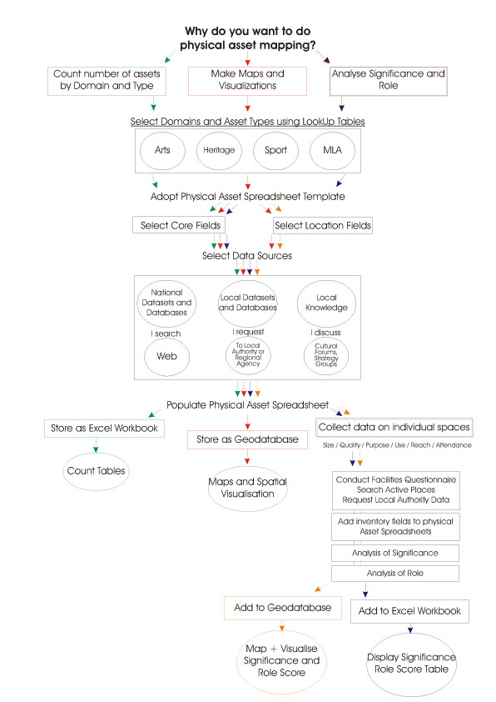

Collecting the data
Data are available from a wide variety of sources. Different data sources will be appropriate for different mapping projects. There are a number of national datasets that can be accessed to identify and map physical assets. Some projects do choose to supplement nationally available data with information from other sources in order develop the regional/local context and knowledge-base.

Points to consider when collecting data:
- Format of the data collected.
- Time taken to manipulate or collate data.
- Cost of data.
- Level of detail.
- Methodology used to generate data.

Creating Data Templates
It is important that the data collected is organised and arranged so that it can be accessed in a straightforward manner. To view the example data template please see the downloadable Excel document available online.

The fields in the data template are crucial to the success of the mapping. Recommended fields are outlined in Section 4.5 (page 21)

Storing Data
Storing and managing data effectively is key to functional data usage. Appropriate storage ensures accuracy, validity and integrity, whilst also saving time and resources. Effective storage also allows data to be preserved for use in the future.

Asset Inventories
Having identified that an asset exists, additional or further information on particular assets (also called inventory data) is a requirement for many mapping projects. This inventory data needs to be identified, collected, accessed and incorporated into the mapping dataset. The following steps help create and establish an asset inventory:

Identifying the requirement
In order to identify the required inventory data, the project objectives, requirements and the current asset typology need to be considered by those undertaking the mapping process.

Collecting the data
Inventory data may come from a range of sources. Some national sources of data can provide detailed information, but in most cases other data sources should be considered.

Incorporating the inventory data
When incorporating your inventory data, there may be more fields that you decide are suitable for your mapping. In adding more fields, the user needs to consider two options for incorporating additional data:

- Inventory data is added to the data template
- Setting up a separate template for inventory data.

Asset Significance
To make good use of your asset mapping in strategic and local decision making you may wish to decide on the significance of individual physical assets so that you can identify their potential role. This should increase the flexibility and use of your asset mapping as a decision support resource.

Allocating roles
Assets may be of differing significance or ‘reach’. An asset with local significance may have the most important role if your asset mapping is being used to underpin a local area development plan or to leverage a Standard Charge or other type of developer contribution. It is therefore important to contextualise the role of an asset in relation to the wider policy objectives under development.

Positioning your cultural and sporting offer
Identifying the significance and role of individual assets enables you to use the evidence contained in the physical asset dataset or database to engage with strategic decision-making.

Making Maps
Desktop GIS software can be used to display not only the locations but also other attributes of physical assets. GIS software is widely available and in order to use it to visualise your assets you will need to collect accurate information about their geographical locations.

The degree of geographical accuracy you require for visualising your assets depends on the scale you wish to display your data. Postcodes will be adequate for most regional level mapping exercises.

There are a number of recommended steps to be taken when making maps, these are summarised in Section 7 (page 32).

Sharing Physical Asset Mapping
Most physical asset mapping projects to date have relied on sharing the distribution and listing of assets in paper or digital based reports and through Excel spreadsheets. If your asset data is geo-coded then sharing your asset information with others interested in using the asset information to make decisions is easier. Asset mapping can be the first step in facilitating a conversation between agencies and organisations on developing the cultural and sporting infrastructure.

Evaluation and Maintenance
It is important for users of the toolkit to stand back and critically assess the toolkit process. It is recommended that a feedback system is developed as part of the project and that those involved are encouraged to provide feedback throughout the project.

Keeping data live
It is essential that the data sources used in mapping are kept up to date. Maintaining the currency ensures accuracy of data, allows users of the toolkit (and its outputs) to access the most up to date information and makes challenges to the data less likely.

Maintaining relevance
As the initial requirements of the initial mapping become superseded and changes to the asset base occur and different agendas are focused upon, it is important that both the data and the toolkit remain current. It is crucial therefore that the C&S asset mapping exercise is not just seen as a one off event; but that the data and mapping is updated at regular intervals. The C&S Physical Asset Mapping Toolkit will provide the essential and cost effective baseline and framework for subsequent exercises.

Links to policy
Once developed it is important that the map is not seen as a static resource with linkage only to the policy drivers that initiated its development. The map will be a live resource that can be built on and developed in the future and it is important that an individual or ‘host’ is given the responsibility for maintaining the strategic relevance of the map.

Brokering Links with Others
It is important that links are developed with other partners and stakeholders and that these links are maintained. As a result of this process it is envisaged that there will be closer collaboration and ties with strategic partners which will benefit future work.

- Introduction
The planning and development of culture and sport ‘assets’ is a key element in achieving policy targets (for example on cultural participation, social inclusion, physical activity and health outcomes) as well as for a wide range of quality of life and local amenity goals. ‘Access’, i.e. proximity, transport, time, information, represents a key barrier to cultural and sporting participation and frequency of use. As such, data on the distribution and location of these facilities are clearly important. Information and knowledge on culture and sporting assets and opportunities are vital to the effective provision of facilities; supporting the avoidance duplication, the optimisation of access and usage and ensuring equitable distribution of culture and sporting amenities (and experiences) for the whole population.

Auditing and mapping physical culture and sport assets is the first step in cultural planning, which can be carried out for a number of purposes. Facilities often host the human skills, expertise, organisations and other resources that ensure the operation, programming and public engagement in culture and sport. Once a sound knowledge of physical assets, their classification, distribution and importance is established, their relationship with people as audiences, participants, users and local communities can be assessed. Mapping physical assets in a systematic way can therefore aid comparative benchmarking of provision and participation and provide the first building block in the Physical-People-Planning approach to developing ‘place’. The following guidelines provide the tools and guidance by which those responsible can ‘do-it-yourself’ using available data for cultural mapping as the first step in the cultural planning and consultation process.

What is the purpose of the toolkit?
This document provides best practice guidelines to support the mapping of Cultural and Sporting (C&S) physical assets. The guidelines demonstrate a systematic approach to the collection and mapping of C&S assets and specific information associated with them.

The document is designed as a toolkit to help consistent mapping of assets, regardless of locality. Use of the same data sources is suggested to aid comparison and understanding. The guidelines encourage the standardisation of formats to enable widespread use. In the long term, these guidelines will support (either through aggregation of data or application at a national level) a national picture of cultural and sporting assets.

Mapping as a process has benefited from innovations in technology, such as GIS software, enabling selected data to be mapped and visualised. It has also benefited from the increased availability of datasets through web services or web-based information providers. Making data more available draws more attention to the quality, accuracy and currency of the underlying data and the classification systems used to select information. The creation of a Culture and Sport Physical Asset Mapping Toolkit is therefore timely, and aims to provide users with a framework so that collection and dissemination of statistics can occur on a co-ordinated and consistent basis.

Table 1: What can you use this mapping toolkit for?
 | Mapping C&S physical assets
 | Understanding the policy context of C&S asset mapping
 | Saving time and resources in understanding the C&S environment
 | Defining C&S physical assets
 | Preparing for and planning a mapping project
 | Accessing information to be used in the mapping process
 | Understanding what additional information could be used in the mapping process
 | Storing information on assets within an accessible framework
 | Identifying, collecting, accessing and incorporating different data sources into the mapping process
 | Visualising and sharing the mapping process
 | Evaluating and maintaining the mapping process

The toolkit will benefit any organisation seeking to map C&S physical assets. It can be used by a range of stakeholders, including (but not limited to) individuals from:
- Executive, Regulatory and Statutory Agencies
- Government Departments
- Non Departmental Public Bodies
- Local Authorities
- Regional Development Agencies
- Education Institutions
- Charities
- Associations or Clubs
- Commercial Organisations

The guidance will facilitate improvement in the collection of data over time and provide a structure for future developments in the collection and release of data.

What is a physical asset?
A C&S physical asset is a place where people go to experience and take part in cultural and sporting activity. Physical assets are therefore facilities with public access. They may be buildings specifically constructed for an art form (a theatre or an art gallery) or a library or museum, heritage building or landscape, where people actively engage in culture, or a space used for a specific sport (an athletics track or football pitch, sports hall or swimming pool). Or it may be a place that has another primary use, such as a school, but provides a valuable local space in which culture or sporting activity is undertaken by the community. There are also spaces in generic community facilities (halls or social clubs, churches, temples or mosques), which are used either regularly or occasionally for culture and sports activity. These are cultural and sporting physical assets but their significance or role in the regional or local cultural infrastructure is primarily to enable community participation.

Physical assets do not include organisations, clubs and groups, culture or sports agencies, the cultural and creative industries or general recreation (such as countryside recreation). Nor does it include the informal performance spaces often used in arts or community based productions or exhibitions (streets and squares, beaches, building exteriors and rooftops) or landmark architecture and public art installations. These provide spaces for public engagement with culture but are not ‘facilities with public access’. However, you may need to consider these types of space and activity if you are undertaking a cultural infrastructure audit; of which physical assets with public access are only one part. For advice on mapping your organisations, partnerships and the outcomes of participation we recommend that you refer to the resources on the Living Places website (If you wish to capture informal spaces and temporary festivals you may wish to create additional fields in the proposed template (see below).

Figure 1 illustrates the complexity of the cultural and sporting infrastructure and locates physical assets as one part of this complex whole.

Figure 1: Culture and sporting infrastructure

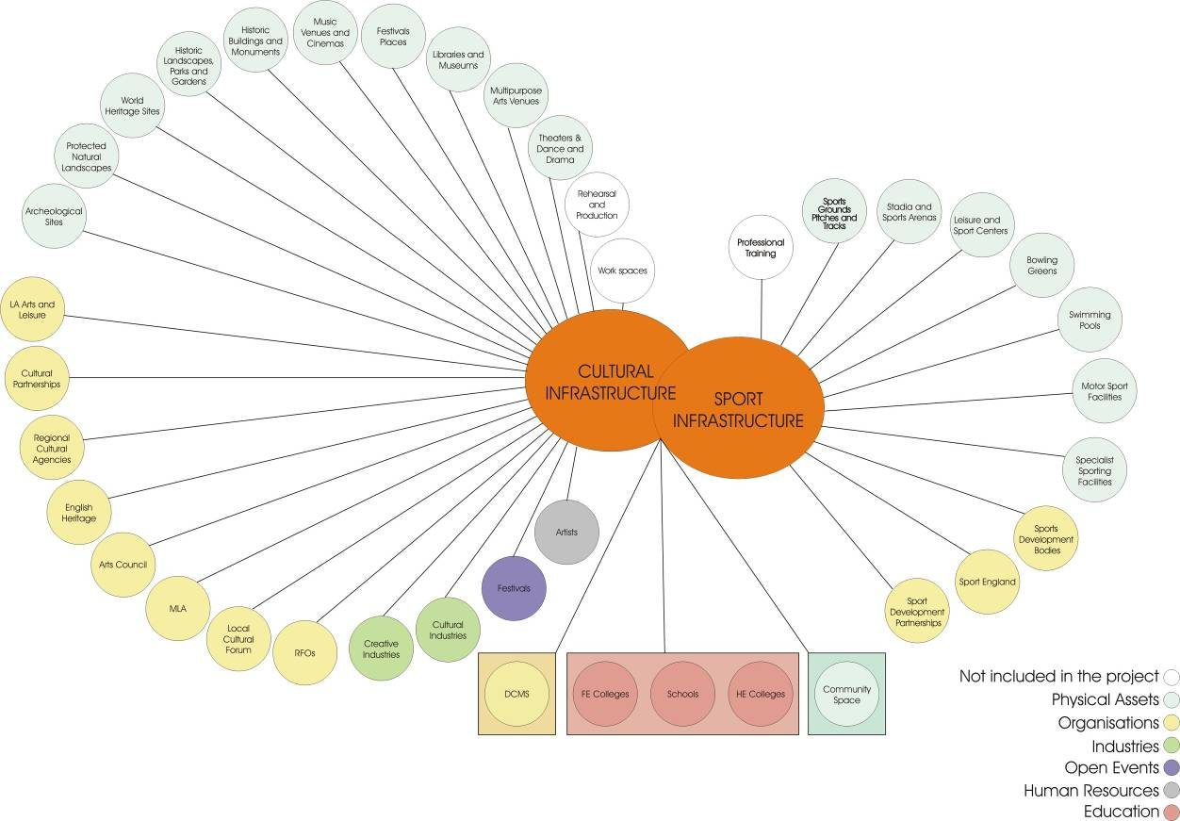

As demonstrated in the diagram above, physical assets are one element of the cultural and sporting infrastructures. The presence of a physical asset should not be used as a proxy for arts or sports provision, as the services also need to be in place to support delivery. As such, physical asset mapping alone should not be seen as a comprehensive methodology for understanding arts or sports provision.

Why create a toolkit to map these?
The development of the toolkit forms part of the wider agenda of work being delivered as part of the CASE programme.

CASE is focused on establishing sound and persuasive evidence of the impact and economic value of culture and sport, and in marshalling the evidence on what works in promoting engagement in order to inform policy at a local and national level. Since 2008 CASE has commissioned a range of activity designed to address the core evidence needs across the sectors. This includes developing new economic measures of the value of engagement, which expand the economic analysis of the sector beyond basic macro-economic measures (such as GVA or job creation) towards measures which better suit their core value – their contribution to quality of life. In addition, CASE has focused on marshalling data and evidence in order to make the strongest arguments for investing in culture and sport opportunities, avoiding generic arguments.

The Department for Culture Media and Sport (DCMS) has also prepared a statement of compliance with the Code of Practice which notes that “For credibility and in order to be useful, statistics need to be produced to common standards and to consistent definitions. This is to ensure that data are comparable between areas or subjects, as well as over time.” Furthermore, the DCMS recognises that a key part of using and collating statistics is to “ensure that workable common frameworks exist”. Within the DCMS Statistical Work plan for 2010/11 it states “We are also working to improve data on cultural and sporting assets, with the aim of understanding the links between supply and demand in cultural and sporting engagement. This work includes the development of a toolkit to help Local Authorities record and map their assets in a consistent and comparable way, and investigation of how we can bring the data together to link to our survey data.”

Accurate and up to date details of existing C & S assets is crucial in C&S planning, particularly location and investment decisions, gap analysis and as a resource for individuals, planners, organisations and other stakeholders. Current and accessible information allows duplication to be avoided and optimises access and usage, whilst also providing a platform for understanding the distribution of culture and sporting amenities and experience for visitors or users of assets.

Access to local knowledge has improved in terms of both the quality and coverage of relevant data in recent years. This has been led by statistical agencies such as the ONS, Ordnance Survey, CIPFA and central government portals and databases like the CLG’s Places database. Concurrently, local authorities are also developing their own local portals and Local Neighbourhood Information Systems. However, it has been noted that culture and sport is not always included as a domain in these datasets.

Local authorities, as well as regional and sub-regional authorities, have carried out cultural and sectoral ‘audits’, as part of local strategies and planning frameworks, and in some cases as part of Sustainable Community Strategies. Cultural agencies and membership bodies have similarly invested in cultural, arts and sports in education and in facility surveys. It is thought that whilst these audits and surveys are beneficial, a lack of reference to national data sources or previous surveys, results in successive audits having to be undertaken at an increased cost of time and resources.

Despite some local neighbourhood sites containing Cultural Vitality Indices that draw upon local as well as national data sources, sectoral bodies and joint initiatives such as Sport England’s Active Places facility database, the Audit Commission’s Fit for the Future, and Living Places guidance and Audience London’s CultureMap, there is perceived shortage in the amount of available C&S asset data. As a result there is a requirement for broader, more comprehensive and better quality data to be available on C&S assets. Hence the development of this toolkit.

The toolkit also contributes to ameliorating financial pressures on organisations. The time and resource savings which can be made by undertaking this mapping process present a number of benefits that can assist organisations and individuals. Key benefits include:
- Reducing spend on external facilitators to undertake projects.
- Reducing time on gathering disparate information.
- Providing a reference and resource base for future mapping studies and users.
- Encouraging standardisation of data to reduce time spent on manipulation and modification and to enable comparative benchmarking.

Where has it already been done?
In producing this document, three organisations agreed to work with us to conduct pilot studies in order to test the approach and provide examples at different stages. These were as follows:

Woolwich Town Centre: Shaping Woolwich Town Centre through Culture
This pilot is a live sub-regional project currently being undertaken by the London Living Places Partnership on behalf of the Greenwich Waterfront Redevelopment Agency, London Thames Gateway Partnership and the London Borough of Greenwich.

London Living Places Partnership has identified Woolwich as a priority place for supporting cultural planning within the London Thames Gateway. The Partnership is working alongside Greenwich Waterfront Regeneration Agency and LB Greenwich Culture Directorate to indentify the ways in which culture and sport can be integral to shaping future of Woolwich Town Centre. In agreement with GRWA / LBG the output of the project will be a report and support on advocacy to establish a platform for ongoing cultural planning work. Physical asset mapping constitutes a core element of this work. The project remit goes beyond asset mapping and is concerned with how assets are used and how they support local participation in cultural activity.

CultureMap: Thames Gateway
CultureMap is the pilot for an online resource bringing information about cultural provision in London together with data about users and audiences. The data are displayed through maps showing London’s cultural infrastructure and population. CultureMap acknowledges that much of the information they display is available elsewhere, but the benefit of the CultureMap project is that this information is not available in one place. CultureMap London is held on a website and is a pilot funded by Arts Council England (London), following research jointly commissioned with the Greater London Authority (GLA) in 2004. It has been created by Audiences London (AL) but the long-term goal is for the project to be developed and owned by a loose consortium of interested parties. A steering group representing potential partners advises AL so that they can develop a resource that can serve a range of needs. AL is the regional audience development agency funded by ACE and London Councils; a primary function is to carry out and bring together cultural research on a not-for-profit, give-and-gain basis.

The policy context was the GLA Cultural Strategy and ACE London support for the development of cultural infrastructure in London.

One North East: Regional asset mapping
A key driver of this work for One North East (the regional development agency for the North East) is the creation of an evidence base to support regional strategic development. It is clear to One North East that “different elements of the cultural sector in the region have varying levels of intelligence on assets, provision and their usage”. This intelligence is in a wide range of formats and not available centrally. As a consequence, particular parts of the sector are able to inform policy discourse and decision making better than others.

More consistent mapping of cultural and sporting assets can establish a robust evidence base that can in turn support:
- Targeted investment and decision making
- Inform prioritisation of activities for cross sector collaboration

The mapping is also intended to highlight opportunities for the sector, ensuring it is situated to benefit regional economic and social development activities.

- Making a start
The process of delivering a physical asset mapping project benefits from getting a committed team together. This may be a steering group bringing together representatives of key regional or local agencies, or it may be a delivery team crossing different local authority departments (for example, arts and leisure and planning, housing or regeneration departments), or it may be a local cultural forum working in partnership with other agencies.

The role of this group is to champion the mapping process, identify its strategic use and to help identify local sources of information to supplement national datasets. Whether you are working in a regional or local context some of the information you require will be held in a variety of places and you may need this group to broker co-operation from supporting agencies.

Delivering the asset mapping is often best done by a dedicated (often small) working group, with a clear and supported leader. In the Shaping Woolwich Town Centre through Culture Pilot study the physical asset mapping was led by one person working across organisations and agencies. Her role was critical.

CultureMap London was also undertaken by a small dedicated team working within AL. Working over the London region as a whole, this team drew together data from local authorities on cultural organisations and assets to incorporate into a web based mapping tool.

In addition to having the right team, it is important that the following points are considered before starting:

Table 2: Mapping project - checklist
Requirement | Complete
Resources: Are there enough resources available for the project?
Management: Is the management and leadership focused and clear?
Expertise: Are any specialist skills or resources required from the project?
Strategic use and motivation: What is the strategic use & motivation behind the project?
Policy context: What is the policy context behind the project?
Aims and objectives: What are the aims and objectives that are guiding the project?
Data availability: What data and information is available, required and suitable for the project?
Ensuring sustainable mapping: What will happen after the initial mapping has occurred?

More detailed guidance on things to consider under each of these points is available in the appendix, section 9.2 (page 45).

- Developing definitions
Defining C&S physical assets poses particular problems, particularly when an asset is used for more than one purpose. Our starting point has been to identify the assets where most culture and sports activity takes place. These assets have been grouped into broad categories, Physical Asset Primary Descriptions (Figure 2), to represent venues and physical assets where similar types of activity take place.

To ease data collection, the identification of physical assets has drawn on the categories used in some of the most accessible national datasets (for example Active Places and National Monuments Register). Assets have been grouped by domain (Arts; Heritage; Museums, Libraries & Archives; and Sport).

The ‘Asset Primary Description’ identifies a general group of assets. Depending on your reasons for undertaking culture and sports asset mapping, you may only need to represent your assets at this aggregate level.

Figure 2: Physical Asset Primary Description
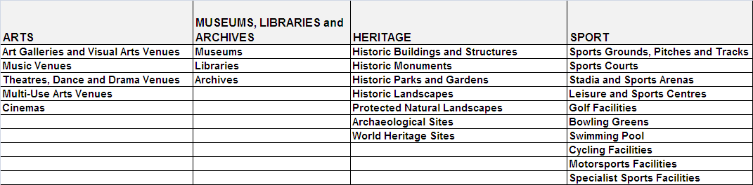

Secondary and Tertiary Descriptions have also been developed to enable further disaggregation where this is required. Again, these are based on categories used in national datasets.

Tables showing the asset typologies by domain are provided in the downloadable template. These list all the assets by domain in a typological hierarchy. There is some variation between the domains, reflecting differences in the nature of their physical assets. Selecting asset Secondary and Tertiary Descriptions however will allow you to create finer grain mapping.

In some cases typologies used for particular purposes (for example the ACE/MLA Standard Charge types) have been included in the template tables to ease cross referencing when applying your mapping to particular strategic decision-making – for example housing growth and development.

Defining and finding your physical assets
Mapping C&S physical assets is an iterative process. It is suggested that you use the definitions in the templates to guide your initial search for regional and local assets using national and local datasets and local knowledge.

There are several sources of data that can be used to find physical assets. Unfortunately there is no one definitive source. Sections 4.4 (page 19) and 4.6 (page 23) provide further information on data sources available to use.

Once individual assets have been identified they can be included in an Asset Data Template. This is outlined in full in section 4.4, Table 3. However it is suggested that you start by allocating a Primary, Second and/or Tertiary type (and/or a Standard Charge type if appropriate) for each individual asset entry. Below are some examples:

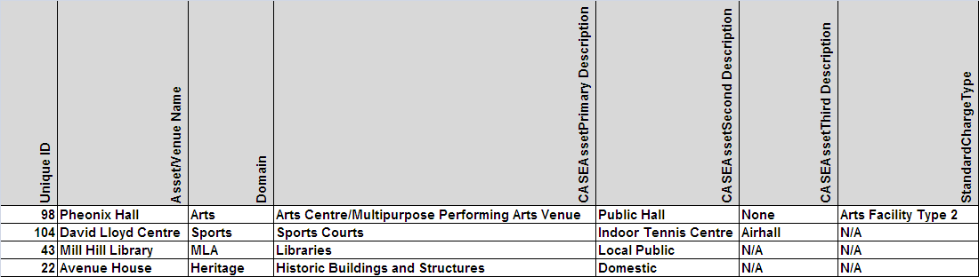

You may then wish to specifically include local information which identifies the current main activity undertaken in a venue, its ownership or whether or not the organisation using the asset undertakes outreach work. Identifying current usage will be particularly important where the asset description refers to the original, rather than current use. The example above could therefore include the following:

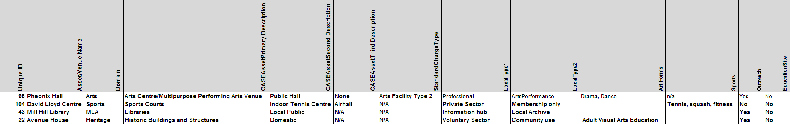

This will then allow you to categorise (and eventually map) your individual assets according to different levels of detail appropriate to your needs. You may only need to know the general pattern of assets, so mapping by Primary Asset Description would be sufficient,

However if you record data on the Secondary Asset Description and collect additional local data for example on Local Types, ArtForm and other headings you can identify important features of the current use of that asset. For example, you would be able to know that an asset listed under the Heritage Domain and identified as a domestic building, is now used as a space for adult visual arts education. Likewise assets which are primarily used for Arts or Sports can have their listed and heritage status recorded.

Whilst it is recommended that the typologies in the templates are used to guide your data collection and classification, it is recognised that some flexibility is appropriate to meet local mapping needs and to reflect the multiple use of certain assets. In some extreme circumstances, individual assets may need to be allocated a dual Domain or Primary Asset status.

Dealing with gaps in definition and data collection
In developing the toolkit every effort has been made to develop typologies that provide both an accessible and comprehensive coverage of asset types for the four CASE domains (Arts, Sports, Heritage and MLA). However, it has not always been possible to capture the full range of individual or specialist physical assets within the typological 3 level structure. Nor has it always been possible to fully document where facilities are shared by a number of activities within a domain (such as in Sports where a number of different types of sports activity may take place in or on the same physical asset – for example a Sports Hall or Grass Pitch). To accommodate this there is flexibility within the proposed structure. Generic labels have often been used at Primary or Secondary Asset Description Level. These can be populated by more detailed level data, for example those developed by sports governing bodies and contained within the Active Places database or in local datasets. You can also add descriptions of specific facilities where appropriate, for example, in the Tertiary Asset description. An example in this typology is the inclusion of Pilates Studios in the Sports domain. You can add other specialist facilities at this level for any one of the Primary or Secondary asset types.

The CASE typology is indicative rather than fixed as there are often gaps in the shared understanding of how to define domain assets. The typology is general enough to accommodate most mapping exercises aimed at scoping the physical assets in cultural and sporting domains. However, it is also flexible enough to accommodate new definitions as these become available.

It may also be difficult to capture differences in definition of the same physical asset used by specific Sports bodies or Arts practices (for example a space may be considered a basketball court by one body and a 5-a-side indoor football pitch by another). Use of the generic Primary Asset Description can help overcome these differences for the purpose of general asset mapping. However, specific definitions from particular users could be included in the inventory process (see section 5) where details on the size and use of assets can be recorded and then made available for domain specific planning and policy development.

- Mapping

The policy background
Before undertaking a mapping exercise, it is important to consider the policy background behind your mapping process. This is important for a number of reasons:
- It allows opportunities to be identified.
- Important policy initiatives can be fed into it.
- Key policy areas which may influence and be impacted by the mapping are understood.

The policy background at all geographical levels needs to be considered, helping the mapping to be tied to national, regional and local objectives to support similar projects. Understanding the policy background can help foster linkages between policy areas and ensure that data collected support wider policy developments.

As such it is important to consider the following questions on the policy background before commencing the mapping project:

- What national (regional/local) policy forms the background to the mapping process?
- What links are there with current policy at the geographic level which is being studied?
- What are the aims and requirements of the policies behind the policy mapping?
- Are any specific outputs required directly linked to these requirements?
- How will the outcomes of the mapping project contribute to the policy aims and objectives?
- What savings will be made as a result of the delivering the mapping project and how will they contribute to the reducing financial pressures?
- Are there similar projects and policy initiatives that the mapping can feed into?

Examples of how the three pilot projects responded to these questions can be found in the appendix, section 9.2, page 45.

The purpose
‘Mapping’ has different meanings (and a different end point) depending on the reasons why you are undertaking the exercise and the outcome you wish to generate. Mapping can simply be an audit of facilities through which you collect information about the location and purpose of your physical resources and record the information on a spreadsheet or in a database. Supplementary information on the asset type, its scale, quality and role can be added as fields (see section 5, page 26). The spreadsheet or database can then be used to create the evidence base for strategic planning – for example Thames Gateway North Kent used a spreadsheet based mapping resource to quantify the number of facilities by district. This helped to identify the gaps in provision by type of asset and by locality.

Collection and sorting of data can also be an important first step leading to visualisation and analysis using GIS. For this to take place particular data on the address and postcode of each asset needs to be recorded accurately. The Partnership for Urban South Hampshire (PUSH) took one step towards this and published maps identifying the specific location of their physical assets (and wider cultural infrastructure). Shaping Woolwich through Culture has developed the GIS mapping further by integrating their physical asset mapping with data on population projections, housing development and travel patterns to support the case for putting culture (and sport) at the centre of the regeneration strategy and to become mainstream within the Local Development Framework.

The approach
A number of decisions arise once the purpose of your mapping becomes clear. These are outlined in the flow chart below:
Figure 3: Mapping Process

Collecting the data
Data identifying and describing assets is available from a wide variety of sources. Different data sources will be appropriate for different mapping projects depending on their purpose and intended usage. As per the diagram above, the decisions you make about the purpose of your mapping will help provide clarity on the kind of data you need to use.

There are a number of national datasets that can be accessed to provide broad coverage of the physical assets, as per the typology in the downloadable template. A directory of these (including contact information for accessing each source) is available in the appendix ( Data sources and Additional data sources table, page 53).

The national resources should speed up data collection and allow you to spend more time using, rather than compiling, the data. A further advantage of the national sources is that they are regularly updated as new data become available.

However, some projects do choose to supplement nationally available data with information from other sources in order to develop the regional/local context and knowledge. However tracking down local data sources can be time consuming and some may not have been updated for some time.

Examples of the use of local information are:

Local Information: Thames Gateway North Kent
- Local Authority websites;
- Local Authority databases listing facilities, community clubs and activities:
- Dartford ‘Community Connects’ online events database;
- Gravesham Wish I Was There database;
- Swale Arts, Sport and Culture directories online;
- About Medway and Medway MOLE;
- Kent County Council clubs and societies database;
- Listings in local newspapers.

Local Information: Woolwich Town Centre
- Local Authority GIS data
- Leisure and arts facilities
- Community and social clubs
- Play areas and recreation grounds

Local Information: Pennine Lancashire Living Places
- Consultation with strategic agencies across region
- Engagement with and accessing datasets held by sector specific agencies (Sport England)
- Web based search using search engines and the websites of assets, organisations and individuals

There are a number of points that need to be taken into consideration when collecting data, these include:

Format
The format of the data is important to consider as some may be incompatible with others. You may need to do some work to standardise the data collected into a similar format (see section 4.7 on storing data, page 23).

Time
Certain datasets will take longer than others to gain access to. This needs to be factored into the project plan and when producing the output of the mapping toolkit. It is also important to consider the time required from individuals and partners to participate in and execute the mapping process. This should be negotiated at the outset of the project as per the project plan.

Cost
There is occasionally a direct cost associated with accessing datasets and this has to be considered when undertaking the mapping process. Increased costs can have impacts on the resources available for the rest of the project and in some cases can be a barrier to completing the work. In these cases alternative datasets may be considered or new revenue funds sourced.

Detail
The data which is required must provide the correct level of detail otherwise it will be ineffective. This must be ascertained before any data is purchased or accessed in full to reduce costs and time spent on trying to use unsuitable data. Where possible, samples of data should be obtained to verify their usefulness.

Methodology
The way the data is collected is also important. Certain datasets use calculations and modelling to create figures within their datasets and these may not be appropriate for your map. Where estimates are used, they need to be clearly identified.

Creating data templates
It is important that the data collected is organised and arranged so that it can be accessed in a straightforward manner. Figure 4 shows a snapshot of what the recommended data template looks like, to view the actual template please see the downloadable Excel document available online.

In order to use the template, a description of the fields and their importance (to be retained for reference) can be found below.
Figure 4: Asset Data Template

Unique ID
The unique identifier is an individual number or code, which is attributed to an asset, so that it can be easily selected from the data set. Having a unique ID for assets is important as it reduces confusion and can help identify duplicates and overlapping assets whilst also helping when working in multiple documents. The name of the asset alone is not suitable for an ID, as there is a greater risk of error when reproduced. For example, spelling mistakes and abbreviations can cause issues when searching or matching based on a name.

Name
The name of the asset needs to be included. This helps identify the asset.

Address
If it is possible, a full address (including postcode) of the asset should be gathered. This helps to corroborate an assets’ location as well as providing important contact details.

Data Source (1, 2 & 3)
The data source that the asset originated from needs to be included here, as well as other sources you have accessed that have identified this asset.

Contact Details
The phone, email, weblink and contact person associated with the asset are fields that if possible should be filled. Depending on the use of the asset mapping toolkit these fields can provide important contact details for quick and effective communication.

Domain
It is important to understand what domain the asset sits in; is it Arts, Museums, Libraries and Archives (MLA), Sports or Heritage?

CASE (Primary, Secondary &Third Description)
In order to categorise and organise the assets it is important that their primary, secondary and third description is filled out. All assets have a primary description but fewer have secondary and third descriptions.

Art Forms/Activities
Brief descriptions on the arts forms and activities that occur at the asset site are important so that users can understand what the asset is.

X and Y
X and Y coordinates are used in GIS systems to convert assets into features on a map. Whilst mapping does not require GIS maps to be made, these are a useful feature of gathering information. The values in the X and Y fields represent coordinates and units such as latitude and longitude or meters. X and Y are coordinates on a map and are valuable fields for enabling GIS (see section 7, page 32).

Ward Name
The electoral district (at sub-national level) in which the asset is located should be specified here.

Ward Code
Ward Codes in England and Wales contain six characters. The first two characters are the county, the next two identify the Local Authority and the last two characters represent the electoral ward of the postcode. It is important to note that electoral ward/division boundary changes are usually enacted on the first Thursday in May each year.

Local Authority Name
The name of the local authority in which the asset is located is listed here.

LACODE
The LACODE is the identifier of a Local Authority within the UK, it is 4 characters, 2 numeric followed by 2 alphabetic.

The ward and local authority codes and names are important identifiers for linking the assets with other inventory data. For example, it is possible to link the assets to characteristics of the immediate area (from data sources suggested in section 5.2). The local authority and ward names and codes are used by a number of different data sources when categorising data and as such it is important to include this information in the template.

Recommended approach to collecting data
This recommended approach is based upon the Pilot Study’s experience in collecting data.

Initial Assessment. To find the broadest coverage of assets, an initial review of the data sources available can establish which are available and cover the C&S assets required for your mapping. This may include some of the data sources listed in the appendix (page 53).

Local and Regional Datasets. A thorough investigation of the datasets that are available at different geographies which are relevant to the mapping project. The local and regional datasets may include statistics or information from local authorities, regional development agencies or city regions. There are also a number of public sector organisation and private bodies that may be able to provide information on assets in a local area. The examples of local information which were used are at the beginning of section 4.4 (page 19)

Inventory. There needs to be a consideration of the inventory fields and details that will support the mapping process. Section 5 provides more detail on adding inventory data.

Recommended data sources
There are numerous data sources that can be used in collecting asset data. Whilst your mapping should consider many data sources to provide broad coverage, the table below provides a listing of those that were found useful in mapping process.
Table 3: Data sources to look at first
Free to Use | Cost Attached
Active Places | POI
Culture24 | OSMasterMap
MAGIC | Point X
Archsearch | TCR
Culture Map London | Experian
Culture Grid
English Heritage
Natural England Data Sets

For more details on these asset coverage provided by data sources please see the downloadable template.

Storing the data
Storing and managing data effectively is key to functional data usage. Appropriate storage ensures accuracy, validity, and integrity whilst also saving time and costs. Effective storage also enables data to be preserved and made accessible for distribution and use in the future.

Digital data can be stored easily and can be made available to secondary users. Web-based platforms are popular and efficient resources that allow the data to be used by others. However, well structured Excel files should be sufficient to allow you to store, access and use your data effectively.

The following points are useful to remember when storing data:

- The dataset should have accompanying information (or metadata) to describe its content. This covers the purpose, origin, time references, geographic location, creator, access conditions and terms of use of the dataset. It is also useful to have information on how the data was developed and a guide for its intended usage.
What is meta data?
Meta Data is loosely defined as “information about data”. It is information about the data element, including description and content. It briefly explains what the field is and what the data field should contain.

The table below shows an example of what your metadata may look like and some of the fields that are important to include when storing data. The data template which accompanies this guidance document contains metadata to help understand what should be included.
Meta Data Example
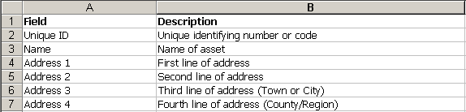

- It is important that the data available are stored in formats which meet long-term requirements. The data will need to be accessed in the future and storing the data in an appropriate format ensures ease of use in the future. Saving the files in a format which is used universally would be an important start in saving data for long term requirements (e.g. Excel).

- Data should be stored with the appropriate guidance on accessing and using data. If possible, the supporting information which was supplied with the data needs to be retained. This includes different versions of the data, information that was supplied when a data request was made and any other supporting information. This can assist users coming back to data and allow new users to understand where the data originated from.

- When storing data, the security and confidentiality requirements of the information needs to be understood and adhered to. Protocols should be established to ensure that confidential data is only accessible to those authorised to use it and that access can be controlled.

- Digital data requires regular backing up. Furthermore, data should be stored on formats that are resistant to deterioration.

For more information about managing and storing data; please refer to the UK Data Archive guidelines, available at:

http://www.data-archive.ac.uk/news/publications/managingsharing.pdf

In order to standardise the information that is obtained from these sources, the data can be placed within a template to ensure that coverage is detailed and information exists on the topics required. This template can be used and populated to provide an initial approach to recording data.
- Asset inventories
Having identified that an asset exists, additional or further information on particular assets is a requirement for many mapping projects. This ‘inventory data’ needs to be identified, collected, accessed and incorporated into the mapping dataset.

Identifying the requirement
In order to identify the required inventory data, the project objectives, requirements and the current asset typology need to be considered by those undertaking the mapping process. This allows for an understanding of how the inventory data ‘fits’ and how it will contribute to the objectives of the mapping process.

Understanding the coverage of the data which is going to be used is essential. It is important that the information required (size, use, ownership, management, accessibility, programming etc) can be obtained from the data source and that the data can tackle the project objectives and requirements.

The following table provides some examples of the kind of inventory data that can be collected.

Table 4: Fields for asset inventories
- Contact Details | - Access arrangements and parking
- Tenure and Space | - Turnover (and other financial information)
- Data on users | - Services offered
- Hours of opening | - What space is utilised for/What activities occur
- Percentage of space used | - Licences of site
- Participation/Usage/Attendance | - Arrangement (ownership) of other services
- Disabled access | - Availability of multi-lingual interpretation

Collecting the data
Inventory data may come from a range of sources. Some national sources of data can provide more detailed information. However, the majority of inventory data will need to be added to the map in a second stage once the assets have been identified.

It is therefore important that additional inventory data is incorporated into the template.
The table below provides an indication of some of the additional data sources that can provide added value and additional information to the data inventory. However, other additional data sources can and should be considered. In order to work out other fields and information which needs to be collected, those undertaking the mapping process need to work with a steering group to identify data sources and inventory fields needed.

Table 5: Table of additional data sources
Data source | Inventory information | Example
CASE  Regional Insights | Regional Insights covers an extensive range of local and regional data sources related to culture and sport, such as economic performance, investment, education and engagement. | Data on local government spend on capital infrastructure can be used to understand investment in assets.
Visit Britain | Visit Britain has statistics available on visitors, segments and sectors as well as trends and forecasts. | The amount of visitors can be tied to specific visitor attractions helping to understand usage of a particular asset.
Arts Council | The Arts Council possesses detailed information on funded organisations and attendance at arts facilities | Information relating to participation in programmes delivered by funded organisations can be used to understand levels of engagement.
Natural England | Natural England possesses a wide range of information on protected sites, habitats and other natural areas. | The protection an asset has or its immediate vicinity can be understood with information from Natural England, whether the asset is a Site of Specialist Scientific interest (SSSI)
Regional Development Agencies and Regional Observatories | Regional Development Agencies and Regional Observatories possess a range of economic, social and environmental statistical information. This information may be in a variety of forms and comparable data for other regions may not exist. | Local information is often available from RDAs and regional observatories, this may include data on the economic performance of the immediate vicinity.
Local Authorities | Local Authorities possess detailed and locally important information on a wide range of topics. However, the resources and timescales of local authorities may be pressured by a significant request for data. | Local Authorities have a wide range of information and sometimes are able to provide specific information concerning assets; this may include planning permission or conservation areas.
Primary data collection | Undertaking a survey across the identified assets is one way of increasing the robust nature of the data that is held. A survey can ascertain more detailed information about assets but has the disadvantages of being costly and time consuming. | Primary research can provide a wide variety of information, please refer to sample questions in the appendix (Section 9.6 in the Appendix) for examples of the data and questions which can be obtained.

Incorporating the inventory data
When incorporating the inventory data into the mapping toolkit it is important to consider again the factors that are associated with collecting data (see section 4.4, page 19). For example, the supplementary data may need re-formatting.

There are more fields that you may decide are suitable for your mapping. In adding more fields, the user needs to consider the time spent on collecting data and the additional information required for the mapping.

There are two possible options for incorporating additional data:

1. Inventory data is added to the data template
Adding the inventory data onto the data template increases the size of the data template. This has the advantage of keeping all of the information together in one place, and therefore reducing unnecessary reproduction of work and encouraging the data to be organised. However, problems arise when the inventory fields are too large or long and therefore it can be pragmatic to store data in additional templates.

To view the template in this format please view.

2. Setting up a separate template for inventory data.
Setting up a separate template for inventory data has a number of advantages. It can benefit from the template data fields such as the Unique ID field, Domain and Ward or Local Authority descriptors to draw upon information from the data template. This can enable more information to be gathered on the asset and allow flexibility in working on asset inventory.

To view the template in this format please view.

- Asset significance and roles

Understanding your assets
Not all assets play the same role in your regional or local area. Some may have regional, national or international significance. For example:
- Many theatres outside London serve as regional centres for the performing arts.
- There are libraries, galleries and museums which house national collections
- Some sporting venues that are predominantly used for national level events.
- There are heritage sites which have international significance, for example those with World Heritage status.

However, other culture and sporting physical assets, such as school or community based facilities, may fulfil a very local function.

To make good use of your asset mapping in strategic and local decision making (related to regeneration and housing development or developing your visitor economy) you may wish to decide on the significance of individual physical assets so that you can identify their potential role.

Deciding on significance
Mapping and Gapping analysis of the West Midlands, a study undertaken by BOP Consulting developed domain specific methodologies for identifying the significance of assets. These involved a combination of expert scoring of facilities and Arts Council funded organisations, an analysis of data on capacity, number of visitors, external awards and status, number of artefacts in a collection etc. The simplified matrix (below) derived from their methodology may be useful in deciding the significance of individual assets. The ‘score’ can then be included in your physical asset spreadsheet or database.

Identifying and recording significance in your asset mapping exercise enables quick selection of assets to match the relevant level of policy development or decision making. This should increase the flexibility and use of your asset mapping as a decision support resource.

Asset Name | Location Type | Catchment | Size | Reach | Quality | Significance Score
 | Metropolitan Centre/Town Centre/  Neighbourhood | Assessment of travel distance | Seating capacity possible as proxy | Audience segmentation/  penetration data | Expert judgement of programming | Rating 1-4 (1 international – 4 local community)

In the examples below the template has been completed on the basis of data collected in C & S asset mapping, easily compiled location type and catchment information and expert judgements. You may wish to supplement this with analysis of the Arts Council and Sport England’s segmentation data. For example, the Arts Council segmentation can tell you about the make-up of a local population in terms of arts engagement. This could then be combined with box office data (with postcodes) to assess the reach/penetration of a particular asset.

Example of Significance:
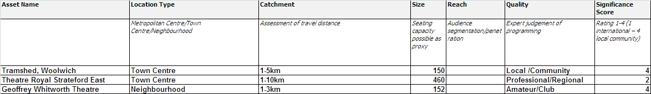

Allocating roles
Assets may be of differing significance or ‘reach’, but this does not mean that the importance of their roles is constrained by this hierarchy. An asset with local significance may have the most important role if your asset mapping is being used to underpin a local area development plan or to leverage Standard Charge funding. It is therefore important to conceptualise the role of an asset in relation to the wider policy objectives under development.

Living Places: Mapping the Cultural Sector in Pennine Lancashire determined the role of their cultural assets in terms of general purpose - ‘Learning and Expression’, ‘Exercising and Exploring’ and ‘The Built Environment’ . This allowed them to make strong connection between their asset mapping and their regional or local policy drivers.

As with significance, identifying the role of an asset and recording this within your asset dataset or database will increase the use of this resource. Below is an example using the Pennine categories. You may wish to define your own categories depending on your policy context.

Example of Role:
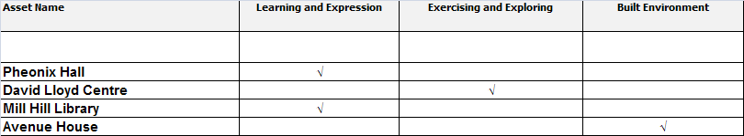

Positioning your cultural and sporting asset ‘offer’
Identifying the significance and role of individual assets enables you to use the evidence contained in the physical asset dataset or database to engage with strategic decision making. This may be on developing your culture or sporting sectors alone or making the connections to key regional and local developments. The asset dataset creates the evidence base. Mapping helps create connections and identify synergies and relevance between policy objectives.

Shaping Woolwich Town Centre through Culture differentiated the significance of local culture and sport physical assets to make the argument for investment in local cultural and sporting assets associated with housing growth. They were also able to identify possible connections between internationally significant assets and the geographical extension of heritage tourism east from Greenwich. Mapping identified possible synergies between new private sector investment in sports facilities, visibility of Olympic training and competition venues and development of a regionally significant sports hub.

- Making and sharing maps
Desktop GIS software can be used to display not only the locations but also other attributes of physical assets. Most mapping projects to date simply identify and display the locations of assets, either by domain and type or by area. Such mapping shows distribution but does not attempt to capture the significance of distributions. This is the case in the following example from Shaping Woolwich Town Centre Through Culture.

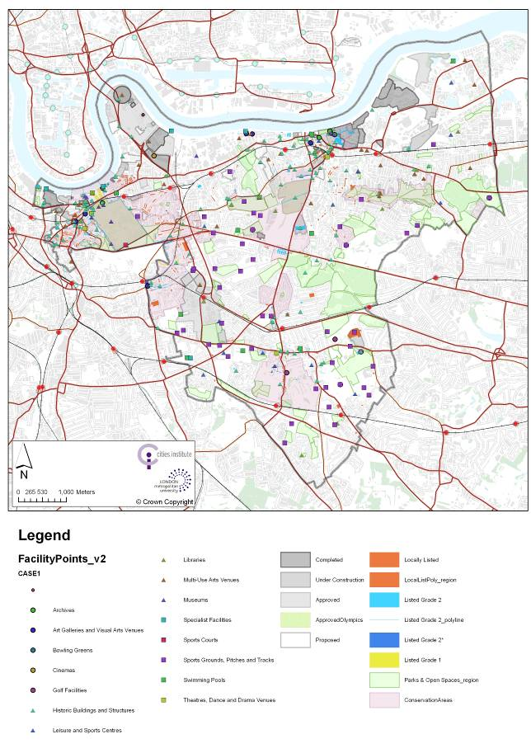

Although GIS software is widely available, to use it to visualise your assets you do need to collect specific and accurate information about their geographical locations. Some sources of data recommended in the Appendix already have this information embedded within them (for example PointX and AddressLayer 2). For example, OS Address Layer 2 relates information about the individual asset to the relevant building. Other datasets (e.g. CultureMap) are based on identifying the post codes of each asset; in this case the geographical accuracy is more limited.

The degree of geographical accuracy you require for visualising your assets depends on the scale you wish to display your data. Postcodes will be adequate for most regional level mapping exercises.

CultureMap contains asset data for London as a whole and for the NUTS sub regions of London based on postcode. Arts and Sports facilities can currently be selected by a number of ‘types’ and maps displayed on their website. Data from CultureMap was supplemented by data from Active Places to create the Domain level mapping below for the London Thames Gateway Local Authorities.

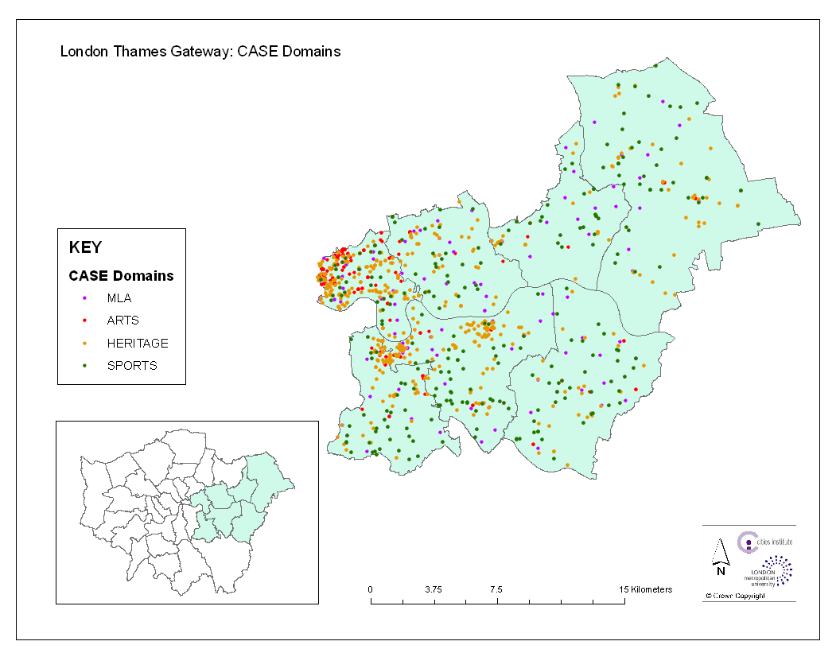

However at more detailed scales, for sites within London Thames Gateway, this level of accuracy is inadequate.

Shaping Woolwich Town Centre Through Culture worked with detailed address information captured in an Excel spreadsheet to enable accurate asset identification at a detailed geographical scale. This required repositioning assets to reflect their building rather than postcode location. This level of detail increased the analytical potential of the data and its use in a ‘master planning’ approach to developing strategy for the town centre.

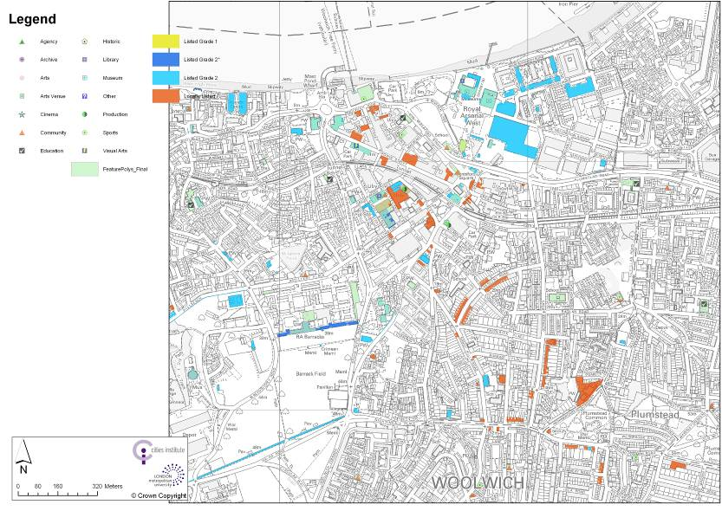

Mapping steps:

- Collecting location data

When collecting and populating the Physical Asset spreadsheet ensure that you collect address information in the allocated fields and that the postcode data is accurate.

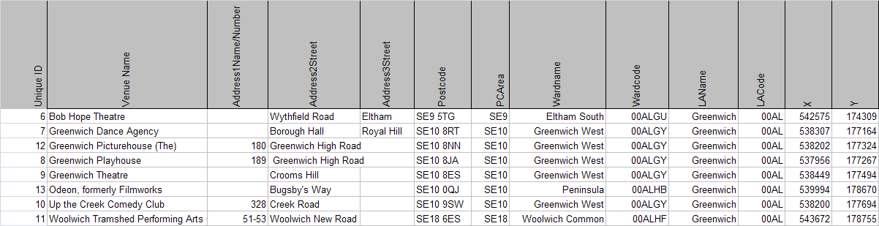

- Compatible storage

If you are going to give your data to someone else to do the GIS mapping it is important to check with them the most appropriate form of data storage. A spreadsheet is usually the best option.

- Visualising assets

Before you visualise your data it is useful to decide what the maps will be used for and how they can contribute to policy discussion and decision making. If the purpose is to represent the overlapping nature of culture and sporting asset the choice of symbols tools and the scale of representation can enhance your argument. Below there is an example of the legend developed for the Woolwich case study.

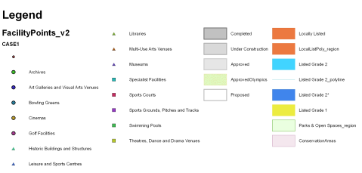

Important here is ensuring consistent use of shapes and colours across asset groups.

- Combining layers

Similarly it may be appropriate to combine layers of geographic information to highlight issues such as conservation area status, population growth or the location of housing development sites with current planning permission. The layers you choose will depend on your policy needs. For example, you may wish to emphasise the role of Local Authority conservation areas as a contribution to the Heritage Landscape of an area, or the role of open space in supporting active lifestyles in relation to specific sports domain physical assets.

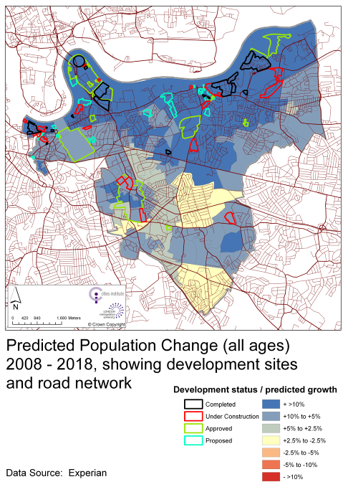

In Woolwich a key driver is supporting cultural and sporting infrastructure development in areas of anticipated housing growth. Further analysis of the accessibility of existing cultural and sporting infrastructure can help to identify the gaps in both current and in future provision (after new housing development has been completed). Below there are examples of how this analysis has been visualised for specific types of facility and at different geographical scales.

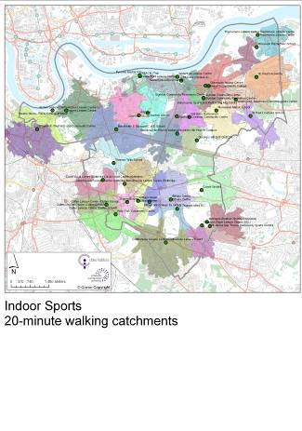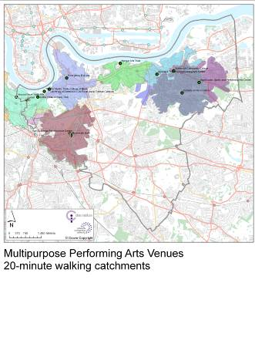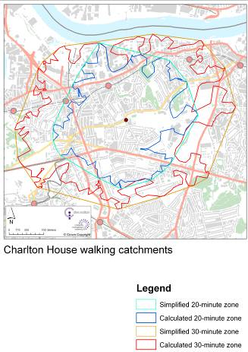

In Woolwich town centre, knowing the relationship between individual development sites, projected population growth and existing assets sites was considered critical to building scenarios for the creation of Woolwich as a good place to live and work.

- Spatial analysis of asset geography

In Toronto, further analysis of the spatial clustering of assets across the city has led to the recognition of key ‘cultural hubs’. A symbology has been devised to visualise this analysis.

This approach is useful and can be adopted to capture the particular characteristics of different clusters of physical assets.

In Woolwich analysis of the spatial clustering of physical assets has led to the identification of cultural nodes.

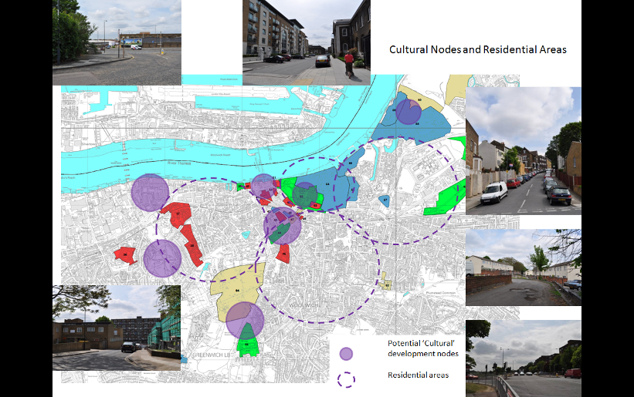

- Visualising inventory data

It is also possible to annotate your visualisation with data from an inventory to display information about the size, quality and use of individual assets. Such data can also be collated and summarised to present tables or graphs to be presented alongside maps.

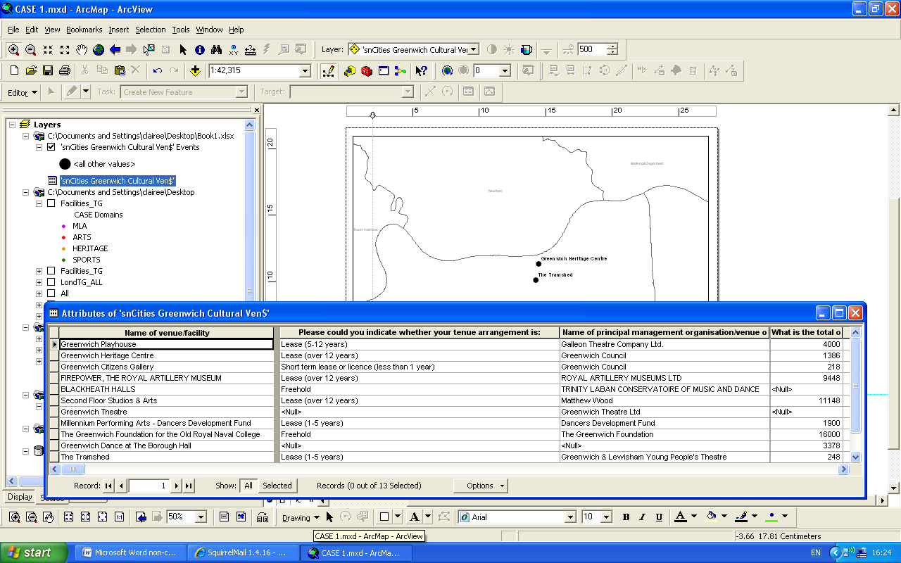

- Visualising assets with segmentation data

Data are available which segment the population by their arts and sports participation . It can be useful to overlay physical assets and this segmentation data, particularly if you can gather information on the catchment areas of users of individual assets. There are however limitations to this ‘layering’ as there is not necessarily a causal link between the data displayed on each layer.

Sharing physical asset mapping
Most physical asset mapping projects to date have relied on sharing the distribution and listing of assets in paper-based reports (or their digital equivalents) and through Excel spreadsheets. If your asset data are geo coded then sharing your asset information is easier, particularly with others for whom the spatial distribution of resources is a key part of their planning and decision making process.

CultureMap London has developed a web based service for displaying and downloading pre-made maps. Asset mapping can be the first step in facilitating a conversation between agencies and organisations on developing the cultural and sporting infrastructure. Visualisation can help to focus attention on the current state of provision and on its relationship to other local or regional issues such as tourist and visitor developments, education and participation programmes, housing development and population growth. These conversations can help to foster strong inter-departmental and inter-agency working and further developments in wider cultural planning.

The first use of asset mapping is to support policy development and delivery. It is therefore important to make the most of your investment in developing this resource by identifying where there may be synergies between policy objectives and initiatives. Figure 5 shows how the asset mapping project for Shaping Woolwich Town Centre responded to, and sought to support, a number of national and local policy initiatives.

Figure 5: Woolwich Case Study: Policy and Initiative Synergies

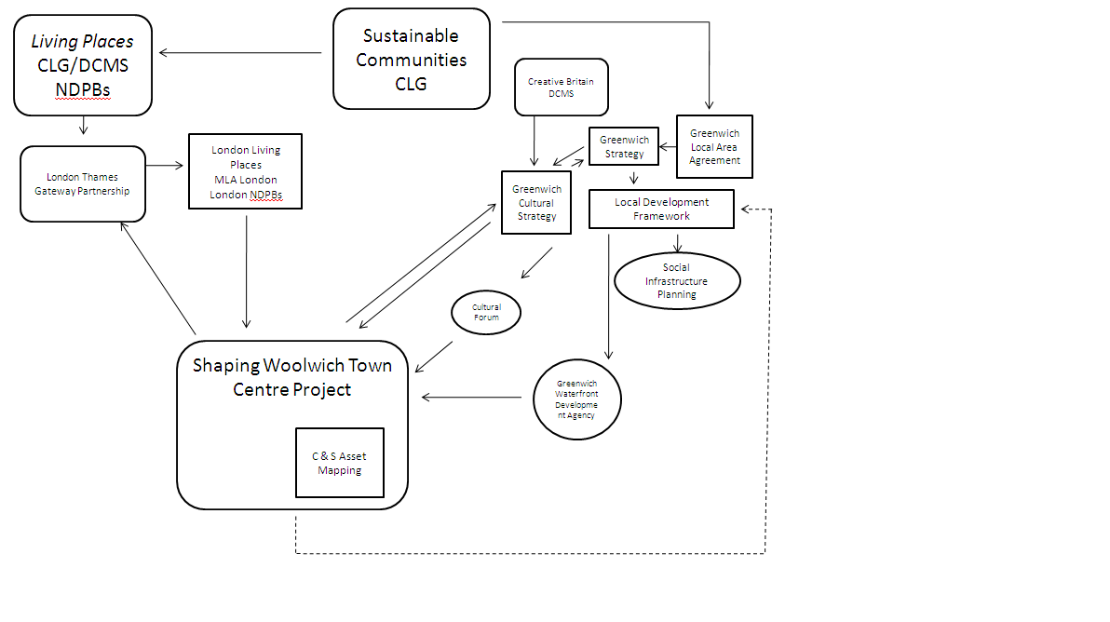
- Evaluation and maintenance
Reviewing and evaluating the mapping project is important to ensure that the outputs are being used effectively and to identify potential improvements to your process.

Evaluation
It is important for users of the toolkit to stand back and critically assess the toolkit process. Through gathering evidence, improvements can be made and challenges identified and resolved. It is recommended that a feedback system is developed as part of the project and that those involved are encouraged to provide feedback at the various stages of the project.

A number of different people need to be involved in providing evidence in evaluation procedures. The users of the data and toolkit need to be consulted to understand any technical and user aspects which are problematic, the creators and those involved in bringing together the data for the mapping need to be consulted to understand any hitches, challenges or barriers. Finally it may also be useful to understand how users who have no familiarity of the mapping process appreciate the outcomes.
The following mechanisms could be used to provide straightforward feedback:

Chart
Produce a visual representation of how the process has gone, demonstrating high points and challenges.

Survey
A survey of map users can be undertaken to understand their experience and to identify concerns that may have arisen.

Open discussions
An open discussion following the mapping can identify any problems which were experienced and allow suggestions for improvements to be made.

Report
In some cases it will be appropriate to produce a more formal review and evaluation of the mapping process.

Evaluation Process
In order to undertake an evaluation, it is recommended that the process outlined in Figure 6 should be followed. This enables an evaluation process that is iterative, reflects upon the process and allows improvements to be incorporated. As such, the process should:

- Establish an evaluation briefing to organise the objectives and aims of the evaluation process. Set out dates and the individuals who need to be consulted to form part of the consultation.

- Set-up consultations or feedback systems to establish any problems or negative assessment that users, producers or output users have encountered.

- Gather evidence from any other sources and organise into categories so that analysis can occur.

- Analyse the evidence to draw conclusions and create actions to be taken forward when the next mapping process occurs. Any changes and modifications to the toolkit process or features of the toolkit need to be incorporated into future mapping projects.

Figure 6: Toolkit evaluation process
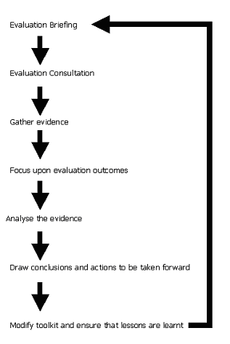

Keeping data ‘live’
It is essential that the data sources used in mapping are kept current. Maintaining the currency ensures accuracy of data and allows users of the toolkit (and its outputs) to access the most up to date information possible. It also ensures that data is less likely to be challenged.

The following table provides a checklist to ensure that data are kept current:

Table 6: Checklist to keep data up to date
Action | Checklist
Run regular checks on the currency of data
Ensure that organisations/websites/data portals have not changed
Out of date information is not used
Ensure that data provided contains date of publication and iteration date
Track new developments in data production
Retain data to provide longitudinal perspective
Any changes to the toolkit and the impacts on data are understood
Ascertain where updates of the data come from

Maintaining the relevance
As the initial requirements of the mapping become outdated, the asset base changes and different agendas are focused upon, it is important that the data and the toolkit remain current. As such, the future of the mapping toolkit and the data collected need to be considered.

It crucial that the C&S asset mapping is not a one off event; updating the map should be undertaken at regular intervals. This ensures that data are kept current and that resources are not wasted.

When looking forward it is important to consider the ownership of the mapping data and the wider data requirements. For example, if the data may become publicly available on the internet then users and owners need to be aware of this.

Wider Uses
It is also possible that in the future, the data from the mapping toolkit are used in wider analysis and research projects. The table below describes some of the data sources that may be used to layer on top of the C&S asset data, to be used in wider research and project work:

Source | Information | Example
Office for National Statistics | The ONS have a wide range of statistics ranging from demographic and social to commercial and business statistics. The wide variety of statistics provides a range of additional inventory information | It is possible that ONS data can be used to understand the correlation between assets and demographics.
Higher Education Statistics Authority (HESA) and The Skills Funding Agency (SFA) Data Service | HESA and The SFA Data Service hold a number of detailed statistics on further and higher education attainment, take-up and destinations. | Educational statistics can help build a picture of the educational attainment in asset catchment areas
Department for Work and Pensions (DWP) | THE DWP have detailed statistics associated with unemployment, claimant counts and labour market activity | It is possible that relationships between unemployment and C&S assets may be investigated through layering the two datasets
National Health Service (NHS) | NHS data holds information on the provision and use of NHS facilities. | There is a possibility to map health indicators and sporting facilities.
Communities and Local Government (CLG) | The CLG holds data on land use, green belts and planning. | It is viable to understand proximity of greenbelts to assets and thereby helping to support protection claims.
Department for Environment, Farming and Rural Affairs (DEFRA) | DEFRA has a wide range of information on farm management, animals, food and farm-gate prices, land management and environmental issues (including pollution) | Information on how assets may ameliorate environmental impact can be gauged from employing both DEFRA and toolkit statistics.
Department for Business, Innovation and Skills (BIS) | BIS has a host of information on business regulation, law, sectors, consumer issues, economics, employment, enterprise, further education and skills, higher education, regional economic development. Statistics and reports are held by BIS and users can access or be signposted to the appropriate area. | It is feasible that layering BIS statistics on top of toolkit outputs can correlate the contribution of C&S assets to a local economy.

Linking to policy/strategy
Once developed it is important that the map is not seen as a static resource with linkage only to the policy drivers that initiated its development. The map will be a ‘live’ resource that can be built on and developed across various remits and it is important that an individual is given the responsibility for maintaining the strategic relevance of the map.

Brokering Links with Others
It is important that links are developed with other partners and stakeholders and that in doing so links are also maintained. As a result of this process it is envisaged that there will be closer collaboration and ties with strategic partners which will benefit future work. The benefits of brokering and maintaining links with others is that knowledge can be shared, trust can be developed and partners can increase the ability to address data problems.

- Appendix

FAQs
I’m trying to add data to the template and I feel it is out of date, what can I do?

To answer this question, a number of issues need to be considered:
- Whether the data is obsolete or has just aged needs to be understood. There is less inconvenience in using data which was generated 2 or 3 years ago compared with data which is 15 years out of date.

- Why the data is out of date also needs to be considered. The data may have been superseded or not available due to the iteration date being infrequent. If it has been superseded, then the latest data set should be used. If the iteration date is close (Next year or month) and the data is crucial to the project then the mapping may be delayed or the data incorporated into the process later on.

It is important to obtain more information about the data source, understand its iteration date or whether it has been superseded. If these steps do not resolve the problem, alternative data need to be sourced. The following steps can help guide you in finding a suitable alternative:

  - Identify the type of data you require
  - Commence desk research to understand if there are official data sources which are comparable (the ONS is a good start) and if not, some desk research on the internet may be required. The potential data source list in section 5 and the Appendix is also a good place to start.
  - Choose a comparable data source and test it,
  - If successful, run toolkit all the way through, if not successful return to stage 2 or 3.

When mapping, I know of an asset that has not been identified in the data, what do I do?

For a number of reasons, assets are not always mapped. Whilst this is frustrating, it is important that the data is recognised in the mapping process. Detailed information is crucial to mapping C&S assets and as a result gaps need to be addressed.

It is possible that other data sources which have not been used in the mapping process may identify it. A short list of data sources may be drawn up and tested to see if there is greater coverage of assets. One way of addressing gaps in data is to use the most robust and geographically detailed resource possible. In many cases, local authorities are the best source of information at this level and the potential sources listed in section 5 will also be able to identify suitable sources which may facilitate the comprehensive mapping which is required.

I would like to know information about an asset but the data source I have chosen does not focus upon a small enough geographic area, what is the alternative?

This is problematic when using secondary data as information is not always is available at a low enough geographic level; as a result alternatives need to be sourced, using the steps outlined above.
Is there is not alternative data available, it is possible that primary research needs to be undertaken to supplement the study and ensure that the objectives and aims of the mapping are met. This may place a significant strain upon resources and time but may ultimately provide the detail required. A decision will therefore need to be made about whether to abandon studying the information that is not available or to use research to supply this information.

The Appendix contains details of questions that may be used in obtaining greater detail (Section 9.6 in the Appendix).

I would like to harvest data from web services using OAI-PMH, do you recommend this?

There are many advantages of using OAI-PMH to export data and in the interests of data availability and access, data which have the capacity to be more approachable and open will help create a more receptive and data friendly environment. However, it is noted that the sources of data which are accessed through OAI-PMH are not always reliable and the open-access nature of the data makes the validity of the data uncertain. It is likely that in the future, an updated C&S mapping toolkit will utilise OAI-PMH more, but currently the narrow coverage of data sources and the questions over validity and reliability makes using exported data a topic for discussion between steering group members.

I have utilised many of the publicly available data sources but I am unsure about using data from private organisations such as TBR and Experian.

Using data from private organisations often entails a cost but there are a number of advantages of using data from private firms that should encourage and provide added value to the toolkit. These datasets are kept up to date and possess inventory data in addition to asset data that can be utilised in the mapping process. This data is available at postcode level, which is valuable when conducting mapping projects. Furthermore, data held by private companies are often able to identify assets that are not always found by publicly available datasets. For example, a wide range of information on private galleries, museums and libraries, which are open to the public, can be found through both TBR and Experian’s datasets.

Where do I begin to start the mapping process?
To start the mapping, it is recommended that you use this guidance document. There are handy templates that accompany the document that can help to develop your mapping successfully.

Detailed guidance on ‘making a start’
Table 7: Before starting, points to consider:
- Resources
It is important to consider the resources available to conduct the physical asset mapping exercise. This guidance aims to reduce the financial and human resource cost of the work by providing the starting point on decision making and tools to help conduct the work.

It is important when undertaking the project that sufficient resources to complete the project are identified and guaranteed at the outset. In identifying whether resources are available, a project plan should be produced and any concerns and risks addressed at the start. This is essential in understanding whether the project is deliverable.

Example:
The pilot studies undertaken for the guidelines considered the resources to be used before undertaking the mapping. It was found that external facilitators were required to undertake some work within the mapping and deadlines could not always be met due to other commitments. Financial and time restrictions can limit the speed in which work can be completed. On commencement of the project, the pilot studies found it useful to pool resources and understand whether external facilitators or consultants are required as part of the process. The planning and budgeting of resources was a key element in addressing cost and time pressures and work around any problems that arose.

- Management
It is important that the mapping process is managed effectively from the start. Ideally a project manager should be identified. The role of the project manager will be to coordinate, lead, deliver and evaluate the project.

It is important that the project has direction and that detailed planning takes place, to ensure that mapping is completed and effectively used.

Example:
The pilot projects benefited from having a clear focus, approachable managers and guidance. The management of the mapping process allowed opportunities and hazards to be identified at an early stage and any issues to be resolved through discussion and open dialogue with partners, team members and stakeholders involved in the process.

- Expertise
Knowledge of the regional or local cultural and sporting sector is an advantage and where possible should be available from the project steering group, or accessible through close project partners. You should also aim to capture diverse views of what constitutes an asset in your project and consider including representatives from the various communities being mapped in your steering group.

You do not need specialist technical expertise to collect physical asset mapping data. At its most basic level ‘mapping’ means collecting and organising information about your physical assets in one dataset. It is recommended that this takes the form of a simple Excel spreadsheet in the first instance.

If you wish to visualise your asset information some expertise in desktop GIS mapping may be required. However, you could also use tables and charts that can be created in Excel and word.

Example:
The pilot studies acknowledged that for some stages of the mapping process, team members with expertise and specialist skills will be required. Having GIS proficiencies are particularly important in displaying data visually and the pilot studies were able to draw upon specific members of their teams or include associate organisations to support this stage of the process.

- Strategic use and goals
Those involved in the project are required to understand the strategic use of outputs. There needs to be a detailed understanding of why the culture and sport physical asset mapping is necessary and the goals and rationale for undertaking it. There should be clear strategic objectives for the use of the data across the steering group.

Example:
On top of understanding policy background, there are also other strategic uses and motivations for undertaking the mapping process. The pilot projects identified a number of strategic uses associated with the policy background. These included a number of supplementary strategic uses, such as supporting departmental work, wider organisational requirements for evidence upon which decisions can be made and the need to tie C&S mapping in and overlap evidence with other information resources. Motivations are often linked to the uses and can be more varied than the policy backgrounds. Some of the motivations for the projects being undertaken include increasing cooperation, encouraging dialogue, assisting future work and improving team understanding of a previously unfamiliar area.

- Policy context
It is also important to understand the policy context for undertaking the mapping. The ‘Why create a toolkit to map these?’ section of this document (page 8) provides the national policy context regarding the development of data of this kind. However, there is also a requirement for the map to be located in a regional and local policy context.

Example:
Examples of the policy backgrounds considered for each project are provided in section 9.2, page 45. The pilot studies all had a clear understanding of the policy background and communicated this to steering group members and other stakeholders.

- Aims and objectives
Those undertaking the project must have a complete understanding of the aims and objectives that underpin the mapping process. Clarity on these will help guide the toolkit process and ensure that users are confident about the outcomes of the project. It is important that those involved in the toolkit have a common goal that is driving the project.

The steering group may wish to engage with a broader group of stakeholders and partners in order to facilitate the identification of shared objectives and potential wider usages of the data.

Example:
The pilot studies undertook their mapping with overarching aims and objectives. Some of these aims and objectives include wider organisational goals and some are more specific. Objectives were established to ensure the aims were met, a plan was developed from these aims and objectives to help work occur efficiently.

- Data availability
The availability of data may, to a certain extent, drive the nature of the project. Understanding the range of data the project currently has access to from across the steering group is a good starting point to consider the level of additional data that may be required. If data are not available, then an iterative process needs to occur to help address and fill gaps in data. Gaps are to be anticipated and are part of the mapping process. It is therefore important to try and obtain broad coverage with the data sources you use and then fill in the gaps resulting from this. Primary data collection may be required to collect data that is not available.

Example:
Each of the pilot studies investigated the available data and assessed the characteristics of the datasets in order to understand which would be most useful. The data were discussed with steering group members and those familiar with the data, enabling the most appropriate and valuable ones to be identified. The pilot studies found that an understanding of the data available supports the mapping process by helping to obtain the most useful and relevant information about assets and reducing time spent on using ineffective data. This may require calling on the expertise of colleagues outside of the steering group.

- Ensuring sustainable mapping
It is important to ensure that there is a forward plan for the ‘life’ and maintenance of the map once the initial project has been delivered. Consideration should be given to how the map will be updated when planning the project.

Example:
The pilot projects intend to use the mapping project over the long term, this will require information which is held on C&S assets to be updated in the future. Maintaining the data ensures currency of information and present opportunities for future work to be fed into or overlaid on the mapping outputs.

Pilot project policy background

Example from One North East
What national (and regional) policy forms the background to the mapping process?
The Local Democracy, Economic Development and Construction Act gives local authorities and regional development agencies (RDAs) a joint responsibility for developing, monitoring and implementing a new strategy for the regions.

This new strategy will have to include details of how the regional economy plans to grow and how the region will contribute to national targets. The mapping will contribute by providing details on:
- Opportunities and challenges over the strategy period.
- Plans to improve economic performance in a sustainable way.
- Priorities for enhancing built and natural environments.
- Regional priorities for investment.

What links are there with current policy at the geographic level which is being studied?
The North East Strategy (NES) is the main driver behind the mapping process. Throughout the process it has become clear that there is a requirement for standard and accessible data on assets in the Region. The NES requires an evidence body from which mapping can inform debate and policy direction. There are also linkages to statutes on preservation and

What are the aims and requirements of the policies behind the policy mapping?
The NES requires a robust evidence base, which in turn can support:
- Future targeted investment and decision making (particularly in relation to cross boundary and cross agency working)
- Inform prioritisation of activity for joint cross sector actions
- Begin to highlight opportunities where the cultural sector is well placed to support regional economic and social development activities

Are any specific outputs required directly linked to these aims?
As a requirement of the policy background to this project, there needs to be a consideration of the link that assets have with tourism and the visitor economy across the region. Any information gaps in the datasets for cultural and tourism assets need to be identified.
How will the outcomes of the mapping project contribute to the policy aims and objectives?
The mapping project will help identify areas for cross analysis based on themes within the NES such as Culture & Health; Culture and Creativity/Education; and in doing so support strategic decision making in relation to the visitor economy. It will do this by:
- Create a series of visual and spatial representations of North East England’s culture and tourism assets and provision
- Create a series of visual and spatial representations of the use of the region’s culture and tourism assets and provision (based on existing data)

What savings will be made and how will they contribute to the reducing financial pressures?
The mapping project reduces the amount of time that the agency has to spend on gathering information. It provides a central reference point for information about C&S activities and reduces the reliance on external facilitators
Are there similar projects and policy initiatives that the mapping can feed into?
This project is also important in tackling the NES themes of environmental quality and quality of place, whilst also feeding into wider organisational focus upon the visitor economy.

Example from CultureMap
What national (and regional) policy forms the background to the mapping process?
CultureMap is a pilot project, funded by Arts Council (London) and underpinned by research commissioned by the GLA in 2004. In the absence of co-ordinated data on cultural venues and potential audiences, it was developed by AL as a regional resource for those undertaking cultural planning and audience development in local authorities, cultural agencies and in individual venues. It has over 400 registered users in a wide variety of national, regional and local cultural agencies and organisations, local authorities and educational establishments. Data and analysis are visualised for London as whole and for 4 sub regions. London Thames Gateway boroughs are covered by viewing the individual authorities in the London Thames Gateway partnership, or by selecting the London East sub region.

What links are there with current policy at the geographic level which is being studied?
In a user survey of CultureMap, users in the London Thames Gateway boroughs identified activities related to the Cultural Olympiad and the Olympic legacy as particularly important. They also note the changed policy emphasis of the Mayor’s Cultural Strategy. This underscores a decentralised approach, suggesting increased awareness of, and tacit support for, cultural assets in the outer London boroughs.

Cultural Metropolis – The Mayor's Priorities for Culture 2009-2012
- Maintain London’s position as a world centre of cultural Excellence
- World-class culture for 2012 and beyond
- Strengthen arts and music education for young people
- Increase access and participation
- Improve provision in outer boroughs
- Develop pathways for new talent
- Create a lively public realm
- Support grassroots culture
- Promote London
- Develop targeted support for the creative industries
- Champion the role of culture in the built environment
- Improve government support for culture in London

In addition some users identified the London Thames Gateway Delivery Strategy as key particularly the emphasis on housing growth. The London Thames Gateway Partnership – Placemaking Principles (2009) include:
- The demands of climate change must drive the development of London Thames Gateway.
- London Thames Gateway must be built on a sustained commitment to quality.
- The success of Thames Gateway rests on the power to work together and independently to achieve change.
- The communities of London Thames Gateway must be able to live together well.
- London Thames Gateway must belong to its citizens.
- London Thames Gateway is defined by its connections.

“Housing alone, whatever the quality, does not deliver liveable places. Evidence confirms that successful places require a multi faceted approach which responds to local context and meaning. Placemaking is where the delivery of ‘hard’ infrastructure meets appropriate social and cultural assets and which provides the basis for a co-ordinated and timely approach to the delivery of what localities need. There are opportunities to get the delivery of social and cultural utilities right at the outset to avoid costly retrofitting. Placemaking requires that we stop divorcing communities from the services and facilities that should support them. Above all we need to remember that the successful places we have up and down the country have only become successful over time.” (LTGP)

Are there similar projects and policy initiatives that the mapping can feed into?
In a survey of CultureMap London users, it was found that this resource was used primarily to locate local arts and cultural development activities or audience development within the wider social and economic context – accessing information on deprivation, population composition and audience penetration. In Thames Gateway this enabled some Local Authority arts officers and policy officers in arts organisations to make a stronger case for supporting cultural organisations and for developing activities related to regeneration.

What information will be required as a result of the policy background?
Need for greater integration of cultural asset data with data on audiences, segmentation, participation, wider geo-demographic analysis and venue accessibility. As CultureMap London acknowledges, most of the data they bring together are available elsewhere. However their integrated use is poorly developed. Detailed local analysis in Thames Gateway is hindered however by the choice of postcode as the location data included in the CultureMap database. While this is appropriate for regional and sub-regional analysis it is inadequate for more fine grain local analysis where building level data are required.
What are the aims and requirements of the policy that underlie and complement the policy mapping?
Users are accessing CultureMap to support policy arguments for cultural development and resource investment and to position local resources in relation to the regional offer. Given the development objectives of Thames Gateway, CultureMap is able to enhance the promotion of cultural development in sub regional regeneration strategies.
How will the outcomes of the mapping project contribute to the policy aims and objectives?
CultureMap visualises and overlays data about cultural provision in London and data about users and audiences, all linked to maps showing the city’s travel infrastructure and population. Much of this information is already available through different sources, but it’s not joined up and not easily accessed. CultureMap changes that and makes it easy to see how provision, users and infrastructure are inter-related.

It is possible to view provision and audiences as they are distributed across the city as a whole, or to focus on a particular sub-region, borough or ward. The data can be viewed from a range of perspectives: the distribution of certain kinds of provision, or types of audiences, related to demographic information. This helps to understand who uses cultural services - and to target those that don’t. The hope is that CultureMap enables partners to talk to each other more effectively.
As a tool it aims to inform decision-making in cultural and organisational planning and to provide useful headlines that can help build the case for culture in London.

CultureMap is being designed with the interests of cultural policy-makers and cultural providers in mind. One of its unique characteristics is that it benefits local authorities, funding and planning agencies and individual organisations alike.

What savings will be made and how will they contribute to the reducing financial pressures?
CultureMap London as applied in Thames Gateway significantly reduced the initial cost of scoping cultural infrastructure for policy purposes. However without access to the underlying dataset of individual assets and organisations, its cost reduction potential for full mapping studies is limited.

London Living Places - Shaping Woolwich Town Centre through Culture
What national (and regional) policy forms the background to the mapping process?
Living Places (2007) is a national initiative supported by DCMS, CLG and HCA and developed in the context of the national Sustainable Communities Plan (2003) to ensure that all communities, particularly those experiencing housing-led growth and regeneration, benefit from cultural and sporting opportunities. Its aim is to embed culture and sport in place shaping alongside other key areas of social infrastructure provision such as education, healthcare and transport. London Living Places, a consortium of cultural agencies, local government and regeneration companies, is taking forward this strategy to locate culture and sport at the heart of the London’s regeneration. Shaping Places in London Through Culture (GLA 2009) endorses this approach for London as a whole and London Thames Gateway in particular, through an integrated approach to planning for cultural development.

Asset mapping in Woolwich is a key element of this integrated planning approach. It identifies:
- Current cultural and sporting offer
- Gaps in existing sports and cultural infrastructure
- Future needs for planned and project housing and population growth
- Places the physical asset in wider cultural and sports context
- Basis of future scenarios for promoting the role of culture and sport in the area

What links are there with current policy at the geographic level which is being studied?
The identification of Woolwich as a priority place for place shaping within the regeneration of Thames Gateway coincided with a planned revision of Making Culture Matter: A Cultural Strategy for Greenwich (during 2010) and preparation of the Local Development Framework for Greenwich (2008-2010). The Shaping Woolwich Town Centre through Culture project is critically important in supporting the integration of the two areas of policy development. The local policy context is framed by The Greenwich Strategy 2006 2015 (Sustainable Communities Strategy, (2008) and the Greenwich Local Area Agreement (2008 – 2011).

Are there similar projects and policy initiatives that the mapping can feed into?
The Greenwich Waterfront Development Agency is responsible for regeneration projects in an area from Greenwich Peninsula to Thamesmead (including Woolwich) and will benefit from this project. The Building Schools for the Future Programme includes a modernisation programme to enhance facilities for wider community use and an improvement initiative for sports / arts specialist schools including Crown Woods (2012 Olympic training venue), Thomas Tallis and Plumstead Manor secondary schools. The project will both reflect and feed back to this programme.

What information will be required as a result of the policy background?
The key policy driver for Woolwich is housing led growth. Data on housing development sites, project household and population structure is therefore critical to understanding future demands on culture and sports assets.

However increasing day visitors, drawn east from Greenwich town centre is also important. Understanding the geographical clustering of potential visitor attractions is important.

The project has included creative and cultural industries in its data capture – separate from the asset mapping - and has identified Woolwich as a centre for cultural production and making as a possible focus for the revised Greenwich Cultural Strategy.

Asset mapping has shown up several gaps in cultural provision including places for live performance and exhibition in the town centre. Information on current and potential audiences would be an advantage.

What are the aims and requirements of the policy that underlie and complement the policy mapping?
- Position Woolwich within London's network of town centres and world city context, as strategic location for the nighttime economy and retail centre.
- Develop Woolwich’s sense of place and local identity within the capital.
- Support and enhance the competitiveness, quality and diversity of town centre retail, leisure and other consumer services
- Assess of cultural and sporting infrastructure needs linked to housing growth
- Expand and strengthened the tourism sector across the Greenwich.
- Provide an Excellent cultural offer to visitors and residents alike
- Enhance access and use of the river, walking and cycling routes, and SE London Green Chain /Green Grid.
- Increase cultural tourism by 10%
- Establish a vibrant and creative community arts and extended schools programme in all schools
- Develop libraries to provide a range of free internet and digital services, increasing usage by a third.
- Promoting the historical cultural heritage of Greenwich. Building on investment in the Woolwich Heritage Quarter (Firepower and Heritage Centre).
- Attract Major Sports Competition to Olympic Venues (outside of the Games period).
How will the outcomes of the mapping project contribute to the policy aims and objectives?
Mapping of assets and related attributes of Woolwich is underpinning ‘masterplanning scenarios’ for cultural and sports infrastructure development to be included in the Cultural Strategy and to be shared with the LDF policy development.

Databases of assets, organisations and of creative industries will provide a resource for sharing with policy officers in a number of LA departments.

Development of static maps into an interacvtive resource is being considered as a part of developing web based resources to promote arts and cultural activity in Woolwich and Greenwich.
What savings will be made and how will they contribute to the reducing financial pressures?

This mapping exercise would not have taken place without the intervention of London Living Places. This regional initiative, based on national investment, has absorbed the majority of the financial cost for external consultants. The opportunity cost for Greenwich has been the brokerage of a stronger link between cultural and spatial planning. Greenwich has benefited from external funding for this project and will have gained an asset archive and GIS mapping which can be easily updated. This offers an inital saving of £20k in the medium term. However the biggest benefit is the assembly of a rich source of evidence for future decision making in planning culture and leisure resources and potential to aid spatial planning policy.

Data sources
Table 8: Data sources
These are the core data sets that are recommended for use in the tool kit modelling. A number of additional

Name | Arts | Sports | Museums, Libraries and Archives | Heritage | Data owner | Data access | Tel | Email | Web | Format of data
Experian National Business Data | x |  | x | x | Experian | To access data, Experian Business Information need to be contacted. | 08700 12 11 11 | business2business@uk.experian.com | http://www.experian.co.uk/www/pages/what_we_offer/products/business_lists.html | CSV files
Point X National Points of Interest | x | x | x | x | Point X | To access the Point X data, Ordnance Survey need to be contacted. Ordnance Survey’s contact details are: | 023 8030 5030 | customerservices@ordnancesurvey.co.uk | http://www.pointx.co.uk/ | Delimited Text File
OS Master Map | x | x | x | x | Ordnance Survey | Purchase from Ordnance survey | 023 8030 5520 | DigitalSalesEnquiries@ordnancesurvey.co.uk | http://www.ordnancesurvey.co.uk/oswebsite/products/osmastermap/layers/addresslayer2/ | CSV
Trends Central Resource | x | x | x | x | TBR (Trends Business Research) | Contact Trends Business Research. | 0191 279 0900 | info@tbr.co.uk | http://www.tbr.co.uk/ | CSV, XLS, Access, SQL
Sports England |  | x |  |  | Active Places Database | To access Active Places, contact: | 0207 2731578 | Nick.Evans@sportengland.org | http://www.activeplacespower.com/ | CSV, XLS
Culture Grid |  |  | x |  | Collections Trust | Web Service coming online in May/June 2010. | 0207 022 1889 | office@collectionstrust.org.uk | http://www.collectionstrust.org.uk/culturegrid | OAI-PMH web service initially, potential to be available in CSV.
English Heritage |  |  |  | x | National Monument Record | Data is available to download. | 01793 414718 | nmrinfo@english-heritage.org.uk | http://services.english-heritage.org.uk/NMRDataDownload/ | GIS SHP File
Natural England |  |  |  | x | Natural England Datasets | Data available from Natural England to download. | 0845 600 3078 | enquiries@naturalengland.org.uk | http://www.gis.naturalengland.org.uk/pubs/gis/GIS_register.asp | GIS SHP File
Natural England |  |  |  | x | Natural England Datasets | Data available from Natural England to download. | 0845 600 3078 | enquiries@naturalengland.org.uk | http://www.gis.naturalengland.org.uk/pubs/gis/GIS_register.asp | GIS SHP File
Natural England |  |  |  | x | Natural England Datasets | Data available from Natural England to download. | 0845 600 3078 | enquiries@naturalengland.org.uk | http://www.gis.naturalengland.org.uk/pubs/gis/GIS_register.asp | GIS SHP File

Additional data sources
In addition to the core data sources there are a number of sources which may be used to provide further depth and additional information to the mapping process.
Table 9: Additional data sources
Name | Arts | Sports | Museums, Libraries and Archives | Heritage | Data owner | Data access | Web
CASE Regional Insights | x | x | x | x | DCMS | Excel spreadsheets available to download from website | http://www.culture.gov.uk/what_we_do/research_and_statistics/5698.aspx
Visit England | x | x | x | x | Visit England | Reports available to download, Contact organisation to access raw data | http://www.visitbritain.org/
Arts Council England: funding | x |  | x |  | Arts Council UK | Reports and data available to download, Contact organisation to access raw data | http://www.artscouncil.org.uk/
Magic |  |  | x | x | DEFRA (Custodian) | GIS datasets available to download form website | http://www.magic.gov.uk/#
Arch Search |  |  |  | x | University of York | OAI-PMH, contact for raw data | http://ads.ahds.ac.uk/
Pastscaoe |  |  |  | x | English Heritage | Available to download, Contact organisation to access raw data | http://www.pastscape.org.uk/
CIPFA |  |  | x |  | Chartered Institute of Public Finance and Accountancy | Contact organisation to access data (CVS, XLS files) | http://www.cipfa.org.uk/
Parks and Gardens UK |  | x |  | x | University of York | Contact organisation to access data (CSV or SQL) | http://www.parksandgardens.ac.uk
World Heritage |  |  | x | x | Unesco | Available from website | http://www.unesco.org.uk/
Natural England |  |  |  | x | Natural England | Data available to download from website | http://www.naturalengland.org.uk/
Culture 24 | x |  |  |  | Culture 24 | OAI-PMH or Text, contact for raw data | http://www.culture24.org.uk/
Museum Yearbook |  |  | x |  | Museum Association | Available to purchase from website | http://www.museumsassociation.org/publications/yearbook

Sample questions for use in primary research
The following questions come from a questionnaire on the cultural activity within a Local Authority. These questions will need to modified for your primary data collection. Other areas of data that may need to be collected include information on the activities that occur at an asset, facilities (toilets, cafes, crèches), size of buildings, other uses, usage and users (demographics, numbers, residence), hours of opening, access and partnerships.

A. General Venue Information
A1. Name of venue/facility
A2. Street number
A3. Street name
A4. Full postcode
A5. Phone number
A6. Website address
A7. General information email
A8. Please could you indicate whether your tenure arrangement is:
A9. Name of principal management organisation/venue operator
A10. Please provide the contact email of a director, chief executive or principal manager

B. General Provision at the Venue
B1. What is the total overall size of the venue in square metres ? You will be asked for individual space
sizes in section C.
B2. How many public car parking spaces does the venue have on site ?
B3. Is there other car parking nearby that can be accessed?
B4. Can you give an estimate of the number of car parking spaces nearby?
B5. How many cycle parking spaces does the venue have on site/adjacent to the venue ?
B6. Is there space for coach parking on site or adjacent to the venue?
B7. Please state roads where coach parking is available?
B8. Please indicate the aspects of the venue that comply with Disability Discrimination Act (DDA)
requirements:
B9. Does the venue hold a premises licence for:
B10. What is the annual turnover (i.e gross income generated) of the venue?
B11. Does the venue/main organisation provide space or services in kind (i.e. achieving social/cultural
benefit rather than income)?

C. Types of Space
C1. Which of these spaces does the venue have?
How many of each of these spaces does the venue have ?
C2. Number of Art Gallery Spaces
C3. Number of Theatre Spaces
C4. Number of Exhibition Spaces
C5. Number of Libraries
C6. Number of Archives
C7. Number of Cinemas
C8. Number of Multi-Purpose Arts Spaces
C9. Number of Rehearsal Rooms
C10. Number of Artists Studios
C11. Number of Production Spaces or Workshops
C12. Number of Media and Digital Studios
C13. Number of Education, Learning Spaces and Classrooms
C14. Number of Meeting Rooms
C15. Number of Function Rooms
C16. Number of Foyer / Reception Spaces
C17. Number of Bars / Cafes
C18. Number of Crèches
C19. Number of Specialist Storage Spaces
C20. Number of Other Spaces Supporting Cultural Activity

TBR is the trading name of Trends Business Research Ltd
Cities Institute, London Metropolitan University
A Standard Charge calculates potential developer contributions as part of Section 106 (’Planning Gain’) agreements and the area based Community Infrastructure Levy. The financial charge for the developer uses a national benchmark for each person expected in a new housing development. The charges are based upon average cost and space estimates for library, archive and museum provision and arts venues. Standard Charge guidance has been developed by the MLA and ACE as part of the Living Places ‘Culture & Sport Planning Toolkit’ - see ‘Public Libraries, Archives and New Development: A standard charge approach’ and ‘Arts and Museums and New Development: A Standard Charge Approach’ : http://living-places.org.uk/culture-and-sport-planning-toolkit/tools-and-guidance/museums-libraries-and-archives-council.html?0=
The C&S Physical Asset Mapping Toolkit fulfils a vital requirement of the Living Places C&S Planning Toolkit, in particular Stage 3: Needs and Provision Assessment and the audit of local provision (www.living-places.org.uk/).
http://www.culture.gov.uk/what_we_do/research_and_statistics/4824.aspx
DCMS (1999) Local Cultural Strategies: Draft Guidance for Local Authorities in England
Audit Commission (2006) Public sports and recreation services: Making them fit for the future
NB. By June 2012 all RDAs will have been abolished and replaced with Local Enterprise Partnerships. As such arrangements for provision of regional information are subject to change.
For an explanation of ACE Segmentation analysis and a ward level data download see http://www.artscouncil.org.uk/about-us/research/arts-based-segmentation-research/about-research/. For Sport England Segmentation analysis see http://www.sportengland.org/research/market_segmentation.aspx
For an explanation of ACE Segmentation analysis and a ward level data download see http://www.artscouncil.org.uk/about-us/research/arts-based-segmentation-research/about-research/. For Sport England Segmentation analysis see http://www.sportengland.org/research/market_segmentation.aspx
http://www.culturemaplondon.org/
Open Archives Initiative Protocol for Metadata Harvesting, see http://www.openarchives.org/

