Title:  Fuel Quality Directive  Lead department or agency:  Department for Transport  Other departments or agencies:
  Impact Assessment (IA)
  IA No: DFT00048
  Date: 10/03/2011
  Stage: Consultation
  Source of intervention: EU
  Type of measure:
  Contact for enquiries:
  Craig Mills
  craig.mills@dft.gsi.gov.uk

Summary: Intervention and Options

What is the problem under consideration? Why is government intervention necessary?
Transport greenhouse gas (GHG) emissions impose a significant external cost that is not reflected in the market price of transport. In particular, fuel suppliers have little incentive to deliver GHG savings through lower emission renewable fuels such as biofuels, at least in the near term, due to their relatively higher costs compared to fossil fuels. Cost differentials are driven primarily by the relative maturity and costs in the different fuels markets, infrastructure requirements etc. Government intervention will therefore be required to meet the Fuel Quality Directive target which requires at least a 6% reduction in lifecycle GHG emissions from the inland surface transport sector by 2020.

What are the policy objectives and the intended effects?
The objective of the policy is for fuel suppliers to deliver a minimum of 6% lifecycle GHG savings in the transport sector. This can be achieved through the supply of biofuel, a change in the fossil fuel mix to less polluting fossil fuels, improvements to fossil fuel extraction/refining processes or increased use of electricity in the transport sector. Given the competitive nature of the fuel market, the cost of delivering these measures is expected to be passed through to final consumers of fossil transport fuel. We do not intend to implement this Directive beyond the minimum requirements.

What policy options have been considered? Please justify preferred option (further details in Evidence Base)
3 potential approaches have been considered for implementation of the Fuel Quality Directive:
A) Do nothing (baseline)
B) Put in place a 6% 2020 GHG savings target with a trajectory of annual targets leading up to 2020 (various targets and trajectories have been considered - options 1 to 5).
C) Put in place a 6% 2020 GHG savings target but delay determining what future steps to take until further evidence on sustainability and deployment issues can be gathered (option 6).

Approach C (option 6) is preferred given the substantial uncertainties and risks around sustainability issues associated with increased deployment of 1st generation crop derived biofuels and the need for further research around implementation options for supplying biofuel in excess of the "blend wall".

When will the policy be reviewed to establish its impact and the extent to which the policy objectives have been achieved? | It be reviewed  04/2014
Are there arrangements in place that will allow a systematic collection of monitoring information for future policy review?

Sign-off For consultation stage Impact Assessments:
I have read the Impact Assessment and I am satisfied that, given the available evidence, it represents a reasonable view of the likely costs, benefits and impact of the leading options.
Signed by the responsible Minister:  Date: 17/02/11

Summary: Analysis and Evidence Policy Option 1
Description:
Put in place a 2020 6% GHG reduction target with a linear trajectory of annual targets from 2017 to 2020
Price Base Year 2010 | PV Base Year 2010 | Time Period Years 20 | Net Benefit (Present Value (PV)) (£m)
Price Base Year 2010 | PV Base Year 2010 | Time Period Years 20 | Low: -1,345 | High: -4,720 | Best Estimate: -2,853

COSTS (£m) | Total Transition  (Constant Price) Years |  | Average Annual  (excl. Transition) (Constant Price) | Total Cost  (Present Value)
Low | 285 | 10 | 289 | 5,779
High | 285 | 10 | 633 | 12,658
Best Estimate | 285 | 10 | 445 | 8,895
Description and scale of key monetised costs by ‘main affected groups’
Monetised costs capture the cost of delivering GHG savings (primarily through the supply of biofuel). These costs are incurred by obligated suppliers (e.g. suppliers of inland surface transport fuel), representing the net cost to business, and are assumed to be passed through 100% to final consumers of inland surface transport fuel given the competitive nature of the fuel market. Other costs included are the administrative costs and relevant infrastructure costs, which are borne by fuel suppliers.
Other key non-monetised costs by ‘main affected groups’
Costs related to the introduction of biofuel "high blend" fuel streams - e.g. supply infrastructure, changes to the vehicle fleet and overcoming consumer preference barriers - have not been quantified due to the lack of available evidence. These costs would be borne primarily by the final consumers of transport fuel. The economy-wide cost of potential increased food prices as a result of increased demand for agricultural feedstocks has not been quantified due to the significant uncertainty and lack of available evidence.
BENEFITS (£m) | Total Transition  (Constant Price) Years |  | Average Annual  (excl. Transition) (Constant Price) | Total Benefit  (Present Value)
Low | n/a |  | 222 | 4,433
High | n/a |  | 400 | 7,938
Best Estimate | n/a |  | 302 | 6,041
Description and scale of key monetised benefits by ‘main affected groups’
Monetised benefits include CO2 savings, air quality impacts, noise impacts, congestion impacts and road traffic accident impacts. These benefits are likely to benefit the wider society which includes a general benefit from reduced GHG emissions and improved air quality, but also road users due to improved travel conditions.
Other key non-monetised benefits by ‘main affected groups’
Non-monetised benefits include GDP effects of potential growth in UK biofuel industry; innovation spillovers from the development of different sectors of the fuel market and associated technologies; and potential benefits to the country from energy security owing to the wider diversity in fuel sources
Key assumptions/sensitivities/risks Discount rate (%) |  |  |  |  | 3.5
There are significant uncertainties around many of the key assumptions of this analysis including: the cost differential between supplying fossil fuel and biofuel (i.e. the future costs of supplying each form of fuel and how they vary over time); the level of GHG savings delivered from the supply of various biofuels; the level of travel demand and hence fuel demand in the future; and the value placed on GHG savings. These uncertainties have been addressed using sensitivity tests where possible. Of note are the very significant uncertainties and risks around the sustainability of biofuels and deployment issues - various scenarios have therefore been explored for trajectories of uptake to reflect this. Committing to one trajectory before this information is clearer has significant risks, hence option 6 is explored.

Impact on admin burden (AB) (£m): |  |  | Impact on policy cost savings (£m): | In scope
New AB: | AB savings: | Net: n/a | Policy cost savings: n/a

Enforcement, Implementation and Wider Impacts
What is the geographic coverage of the policy/option?
From what date will the policy be implemented? |  |  | 15/12/2011
Which organisation(s) will enforce the policy? |  |  | DfT
What is the annual change in enforcement cost (£m)? |  |  | 0
Does enforcement comply with Hampton principles?
Does implementation go beyond minimum EU requirements?
What is the CO₂ equivalent change in greenhouse gas emissions?  (Million tonnes CO₂ equivalent) |  |  | Traded:  15 |  | Non-traded:  -110
Does the proposal have an impact on competition?
What proportion (%) of Total PV costs/benefits is directly attributable to primary legislation, if applicable? |  |  | Costs:  100 |  |  | Benefits:  100
Annual cost (£m) per organisation  (excl. Transition) (Constant Price) | Micro | < 20 | Small | Medium |  |  | Large
Are any of these organisations exempt?

Specific Impact Tests: Checklist
Set out in the table below where information on any SITs undertaken as part of the analysis of the policy options can be found in the evidence base. For guidance on how to complete each test, double-click on the link for the guidance provided by the relevant department.
Please note this checklist is not intended to list each and every statutory consideration that departments should take into account when deciding which policy option to follow. It is the responsibility of departments to make sure that their duties are complied with.
Does your policy option/proposal have an impact on…? | Impact | Page ref within IA
Statutory equality duties |  | 57

Economic impacts
Competition |  | 55
Small firms |  | 56

Environmental impacts
Greenhouse gas assessment |  | 44
Wider environmental issues

Social impacts
Health and well-being
Human rights
Justice system
Rural proofing |  | 57

Sustainable development |  | 57

Summary: Analysis and Evidence Policy Option 2
Description:
Put in place a 2020 6% GHG reduction target with a linear trajectory of annual targets from 2014 to 2020
Price Base Year 2010 | PV Base Year 2010 | Time Period Years 20 | Net Benefit (Present Value (PV)) (£m)
Price Base Year 2010 | PV Base Year 2010 | Time Period Years 20 | Low: --1,677 | High: -5,453 | Best Estimate: -3,529

COSTS (£m) | Total Transition  (Constant Price) Years |  | Average Annual  (excl. Transition) (Constant Price) | Total Cost  (Present Value)
Low | 285 | 10 | 339 | 6,777
High | 285 | 10 | 725 | 14,493
Best Estimate | 285 | 10 | 523 | 10,473
Description and scale of key monetised costs by ‘main affected groups’
Monetised costs capture the cost of delivering GHG savings (primarily through the supply of biofuel). These costs are incurred by obligated suppliers (e.g. suppliers of inland surface transport fuel), representing the net cost to business, and are assumed to be passed through 100% to final consumers of inland surface transport fuel given the competitive nature of the fuel market. Other costs included are the administrative costs and relevant infrastructure costs, which are borne by fuel suppliers.
Other key non-monetised costs by ‘main affected groups’
Costs related to the introduction of biofuel "high blend" fuel streams - e.g. supply infrastructure, changes to the vehicle fleet and overcoming consumer preference barriers - have not been quantified due to the lack of available evidence. These costs would be borne primarily by the final consumers of transport fuel. The economy-wide cost of potential increased food prices as a result of increased demand for agricultural feedstocks has not been quantified due to the significant uncertainty and lack of available evidence.
BENEFITS (£m) | Total Transition  (Constant Price) Years |  | Average Annual  (excl. Transition) (Constant Price) | Total Benefit  (Present Value)
Low | n/a |  | 255 | 5,101
High | n/a |  | 452 | 9,040
Best Estimate | n/a |  | 347 | 6,944
Description and scale of key monetised benefits by ‘main affected groups’
Monetised benefits include CO2 savings, air quality impacts, noise impacts, congestion impacts and road traffic accident impacts. These benefits are likely to benefit the wider society which includes a general benefit from reduced GHG emissions and improved air quality, but also road users due to improved travel conditions.
Other key non-monetised benefits by ‘main affected groups’
Non-monetised benefits include GDP effects of potential growth in UK biofuel industry; innovation spillovers from the development of different sectors of the fuel market and associated technologies; and potential benefits to the country from energy security owing to the wider diversity in fuel sources
Key assumptions/sensitivities/risks Discount rate (%) |  |  |  |  | 3.5
There are significant uncertainties around many of the key assumptions of this analysis including: the cost differential between supplying fossil fuel and biofuel (i.e. the future costs of supplying each form of fuel and how they vary over time); the level of GHG savings delivered from the supply of various biofuels; the level of travel demand and hence fuel demand in the future; and the value placed on GHG savings. These uncertainties have been addressed using sensitivity tests where possible. Of note are the very significant uncertainties and risks around the sustainability of biofuels and deployment issues - various scenarios have therefore been explored for trajectories of uptake to reflect this. Committing to one trajectory before this information is clearer has significant risks, hence option 6 is explored.

Impact on admin burden (AB) (£m): |  |  | Impact on policy cost savings (£m): | In scope
New AB: | AB savings: | Net: n/a | Policy cost savings: n/a

Enforcement, Implementation and Wider Impacts
What is the geographic coverage of the policy/option?
From what date will the policy be implemented? |  |  | 15/12/2011
Which organisation(s) will enforce the policy? |  |  | DfT
What is the annual change in enforcement cost (£m)? |  |  | 0
Does enforcement comply with Hampton principles?
Does implementation go beyond minimum EU requirements?
What is the CO₂ equivalent change in greenhouse gas emissions?  (Million tonnes CO₂ equivalent) |  |  | Traded:  17 |  | Non-traded:  -124
Does the proposal have an impact on competition?
What proportion (%) of Total PV costs/benefits is directly attributable to primary legislation, if applicable? |  |  | Costs:  100 |  |  | Benefits:  100
Annual cost (£m) per organisation  (excl. Transition) (Constant Price) | Micro | < 20 | Small | Medium |  |  | Large
Are any of these organisations exempt?

Specific Impact Tests: Checklist
Set out in the table below where information on any SITs undertaken as part of the analysis of the policy options can be found in the evidence base. For guidance on how to complete each test, double-click on the link for the guidance provided by the relevant department.
Please note this checklist is not intended to list each and every statutory consideration that departments should take into account when deciding which policy option to follow. It is the responsibility of departments to make sure that their duties are complied with.
Does your policy option/proposal have an impact on…? | Impact | Page ref within IA
Statutory equality duties |  | 57

Economic impacts
Competition |  | 55
Small firms |  | 56

Environmental impacts
Greenhouse gas assessment |  | 44
Wider environmental issues

Social impacts
Health and well-being
Human rights
Justice system
Rural proofing |  | 57

Sustainable development |  | 57

Summary: Analysis and Evidence Policy Option 3
Description:
Put in place a 2020 6% GHG reduction target with a stretching trajectory of annual targets from 2014 to 2020
Price Base Year 2010 | PV Base Year 2010 | Time Period Years 20 | Net Benefit (Present Value (PV)) (£m)
Price Base Year 2010 | PV Base Year 2010 | Time Period Years 20 | Low: -1,782 | High: -5,974 | Best Estimate: -3,843

COSTS (£m) | Total Transition  (Constant Price) Years |  | Average Annual  (excl. Transition) (Constant Price) | Total Cost  (Present Value)
Low | 285 | 10 | 355 | 7,092
High | 285 | 10 | 777 | 15,531
Best Estimate | 285 | 10 | 556 | 11,129
Description and scale of key monetised costs by ‘main affected groups’
Monetised costs capture the cost of delivering GHG savings (primarily through the supply of biofuel). These costs are incurred by obligated suppliers (e.g. suppliers of inland surface transport fuel), representing the net cost to business, and are assumed to be passed through 100% to final consumers of inland surface transport fuel given the competitive nature of the fuel market. Other costs included are the administrative costs and relevant infrastructure costs, which are borne by fuel suppliers.
Other key non-monetised costs by ‘main affected groups’
Costs related to the introduction of biofuel "high blend" fuel streams - e.g. supply infrastructure, changes to the vehicle fleet and overcoming consumer preference barriers - have not been quantified due to the lack of available evidence. These costs would be borne primarily by the final consumers of transport fuel. The economy-wide cost of potential increased food prices as a result of increased demand for agricultural feedstocks has not been quantified due to the significant uncertainty and lack of available evidence.
BENEFITS (£m) | Total Transition  (Constant Price) Years |  | Average Annual  (excl. Transition) (Constant Price) | Total Benefit  (Present Value)
Low | n/a |  | 266 | 5,310
High | n/a |  | 478 | 9,577
Best Estimate | n/a |  | 364 | 7,286
Description and scale of key monetised benefits by ‘main affected groups’
Monetised benefits include CO2 savings, air quality impacts, noise impacts, congestion impacts and road traffic accident impacts. These benefits are likely to benefit the wider society which includes a general benefit from reduced GHG emissions and improved air quality, but also road users due to improved travel conditions.
Other key non-monetised benefits by ‘main affected groups’
Non-monetised benefits include GDP effects of potential growth in UK biofuel industry; innovation spillovers from the development of different sectors of the fuel market and associated technologies; and potential benefits to the country from energy security owing to the wider diversity in fuel sources
Key assumptions/sensitivities/risks Discount rate (%) |  |  |  |  | 3.5
There are significant uncertainties around many of the key assumptions of this analysis including: the cost differential between supplying fossil fuel and biofuel (i.e. the future costs of supplying each form of fuel and how they vary over time); the level of GHG savings delivered from the supply of various biofuels; the level of travel demand and hence fuel demand in the future; and the value placed on GHG savings. These uncertainties have been addressed using sensitivity tests where possible. Of note are the very significant uncertainties and risks around the sustainability of biofuels and deployment issues - various scenarios have therefore been explored for trajectories of uptake to reflect this. Committing to one trajectory before this information is clearer has significant risks, hence option 6 is explored.

Impact on admin burden (AB) (£m): |  |  | Impact on policy cost savings (£m): | In scope
New AB: | AB savings: | Net: n/a | Policy cost savings: n/a

Enforcement, Implementation and Wider Impacts
What is the geographic coverage of the policy/option?
From what date will the policy be implemented? |  |  | 15/12/2011
Which organisation(s) will enforce the policy? |  |  | DfT
What is the annual change in enforcement cost (£m)? |  |  | 0
Does enforcement comply with Hampton principles?
Does implementation go beyond minimum EU requirements?
What is the CO₂ equivalent change in greenhouse gas emissions?  (Million tonnes CO₂ equivalent) |  |  | Traded:  18 |  | Non-traded:  -129
Does the proposal have an impact on competition?
What proportion (%) of Total PV costs/benefits is directly attributable to primary legislation, if applicable? |  |  | Costs:  100 |  |  | Benefits:  100
Annual cost (£m) per organisation  (excl. Transition) (Constant Price) | Micro | < 20 | Small | Medium |  |  | Large
Are any of these organisations exempt?

Specific Impact Tests: Checklist
Set out in the table below where information on any SITs undertaken as part of the analysis of the policy options can be found in the evidence base. For guidance on how to complete each test, double-click on the link for the guidance provided by the relevant department.
Please note this checklist is not intended to list each and every statutory consideration that departments should take into account when deciding which policy option to follow. It is the responsibility of departments to make sure that their duties are complied with.
Does your policy option/proposal have an impact on…? | Impact | Page ref within IA
Statutory equality duties |  | 57

Economic impacts
Competition |  | 55
Small firms |  | 56

Environmental impacts
Greenhouse gas assessment |  | 44
Wider environmental issues

Social impacts
Health and well-being
Human rights
Justice system
Rural proofing |  | 57

Sustainable development |  | 57

Summary: Analysis and Evidence Policy Option 4
Description:
Put in place a 2020 6% GHG reduction target with a linear trajectory of annual targets from 2011 to 2020
Price Base Year 2010 | PV Base Year 2010 | Time Period Years 20 | Net Benefit (Present Value (PV)) (£m)
Price Base Year 2010 | PV Base Year 2010 | Time Period Years 20 | Low: -1,926 | High: -5,996 | Best Estimate: -3,974

COSTS (£m) | Total Transition  (Constant Price) Years |  | Average Annual  (excl. Transition) (Constant Price) | Total Cost  (Present Value)
Low | 285 | 10 | 369 | 7,377
High | 285 | 10 | 784 | 15,678
Best Estimate | 285 | 10 | 570 | 11,419
Description and scale of key monetised costs by ‘main affected groups’
Monetised costs capture the cost of delivering GHG savings (primarily through the supply of biofuel). These costs are incurred by obligated suppliers (e.g. suppliers of inland surface transport fuel), representing the net cost to business, and are assumed to be passed through 100% to final consumers of inland surface transport fuel given the competitive nature of the fuel market. Other costs included are the administrative costs and relevant infrastructure costs, which are borne by fuel suppliers.
Other key non-monetised costs by ‘main affected groups’
Costs related to the introduction of biofuel "high blend" fuel streams - e.g. supply infrastructure, changes to the vehicle fleet and overcoming consumer preference barriers - have not been quantified due to the lack of available evidence. These costs would be borne primarily by the final consumers of transport fuel. The economy-wide cost of potential increased food prices as a result of increased demand for agricultural feedstocks has not been quantified due to the significant uncertainty and lack of available evidence.
BENEFITS (£m) | Total Transition  (Constant Price) Years |  | Average Annual  (excl. Transition) (Constant Price) | Total Benefit  (Present Value)
Low | n/a |  | 273 | 5,451
High | n/a |  | 486 | 9,712
Best Estimate | n/a |  | 372 | 7,445
Description and scale of key monetised benefits by ‘main affected groups’
Monetised benefits include CO2 savings, air quality impacts, noise impacts, congestion impacts and road traffic accident impacts. These benefits are likely to benefit the wider society which includes a general benefit from reduced GHG emissions and improved air quality, but also road users due to improved travel conditions.
Other key non-monetised benefits by ‘main affected groups’
Non-monetised benefits include GDP effects of potential growth in UK biofuel industry; innovation spillovers from the development of different sectors of the fuel market and associated technologies; and potential benefits to the country from energy security owing to the wider diversity in fuel sources
Key assumptions/sensitivities/risks Discount rate (%) |  |  |  |  | 3.5
There are significant uncertainties around many of the key assumptions of this analysis including: the cost differential between supplying fossil fuel and biofuel (i.e. the future costs of supplying each form of fuel and how they vary over time); the level of GHG savings delivered from the supply of various biofuels; the level of travel demand and hence fuel demand in the future; and the value placed on GHG savings. These uncertainties have been addressed using sensitivity tests where possible. Of note are the very significant uncertainties and risks around the sustainability of biofuels and deployment issues - various scenarios have therefore been explored for trajectories of uptake to reflect this. Committing to one trajectory before this information is clearer has significant risks, hence option 6 is explored.

Impact on admin burden (AB) (£m): |  |  | Impact on policy cost savings (£m): | In scope
New AB: | AB savings: | Net: n/a | Policy cost savings: n/a

Enforcement, Implementation and Wider Impacts
What is the geographic coverage of the policy/option?
From what date will the policy be implemented? |  |  | 15/12/2011
Which organisation(s) will enforce the policy? |  |  | DfT
What is the annual change in enforcement cost (£m)? |  |  | 0
Does enforcement comply with Hampton principles?
Does implementation go beyond minimum EU requirements?
What is the CO₂ equivalent change in greenhouse gas emissions?  (Million tonnes CO₂ equivalent) |  |  | Traded:  18 |  | Non-traded:  -131
Does the proposal have an impact on competition?
What proportion (%) of Total PV costs/benefits is directly attributable to primary legislation, if applicable? |  |  | Costs:  100 |  |  | Benefits:  100
Annual cost (£m) per organisation  (excl. Transition) (Constant Price) | Micro | < 20 | Small | Medium |  |  | Large
Are any of these organisations exempt?

Specific Impact Tests: Checklist
Set out in the table below where information on any SITs undertaken as part of the analysis of the policy options can be found in the evidence base. For guidance on how to complete each test, double-click on the link for the guidance provided by the relevant department.
Please note this checklist is not intended to list each and every statutory consideration that departments should take into account when deciding which policy option to follow. It is the responsibility of departments to make sure that their duties are complied with.
Does your policy option/proposal have an impact on…? | Impact | Page ref within IA
Statutory equality duties |  | 57

Economic impacts
Competition |  | 55
Small firms |  | 56

Environmental impacts
Greenhouse gas assessment |  | 44
Wider environmental issues

Social impacts
Health and well-being
Human rights
Justice system
Rural proofing |  | 57

Sustainable development |  | 57

Summary: Analysis and Evidence Policy Option 5
Description:
Put in place a 2020 7% GHG reduction target with a linear trajectory of annual targets from 2011 to 2020
Price Base Year 2010 | PV Base Year 2010 | Time Period Years 20 | Net Benefit (Present Value (PV)) (£m)
Price Base Year 2010 | PV Base Year 2010 | Time Period Years 20 | Low: -2,426 | High: -7,737 | Best Estimate: -5,125

COSTS (£m) | Total Transition  (Constant Price) Years |  | Average Annual  (excl. Transition) (Constant Price) | Total Cost  (Present Value)
Low | 285 | 10 | 463 | 9,263
High | 285 | 10 | 983 | 19,653
Best Estimate | 285 | 10 | 719 | 14,380
Description and scale of key monetised costs by ‘main affected groups’
Monetised costs capture the cost of delivering GHG savings (primarily through the supply of biofuel). These costs are incurred by obligated suppliers (e.g. suppliers of inland surface transport fuel), representing the net cost to business, and are assumed to be passed through 100% to final consumers of inland surface transport fuel given the competitive nature of the fuel market. Other costs included are the administrative costs and relevant infrastructure costs, which are borne by fuel suppliers.
Other key non-monetised costs by ‘main affected groups’
Costs related to the introduction of biofuel "high blend" fuel streams - e.g. supply infrastructure, changes to the vehicle fleet and overcoming consumer preference barriers - have not been quantified due to the lack of available evidence. These costs would be borne primarily by the final consumers of transport fuel. The economy-wide cost of potential increased food prices as a result of increased demand for agricultural feedstocks has not been quantified due to the significant uncertainty and lack of available evidence.
BENEFITS (£m) | Total Transition  (Constant Price) Years |  | Average Annual  (excl. Transition) (Constant Price) | Total Benefit  (Present Value)
Low | n/a |  | 342 | 6,837
High | n/a |  | 596 | 11,916
Best Estimate | n/a |  | 463 | 9,255
Description and scale of key monetised benefits by ‘main affected groups’
Monetised benefits include CO2 savings, air quality impacts, noise impacts, congestion impacts and road traffic accident impacts. These benefits are likely to benefit the wider society which includes a general benefit from reduced GHG emissions and improved air quality, but also road users due to improved travel conditions.
Other key non-monetised benefits by ‘main affected groups’
Non-monetised benefits include GDP effects of potential growth in UK biofuel industry; innovation spillovers from the development of different sectors of the fuel market and associated technologies; and potential benefits to the country from energy security owing to the wider diversity in fuel sources
Key assumptions/sensitivities/risks Discount rate (%) |  |  |  |  | 3.5
There are significant uncertainties around many of the key assumptions of this analysis including: the cost differential between supplying fossil fuel and biofuel (i.e. the future costs of supplying each form of fuel and how they vary over time); the level of GHG savings delivered from the supply of various biofuels; the level of travel demand and hence fuel demand in the future; and the value placed on GHG savings. These uncertainties have been addressed using sensitivity tests where possible. Of note are the very significant uncertainties and risks around the sustainability of biofuels and deployment issues - various scenarios have therefore been explored for trajectories of uptake to reflect this. Committing to one trajectory before this information is clearer has significant risks, hence option 6 is explored.

Impact on admin burden (AB) (£m): |  |  | Impact on policy cost savings (£m): | In scope
New AB: | AB savings: | Net: n/a | Policy cost savings: n/a

Enforcement, Implementation and Wider Impacts
What is the geographic coverage of the policy/option?
From what date will the policy be implemented? |  |  | 15/12/2011
Which organisation(s) will enforce the policy? |  |  | DfT
What is the annual change in enforcement cost (£m)? |  |  | 0
Does enforcement comply with Hampton principles?
Does implementation go beyond minimum EU requirements?
What is the CO₂ equivalent change in greenhouse gas emissions?  (Million tonnes CO₂ equivalent) |  |  | Traded:  22 |  | Non-traded:  -161
Does the proposal have an impact on competition?
What proportion (%) of Total PV costs/benefits is directly attributable to primary legislation, if applicable? |  |  | Costs:  100 |  |  | Benefits:  100
Annual cost (£m) per organisation  (excl. Transition) (Constant Price) | Micro | < 20 | Small | Medium |  |  | Large
Are any of these organisations exempt?

Specific Impact Tests: Checklist
Set out in the table below where information on any SITs undertaken as part of the analysis of the policy options can be found in the evidence base. For guidance on how to complete each test, double-click on the link for the guidance provided by the relevant department.
Please note this checklist is not intended to list each and every statutory consideration that departments should take into account when deciding which policy option to follow. It is the responsibility of departments to make sure that their duties are complied with.
Does your policy option/proposal have an impact on…? | Impact | Page ref within IA
Statutory equality duties |  | 57

Economic impacts
Competition |  | 55
Small firms |  | 56

Environmental impacts
Greenhouse gas assessment |  | 44
Wider environmental issues

Social impacts
Health and well-being
Human rights
Justice system
Rural proofing |  | 57

Sustainable development |  | 57

Summary: Analysis and Evidence Policy Option 6
Description:
Put in place a 2020 6% GHG reduction target but delay setting a trajectory of annual targets until further evidence on sustainability and deployment options can be fully researched.
Price Base Year 2010 | PV Base Year 2010 | Time Period Years 20 | Net Benefit (Present Value (PV)) (£m)
Price Base Year 2010 | PV Base Year 2010 | Time Period Years 20 | Low: -1,345 | High: -5,974 | Best Estimate: N/A

COSTS (£m) | Total Transition  (Constant Price) Years |  | Average Annual  (excl. Transition) (Constant Price) | Total Cost  (Present Value)
Low | 285 | 10 | 289 | 5,779
High | 285 | 10 | 777 | 15,531
Best Estimate | 285 | 10 | N/A | N/A
Description and scale of key monetised costs by ‘main affected groups’ There is no best estimate since there are a range of trajectories that could fit this option. Monetised costs capture the cost of delivering GHG savings. These costs are incurred by obligated suppliers (e.g. suppliers of inland surface transport fuel), representing the net cost to business, and are assumed to be passed through 100% to final consumers of inland surface transport fuel given the competitive nature of the fuel market. Other costs include the administrative costs and relevant infrastructure costs, which are borne by fuel suppliers.
Other key non-monetised costs by ‘main affected groups’
Costs related to the introduction of biofuel "high blend" fuel streams - e.g. supply infrastructure, changes to the vehicle fleet and overcoming consumer preference barriers - have not been quantified due to the lack of available evidence. These costs would be borne primarily by the final consumers of transport fuel. The economy-wide cost of potential increased food prices as a result of increased demand for agricultural feedstocks has not been quantified due to the significant uncertainty and lack of available evidence.
BENEFITS (£m) | Total Transition  (Constant Price) Years |  | Average Annual  (excl. Transition) (Constant Price) | Total Benefit  (Present Value)
Low | N/A |  | 222 | 4,433
High | N/A |  | 478 | 9,577
Best Estimate | N/A |  | N/A | N/A
Description and scale of key monetised benefits by ‘main affected groups’
There is no best estimate since there are a range of trajectories that could fit this option. Monetised benefits include CO2 savings, air quality impacts, noise impacts, congestion impacts and road traffic accident impacts. These benefits are likely to benefit the wider society which includes a general benefit from reduced GHG emissions and improved air quality, but also road users due to improved travel conditions.
Other key non-monetised benefits by ‘main affected groups’
Non-monetised benefits include GDP effects of potential growth in UK biofuel industry; innovation spillovers from the development of different sectors of the fuel market and associated technologies; and potential benefits to the country from energy security owing to the wider diversity in fuel sources
Key assumptions/sensitivities/risks Discount rate (%) |  |  |  |  | 3.5
There are significant uncertainties around many of the key assumptions of this analysis including: the cost differential between supplying fossil fuel and biofuel (i.e. the future costs of supplying each form of fuel and how they vary over time); the level of GHG savings delivered from the supply of various biofuels; the level of travel demand and hence fuel demand in the future; and the value placed on GHG savings. These uncertainties have been addressed using sensitivity tests where possible. Of note are the very significant uncertainties and risks around the sustainability of biofuels and deployment issues - various scenarios have therefore been explored for trajectories of uptake to reflect this. This cost and benefits of this option are sensitive to which trajectory is chosen.

Impact on admin burden (AB) (£m): |  |  | Impact on policy cost savings (£m): | In scope
New AB: | AB savings: | Net: n/a | Policy cost savings: n/a

Enforcement, Implementation and Wider Impacts
What is the geographic coverage of the policy/option?
From what date will the policy be implemented? |  |  | 15/12/2011
Which organisation(s) will enforce the policy? |  |  | DfT
What is the annual change in enforcement cost (£m)? |  |  | 0
Does enforcement comply with Hampton principles?
Does implementation go beyond minimum EU requirements?
What is the CO₂ equivalent change in greenhouse gas emissions?  (Million tonnes CO₂ equivalent) |  |  | Traded:  17 |  | Non-traded:  -124
Does the proposal have an impact on competition?
What proportion (%) of Total PV costs/benefits is directly attributable to primary legislation, if applicable? |  |  | Costs:  100 |  |  | Benefits:  100
Annual cost (£m) per organisation  (excl. Transition) (Constant Price) | Micro | < 20 | Small | Medium |  |  | Large
Are any of these organisations exempt?

Specific Impact Tests: Checklist
Set out in the table below where information on any SITs undertaken as part of the analysis of the policy options can be found in the evidence base. For guidance on how to complete each test, double-click on the link for the guidance provided by the relevant department.
Please note this checklist is not intended to list each and every statutory consideration that departments should take into account when deciding which policy option to follow. It is the responsibility of departments to make sure that their duties are complied with.
Does your policy option/proposal have an impact on…? | Impact | Page ref within IA
Statutory equality duties |  | 57

Economic impacts
Competition |  | 55
Small firms |  | 56

Environmental impacts
Greenhouse gas assessment |  | 44
Wider environmental issues

Social impacts
Health and well-being
Human rights
Justice system
Rural proofing |  | 57

Sustainable development |  | 57

Evidence Base (for summary sheets) – Notes
Use this space to set out the relevant references, evidence, analysis and detailed narrative from which you have generated your policy options or proposal. Please fill in References section.
References
Include the links to relevant legislation and publications, such as public impact assessment of earlier stages (e.g. Consultation, Final, Enactment).

No. | Legislation or publication
EU Fuel Quality Directive:
http://eur-lex.europa.eu/LexUriServ/LexUriServ.do?uri=CELEX:32009L0030:EN:NOT
UK Renewable Energy Strategy 2009: Impact Assessment for the Transport Sector:
http://www.decc.gov.uk/assets/decc/What%20we%20do/UK%20energy%20supply/Energy%20mix/Renewable%20energy/Renewable%20Energy%20Strategy/1_20090715120318_e_@@_UKRenewableEnergyStrategy2009IAfortheTransportSectorURN09D684.pdf
RFA Provisional Year 2 RTFO Report, April 2009 – April 2010:
http://www.renewablefuelsagency.gov.uk/carbon-and-sustainability/rtfo-reports
Committee on Climate Change website – surface transport sector:
http://www.theccc.org.uk/sectors/surface-transport
Climate Change Act 2008:
http://www.legislation.gov.uk/ukpga/2008/27/contents
Renewable Transport Fuel Obligations (Amendment) Order (2009):
http://www.legislation.gov.uk/uksi/2009/843/contents/made
ECJ v. France - Case C-304/02:
http://curia.europa.eu/jurisp/cgi-bin/form.pl?lang=en
DECC IAG Carbon Prices (Table 3):
http://www.decc.gov.uk/assets/decc/Statistics/analysis_group/81-iag-toolkit-tables-1-29.xls
DECC Oil Price Projections (2008 prices) and Energy and Emissions Projections July 2010 (UEP):
http://decc.gov.uk/en/content/cms/statistics/projections/projections.aspx
EU Renewable Energy Directive – Promotion of the use of energy from renewable sources:
http://eur-lex.europa.eu/LexUriServ/LexUriServ.do?uri=OJ:L:2009:140:0016:0062:en:PDF
Digest of UK Energy Statistics (DUKES):
http://www.decc.gov.uk/en/content/cms/statistics/publications/dukes/dukes.aspx
REA-Imperial Peer-Reviewed Biofuel Scenario Modelling (2009):
http://www.biofuelsnow.co.uk/resources.php
+ Add

Evidence Base
Ensure that the information in this section provides clear evidence of the information provided in the summary pages of this form (recommended maximum of 30 pages). Complete the Annual profile of monetised costs and benefits (transition and recurring) below over the life of the preferred policy (use the spreadsheet attached if the period is longer than 10 years).
The spreadsheet also contains an emission changes table that you will need to fill in if your measure has an impact on greenhouse gas emissions.
Annual profile of monetised costs and benefits* - (£m) constant prices
 | Y₀ | Y₁ | Y₂ | Y₃ | Y₄ | Y₅ | Y₆ | Y₇ | Y₈ | Y₉
Transition costs
Annual recurring cost
Total annual costs
Transition benefits
Annual recurring benefits
Total annual benefits
* For non-monetised benefits please see summary pages and main evidence base section



Evidence Base (for summary sheets)

Contents

EXECUTIVE SUMMARY 18

SECTION 1 – Introduction 19
Problem under consideration
Rationale for intervention
Policy objective

SECTION 2 – Do nothing (baseline) 21
The Renewable Transport Fuel Obligation (RTFO)

SECTION 3 – Wider Context 23
The Fuel Quality Directive
The Renewable Energy Directive
Implementing a GHG savings obligation
Potential impact of a GHG savings obligation on the market for biofuels
Constraints on blending biofuels with petrol and diesel – “the Blend Wall”

SECTION 4 – Analytical Approach 27
Options for setting GHG saving obligation targets and trajectories
Overview of analytical approach
Costs of delivering GHG savings required under the FQD
The additional cost of supplying biofuel
Biofuel abatement costs
Bioethanol – average GHG savings trajectory and abatement costs
Biodiesel – average GHG savings trajectory and abatement costs
Additional costs associated with the supply of biofuel
Estimated abatement costs — other abatement options
Administrative/ Enforcement Costs
Cost Pass-through
Unquantified Costs
Benefits of delivering GHG savings required under the FQD
GHG Savings
Ancillary Benefits
Unquantified Benefits

SECTION 5 - Cost Benefit Analysis (options 1 to 5) 41
Options analysis
Monetised Costs and Benefits
GHG Savings
Pump price Impacts
Feasibility
Sensitivity Analysis – Oil Price Scenarios
Sensitivity Analysis – High and Low GHG savings
Sensitivity Analysis – High and low overall costs

SECTION 6 - Put in place a 6% 2020 GHG savings obligation but delaying 52
determining what further steps to take to implement the GHG saving
obligation (approach C / Option 6)

SECTION 7 - Summary and Preferred Option 54
ANNEXES 55
Annex 1 — Post Implementation review
Annex 2 — Competition Assessment
Annex 3 — Small Firms Assessment
Annex 4 — Sustainable Development
Annex 5 — Racial and Disability Equality
Annex 6 — Gender Equality
Annex 7 — Rural Proofing Assessment
Annex 8 — Fossil fuel and biofuel price projections
Annex 9 — road transport fuel demand elasticity and ancillary benefit coefficients
Annex 10 — dieselisation assumptions
Annex 11 — Energy demand, carbon emissions and carbon values
Annex 12 — Expansion of scope (alternative GHG saving options under the FQD)
Annex 13 — expansion of scope (NRMM)
Annex 14 — OECD FAO Aglink-Cosimo model
Annex 15 — GHG accounting methodology
Annex 16 — Average GHG savings trajectory assumptions

Executive Summary

- This impact assessment presents cost benefit analysis underlying 3 high level approaches for implementation of Article 7a of the EU Fuel Quality Directive. This requires EU inland surface transport fuel suppliers (principally those providing fuel and energy for land-based transport, and other non-road mobile machinery (including inland waterway vessels) and recreational craft when not at sea) to reduce greenhouse gas (GHG) emissions by a minimum of 6% by 2020, relative to fossil fuel. The 3 approaches (which are set out in the accompanying consultation document) are:

Approach A: Do nothing (impact assessment baseline)
Approach B: Put in place a 2020 GHG savings target with a trajectory of interim GHG savings targets leading up to 2020 (impact assessment options 1 to 5)
Approach C: Put in place a 6% 2020 GHG savings target but delay setting a trajectory of interim GHG savings targets until further analysis on sustainability and deployment issues has taken place (impact assessment option 6)

- The impact assessment presents cost benefit analyses of a number of options for implementation of the identified approaches. In addition to quantifying the costs and benefits; underlying assumptions, uncertainties and evidence gaps have also been set out.

- It is recognised that there are uncertainties around many of the assumptions that have been necessary to make as part of the analysis, and some areas are subject to limitations on the availability of evidence. We would therefore welcome any analysis and evidence that consultees are able to provide in order to improve the analysis where possible.

- The analysis identifies option 6 (approach C) as the preferred option. Option 6 involves putting in place a 6% 2020 GHG savings target but delaying determining what further steps to take to implement the GHG saving obligation until further evidence on some fundamental issues (e.g. sustainability and deployment options) has been developed and examined.

SECTION 1 - Introduction

- This Impact Assessment considers the estimated costs, benefits and wider issues arising from a range of options for implementation of Article 7a of the Fuel Quality Directive (FQD), which requires suppliers to reduce lifecycle GHG emissions per unit energy from fuel supplied for road transport, non-road mobile machinery (NRMM) (including inland waterway vessels when not at sea), agricultural and forestry tractors, and recreational craft when not at sea by a minimum of 6% by 2020. Costs and benefits are measured as additional to the costs and benefits attributable to the Renewable Transport Fuel Obligation (RTFO) which is the policy currently in place to support renewable energy in the road transport sector.

- The analysis presented is intended to provide the order of magnitude of expected effects though of course there are considerable uncertainties in several areas. The analysis has been described in as transparent a way as possible, noting that there are limitations to what is possible given current available evidence. The Department welcomes any additional evidence that stakeholders are able to offer to complement the analysis and would like to invite stakeholders to submit such evidence as part of the consultation process.

- Six options have been considered in this Impact Assessment for the implementation of the FQD. As outlined in paragraph 1, these options underlie 3 broad approaches for transposition of the directive which are set out in the accompanying consultation document. Options 1 to 5 correspond with approach B in the accompanying consultation document. Option 6 corresponds with approach C. The options presented in the analysis are as follows:

- Put in place a 2020 6% GHG reduction target with a linear trajectory of annual targets from 2017 to 2020 (approach B)
- Put in place a 2020 6% GHG reduction target with a linear trajectory of annual targets from 2014 to 2020 (approach B)
- Put in place a 2020 6% GHG reduction target with a stretching trajectory of annual targets from 2014 to 2020 (approach B)
- Put in place a 2020 6% GHG reduction target with a linear trajectory of annual targets from 2012 to 2020 (approach B)
- Put in place a 2020 7% GHG reduction target with a linear trajectory of annual targets from 2012 to 2020 (approach B)
- Put in place a 2020 6% GHG reduction target but delay determining what further steps to take to implement the GHG saving obligation until further evidence on some fundamental issues (e.g. sustainability and deployment options) has been developed and examined (approach A).

- All options have been evaluated against a baseline of “doing nothing” which, in this case, means leaving an unamended RTFO in place as the incentive mechanism for delivering GHG savings from transport fuel.

- This analysis will consider:

- The options available for fuel suppliers to meet their GHG obligations, and the costs and benefits of doing so, including administrative costs
- The key uncertainties in the analysis and how these can be assessed through sensitivity tests
- The estimated GHG savings potentially achievable from the FQD obligations over the period to 2030
- The expected impact on fuel prices as a result of suppliers passing the costs of meeting their obligations through to consumers
- The wider costs and benefits to society of delivering lifecycle GHG reductions in fuel for road transport and NRMM.

- The analysis is arranged as follows: Section 2 looks at the costs, benefits and wider implications associated with doing nothing (baseline); Section 3 looks at the costs and benefits associated with various options for implementation of an obligation setting mandatory targets for fuel suppliers to reduce lifecycle GHG emissions in line with the requirements of the Directive (options 1 to 5); Section 4 looks at putting in place a 6% GHG savings target for 2020 but delaying determining what further steps to take to implement the GHG saving obligation (option 6). Section 5 summarises the preferred option.

Problem under consideration

- The UK is committed, through legally binding “carbon budgets”, to reducing greenhouse gas (GHG) emissions by 34% below 1990 levels in 2020 and by at least 80% below 1990 levels in 2050. As transport sector emissions account for around 21% of total UK emissions, reducing GHG emissions from transport fuel has a key role to play in meeting these targets.

- The FQD requires fuel suppliers to reduce the lifecycle GHG emissions per unit energy of road transport and non-road mobile machinery fuel they supply fuel by a minimum of 6% by 2020, relative to fossil fuel. This can be achieved through a number of measures including biofuels, electric vehicles, improvements to fossil fuel extraction/refining processes, and switching to alternative fossil fuels (e.g. methane, LPG). Within a timeframe to 2020, biofuels are expected to be the dominant contributor to reducing transport fuel GHG emissions.

- In order to comply with this directive additional intervention over and above policy measures currently in place will be required.

Rationale for intervention

- The costs of climate change are not directly reflected in transport fuel production costs and suppliers therefore lack the incentive to reflect these costs in their supply decisions. In the absence of intervention, the transport fuel market is unlikely to decarbonise in line with targets set in the FQD or carbon budgets due to the additional costs required to make GHG savings.

Policy objective

- The objective of the policy options set out in the following analysis is to reduce lifecycle GHG emissions from transport fuel, as required by the FQD and UK carbon budgets, in a cost effective manner.

SECTION 2 – Do nothing (baseline)

- Doing nothing implies leaving support for renewable transport fuel unchanged from the currently legislated levels. This option sets out the baseline against which all other options are assessed. Therefore, there are no additional GHG savings (benefits) or costs. It reflects a continuation of the current RTFO with no additional stringency. However, this option may lead to infraction proceedings being taken against the UK by the European Commission. If infracted, additional costs may be incurred in the form of fines for non-compliance with the FQD.

The Renewable Transport Fuel Obligation (RTFO)

- The RTFO requires relevant (i.e. obligated) road transport fuel suppliers to supply biofuel in increasing volumes as a percentage of total fuel supplied. The RTFO sets obligation levels which peak at 5% by volume in 2013/14, as set out in the table below.

Figure 1: RTFO biofuel supply target as % of total transport fossil fuel supplied to 2013/2014

Year | % Obligated
2008 / 2009 | 2.50%
2009 / 2010 | 3.25%
2010 / 2011 | 3.50%
2011 / 2012 | 4.00%
2012 / 2013 | 4.50%
2013 / 2014 & onwards | 5.00%

- Average lifecycle GHG savings of 56% from bioethanol and 44% from biodiesel (note that this figure includes biodiesel produced from used cooking oil and tallow feedstocks which typically have a relatively higher GHG saving) have been projected for biofuel delivered under the RTFO (for further detail see annex 16). Lifecycle GHG savings from displaced fossil fuel net of GHG emissions from the production of biofuel of around 1.5% (2.35 MTCO₂e) are projected for 2013/14 onwards when the RTFO obligation level peaks at 5% road transport fuel (by volume) This falls far short of the 6% GHG savings in 2020 required under the FQD.

Figure 2: Projected GHG savings from the RTFO, relative to the case if it were not in operation
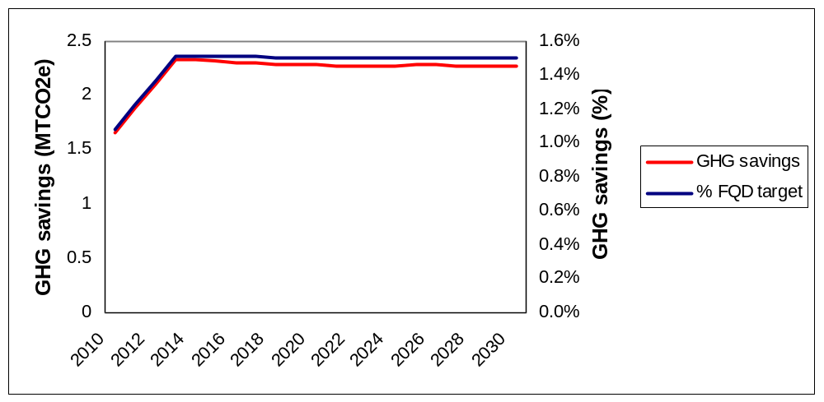
Source: DfT modelling

Infraction risk

- Infraction can result in very substantial fines. For example in 2005, following a particularly serious and long-running case, the European Court of Justice fined France a figure of nearly €58 million for each 6-months of delay in complying with a judgment of the court concerning fisheries on top of a lump sum of €20 million.

- While the size of fines in any given case will continue to depend on the European Court of Justice’s (ECJ) assessment of the seriousness of the breach, its duration and the ability of the Member State to pay, Member States have recently signalled their willingness to accept a more punitive regime. This is reflected in the fact that the infraction process in non-notification cases has just been streamlined under the Lisbon Treaty so that the ECJ can move to fine a Member State significantly more swiftly than has to date been possible.

- This information is intended to give an indication of the possible scale of the costs of infraction. It should be noted that the UK would of course seek to avoid infraction through the appropriate transposition of the Directive.

RTFO baseline

- In the following analysis, which looks at options for implementing the FQD, cost and benefit estimates are presented as additional to (i.e. net of) the projected costs and benefits attributable to the current RTFO trajectory.

SECTION 3 – Wider context

Introduction

- This section describes the relevant context for the implementation of the Directive in terms of summarising the requirements of the FQD; describing how it could be implemented; providing a high-level overview of the potential impact of the FQD on the market for biofuels; and explaining the relevance of the Renewable Energy Directive (Directive 2009/28/EC).

- Although the Directive will be implemented at the EU level, this Impact Assessment considers the costs and benefits to the UK only.

The Fuel Quality Directive

- Article 7a of the FQD requires fuel suppliers (i.e. not Member States) to reduce the lifecycle GHG emissions per unit energy of road transport and non-road mobile machinery fuel they supply by a minimum of 6% by 2020, relative to fossil fuel. It also requires Member States to ensure that these reductions are delivered as gradually as possible (e.g. by setting of a trajectory of GHG reduction targets out to 2020). GHG emission reductions could be delivered in a range of ways. These include, the deployment of biofuel, switching to less polluting fossil fuels (e.g. fossil methane, LPG) a reduction in the GHG intensity of fossil fuels through changes to the extraction/refining processes or through the deployment of electric vehicles (provided that the electricity can be appropriately accounted for). GHG savings are measured relative to the EU average lifecycle GHG emissions from fossil fuels in 2010; to date, the European Commission has yet to come forward with a proposal for adoption through the EU’s committee system for approving delegated legislation (‘comitology’).

- In practice, it is anticipated that a large majority of the GHG savings will be delivered through increased use of biofuels. Use of biofuels is currently mandated in the UK through the RTFO. Implementing the FQD will therefore require making changes to the RTFO or introducing parallel obligations, so that fuel suppliers are required to meet GHG intensity targets in a cost-effective manner.

- Relative to the RTFO, the FQD applies to a wider section of the fuel supply covering non-road mobile machinery — which includes railway engines, inland waterway vessels when not at sea, construction machinery, as well as agricultural and forestry tractors, and recreational craft when not at sea — in addition to road transport fuel. In addition, the current RTFO is a volume based obligation requiring suppliers to supply a particular volume of biofuel irrespective of source or inherent GHG savings; in contrast the FQD specifically targets GHG savings.

- The FQD also covers a wider range of potential GHG reduction pathways including electricity used in transport applications and changes to fossil fuel extraction/processing. Under the FQD all relevant fuel and energy suppliers are required to reduce lifecycle GHG emissions by 6% whereas the RTFO only applies to suppliers who supply in excess of the obligation threshold, currently 450,000 litres each year.

- This expansion of scope is covered quantitatively in the cost benefit analysis in section 4 and in more qualitative detail in annexes 12 and 13.

The Renewable Energy Directive

- The Renewable Energy Directive (Directive 2009/28/EC, the “RED”) requires Member States to ensure that 10 % of the energy used in transport is from renewable sources in 2020, sets out an indicative trajectory, and requires the introduction of mandatory sustainability criteria for biofuels contributing to these targets.

- Proposals for transposition of the RED are the subject of a separate consultation. The consultation proposes that the RED is implemented into UK legislation through amendment of the RTFO Order.

- It should be noted that the requirements of the RED and associated trajectory have not been explicitly and separately considered in relation to the baseline for the purposes of this impact assessment. This is because it is expected that for the UK to meet the requirements of both the RED and FQD, it is most cost effective to consider one trajectory only i.e. one that satisfies both Directives. In this case, as the FQD requirements are more stringent, meeting this would also satisfy the RED.

Implementing a GHG savings obligation

- In the following analysis, the policy instrument used to deliver GHG savings required by the FQD is referred to as a “GHG saving obligation”. In practice this means placing a legal requirement on the relevant transport fuel suppliers to demonstrate that they have delivered GHG savings required by the target. As such, the method which suppliers use to decarbonise the fuel supply is left to their discretion allowing them flexibility to deliver GHG savings at least cost.

Potential impact of a GHG savings obligation on the market for biofuels

- At present, the UK biofuels market is primarily driven by volume (or energy content) and not GHG savings. This is because the financial incentive currently in place (the RTFO) effectively provides a subsidy on a volume basis because fuel suppliers are able to pass the costs of meeting the obligation through to the pump price of fuel. Biofuels supplied to the UK, as reported to the RFA, currently deliver a very wide range of GHG savings, from a low of –35% to a high of +93% GHG savings relative to the displaced fossil fuel (see annex 16 for a breakdown of GHG savings reported to the RFA).

- Moving from a volume obligation (the current RTFO) to a GHG saving obligation would be expected to have significant implications for the biofuel supply market. Given the expected increase in demand for fuels that are able to offer higher GHG savings relative to others, it is likely that the structure of biofuels market would change so that biofuels delivering high GHG savings would command higher prices than biofuels with low GHG savings (for a given supply). In effect, transport sector GHG savings would become commoditised. At present biofuels pricing is not driven significantly by GHG savings so there is no incentive for higher GHG savings to be achieved.

- Implementation of the FQD and the RED in other EU Member States is expected to impact on the biofuels market across the EU. The introduction of GHG mandates in Europe (i.e. the planned introduction of a GHG mandate in Germany in 2015) is likely to mean that biofuel producers would have a strong incentive to optimise their products and processes to deliver higher GHG savings.

- There are many potential pathways that can be used to deliver higher GHG savings biofuel. These include lowering the carbon intensity of the underlying feedstock, which can be achieved through increasing yields; switching feedstocks; and decreasing the use of fertilisers. GHG savings can also be made through process improvements in biofuel production. Process improvements can take many forms. Some of the most significant savings can be made by increasing the energy efficiency of the production process or generating production energy from renewable sources. An example of how process improvements can be made is British Sugar’s Wissington bioethanol refinery which uses a combined heat and power boiler to produce process heat. This process delivers an estimated 81% lifecycle GHG saving, which is significantly higher than the RED’s 52% default value for lifecycle GHG savings for sugar beet bioethanol.

- In general, a move to a GHG driven biofuels market is thought likely to benefit EU biofuel producers and farmers. This is because farming practices tend to be relatively more efficient and yields tend to be relatively higher.

Constraints on blending biofuels with petrol and diesel – “the Blend Wall”

- At present, the vast majority of biofuel delivered under the RTFO is supplied in low concentrations as part of a biofuel/fossil fuel blend (i.e. the blend of fuel which is currently supplied at a typical garage forecourt). The amount of biofuel that can be blended in fossil petrol and diesel is currently limited by a combination of EU legislation and industry fuel standards. The current limit is 5% by volume for bioethanol in petrol and 7 % by volume for biodiesel in diesel; however, the bioethanol limits will be raised to 10 % by 2011. These limits exist because current vehicles are not compatible with, or warranted for use with, higher percentages of biofuel than these levels. The effect of these limits results in a “blend wall”, which is the point at which the vehicle fleet cannot take higher levels of biofuel without encountering warranty or performance issues. Only a very small proportion of overall biofuel supply is delivered to final fuel consumers as a “high blend”, which is only suitable for a small subset of the vehicle fleet.

- Under the current RTFO biofuel deployment trajectory (which rises to 5% by volume in 2013/14), it is not necessary for biofuel to be supplied in excess of the blend wall for the obligation to be met. However, the introduction of a significantly more demanding 6% GHG reduction target will be likely to require that biofuel is supplied in excess of the blend wall by 2020. It should also be noted that, in the absence of the FQD, biofuel in excess of the blend wall would be expected to be required to meet the RED 10% renewable energy in transport target in 2020 (see paragraph 30).

- There is considerable uncertainty over how the FQD targets may be met in practice. Options include the introduction of high blend fuel streams, increased uptake of biomethane/electric vehicles, introduction of biofuel which can be blended at higher concentrations (e.g. biobutanol and partially renewable fuels such as Hydrogenated Vegetable Oil) and the development of 2nd generation “drop in” biofuels that are chemically identical to fossil fuels and therefore do not have any blending limits. Some of these options may require significant additional investment in new infrastructure and vehicle technology. Further analysis is required for these impacts to be robustly quantified.

- In practice, under current market conditions, there are infrastructure barriers to the deployment of high blend fuel streams. These include the likely requirement for new fuel supply infrastructure, availability of vehicles capable of accepting high blends, the tax system, and the consumer incentive to purchase high blend biofuels when there are alternatives available.

SECTION 4 – Analytical Approach

Options for setting GHG saving obligation targets and trajectories

- The FQD requires that GHG savings are delivered “as gradually as possible”. This may imply putting in place a trajectory of annual GHG savings targets leading up to 2020.

- Given the significant uncertainty and evidence gaps surrounding the costs, benefits, feasibility and distributional impacts of delivering future GHG savings, relative to fossil fuels, a scenario based approach has been used on the basis of a range of potential trajectories. The scenarios presented should be regarded as illustrative and any numbers should be considered as part of a (necessarily wide) range, rather than point estimates. The analysis is intended only to provide a sense of the relative magnitude of expected effects and to present an assessment of the uncertainties, underlying assumptions and limitations of the analysis.

- Figure 3 presents the range of annual target trajectory options that have been explored. These trajectories have been chosen to represent the range of potential options available for implementation of the FQD GHG savings target in the UK. Further discussion around the feasibility of the individual trajectories is included in Section 5.

Figure 3: GHG savings target trajectory options
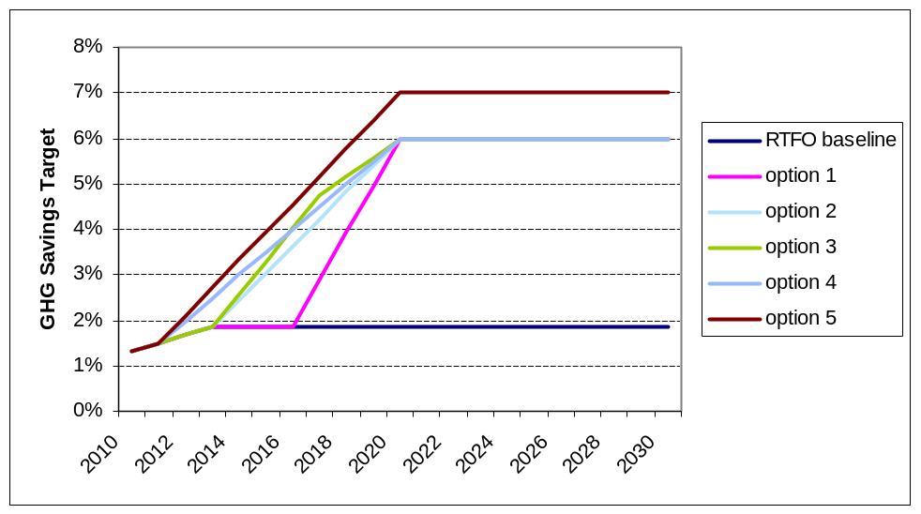

- RTFO baseline: The RTFO continues along its current trajectory delivering 5% biofuel by volume or estimated GHG savings of around 1.8% from 2013/14 onwards. The 2020 FQD 6% GHG savings target is therefore not met.

- Option 1: The RTFO continues to 2017, at which point a GHG savings obligation is introduced which increases linearly with annual targets leading up to a 6% GHG savings target in 2020.

- Option 2: The RTFO continues to 2014, at which point a GHG savings obligation is introduced which increases linearly with annual targets leading up to a 6% GHG savings target in 2020.

- Option 3: The RTFO continues to 2014, at which point a GHG savings obligation is introduced which increases linearly (initially at a faster rate) with annual targets leading up to 4.8% in 2017 and then more slowly to 6% in 2020. (stretching trajectory)

- Option 4: A GHG savings obligation is introduced in 2012 which increases linearly with annual targets leading up to a 6% GHG savings target in 2020.

- Option 5: A GHG savings obligation is introduced in 2012 which increases linearly with annual targets leading up to a 7% GHG savings target in 2020. (stretching target)

Overview of analytical approach

- Recognising the significant uncertainties around the implementation of the FQD, including the responses of fuel suppliers to any long term obligation, the costs of compliance and the trajectory illustrated to meet the 2020 6% obligation, the analytical approach used for modelling FQD target trajectory impacts is indicative but based on the best available evidence. Sensitivity tests have been taken forward to reflect the considerable uncertainties around several key assumptions, as will be explained.

- The following analysis seeks to compare the costs and benefits of meeting a variety of FQD GHG saving trajectories under the options described above. In particular it will highlight the estimated GHG impacts, the administrative costs on suppliers and the potential impacts on fuel prices.

- To estimate the costs, benefits and impacts of meeting the FQD obligation by 2020, it is important to make assumptions about:

  - The options for suppliers to meet the FQD targets and therefore the potential GHG savings from deploying biofuels as part of the transport fuel mix over the period to 2020;
  - Estimated costs incurred by suppliers to meet FQD obligations; and
  - The trajectory of GHG savings required in order to meet the 2020 FQD target.

- The assessment relies on a model built specifically for this analysis, which draws on available evidence to explore how GHG savings could be achieved to meet the FQD 2020 obligations for each trajectory covered.

- GHG abatement options included in the modelling reflect a combination of: uptake of 1st generation crop-derived biofuel; uptake of non-1st generation biofuel (i.e. biofuel derived from waste and advanced biofuels); and, fossil fuel extraction/refining improvements. However, given the uncertainty over the cost and feasible potential for GHG savings from non-1st generation biofuel GHG saving options in the period to 2020, a simplifying assumption has been made when calculating costs. Petrol is assumed to be de-carbonised in line with the target trajectory using only crop-derived bioethanol and diesel is assumed to be de-carbonised in line with the target trajectory using only crop derived biodiesel. This is not to say that this is Government's preferred way in which the targets should be met, nor is it the case that all suppliers would only explore these options because lower cost alternatives may be feasible, but it is an assumption made for the purposes of this analysis given available evidence. Additional evidence is invited as part of the consultation.

Costs of delivering GHG savings required under the FQD

- In the absence of a GHG savings obligation to 2020, transport fuel suppliers are assumed to maximise profits and minimise costs. The implementation of a GHG savings obligation is expected to impose additional costs on transport fuel suppliers relative to the status quo (i.e. the additional cost of supplying biofuel relative to fossil fuel, the additional cost of using electric vehicles relative to conventional vehicles and the additional cost of reducing GHG emissions from fossil fuel extraction/refining).

- Given that biofuels are expected to be the only feasible option for delivering the majority of the GHG savings required to meet the 6% GHG savings target in 2020, the primary focus of this cost benefit analysis is to look at the additional cost associated with delivering GHG savings through the deployment of biofuel. This is not to say that other options are not possible, but it has not been possible to include them in the analysis at this stage given the lack of available evidence. Alternative options have therefore been addressed qualitatively.

The additional cost of supplying biofuel

- In general, biofuel prices are higher than fossil fuel prices because, at present, the cost of producing biofuels is higher than the price of supplying the equivalent fossil fuel. The difference in cost between supplying biofuel and supplying fossil fuel is referred to as the “spread” between biofuel and fossil fuel prices. Using petrol and diesel price projections consistent with oil price projections produced by the Department of Energy and Climate Change (DECC) and bioethanol/biodiesel price projections produced by the OECD FAO Aglink-Cosimo model (see Annex 14 for a description of the model) it is possible to estimate the cost differential between supplying fossil fuel and biofuel. The following charts show central estimates of the spread, both in volume terms and energy adjusted terms (energy density data can be found in Annex 11). When considering GHG savings the relevant measure is the energy adjusted spread because this allows the GHG savings to be compared with the fuel purchased by consumers to travel their given distances (i.e. we take the underlying projected baseline level of travel demand as a given); as such, the percentage GHG savings used in this analysis are presented on an energy adjusted basis.

Figure 4: Central estimates of spreads for biodiesel and bioethanol
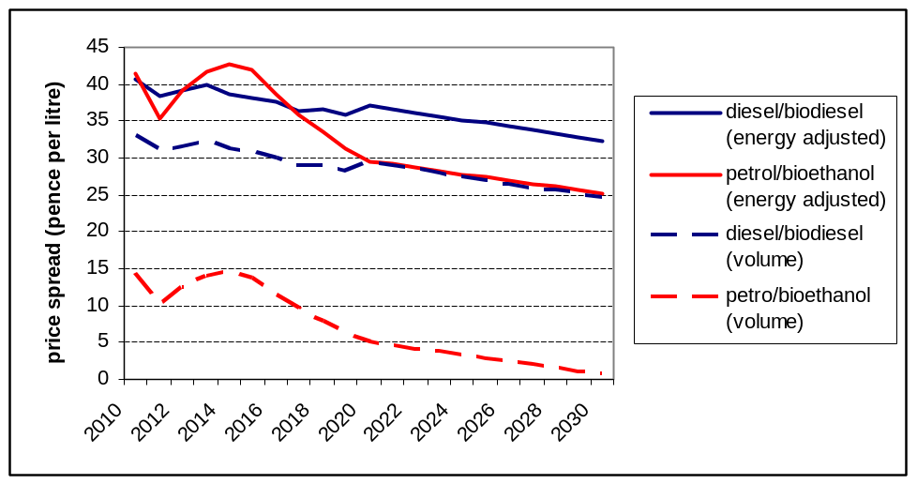
Source: Internal analysis based on OECD Aglink-Cosimo biofuel price projections and DECC oil price projections
- As can be seen from the Figure 4, bioethanol is currently estimated to be around 14 ppl more expensive than petrol on a volume basis. As the price of petrol increases (driven by rising oil prices) and the price of bioethanol decreases over time (due to efficiencies in production and technological development for example), the spread is expected to narrow gradually and petrol and bioethanol prices are projected to converge at around 2030 under central fossil fuel price assumptions (higher oil prices would bring this date of convergence forward). However, as the energy density of bioethanol is only around two-thirds that of petrol, the energy adjusted spread between petrol and bioethanol prices is considerably higher, going from around 35 to 43 ppl (energy adjusted – petrol equivalent) at present to around 25ppl in 2030. Although on a volume basis, biodiesel is currently estimated to be some 33ppl more than diesel, the relative spread when accounting for the energy adjustment is not as great as for bioethanol/petrol. This is because the energy density of biodiesel is around 90% that of fossil diesel, so the volume and energy adjusted spread are much closer together. The energy adjusted spread is estimated to fall gradually from around 40 ppl (energy adjusted) at present to around 25 ppl in 2030. The full datasets used to calculate these spreads can be found in Annex 8.

- The additional cost of supplying biofuel is highly sensitive to the underlying oil price. Holding biofuel prices constant, higher fossil fuel prices will decrease the spread between biofuel and fossil fuel prices. Lower oil prices will increase the spread making biofuels less cost effective. In reality, there is thought to be some correlation between oil prices and biofuel prices which dampens this effect. On the supply side, energy is a significant agricultural input so an increase in energy prices will result in an increase in the cost of producing crop-derived biofuel. On the demand side, biofuel subsidies are often directly correlated with underlying oil prices which means that fuel suppliers’ willingness to pay for biofuel will rise/fall in line with underlying fossil fuel prices (high oil prices reduce the cost of supplying biofuel). The following charts show the estimated adjusted spreads under the DECC “low”, “central”, “high” and “high high” oil price scenarios (see annex 8 for more detail).

Figure 5: Energy adjusted spread for bioethanol across a range of oil price scenarios
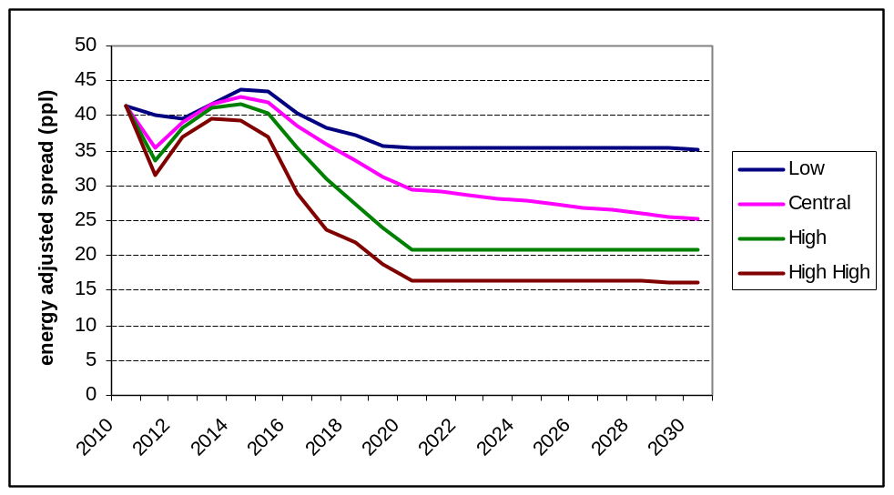
Source: Internal analysis based on OECD Aglink-Cosimo biofuel price projections and DECC oil price projections

Figure 6: Energy adjusted spread for biodiesel across a range of oil prices scenarios
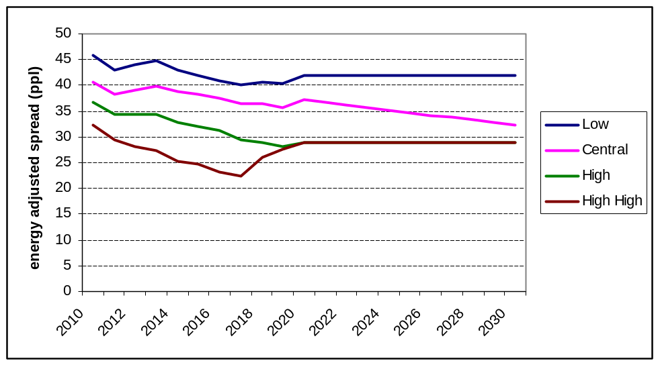
Source: Internal analysis based on OECD Aglink-Cosimo biofuel price projections and DECC oil price projections

- Movements in the energy-adjusted spread between fossil fuel and biofuel prices are determined by movements in the underlying biofuel and fossil fuel price projections. In general (across all of the fossil fuel price scenarios), bioethanol prices fall in the short run (to 2011) and increase over the years to 2015 as demand pressure from mandated demand grows which pushes prices up. The bioethanol price then falls gradually as supply expands to meet demand in the long term.

- The energy-adjusted spread between biodiesel and fossil diesel prices behaves more predictably and remains relatively constant over time. The biodiesel/diesel spread falls less over time than the bioethanol/petrol spread because increased biofuel demand is expected to create more price pressure in biodiesel feedstock markets than in bioethanol feedstock markets. This is because there is less potential to increase vegetable oil (biodiesel feedstock) production relative to bioethanol feedstocks (i.e. wheat, corn, sugar). In the High–High oil price scenario, the biodiesel/diesel spread is projected to increase from 2017 to 2020 owing to the price effect an increase in mandated demand (driven by high oil prices) which is not offset by an increase in vegetable oil production.

- The uncertainties in the spread should be recognised, particularly given the timeframe for analysis is out to 2030. Therefore, sensitivity tests have been carried out, as explored through exploring alternative oil price assumptions (and hence varying the spread).

Abatement of GHGs through the supply of biofuel

- When estimating the cost of implementing a GHG saving obligation, it is necessary to consider the £/tCO₂e abatement costs along with the additional cost associated with supplying a given volume of biofuel (though of course they are linked to some extent). As lifecycle GHG savings from biofuel vary widely and are contingent upon a number of factors, not least the options chosen by the supplier to meet their obligations. In turn, this leads to variations in feedstock type, region of origin, crop yields, fertiliser use, transport emissions and process energy used we need to project average GHG savings going forward which can be used to inform calculations of £/tCO₂e abatement costs.

- Following the introduction of a GHG savings obligation, because of the impact on the demand and supply across different fuel sources, it is expected that pricing in the UK (and also within the EU when other Member States adopt the FQD) biofuels market will change to reflect GHG savings. It is also expected that an explicit economic incentive to deliver GHG savings and competitive pressures will drive down the production costs associated with delivering GHG savings over time as the market matures, relative to levels seen in the current volume/energy driven market. In order to estimate the cost of delivering a GHG reduction target, it is necessary to make projections of likely abatement costs going forward in a GHG driven market, given the implicit assumptions about the action taken by suppliers to meet their obligations. Given uncertainty over the evolution of the biofuels market and potential for GHG reduction, alongside considerable uncertainty over future oil prices and feedstock prices, these abatement cost estimates should be interpreted as illustrative and as part of a necessarily wide range.

Bioethanol – average GHG savings trajectory and abatement costs

- GHG savings from crop-derived bioethanol vary widely. Typical GHG savings values, taken from Annex V of the RED, show a range from 32% for wheat derived ethanol (which uses coal for process energy) to 71% for Brazilian sugar cane ethanol. Using the energy adjusted spread for bioethanol (i.e. reflecting the additional cost of supplying a unit of energy from bioethanol relative to petrol) we can estimate the implied abatement costs for carbon savings attributed to bioethanol across a range of differently sourced bioethanol and therefore different sources of GHG savings. Using the central values for bioethanol and petrol prices in 2010, the implied estimated abatement cost for bioethanol delivering 32% GHG savings is some £471/tCO₂e. For bioethanol delivering 71% GHG savings, the implied abatement cost is around £212/tCO₂e.

- The latest GHG savings data from the Renewable Fuels Agency (provisionally) reports weighted average GHG savings delivered by the UK bioethanol supply at 63% in the obligation year 09/10. This implies an average abatement cost of £239/tCO₂e.

- Looking forward, for the purposes of this analysis it is necessary to make estimates of average abatement costs that could be delivered under a GHG driven biofuels mandate by estimating an average GHG savings profile for bioethanol going forward over time, assuming a proportion of bioethanol is supplied to meet the FQD objectives.

- Average GHG savings from bioethanol are projected to remain constant at around 66%/67% over the period from 2010 to 2030. These projected savings are based upon an assessment of current data and possible GHG saving options available from bioethanol production technologies and feedstocks. However, it is important to recognise that the projections are inherently uncertain and thus should be considered to be purely illustrative. In order to account for this uncertainty, a “low” and “high” sensitivity are also taken (for further details on the analysis behind the average GHG savings trajectories see annex 15). The "low" and "high" scenarios are illustrated to vary 10% either side of the central scenario; this sensitivity range reflects the expected focus on the market of those fuels offering greater GHG savings hence very low average GHG savings would not be considered likely. The high scenario exceeds the GHG savings of the highest GHG-saving bioethanol currently on the market, as referred to above. Consultees are invited to comment on the likely accuracy of these projections.

Figure 7: Average GHG savings projections for bioethanol (under a GHG savings obligation)
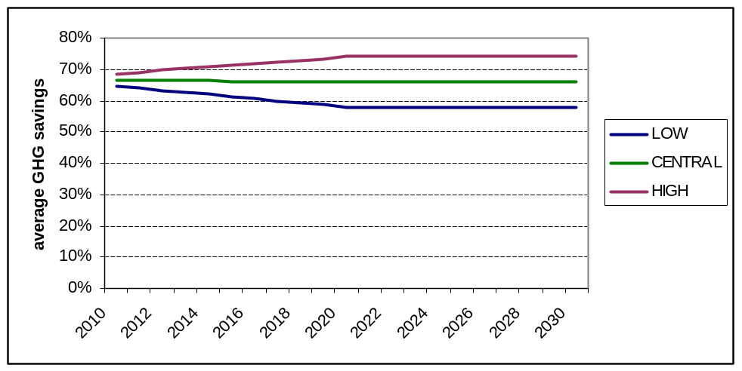
Source: internal analysis

- Across all three GHG savings scenarios abatement costs are projected to fall over time. This is due to a declining spread between projected bioethanol and petrol prices, as oil prices rise and bioethanol prices fall over time. Under the central GHG savings scenario for GHG savings abatement costs are estimated to fall from £226/tCO₂e to £139/tCO₂e over the period from 2010 to 2030. The kink in abatement cost projections is caused by the underlying bioethanol price projections (see paragraph 60 for further explanation).

Figure 8: Projected GHG abatement costs for bioethanol across average GHG savings scenarios
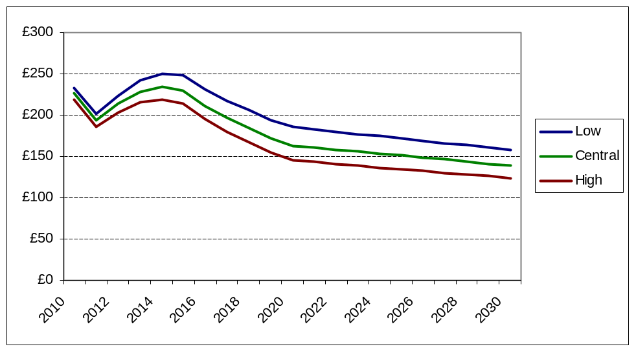
Source: Internal analysis based on OECD Aglink-Cosimo biofuel price projections, DECC oil price projections and average GHG savings projections.

- The projected abatement costs (i.e. abating one tonne of CO2 e through the provision of biofuel to displace fossil fuel) are very sensitive to underlying assumptions, in particular the spread between petrol and bioethanol prices and average GHG saving assumptions. Figure 9 shows the projected abatement cost across a range of oil price scenarios. Under the high oil price scenario, abatement costs are lower. This is because the spread between petrol and bioethanol (i.e. the additional cost of supplying bioethanol) is lower. Under the low oil price scenario the reverse is true.

Figure 9: Projected GHG abatement costs for bioethanol under DECC oil price scenarios
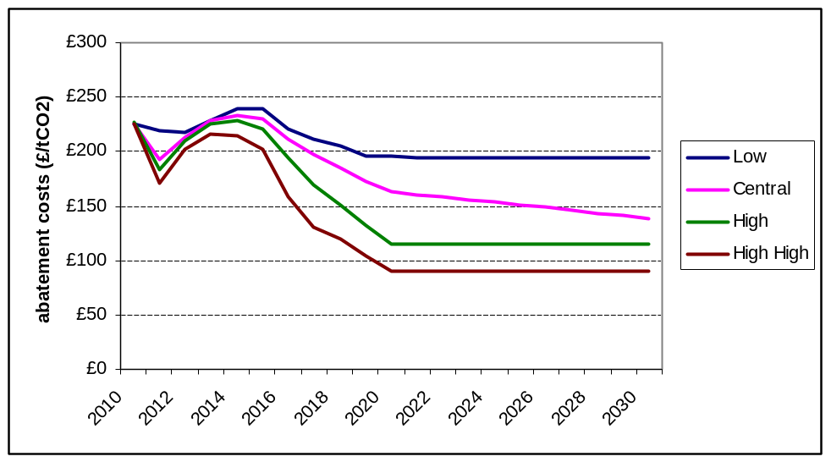
Source: Internal analysis based on OECD Aglink-Cosimo biofuel price projections, DECC oil price projections and average GHG savings projections.

Biodiesel – average GHG savings trajectory and abatement costs

- As with bioethanol, GHG savings from crop-derived biodiesel vary widely but to a lesser degree than bioethanol. Typical values presented in Annex V of the RED range from 36% for palm oil (process unspecified) to 68% for HVO palm oil with methane capture at the oil mill. Using the energy adjusted spread for biodiesel (i.e. the additional cost of supplying a unit of energy from biodiesel relative to fossil diesel) we can estimate the implied abatement costs for different forms of biofuel and therefore the different GHG savings. Using the central values for biodiesel and fossil diesel prices in 2010, the implied abatement cost for biodiesel delivering 36% GHG savings is £369/tCO₂e. For biodiesel delivering 68% GHG savings, the implied abatement cost is £195/tCO₂e.

- Estimates based upon the latest GHG savings data from RFA (Annex 15) shows weighted average GHG savings delivered by the UK crop-derived biodiesel supply at 40% in the obligation year 09/10. This implies an average abatement cost of £329/tCO₂e. This cost is higher than the average abatement cost attributed to bioethanol for two reasons: i) the GHG savings delivered by biodiesel are estimated to be lower; ii) the additional cost of supplying biodiesel is estimated to be higher.

- Average GHG savings from biodiesel are projected to rise gradually from 40% to 56% over the period from 2010 to 2030 (incidentally, rising to 50% by 2017 under the central scenario, which would be consistent with the mandatory sustainability criteria proposed by the RED). Again, it is important to recognise that these projections are highly uncertain; therefore, a “low” and “high” sensitivity are also taken, again varying by 10% either side of the central case (for further details on the analysis behind the average GHG savings trajectories see annex 16). As with bioethanol, the range illustrated is intended to reflect the market being driven by GHG savings, hence the demand for lower GHG savings referred to in paragraph 72 is likely to fall.

Figure 10: Projected average GHG savings projections for biodiesel (under a GHG savings obligation)
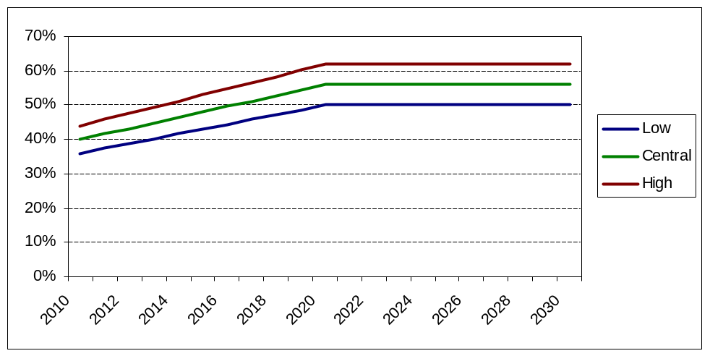
Source: internal analysis

- Across all three GHG savings scenarios abatement costs are projected to fall over time. This is due to a combination of rising average GHG savings and a declining spread between biodiesel and fossil diesel prices. Under the central GHG savings scenario abatement costs are illustrated to fall from £332/tCO₂e to £188/tCO₂e over the period from 2010 to 2030.

Figure 11: Projected GHG abatement costs for biodiesel
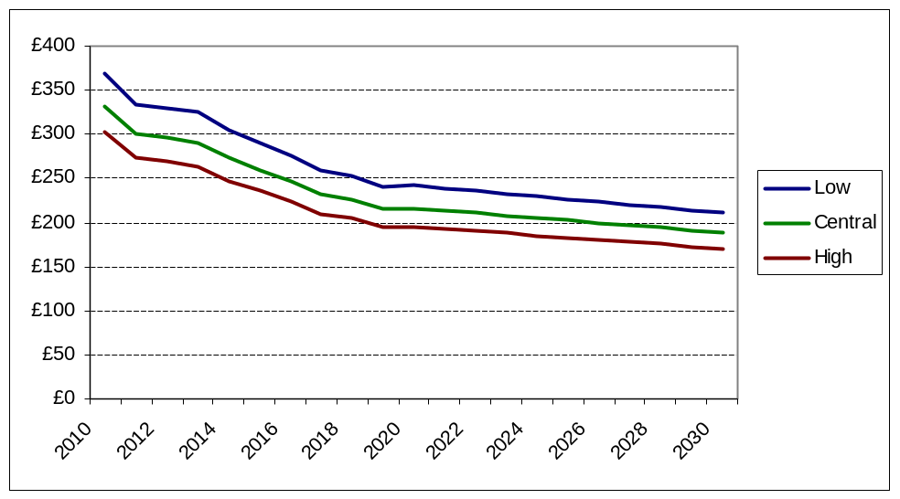
Source: Internal analysis based on OECD Aglink-Cosimo biofuel price projections, DECC oil price projections and average GHG savings projections.

- As is the case with our analysis concerning bioethanol, the projected abatement costs through the use of biodiesel are very sensitive to the underlying assumptions, in particular the spread between fossil diesel and biodiesel prices and average GHG saving assumptions. The following chart shows the projected abatement cost under “low” and “high” oil price scenarios. Under the “high” oil price scenario, abatement costs are lower. This is because the spread (i.e. the additional cost of supplying bioethanol) is lower. Under the “low” oil price scenario the reverse is true.

Figure 12: Projected GHG abatement costs for biodiesel under DECC oil price scenarios
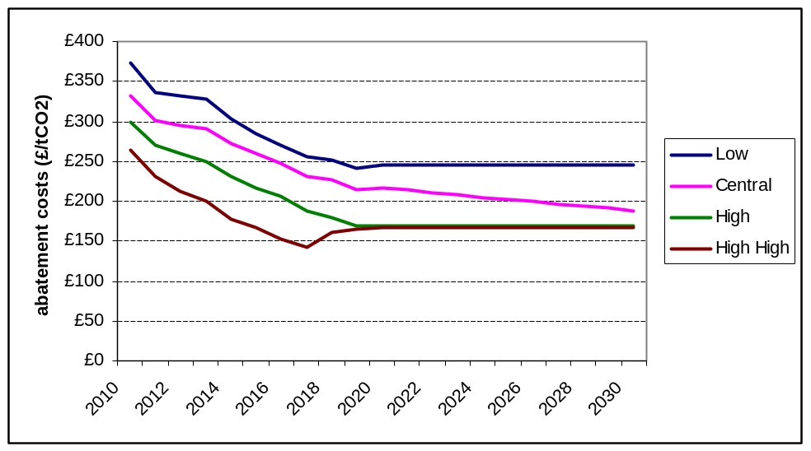
Source: Internal analysis based on OECD Aglink-Cosimo biofuel price projections, DECC oil price projections and average GHG savings projections.

Additional costs associated with the supply of biofuel

- Over and above the cost of purchasing biofuel, additional costs will also be incurred through investment required to upgrade the existing refining and distribution infrastructure to handle increased volumes of biofuel. The additional infrastructure cost required to deliver higher volumes of biofuel was estimated following consultation with industry as part of previous analysis looking at meeting the 10% renewable energy transport target required by the RED. As a similar volume of biofuel is likely to be required to meet the FQD GHG savings target the same figure has been used. It is estimated that the additional costs required to upgrade the UK refinery infrastructure for the industry is £315m in 2010 prices. This has been captured in the modelling as a one-off cost incurred in 2014 and is the illustrative central assumption. If consultees have additional evidence in this area then it would be most welcome.

- The modelling does not capture the additional costs involved in passing the “blend wall” (e.g. deploying “high blend” fuel streams or switching to advanced or alternative biofuels). This is a significant omission as these costs are potentially substantial. Further research into the costs and benefits associated with passing the “blend wall” potential options is required. Additional evidence from stakeholders would be welcome in this area.

Estimated abatement costs — other abatement options

- Given the current levels of maturity (and immaturity) of the various biofuels technologies, crop-derived bioethanol and biodiesel are expected to provide the majority of effort required to deliver GHG savings required to meet the FQD GHG savings target in the period to 2020. However, there are other abatement options available to obligated suppliers including waste-derived biofuel such as tallow, used cooking oil and biomethane. GHG savings can also be delivered through the adoption of advanced biofuels, alternative fossil fuels with lower carbon intensities (e.g. fossil methane and LPG), electric vehicles and improvements to fossil fuel extraction/refining processes.

- It has not been possible to robustly model the potential penetration of these alternative (non 1st generation biofuel) GHG saving options and costs over the period to 2030 owing to the lack of available evidence. At present, increased supply of waste-derived biofuel looks the most likely to make an impact as it is currently supplied in significant quantities (see Annex 12) and delivers high GHG savings which would potentially be more attractive, and therefore stimulate a greater market, under a GHG obligation than at present.

- Rather than model them separately, for the purposes of the Cost Benefit Analysis modelling, non crop-derived biofuel abatement options have been captured as a subset of the projected biodiesel supply. This is because obligated suppliers are assumed to substitute biodiesel for alternative GHG saving options. As the supply of alternative GHG saving options is constrained (i.e. they cannot be sourced in infinite quantities), it is assumed that suppliers' willingness to pay for these alternative options is determined by the cost of GHG savings from biodiesel (i.e. the price of tallow and used cooking oil could be driven up by suppliers who increase their demand for these higher GHG saving fuels in order to avoid the cost of delivering GHG savings through crop-derived biodiesel). This is a conservative assumption and the cost estimates should be thought of as representing an upper bound. In reality, obligated suppliers may be able to source alternative GHG savings at a lower cost than GHG savings from biodiesel.

Administrative/Enforcement Costs

- The additional administrative cost (over and above those already incurred under the RTFO) of complying with a GHG driven obligation (i.e. reporting requirements) have been estimated following informal consultation with industry. Industry-wide, these costs are illustratively estimated to be between an additional £4,000 and £17,500 per year, per supplier. For the purposes of this impact assessment a central estimate of £10,750 has been taken. Taking the conservative assumption that all 53 firms registered under the current RTFO will bear these additional costs to the full extent, the industry-wide increase in administrative burden is estimated at around £569,750 annually, starting from the point at which a GHG savings obligation is introduced. Obviously, in practice there will be significant variations in the administrative costs faced by suppliers but for the purposes of this analysis, an illustrative average has been considered. No additional on-going government-funded administration/enforcement costs are expected (over and above what would have been incurred under the RTFO). Transitional administrative costs (i.e. changing systems from a volume to a GHG savings obligation) in the region of £50,000 to £200,000 have been estimated. There is substantial uncertainty over the likely magnitude of these costs but they have been illustrated here, based on available evidence. Stakeholder views are welcomed on the likely accuracy of these estimates.

- In addition, the FQD also requires expanding the scope of the obligation to cover all fossil fuel suppliers (as opposed to the current RTFO which covers only those supplying annual volumes greater than 450,000 litres). Options around extending the obligation to cover all fuel suppliers, irrespective of size, have not been monetised at this stage of the policy process. Stakeholder views on this subject are welcomed as part of the consultation.

Cost Pass-through

- Given the competitive nature of the fuel market, the additional costs of delivering GHG savings required by the FQD (over and above the cost of supplying fossil fuel with no GHG saving measures) are assumed to be passed through 100% to the final consumer of the underlying transport fuel. This assumption has been made due to the highly competitive nature of the fuel supply market and the inherent substitutability of refined fuels from different producers (i.e. petrol from all refineries is identical). Therefore refinery operators cannot exert significant market power and are assumed to be unable to unilaterally influence the market price.) The cost of de-carbonising petrol using bioethanol is modelled as being passed through to petrol prices and biodiesel costs are modelled as being passed through to diesel pump prices.

- It is recognised that the degree of cost pass-through may vary, at least in the short term, across the industry depending on the particular fuel markets served and the nature of demand, and the particular market conditions such as the degree of competitiveness. Generally however, full cost pass-through would be expected in the longer term. Stakeholder input on the pass-through of costs would be appreciated as part of this consultation.

Unquantified Costs

- Implementing a GHG saving obligation will create a number of additional costs that have not been quantified in the following analysis due to a lack of available evidence. These include:
- Increased demand for biofuel may lead to higher feedstock prices, which would be felt more widely across the economy (e.g. increased demand for wheat may lead to an increase in bread prices).
- Supplying biofuel in excess of the “blend wall” would cost more than simply blending conventional biofuel (i.e. crop-derived bioethanol and crop-derive FAME biodiesel) with petrol and diesel. (For more detail see paragraph 39).
- There may be potential balance of payment/exchange rate impacts from the increased value of imports due to the imported biofuel being more expensive than imported fossil fuel. (This will depend on the level of domestic biofuel production and could potentially be a benefit).
- Potential costs of modifications to vehicles and machinery required to cope with higher volumes of biofuel being blended into the fuel supply.
- The wider GDP impacts associated with any rises in transport costs resulting from the supply of biofuels.

Benefits of delivering GHG savings required under the FQD

GHG Savings

- The primary benefit of implementing a GHG saving obligation for transport fuel is the avoided GHG emissions. Total GHG emissions from transport fuel have been estimated using Department of Energy and Climate Change estimates of transport sector energy demand, internal analysis of NRMM energy demand and lifecycle GHG emissions for petrol and diesel. These projections suggest that lifecycle GHG emissions from transport fuel could be around 152 MTCO₂e in 2020 (in the absence of RTFO/FQD decarbonisation measures). These estimates and underlying data can be found in annex 11. DECC projections have been used in order to be consistent with projections of petrol and diesel use made by DECC in wider climate change policy analysis.

- GHG savings target values (expressed in CO₂e terms) are calculated by multiplying total lifecycle (including production emissions) carbon emissions by the obligation level in any given year. For example, a 6% GHG savings obligation in 2020 would deliver savings equivalent to 6% × total transport emissions (MTCO₂e) in 2020, which is 0.06 × 160 = 9.6 MTCO₂e.

- Lifecycle GHG savings have been monetised using DECC’s carbon saving values for the traded and non-traded sectors. GHG savings/emissions have been split into various sectors, including UK traded sector, UK non-traded sector, EU and rest of the world. A more detailed description of the carbon accounting methodology used is outlined in Annex 15.

Ancillary Benefits

- Other benefits attributed to delivering GHG savings required by the FQD include reduced congestion, reduced accidents, reduced noise pollution and improved air quality. These result from a reduced level of road transport mileage that would be expected as a consequence of higher pump prices resulting from the additional cost of delivering GHG savings required under the FQD. Improvements in air quality are also estimated to result from a reduction in demand for transport fuel.

- The elasticity used to calculate the change in transport fuel demand and conversion factors for converting reduced mileage to monetised benefits can be found in Annex 9.

Unquantified Benefits

- Implementing a GHG saving obligation will create a number of additional benefits which have not been quantified in the following analysis. These include:
- Potential improved profitability for UK biofuel producers and farmers
- Potential exchequer impacts from a potential increase in fuel duty revenue (due to an increase in the volume of road transport fuel supplied, but this may be at least partially off-set by any fiscal incentives provided to incentivise renewable fuels)
- Innovation benefits from the incentive to provide renewable fuels in order to meet the GHG obligation
- Wider economic benefits resulting from any increase in the UK biofuel-related agricultural markets

Assumptions, uncertainty and evidence gaps

- Underpinning the analysis are several assumptions which are inherently uncertain. There are also a number of significant evidence gaps. The following describes the key assumptions and uncertainties; additional evidence from consultees would be welcome.

Options for passing the “blend wall”

- At this stage, no costs have been included to reflect the potential measures necessary to pass the “blend wall” (e.g. high-blend bioethanol or biodiesel fuel streams). In reality there are likely to be additional costs involved with new supply infrastructure, new vehicles capable of accepting high blend fuel, the supply of advanced biofuels and the removal of barriers to consumer uptake of higher cost biofuel blends. The evidence base in this area is particularly uncertain so this area will be considered in greater detail as more evidence emerges.

Emissions from Indirect Land Use Change (ILUC)

- CO₂e savings are based on direct emissions (i.e. agricultural and refining emissions) and do not include the potential effects of indirect land use change (ILUC). In absence of mitigating measures, CO₂e emissions attributable to ILUC could potentially be very significant for some biofuel feedstocks and could reduce the estimated GHG benefits delivered by biofuels policy. However, work is on-going at the EU level to assess the effects of ILUC and to consider whether these effects should be accounted for under the RED and FQD.

Fossil fuel and biofuel price projections

- Fossil fuel and biofuel projections are fundamental to estimating the future costs of biofuel support policy. However, these are inherently uncertain. The projections used for this analysis (including sensitivities) can be found in Annex 8.

Bioethanol/biodiesel split

- The modelling implicitly assumes that both the diesel and petrol supply are decarbonised (symmetrically) by the level of the FQD target using biodiesel and bioethanol respectively. In reality, more biodiesel may be supplied than bioethanol (or vice versa). GHG savings from other sources may also have a role to play.

Dieselisation of fossil fuel demand

- Assumptions have been made around the trend towards dieselisation of the UK vehicle fleet and are implicit in the transport energy demand projections which underpin the modelling. These projections can be found in Annex 9.

Maximum rate of deployment/barriers to deployment

- The following cost benefit analysis implicitly assumes that transport fuel suppliers will be able to meet a given GHG savings target in a given year. In reality there will be barriers to deployment which may prevent targets from being achieved (e.g. infrastructure, consumer demand). These have not been specifically modelled.

Potential for non-biofuel GHG savings

- Currently, there is limited knowledge concerning the potential for GHG savings from non-biofuel options (e.g. electric vehicle, fuel switching, refining/extraction improvements).More detail on alternative GHG saving options can be found in annex 12.

SECTION 5 - Cost Benefit Analysis (options 1 to 5)

Summary

- All monetised costs and benefits are presented in 2010 prices. Future costs and benefits have been discounted into 2010 terms using the government standard Treasury “Green Book” discounting methodology.

- All costs and benefits presented for FQD options are estimated as additional to those projected under the current Renewable Transport Fuel Obligation (RTFO) baseline (i.e. the costs and benefits of delivering FQD GHG savings target are presented net of costs and benefits which would have occurred under the current RTFO trajectory).

Options analysis

- The following chart shows the GHG savings trajectories presented in the following cost benefit analysis. This selection of trajectories has been chosen to represent the range of possible target trajectories which could be used to deliver the GHG savings required under the FQD.

Figure 13: GHG savings target trajectory options

Monetised Costs and Benefits

- The following table sets out quantified costs and benefits associated with the various trajectory options under central assumptions.

Figure 14: Projected costs and benefits of FQD trajectory options
Cost Benefit summary |  | option 1 | option 2 | option 3 | option 4 | option 5
additional compliance cost to 2030 (£m) | £m | -8,605 | -10,182 | -10,838 | -11,127 | -14,088
additional administrative costs to 2030 (£m) | £m | -5 | -6 | -6 | -7 | -7
additional infrastructure costs (£m) | £m | -285 | -285 | -285 | -285 | -285
additional GHG savings to 2030 (£m) | £m | 4,102 | 4,736 | 4,956 | 5,089 | 6,244
ancillary benefits to 2030 (£m) | £m | 1,939 | 2,208 | 2,330 | 2,356 | 3,011
Net Benefit to 2030 (£m) | £m | -2,853 | -3,529 | -3,843 | -3,974 | -5,125

- As can be seen from the “net benefit” row of the table, de-carbonising the transport fuel supply is estimated to be a net cost measure (i.e. it delivers a negative overall benefit to society). That is to say, the monetised costs outweigh the monetised benefits. Option 5, which delivers the most additional GHG savings to 2030, is estimated to create the lowest net benefit to society. Option 1, which delivers least additional GHG savings, is estimated to create the highest net benefit.

- Compliance costs (i.e. the costs of supplying the GHG savings needed to meet the obligation) are higher for trajectories which deliver greater volumes of carbon savings over the period to 2030 because more effort is required by the supplier. Benefits also increase with the obligation level as the GHG savings increase. Monetised GHG savings increase as a higher obligation level requires more GHG savings. Ancillary benefits (e.g. reduced congestion and accidents, improved air quality etc) which result from lower levels of driving – a consequence of higher fuel prices – also rise in tandem with the obligation level. However, the absolute increase in compliance costs is greater than the absolute increase in benefits which means that the overall net benefit decreases as carbon savings increase. In general, more stretching trajectories have higher net costs.

- As biofuel abatement costs are projected to fall over time, trajectories which are more heavily weighted towards the future are less expensive relative to trajectories which are weighted towards the present. Option 1 which delivers the least GHG savings and is most weighted towards the future (i.e a trajectory of GHG reduction targets kicks in from 2017 onwards) is the least cost option. Option 4 which delivers the most GHG savings (of the trajectories which peak at a 6% GHG savings target) and is weighted towards the present (i.e. a trajectory of GHG reduction targets begins in 2011) is the most expensive option. This effect is also due to the fact that future costs and benefits are more highly discounted than costs and benefits closer to the present.

GHG Savings

Figure 15: Projected GHG savings and carbon cost-effectiveness of FQD trajectory options
Life-cycle GHG savings |  | option 1 | option 2 | option 3 | option 4 | option 5
additional CO2 savings in 2020 | MTCO₂e | 6.8 | 6.8 | 6.8 | 6.8 | 8.3
additional CO2 savings to 2030 | MTCO₂e | 85.2 | 95.5 | 99.2 | 100.9 | 123.6
£/tCO₂e (to 2030) | £/tCO₂e | 33.5 | 36.9 | 38.7 | 39.4 | 41.4

- Figure 15 shows that options 1,2,3 and 4 which all have a 6% GHG savings target in 2020 are estimated to deliver 6.8 megatonnes CO₂e GHG savings over and above what would otherwise have been delivered in an RTFO baseline in 2020. Option 5, which has a 7% 2020 GHG savings target, is estimated to deliver and additional 8.3 megatonnes CO₂e GHG savings in 2020.

- Trajectory options with higher average target levels (i.e. options with more gradual trajectories which start earlier in the lead up to the 2020 target or, in the case of option 5, have a higher 2020 target) deliver higher total volumes of GHG savings over the period to 2030. Option 1 which has a steep trajectory starting in 2017 delivers the lowest volume of overall GHG savings. Option 5 which starts in 2011 and has a 7% 2020 GHG savings target delivers the largest volume of overall GHG savings. The £/tCO₂e metric (which is presented net of monetised benefits) are negatively correlated with delivery of higher overall GHG savings and the extent to which the trajectory of targets is front loaded.

Pump price Impacts

- The additional impact of the FQD on pump prices has been estimated and presented for the year 2020, which is when compliance costs are projected to peak. Pump price impacts have been presented in 3 different forms:

      - Pence per litre (ppl) impacts which show how the cost of a litre of road transport fuel (at the retail point of purchase) is estimated to change in 2020. This figure implicitly assumes that biofuel can be blended with fossil fuel at concentrations required to meet the target. This may be unrepresentative of reality due to the blend wall (see paragraph 39).
      - Energy cost (p/GJ) impacts which show the additional cost of supplying transport fuel (in energy terms) net of tax (i.e. increased VAT and fuel duty) impacts.
      - Driving cost impacts (% increase) which show the increase in cost of supplying transport fuel (in energy terms) inclusive of tax.

- When considering overall costs to society, the “energy cost” is the key metric as it captures the additional cost (excluding monetised benefits) to society of meeting its energy needs under the FQD. The “pump price” metric is distorted by changes in the energy density of fuel and the “consumer cost” metric is distorted by tax transfers from consumers to government.

Figure 16: Projected pump price impacts of FQD trajectory options
2020 PUMP PRICE IMPACTS
petrol |  | option 1 | option 2 | option 3 | option 4 | option 5
pump price | ppl | 0.5 | 0.5 | 0.5 | 0.5 | 0.6
pump price | % increase on baseline cost | 0.6% | 0.6% | 0.6% | 0.6% | 0.7%
energy cost | £/GJ | £0.54 | £0.54 | £0.54 | £0.54 | £0.67
energy cost | % | 4.3% | 4.3% | 4.3% | 4.3% | 5.4%
consumer cost | £/GJ | £1.41 | £1.41 | £1.41 | £1.41 | £1.77
consumer cost | % | 3.5% | 3.5% | 3.5% | 3.5% | 4.4%
road diesel
pump price | ppl | 2.5 | 2.5 | 2.5 | 2.5 | 3.1
pump price | % | 1.8% | 1.8% | 1.8% | 1.8% | 2.3%
energy cost | £/GJ | £0.68 | £0.68 | £0.68 | £0.68 | £0.86
energy cost | % | 5.4% | 5.4% | 5.4% | 5.4% | 6.9%
consumer cost | £/GJ | 0.96 | 0.96 | 0.96 | 0.96 | 1.21
consumer cost | % | 2.6% | 2.6% | 2.6% | 2.6% | 3.2%
NRMM diesel
pump price | ppl | 4.1 | 4.1 | 4.1 | 4.1 | 4.8
pump price | % | 5.7% | 5.7% | 5.7% | 5.7% | 6.7%
energy cost | £/GJ | £1.09 | £1.09 | £1.09 | £1.09 | £1.27
energy cost | % | 9.0% | 9.0% | 9.0% | 9.0% | 10.5%
consumer cost | £/GJ | £1.37 | £1.37 | £1.37 | £1.37 | £1.60
consumer cost | % | 6.9% | 6.9% | 6.9% | 6.9% | 8.1%

Petrol

- The estimated 2020 pump price impact of blending bioethanol into petrol is relatively low (0.5ppl [0.6% additional cost above baseline pump price] for a 6% target), as bioethanol is not much more expensive than petrol on a volume basis. However, as bioethanol is significantly less energy dense there are significant costs associated with buying additional volumes of fuel required to bridge this energy gap. This is reflected in the increase in energy costs (£0.54/GJ [4.3%]) which are significantly higher. The consumer costs are higher again (£1.41/GJ [3.5%]), as an increase in volume of fuel demanded means that more duty (which is levied on a per litre basis) is paid.

Road diesel

- Road diesel pump price impacts are higher than petrol (2.5ppl [1.8% additional cost above baseline pump price] for a 6% target). This is because biodiesel is more expensive than bioethanol on a volume basis. Road diesel energy costs are also higher than petrol (£0.68/GJ [5.4%]) because GHG savings from biodiesel are estimated to be more expensive than GHG savings from bioethanol. Consumer cost impacts for road diesel (£0.96/GJ [2.6%]) are lower than for petrol because biodiesel is more energy dense than bioethanol. This means that a lower additional volume of fuel need to be supplied (to offset the lower energy density of biofuel) incurring less additional taxation.

NRMM diesel

- Although the absolute cost of delivering GHG savings for NRMM diesel is identical to that of road diesel, the additional cost (relative to an RTFO baseline) is higher as NRMM fuel is not currently obligated under the RTFO. NRMM diesel pump price impacts are estimated to be 4.1ppl (5.7%) for a 6% target. Energy cost impacts are £1.09/GJ (9.0%). Consumer cost impacts are £1.37 (6.9%). The percentage increase in consumer costs is significantly higher than for road diesel due to the fact that duty is levied on NRMM fuel at a lower rate and a given increase in input costs will result in a higher proportional impact on the final price paid by consumers.

Carbon Accounting

Figure 17: Change in sectoral GHG emissions (carbon accounting)
Carbon Accounting |  | option 1 | option 2 | option 3 | option 4 | option 5
Change in traded valued emissions | MTCO₂e | 14.7 | 16.7 | 17.4 | 17.6 | 21.6
Change in non-traded valued emissions | MTCO₂e | -109.5 | -123.5 | -128.5 | -131.0 | -160.7

- When calculating the monetised value of GHG savings, lifecycle GHG emissions savings related to biofuels production are allocated into traded and non-traded sectors and valued using the relevant carbon price (for more details on the GHG accounting methodology see annex 15).

Feasibility

- In general, a steeper trajectory will make a given option harder to achieve. There is significant risk that, due to the steep incline of the target trajectory, option 1 may not be deliverable in practice, given the considerable barriers associated with increasing biofuel supply beyond the blend wall, particularly in the near-term. Conversely, option 5 has the best chance of success due to the long and gradual trajectory from 2011. As highlighted in paragraph 39, further analysis of deployment options required to pass the blend wall is needed.

Sensitivity Analysis: exploring the impacts of alternative assumptions

Oil Price Scenarios

Figure 18: Projected costs and benefits of FQD trajectory options under oil price sensitivities
Cost Benefit summary |  | low | central | high high
additional compliance cost to 2030 (£m) | £m | -12,211 | -10,182 | -7,480
additional administrative costs to 2030 (£m) | £m | -6 | -6 | -6
additional infrastructure costs (£m) | £m | -285 | -285 | -285
additional GHG savings to 2030 (£m) | £m | 4,823 | 4,736 | 4,507
ancillary benefits to 2030 (£m) | £m | 2,796 | 2,208 | 1,409
NPV to 2030 (£m) | £m | -4,884 | -3,529 | -1,855

- Figure 18 shows cost-benefit analysis results for option 2 (which is taken as an illustrative central option scenario) across a range of oil price scenarios. In general, a higher oil price implies higher costs of delivering GHG savings through biofuels. This is because the spread (difference) between the costs of supplying biofuel instead of fossil fuel (the compliance cost) is estimated to be greater under a low oil price. GHG saving benefits remain constant across scenarios as carbon prices and GHG savings targets do not vary with the oil price. Ancillary benefits fall as the oil price rises because the decrease in fuel demand (which creates indirect benefits such as reduced congestion and accidents) attributed to the additional cost of supplying biofuel falls as the oil price rises (i.e. the more expensive oil is, the lower is the difference in cost between biofuels and fossil fuels, hence there is a lower fuel price effect causing changes to behaviour). Overall, the net benefit falls as the oil price rises from -£4.9bn to -£1.9bn as the oil price scenario changes from “low” to “high high”.

Figure 19: Projected GHG savings and carbon cost-effectiveness of FQD trajectory options under oil price sensitivities
Life-cycle GHG savings |  | low | central | high high
additional CO2 savings in 2020 (MTCO2) | MTCO₂e | 6.9 | 6.8 | 6.5
additional CO2 savings to 2030 (MTCO2) | MTCO₂e | 97.3 | 95.5 | 90.9
£/tCO₂e (to 2030) | £/tCO₂e | 50.2 | 36.9 | 20.4

- Additional GHG savings across the scenarios are constant across the oil price scenarios as for the purposes of this impact assessment, overall energy demand and therefore the required GHG savings are assumed to remain constant (however, this may not be a fair reflection of reality as energy demand is likely to fall as oil prices rise). The £/tCO₂e cost effectiveness metric is shown in figure 19 and falls as the oil price rises (i.e. the net cost to society is lower when oil is more expensive) due to the fall in the spread between biofuel prices and fossil fuel prices and therefore overall compliance costs.

Figure 20: Projected pump price impacts of FQD trajectory options under oil price sensitivities
2020 PUMP PRICE IMPACTS
petrol |  | low | central | high high
pump price | ppl | 1.2 | 0.5 | -1.4
pump price | % | 1.6% | 0.6% | -1.4%
energy cost | £/GJ | £0.64 | £0.54 | £0.30
energy cost | % | 6.4% | 4.3% | 1.4%
consumer cost | £/GJ | £1.54 | £1.41 | £1.13
consumer cost | % | 4.1% | 3.5% | 2.2%
road diesel
pump price | ppl | 2.9 | 2.5 | 1.6
pump price | % | 2.3% | 1.8% | 0.9%
energy cost | £/GJ | £0.76 | £0.68 | £0.55
energy cost | % | 7.7% | 5.4% | 2.6%
consumer cost | £/GJ | 1.05 | 0.96 | 0.81
consumer cost | % | 3.1% | 2.6% | 1.7%
NRMM diesel
pump price | ppl | 4.9 | 4.1 | 2.6
pump price | % | 8.1% | 5.7% | 2.3%
energy cost | £/GJ | £1.23 | £1.09 | £0.84
energy cost | % | 13.1% | 9.0% | 4.0%
consumer cost | £/GJ | £1.54 | £1.37 | £1.08
consumer cost | % | 9.3% | 6.9% | 3.5%

- Figure 20 shows that pump price impacts fall as the oil price rises due to the fall in the spread between biofuel prices and fossil fuel prices and therefore overall compliance costs.

High and Low GHG savings assumptions

- The following sensitivity analysis looks at the costs and benefits under three different “average GHG savings” scenarios (annex 15) i.e. the GHG saving per unit of biofuel supplied is altered. Under the “high” scenario suppliers are assumed to source biofuels delivering higher GHG savings than under the central scenario. Under the “low” scenario suppliers are assumed to source biofuels delivering lower GHG savings than under the central scenario.

Figure 21: Projected costs and benefits of FQD trajectory options under average GHG savings sensitivities
Cost Benefit summary |  | low | central | high
additional compliance cost to 2030 (£m) | £m | -11,790 | -10,182 | -8,762
additional administrative costs to 2030 (£m) | £m | -6 | -6 | -6
additional infrastructure costs (£m) | £m | -285 | -285 | -285
additional GHG savings to 2030 (£m) | £m | 5,642 | 4,736 | 4,095
ancillary benefits to 2030 (£m) | £m | 2,592 | 2,208 | 1,876
Net Benefit to 2030 (£m) | £m | -3,847 | -3,529 | -3,083

- As figure 21 shows, assuming constant biofuel prices (by volume) across scenarios, abatement costs are higher under scenarios where average GHG savings are lower because more needs to be supplied for a given GHG saving. Therefore compliance costs are highest under the “low” average GHG savings scenario and lowest under the “high” scenario. Ancillary benefits, which result from higher fuel costs leading to lower transport energy demand, are directly influenced by compliance costs and fall as average GHG savings rise because the costs to suppliers are lower hence there is a lower pump price increase.

- As GHG savings in the RTFO baseline are estimated to be lower in scenarios which deliver lower average GHG savings (therefore the contribution of the RTFO to meeting FQD targets is lower), greater volumes of additional GHG savings are required to meet the FQD target. Therefore, additional GHG savings benefits attributed to the FQD are estimated to be higher under scenarios which deliver lower average GHG savings.

- The overall net benefit to society decreases as average GHG savings fall (and costs rise). This pattern is reflected in policy carbon cost effectiveness (£/tCO₂e): biofuels are more cost effective (i.e. lower £/tCO2e) with higher average GHG savings, as shown in figure 22. Pump price impacts also follow this pattern due to lower compliance costs under scenarios with higher average GHG savings, this is shown in figure 23.

Figure 22: Projected GHG savings and carbon cost-effectiveness of FQD trajectory options under average GHG savings sensitivities
Life-cycle GHG savings |  | low | central | high
additional CO2 savings in 2020 | MTCO₂e | 7.5 | 6.8 | 6.4
additional CO2 savings to 2030 | MTCO₂e | 105.1 | 95.5 | 89.2
£/tCO₂e (to 2030) | £/tCO₂e | 36.6 | 36.9 | 34.6

Figure 23: Projected pump price impacts of FQD trajectory options under average GHG savings sensitivities
2020 PUMP PRICE IMPACTS
petrol |  | low | Central | high
pump price | ppl | 0.6 | 0.5 | 0.4
pump price | % | 0.7% | 0.6% | 0.6%
energy cost | £/GJ | £0.65 | £0.54 | £0.45
energy cost | % | 5.2% | 4.3% | 3.6%
consumer cost | £/GJ | £1.71 | £1.41 | £1.18
consumer cost | % | 4.2% | 3.5% | 2.9%
road diesel
pump price | ppl | 2.9 | 2.5 | 2.1
pump price | % | 2.2% | 1.8% | 1.5%
energy cost | £/GJ | £0.81 | £0.68 | £0.57
energy cost | % | 6.5% | 5.4% | 4.6%
consumer cost | £/GJ | 1.14 | 0.96 | 0.81
consumer cost | % | 3.1% | 2.6% | 2.2%
NRMM diesel
pump price | ppl | 4.6 | 4.1 | 3.7
pump price | % | 6.4% | 5.7% | 5.2%
energy cost | £/GJ | £1.22 | £1.09 | £0.98
energy cost | % | 10.1% | 9.0% | 8.2%
consumer cost | £/GJ | £1.53 | £1.37 | £1.24
consumer cost | % | 7.8% | 6.9% | 6.3%

High and low overall cost assumptions

- High and low overall cost scenarios have been developed to form the upper and lower cost bounds of the cost ranges presented in the impact assessment options summary sheets. The high overall cost scenario combines “low” oil price, “low” average GHG savings and “low” carbon price. The “low” overall cost scenario is composed of the assumptions reversed – “high high” oil price, “high” average GHG savings and “high” carbon price.

High overall cost scenario

Figure 24: FQD trajectories under high overall cost scenarios
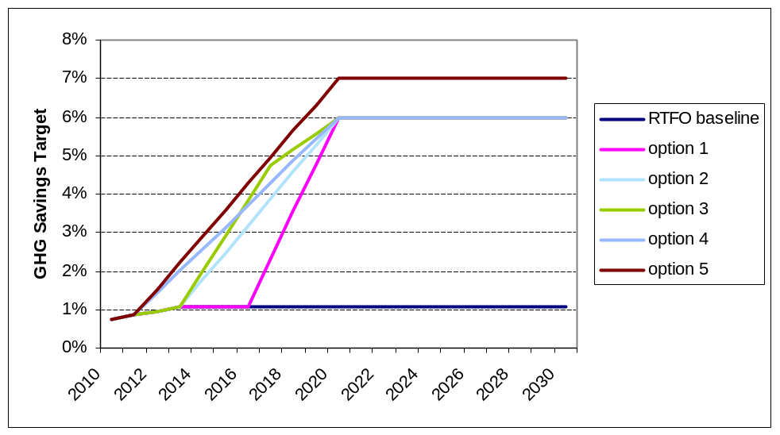

- Under the high overall cost scenario as shown in figure 24 average GHG savings in the (RTFO) baseline are lower. Therefore each of the trajectories requires more additional GHG savings to meet a 6% or 7% 2020 GHG savings target.

Figure 25: Costs and benefits under high overall cost scenario
Cost Benefit summary |  | option 1 | option 2 | option 3 | option 4 | option 5
additional compliance cost to 2030 (£m) | £m | -12,368 | -14,202 | -15,240 | -15,386 | -19,361
additional administrative costs to 2030 (£m) | £m | -5 | -6 | -6 | -7 | -7
additional infrastructure costs (£m) | £m | -285 | -285 | -285 | -285 | -285
additional GHG savings to 2030 (£m) | £m | 4,976 | 5,746 | 6,059 | 6,218 | 7,492
ancillary benefits to 2030 (£m) | £m | 2,962 | 3,294 | 3,498 | 3,494 | 4,424
Net Benefit to 2030 (£m) | £m | -4,720 | -5,453 | -5,974 | -5,966 | -7,737

- Under the high overall cost scenario, compliance costs are higher due to lower average GHG savings in the baseline (meaning more additional GHG savings will be required to meet a given GHG savings target). Lower assumed average GHG savings under the FQD mean that a greater volume of biofuel will be required to deliver GHG savings, further increasing costs. Monetised benefits from GHG savings (relative to the central cost scenario) are higher due to the larger overall volume of GHG savings required for a given option. Ancillary benefits (i.e. congestion, accidents, noise) are also higher due to increased pump price impacts leading to lower overall fuel demand. Overall net benefit values are lower (i.e. more negative) under the high overall cost scenario than under the central cost scenario.

Figure 26: Lifecycle GHG savings under high overall cost scenario
Life-cycle GHG savings |  | option 1 | option 2 | option 3 | option 4 | option 5
additional CO2 savings in 2020 | MTCO₂e | 7.6 | 7.6 | 7.6 | 7.6 | 9.2
additional CO2 savings to 2030 | MTCO₂e | 95.6 | 107.1 | 111.9 | 113.7 | 136.9
£/tCO₂e (to 2030) | £/tCO₂e | 49.4 | 50.9 | 53.4 | 52.5 | 56.5

- Relative to the central scenario, figure 26 shows additional GHG savings under the high overall cost scenario are higher due to lower GHG savings in the baseline (resulting from assumed lower average RTFO GHG savings). The £/tCO₂e cost effectiveness metric is higher (i.e. more expensive per tonne of CO₂ saved) due to the lower overall net benefit (which is driven by higher compliance costs e.g. the cost of supplying GHG savings rises).

Figure 27: Pump price impacts under high overall cost scenario
2020 PUMP PRICE IMPACTS
petrol |  | option 1 | option 2 | option 3 | option 4 | option 5
pump price | ppl | 1.5 | 1.5 | 1.5 | 1.5 | 1.8
pump price | % | 1.8% | 1.8% | 1.8% | 1.8% | 2.1%
energy cost | £/GJ | £0.78 | £0.78 | £0.78 | £0.78 | £0.96
energy cost | % | 7.8% | 7.8% | 7.8% | 7.8% | 9.6%
consumer cost | £/GJ | £1.86 | £1.86 | £1.86 | £1.86 | £2.31
consumer cost | % | 5.0% | 5.0% | 5.0% | 5.0% | 6.2%
road diesel
pump price | ppl | 3.5 | 3.5 | 3.5 | 3.5 | 4.4
pump price | % | 2.8% | 2.8% | 2.8% | 2.8% | 3.5%
energy cost | £/GJ | £0.90 | £0.90 | £0.90 | £0.90 | £1.13
energy cost | % | 9.2% | 9.2% | 9.2% | 9.2% | 11.5%
consumer cost | £/GJ | 1.26 | 1.26 | 1.26 | 1.26 | 1.58
consumer cost | % | 3.7% | 3.7% | 3.7% | 3.7% | 4.6%
NRMM diesel
pump price | ppl | 5.5 | 5.5 | 5.5 | 5.5 | 6.3
pump price | % | 9.0% | 9.0% | 9.0% | 9.0% | 10.5%
energy cost | £/GJ | £1.38 | £1.38 | £1.38 | £1.38 | £1.61
energy cost | % | 14.6% | 14.6% | 14.6% | 14.6% | 17.1%
consumer cost | £/GJ | £1.72 | £1.72 | £1.72 | £1.72 | £2.01
consumer cost | % | 10.4% | 10.4% | 10.4% | 10.4% | 12.1%

- As shown in figure 27, pump price impacts are higher under the high overall cost scenario due to higher compliance costs resulting from lower projected average GHG savings.

Low overall cost scenario

Figure 28: FQD trajectories under low overall cost scenarios
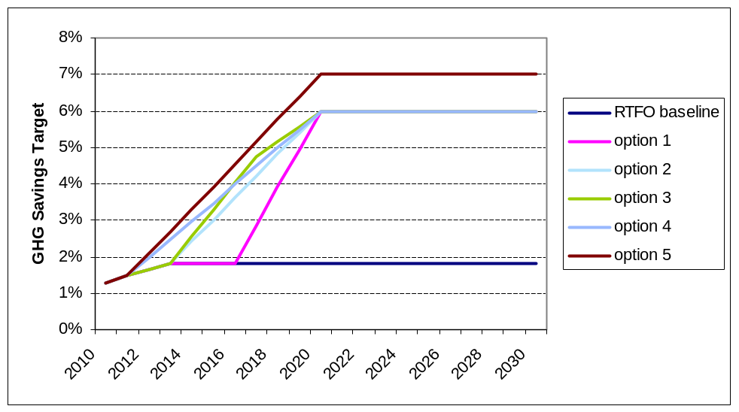

- Under the low overall cost scenario average GHG savings in the (RTFO) baseline are higher than under the central cost scenario due to higher assumed average baseline GHG savings. Therefore each of the trajectories requires less additional GHG savings to meet a 6% or 7% 2020 GHG savings target.

Figure 29: Costs and benefits under high overall cost scenario
Cost Benefit summary |  | option 1 | option 2 | option 3 | option 4 | option 5
additional compliance cost to 2030 (£m) | £m | -5,489 | -6,486 | -6,801 | -7,085 | -8,971
additional administrative costs to 2030 (£m) | £m | -5 | -6 | -6 | -7 | -7
additional infrastructure costs (£m) | £m | -285 | -285 | -285 | -285 | -285
additional GHG savings to 2030 (£m) | £m | 3,375 | 3,898 | 4,055 | 4,168 | 5,188
ancillary benefits to 2030 (£m) | £m | 1,058 | 1,203 | 1,255 | 1,283 | 1,649
NPV to 2030 (£m) | £m | -1,345 | -1,677 | -1,782 | -1,926 | -2,426

- As figure 29 shows, compliance costs are lower under the low overall cost scenario as lower volumes of biofuel are required to meet the target because average GHG savings are higher under this scenario. Monetised GHG benefits are also lower as less additional (to the RTFO baseline) GHG savings are required to meet the targets. Ancillary benefits (i.e. congestion, accidents, noise) are also lower due to a lower increase in pump price impacts (which correspond to a lower fall in demand for road transport energy).

Figure 30: Lifecycle GHG savings under low overall cost scenario
Life-cycle GHG savings |  | option 1 | option 2 | option 3 | option 4 | option 5
additional CO₂e savings in 2020 | MTCO₂e | 6.0 | 6.0 | 6.0 | 6.0 | 7.5
additional CO₂e savings to 2030 | MTCO₂e | 75.7 | 84.9 | 87.7 | 89.2 | 110.9
£/tCO₂e (to 2030) | £/tCO₂e | 17.8 | 19.8 | 20.3 | 21.6 | 21.9

- Overall GHG savings (additional to the RTFO baseline) are lower under the low overall cost scenario due to higher projected baseline GHG savings, as shown in figure 30. The £/tCO₂e cost effectiveness metric is lower due to higher overall net benefit (which is driven by lower compliance costs e.g. the cost of supplying GHG savings falls).

Figure 31: Pump price impacts under low overall cost scenario
2020 PUMP PRICE IMPACTS
petrol |  | option 1 | option 2 | option 3 | option 4 | option 5
pump price | ppl | -1.2 | -1.2 | -1.2 | -1.2 | -1.5
pump price | % | -1.2% | -1.2% | -1.2% | -1.2% | -1.4%
energy cost | £/GJ | £0.25 | £0.25 | £0.25 | £0.25 | £0.32
energy cost | % | 1.2% | 1.2% | 1.2% | 1.2% | 1.5%
consumer cost | £/GJ | £0.94 | £0.94 | £0.94 | £0.94 | £1.19
consumer cost | % | 1.8% | 1.8% | 1.8% | 1.8% | 2.3%
road diesel
pump price | ppl | 1.3 | 1.3 | 1.3 | 1.3 | 1.7
pump price | % | 0.7% | 0.7% | 0.7% | 0.7% | 1.0%
energy cost | £/GJ | £0.47 | £0.47 | £0.47 | £0.47 | £0.60
energy cost | % | 2.2% | 2.2% | 2.2% | 2.2% | 2.8%
consumer cost | £/GJ | 0.69 | 0.69 | 0.69 | 0.69 | 0.88
consumer cost | % | 1.4% | 1.4% | 1.4% | 1.4% | 1.8%
NRMM diesel
pump price | ppl | 2.4 | 2.4 | 2.4 | 2.4 | 2.8
pump price | % | 2.1% | 2.1% | 2.1% | 2.1% | 2.5%
energy cost | £/GJ | £0.76 | £0.76 | £0.76 | £0.76 | £0.89
energy cost | % | 3.6% | 3.6% | 3.6% | 3.6% | 4.2%
consumer cost | £/GJ | £0.97 | £0.97 | £0.97 | £0.97 | £1.14
consumer cost | % | 3.2% | 3.2% | 3.2% | 3.2% | 3.7%

- As figure 31 shows, pump price impacts are higher under the high overall cost scenario due to higher compliance costs resulting from lower projected average GHG savings.

SECTION 6 - Put in place a 6% 2020 GHG savings obligation but delaying determining what further steps to take to implement the GHG saving obligation (approach C / Option 6)

Rationale

- There are a number of significant uncertainties surrounding increased deployment of biofuel including indirect land use change, impact on food markets and the feasibility and costs of deploying biofuels in excess of the “blend wall” (which is required to meet a 6% GHG savings target). It is important that more evidence is sought on these issues as they have significant implications for the consideration of options for meeting the FQD targets.

- Given these uncertainties, option 6 (outlined in approach C in the accompanying consultation document) proposes to put in place a 6% GHG saving target in 2020 but delay determining what further steps to take to implement the GHG saving until sustainability and deployment issues can be addressed effectively.

Cost Benefit Analysis

- The costs and benefits associated with this option will fall within the range of those presented for options 1, 2 and 3 in the previous analysis in section 3. These trajectories represent a range of scenarios showing how a 6% 2020 target - with a trajectory starting in 2014 onwards - could be achieved, with option 1 forming the lower end of the range (in terms of costs) and option 3 forming upper end of the range. More detailed qualitative and quantitative analysis of these options can be found in section 3 (paras 102 – 133). Analysis, sensitivities and caveats apply as per the previous analysis in section 3.

Figure 32: Subset of GHG savings target trajectory options for Approach C
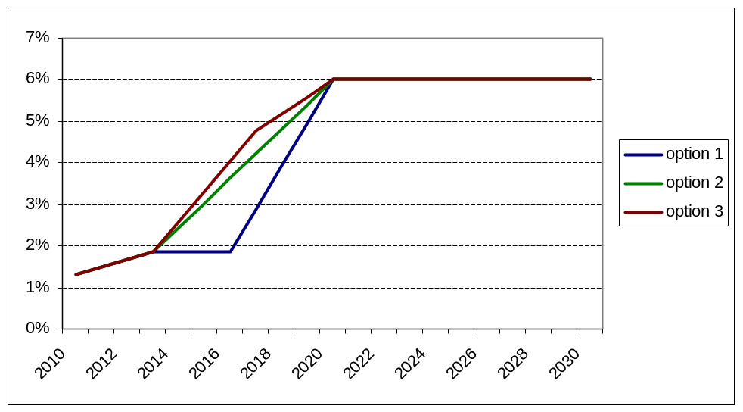

Figure 33: Range of potential costs and benefits under Approach C
Cost Benefit summary |  | option 1 | option 2 | option 3
additional compliance cost to 2030 (£m) | £m | -8,605 | -10,182 | -10,838
additional administrative costs to 2030 (£m) | £m | -5 | -6 | -6
additional infrastructure costs (£m) | £m | -285 | -285 | -285
additional GHG savings to 2030 (£m) | £m | 4,102 | 4,736 | 4,956
ancillary benefits to 2030 (£m) | £m | 1,939 | 2,208 | 2,330
NPV to 2030 (£m) | £m | -2,853 | -3,529 | -3,843

- Figure 33 shows the range of potential costs and benefits associated with approach C. Costs and benefits depend upon the profile of the trajectory chosen to reach the 6% target in 2020. Trajectories which are weighted towards 2010 will lead to greater costs and benefits and a higher overall net cost. Option 3 leads to the highest net cost to society and option 1 leads to the lowest. This is because a greater overall volume of biofuel (which is estimated to be more expensive than the fossil fuel which it displaces) will be supplied under these trajectories. However, trajectories weighted towards the present are more likely to deliver the 2020 6% GHG savings target as the industry will have more time to adapt to the changes required to deliver the target.

Infraction risk

- Option 6 (approach C) is considered to mitigate infraction risk relative to doing nothing baseline scenario (approach A), however option 6 does not completely mitigate all infraction risk as the absence of a trajectory of annual GHG savings targets (as would be delivered under approach B) could be viewed as non-compliance with the directive.

- The infraction risk for this option has not been explicitly quantified in the Impact Assessment. This is because it is unclear at this stage what the relative likelihood of infraction would be, as well as the exact scale of any fines.

SECTION 7 - Summary and Preferred Option

- Given continued substantial uncertainty over sustainability impacts associated with increased biofuel deployment and the practicalities of delivering biofuel in excess of the blend wall, option 6 (approach C) is recommended as the preferred option. This allows time for required evidence and information to be developed before committing to a trajectory to achieve the FQD target for 2020, while also proving clarity for the industry regarding the level of that 2020 target. To set the trajectory in advance of having this information raises potential risks of setting obligations on business that may not be justified.

- Putting in place a 6% GHG 2020 savings target whilst delaying determining what further steps to take to implement the GHG saving obligation will allow us to demonstrate compliance with the Fuel Quality Directive whilst maintaining flexibility to conduct further research into sustainability and deployment options in advance of setting a final target trajectory. It also allows a better understanding to be built of associated issues regarding the risks and costs to business before committing to a particular trajectory; and therefore increases the ability to set a trajectory at an appropriate time which allows the FQD targets to be met cost effectively.

Annexes
Annex 1 should be used to set out the Post Implementation Review Plan as detailed below. Further annexes may be added where the Specific Impact Tests yield information relevant to an overall understanding of policy options.

Annex 1: Post Implementation Review (PIR) Plan
A PIR should be undertaken, usually three to five years after implementation of the policy, but exceptionally a longer period may be more appropriate. A PIR should examine the extent to which the implemented regulations have achieved their objectives, assess their costs and benefits and identify whether they are having any unintended consequences. Please set out the PIR Plan as detailed below. If there is no plan to do a PIR please provide reasons below.
Basis of the review: [The basis of the review could be statutory (forming part of the legislation), it could be to review existing policy or there could be a political commitment to review];
The preferred option presented in this impact assessment is to delay determining what further steps to take to implement a GHG saving obligation until sustainability and deployment issues can be addressed effectively. A review will be required in order to make a decision on implementing a trajectory of targets.
Review objective: [Is it intended as a proportionate check that regulation is operating as expected to tackle the problem of concern?; or as a wider exploration of the policy approach taken?; or as a link from policy objective to outcome?]
The review objective is to determine a sustainable and feasible approach for delivering GHG savings required under the FQD.
Review approach and rationale: [e.g. describe here the review approach (in-depth evaluation, scope review of monitoring data, scan of stakeholder views, etc.) and the rationale that made choosing such an approach]
A full cost-benefit analysis and impact assessment covering all aspects of implementing the FQD.
Baseline: [The current (baseline) position against which the change introduced by the legislation can be measured]
The Renewable Transport Fuel Obligation.
Success criteria: [Criteria showing achievement of the policy objectives as set out in the final impact assessment; criteria for modifying or replacing the policy if it does not achieve its objectives]
Identification of a sustainable and feasible policy option for delivering FQD GHG savings targets.
Monitoring information arrangements: [Provide further details of the planned/existing arrangements in place that will allow a systematic collection systematic collection of monitoring information for future policy review]
The RTFO administrator collects detailed data on the UK biofuel supply.
Reasons for not planning a PIR: [If there is no plan to do a PIR please provide reasons here]

Annex 2 — Competition Assessment

- Along with GHG savings, the main economic impact of implementing the FQD 6% GHG savings target is expected to be an increase in transport fuel costs in the UK. Increases would be expected to be felt particularly keenly by consumers of fuel for NRMM (which is not currently covered under the RTFO), as the increase in fuel costs would be proportionally larger in this sector (as it is not currently obligated under the RTFO).

- In general — within the UK/EU economy — impacts of cost increases attributable the FQD are expected to be felt in proportion to the reliance on such fuels. However the cost base of those who rely on such fuels disproportionately, for example due to the physical location of their agricultural activities, may be expected to be disproportionately affected. EU global competitiveness may suffer as a result of increased input costs relative to international competitors, and this may also be the case more widely for export industries which rely on transport fuel as a significant input may be put at a competitive disadvantage relative to international competitors.

- The Directive is to be implemented across the EU as a whole in order to ensure as far as possible, a level playing field, though it is recognised that some fuel suppliers are global and therefore may need to adapt their EU operations specifically.

- The fact that there is no minimum threshold allowed for in the Directive means that all suppliers of relevant fuel will be obligated. Although in one sense this creates a level playing field it means that the effects of such an obligation will be felt to varying degrees across the industry, with some companies more able to adapt to the FQD requirements more readily than others, and at a different cost. The distribution of effects would therefore be expected to differ, depending on the particular fuel markets served, the size of the supplier, the cost base etc. These differences may in turn have an adverse impact on the competitiveness of some firms in the industry.

- The preferred option signals the direction of policy by setting the 2020 target but allows time for the essential evidence to be gathered before committing to a detailed trajectory over that timeframe. No impacts are therefore expected before 2014.

Annex 3 — Small Firms Assessment

- Along with GHG savings, the main economic impact of implementing the FQD 6% GHG savings target is expected to be an increase in transport fuel costs across the economy. It is assumed that, in general, small firms and large firms will use same relative volume of fuel for a given economic activity and will be affected equally by any increase in fuel costs though the proportion of business costs accounted for by transport costs is likely to vary. The impact will therefore vary by supplier.

- As mentioned in the Competition Assessment, the Directive’s requirement that all fuel suppliers are obligated will impose some fixed administrative costs on all transport fuel suppliers (These are covered in more detail in paragraph 82). As smaller suppliers have a smaller revenue base than larger suppliers they will be affected disproportionately by the imposition of any fixed costs. Options around extending the obligation to cover all fuel suppliers, irrespective of size, have not been monetised at this stage of the policy process. Stakeholder views on this subject are invited as part of the consultation.

- The particular impact on small firms would be expected to vary, depending on the particular fuels supplied, their existing business models and ability to adapt to changes in obligations placed upon them, their existing cost base, their level of competition from larger players who may experience different impacts to them etc. Again, stakeholder views on these issues are invited.

- Under the preferred option, no additional impacts would be expected before 2014 (though there may be some industry preparatory costs)

Annex 4 — Sustainable Development

- An increase in biofuel demand would increase the potential for sustainable biofuels to contribute to sustainable development through the decarbonisation of the UK’s transport system and contribute towards meeting the Department’s transport sector carbon budgets.

- However, increased biofuel deployment can potentially have adverse impacts on sustainability such as biodiversity impacts and GHG emissions associated with agriculture and refining.

- In order for biofuel to count towards the FQD GHG savings target, it must be compliant with the mandatory sustainability criteria (which sets minimum standards for lifecycle GHG savings and biodiversity impacts).

- GHG emissions from the indirect effects of feedstock crop cultivation (this is often referred to as indirect land use change, ILUC, which is for example, the displacement of cultivation onto land which leads to GHG emissions) are not currently addressed by the mandatory sustainability criteria. The Department for Transport is currently conducting research into this issue.

Annex 5 — Racial and Disability Equality

- Along with GHG savings, the main economic impact of implementing the FQD 6% GHG savings target will be an increase in transport fuel costs across the economy. For this to have a negative impact across racial groups, the amount of fuel consumed and the type of fuel consumed would need to be greater for people of a specific racial groups relative to the whole population. The Department for Transport is not aware of any evidence that disaggregates fuel consumption between racial groups on a quantitative or qualitative basis.

- Likewise, for the policy to have a negative impact upon disabled people, the amount of fuel consumed and the type of fuel consumed would need to be greater for disabled people relative to the whole population. The Department for Transport is not aware of any evidence that disaggregates fuel consumption between groups on a quantitative or qualitative basis. However, to the extent that some disabled people are reliant on personal road transport, any increase in fuel prices, as set out in this analysis, would affect their travel costs adversely.

Annex 6 — Gender Equality

- Along with GHG savings, the main economic impact of implementing the FQD 6% GHG savings target will be an increase in transport fuel costs across the economy. For this to have a negative impact between genders, the amount of fuel consumed and the type of fuel consumed would need to be greater for people of a specific gender relative to the whole population. As stated above, The Department for Transport is not aware of any evidence that disaggregates fuel consumption between gender groups on a quantitative or qualitative basis.

Annex 7 — Rural Proofing Assessment

- An increase in NRMM fuel prices could pose an additional cost burden on rural businesses, as many of these will be in the agricultural sector, which is one of the main users of non-road mobile machinery. The estimated impact on NRMM fuel prices has been set out in this analysis.

- An increase in road transport fuel costs may also have a disproportionate impact on rural communities and businesses which have higher fuel demand than their urban counterparts. But the UK agriculture sector may benefit if there are opportunities for the UK to supply sustainable biofuels and contribute to the UK meeting its obligations.

- An increase in biofuel demand could reduce opportunities for UK biofuel refiners and feedstock suppliers if they have previously specialised in the supply of biofuels which offer relatively lower GHG savings, which may have impacts on rural incomes through either higher employment in biofuel production facilities or through increased business opportunities for UK biofuel supply chains. These impacts have not been directly quantified.

- Increased biofuel deployment may be an issue for particularly remote rural areas that are serviced by marine tankers. The chemical properties of hydrocarbon petrol and ethanol are such that they do not mix particularly well at the molecular level, and can easily be encouraged to separate with the addition of water. This is known as phase separation and is problematic because standard marine tankers do not keep moisture from coming into contact with the fuel adequately. Thus in remote areas of the country that are supplied primarily by these means, such as the “Highlands and Islands” in Scotland, may not be able to take the same biofuel blend as the rest of the country.

Annex 8 — Fossil fuel and biofuel price projections

- Biofuel price projections were developed using the OECD FAO Aglink-Cosimo model and have been modelled to correspond with the four different DECC oil price scenarios – “low”, “central”, “high” and “high–high”.

Figure A1: biodiesel/bioethanol price projections
 | bioethanol |  |  |  | Biodiesel
 | low | central | high | high–high | low | central | high | High–high
2010 | 43 | 49 | 52 | 57 | 66 | 70 | 73 | 77
2011 | 42 | 45 | 48 | 53 | 64 | 69 | 72 | 78
2012 | 43 | 48 | 52 | 59 | 66 | 70 | 74 | 80
2013 | 45 | 50 | 55 | 62 | 67 | 71 | 75 | 82
2014 | 46 | 50 | 56 | 64 | 66 | 70 | 75 | 84
2015 | 47 | 50 | 56 | 65 | 66 | 70 | 76 | 86
2016 | 45 | 48 | 54 | 62 | 66 | 70 | 77 | 89
2017 | 44 | 47 | 52 | 59 | 65 | 69 | 77 | 88
2018 | 43 | 46 | 51 | 58 | 66 | 70 | 78 | 91
2019 | 42 | 45 | 50 | 56 | 66 | 70 | 79 | 92
2020 | 42 | 44 | 49 | 54 | 67 | 71 | 81 | 96
2021 | 42 | 44 | 49 | 54 | 67 | 71 | 81 | 96
2022 | 42 | 44 | 49 | 54 | 67 | 71 | 81 | 96
2023 | 42 | 44 | 49 | 54 | 67 | 71 | 81 | 96
2024 | 42 | 44 | 49 | 54 | 67 | 71 | 81 | 96
2025 | 42 | 44 | 49 | 54 | 67 | 71 | 81 | 96
2026 | 42 | 44 | 49 | 54 | 67 | 71 | 81 | 96
2027 | 42 | 44 | 49 | 54 | 67 | 71 | 81 | 96
2028 | 42 | 44 | 49 | 54 | 67 | 71 | 81 | 96
2029 | 42 | 44 | 49 | 54 | 67 | 71 | 81 | 96
2030 | 42 | 44 | 49 | 54 | 67 | 71 | 81 | 96
Source: OECD FAO Aglink-Cosimo modelling

- Projections of future oil prices are produced by the Department of Energy and Climate Change.
Figure A2: DECC oil price scenarios (2008 prices)
Low | Central | High | High High
50 | 70 | 84 | 103
50 | 71 | 87 | 111
52 | 72 | 91 | 119
54 | 73 | 95 | 126
56 | 74 | 98 | 134
58 | 75 | 102 | 142
60 | 76 | 105 | 150
60 | 77 | 109 | 150
60 | 78 | 113 | 150
60 | 79 | 116 | 150
60 | 80 | 120 | 150
60 | 81 | 120 | 150
60 | 82 | 120 | 150
60 | 83 | 120 | 150
60 | 84 | 120 | 150
60 | 85 | 120 | 150
60 | 86 | 120 | 150
60 | 87 | 120 | 150
60 | 88 | 120 | 150
60 | 89 | 120 | 150
60 | 90 | 120 | 150
Source: DECC

- Projections of pre-tax petrol/diesel prices based on underlying DECC oil price scenarios are presented in table A2.

Figure A3: fossil diesel/petrol price projections (pre-tax price)
 | petrol |  |  |  | Diesel
 | low | central | high | high–high | low | central | high | High–high
2010 | 30 | 39 | 46 | 54 | 32 | 43 | 50 | 60
2011 | 30 | 40 | 47 | 58 | 32 | 43 | 52 | 64
2012 | 31 | 40 | 49 | 62 | 33 | 44 | 54 | 68
2013 | 32 | 41 | 51 | 65 | 34 | 44 | 56 | 72
2014 | 33 | 41 | 52 | 69 | 35 | 45 | 57 | 76
2015 | 34 | 41 | 54 | 72 | 36 | 45 | 59 | 80
2016 | 35 | 42 | 55 | 76 | 38 | 46 | 61 | 85
2017 | 35 | 42 | 57 | 76 | 38 | 46 | 63 | 85
2018 | 35 | 43 | 59 | 76 | 38 | 47 | 65 | 85
2019 | 35 | 43 | 60 | 76 | 38 | 47 | 67 | 85
2020 | 35 | 44 | 62 | 76 | 38 | 48 | 69 | 85
2021 | 35 | 44 | 62 | 76 | 38 | 48 | 69 | 85
2022 | 35 | 45 | 62 | 76 | 38 | 49 | 69 | 85
2023 | 35 | 45 | 62 | 76 | 38 | 50 | 69 | 85
2024 | 35 | 46 | 62 | 76 | 38 | 50 | 69 | 85
2025 | 35 | 46 | 62 | 76 | 38 | 51 | 69 | 85
2026 | 35 | 47 | 62 | 76 | 38 | 51 | 69 | 85
2027 | 35 | 47 | 62 | 76 | 38 | 52 | 69 | 85
2028 | 35 | 48 | 62 | 76 | 38 | 52 | 69 | 85
2029 | 35 | 48 | 62 | 76 | 38 | 53 | 69 | 85
2030 | 35 | 49 | 62 | 76 | 38 | 53 | 69 | 85
Source: DfT road transport fuel price model (based on DECC oil prices)

Annex 9 — road transport fuel demand elasticity and ancillary benefit coefficients

- Table A3 shows projections of the elasticity of demand for road transport fuel which shows the reduction in road transport fuel demand estimated for a 1% increase in pump prices (e.g. a 1% increase in pump prices in 2012 will lead to a 0.2% decrease in demand for road transport fuel.

Figure A4: price elasticity of demand for road transport fuel
 | Elasticity (%)
2010 | -0.21
2011 | -0.21
2012 | -0.20
2013 | -0.20
2014 | -0.20
2015 | -0.19
2016 | -0.19
2017 | -0.18
2018 | -0.18
2019 | -0.18
2020 | -0.17
2021 | -0.17
2022 | -0.17
2023 | -0.17
2024 | -0.16
2025 | -0.16
2026 | -0.16
2027 | -0.15
2028 | -0.15
2029 | -0.15
2030 | -0.14
Source: Internal analysis (DfT)

- A decrease in overall fuel consumption is caused by a decrease in total vehicle kilometres driven. The following series shows average km/litre and allows us to calculate a reduction/increase in vehicle kilometres from a reduction/increase in total fuel consumption.

Figure A5: vehicle kilometre per litre conversion factors for petrol and diesel
 | Average Petrol km/L | Average Diesel km/L
2010 | 13.19 | 15.99
2011 | 13.36 | 16.12
2012 | 13.57 | 16.25
2013 | 13.79 | 16.38
2014 | 14.03 | 16.49
2015 | 14.32 | 16.64
2016 | 14.61 | 16.77
2017 | 14.90 | 16.90
2018 | 15.18 | 17.02
2019 | 15.45 | 17.13
2020 | 18.85 | 20.68
2021 | 15.94 | 17.33
2022 | 16.15 | 17.41
2023 | 16.34 | 17.49
2024 | 16.52 | 17.55
2025 | 16.67 | 17.59
2026 | 16.80 | 17.63
2027 | 16.90 | 17.66
2028 | 16.98 | 17.68
2029 | 17.04 | 17.69
2030 | 17.09 | 17.70
Source: Internal analysis (DfT)

- An increase/reduction in vehicle kilometres is estimated to produce benefits which can be quantified in monetised terms. For example, fewer cars on the road will lead to less time lost through congestion. A change in vehicle kilometres has been explicitly linked to the following benefits through the (£/vehicle km) presented in the following table.

Figure A6: monetised benefits conversion factors for vehicle kilometre changes
 | Diesel AQ | Petrol AQ | Infrastructure | Accidents | Noise | Congestion
2010 | -0.00161 | -0.00017 | -0.00076 | -0.0175 | -0.00137 | -0.01906
2011 | -0.00161 | -0.00017 | -0.00076 | -0.01771 | -0.00138 | -0.02027
2012 | -0.00161 | -0.00017 | -0.00076 | -0.01792 | -0.0014 | -0.02149
2013 | -0.00161 | -0.00017 | -0.00076 | -0.01814 | -0.00142 | -0.02271
2014 | -0.0016 | -0.00016 | -0.00076 | -0.01836 | -0.00143 | -0.02392
2015 | -0.0015 | -0.00016 | -0.00076 | -0.01858 | -0.00145 | -0.02514
2016 | -0.0015 | -0.00016 | -0.00076 | -0.0188 | -0.00147 | -0.02635
2017 | -0.0015 | -0.00016 | -0.00076 | -0.01903 | -0.00148 | -0.02757
2018 | -0.00149 | -0.00016 | -0.00076 | -0.01926 | -0.0015 | -0.02879
2019 | -0.00149 | -0.00015 | -0.00076 | -0.01949 | -0.00152 | -0.03
2020 | -0.0014 | -0.00015 | -0.00076 | -0.01973 | -0.00154 | -0.03122
2021 | -0.00139 | -0.00015 | -0.00076 | -0.01996 | -0.00156 | -0.03243
2022 | -0.00139 | -0.00015 | -0.00076 | -0.02021 | -0.00158 | -0.03365
2023 | -0.00139 | -0.00014 | -0.00076 | -0.02045 | -0.0016 | -0.03487
2024 | -0.00139 | -0.00014 | -0.00076 | -0.0207 | -0.00161 | -0.03608
2025 | -0.0013 | -0.00014 | -0.00076 | -0.02094 | -0.00163 | -0.0373
2026 | -0.0013 | -0.00014 | -0.00076 | -0.0212 | -0.00165 | -0.03851
2027 | -0.00129 | -0.00014 | -0.00076 | -0.02145 | -0.00167 | -0.03973
2028 | -0.00129 | -0.00013 | -0.00076 | -0.02171 | -0.00169 | -0.04094
2029 | -0.00129 | -0.00013 | -0.00076 | -0.02197 | -0.00171 | -0.04216
2030 | -0.00121 | -0.00013 | -0.00076 | -0.02224 | -0.00173 | -0.04338
Source: Internal analysis (DfT)

Annex 10 — dieselisation assumptions

- Assumptions around dieselisation of the road transport fleet have been taken from the DECC energy model. The following table shows the projection of dieselisation rates used in the modelling.

Figure A7: dieselisation projection for road transport fuel
 | diesel | petrol
2010 | 55% | 45%
2011 | 55% | 45%
2012 | 56% | 44%
2013 | 57% | 43%
2014 | 58% | 42%
2015 | 59% | 41%
2016 | 59% | 41%
2017 | 60% | 40%
2018 | 61% | 39%
2019 | 61% | 39%
2020 | 62% | 38%
2021 | 62% | 38%
2022 | 62% | 38%
2023 | 63% | 37%
2024 | 63% | 37%
2025 | 63% | 37%
2026 | 64% | 36%
2027 | 64% | 36%
2028 | 64% | 36%
2029 | 64% | 36%
2030 | 65% | 35%
Source: Internal analysis

Annex 11 — Energy demand, carbon emissions and carbon values

- Figure A7 shows projected demand for transport energy over the period from 2010 to 2030. Road diesel, road petrol and rail figures are taken from DECC energy modelling. The estimate for NRMM is based on internal analysis conducted by the Department. Figure A9 shows estimated GHG emissions that have been calculated using the energy figures in Figure A7 and the lifecycle GHG emissions factors which are listed in Figure A8.

Figure A8: Transport Energy Demand Projections across energy price scenarios (terajoules)
LOW
diesel | petrol | rail | NRMM | total diesel | total petrol
943,047 | 775,932 | 30,496 | 84,111 | 1,057,654 | 775,932
962,377 | 775,835 | 30,263 | 85,013 | 1,077,653 | 775,835
982,519 | 766,983 | 30,066 | 85,481 | 1,098,066 | 766,983
1,000,549 | 754,581 | 29,931 | 85,636 | 1,116,116 | 754,581
1,017,581 | 740,593 | 29,661 | 85,649 | 1,132,891 | 740,593
1,026,045 | 720,803 | 29,395 | 85,604 | 1,141,044 | 720,803
1,034,272 | 704,346 | 29,134 | 85,533 | 1,148,940 | 704,346
1,042,175 | 690,211 | 28,878 | 85,451 | 1,156,504 | 690,211
1,050,200 | 678,394 | 28,627 | 85,445 | 1,164,273 | 678,394
1,057,851 | 668,399 | 28,381 | 85,478 | 1,171,710 | 668,399
1,065,573 | 660,158 | 28,140 | 85,529 | 1,179,242 | 660,158
1,072,617 | 653,392 | 28,140 | 85,590 | 1,186,347 | 653,392
1,079,177 | 647,689 | 28,140 | 85,655 | 1,192,972 | 647,689
1,085,771 | 643,020 | 28,140 | 85,723 | 1,199,634 | 643,020
1,092,426 | 639,366 | 28,140 | 85,793 | 1,206,358 | 639,366
1,099,321 | 637,117 | 24,946 | 85,862 | 1,210,130 | 637,117
1,104,101 | 632,337 | 24,946 | 85,862 | 1,214,910 | 632,337
1,108,913 | 627,525 | 24,946 | 85,862 | 1,219,722 | 627,525
1,113,702 | 622,736 | 24,946 | 85,862 | 1,224,511 | 622,736
1,118,436 | 618,002 | 24,946 | 85,862 | 1,229,244 | 618,002
1,123,140 | 613,298 | 24,946 | 85,862 | 1,233,949 | 613,298
CENTRAL
diesel | petrol | rail | NRMM | total diesel | total petrol
943,047 | 775,932 | 30,496 | 84,111 | 1,057,654 | 775,932
952,165 | 767,603 | 30,263 | 84,111 | 1,066,539 | 767,603
966,778 | 754,695 | 30,066 | 84,111 | 1,080,955 | 754,695
982,736 | 741,147 | 29,931 | 84,111 | 1,096,778 | 741,147
999,304 | 727,291 | 29,661 | 84,111 | 1,113,076 | 727,291
1,008,154 | 708,234 | 29,395 | 84,111 | 1,121,660 | 708,234
1,017,081 | 692,638 | 29,134 | 84,111 | 1,130,326 | 692,638
1,025,830 | 679,386 | 28,878 | 84,111 | 1,138,820 | 679,386
1,033,800 | 667,800 | 28,627 | 84,111 | 1,146,539 | 667,800
1,040,932 | 657,709 | 28,381 | 84,111 | 1,153,424 | 657,709
1,047,910 | 649,215 | 28,140 | 84,111 | 1,160,161 | 649,215
1,054,084 | 642,102 | 28,140 | 84,111 | 1,166,334 | 642,102
1,059,722 | 636,012 | 28,140 | 84,111 | 1,171,973 | 636,012
1,065,349 | 630,925 | 28,140 | 84,111 | 1,177,599 | 630,925
1,071,013 | 626,833 | 28,140 | 84,111 | 1,183,264 | 626,833
1,076,900 | 624,123 | 24,946 | 84,111 | 1,185,957 | 624,123
1,081,583 | 619,440 | 24,946 | 84,111 | 1,190,640 | 619,440
1,086,296 | 614,726 | 24,946 | 84,111 | 1,195,354 | 614,726
1,090,987 | 610,035 | 24,946 | 84,111 | 1,200,045 | 610,035
1,095,625 | 605,398 | 24,946 | 84,111 | 1,204,682 | 605,398
1,100,233 | 600,789 | 24,946 | 84,111 | 1,209,290 | 600,789
HIGH
diesel | petrol | rail | NRMM | total diesel | total petrol
943,047 | 775,932 | 30,496 | 84,111 | 1,057,654 | 775,932
945,816 | 762,485 | 30,263 | 83,550 | 1,059,630 | 762,485
956,229 | 746,460 | 30,066 | 83,193 | 1,069,488 | 746,460
969,110 | 730,871 | 29,931 | 82,945 | 1,081,986 | 730,871
983,105 | 715,501 | 29,661 | 82,748 | 1,095,513 | 715,501
989,688 | 695,262 | 29,395 | 82,570 | 1,101,654 | 695,262
996,434 | 678,578 | 29,134 | 82,404 | 1,107,972 | 678,578
1,003,029 | 664,286 | 28,878 | 82,242 | 1,114,149 | 664,286
1,008,886 | 651,706 | 28,627 | 82,084 | 1,119,597 | 651,706
1,013,956 | 640,664 | 28,381 | 81,931 | 1,124,268 | 640,664
1,018,910 | 631,248 | 28,140 | 81,783 | 1,128,833 | 631,248
1,023,113 | 623,236 | 28,140 | 81,640 | 1,132,892 | 623,236
1,028,130 | 617,052 | 28,140 | 81,604 | 1,137,873 | 617,052
1,033,821 | 612,254 | 28,140 | 81,622 | 1,143,583 | 612,254
1,039,895 | 608,621 | 28,140 | 81,667 | 1,149,702 | 608,621
1,046,350 | 606,417 | 24,946 | 81,725 | 1,153,022 | 606,417
1,050,900 | 601,867 | 24,946 | 81,725 | 1,157,571 | 601,867
1,055,480 | 597,287 | 24,946 | 81,725 | 1,162,151 | 597,287
1,060,038 | 592,729 | 24,946 | 81,725 | 1,166,709 | 592,729
1,064,544 | 588,224 | 24,946 | 81,725 | 1,171,215 | 588,224
1,069,021 | 583,746 | 24,946 | 81,725 | 1,175,693 | 583,746
HIGH HIGH
diesel | petrol | rail | NRMM | total diesel | total petrol
943,047 | 775,932 | 30,496 | 84,111 | 1,057,654 | 775,932
937,579 | 755,844 | 30,263 | 82,823 | 1,050,665 | 755,844
942,563 | 735,792 | 30,066 | 82,004 | 1,054,634 | 735,792
951,477 | 717,572 | 29,931 | 81,436 | 1,062,843 | 717,572
962,195 | 700,283 | 29,661 | 80,988 | 1,072,843 | 700,283
965,962 | 678,594 | 29,395 | 80,591 | 1,075,948 | 678,594
970,058 | 660,616 | 29,134 | 80,222 | 1,079,415 | 660,616
974,123 | 645,142 | 28,878 | 79,871 | 1,082,873 | 645,142
979,999 | 633,046 | 28,627 | 79,734 | 1,088,360 | 633,046
986,390 | 623,247 | 28,381 | 79,704 | 1,094,474 | 623,247
993,320 | 615,394 | 28,140 | 79,729 | 1,101,189 | 615,394
999,829 | 609,053 | 28,140 | 79,782 | 1,107,750 | 609,053
1,005,988 | 603,763 | 28,140 | 79,846 | 1,113,974 | 603,763
1,012,227 | 599,465 | 28,140 | 79,917 | 1,120,283 | 599,465
1,018,526 | 596,114 | 28,140 | 79,989 | 1,126,655 | 596,114
1,025,042 | 594,068 | 24,946 | 80,061 | 1,130,049 | 594,068
1,029,499 | 589,611 | 24,946 | 80,061 | 1,134,506 | 589,611
1,033,986 | 585,124 | 24,946 | 80,061 | 1,138,993 | 585,124
1,038,451 | 580,659 | 24,946 | 80,061 | 1,143,458 | 580,659
1,042,865 | 576,245 | 24,946 | 80,061 | 1,147,872 | 576,245
1,047,252 | 571,859 | 24,946 | 80,061 | 1,152,259 | 571,859
Source: DECC UEP projections and internal analysis (NRMM)

Figure A9: Lifecycle GHG emissions from fossil fuel
 | kgCO₂/L (lifecycle)
diesel | 3.16
petrol | 2.79
Source: Renewable Energy Directive

Figure A10: Fossil fuel and biofuel energy density assumptions
 | MJ/litre
diesel | 36.57
petrol | 32.84
biodiesel | 33.10
bioethanol | 21.29
Source: Fossil fuel values from Digest of UK and Energy Statstics. Biofuel values from CCC analysis

Figure A11: Lifecycle GHG emissions projections for transport fuel (central energy demand)
 | CO₂ emissions (MTCO₂)
 | diesel | petrol | total
2010 | 89.6 | 65.0 | 154.6
2011 | 91.1 | 64.9 | 156.0
2012 | 93.1 | 64.3 | 157.4
2013 | 94.8 | 63.4 | 158.3
2014 | 96.6 | 62.5 | 159.1
2015 | 98.2 | 61.4 | 159.6
2016 | 99.5 | 60.4 | 160.0
2017 | 100.7 | 59.5 | 160.2
2018 | 101.6 | 58.7 | 160.3
2019 | 102.4 | 57.9 | 160.3
2020 | 103.1 | 57.2 | 160.3
2021 | 103.7 | 56.6 | 160.3
2022 | 104.2 | 56.0 | 160.2
2023 | 104.6 | 55.5 | 160.2
2024 | 105.0 | 55.1 | 160.1
2025 | 105.4 | 54.8 | 160.2
2026 | 106.5 | 54.8 | 161.3
2027 | 107.1 | 54.4 | 161.6
2028 | 107.7 | 54.1 | 161.9
2029 | 108.4 | 53.8 | 162.2
2030 | 109.0 | 53.5 | 162.5
Source: Internal analysis (based on energy demand projections in Figure AX and life cycle GHG emission factors in Figure AX). Diesel emissions captures road, NRMM and rail diesel.

Figure A12: Carbon Price projections
Source: DECC
 | £/tCO₂
 | non-traded | traded
2010 | 53 | 15
2011 | 54 | 15
2012 | 55 | 15
2013 | 56 | 15
2014 | 56 | 15
2015 | 57 | 16
2016 | 58 | 16
2017 | 59 | 16
2018 | 60 | 16
2019 | 61 | 17
2020 | 62 | 17
2021 | 63 | 22
2022 | 64 | 28
2023 | 65 | 33
2024 | 66 | 39
2025 | 67 | 45
2026 | 68 | 50
2027 | 69 | 56
2028 | 70 | 61
2029 | 71 | 67
2030 | 72 | 72

Annex 12 — Expansion of scope (alternative GHG saving options under the FQD)

- In addition to crop derived bioethanol and biodiesel, there are a number of additional abatement options available to obligated suppliers under the Fuel Quality Directive. These include improvements to fossil fuel extraction/refining processes, waste derived biofuels (e.g. biomethane, switching to less GHG intense fossil fuel (e.g. fossil methane, LPG) and advanced biofuels. It has not been possible to produce robust estimates of uptake for these options. The following text provides a qualitative discussion of potential and deployment issues.

Extraction/refining process improvements

- Lowering the GHG intensity of fossil fuel extraction can be achieved through a number of means such as reduced flaring of natural gas (which is often released during the extraction of crude oil) or switching from heavier to lighter varieties of crude oil (which require less energy to refine). It is unclear what feasible potential there is to achieve these reductions. Much of global flaring takes place in regions which are remote/underdeveloped (e.g. Russia, Nigeria, Iraq) and therefore may lack the necessary infrastructure to make effective use of gas that would otherwise be flared. In theory, it should be possible for refiners to switch to lighter sources of crude (although there may be some technical issues related to switching); however, it has not yet been agreed at EU level whether such savings will be counted towards the FQD target.

- Analysis carried out by the Energy Crops Company on behalf of the Department suggests that there is limited potential for refining improvements to deliver GHG savings within the UK as all feasible options have been exhausted under the EU Emissions Trading Scheme which covers all large transport fuel refineries. Indeed the prospect that UK emissions may rise due to a trend towards the use of heavier crude oil in UK refineries raises the prospect that baseline emissions from fossil petrol and diesel may rise over time. In contrast, internal Department analysis indicates that GHG from changes to extraction/refining processes may fall within the range of –0.6% to +1.6% of total transport sector emissions. Owing to these uncertainties, GHG savings/emissions from extraction/refining processes have not been explicitly captured in the modelling.

Waste derived biofuel

- Waste-derived biofuel is currently supplied in significant volume under the RTFO. Volumes supplied in the 09/10 obligation year can be seen in figure A7. Under a GHG savings framework, the waste-derived biofuel supply would be expected to increase as it would receive a larger relative level of subsidy (compared to crop-derived bioethanol and biodiesel with lower average GHG savings). However, there is considerable uncertainty over the feasible potential UK transport sector supply of waste-derived biofuel and how it will react to an increase in demand. This is because the overall supply potential is difficult to estimate and there is competing demand in other markets for these commodities, both domestically and globally.

Figure A13: volumes of waste derived biofuel supplied under the RTFO in obligation year 09/10
Fuel Type | Volume Supplied (litres) | Percentage
tallow | 185,805,587 | 11.85%
used cooking oil | 47,555,359 | 3.03%
biomethane | 195,797 | 0.01%
Source: Renewable Fuels Agency

Switching to alternative fossil fuels

- GHG savings can be delivered through fuel switching from petrol and diesel to less GHG intense fuel such as LPG and CNG. There is considerable uncertainty over the feasible potential UK transport sector supply. LPG and CNG have been available for quite some time in the UK at a lower rate of duty relative to road diesel and petrol. Despite this financial incentive, there has not been considerable uptake of these fuels. Therefore, there is no strong reason to believe that uptake would increase dramatically following the introduction of a GHG savings obligation.

Advanced biofuels

- Biofuels other than crop-derived bioethanol and FAME biodiesel have not been explicitly captured by the modelling used in this paper. However, they can be used towards meeting the FQD target. In the most recent RTFO obligation year, no advanced biofuels were supplied. This is thought to be primarily attributable to the relatively high cost of such fuels. It is unclear if, and when, advanced biofuels will become cost competitive.

Electric Vehicles

- In contrast to the RTFO (in its current form), electricity used in road transport is eligible to count towards meeting the FQD greenhouse gas saving target. Therefore GHG savings from running vehicles on electricity rather than fossil fuels, as long as the amount of electricity supplied for this purpose can be proven and verified, could help achieve the FQD target. In principle, suppliers of electricity for use in road vehicles could group with obligated suppliers to contribute toward GHG targets under the FQD. Therefore suppliers of electricity destined for road transport could generate revenue from supplying electricity to EVs. This may provide them with the incentive to encourage the uptake and use of electric vehicles (EVs).

- Given the uncertainties around the uptake and use of EVs, further analysis of uptake trajectories and how electric vehicles might be included in the FQD is required in order to build a deeper understanding of this issue. For this reason electric vehicles have not been reflected in the modelling at this stage.

Annex 13 — expansion of scope (NRMM)

- In addition to road transport fuel the FQD also covers fuel destined for NRMM. This term is used loosely to capture applications such as includes inland waterway vessels when not at sea, construction machinery, agricultural and forestry tractors, and recreational craft when not at sea. Internal Department analysis estimates the NRMM fuel supply to be around 2 megatonnes (2.3 billion litres) of diesel annually. This figure has been used to capture the NRMM supply in the cost benefit analysis modelling.

Annex 14 — OECD-FAO Aglink-Cosimo model

- The biofuel prices that are assumed in the analysis are derived from outputs produced by the OECD-FAO Aglink-Cosimo model.

- The OECD-FAO Aglink-Cosimo model is a partial equilibrium agricultural commodities model that has a biofuels module attached to it. The biofuels component of the model is focused on four major economic centres: the EU27 group, the USA, Canada, and Brazil. Other important economic areas also enter the modelling, however, including Indonesia, Thailand, Argentina, and China. This gives good coverage of biofuel production: these areas accounted for 95% of world ethanol production and 82% of world biodiesel production in 2007. The model operates by taking a bottom up approach to estimating ethanol and biodiesel prices. Net cost production functions take into account feedstock prices, production costs, revenues from by-products and capital costs. These net cost functions interact with demand functions that are defined by mandates and the price of fossil fuel substitutes. This market clearing price mechanism operates in terms of a global market, taking into account prevailing restrictions on international trade.

- The OECD-FAO Aglink-Cosimo model was used to generate ethanol and biodiesel price outputs under different EU27 biofuel mandates against a baseline level of demand from other key economic regions. Each run of the model generated one mandate/price output scenario that was interpreted as an individual point on a EU27 consumption supply curve. This process was repeated over a variety of oil price and agricultural yield scenarios in order to give a range of possible biofuel costs and prices. These supply curves were then be used to estimate the price of ethanol and biodiesel assuming that the UK is a price taker in the EU27 market.

Annex 15 — GHG accounting methodology

- In order to monetise the net change in lifecycle GHG emissions which are projected to occur under a GHG savings obligation, GHG savings and emissions have been split into various sectors and valued at the relevant carbon price. The monetised value of GHG emissions is subtracted from the value of GHG savings to produce a value for lifecycle GHG savings.

Figure A14: Allocation of GHG savings/emissions to carbon prices
 | UK | EU | RoW
Tailpipe | non-traded | n/a | n/a
Industry | traded | zero | traded
Agriculture | non-traded | zero | traded

- Geographically, emissions/savings have been split into the UK, the EU (ex-UK) and rest of the world. From a sectoral point of view, GHG emissions savings have been split into i) tailpipe savings from displaced fossil fuel (non-traded sector carbon price used); ii) industry savings from lower emissions due to less fossil fuel refining (carbon price location dependent); industry emissions from biofuel refining (carbon price location dependent); and iv) agricultural emissions from feedstock production (carbon price location dependent). The allocation of savings/emissions to carbon price is summarised in figure A14.

FigureA15: Graphical Illustration of GHG accounting methodology
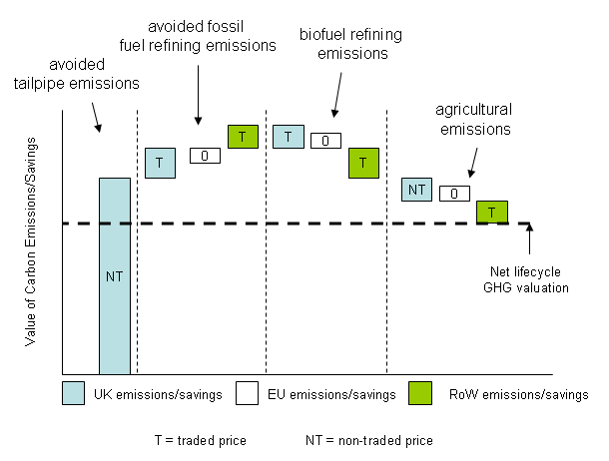

- UK transport sector (tailpipe) and agricultural emissions are valued using the non-traded sector carbon price in line with cross-government GHG guidance. There are no tailpipe emissions in the EU (ex-UK) or the rest of the world as this is a UK policy. EU (ex-UK) emissions/savings have not been valued as any change is assumed to be offset under individual member states’ carbon reduction schemes and the EU ETS. Emissions/savings in the rest of the world are valued at the traded price in line with cross-government GHG guidance.

Annex 16 — Average GHG savings trajectory assumptions

- Future GHG savings from the UK biofuel supply are highly uncertain. The following analysis sets out the average GHG savings trajectories, both under an FQD GHG savings obligation and under an RTFO baseline, used in the cost benefit analysis modelling and underlying assumptions.

Fuel Quality Directive average GHG savings trajectories

Figure A16: FQD crop-derived bioethanol supply in 2011
 | LOW |  | HIGH
 | GHG Saving | Market (%) | GHG Saving | Market (%)
Sugarcane | 71% | 60% | 71% | 60%
Wheat | 50% | 20% | 60% | 20%
Sugar Beet | 60% | 20% | 70% | 20%
Average | 65% |  | 69%
Scenario mid-point | 67%
Source: Internal analysis

Figure A17: FQD crop-derived bioethanol supply in 2020
 | LOW |  | HIGH
 | GHG Saving | Market (%) | GHG Saving | Market (%)
Sugarcane | 71% | 35% | 80% | 35%
Wheat | 50% | 60% | 70% | 60%
Sugar Beet | 60% | 5% | 80% | 5%
Average | 58% |  | 74%
Scenario mid-point | 66%
Source: Internal analysis

Figure A18: FQD crop-derived biodiesel supply in 2011
 | LOW |  | HIGH
 | GHG Saving | Market (%) | GHG Saving | Market (%)
Veg Oils (FAME) | 35% | 100% | 45% | 100%
HVO | 50% | 0% | 70% | 0%
Average | 35% |  | 45%
Scenario mid-point | 40%
Source: Internal analysis

Figure A19: FQD crop-derived biodiesel supply in 2020
 | LOW |  | HIGH
 | GHG Saving | Market (%) | GHG Saving | Market (%)
Veg Oils (FAME) | 50% | 100% | 60% | 84%
HVO | 50% | 0% | 70% | 16%
Average | 50% |  | 62%
Scenario mid-point | 56%
Source: Internal analysis

Figure A20: FQD average GHG savings trajectories for crop-derived bioethanol
Source: Internal analysis

Figure A21: FQD average GHG savings trajectories for crop-derived biodiesel
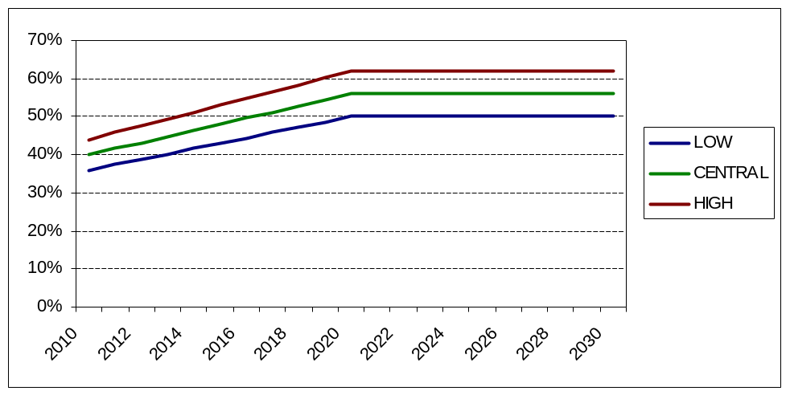
Source: Internal analysis

- Under a GHG savings obligation biofuel producers will have a strong incentive to increase the average GHG savings delivered by biofuels. The preceding tables (Figures A16 to A20) show illustrative average GHG savings scenarios in 2011 and 2020 which would be expected to occur under a GHG savings obligation. High and low scenarios and a weighted average mid-point GHG saving are shown for both of these years. Illustrative feedstock mixes and GHG savings are also shown. These illustrative scenarios have been developed in conjunction with stakeholders. Consultees are invited to comment on the likely accuracy of these illustrative average GHG savings trajectories.

- Average GHG saving trajectories for biodiesel (figure A21) and bioethanol figure (A20) have been plotted between these points which assume a gradual evolution in GHG savings as biofuel producers optimise their processes to deliver increased lifecycle GHG savings.

- The central bioethanol scenario remains relatively constant (at around 66% - 67% GHG savings) across the period. This is because high GHG saving Brazilian sugarcane bioethanol contributes significantly to the relatively low volumes of bioethanol required at the start point of the trajectory. As demand increases, Brazilian sugarcane bioethanol is assumed to form a lower proportion of the overall bioethanol mix and contributes less to overall GHG savings. Improvements to GHG savings for other sources of bioethanol over time offset this effect, keeping aggregate GHG savings constant across the period to 2020. The low scenario moves from average GHG savings of 58% to 65% and GHG savings in the high scenario move from 69% to 74% over the period 2011 to 2030. GHG savings are assumed to remain constant from 2020 to 2030.

- The central biodiesel average GHG savings scenario rises gradually from 40% in 2011 to 56% in 2020. This is driven by process improvement and improvements to agriculture for FAME biodiesel and some penetration of Hydrogenated Vegetable oil biodiesel (which typically delivers higher GHG savings). The low scenario moves from average GHG savings of 35% to 50% (jumping to 50% in 2017 when minimum GHG savings requirements are assumed to be introduced) and GHG savings in the high scenario move from 45% to 62% over the period 2011 to 2030. GHG savings are assumed to remain constant from 2020 to 2030.

RTFO (baseline) average GHG savings trajectories

Figure A22: RTFO average GHG savings trajectories for crop-derived bioethanol
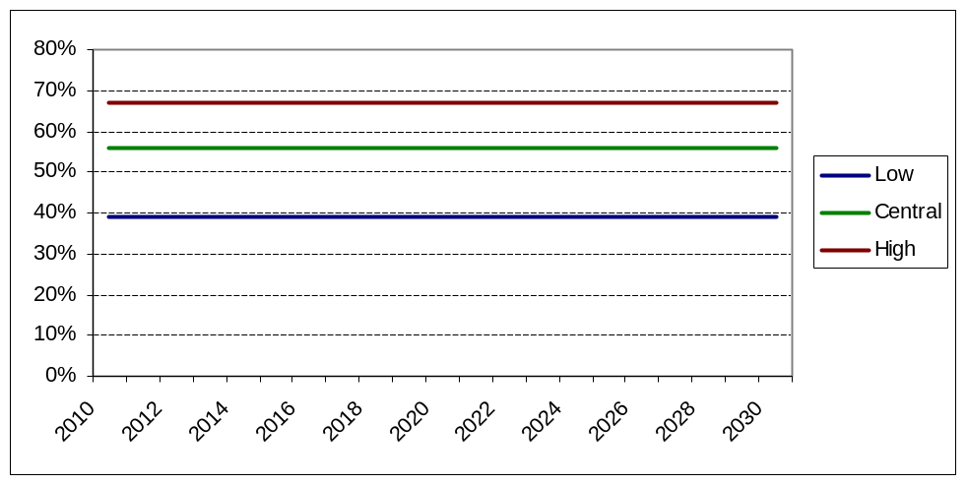
Source: Internal analysis based on RFA data

Figure A23: RTFO average GHG savings trajectories for crop-derived biodiesel
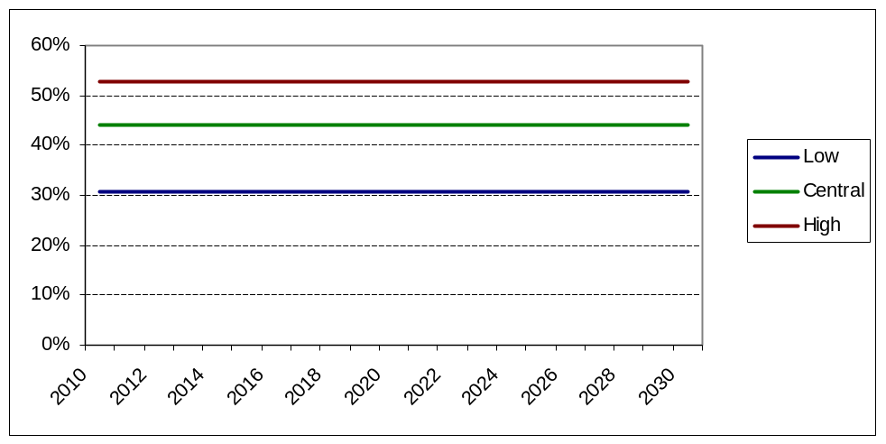
Source: Internal analysis based on RFA data

- Average GHG savings under the RTFO baseline (assuming that the current trajectory remains unchanged) are highly uncertain over the period to 2020, therefore a wide range of illustrative GHG savings has been taken.

- Reported average GHG savings from bioethanol started off very high in the first year of the RTFO (70% average GHG savings) due to the very high proportion of Brazilian sugarcane bioethanol in the mix. In the second obligation year, the proportion of Brazilian sugarcane bioethanol fell and (provisional) average GHG savings also fell to 63%. At the time of writing, average GHG savings from bioethanol in the first two months of the (provisional) average GHG savings from bioethanol stand at 48% due to a further fall in the proportion of Brazilian bioethanol supplied. The (illustrative) central scenario for average GHG savings from bioethanol has therefore been set at 56% across the period to 2030. The low scenario has been set at 30% below this level at 39%, rising to 50% in 2017 when the EU mandatory sustainability criteria requirement of 50% minimum GHG savings kicks in. The high scenario has been set 20% above the central scenario at 67%. The low scenario is more heavily weighted due to the downside risk of other EU member states introducing GHG obligations (therefore providing the incentive for suppliers within those countries to outbid UK suppliers for high GHG saving biofuel).

- Reported average GHG savings from biodiesel (including waste-derived biodiesel) were 47% in the first year of the RTFO and 46% in the second year of the RTFO (provisional estimates). At the time of writing, average GHG savings from bioethanol in the first two months of the (provisional) average GHG savings from biodiesel stand at 43%. The (illustrative) central scenario for average GHG savings from crop-derived biodiesel has been set at 44% across the period to 2030. The low scenario has been set at 30% below this level at 31%. The high scenario has been set 20% above the central scenario at 53%. The low scenario is more heavily weighted due to the downside risk of other EU member states introducing GHG obligations (therefore providing the incentive for suppliers within those countries to outbid UK suppliers for high GHG saving biofuel).

- Consultees are invited to comment on the likely accuracy of these illustrative average GHG savings trajectories.

Race, disability and gender Impact assessments are statutory requirements for relevant policies. Equality statutory requirements will be expanded 2011, once the Equality Bill comes into force. Statutory equality duties part of the Equality Bill apply to GB only. The Toolkit provides advice on statutory equality duties for public authorities with a remit in Northern Ireland.
Race, disability and gender Impact assessments are statutory requirements for relevant policies. Equality statutory requirements will be expanded 2011, once the Equality Bill comes into force. Statutory equality duties part of the Equality Bill apply to GB only. The Toolkit provides advice on statutory equality duties for public authorities with a remit in Northern Ireland.
Race, disability and gender Impact assessments are statutory requirements for relevant policies. Equality statutory requirements will be expanded 2011, once the Equality Bill comes into force. Statutory equality duties part of the Equality Bill apply to GB only. The Toolkit provides advice on statutory equality duties for public authorities with a remit in Northern Ireland.
Race, disability and gender Impact assessments are statutory requirements for relevant policies. Equality statutory requirements will be expanded 2011, once the Equality Bill comes into force. Statutory equality duties part of the Equality Bill apply to GB only. The Toolkit provides advice on statutory equality duties for public authorities with a remit in Northern Ireland.
Race, disability and gender Impact assessments are statutory requirements for relevant policies. Equality statutory requirements will be expanded 2011, once the Equality Bill comes into force. Statutory equality duties part of the Equality Bill apply to GB only. The Toolkit provides advice on statutory equality duties for public authorities with a remit in Northern Ireland.
Race, disability and gender Impact assessments are statutory requirements for relevant policies. Equality statutory requirements will be expanded 2011, once the Equality Bill comes into force. Statutory equality duties part of the Equality Bill apply to GB only. The Toolkit provides advice on statutory equality duties for public authorities with a remit in Northern Ireland.
Lifecycle GHG savings refer to the difference in total GHG emissions from using biofuel (or alternative GHG saving measures) in place of fossil fuel. This includes emissions from the production of fossil fuels and biofuels.
For ease of reading, these applications are collectively termed “road transport and NRMM” for the remainder of this document.
GHG savings are measured as CO₂e which means tonnes of CO₂ equivalent and captures other green house gases such as methane in relative terms.
Suppliers of less than 450,000 litres are exempt from the current RTFO. In addition, suppliers of less than 1,000,000 litres are not subject to the RTFO in respect of the first 450,000 litres of fuel they supply.
The Renewable Transport Fuel Obligations Order 2007 No. 3072 (as amended)
Sugar beet GHG savings taken from the latest RFA carbon and sustainability reporting http://www.renewablefuelsagency.gov.uk/carbon-and-sustainability/rtfo-reports .
Annex III of Directive 98/70/EC as amended by 2003/17/EC, and industry standard EN 228:2008
Industry standard EN 590:2009
Annex I of Directive 98/70/EC as amended by 2009/30/EC
Advanced biofuels also known as 2nd or 3rd Generation biofuels, are made from non-food feedstocks such as wood or algae.
Hydrogenated Vegetable Oil
In reality this is unlikely as some biofuel supply operations are significantly less complex than others. Administrative cost estimates were produced in conjunction with large obligated suppliers and therefore may be overestimates of potential costs faced by smaller operators.
Estimate provided by the RFA.
An analysis of minimum threshold options is included in the “minimum threshold” impact assessment which accompanies the DfT Renewable Energy Directive consultation.
Although the DECC projections of energy demand are based on the assumption that the Renewable Energy Directive targets for biofuel are met, because we are using only the overall energy demand and not fuel volumes, any potential risk of double counting in this context is minimal.
This relation does not hold for the difference between £/ tCO₂e in the low and central scenario as baseline GHG savings in the “low” scenario fall significantly more relative to estimated GHG savings modelled for the “low” FQD scenario (see annex 15 for more detail).
http://www.decc.gov.uk/en/content/cms/statistics/projections/projections.aspx
http://www.decc.gov.uk/en/content/cms/statistics/publications/dukes/
http://www.theccc.org.uk/other_docs/Tech%20paper%20supply%20side%20FINAL.pdf (p.41)
http://www.decc.gov.uk/assets/decc/statistics/analysis_group/122-valuationenergyuseggemissions.pdf
Reported RTFO GHG savings data can be found on the RFA’s website http://www.renewablefuelsagency.gov.uk/carbon-and-sustainability/rtfo-reports
Waste derived biodiesel has been included in average GHG savings trajectories for the baseline, as the RTFO provides an incentive on a per litre basis and therefore does not offer differentiated support levels for crop-derived biodiesel and waste-derived biodiesel.

