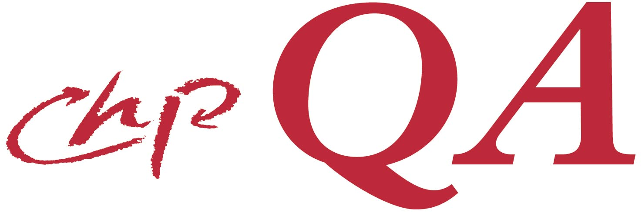 | 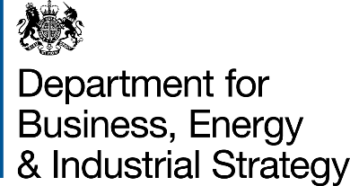

Quality Assurance for Combined Heat & Power

Form F1 – Application to Register with the CHPQA programme
- This Form will need to be resubmitted only if the details in section 1 or 2 change.
- Information provided on this Form will be stored electronically and treated in the strictest confidence. Only the government or its agents will use it for the purpose of the CHPQA programme, including collection and collation of national statistics, and the administration and development of government schemes, including the Renewables Obligation, the Renewable Heat Incentive and Contracts for Difference.

This Form should be completed and returned to The Administrator, CHPQA programme, The Gemini Building, Fermi Avenue, Didcot OX11 0QR

1. SCHEME LOCATION DETAILS
Site Name |  | Site reference [Office use only]
Company Name
Site Address

Town
County |  | Post Code:
Specific instructions to get to site

2. NOMINATED RESPONSIBLE PERSON
Enter details of the person who is the nominated Responsible Person for the energy management of the above Scheme. All future communication will be with this person.
Organisation Name
Contact Name |  | Position held:
Address

Town
County |  | Post Code:
Telephone No:
Email:

Further information on the CHPQA programme and detailed Guidance on applying to the programme, can be obtained from the CHPQA Helpline (01235 753004) or from the GOV.UK web site: https://www.gov.uk/guidance/combined-heat-power-quality-assurance-programme

I confirm that to the best of my knowledge I am the only person applying to register with the CHPQA programme for the above scheme and that all details in this Form are correct. I confirm I shall inform the CHPQA Administrator should any of the above details change.

Signature ____________________________________ Date _____________________
Name ________________________ (block capitals) Position held _____________________
Company _____________________________________ Telephone No _____________________
Address __________________________________________________________________________

The CHPQA programme is carried out on behalf of the Department for Business, Energy & Industrial Strategy, the Scottish and Welsh Governments, and the Northern Ireland Department for the Economy.

