This document was archived because it is no longer current.
Learning through London: Westminster adult education service

URN: 55353
Region: London
Remit: Further education and skills

Provider background
Westminster City Council provides adult and community learning for those living and working in the city through the Westminster Adult Education Service (WAES). Learning through London is part of a package of Family Learning programmes on offer to the residents of Westminster.

Brief description
Learning through London supports adults and children in some of the most deprived neighbourhoods in the country, most of whom speak English as a second language. Some have limited engagement with their children’s school and education and have little knowledge of how to travel independently beyond their local community. Most participants have children at a local primary school.
The core aims of the project are to:
- support the development of learners’ English language skills
- help parents and carers support their children’s learning and development
- develop families’ confidence in using public transport
- increase parental and carer engagement with schools
- extend families’ experiences beyond their immediate neighbourhood
- give families new ideas, through visits and practical activities, to help them to support their children’s learning.
WAES achieves this through family trips to museums, art galleries and the theatre, complemented by workshops and short courses at schools, nurseries, children’s centres, community centres and libraries. Many courses have crèche facilities available. Learners’ independence and confidence are developed as they increasingly take responsibility for planning the excursions and use public transport.
Partners have included:
- London Transport Museum
- Tate Britain
- Royal Opera House
- Museum of Childhood
- British Museum
- Victoria and Albert Museum
- The Natural History Museum.
Over three and a half years, 120 adults and 126 children have benefited from 14 courses. The following schools have been instrumental in supporting families to participate:
- Gateway Academy
- Essendine Primary School
- All Souls CofE Primary School
- Christ Church Bentinck CofE Primary School

Getting the project started
The project was established in 2011. It built on existing programmes and partnerships with local primary schools. At its inception, the project received discretionary funding through local ward council funds. Over the life of the project, it has continued to receive support from ward funds from time to time. It is now funded primarily through the community learning budget.

Overcoming the key challenges

Promoting courses
Schools, particularly their home-school liaison staff, are the key to the programme’s success in engaging families. Staff develop trusting relationships with families who are often nervous about travelling outside of their immediate neighbourhood and meeting new people. Staff use this relationship well to open up new learning opportunities. They successfully encourage learners to participate through promoting Learning through London and remind them of when sessions take place through text and face-to-face contact. Family Learning tutors offer additional support and encouragement to learners by attending coffee mornings and running taster workshops prior to the delivery of courses.

Minimising costs
The cost of undertaking trips and activities is a perceived barrier by learners. The programme includes the purchase of Oyster cards and the provision of childcare for younger siblings for the duration of the course. Museums and galleries often provide free or subsidised entry to learners where there would normally be a charge. The programme is free for families. Through the programme, participants learn that using public transport and effective budgeting for days out can minimise their costs. They learn to take advantage of the many free, low-cost and high-quality days out that London museums and galleries provide.

You don’t know what you don’t know!
The vast majority of learners begin the programme with limited knowledge of what museums and galleries in London offer. Consequently, they have never considered these as activities that are for them and their children. The project successfully broadens learners’ thinking and their own research skills so that they are better able to undertake independent activities across London with their children.

Productive partnerships, shared aims
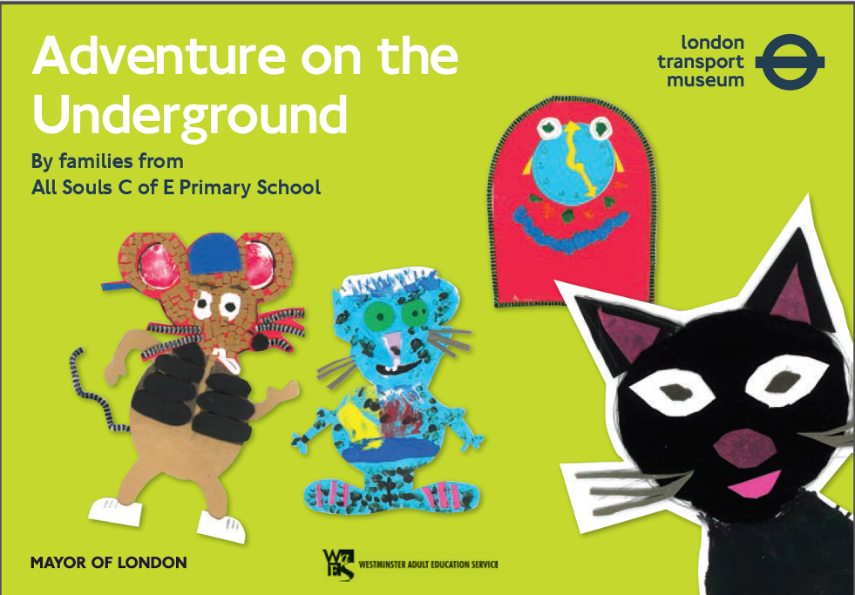
Active partnerships with museums, galleries and theatres are central to enriching the curriculum for learners. Widening participation and attracting non-traditional visitors are shared aims between WAES and their partners. Two special projects have been delivered as a result. Family Learning delivered a two-part workshop, where families learnt about theatre through puppet- and mask-making, before visiting the Royal Opera House where they undertook further workshops and a backstage tour.
With the London Transport Museum, WAES delivered a storytelling project, where families conceived, wrote and illustrated a story based on the museum. The booklet, ‘Adventure on the Underground,’ can be found by following this link:
www.ltmuseum.co.uk/assets/downloads/pdfs/ESOL_Story_Resource_smaller_size.pdf

Developing the skills of adults and children and making a difference
The programme provides a holistic learning experience. As a result, learners develop a broad range of practical skills and knowledge that they use in their everyday lives. Typically, the programme includes weekly sessions over a six- to nine-week period. Initial sessions are focused on sparking the interest of learners. Historical and artistic objects, such as a Victorian iron, a suffragette handkerchief and Russian nesting dolls, are used to encourage questioning and study of unfamiliar and historical objects.
Learners develop practical skills and knowledge, such as map reading and how to use an Oyster card, to travel across London. These skills are developed both in the classroom and through the visits undertaken. Their skills are built incrementally, with learners taking responsibility for organising visits.

I want to show my kids these places and talk to them about the pictures they see and get them to write a story about what they see.

Learners have good opportunities to develop their English and mathematics skills. They budget for trips and estimate travel times. They practise their written English and learn to recognise and understand signage and symbols when using public transport and at the museums and galleries.
Parents and carers develop a thirst for learning and develop new interests very well, such as in the history of art. They learn about British social history and develop a deeper cultural understanding of the United Kingdom. They develop effective strategies to support their children’s development, such as consolidating learning by using photographs to reflect on learning and using questions to prompt their children’s thinking. They are able to provide richer and more varied activities for their children during weekends and during school holidays. Parents and carers increasingly act as good role models of learning to their children.

I know more about art and I can actually read maps now!

The programme enhances the quality of life for families. They develop new friendships and 86% of learners move onto other courses and programmes.
Learners themselves praise the programme highly:
- ‘It’s given me brilliant ideas about the museums in London’
- ‘I know more about art and I can actually read maps now!’
- ‘I want to show my kids these places and talk to them about the pictures they see and get them to write a story about what they see.’

The keys to success
- Barriers to participation are removed successfully.
- Incrementally, learners take responsibility as they grow in skills and confidence.
- Learning is practical, hands on and relevant to the learners’ lives.
- Excellent partnerships with schools, museums, galleries and theatres promote participation well and greatly enrich the experience for learners.

Extending the life of the project
The programme continues to be funded by WAES through the community learning budget supplemented by discretionary ward funding. At Essendine Primary School, parents and carers, with the support of the school, are setting up a museum club to continue to work collectively to plan and deliver new cultural experiences in London for themselves and other families. This ‘model’ is being considered by WAES as a logical progression route for families when the Learning through London programme ends.
The programme methodology, its practical nature, is being considered more widely across the service and influencing the development of the curriculum in community learning programmes.

