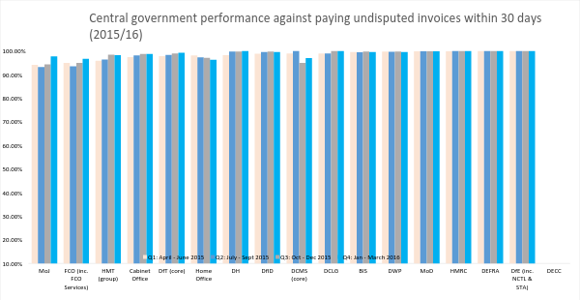

Source – central government departments payment performance data as published on their GOV.UK pages:
DfE (inc. NCTL & STA) – published data here | DECC – data not published | DEFRA – published data here | DH – published data here | DWP – published data here
BIS – published data here | MoD – published data here | HMRC – published data here | Cabinet Office – published data here | DfT (core) – published data here
DCLG – published data here | Home Office – published data here | MoJ – published data here | FCO (inc. FCO Services) – published data here | DfID – published data here
DCMS (core) – published data here | HMT (group) – published data here

