Quick Start Guide

Accessing and navigating Ofsted’s Provider Portal

|  |  |  |
| --- | --- | --- |
| This guide shows you how to use Ofsted’s Provider Portal, including how to access it, where to find information on your inspection, and how to navigate between different areas and upload documents. Key  |  |  | | --- | --- | | * Information point * ‘Click’ instruction * Data entry instruction |  | |

Contents

Key 1

Accessing the Provider Portal 3

What you will see on your Provider Profile page 5

Ofsted team 6

Documents uploaded by Ofsted 6

Documents uploaded by provider 7

Forms 11

Factual accuracy check 11

Survey 12

# Accessing the Provider Portal

* We will send you two emails: the first provides your username and a link to access the Provider Portal; the second provides your password for the Provider Portal.
* If you are missing these emails from your inbox, please check your email account’s spam or junk folder in case the messages have been filtered out.
* Click on the link to go to the login page.

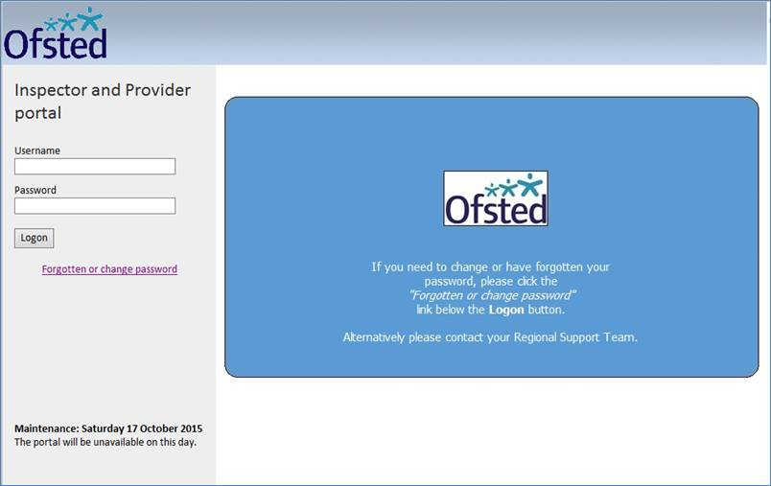

* Enter your username and password in the relevant fields.
* If your username or password is not correct, the message below will be displayed.

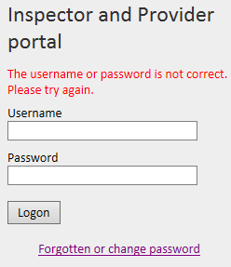

* To reset your password, click on the ‘Forgotten or change password’ link. Follow the onscreen instructions to unlock your account.
* If your identity cannot be verified, please contact your inspection support administrator.
* Once you have reached the ‘Password Reset’ screen, enter your new password and click ‘Next’.[1]

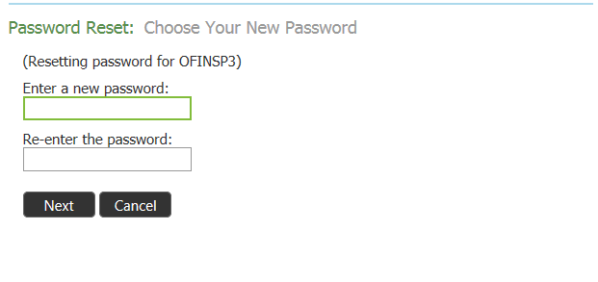

* Your password is now reset. Continue to the login page by clicking the ‘Click here’ link.

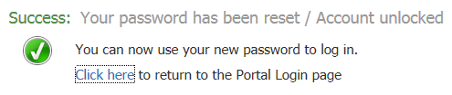

* Enter your new login details to access the Provider Portal.

# What you will see on your Provider Profile page

* The Provider Portal page is specific to your inspection or visit. It is made up of several areas, which include:
* information about your inspection and Ofsted’s team
* links to Ofsted’s inspection documents
* links to documents that your organisation has uploaded

links to various forms.

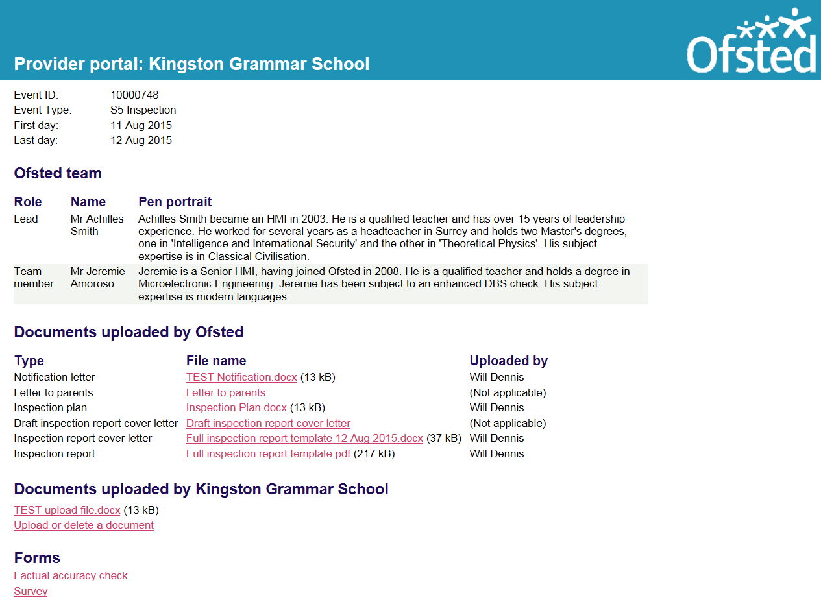

* The top section of the screen displays basic information about the inspection or visit. You can see the event ID, event type and inspection dates.

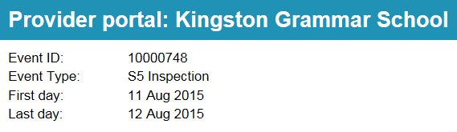

## Ofsted team

* This section of the Provider Portal gives information on the inspectors who will be carrying out your inspection.
* You can see their roles, as well as some basic information about them in their pen portraits.

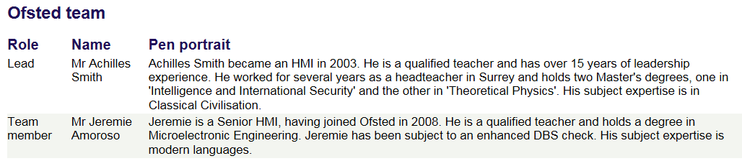

## Documents uploaded by Ofsted

* This section contains Ofsted documents related to your inspection.
* Simply click on the ‘File name’ link of the document you wish to view.

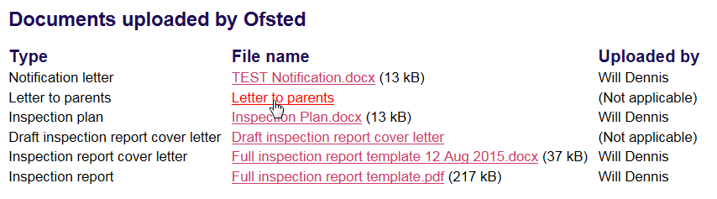

* This will download the document to your computer. Depending on your internet browser, you may need to click to open the downloaded file.
* Click on the ‘Open’ button.

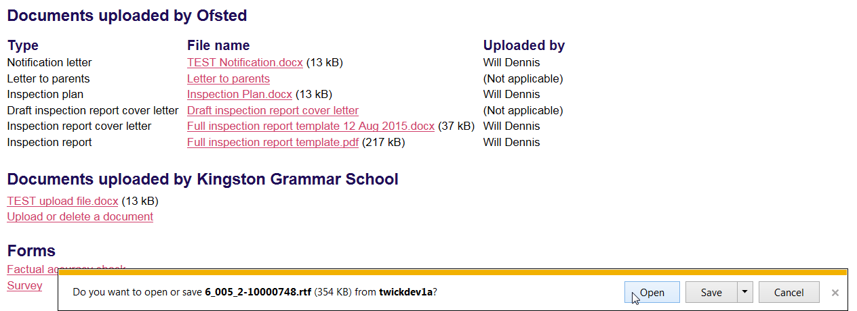

* This will open the document. You will then be able to save or print it as required.

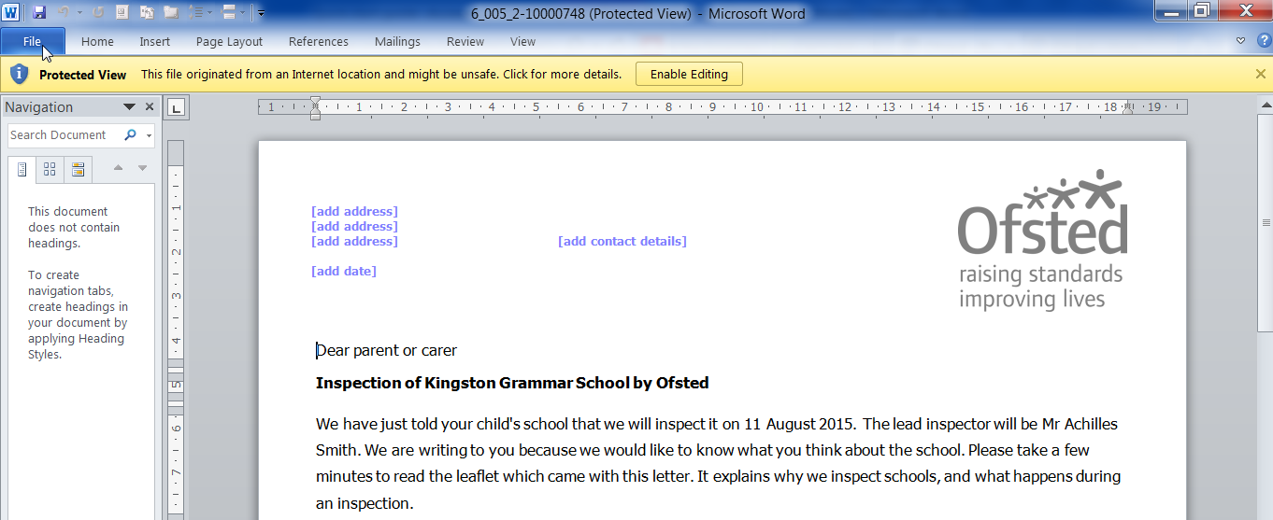

## Documents uploaded by provider

* In this section of the Portal, you can download, upload or delete documents.

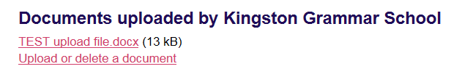

* To download a document that you have previously uploaded, simply click on the file name link.

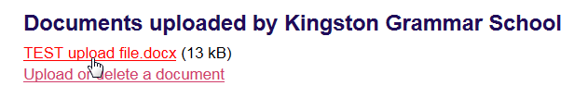

* To upload a new document, click on the ‘Upload or delete a document’ link.

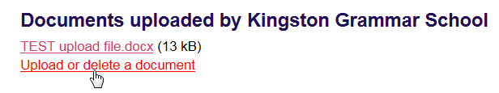

* This will open the ‘Documents Uploaded by Provider**’** screen.
* Click on the ‘Upload’ link and browse to where the document is saved.

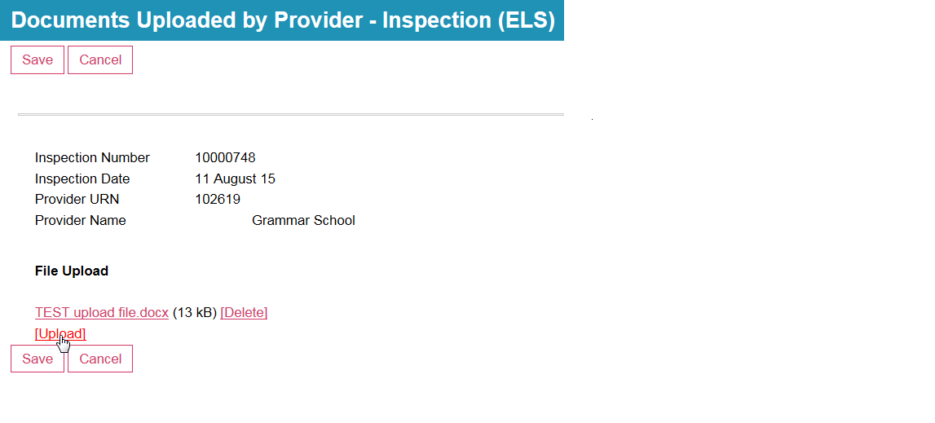

* Select the document and click on the ‘Open’ button to upload it.

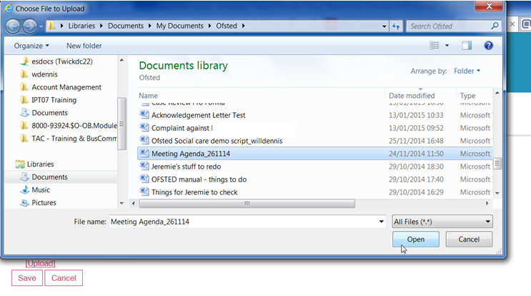

* Your uploaded document will now be visible in the ‘Documents Uploaded by Provider’ screen.

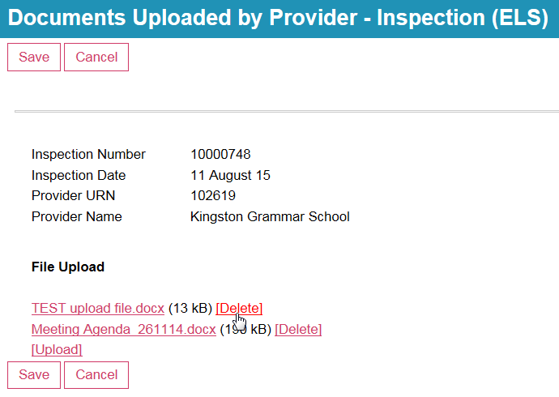

* To delete a document, click on the ‘Delete’ link.
* Confirm you wish to delete the document by clicking on the ‘Yes - Delete’ button.

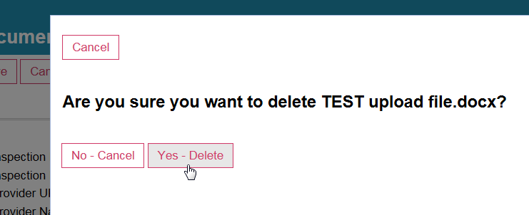

* To confirm your updates, click on the ‘Save’ button.

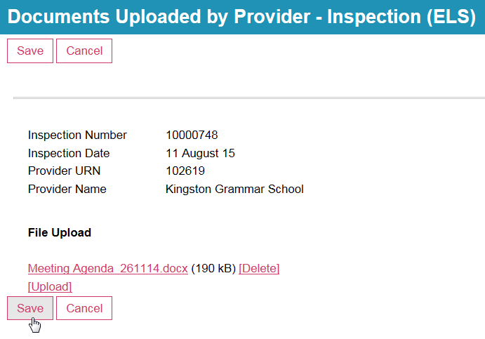

* Your new uploaded document(s) will now be visible on your Provider Profile. Any deleted documents will be removed.

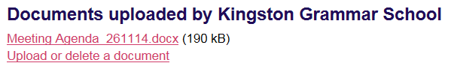

## Forms

* The ‘Forms’ section near the bottom of the screen has links to the ‘Factual accuracy check’ and ‘Survey’ forms.

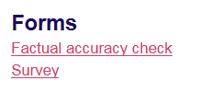

### Factual accuracy check

* Once you have received the draft inspection report, you must complete a factual accuracy check.
* Click on the ‘Factual accuracy check’ link to open the form.

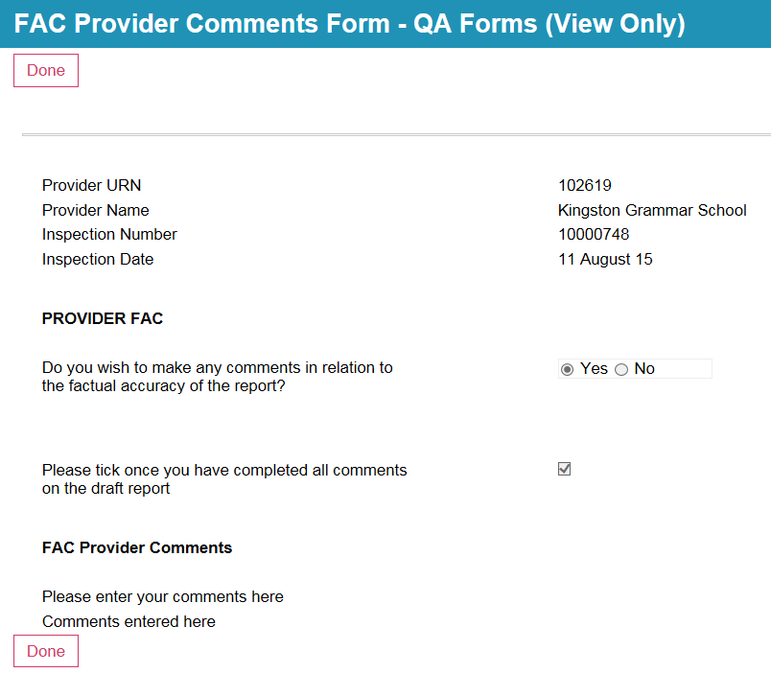

* Click the ‘Yes’ or ‘No’ button to indicate whether or not you wish to make any comments about the factual accuracy of the report.
* Click on the checkbox to confirm that you have entered all your comments on the draft report.
* Enter any comments in the free text box toward the bottom of the screen.
* Note that once you have completed the factual accuracy check this screen will be ‘VIEW’ only and you will not be able to change it.
* Click on ‘Done’ when you have finished.

### Survey

* Click on the ‘Survey’ link if you wish to provide feedback on Ofsted. This is optional.



* Click on the buttons to record your feedback.

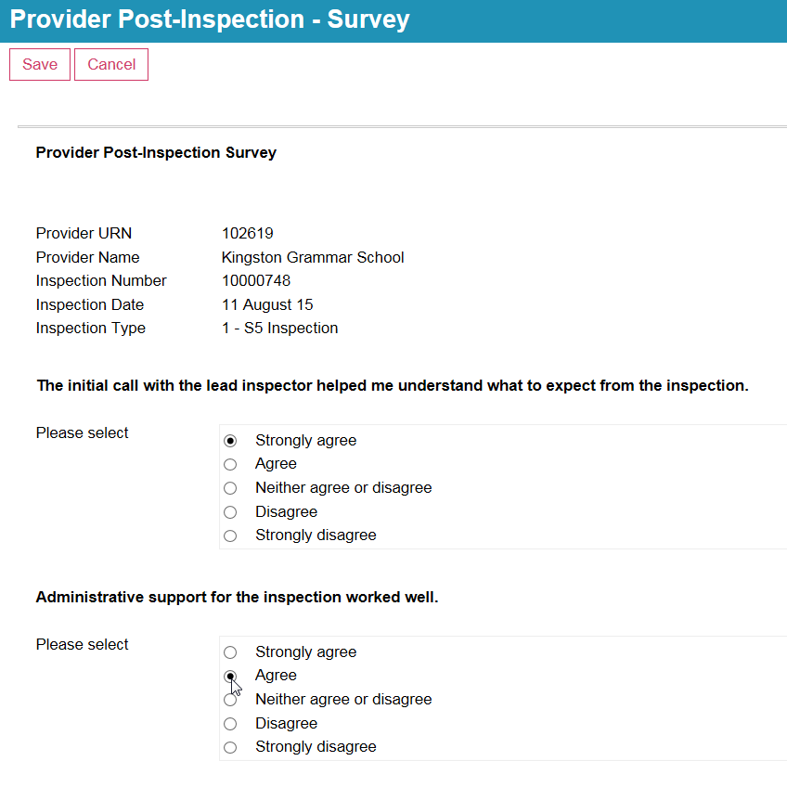

* Towards the bottom of the form, select the three activities undertaken by the inspector(s) that you found most/least useful in identifying ways to improve. You can do this by clicking on the drop-down menu and choosing one of the options.
* Use the free text box to describe why these activities were the most/least useful.

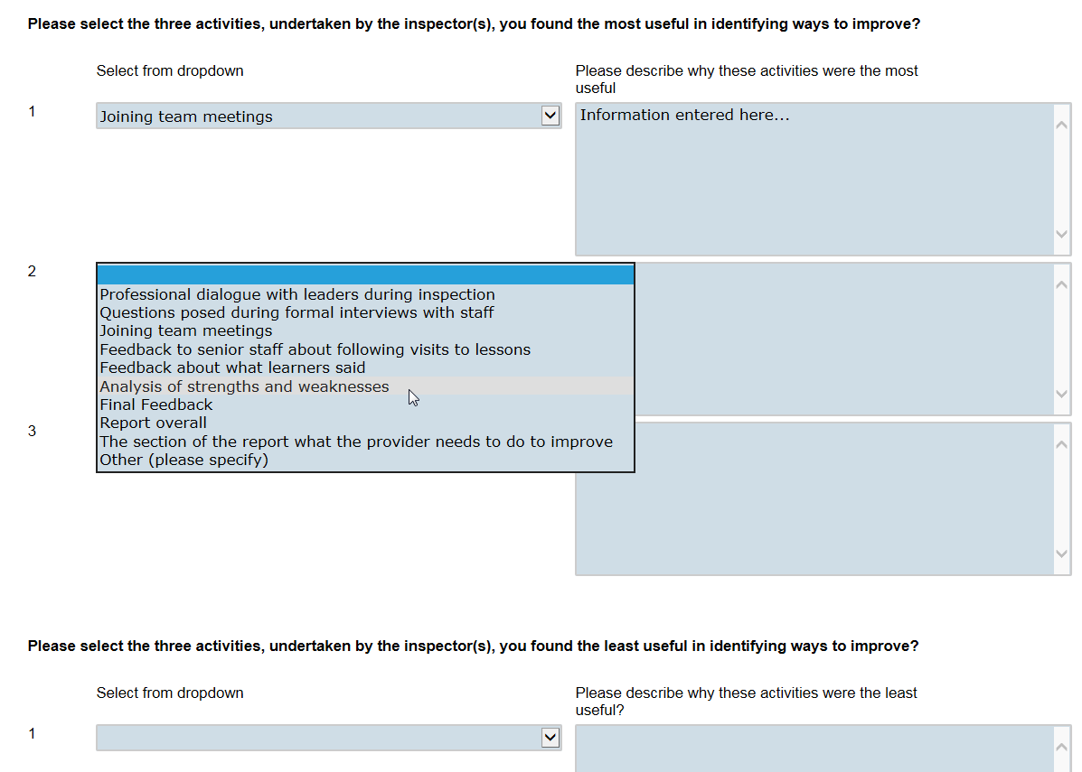

* Use the free text box at the bottom of the screen to describe how the inspection could be improved.

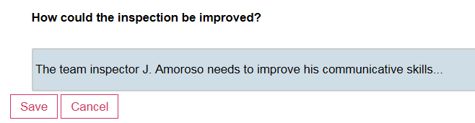

* Click on the ‘Save’ button to exit from the form.

1. Your new password should contain at least eight characters, alpha-numeric and at least one capital letter.