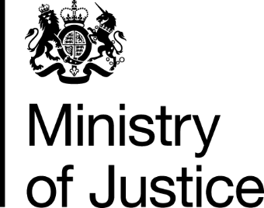

 | Our Reference: 109493 |  | February 2017

Freedom of Information Request

You asked for the following information from the Ministry of Justice (MoJ):

Please can you confirm how many applications under paragraph 29, Schedule 1, Part 1 of LASPO have been made for legal help for each year since 1 April 2013.

Your request has been handled under the FOIA.

I can confirm that the MoJ holds the information that you have requested and I have provided this below. I have interpreted ‘applications’ as relating to the submission of a claim for payment to the Legal Aid Agency (i.e. when a case has concluded). In Legal Help matters the ‘application’ process, i.e. the decision to open a file, is devolved to the legal aid provider. As it is not possible to break this data down to the necessary level in order to be able to provide volumes of new matter starts reported, this data is based upon closed cases.

LH Immigration Claims: Victim of domestic violence and residence cards
The volume of claims (closed cases) received between 1 April 2013 to 30 Sep 2016.

Financial Year | Volume of Claims
FY 13/14 | 293
FY 14/15 | 553
FY 15/16 | 453
FY 16/17* | 253

*Note: FY 16/17 covers the period of April to September 2016. This is because this is the most recent period for which the LAA has made published statistics available.

