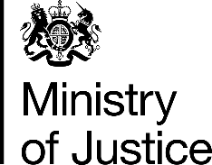 | July 2017

Freedom of Information Act (FOIA) Request – 113105

You asked for the following information from the Ministry of Justice (MoJ):

I would be grateful if you would supply me with the following information or point me in the direction of where I can find this information.

Will you please tell me how many convictions there have been either in the last five years, or, if this information is not available then the latest 12 month period for which you hold the information.

How many people have been convicted of offences under each of the following sections:-

1) Section 53A, Sexual Offences Act 2003 (Paying for sexual services of a prostitute subjected to force)

2) Section 52 and Section 53, Sexual Offences Act 2003 (S52 Causing or inciting prostitution for gain, S53 Controlling prostitution for gain)

3) Section 33 and Section 33A, Sexual Offences Act 1956 (Keeping a brothel)

Your request has been handled under the FOIA.

I can confirm that the MoJ holds the information that you have requested and I have provided it in the attached annex, covering the period from 2012 to 2016.

