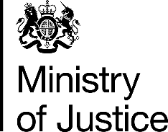 | July 2017

Freedom of Information Act (FOIA) Request – 112549

You asked for the following information from the Ministry of Justice (MoJ):

Under the Freedom of Information Act, please can you provide me with information about how many people were convicted of (a) drunk and disorderly behaviour and (b) drunk and aggravated behaviour in each police force area in England and Wales in 2015/16.
If possible, please could you include information about the number of people convicted of the above two offences in 2015/16, who have more than one previous conviction (in any year) for either offence.

Your request has been handled under the FOIA.

I can confirm that the MoJ holds the information that you have requested and I have provided some of it in the attached table.

The table provides the number of offenders found guilty of offences related to drunkenness (both simple and aggravated), in England and Wales by police force area, in 2015/16.

With regard to information about those found guilty who had previous convictions, the information is exempt from disclosure under section 21 of the FOIA, because it is reasonably accessible to you. The information can be accessed via the following link to the MoJ FOI Disclosure log for December 2016, where you will find the information in table 3 of the ‘Convictions for drunk and disorderly tables’.

https://www.gov.uk/government/publications/foi-releases-for-december-2016

