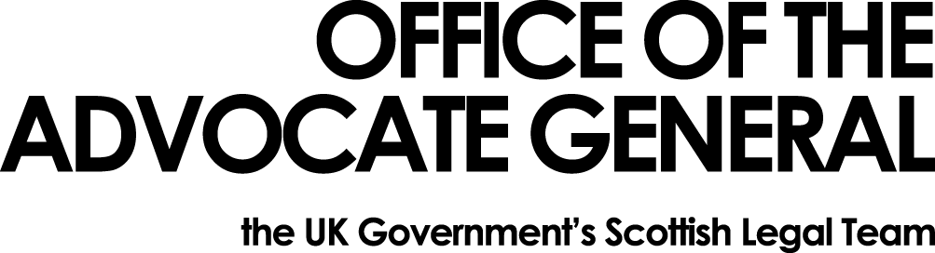
REDACTED | Area G-G  OAG  Victoria Quay  Edinburgh EH6 6QQ  Date 03.06.16

Dear REDACTED

Freedom of Information Request

Thank you for your email of 27 April 2016 requesting information under the Freedom of Information Act 2000 (FOIA). You asked:
1. How much was spent in 2015 by the department on travel costs for all staff, Ministers, Directors and political appointees broken down by road, rail and air?
2. How much was spent in 2015 by the department on accommodation for all staff, Ministers, Directors and political appointees broken down by domestic and foreign expenditure?
3. Does the department use the services of a travel management company to minimise these costs to the taxpayer?
4. If yes to question 3, which travel management company does the department use currently?
5. If yes to question 3, how much has the outside company been paid in respect of it's services (excluding travel and accommodation charges) in 2015?
6. If yes to question 3, how much has the employment of an external travel management company saved the department in 2015?
We do not hold all the information you have requested as our travel arrangements are handled by Scotland Office. I apologise that it has taken us some time to collect this information, however I can now answer your questions in the order they were asked.

1. Ministers Director Staff

Air £22,215.98 £5,311.12 £23,776.99
Rail £821.33 £168.11 £23,362.84
Road £2,994.73 £649.31 £11,258.25

2. Ministers Director Staff

Hotel Domestic £Nil £998.32 £16,005.35
Hotel Foreign £222.81 £nil £221.71
3. Yes
4. The Office of the Advocate General, through its relationship with Scotland Office utilises the contract called off the Scottish Government One-stop shop Framework agreement for the provision of Travel services, Accommodation and Conference Venues Booking. During 2015-16 the contract with the travel management company changed from Capita to the current provider,Redfern Travel.
5. We do not hold this information for Capita, the previous service provider. Redfern have been paid £447.17 by the Scotland Office.
6. The savings accrued by the Scotland Office (we cannot separate out OAG) were £169,223.95 through the contract with Capita and £11,926.10 by using the contract with Redfern Travel.

You may, if dissatisfied with the treatment of your request, ask the Office of the Advocate General to conduct an internal review of its decision. The internal review will be conducted by someone other than the person who took the initial decision. Requests for internal review should be addressed to the Information Officer, Office the Advocate General, Victoria Quay, Edinburgh, EH6 6QQ.

If following the internal review you remain dissatisfied with the treatment of your request by OAG then you may take your complaint to the Information Commissioner, whose address is Wycliffe House, Water Lane, Wilmslow, Cheshire, SK9 5AF. Details of the complaints procedure can be found here:
http://www.ico.gov.uk/complaints/freedom_of_information.aspx

Yours sincerely

REDACTED

