Do not remove this if sending to pagerunnerr Page Title

Response to consultation on local authority parking
The Department for Transport has actively considered the needs of blind and partially sighted people in accessing this document. The text will be made available in full on the Department’s website. The text may be freely downloaded and translated by individuals or organisations for conversion into other accessible formats. If you have other needs in this regard please contact the Department.
Department for Transport
Great Minster House
33 Horseferry Road
London SW1P 4DR
Telephone 0300 330 3000
Website www.gov.uk/dft
General enquiries https://forms.dft.gov.uk

© Crown copyright 2014
Copyright in the typographical arrangement rests with the Crown.
You may re-use this information (not including logos or third-party material) free of charge in any format or medium, under the terms of the Open Government Licence. To view this licence, visit
www.nationalarchives.gov.uk/doc/open-government-licence  or write to the Information Policy Team, The National Archives, Kew, London TW9 4DU, or e-mail: psi@nationalarchives.gsi.gov.uk.
Where we have identified any third-party copyright information you will need to obtain permission from the copyright holders concerned.
Contents
1. Introduction and purpose 4
2. Overview of respondents 5
3. Analysis of responses 6

Introduction and purpose
The Government launched a consultation paper on local authority parking enforcement on 6 December 2013. The consultation closed on 14 February 2014. The purpose of this document is to report on the feedback received during the consultation period. This document also includes a breakdown of who responded to the consultation together with an analysis of their responses to the consultation questions.
The consultation asked a number of questions and invited views on a number of aspects of local authority parking enforcement. These were:
  - Do you consider local authority parking is being applied fairly and reasonably in your area?
  - What are your views on Government proposals to ban CCTV cameras for parking enforcement?
  - Do you think the Traffic Adjudicators should have wider powers to allow appeals?
  - Do you agree that guidance should be updated to make clear in what circumstances adjudicators may award costs? If so, what should those circumstances be?
  - Do you think motorists who lose an appeal at a parking tribunal should be offered a 25% discount for prompt payment?
  - Do you think local residents and firms should be able to require councils to review yellow lines, parking provision, charges etc in their area? If so, what should the reviews cover and what should be the threshold for triggering a review?
  - Do you think that authorities should be required by regulation to allow a grace period at the end of paid-for parking?
  - Do you think a grace period should be offered more widely - for example a grace period for over-staying in free parking bays, at the start of pay and display parking and paid for parking bays, and in areas where there are traffic restrictions (such as loading restrictions, or single yellow lines)?
  - If allowed, how long do you think a grace period should be?
  - Do you think the Government should be considering any further measures to tackle genuinely anti-social parking or driving? If so, what?

Overview of respondents
A total of 836 responses were received to the consultation. Responses were received via letter, email and through an online response form. The consultation also asked whether respondents were responding on behalf of an organisation or as an individual, to which 805 respondents gave an answer.
In total 481 responses (58%) were from individuals, 324 (39%) were from organisations, and 21 (3%) did not say.

Analysis of responses
The charts which follow summarise the consultation responses. Many respondents did not answer all the questions, did not enter a response or did not make the view explicit in their response.
The tables show all the responses that were received. The first four columns include all the results, whereas the percentages are calculated only from those who gave a "yes" or "no" answer. For example, in the first table 442 individuals responded to the question, of which 421 gave a yes/no answer. The percentages are calculated from the yes/no answers, so for "yes" answers Individual is calculated as 211/421= 50%, Organisation as 212/261=81% and Overall as 424/686=62%, and so on. This method is used in all the tables, and the percentages are shown in the charts in this document.
Question 1: Do you consider local authority parking enforcement is being applied fairly and reasonably in your area?
 | Yes | No | Other | Total | Yes | No | Other | Total y/n
Individual | 211 | 210 | 21 | 442 | 50% | 50% | - | 421
Organisation | 212 | 49 | 7 | 268 | 81% | 19% | - | 261
Did not say | 1 | 3 | 2 | 6 | - | - | -
Total | 424 | 262 | 30 | 716 | 62% | 38% | - | 686
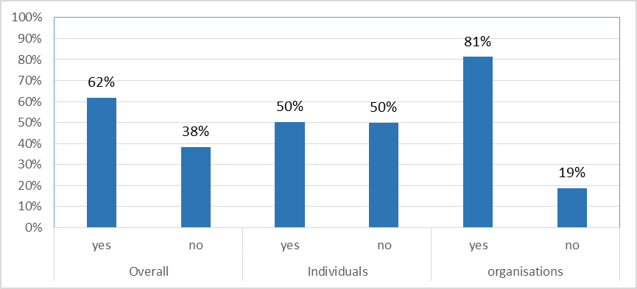

  - The majority of respondents considered that local authority parking enforcement is applied fairly and reasonably. However this response varied considerably between organisations and individuals.
  - For individuals half agree or disagree that enforcement is applied fairly and reasonably
  - For organisations, the numbers agreeing that parking is applied fairly and reasonably are much higher, at 81%. Many of the organisational responses were from local authorities.

Government Position
The Government will amend guidance to make it clear that motorists parking at an out-of-order meter should not be issued a penalty charge where there are no alternative ways to pay.

Question 2: The Government intends to abolish the use of CCTV cameras for parking enforcement. Do you have any views or comments on this proposal?
 | Yes | No | Other | Total | Yes | No | Other | Total y/n
Individual | 378 | 26 | 14 | 418 | 94% | 6% | - | 404
Organisation | 264 | 22 | 5 | 291 | 92% | 8% | - | 286
Did not say | 2 | 3 | 0 | 5 | - | - | -
Total | 644 | 51 | 19 | 714 | 93% | 7% | - | 695
Whilst many respondents said that they had a view, not all choose to express their view in the consultation. The views and comments from those who did express their view were considered to see if the respondent supported the proposal to abolish the use of CCTV cameras for parking enforcement or not.

How different groups responded to the proposal to ban CCTV enforcement of parking
Local authorities – generally opposed an outright ban on cameras. Although many local authorities do not use CCTV for parking enforcement they tended to consider that it should be available as a tool, if required. Those that used it, for example in urban areas, considered that it was a necessary and efficient means of ensuring that road safety issues (e.g. around schools) and traffic congestion (e.g. bus lanes, access to hospitals) were adequately managed as part of the statutory network management duty.
Cycling groups – generally did not support a ban. They reported problems where vehicles are parked inconsiderately and in contravention of the regulations, making cycle and pedestrian journeys not just inconvenient but more dangerous. They thought that CCTV should be used if appropriate and that it would continue to be an important tool in the reduction of rogue parking.
Disabled Groups – generally did not support a camera ban. They would welcome visible blue badge parking enforcement but saw CCTV as a vital tool to help improve road safety, especially outside schools and at bus stops.
Transport Groups – commented that they regarded CCTV as an effective deterrent, without which school ziz-zag markings would be difficult to enforce. They also said that some areas can become "no go" areas for Civil Enforcement Officers because of the risk of verbal or physical abuse and considered that CCTV had a vital role to play in promoting adherence to traffic regulations, aiding road safety and maintaining traffic flow..
Motoring Groups – had mixed views about a camera ban. Some thought a blanket abolition would be a retrograde step, but others considered that if CCTV is to be retained, its use should be prescribed in law and on the Penalty Charge Notice. They commented that local authorities should also be required to include, in annual parking reports, information about the reasons, practices and impact of CCTV enforcement in their areas.
Schools – were opposed to a camera ban. Views expressed included that it was a significant safety issue to maintain safe parking outside schools. Others suggested it would leave schools powerless to rein in reckless parents. Head teachers warned of more disputes and greater safety hazards. The visibility of cameras was seen to have a useful deterrent effect. Some local authorities reported a decline in the number of tickets issued due to the deterrent effect of cameras. When camera cars are not used, dangerous parking was reported to increase.
Business had mixed views – some supported a ban of CCTV because of its abuse by local authorities. Some businesses reported that customers visiting shops regularly received parking tickets. Others opposed a complete ban where CCTV is used appropriately and offers an economic means of enforcing parking restrictions. They commented that it could remain beneficial at particular times and at particular locations.
Bus operators – opposed a camera ban on the grounds that authorities should be able to enforce bus lane contraventions in the most efficient and cost effective way. They considered a ban would increase congestion, prevent the free movement of buses and result in modal shift from public transport to cars.

Government Position
The government intends to press on and take action to see a ban on the use of CCTV cameras to enforce parking contraventions in the vast majority of cases.
The consultation showed that many respondents argued for some CCTV use to be retained where there are clear safety or serious congestion issues such as outside schools, in bus lanes and on red routes.
The Government therefore intends to see a ban on the use of CCTV cameras with some limited exceptions. At present there are over 40 different parking contraventions, and in future the government intends that CCTV cameras will be banned in all but the following limited circumstances:
  - When stopped in restricted areas outside a school;
  - When stopped (where prohibited) on a red route;
  - Where parked (where prohibited) in a bus lane;
  - Where stopped on a restricted bus stop or stand;
The Government will seek to legislate through the Deregulation Bill currently before Parliament.

Question 3: Do you think the traffic adjudicators should have wider powers to allow appeals?
 | Yes | No | Other | Total | Yes | No | Other | Total y/n
Individual | 206 | 133 | 67 | 406 | 61% | 39% | - | 339
Organisation | 85 | 153 | 21 | 259 | 36% | 64% | - | 238
Did not say | 4 | 1 | 1 | 6 | - | - | -
Total | 295 | 287 | 89 | 671 | 51% | 49% | - | 582
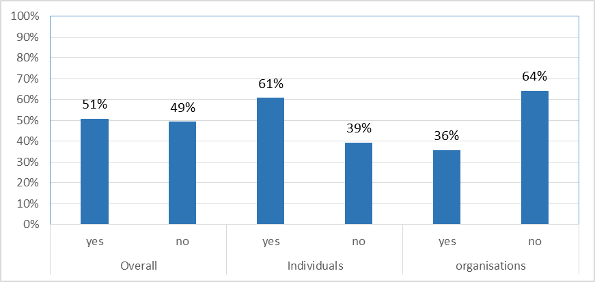

  - Overall, opinions were split 51:49 on this question
  - Individuals were more in favour of giving the traffic adjudicators wider powers to allow appeals (61%), but a minority of organisations supported this (36%).

Government Position
The Government intends to legislate at the earliest opportunity to see a ban on the use of CCTV cameras to enforce parking contraventions in the vast majority of cases. If successful, adjudicators can take account of this when determining appeals.
The Government proposes to widen the powers of parking adjudicators. This could include, for example, measures to protect drivers where adjudicators have repeatedly identified a problem at a specific location (such as inadequate signage) and parking tickets have repeatedly been issued. In such circumstances, potential measures could include the ability for an Adjudicator to direct an authority to stop issuing tickets or direct the authority to change the signage, or indeed both.

Question 4: Do you agree that guidance should be updated to make clear in what circumstances adjudicators may award costs? If so, what should those circumstances be?
 | Yes | No | Other | Total | Yes | No | Other | Total y/n
Individual | 207 | 40 | 133 | 380 | 84% | 16% | - | 247
Organisation | 76 | 39 | 32 | 147 | 66% | 34% | - | 115
Did not say | 4 | 1 | 0 | 5 | - | - | -
Total | 287 | 80 | 165 | 532 | 78% | 22% | - | 367
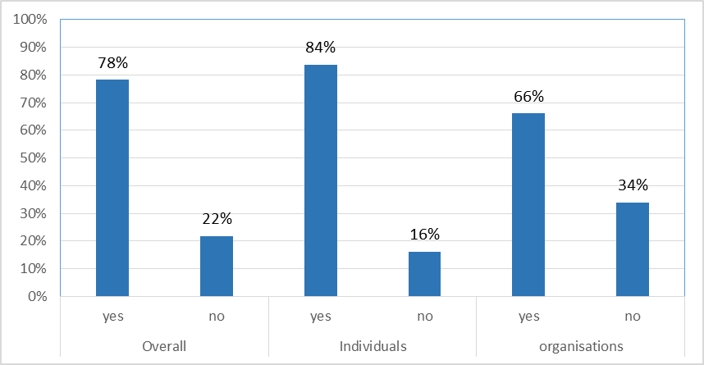

  - The majority of respondents supported the proposal for guidance on costs to be updated to clarify where adjudicators may award costs.
  - Many of the responses were “in principle” on the basis that greater clarity should always be supported.
  - However, the Traffic Adjudicators made clear in their response to the consultation that they considered the current cost provisions to be adequate. They pointed out that the costs involved in appealing are low, and that the act of appealing is becoming easier with online appeals. They added that costs are not awarded punitively but to cover costs and expenses reasonably incurred. They suggest that changing the costs provisions would complicate the process and not encourage proportionality.

Government Position
Government promotes transparency and will change the guidance on costs, when the statutory guidance is revised, to make it clearer what provisions there are available to the public.
Question 5: Do you think motorists who lose an appeal at a parking tribunal should be offered a 25% discount for prompt payment?
 | Yes | No | Other | Total | Yes | No | Other | Total y/n
Individual | 209 | 172 | 25 | 406 | 55% | 45% | - | 381
Organisation | 64 | 190 | 10 | 264 | 25% | 75% | - | 254
Did not say | 1 | 4 | 0 | 5 | - | - | -
Total | 274 | 366 | 35 | 675 | 43% | 57% | - | 640
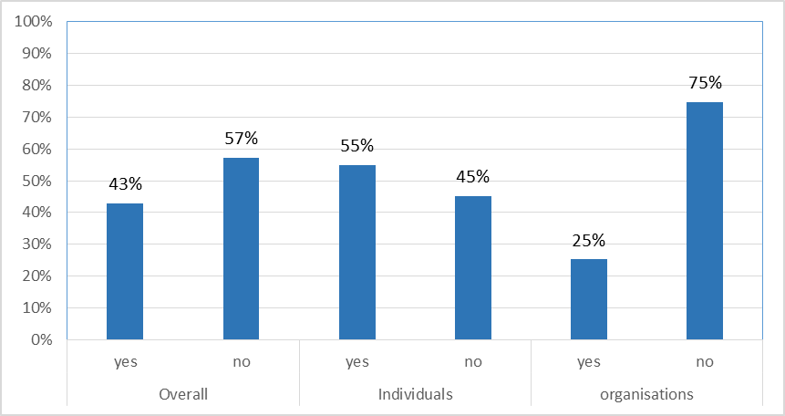

  - Opinions on a further discount on appeal were broadly split, with just over half of individuals agreeing with this proposal. However the majority (75%) of organisations disagreed with this proposal.
  - Whilst there was support for this proposal from some quarters, others were concerned that providing a discount to motorists who lose an appeal would encourage a high level of spurious appeals.
  - The Transport Select Committee recommended that the Government should conduct a trial of this proposal with a local authority to assess the potential impacts on appeal levels.
  - The Traffic adjudicators did not support this proposal, indicating that it could generate spurious appeals.

Government Position
The Department will look to work in partnership with a local authority to assess the impacts of introducing a 25% discount to motorists who lose an appeal at tribunal level on a trial basis, as recommended by the Transport Select Committee.

Question 6: Do you think local residents and firms should be able to require councils to review yellow lines, parking provision, charges etc in their area? If so, what should the reviews cover and what should be the threshold for triggering a review?
 | Yes | No | Other | Total | Yes | No | Other | Total y/n
Individual | 283 | 117 | 11 | 411 | 71% | 29% | - | 400
Organisation | 119 | 130 | 14 | 263 | 48% | 52% | - | 249
Did not say | 4 | 1 | 0 | 5 | - | - | -
Total | 406 | 248 | 25 | 679 | 62% | 38% | - | 654
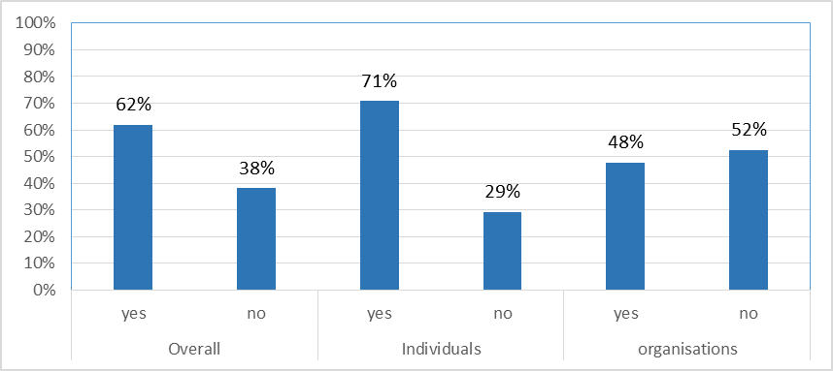

  - Overall the majority of respondents were in favour of this proposal, with greater support from individuals (71%) than from organisations (48%).
  - Most local authorities were against this proposal, arguing that reviews were already carried out relatively frequently, and that there was already provision for people to make representations under the current local government arrangements.
  - Others expressed concerns that any threshold to trigger a review should be set appropriately high to prevent local authorities being required to act by relatively small lobbying groups, and that a minimum period between reviews should be set to prevent multiple applications.

Government Position
The Government wants to encourage councils to review their use of parking restrictions such as yellow lines, and to consider introducing more short stay parking bays. Local authority parking strategies should benefit the efficient operation of the local community, and the Government (under the Department for Communities and Local Government) will change the rules so that local residents and firms will be able to make their council review parking, including the provision of parking, parking charges and the use of yellow lines.
Question 7: Do you think that authorities should be required by regulation to allow a grace period at the end of paid for parking?
 | Yes | No | Other | Total | Yes | No | Other | Total y/n
Individual | 208 | 191 | 14 | 413 | 52% | 48% | - | 399
Organisation | 122 | 136 | 13 | 271 | 47% | 53% | - | 258
Did not say | 5 | 0 | 0 | 5 | - | - | -
Total | 335 | 327 | 27 | 689 | 51% | 49% | - | 662
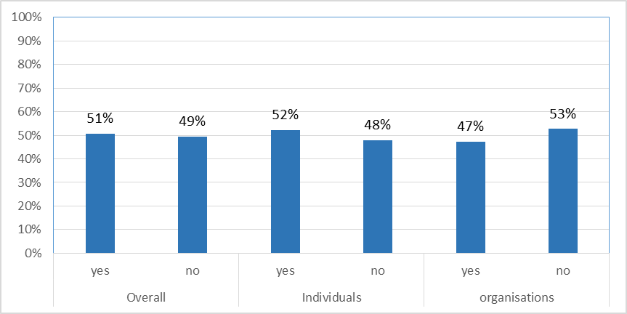

  - Responses on grace periods for paid for parking were evenly split, between both organisations and individuals. Of those who supported this proposal a period of 5-10 minutes was considered to be an appropriate mandatory “free” period to be added at the end of on-street paid for parking.
  - A number of authorities pointed out that they already operate, as a matter of good practice that Civil Enforcement Operators exercise an “observation period” of about 5 minutes after paid for time has expired.
  - Some authorities argued that they should retain the flexibility to set different observation or grace periods appropriate to the circumstances rather than be placed under a mandatory requirement.

Government Position
The Government intends to introduce a mandatory 10 minute free period at the end of paid-for on-street parking either through amendments to statutory guidance or regulations.

Question 8: Do you think that a grace period should be offered more widely – for example a grace period for overstaying in free parking bays, at the start of pay and display parking and paid for parking bays, and in areas where there are parking restrictions (such as loading restrictions, or single yellow lines?
 | Yes | No | Other | Total | Yes | No | Other | Total y/n
Individual | 171 | 207 | 21 | 399 | 45% | 55% | - | 378
Organisation | 68 | 174 | 5 | 247 | 28% | 72% | - | 242
Did not say | 4 | 0 | 1 | 5 | - | - | -
Total | 243 | 381 | 27 | 651 | 39% | 61% | - | 624
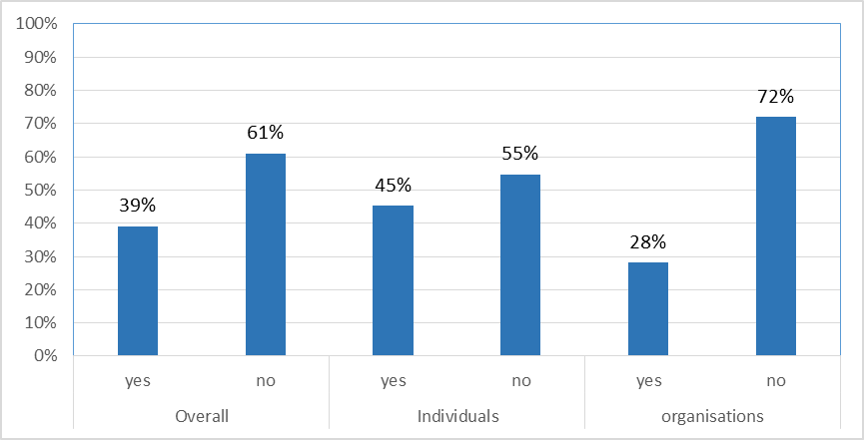

  - This question was about extending grace periods to other areas such as yellow lines and loading bays.
  - The majority of individuals (55%) and organisations (73%) disagreed with this proposal.
  - There were concerns that allowing free periods in places where parking is not permitted (such as on double-yellow lines), could lead to confusion and encourage more anti-social and potentially dangerous parking, and also lead to sequential parking in some popular areas where kerb-space might be continually occupied despite there being a restriction in place.

Government Position
To ensure a consistent approach for motorists the Government intends to introduce a 10 minute mandatory grace period at the end of free on-street parking. This will mean that whether motorists pay for their parking, or it is available free for a time, they can have confidence that they will not be penalised for returning a few minutes late. DCLG will also lead on work to extend the same grace period to local authority off-street parking.
Question 9: If allowed, how long do you think the grace period should be?
A wide range of views were offered varying between 0-30 minutes.

Government Position
The Government recognises that many local authorities already operate a 5 minute observation period. The Government considers that 10 minutes would be an appropriate period of grace.

Question 10. Do you think the Government should be considering any further measures to tackle genuinely anti-social parking or driving? If so, what?
An extremely wide range of ideas were offered. Some common themes included tougher enforcement against offenders, a uniform approach to pavement parking and tackling problems of unregistered vehicles.

Government Position
The Government is not proposing any further measures at this stage but may reconsider the responses to this question when the measures set out above have been implemented.

