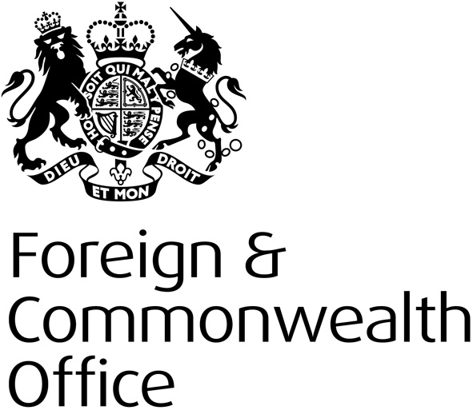

Human Rights and Democracy
Programme

FREQUENTLY ASKED QUESTIONS

Financial Year 2015-16
Human Rights and Democracy Department

PROJECT FAQS

- Can a project cover more than one thematic area?
A project can cover more than one thematic area, but the implementer should pay particular attention to the link with the focus indicators and issues. There is a risk that a project covering more than one theme could lose its strategic focus and be unrealistic in its aims.

- Do you have priority countries for the programme?
Yes, see Annex A of the 2015-16 HRDP Strategy. Our designated HRDP priority countries are those where we actively encourage project bids. These are countries which:
- are one of the FCO’s countries of concern or country case studies, as set out in the Annual Human Rights and Democracy Report, and/or;
- have particular opportunities to promote and protect human rights for one or more of our thematic priorities.
Programme does accept bids from countries not on this list. However, please ensure that project proposals from non-priority countries set out a strong rationale for funding.

- Do you fund research projects?
Yes. However, the proposal would need to explain clearly how the research will be used or disseminated to create impact during the project timeline.

- Do you fund legal aid or strategic litigation?
We do not fund general legal aid (e.g. paying for large numbers of people to access legal advice or legal cases that are not strategic).

We would only look to fund strategic litigation that has a wider precedent or impact on wider policy. We would also require a detailed explanation of why the litigation is particularly strategic and relevant to what the project is trying to achieve. Given that litigation can take years, the project must consider what impact the litigation can have in the time available for the project, and how the cases will be financed once FCO funding ended.

BIDDING PROCESS FAQS

- Is the start date fixed?
No. Projects can start any time between 1 April 2015 and the end of the financial year, but we recommend that projects start as close to 1 April as possible in order to maximise the time to deliver the project. Please note: project activities cannot start before the Grant Contract has been signed.

- Is the end date fixed?
Yes. All projects should end by 28 February 2016 in order to provide time to close down the project before the end of the financial year.

- Can we bid for multi-year funds?
No. We have not had a 2016-17 allocation programme confirmed so all projects must complete in the 2015-16 financial year.

- Will there be a second bidding round in 2015-16?
All existing HRDP funds will be committed during a single allocation round. If needed (because of extra funds becoming available), we may run a second allocation round later in the year with notification placed on our website.

- How much funding is available?
We will fund projects up to a value of £200,000. Projects in excess of that amount may be considered exceptionally. You should bid for what you think the project will cost to deliver.

- What about HRDP non-priority countries and non- Official Development Assistance (ODA) countries?
Projects are accepted from both HRDP non-priority and non-ODA- eligible countries; however, the majority of funding will go to HRDP priority countries, and only a very small percentage of the available funding can be spent in non-ODA eligible countries. Please see the OECD website for a list of ODA eligible countries.

- Is there a limit on how many bids each Embassy or High Commission can submit to the London Programme Team for final assessment?
Yes. We will accept a maximum of four proposals from priority countries, and a maximum of two proposals from non-Priority countries.

- Do you welcome projects that are joint-funded?
We welcome projects jointly funded with other donors as a way of increasing impact and enhancing coordination. All projects must demonstrate how they complement the efforts of other donors and bring added value. We strongly encourage projects that seek to secure future funding from other bodies (e.g. EU, UN) for follow-on work.

- Do you accept more than five proposals per implementer?
The HRDP will no longer cap the number of proposals received by implementers. However, please note that, during the final assessment of projects, the HRDP Programme Board will take into consideration the spread of implementers when making their final funding decisions.

- Can multi-country projects be managed by an Embassy or High Commission?
While the guidance does say that implementers should submit multi-country proposals to the relevant human rights desk officer in London, we’re happy to receive multi-country proposals from an Embassy or High Commission.

Where multi-country proposals come from an Embassy or High Commission, they must be managed by a FCO project officer from that location. The project officer would be responsible for overseeing the project, liaising with FCO staff in other relevant countries, and ensuring monitoring is completed in each country. We have funding available for FCO Locally Engaged Project staff and monitoring costs; please get in touch with the HRDP team to discuss.

- How are the project proposals assessed by the HRDP Team in London?
All applications are sifted first to ensure that the projects meet the key criteria (strategic fit, demonstrating impact, and value for money) and have all the necessary documentation attached. The top-rated proposals go to the HRDP Board; we hold a board for each thematic priority.

The HRDP Board comprises of human rights and project experts, as well as independent members.

- Can International Organisations bid?
Yes.

- Does an organisation have to be a NGO to receive grant funding?
No. It isn’t necessary for a recipient to be a NGO. However, in many cases it is likely that the applicant for grant funding will be an NGO or other similar type of not-for-profit organisation.

BUDGET FAQS

- Do you pay Per Diems (daily allowances)?
No. We will reimburse reasonable actual costs. These must be clearly broken down in the activity based budget (ABB).

- Do you buy equipment? (not including basic stationary for training etc.)
Programme funds should not be used to purchase equipment, such as laptops, vehicles etc, unless the provision of the item is essential to the delivery of the project.

- Do you pay staff costs?
Yes, for staff working directly on the project (e.g. project managers, trainers etc.). You should ensure that costs are reasonable, and include the seniority of the staff member and the percentage of time they will be working on the project. This should be broken down in the ABB as the rate per hour or day. Please note:
- the FCO will not pay for staff benefits that are not required by local law; and,
- for staff working indirectly on the project, such as finance staff or senior management, these costs should be included under administration costs.
- How are implementers paid? Can implementers request advance payments?
The standard wording of the Grant Contract is to pay implementers quarterly, 3 months in arrears. However, under exceptional circumstances, it is possible to request advance payment of up 25% of the value of the project. This should be made clear in the full project proposal.

- Do you pay administration costs?
Yes. However, the combined total of management fees, overheads and administration costs must not exceed 10% of the overall project cost. Administration costs should be broken down into component parts.

