


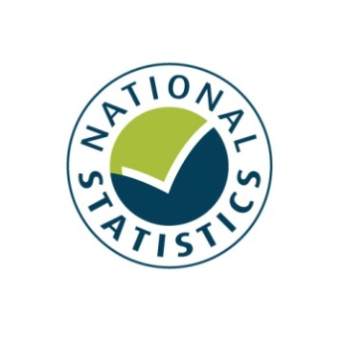


Taking Part 2012/13 Quarter 4
Statistical Release
June 2013

Taking Part is a National Statistic and has been produced to the standards set out in the Code of Practice for Official Statistics

The United Kingdom Statistics Authority has designated these statistics as National Statistics, in accordance with the Statistics and Registration Service Act 2007 and signifying compliance with the Code of Practice for Official Statistics.
Designation can be broadly interpreted to mean that the statistics:
• meet identified user needs;
• are well explained and readily accessible;
• are produced according to sound methods; and
• are managed impartially and objectively in the public interest.

Once statistics have been designated as National Statistics it is a statutory requirement that the Code of Practice shall continue to be observed. See the UK Statistical Authority assessment

Contents

Key findings 4
Introduction 9
Chapter 1: The 2012 Olympic and Paralympic Games 11
Chapter 2: Heritage 16
Chapter 3: Museums and galleries 19
Chapter 4: Libraries 23
Chapter 5: Arts 26
Chapter 6: Archives 30
Chapter 7: Volunteering and charitable giving 32
Chapter 8: Equalities 36
Annex A: Background note 43
Annex B: Key terms and definitions 46
Annex C: Sector definitions 48

Key findings

Taking Part is a household survey in England, it looks at participation in the cultural sectors. This report presents the latest headline estimates for the year up to and including March 2013. The survey has run for eight years and is used widely by policy officials, academics and charities to measure participation in the cultural sectors. Please note the time period reported in this release now includes the period when the UK hosted the 2012 Olympic and Paralympic Games, which might have had an effect on participation in some of the sectors.

2012 Olympic and Paralympic Games

    - In 2012/13, 20 per cent of respondents who had taken part in sport or recreational activity answered that the UK winning the bid to host the 2012 Olympics had motivated them to do more of these activities, an increase from 8 per cent in 2005/06

    - 7 per cent of respondents who had taken part in cultural activities felt that the UK winning the bid to host the 2012 Olympics had motivated them to take part in more cultural activities. 10 per cent of those who had volunteered felt it motivated them to do more voluntary work.

    - 90 per cent of adults intended to follow or followed the London 2012 Olympic or Paralympic Games, for example by watching on television at home.

    - 19 per cent of adults got actively involved, or intended to get actively involved¹ in the Games, for example by attending a free Olympic event.
    - Nearly three quarters (74%) of adults were slightly or strongly supportive of the UK hosting the 2012 Olympic and Paralympic Games. Attitudes have fluctuated since 2005/06 (71% slightly or strongly supportive), with a low in 2007/08 of 60 per cent.

Culture

- Nearly three quarters (73%) of adults visited a heritage site in the last year. This represents a significant increase of 3 percentage points since the survey began in 2005/06 but a similar level to 2011/12.

- Museum and Gallery attendance rates in 2012/13 (53%) were at their highest level since the Taking Part survey began in 2005/06, meaning the majority of adults had visited a museum or gallery in the 12 months prior to interview.

- In 2012/13 the proportion of people who had visited a museum or gallery in the last year had significantly increased since 2005/06 (from 42% to 53%), representing a general upward trend since 2008/09.

- 37 per cent of adults had used a library in the 12 months prior to being interviewed, a significant decrease from 48 per cent in 2005/06 and from 39 per cent in 2011/12

- 78 per cent of adults had attended or participated in the arts in the previous year, a significant increase since 2005/06 (76%) and 2010/11 (76%). In 2012/13 art engagement was at a similar rate to 2011/12 (78%) but higher than any other previous survey year from 2005/06 onwards. The upward trend has only been present recently, prior to 2011/12, art engagement had been fairly stable.

Volunteering and charitable giving

- The proportion of adults who had volunteered in the last 12 months was 26 per cent, an increase from 24 per cent in 2005/06. 9 per cent of all adults had volunteered in a DCMS sector (Arts, Museums or Galleries, Heritage, Libraries, Archives or Sport.) This was an increase from 7 per cent in 2005/06.

- There has been a significant increase in the proportion of adults from black and ethnic minority (BME) groups who had volunteered in the last 12 months compared to 2005/06 (up from 20% to 27%). This may be linked to the UK winning the bid to host the 2012 Olympic and Paralympic Games, since 25 per cent of BME volunteers said they were motivated to do more voluntary work as a result of the UK hosting the 2012 Olympics.

- There has been a significant increase in the proportion of adults aged 16-24 years (up from 25% to 35%) and women (25% to 28%) who had volunteered in the last 12 months compared to 2005/06. 14 per cent of 16-24 year olds said the UK hosting the 2012 Olympic Olympics has motivated them to do more voluntary work, this figure was 10 per cent for women

- 90 per cent of adults had donated money (including donations into a collection box) in the last 12 months, 32 per cent of adults had donated to a DCMS sector. These were both at a similar level to 2010/11

Digital engagement

- 31 per cent of adults had visited a museum or gallery website in the year ending March 2013, the highest reported level since data collection began in 2005/06 when the figure was 16 per cent.

- Since 2005/06, the proportion of people who have visited heritage websites significantly increased from 18 per cent to 31 per cent, the highest level reported since data collection began.

- In the year ending March 2013, 17 per cent of adults had visited a library website in the 12 months prior to being interviewed, a significant increase from 9 per cent in 2005/06.

Equalities

- In 2012/13 adults from black and minority ethnic (BME) groups were less likely to have engaged with heritage, museums and galleries, or the arts, but were more likely to have visited libraries than adults from the white group:
- 57 per cent visited a heritage site in the last year (compared with 75% for the white group).
- 45 per cent visited a museum or gallery (compared with 54% for the white group).
- 70 per cent participated in the arts (compared with 79% for the white group).
However:
- 45 per cent visited a library (compared with 36% for the white group).

- BME visits to museums and galleries increased from 35 per cent in 2005/06 to 45 per cent in 2012/13.

- BME visits to heritage sites increased from 51 per cent in 2005/06 to 57 per cent in 2012/13.

- People from BME groups had high levels of enjoyment in cultural activities (which were similar to those for the white group); with, for example, 88 per cent of people from BME groups enjoyed visiting a place of historical interest (compared with 89% for the white group).

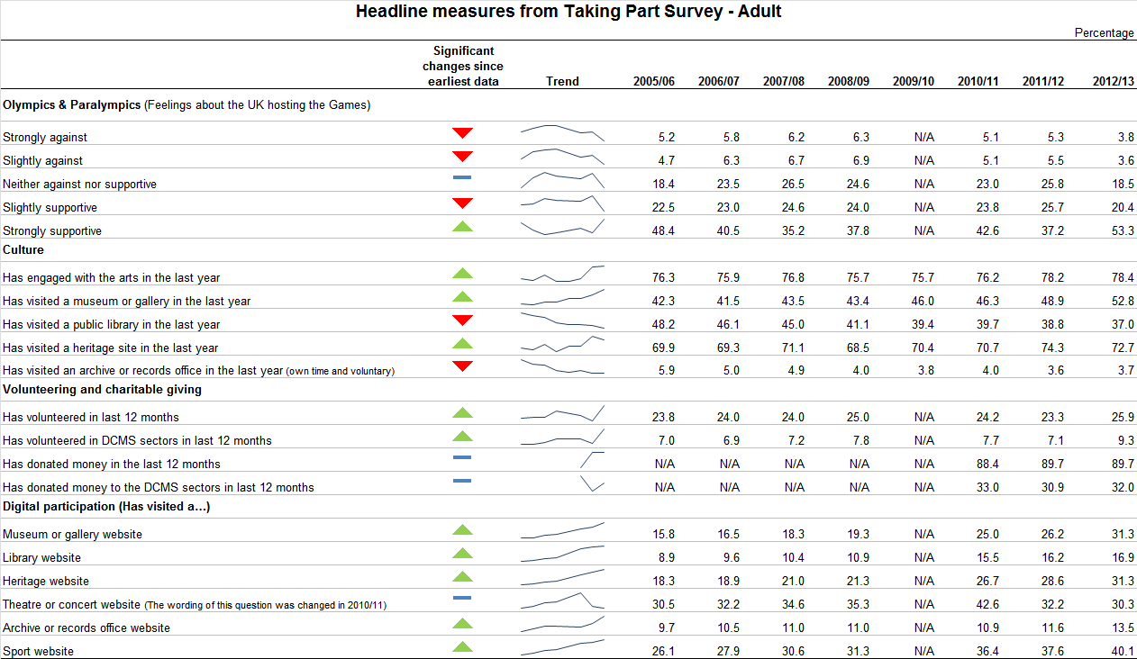
Introduction

This report
Taking Part is a household survey in England, it looks at participation in the cultural sector. This report presents the latest headline estimates for the year up to and including March 2013. The survey has run for eight years and was commissioned by the Department for Culture, Media and Sport (DCMS) in partnership with Arts Council England, English Heritage, and Sport England. The statistics are used widely by policy officials, academics, the private sector and charities to measure participation in the cultural sectors.

Taking Part is the key evidence base for DCMS, providing reliable national estimates of participation and supporting the Department’s aim of improving the quality of life for everyone, by providing people with the chance to get involved in a variety of cultural and sporting opportunities. The survey also aims to inform the DCMS Structural Reform Priorities and Business Plan through the provision of data for DCMS input and impact indicators. See the latest DCMS indicators

This report presents headline findings for the main cultural estimates along with updates on data which are used to measure the influence of London hosting the 2012 Olympic and Paralympic Games. Data are also used to measure volunteering and charitable giving policy objectives. Where analysis has been extended to look at digital engagement within the DCMS sectors (heritage, museums and galleries, libraries and archives, arts, volunteering and charitable giving), this is presented alongside the relevant sector figures. An additional chapter has been included in this release looking at participation and attendance across the cultural sectors amongst black and minority ethnic groups.

Government policies which might have had an impact on participation figures have been outlined at the beginning of relevant chapters throughout the report. This does not indicate that these policies have directly caused the change in participation, simply that they might be a factor. Where observations are made over time, the latest data are compared with the earliest available data (typically 2005/06) unless otherwise stated. Key terms and definitions are provided in Annex B and C of this release.

The latest results presented in this report are based on interviews conducted between April 2012 and March 2013. The total sample size for this period is 9,838. When differences are stated, statistical significance tests have been run at the 95% level. All differences and changes reported are statistically significant at the 95% confidence level unless otherwise stated. This means the probability that any given difference happened by chance is low (at most 1 in 20).

See below for additional resources relating to this release
Spreadsheets and documents accompanying this release

Forthcoming releases and events
The next adult release, scheduled for September 2013, will present the quarter 1 estimates for year 9 (July 2012 – June 2013) for adults.

There will also be an annual child release presenting estimates for 2012/13 in August 2013.

Future adult releases will follow a similar schedule, being released at the end of March, June, September and December ahead of quarterly reporting on the input and impact indicators that are produced by all Departments.

In addition, topic specific analysis will be published throughout the year, looking in depth at particular areas of the survey. Previous reports have covered Big Society and sport participation (published in the annex of the 2011/12 technical report) The third and most recent report on the 2012 Olympic and Paralympic Games was published 13th December 2012

The most recent Taking Part User Event was held on 28th November 2012. See here for details of the Taking Part User Event and materials from previous events

If you would like further information on these releases or the Taking Part survey, please contact the Taking Part team on TakingPart@culture.gsi.gov.uk. Additional contact details are contained within Annex A.

Sport consultation
As detailed in the last statistical release and on our consultation pages in March, the responsibility for reporting Official Statistics on sport participation now falls entirely with Sport England.
Sport participation data are reported on by Sport England in the Active People Survey.

- The 2012 Olympic and Paralympic Games

This chapter relates to the UK hosting the 2012 Olympic and Paralympic Games. It includes analysis on the extent to which people in England supported hosting the Games; how people got involved or intended to get involved in the Games and whether the Games motivated people to participate in voluntary work, cultural activities or sport.

The latest survey results are from interviews conducted between April 2012 and March 2013 so now include the period when the UK hosted the 2012 Olympic and Paralympic Games between July and September 2012. Further analysis looking at participation rates during the quarter when the 2012 Games were held will be carried out as part of the London 2012 Meta-evaluation and published at the end of July 2013.

Government policy, which may have influenced the statistics presented, is described below:
The Government has a policy to make the most of the 2012 Olympic and Paralympic Games; to deliver a legacy over the next ten years, across the four themes of sport and healthy living, growth and the economy, communities and volunteering and the regeneration of East London. The Paralympic legacy cuts across those four themes. This includes encouraging more people to take part in sport and volunteering. The Government intends to use the success of Games-related volunteering to increase the rate of volunteering, including through initiatives such as ‘Join in’, which is funded by the Office for Civil Society to promote sport related volunteering. It intends to promote cultural engagement following the Cultural Olympiad, which attracted around 20 million people to events across the UK.
Legacy planning had been part of the planning for the Games from the bid stage onwards. The Government set out its legacy plans in a Written Ministerial Statement from the then Secretary of State for Culture, Media and Sport in December 2010. A meta-evaluation of the Games’ legacy benefits has been commissioned by the DCMS. An initial pre-Games report of legacy benefits was published in November 2012.

Key findings

    - In 2012/13, 20 per cent of respondents who had taken part in sport or recreational activity answered that the UK winning the bid to host the 2012 Olympics had motivated them to do more of these activities, an increase from 8 per cent in 2005/06

    - 7 per cent of respondents who had taken part in cultural activities felt that the UK winning the bid to host the 2012 Olympics had motivated them to take part in more cultural activities. 10 per cent of those who had volunteered felt it motivated them to do more voluntary work.

    - 90 per cent of adults intended to follow or followed the London 2012 Olympic or Paralympic Games, for example by watching on television at home.

    - 19 per cent of adults got actively involved, or intended to get actively involved¹ in the Games, for example by attending a free Olympic event.
    - Nearly three quarters (74%) of adults were slightly or strongly supportive of the UK hosting the 2012 Olympic and Paralympic Games. Attitudes have fluctuated since 2005/06 (71% slightly or strongly supportive), with a low in 2007/08 of 60 per cent.

The 2012 Olympic and Paralympic Games

Since 2011/12, the Taking Part survey has asked questions on adults’ intention to get involved or their actual involvement in the Games. In the year ending March 2013, 90.0 per cent of adults intended to follow or followed the London 2012 Olympic or Paralympic Games in some way. Of all survey respondents in the 12 months to March 2013 people followed or intended to follow the Games in the following ways:
- Watching on TV at home (up to 87.1 per cent from 81.4 per cent in 2011/12)
- Reading an on or offline newspaper (up to 37.9 per cent from 32.1 per cent in 2011/12)
- Listening to the radio at home (16.2 per cent, a similar level to 2011/12)
- Watching or listening on the internet at home (up to 15.9 per cent from 13.2 per cent in 2011/12
- Watching live events on a public big screen (11.3 per cent, a similar level to 2011/12)

Additionally from July 2011, adults were asked whether they intended to, or actually did actively follow or get involved in the London 2012 Olympic or Paralympic Games.
In the year ending March 2013, 18.8 per cent of adults said they did, a significant decrease from 24.4 per cent in 2011/12. The following ways were reported:
- Attending a free Olympic or Paralympic event (6.4 per cent, down from 8.7 per cent in 2011/12)
- Attending a ticketed Olympic or Paralympic event (9.6 per cent, up from 7.9 per cent in 2011/12)
- Taking part in a Games related community event or activity, e.g. street party or local Inspire Mark project (3.5%, a similar level to 2011/12)
- Using new or improved sports facilities linked to the Games (0.7 per cent, down from 2.5 per cent in 2011/12).
- Gaining Games related employment or training (1.0 per cent, down from 1.9 per cent in 2011/12)
- Taking part in a Games related cultural event or activity (1.6%, a similar level to 2011/12)
- Volunteering during the Games, e.g. as a Gamesmaker or London Ambassador (0.4 per cent, down from 1.7 per cent in 2011/12)
- Taking part in a Games related sport or physical activity (0.5 per cent, down from 1.0 per cent in 2011/12).

In 2012/13, 19.8 per cent of respondents who had taken part in sport or recreational activity answered that the UK winning the bid to host the 2012 Olympics had motivated them to do more of these activities. This was a significant increase from 7.7 per cent in 2005/06 and higher than any year since then.

7.4 per cent of respondents who had taken part in cultural activities felt that the UK winning the bid to host the 2012 Olympics had motivated them to take part in more cultural activities. 9.8 per cent of those who had volunteered felt it motivated them to do more voluntary work. These were both significantly higher than in 2010/11 when the figures were 4.0 per cent and 6.6 per cent respectively.

Support for the UK hosting the 2012 Olympic and Paralympic Games

Attitudes towards the UK hosting the Games have fluctuated over the period since 2005/06.
- The rate of people who were either slightly or strongly supportive in 2012/13 (73.7%) was the highest of any survey year.
- The proportion of those who were strongly supportive increased significantly from 48.4 per cent in 2005/06 to 53.3 per cent in the latest results. Strong support for hosting the Games is now at the highest level reported in any survey year.
- The proportion or respondents who were slightly supportive significantly decreased from 2005/06 (22.5%) to 2012/13 (20.4%).
- The proportion who were neither against nor supportive of the Games was similar in the year ending March 2013 (18.5%) to 2005/06 (18.4%). The latest data also represents a decrease from 25.8 per cent in 2011/12.
- The proportion that were slightly against (3.6%) and strongly against (3.8%) has decreased since 2005/06 and 2011/12 (Figure 1.1).

London won the bid to host the Olympic and Paralympic games on the 6th July 2005. The Games was staged in July, August and September of 2012. These figures represent increasingly strong support for the Games.

Figure 1.1: Adults’ opinions about the UK hosting the 2012 Olympic Games, 2005/06 to April 2012 – March 2013
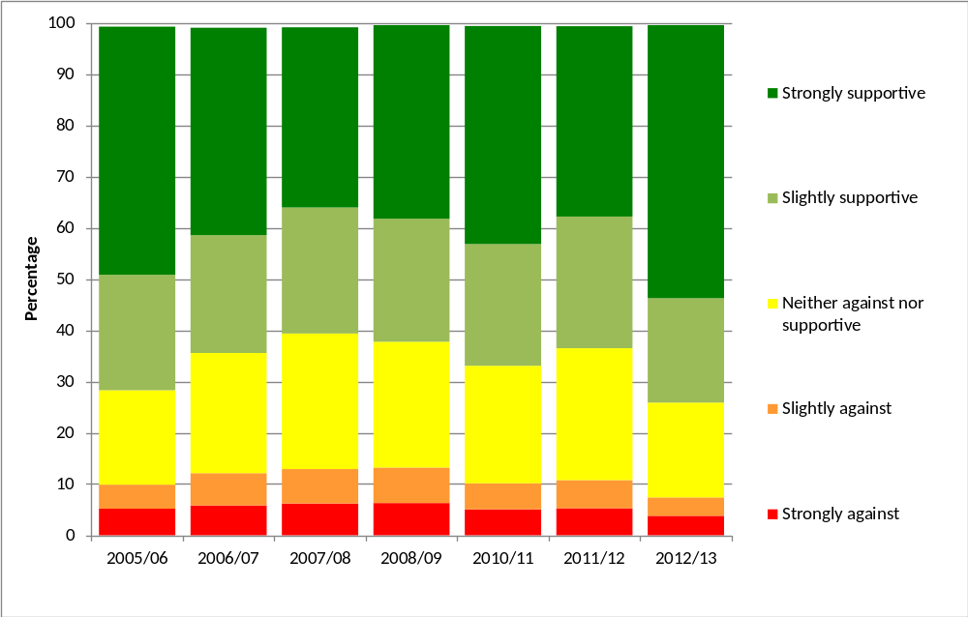
Notes
(1) Confidence intervals range between +/-0.4 and +/-1.3 from 2005/06 onwards.
(2) This question was not asked in 2009/10

As the following breakdowns show the increase in support described above was not driven by any particular subgroup or demographic but reflected an increase across all respondents.

- By ethnic origin

A higher proportion of adults from black and minority ethnic (BME) groups were supportive of the Games than those from the white group (81.0% and 73.1% respectively). The proportion of adults from the white group supportive of the Games in the latest survey data significantly increased since 2010/11 (65.4%) and 2011/12 (61.9%). The corresponding proportion of adults from BME groups is similar to 2005/06 but has increased from 73.9 per cent to 81.0 per cent since 2011/12

- By gender and age

Support for the UK hosting the Games was similar for men and women (73.7% and 74.3% respectively). Support by men increased significantly since 2010/11 (69.9%) and 2011/12 (64.5%), and support by women also increased significantly since 2010/11 (63.7%) and 2011/12 (62.0%)

The 25-44 year old age group was 76.8 per cent supportive of the Games, this was significantly greater than those aged 45-64 (72.5%), 65-74 (72.4%) and 75+ (72.7%)

Those aged 16-24 were 72.7 per cent supportive of the Games, a similar level to 2010/11 (69.2%) but a significant increase from 2011/12 (65.6%)

All age groups except 16-24 year olds underwent a significant increase in support since 2010/11.

- By region

There were significant increases in support for the Games from 2010/11 to the year ending March 2013 amongst all English regions except the North West, for which the rate remained similar. The North West and Yorkshire and the Humber were significantly less supportive than most other regions.

The levels of support within London, where the majority of the Games were held, varied. Looking at the complete 8 year survey period between July 2005 and March 2013, 75.1 per cent of respondents in Wandsworth (the most supportive London borough) were supportive of the Games, compared to 56.4 per cent of respondents in Kingston upon Thames (the least supportive London borough).

Figure 1.2: Proportion of adults who were slightly or strongly supportive of the UK hosting the 2012 Olympic Games by London borough, July 2005 to March 2013

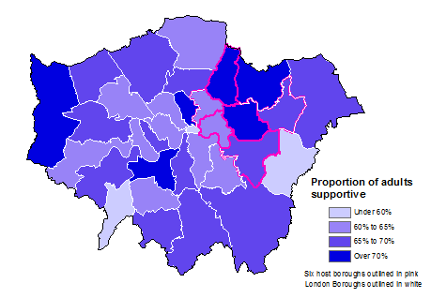
Notes
- Results for the City of London are indicative due to a small sample size.
- Sample sizes vary by London Borough (excluding City of London) from 198 to 785.
- The six host boroughs are Barking and Dagenham, Greenwich, Hackney, Newham, Tower Hamlets and Waltham Forest.

Further detail on this section can be found in the accompanying spreadsheets to this release

- Heritage

The Taking Part survey measures adult participation in heritage by whether respondents visited a heritage site in the 12 months prior to interview, as well as the frequency with which heritage sites were visited. Details on the ways that people digitally engage with heritage are given at the end of this chapter. Digital engagement with the heritage sector includes visiting a heritage website to take a virtual tour of a historical site, learn about history or the historic environment, or discuss history or the historic environment on a forum.

English Heritage also published two reports in 2011 which build on the Taking Part survey to explore participation within the Heritage sector in more detail.
- The Visiting the Past report analyses the factors which affect people's likelihood of visiting three kinds of historic sites:
- Historic parks and gardens
- Historic places of worship
- Monuments, castles and ruins
It examines the effects of the demographic characteristics of visitors (eg age), other activities and social circumstances on the probability of visiting these sites. The findings are based on a statistical analysis of the visiting patterns of over 25,000 people surveyed in Taking Part.
- The Mapping Leisure report uses visualisation techniques to create a series of pictures of Taking Part data, allowing the landscape of cultural and sporting participation in England to be visually explored. The pictures visualise the participation levels, demographics, and connections, of over 100 cultural and sporting activities (including heritage). The report interprets the pictures and discusses the questions they raise.

Government policy, which might have influenced the statistics presented is described below:
DCMS is responsible for ensuring that the historic environment of England is properly protected and conserved, so that present and future generations can enjoy the benefits of engaging with heritage. Through the bodies it funds, DCMS seeks to promote understanding and access to the historic environment, allowing people to appreciate the heritage assets around them. Further details of the department’s role in relation to heritage is set out on our website.
DCMS funds English Heritage, the Government’s statutory advisor on the historic environment, as well as funding and supporting a number of other bodies, including the National Heritage Memorial Fund and the Churches Conservation.

Key findings

- Nearly three quarters (73%) of adults visited a heritage site in the last year. This represents a significant increase of 3 percentage points since the survey began in 2005/06 but a similar level to 2011/12.

- 30 per cent of adults reported visiting a heritage site less than once a month but at least three or four times a year, a significant increase since 2005/06, following a continuous upward trend from then to the current period.

- There have been significant increases since 2005/06 in the proportion of people who had visited a heritage site over the previous year across almost all age groups and socio-demographic groups (apart from the 16-24 and 25-44 year old age groups, those in the upper socio-economic group, those living in private rented sector housing and those who stated no religion or other religion).

Heritage attendance

The latest results show that 72.7 per cent of adults visited a heritage site in the 12 months prior to interview. This was a significant increase from 69.9 per cent in 2005/06 but not statistically different to 2011/12 (74.3%). The proportion of adults visiting a heritage site was stable between 2005/06 and 2010/11, but has significantly increased since.

Figure 2.1: Proportion of adults who had attended a heritage site in the last 12 months, 2005/06 to 2012/13

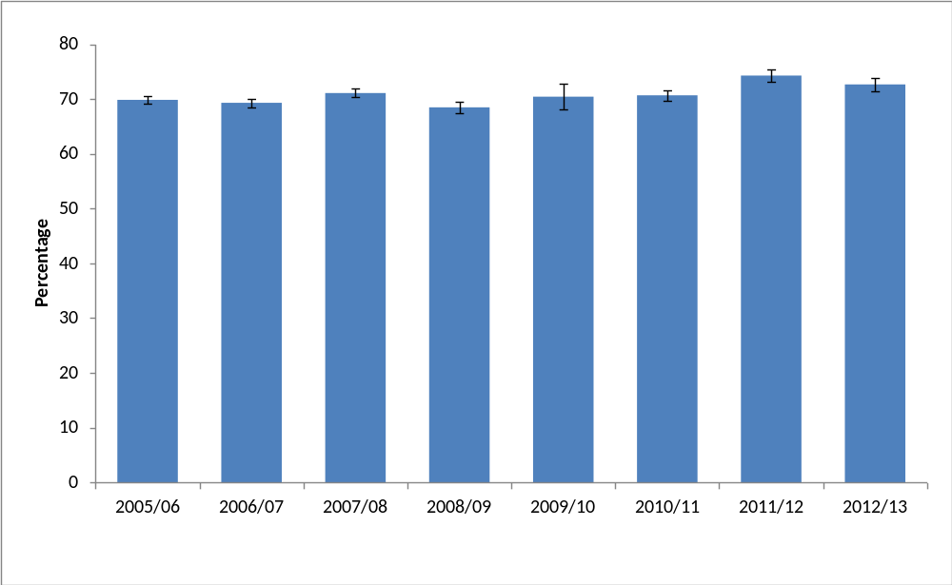
Notes
- Confidence intervals range between +/-0.7 and +/-2.4 from 2005/06 onwards.

There was an increase in the rate of adults who visited a heritage site less often than once a month but at least three or four times a year (30.5%, an increase of 4.0 percentage points from 2005/06). This represented a gradual upward trend since 2005/06 to the current period.

Socio-demographic groups which experienced large significant increases between 2005/06 and 2012/13 were:
- 65-74 year olds (an increase of 8.1 percentage points to 78.0%)
- 75+ year olds (an increase of 8.1 percentage points to 60.3%)
- Black or ethnic minority groups (an increase of 6.6 percentage points to 57.2%)
- Other religion (an increase of 6.3 percentage points to 56.0%)

Those who had visited a heritage site in the 12 months prior to interview who lived in the “most deprived” index of multiple deprivation group, underwent a significant increase of 14.9 percentage points to 54.7 per cent in the year ending March 2012 since 2009/10 when data using this classification were first collected. There were also significant increases for adults in the “wealthy achievers” and “comfortably off” ACORN classifications.

There have been significant increases since 2005/06 amongst those who lived in the
- North East (5.8 percentage points to 74.9%)
- Yorkshire and the Humber (7.8 percentage points to 76.1%)
- West Midlands (5.3 percentage points to 71.1%).
The above increases first became significantly different from 2005/06 from 2010/11 onwards. Prior to this, trends were relatively stable.

There were significant increases for adults in both urban (70.6%) and rural (81.4%) areas in 2012/13 compared to 2005/06 (68.0% and 77.4% respectively). However compared to 2011/12 there was a significant decrease in the rate for adults living in urban areas (72.9% in 2011/12). The rate remained similar for rural areas compared to 2011/12 (80.4%).

Digital engagement

Since 2005/06, the proportion of people visiting heritage websites significantly increased from 18.3 per cent to 31.3 per cent, the highest level reported since data collection began in 2005/06. The proportion of adults visiting heritage websites has gradually increased year on year but was only first significantly greater than in 2005/06 in 2010/11, after which it has continued to rise. Data were not collected in 2009/10,

The Taking Part survey added new questions on heritage websites from July 2011. From April 2012 to March 2013, of people who visited a heritage website:
- Three in five respondents used a heritage website to plan how to get to a historic site (60.7%).
- Almost half used a heritage website to learn about history or the historic environment (48.7%),
- Just under a quarter used a heritage website to buy tickets to visit a historic site (24.3%).
- 2.2 per cent of adults who visited a heritage website used it to discuss history or visits to the historic environment on a forum.
- 17.1 per cent of adults had visited a heritage website to take a virtual tour of a historical site.

Further detail on this section can be found in the accompanying spreadsheets to this release

- Museums and galleries

This chapter examines museum and gallery attendance in the last 12 months, by a range of area-level and socio-demographic breakdowns. Details on the ways that people digitally engage with museums and galleries are also given. Digital engagement with museums and galleries is defined as using websites to look at items from a collection, find out about a particular subject, take a virtual tour of a museum or gallery or to view or download an event or exhibition.

The Department also publishes monthly museum and gallery visits figures. To note these figures are from the perspective of individual museum and galleries, therefore one person may visit a number of museum and galleries and be counted more than once by different institutions, data also include overseas visitors. Taking Part is a household survey in England and measures participation from the view point of the individual. Despite these differences the overall trend has been similar, showing an upward trend since 2005/06.

Until 2011/12, Arts Council England also published data on the number of museum visits from those sites participating in the Renaissance in the Regions programme. This was a quarterly return and the figures are not entirely comparable with those published in the Taking Part survey, one person may visit a number of participating museums and be counted more than once by different institutions under the Renaissance in the Regions programme. The figures will also include overseas visitors, which the Taking Part survey does not. Despite these differences, a broadly similar trend is shown in these data as in the Taking Part survey.

Government policy, which may have influenced the statistics presented, is described below:
DCMS directly sponsors 20 museums and galleries, of which 13 were founded by Act of Parliament and are defined as “National Museums”. All DCMS sponsored institutions receive Grant-in-Aid funding from DCMS. Details of how much funding individual museums will receive are published in an annual report. Providing free admission (since 2001) to the permanent collections remains a condition of the national museums and galleries’ Grant-in-Aid funding.

The Department also:
- funds Renaissance in the Regions, a program to support England’s regional museums
- invests in museum and gallery education programmes
- co-funds and administers the DCMS/Wolfson Museums and Galleries Improvement Fund
DCMS’ stewardship of sponsored museums is at arm’s length. The Department does not intervene in their day-to-day business operations. Each sponsored museum is run by an independent Board of Trustees. The majority of these Trustees are appointed either by the Prime Minister or the Secretary of State for DCMS. The Boards of Trustees are responsible for:
- preserving and adding to the objects in their collections
- ensuring that the collections are exhibited to the public and available for study
- promoting the public’s enjoyment of science, history, art or design through their collections

Key findings

- The proportion of people who had visited a museum or gallery in the last year has significantly increased since 2005/06 (from 42% to 53%), representing a general upward trend since 2008/09.

- Attendance rates (53%) have been at their highest level since the Taking Part survey began in 2005/06, meaning the majority of adults had visited a museum or gallery in the 12 months prior to interview.

- 31 per cent of adults said they had visited museums or galleries 1-2 times a year, 17 per cent did so 3-4 times a year, 4 per cent at least once a month and 1 per cent went at least once a week.

- There has been a significant decrease since 2005/06 in the proportion of adults who had not visited a museum. Between 2011/12 and the year ending March 2013 this fell 4 percentage points to 47 per cent.

Overall attendance at museums and galleries

In the period April 2012 to March 2013, 52.8 per cent of adults visited a museum or gallery, an increase in attendance from 2005/06 (42.3%). This was the highest proportion recorded since the survey began in 2005/06, as shown in Figure 4.1. The vast majority of visits were made in people’s own free time (97.4%), with a small percentage attending for paid work or for academic study (2.8% and 2.6% respectively).

People who live in rural areas were just as likely as people in urban areas to have visited a museum or gallery in the last year, however there were variations by region.

In April 2012 to March 2013:
- Londoners (57.4%) had higher rates of attendance, compared to all other regions except the North East, Yorkshire and The Humber and the South East where the difference from London was not significant.
- Attendance in the West Midlands (47.5%) was lower than that of Yorkshire and The Humber (54.6%), London (57.4%) and the South East (55.7%). The rate for the West Midlands was not significantly lower than for the other regions of England.
- Since 2005/06, the proportion of people visiting museums or galleries increased significantly in all regions of England.

Figure 3.1: Proportion of adults who had visited a museum or gallery in the last year, 2005/06 to 2012/13
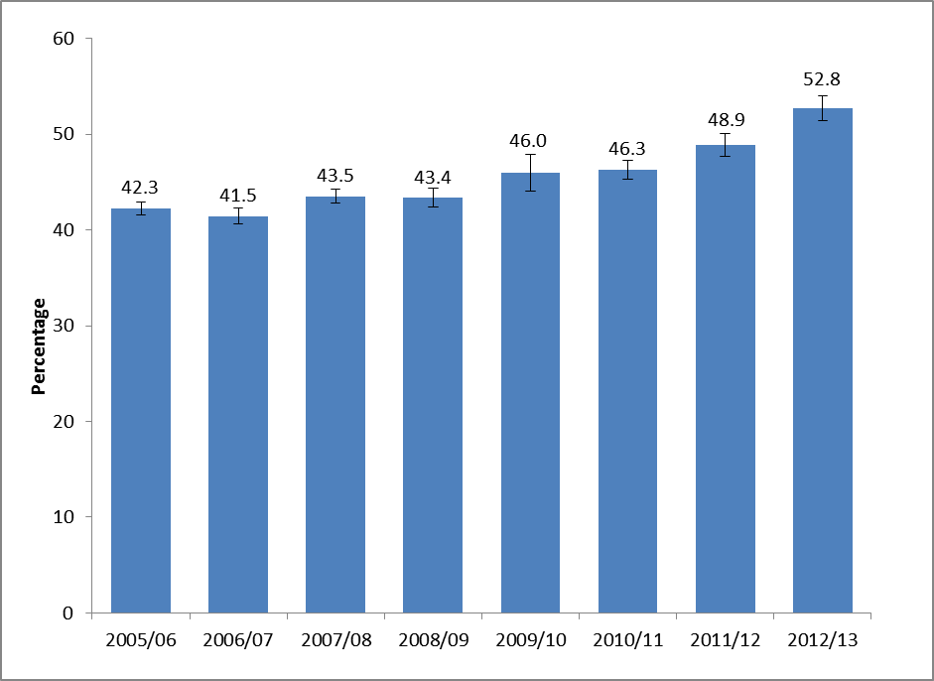
Notes
- Confidence intervals range between +/-0.7 and +/-1.9 from 2005/06 onwards.
- Years where confidence intervals overlap cannot be reliably compared.

People in higher ACORN groups had greater attendance rates for museums and galleries in the last year than those in lower groups. For example those categorised as Wealthy Achievers (60.4%) had significantly higher attendance rates than those categorised as moderate means (45.0%) or hard pressed (38.7%). Likewise those in the Urban Prosperity category (67.2%) also had significantly higher attendance rates than those of moderate means and the hard pressed. This is depicted in Figure 4.2. There has been a significant increase in attendance rates amongst all ACORN groups since 2005/06.

Over three in five adults (61.6%) in the upper socio-economic group visited a museum or gallery in the last year compared to 39.5 per cent in the lower group. Over half of working adults had attended (57.3%) compared to 46.1 per cent of adults not working.

Compared to 2011/12, the proportion who visited a museum or gallery in the year ending March 2013 increased amongst most demographic groups, the only exceptions being:
- 16-24 and 25-44 year olds
- Those in social or private sector rented housing
- Respondents from black and minority ethnic (BME) groups
- Those of no religion

Figure 3.2: Proportion of adults who had visited a museum or gallery in the last year, by ACORN group, 2012/13.

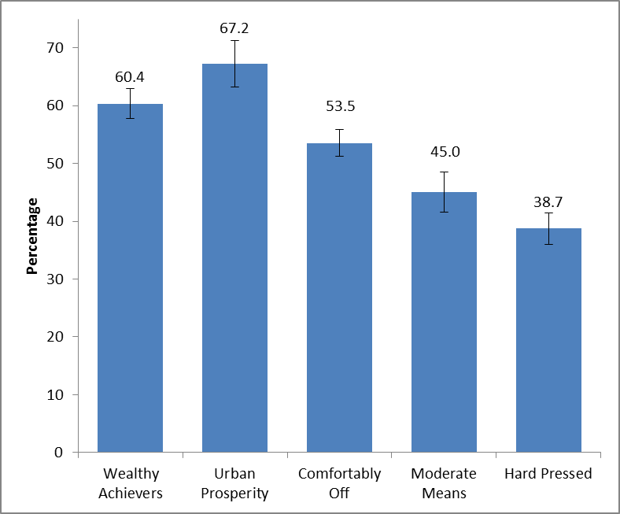
Notes
- Confidence intervals range between +/-2.3 and +/-4.1. Categories where confidence intervals overlap cannot be reliably compared.

Digital engagement

31.3 per cent of adults had visited a museum or gallery website in the year ending March 2012, the highest reported level since data collection began in 2005/06 when the figure was 15.8 per cent. There has been a gradual upward trend in digital engagement with museum and galleries since the data were first collected in 2005/06 although 2010/11 was the first period to show as a significantly higher proportion than 2005/06.

Between 2005/06 and the year ending March 2013, of those who had visited a museum or gallery website, there was
- A significant increase in the proportions of people visiting a museum or gallery website to find out about or order tickets for an exhibition or event (from 47.9% to 60.4%).
- A significant decrease in the proportion of adults who had visited a museum or gallery website to look at items from a collection (from 33.7% to 21.3%).

The Taking Part survey added new questions on museum and gallery websites from July 2011. In the year ending March 2013, of those who had visited a museum or gallery website, 45.8 per cent had done so to find out about a particular subject, 17.1 per cent of adults had taken a virtual tour of a museum or gallery and 13.1 per cent had viewed or downloaded an event or exhibition. The values above are not significantly different from the corresponding figures from 2011/12.
Further detail on this section can be found in the accompanying spreadsheets to this release
- Libraries

This chapter examines library participation as measured by attendance in the last 12 months, by a range of area-level and socio-demographic breakdowns. Details on the ways that people digitally engage with library services are also given. Digital engagement with libraries is defined as completing a transaction (e.g. reserving or renewing items or paying a fine), searching and viewing online information or making an enquiry.

Government policy, which might have influenced the statistics presented, is described below:
Individual public library services are delivered by 151 library authorities in England, and they have a statutory duty under the Public Libraries & Museums Act 1964 to provide a comprehensive and efficient library service, set in the context of local need, specifically of those who live, work and study in the local area. Central Government core funding for public libraries is paid through the local government settlement, administered by the Department for Communities and Local Government (CLG). Local authorities decide how to allocate funding to public libraries in the light of their statutory duties and local priorities, and in 2011-12 authorities in England invested £820m in their public library services.

The 1964 Act imposes a duty on the Secretary of State for Culture, Media and Sport to oversee and promote the public library service and to secure discharge of the statutory duties of local authorities as well as providing certain powers to take action where a local authority is in breach of its own duty.

The Government is responsible for national library policy and works closely with the development agency for libraries, Arts Council England. Further information about the Arts Council’s support for public libraries is available on their website.

Key findings

- 37 per cent of adults had used a library in the 12 months prior to being interviewed, a significant decrease from 48 per cent in 2005/06 and 39 per cent in 2011/12.

- Since 2005/06, the proportion of people using a public library has declined in all regions.

Library attendance

In 2012/13, 37.0 per cent of adults reported using a library service in the last 12 months, a significant decrease from 48.2 per cent in 2005/06, and from 2011/12 (38.8%) (Figure 4.1).

As figure 4.1 shows, library usage has remained consistently higher amongst women than men, although usage has dropped significantly amongst both groups since 2005/06, from 52.3 per cent to 42.3 per cent for women and 43.8 per cent to 31.4 per cent for men.

Figure 4.1: Proportion of adults who had attended a library by sex, 2005/06 to 2012/13

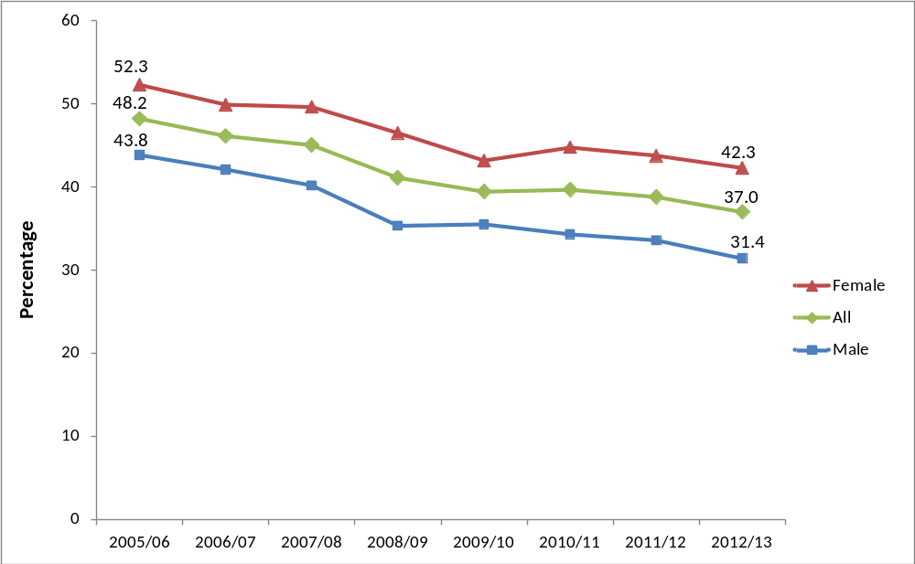
Notes
- Confidence intervals range between +/-0.7 and +/-2.5 from 2005/06 onwards.

Between 2005/06 and 2012/13, the proportion of people using a public library declined in all regions and in both urban and rural areas.

Compared to 2005/06 there has been a decline in library usage amongst all age groups. Compared to 2011/12 there were significant decreases in the proportion of respondent who visited a library in the 12 months prior to interview amongst:
- 45-64 year olds
- The upper socio-economic group
- Those who were in work
- Home owners,
- Those from a white background
- Those who were non-religious
- Those who did not have a long standing illness or limiting disability.

In 2012/13, the following patterns of library attendance were observed:

- Women (42.3%) had a higher rate of library attendance than men (31.4%).
- Adults in upper socio-economic groups (39.7%) had a higher rate of library attendance than people in lower socio-economic groups (33.0%).
- Adults who were not working (41.0%) had higher rates of library attendance than those who were working (34.3%).
- Adults from black and minority ethnic (BME) groups (45.1%) had higher rates of library attendance then adults from the white group (35.9%).

Digital engagement

In the year ending March 2013, 16.9 per cent of adults had visited a library website in the 12 months prior to being interviewed, a significant increase from 8.9 per cent in 2005/06.

Of those who had visited a library website, 75.0 per cent had searched and viewed online information or made an enquiry. 41.8 per cent had completed a transaction e.g. reserved or renewed items or paid a fine, a significant increase from 28.1 per cent in 2006/07.

Further detail on this section can be found in the accompanying spreadsheets to this release

- Arts

Taking Part asks respondents whether they have attended or participated in a range of arts activities. These two forms of activity (attendance and participation) are combined to provide the overall measure of arts engagement. Examples of arts engagement include painting (participation) or attending a theatre (attendance). Details on the ways that people digitally engage with the arts are also given. Digital engagement with the arts is defined as viewing or downloading part or all of a performance or exhibition, discussing the arts or sharing art that others have created, uploading or sharing art that you have created yourself or finding out how to take part or improve your creative skills.

Government policy, which might have influenced the statistics presented, is described below:
It is a strategic Departmental objective to enhance access to the Arts, increasing both the numbers of those taking part in and attending arts events.

DCMS work with:
- Arts Council England on their objective to get more people attending and participating in the arts
- Voluntary Arts Network to make sure that the right pathways are available for anyone to participate in the arts
- Department for Business, Innovation and Skills to increase available opportunities in Informal Adult Learning: more information on the National Institute of Adult Continuing Education website
- National Association of Local Government Arts Officers to remove barriers to participation at a local level

DCMS funding for the arts is channelled through Arts Council England, which is the national development agency for the arts in England.

Key findings

- 78 per cent of adults had attended or participated in the arts in the previous year, a significant increase since 2005/06 (76%) and 2010/11 (76%). In 2012/13 art engagement was at a similar rate to 2011/12 (78%) but higher than any other previous survey year from 2005/06 onwards. The upward trend has only been present recently. Prior to 2011/12, art engagement had been fairly stable.

- Arts engagement in urban areas in the year ending March 2013 (78%) was at a similar level to 2011/12 (78%) but had increased to a higher rate than in any other survey year since data collection began in 2005/06. It also represented a significant increase from 75 per cent in 2005/06. Those living in rural areas had a higher participation rate than those in urban areas (81% compared to 78%).

- Adults aged 65-74 and 75+ have seen a significant increase in engagement since 2005/06 (from 71% to 79% for 65-74 year olds and from 58% to 64% for aged 75 and over). However, adults aged 75 and over still had significantly lower arts engagement rates compared to other age groups.

Arts engagement

The latest results show 78.4 per cent of adults had engaged in the arts in the last year, a significant increase reported since 2005/06 (76.3%) and 2010/11 (76.2%). It was however a similar rate to 2011/12 (78.2%).

Women (81.6%) had higher arts engagement rates than men (75.1%) between April 2012 and March 2013. There has been a significant increase in women’s engagement with the arts since 2005/06, but for men, their level of engagement has remained similar over this period. Art engagement rates for both men and women had been stable until 2010/11, after which the trend for women has increased.

Figure 5.1: Proportion of adults who had attended or participated in the arts, by sex, 2005/06 to April 2012 – March 2013

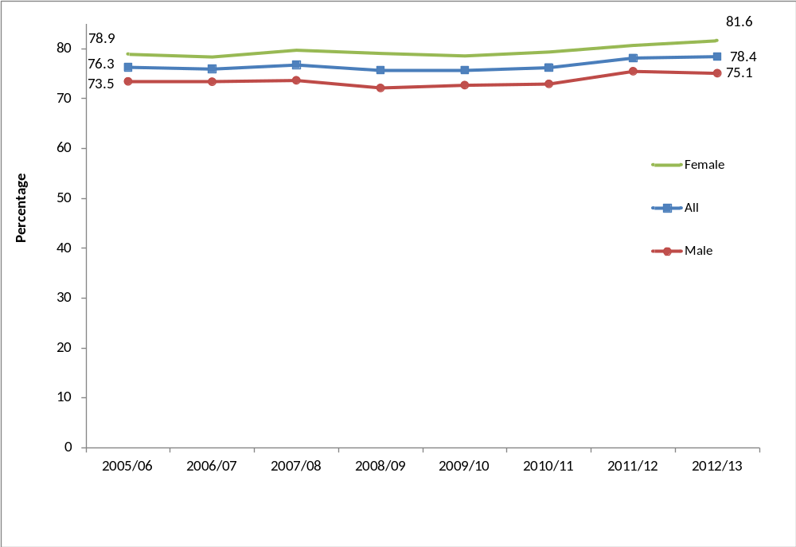

Notes
(1) Confidence intervals range between +/-0.9 and +/-3.1 from 2005/06 onwards.

In the year ending March 2013,
- 64.1 per cent of adults had engaged with the arts three or more times in the previous 12 months, a significant increase from 62.5 per cent in 2005/06 and from 61.2 in 2010/11.
- 8.3 per cent of adults had engaged once only in the previous 12 months, a significant increase from 7.2 per cent in 2005/06.
- 21.6 per cent of adults had not engaged with the arts at all in the previous 12 months, a significant decrease from 23.8 per cent in 2005/06 and 23.9 per cent in 2010/11.

Figure 5.2 shows that the proportion of adults who had engaged with the arts once in the previous 12 months has had a substantial overall increase, whilst the rate of those who had not engaged with the arts in the last 12 months has had a substantial decrease since 2005/06. There has been an upwards trend of those engaging at least once in the last 12 months, but there been no discernible trends for other frequencies of engagement over the time period.

Figure 5.2: Indexed arts engagement, by frequency of attendance, 2005/06 to April 2012 – March 2013
Indexed, 2005/06 = 100
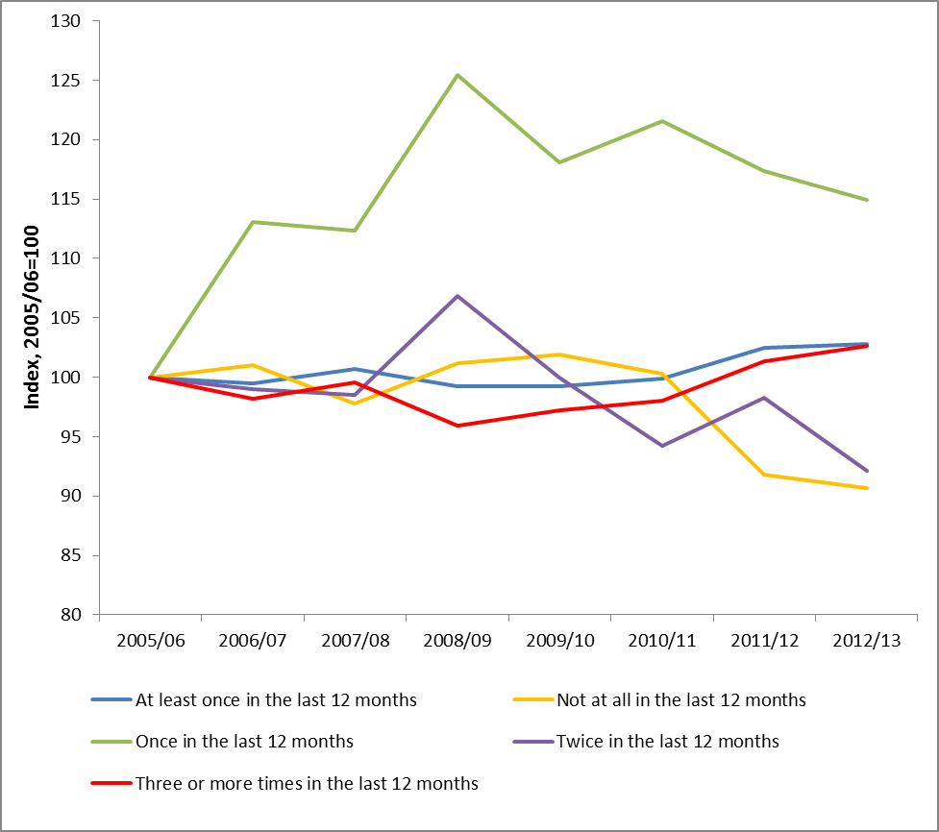

Since 2005/06 there have been significant increases for adults engaging in art in:
- The North West (from 71.5% to 76.4%)
- Yorkshire and The Humber (from 71.8% to 76.4%)
- The East Midlands (from 75.8% to 80.1%)
- The East of England (from 79.7% to 83.6%)

There were increases in arts engagement for adults living in urban areas (from 74.9% to 77.7%) during this period. Arts engagement tended to be higher among people who lived in less deprived neighbourhoods.

In the year to April 2013, the following patterns of arts engagement were observed amongst demographic groups:
- People aged 75 and over had lower arts engagement rates (64.3%) than the other age groups. Although the 65-74 and 75+ age groups have both seen a significant increase in engagement since 2005/06 (from 70.7% to 79.5% for 65-74 year olds, from 57.7% to 64.3% for age 75 and over), engagement rates for the younger age groups have remained steady during that period.
- Arts engagement was higher amongst adults from the white group (79.5%) than adults from black and minority ethnic (BME) groups (70.4%).
- People with no long-standing illness or disability had a higher arts engagement rate (80.7%) than people with a long-standing illness or disability (73.4%). This could be due to barriers, for example lack of suitable transport to art facilities or a lack of hearing loops at the venue, enabling people with a long-standing illness or disability to engage. Both groups have seen a significant increase since 2005/06.

These patterns are consistent with previous years.

Digital engagement

In the year ending March 2013, 30.3 per cent of adults had visited a theatre or concert website, no significant change from 2005/06 when the rate was 30.5 per cent but a significant decrease from 2010/11 (42.6%) and 2011/12 (32.2%). However the wording of this question changed slightly in July 2011 which coincides with a decline in the proportion visiting these types of sites.

Of those who had visited a theatre or concert website, 48.8 per cent of people had bought tickets for an arts performance or exhibition, a significant increase from 43.2 per cent in 2006/07, but a significant decrease from 67.7 per cent in 2010/11 and 54.7 per cent in 2011/12.

The Taking Part survey added new questions about arts websites from July 2011. Between April 2012 and March 2013, for those who had visited an arts website, 71.5 per cent did so to find out more about an artist, performer or event and 24.9 per cent did so to view or download part or all of a performance or exhibition, a significant increase from 2011/12 (20.7%). 8.2 per cent of adults visited an arts website to find out how to take part or improve their creative skills, a similar proportion to 2011/12 which was the first full year of data collection.

Further detail on this section can be found in the accompanying spreadsheets to this release

- Archives

This chapter examines attendance at archives in the 12 months prior to interview by a range of area-level and socio-demographic breakdowns. Details on the way that people digitally engage with archives are also given. Digital engagement with archives is defined as completing a transaction, viewing digitised documents online or searching a catalogue.

Key findings

- The proportion of adults who had visited an archive (in their own time or for voluntary work) was 4 per cent, a significant decrease from the 2005/06 level.

- Using the wider measure, which includes paid work visits and visits for academic study, the proportion of adults who attended in the last year has remained steady since 2008/09 when the data were first collected and was 5 per cent in the period from April 2012 to March 2013.

- In the same period, nearly half of adults who visited an archive (49%) did so just once in the last 12 months.

- The 65-74 year old age band had the highest proportion of archive visits in the last 12 months (7%) whilst visits amongst 16 to 24 year olds (2%) were significantly lower than people aged 45-64 and 65-74

Overall participation in archives

In the latest period, 3.7 per cent of adults had visited an archive in the last year in their own time or as part of voluntary work. This was significantly lower than in 2005/06 (5.9%). Using the wider measure, including paid work visits and academic study visits, the proportion in the latest period increased to 4.7 per cent of all adults. The trend over time, shown in Figure 6.1 below, was a downward one with a small peak in 2010/11.

Almost three quarters of all archive visits (74.9%) were in visitors own time, followed by 15.8 per cent visiting for paid work, and 8.9 per cent for academic study.

There have been significant decreases in archive attendance rates since 2005/06 in all regions apart from the North East, Yorkshire and The Humber, the East Midlands and the South West where rates have remained steady.

Figure 6.1: Percentage of adults who had visited an archive or records office, 2005/06 to 2012/13

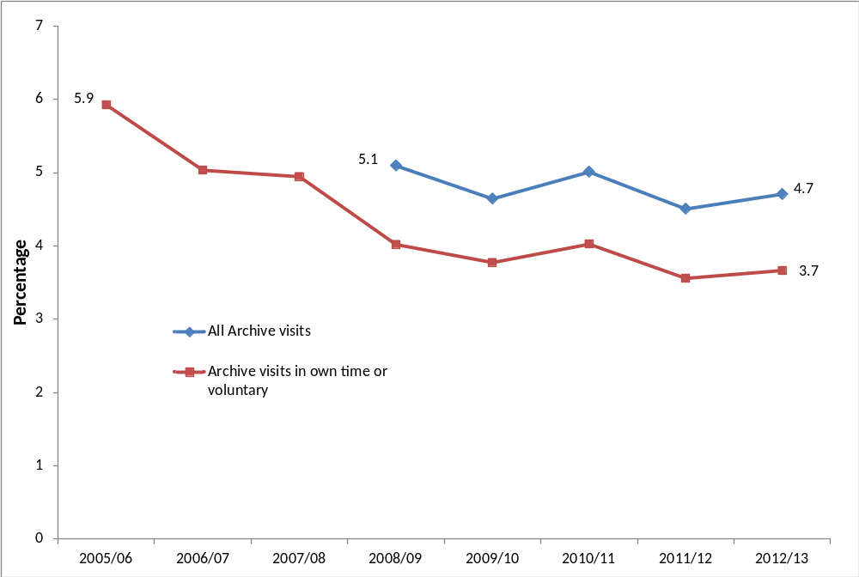
Notes
- Confidence intervals range between +/-0.3 and +/-0.8 from 2005/06 onwards.
- Some archive questions were not asked prior to the 2008/09 survey.

There has been little variation between different demographic groups (apart from age), although adults from upper socio-economic groups had a significantly higher attendance rate (4.6%) than those in lower socio-economic groups (2.7%).

The 65-74 year old age band had the significantly highest proportion of archive visits in the last 12 months (6.6 per cent of people this age) whilst visits amongst 16 to 24 year olds (1.7% of people this age) were significantly lower than people aged 45-64 and 65-74.

Digital engagement

A higher proportion of adults visited an archive or records office online than in person. In April 2012 – March 2013, 13.5 per cent of adults had visited an archive or records office website in the last 12 months, a significant increase from 9.7 per cent in 2005/06. Of those who had visited an archive or records office website, 63.8 per cent had done so to view digitised documents, 34.5 per cent of adults had searched a catalogue, a fifth (22.1%) of adults had found information out about the archive (e.g. opening hours) and 19.3 per cent had completed a transaction, for example, to purchase records.

Further detail on this section can be found in the accompanying spreadsheets to this release

- Volunteering and charitable giving
Taking Part asks whether respondents have participated in voluntary work in the last 12 months and whether this relates to any of the DCMS sectors (sport, art, heritage, museum and galleries, libraries and archives). The survey also includes a range of questions on social capital and cohesion, as well as charitable donations and whether these relate to DCMS sectors.

Government policy, which might have influenced the statistics presented, is described below:
The Government has a policy to encourage charitable giving across society as a whole, to make it easier to give and provide better support to organisations that facilitate giving, whether through digital technology or simplification of the tax system.

For example:
- To encourage giving through the £100 million Catalyst match funding programme which helps cultural organisations diversify their income streams
- tax incentives aimed at boosting legacy giving to cultural bodies and other charities
- The first tax incentive policy to encourage lifetime giving of works of art to public collections through the Cultural Gifts Scheme.

Key findings

- The proportion of adults who had volunteered in the last 12 months was 26 per cent an increase from 23.8 per cent in 2005/06. 9 per cent of all adults had volunteered in a DCMS sector (Arts, Museums or Galleries, Heritage, Libraries, Archives, Sport.) This was an increase from 7 per cent in 2005/06.

- There has been a significant increase in the proportion of adults from black and minority ethnic (BME) groups who had volunteered in any sector in the 12 months prior to interview compared to 2005/06 (up from 20% to 27%). This may be linked to the UK winning the bid to host the 2012 Olympic and Paralympic Games since 25 per cent of black and minority ethnic volunteers said they were motivated to do more voluntary work as a result of the UK hosting the 2012 Olympics.

- There has been a significant increase in the proportion of adults aged 16-24 years (up from 25% to 35%) and women (25% to 28%) who had volunteered in the last 12 months compared to 2005/06. 14 per cent of 16-24 year olds said the UK hosting the 2012 Olympic Olympics has motivated them to do more voluntary work, this figure was 10 per cent for women

- 90 per cent of adults had donated money (including donations into a collection box) in the last 12 months, 32 per cent of adults had donated to a DCMS sector. These were both at a similar level to 2010/11

Volunteering

A quarter of adults (25.9%) reported that they had taken part in voluntary activities in the last 12 months. This was the first year of data collection that this measure has been significantly higher than in 2005/06, when the figure was 23.8 per cent. The proportion of all adults that had volunteered in a DCMS sector was 9.3 per cent, a significant increase of 2.3 percentage points since 2005/06 when the rate was 7.0 per cent.

There has been a significant increase in the proportion of adults from black and minority ethnic (BME) groups who had volunteered in the last 12 months compared to 2005/06 (up from 19.6% to 26.8%). The time series in Figure 7.1 shows a gradual increase in the proportion of BME adults who have volunteered since 2005/06, whilst the corresponding proportion of adults from the white group has remained stable since 2005/06. This may be linked to the UK winning the bid to host the 2012 Olympic and Paralympic Games, since 25.0 per cent of black and minority ethnic volunteers said they were motivated to do more voluntary work as a result of the UK winning the bid, compared to only 7.9 per cent of volunteers from the white group.

Figure 7.1: Proportion of adults who had volunteered by ethnicity, 2005/06 to 2012/13

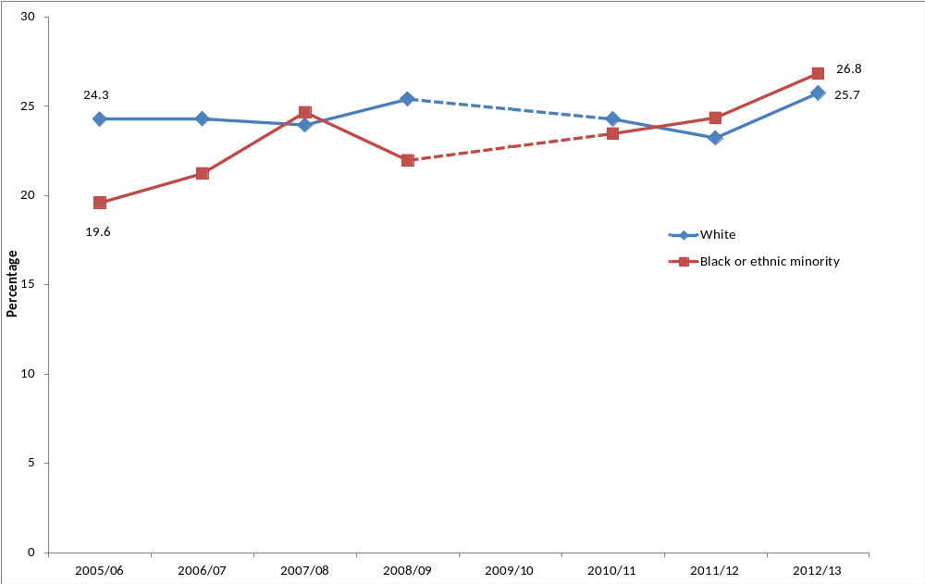
Notes
- Confidence intervals range between +/-0.7 and +/-5.0 from 2005/06 onwards
- Volunteering questions were not asked in 2009/10

In 2012/13, there was a significant difference in the proportion of males and females who volunteered in the sports sector. Over double the proportion of men volunteered in sport compared to females (31.2% compared to 14.4%). This has been the case since 2010/11.

There has also been a significant increase in the proportion of:

- adults aged 16-24 years who had volunteered in the last 12 months compared to 2005/06 (up from 24.7% to 34.9%). There was no significant change for other age groups over this time period.
- women who had volunteered in the last 12 months compared to 2005/06 (up from 24.7% to 28.0%). A greater proportion of women volunteered compared to men in 2012/13 (28.0% compared to 23.7% respectively).
- those in the lower socio-economic group – up from 16.1 per cent in 2005/06 to 18.2 per cent in 2012/13.
- those not working – up from 23.8 per cent in 2005/06 to 27.1 per cent in 2012/13.
- those in the social rented sector (from 16.0% in 2005/06 to 19.4% in 2012/13) and the private rented sector (from 21.8% in 2005/06 to 26.3% in 2012/13).
- those with no religion (from 20.3% in 2005/06 to 23.2% in 2012/13) or of other religion (from 19.5% in 2005/06 to 26.6% in 2012/13).
- adults with a disability or long term illness (from 23.5% in 2005/06 to 26.5% in 2012/13) and those without a disability or long term illness (from 23.9% in 2005/06 to 25.7% in 2012/13).

Adults who had participated in a DCMS sector had higher volunteering rates within that sector than adults who had not participated, with the exception of the museum and galleries sector where the difference was not significant. For example, of adults who had participated in sport, 30.8 per cent of them had volunteered in sport, compared with just 11.0 per cent of those who did not play sport.

Respondents who volunteered in the museums sector, on average did so for 11 hours during the four weeks prior to interview. For those who volunteered in the heritage sector, the average time spent doing so in this period was 9 hours, 26 minutes. The corresponding average volunteering times in the arts and sport sectors were 9 hours and 16 minutes and 9 hours and 8 minutes respectively in the four weeks prior to interview.

There was a significant increase in the proportion of respondents from urban areas who had volunteered in the last 12 months, from 22.1 per cent in 2005/06 and 24.7 per cent in 2012/13. However the rate of urban respondents volunteering was significantly lower than the rate for rural respondents in 2012/13.

Charitable giving

Taking Part asks whether respondents had donated money in the last 12 months and whether this was to a DCMS sector.

In 2012/13, 89.7 per cent of adults had donated money (including any donations into a collection box) in the last 12 months. 32.0 per cent of all adults had donated to at least one of the DCMS sectors. Of all those who had donated, 15.8 per cent of adults had donated to the museums and galleries sector in the last 12 months, 15.2 per cent to heritage, 6.9 per cent to sport, 6.6 per cent to the arts and 0.9 per cent to libraries. These are similar proportions to when the question was first asked in 2010/11.

34.2 per cent of adults donated money less often than once a month but at least 3 or 4 times a year. A further 36.5 per cent donated less often than once a week but at least once a month, a significant increase from 32.8 per cent in 2010/11. There was a significant decrease amongst those who gave only once in the last 12 months from 2005/06 (9.5%) to 2012/13 (7.6%).
Charitable giving to the DCMS sectors significantly increased from 2010/11 to 2012/13 in the
- East Midlands (from 28.2% to 35.5%)
- West Midlands (from 22.8% to 29.9%)

Charitable giving to the DCMS sectors significantly decreased from 2010/11 to 2012/13 in the
- North East (from 35.0% to 23.2%)
- South East (from 39.7% to 33.2%)

Over four in five (84.4%) of respondents said they intended to give the same to DCMS sectors in the next 12 months, a significant increase from 2010/11 when the rate was 76.8 per cent. Of those who said they intended to give more to DCMS sectors in the next 12 months, 13.0 per cent gave the reason because “they need the money” and over a third (34.5%) said it was because “they have more money / I can afford to give more”. However of those who said they intended to give less to DCMS sectors in the next 12 months, 39.8 per cent said this was because they “have less money / can’t afford to give”.

Overall civic participation

Taking Part asks a series of questions on sport and cultural facilities in the respondent’s local area.

Over a quarter of adults (26.0%) had taken action to try to get something done about sport and cultural facilities in their area, or did not need to take such action. The most common action that had been taken was to contact the council, with 12.6 per cent of adults having done so. Also 5.5 per cent of adults had contacted their local councillor or MP.

40.9 per cent of adults had been involved in groups, clubs or organisations in the last 12 months. Of those adults, the most popular type of group was sport/exercise groups (49.4%) followed by hobbies/social clubs (37.4%), which had both remained at a similar level to 2010/11.

Further detail on this section can be found in the accompanying spreadsheets to this release

- Equalities

This chapter explores BME (Black and Minority Ethnic) engagement with cultural activities between April 2012 and March 2013. Cultural sectors measured by Taking Part are Heritage, Museums & Galleries, Libraries and Archives. Analysis in this chapter covers BME attendance, participation and enjoyment across these cultural sectors as well as digital participation, volunteering and charitable giving within these sectors.

The chapter compares engagement between adults in the BME group with those in the non-BME (white) group. The underlying survey questions on ethnicity asked in Taking Part follow the recommended classifications set out by the Office for National Statistics. Respondents are asked to self-identify which of these ethnic categories they are part of.

Headline data show that there are significant differences in participation and attendance rates between BME and white groups. However, there may be differences in underlying factors between these groups such as location, age and income which might affect or drive these results. We have not accounted for differences in any underlying factors in this initial analysis.

There were no statistically significant differences identified between the engagement rates of the different individual ethnic groups which form the BME group, nor between BME men and BME women. A larger sample size would be needed to analyse these further breakdowns.

Key findings
- In 2012/13 adults from black and minority ethnic (BME) groups were less likely to have engaged with heritage, museums and galleries, or the arts, but were more likely to have visited libraries than adults from the white group:
- 57 per cent visited a heritage site in the last year (compared with 75% for the white group).
- 45 per cent visited a museum or gallery (compared with 54% for the white group).
- 70 per cent participated in the arts (compared with 79% for the white group).
However:
- 45 per cent visited a library (compared with 36% for the white group).

- BME visits to museums and galleries increased from 35 per cent in 2005/06 to 45 per cent in 2012/13.
- BME visits to heritage sites increased from 51 per cent in 2005/06 to 57 per cent in 2012/13.
- People from BME groups had high levels of enjoyment in cultural activities (which were similar to those for the white group); with, for example, 88 per cent of people from BME groups enjoyed visiting a place of historical interest (compared with 89% for the white group).
Rates of engagement

In 2012/13, people from black and minority ethnic (BME) groups were less likely to have engaged with heritage, museums and galleries, or the arts, but were more likely to have visited libraries than people from the white group. There was no significant difference in archives attendance between BME and white groups in 2012/13.

Heritage

- In 2012/13, 57.2 per cent of people from a BME group had visited a heritage site in the last year, lower than the rate for the white group (74.6%).
- People from BME groups were also less likely to have visited heritage sites frequently (at least three times a year), 28.6 per cent had visited compared with 48.4 per cent for the white group.
- 2.2 per cent of people from BME groups had been involved in a historic re-enactment in the last year, significantly lower than the rate for the white group (4.6%).

Museums and galleries

- 45.0 per cent of people from a BME group had visited a museum or gallery in the last year in 2012/13, lower than the participation rate for the white group (53.7%).
- People from BME groups were also less likely to have regularly visited museums and galleries (at least three times a year), only 15.5 per cent visited this frequently compared with 22.1 per cent for the white group.

Arts

- 70.4 per cent of people from a BME group had engaged in the arts in the last year in 2012/13. This is lower than the participation rate for the white group (79.5%).
- People from BME groups were also less likely to have engaged in arts activities on a more regular basis (at least three times a year), 57.3 per cent had participated this regularly compared with 65.0 per cent for the white group.
- There were no significant differences in rates of playing a musical instrument, 4.2 per cent of people from BME groups had played to an audience and 10.1 per cent had played on their own, compared with 3.5 per cent and 11.2 per cent respectively for the white group.

Libraries and Archives

- 45.1 per cent of BME adults visited a library in 2012/13. This was a higher rate compared with the white group (35.9%).
- 3.2 per cent of BME adults from BME groups visited an archive. There was no significant difference in archive attendance between adults from BME and white groups.

Figure 8.1: Proportion of adults who had engaged in cultural activities, by ethnicity, 2012/13
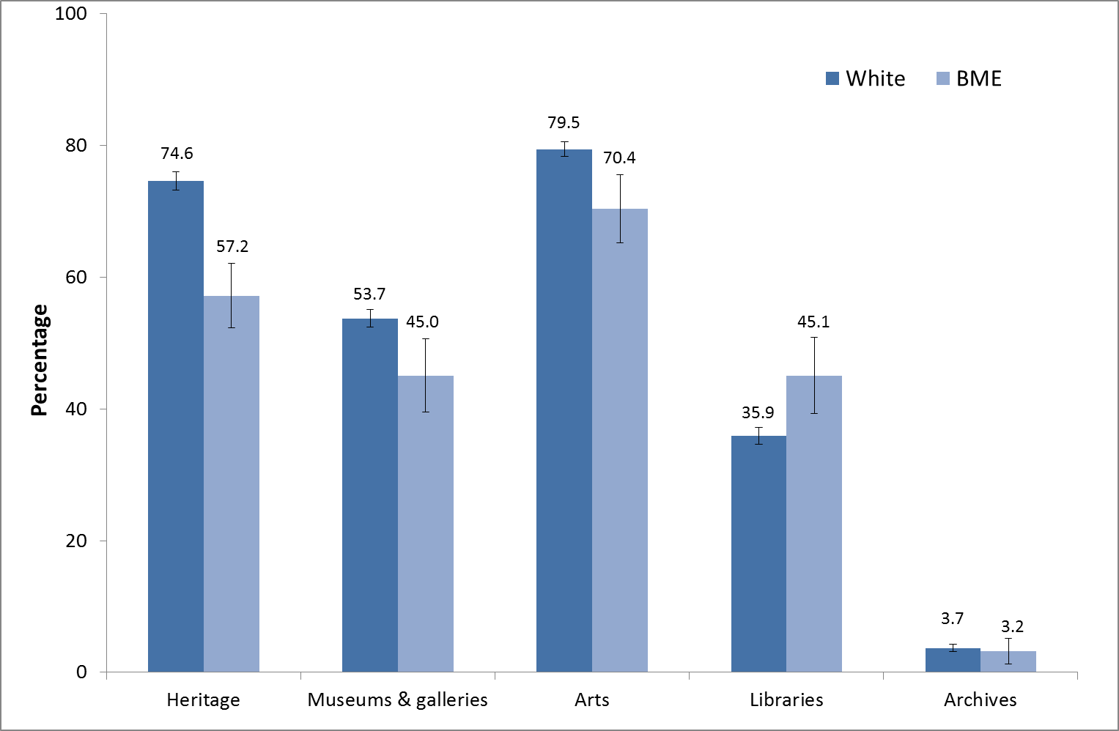
Note:
1. Confidence intervals range between +/- 1.1 and +/-5.7
2. All differences in engagement rates between BME and white groups in 2012/13 are significant apart from for archives.

Changes over time

There has been some fluctuation in BME participation rates since the survey began. Whilst BME participation rates in 2012/13 were similar to the previous year (2011/12), there have been some significant increases since 2005/06 (the first year that data were collected).
- BME visits to heritage sites increased from 50.7 per cent in 2005/06 to 57.2 per cent in 2012/13 (Figure 8.2).
- BME visits to museums and galleries increased from 35.4 per cent in 2005/06 to 45.0 per cent in 2012/13 (Figure 8.3).
- There has been no significant change in BME engagement in the arts since 2005/06.
- The gap between BME and white engagement rates for arts has fluctuated over the years, with no identifiable trend (Figure 8.4).
- The rate of library attendance for BME adults has declined from 57.5 per cent in 2005/06 to 45.1 per cent in 2012/13 (Figure 8.5).
- BME attendance at libraries was 9.1 percentage points cent higher in 2012/13 than for the white group. This gap has persisted since 2005/06.
- There has been no significant change in archives attendance in 2012/13 for BME adults since 2005/06. Archive attendance has been lower for adults in the BME group for all years apart from 2007/08, 2009/10 and 2012/13, where there was no significant difference.
Figure 8.2: Proportion of adults who had visited a heritage site in the last year, by ethnicity, 2005/06 to 2012/13.

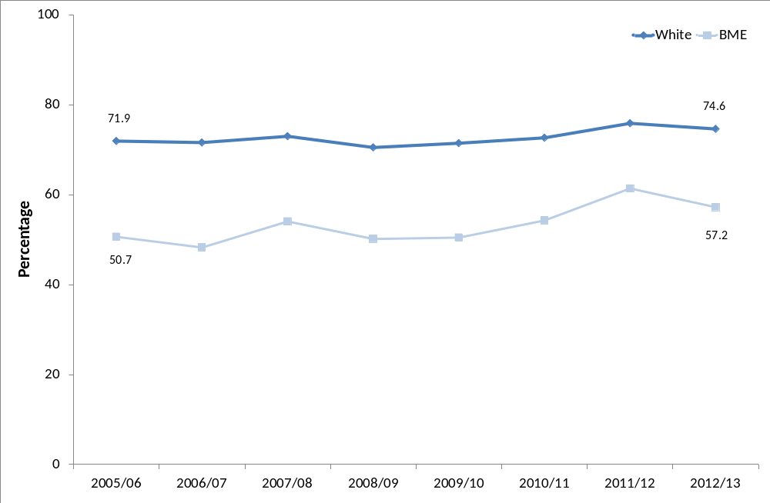
Note:
- Confidence intervals range between +/- 0.7 and +/-7.5 from 2005/06 onwards

Figure 8.3: Proportion of adults who had visited a museum or gallery in the last year, by ethnicity, 2005/06 to 2012/13.
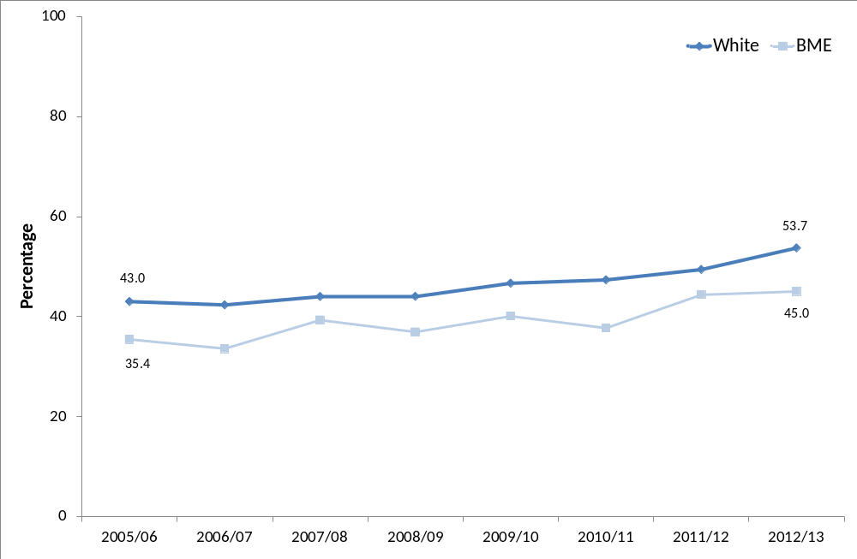
Note:
- Confidence intervals range between +/- 0.8 and +/-6.8 from 2005/06 onwards

Figure 8.4: Proportion of adults who had engaged with the arts in the last year, by ethnicity, 2005/06 to 2012/13
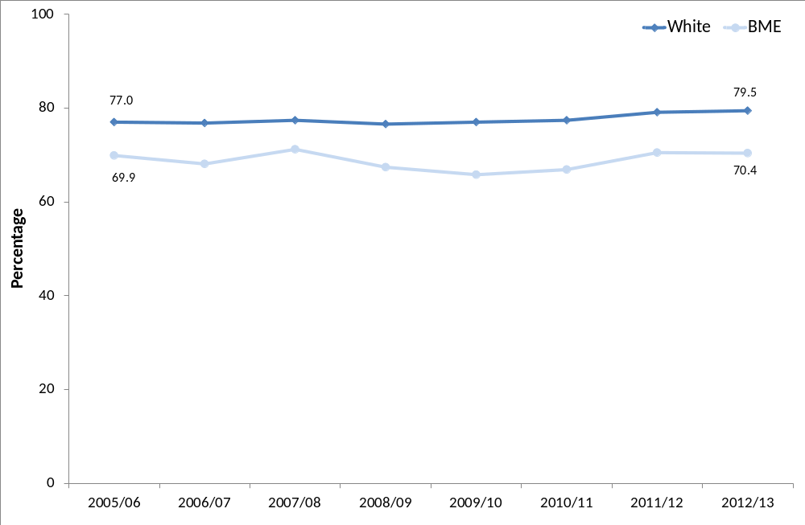
Note:
- Confidence intervals range between +/- 0.7 and +/-7.0 from 2005/06 onwards

Figure 8.5: Proportion of adults who had visited a library in the last year, by ethnicity, 2005/06 to 2012/13
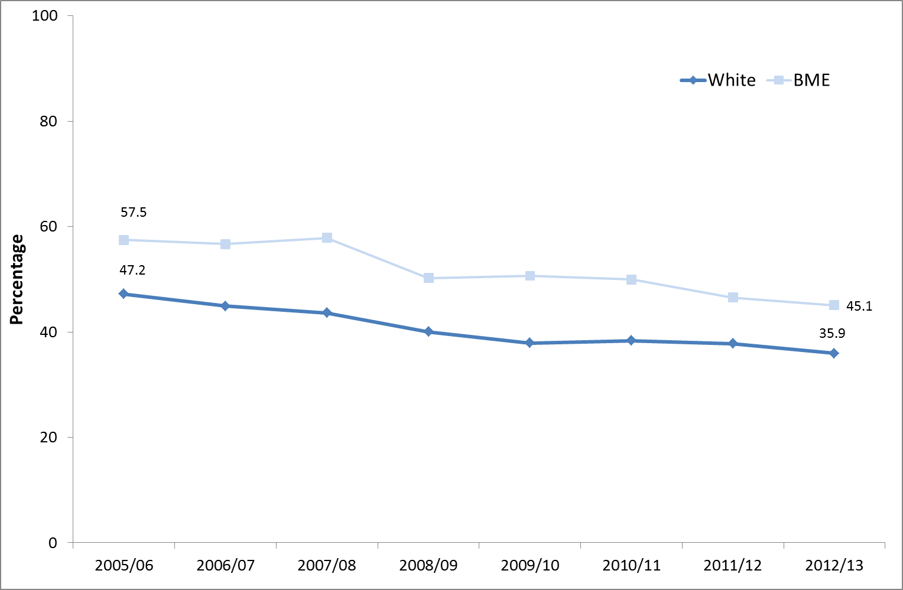
Note:
- Confidence intervals range between +/- 0.9 and +/-5.7 from 2005/06 onwards

Table 8.1: The percentage point gap between BME and white participation rates, 2005/06 to 2012/13

 | 2005/06 | 2006/07 | 2007/08 | 2008/09 |  | 2009/10 | 2010/11 | 2011/12 | 2012/13
Art | 7.1 | 8.7 | 6.3 | 9.2 | 11.2 |  | 10.5 | 8.7 |  | 9.1
Heritage | 21.3 | 23.3 | 19.0 | 20.3 | 21.0 |  | 18.4 | 14.5 |  | 17.4
Museums & galleries | 7.6 | 8.7 | 4.7 | 7.1 | 6.6 |  | 9.6 | 5.1 |  | 8.7
Libraries | -10.3 | -11.7 | -14.2 | -10.2 | -12.7 |  | -11.6 | -8.8 |  | -9.1
Archives | 2.3 | 1.4 | 0.7 | 1.9 | 1.9 |  | 1.6 | 1.6 |  | 0.5

All of the differences between BME and white groups (shown in Table 8.1) are significant at the 95 per cent level with the exception of the difference in the rate of museum and gallery attendance in 2009/10 and for archive attendance in 2007/08, 2009/10 and 2012/13.

Enjoyment in cultural activities

People from BME groups had high levels of enjoyment in cultural activities (of those who took part they rated their experience positively with a rating of at least 7 out of 10) and these were similar to the enjoyment levels for the white group.

- 79.7 per cent had enjoyed arts participation, compared with 84.4 per cent for the white group.
- 84.4 per cent had enjoyed attending an arts event, compared with 85.3 per cent for the white group.
- 86.4 per cent had enjoyed visiting a museum, compared with 84.3 per cent for the white group.
- 88.5 per cent had enjoyed visiting a place of historical interest, compared with 88.6 per cent for the white group.

Digital engagement in cultural activities

People from BME groups were generally less likely to have visited cultural websites than people from the white group, apart from library websites where they were more likely to have visited. This is the same pattern as for actual engagement where BME attendance has also been higher.

In 2012/13, 24.5 per cent of BME adults had visited heritage related sites (lower than the 32.1% rate for the white group). 24.2 per cent of BME adults visited arts related sites (lower than the 31.1% rate for the white group). 8.4% of BME adults visited an archive website, significantly less compared with the white group (14.1%).

There were similar levels of visits to museum or gallery websites, 32.1 per cent of people visited from BME groups compared with 31.2 per cent from the white group.

However, 25.4% of BME adults visited library websites – significantly more than from the white group (15.9%).

Volunteering and charitable giving to cultural organisations

Whilst donations to cultural organisations were quite low across the board, donations from people from BME groups were even lower than from the white group.
- 6.9 per cent of BME adults had donated to heritage organisations, compared with 16.2 per cent for the white group
- 3.5 per cent of BME adults had donated to arts organisations, compared with 6.9 per cent for the white group
- 10.5 per cent of BME adults had donated to museums and art galleries, compared with 16.5 per cent for the white group.

This is in-line with overall lower rates of charitable giving by people from BME groups, however, as charitable giving is strongly related to the individual’s income level this may explain why people from BME groups were less likely to give money to charity.

There were also low rates of volunteering for cultural organisations, only 2.8 per cent of people from BME groups volunteered for an arts organisation in 2012/13 and less than 0.3 per cent volunteered for a museum or gallery. This was similar to volunteering rates for the white group (2.4% and less than 0.5% respectively). However, volunteering in heritage organisations by people from BME groups was significantly lower than for the white group (less than 0.4% compared with 1.5%).

Annex A: Background note

- The Taking Part survey is commissioned by the Department for Culture, Media and Sport (DCMS) and its partner arm’s length bodies (ALBs). For 2011 to 2015 these are Arts Council England, English Heritage and Sport England.

- Taking Part is a National Statistic and as such has been produced to the high professional standards set out in the Code of Practice for Official Statistics. National Statistics undergo regular quality assurance reviews to ensure they meet customer needs and are produced free from any political interference. See the statistics authority code of practice for more information.

The United Kingdom Statistics Authority has designated these statistics as National Statistics, in accordance with the Statistics and Registration Service Act 2007 and signifying compliance with the Code of Practice for Official Statistics.
Designation can be broadly interpreted to mean that the statistics:
• meet identified user needs;
• are well explained and readily accessible;
• are produced according to sound methods; and
• are managed impartially and objectively in the public interest.

Once statistics have been designated as National Statistics it is a statutory requirement that the Code of Practice shall continue to be observed. See the UK Statistical Authority assessment for more information.

- Stringent quality assurance procedures have been adopted for this statistical release. All data and analysis has been checked and verified by two different members of the team and TNS-BMRB to ensure the highest level of quality.

Guidance on the quality that is expected of Taking Part statistical releases is provided in a quality indicators document. These quality indicators outline how statistics from the Taking Part survey match up to the six dimensions of quality defined by the European Statistical System (ESS). These are: relevance, accuracy, timeliness, accessibility, comparability and coherence.

- The latest results presented here are based on interviews issued between April and March 2013. The total sample size for this period is 9,838.

- The survey measures participation by adults (aged 16 and over) and children (5-10 and 11-15) living in private households in England. No geographical restriction is placed on where the activity or event occurred. Further information on data for Scotland, Wales and Northern Ireland can be found in question 2 of the “Taking Part: Guidance Note”

- The median adult sample interview length for the 2012/13 survey was 44 minutes 2 seconds (mean 46 minutes 52 seconds). The median survey length for the 5-10 year old child interview was 12 minutes 2 seconds (mean 12 minutes 44 seconds) and for 11-15 year olds it was 21 minutes 50 seconds (mean 23 minutes 59 seconds).

- Participation in these activities must be for the purpose of recreation or leisure, including voluntary work. It excludes involvement in activities where the prime motivation is paid work or academic studies. The exceptions to this are attendance at historic environment sites which includes visits made for academic study. Paid work visits and academic study visits are also included in one of the archive attendance measures.

- The range has been calculated using a 95% confidence interval. This means, had the sample been conducted 100 times, creating 100 confidence intervals, then 95 of these intervals would contain the true value. All estimates have been rounded to one decimal place. An overall design factor of 1.322 has been applied to the adult dataset for the period April 2012 to March 2013. Individual adult design factors have been calculated for each sector in this period, ranging from 0.007 to 10.179

- Statistical significance tests have been run at the 95% level. A significant increase at the 95% level means that there is less than 5% (1 in 20) chance that the difference observed within the sampled respondents was not also observed in the English population as a whole.

- Some figures may have been revised from previous releases, in which case the figures in this release supersede those from previous statistical releases. For more detailed information on the DCMS revisions policy and how revisions are handled for the Taking Part Survey, please see the DCMS statement of compliance

- The data are weighted to ensure the representativeness of the Taking Part sample. There are two types of weighting: i) to compensate for unequal probabilities of selection; and ii) to adjust for differential non-response. Weighting is based on mid-2009 population estimates from the Office for National Statistics.

- For more information see the Taking Part Survey webpages, including previous publications.

Versions of the questionnaires from all years of the survey are available.

- As published in the last statistical release and on our consultation pages in March, sport participation data are no longer analysed or reported on by DCMS or in the Taking Part publications. Sport participation data are reported on by Sport England in the Active People Survey.

- The fieldwork for the survey is being conducted by TNS-BMRB. For more information, see http://www.tns-bmrb.co.uk

- We can also provide documents to meet the specific requirements of people with disabilities. Please call 020 7211 6000 or email takingpart@culture.gsi.gov.uk

- This report has been produced by Tom Knight, Sam Tuckett, Philippa Robinson and Penny Allen (DCMS). Acknowledgement goes to colleagues within the DCMS, partner ALBs and TNS-BMRB for their assistance with the production and quality assurance of this release.

- The responsible statistician for this release is Tom Knight. For enquiries on this release, please contact Tom Knight on 0207 211 6021 or Penny Allen on 0207 211 6106 or Sam Tuckett on 0207 211 2382.

- For general enquiries telephone: 0207 211 6200
Department for Culture Media and Sport
4th floor
100 Parliament Street
London
SW1A 2BQ
enquiries@culture.gov.uk
Annex B: Key terms and definitions

Term | Definition
2012/13 Q4 | This is the time period covering April 2012-March 2013. It is also referred to as the year or 12 months to March 2013.
ACORN classification | A classification of residential neighbourhoods is a geo-demographic information system categorising some United Kingdom postcodes into various types based upon census data and other information such as lifestyle surveys.
Actively get involved in the Olympics | This covers  - Attending (Attended) a free Olympic or Paralympic event (e.g. marathon, cycling, road racing)  - Attending (Attended) a ticketed Olympic or Paralympic event  - Taking part (Took part) in a Games related sports or physical activity (e.g. AdiZone, Gold Challenge, Cadbury’s Spots V Stripes)  - Using (Used) a new or improved sports facility linked to the 2012 Games (e.g. Inspire-marked)  - Games related employment or training  - Taking part (Took part) in a Games related cultural event or activity (e.g. Cultural Olympiad, London 2012 Festival)  - Volunteering (Volunteered) during the Games (e.g. as a Gamesmaker, London Ambassador or for Cadbury’s Spots V Stripes)  Taking part (Took part) in a Games related community event or activity (e.g. street party or local Inspire Mark project)
Archives | Archives are collections of documents that have been created by families, individuals, businesses or organisations and have been specially chosen to be kept permanently. Further information is available in Annex C.
Arts | A list of arts that the respondent may have participated or attended is available in Annex C: Sector definitions.
Attendance | This refers to the respondent going to a place, for example, attending a library or a heritage site.
Civic participation | Actions include, contact a local radio station, TV station or paper; talk to / written to a sporting or cultural facility, contact the council, contact a local councillor or MP, join a local group or attend a neighbourhood forum, attend a protest meeting or joined a campaign group, or help organise a petition.
Confidence interval | This provides a range in which there is a specific probability that the true value will lie within. For the Taking Part survey, 95% confidence intervals are used which means, had the sampling been conducted 100 times, creating 100 confidence intervals, then 95 of these intervals would contain the true value.
DCMS sectors | The DCMS sectors are the culture, arts, sport, volunteering and charitable giving sectors.
Digital participation | This refers to visiting websites for a number of reasons. These are outlined in Annex C: Sector definitions.
Digitally engage | This refers to the respondent engaging with the DCMS sectors via the internet.
Term | Definition
Engagement | This refers to either attending and/or participating in the sport, culture or arts sector. For example, if the respondent attended an art gallery (attendance) or gave a dance performance (participation).
Following the Olympics | This covers watching the Olympics on TV at home, listening to the radio at home, watching or listening on the internet at home, reading the newspaper online or offline or watching live events on a public big screen.
Historic environment | A list of all historic environments is available in Annex C: Sector definitions.
Index of Multiple Deprivation (IMD) decile group | The Index of Multiple Deprivation is a composite index which measures neighbourhood deprivation across seven domains (for example housing and income deprivation). The IMD decile group splits neighbourhoods into ten groups according to the level of deprivation (eg 10% most deprived neighbourhoods).
Participation | This refers to the respondent actively taking part in the activity. For example heritage participation could refer to visiting a monument such as a castle, fort or ruin, whilst participating in the arts may refer to painting.
Public library service | A list of valid uses of a public library is available in Annex C: Sector definitions.
Significant increase/decrease | A significant increase/decrease at the 95% level means that there is less than a 5% (1 in 20) chance that the difference observed within the sampled respondents is not representative of the English population as a whole.
Socio-demographic groups | Categorising the respondents by different social classes such as age, gender, employment status, housing tenure, ethnicity, religion, disability/illness status and National Statistics Socio-Economic Classes (NS-SEC)
Taking Part Survey | A survey commissioned by the Department for Culture, Media and Sport (DCMS) in partnership with the Arts Council England, English Heritage and Sport England, looking at engagement and non-engagement in culture, leisure and sport. Further information is available on the Taking Part Web pages
Volunteering | Offering one’s time for free. This could be organising or helping to run an event, campaigning, conservation, raising money, providing transport or driving, taking part in a sponsored event, coaching, tuition or mentoring for no expense.

Annex C: Sector definitions

The following annex presents the various definitions for adult participation in DCMS sectors.

Libraries
The respondent is asked if they have used a public library service. If the respondent is unsure what is in scope, the interviewer has the following definition to refer to.
“Use of a public library can include:
- A visit to a public library building or mobile library to make use of library services (including to print/use electronic resources or to take part in an event such as a reading group or author visit)
- The use of on-line library resources or services remotely (i.e. used a computer outside the library to view the website, catalogue or databases)
- Access, and receipt, of the library service by email, telephone, fax or letter
- Receipt of an outreach service such as home delivery or library events outside a library building
Use of other libraries and archive services is excluded.”

Museum, gallery or archive
The respondent is asked if they have attended a museum, gallery or archive. If the respondent is unsure what is in scope, the interviewer has the following definition to refer to.
“Archives are documents that have been created by families, individuals, businesses or organisations and have been specially chosen to keep permanently. They can be written papers such as letters or diaries, maps, photographs or film or sound recordings. Archives are historical documents but do not have to be very old. Places that keep archives are usually called a record office or archive centre.
Registering a birth, death or marriage happens at a registry office, not at an archive centre/record office.”

Arts
The respondent is asked if they have participated in a given list of arts activities, or attended a given list of arts events. Eligible activities and events are as follows.
Participation:
- Dance – ballet or other dance (for fitness and not for fitness)
- Singing – live performance or rehearsal/practice (not karaoke)
- Musical instrument – live performance, rehearsal/practice or played for own pleasure
- Written music
- Theatre – live performance or rehearsal/practice (e.g. play or drama)
- Opera/musical theatre – live performance or rehearsal/practice
- Carnival (e.g. as a musician, dancer or costume maker)
- Street arts (art in everyday surroundings like parks, streets, shopping centre)
- Circus skills (not animals) – learnt or practised
- Visual art – (e.g. painting, drawing, printmaking or sculpture)
- Photography – (as an artistic activity, not family or holiday ‘snaps’)
- Film or video – making as an artistic activity (not family or holidays)
- Digital art – producing original digital artwork or animation with a computer
- Craft – any craft activity (e.g. textiles, wood, metal work, pottery, calligraphy etc)
- Creative writing – original literature (e.g. stories, poems or plays)
- Book club – being a member of one

Attendance:
- Visual art exhibition (e.g. paintings, photography or sculpture)
- Craft exhibition (not crafts market)
- Event which included video or digital art
- Event connected with books or writing
- Street arts (art in everyday surroundings like parks, streets or shopping centre)
- Public art display or installation (an art work such as sculpture that is outdoors or in a public place)
- Circus (not animals)
- Carnival
- Culturally specific festival (e.g. Mela, Baisakhi, Navratri)
- Theatre (e.g. play, drama, pantomime)
- Opera/musical theatre
- Live music performance (e.g. classical, jazz or other live music event but not karaoke)
- Live dance event (e.g. ballet, African People’s dance, South Asian, Chinese, contemporary or other live dance)

Historic environment
The respondent is asked if they have visited the following list of historic environment sites.

- A city or town with historic character
- A historic building open to the public
- A historic park, garden or landscape open to the public
- A place connected with industrial history or historic transport system
- A historic place of worship attended as a visitor
- A monument such as a castle, fort or ruin
- A site of archaeological interest
- A site connected with sports heritage

Digital Participation
Digital Participation includes visiting websites for at least one of the following reasons:

- Museum or gallery website – To look at items from a collection.
- Museum or gallery website – To find out about a particular subject.
- Museum or gallery website – To take a virtual tour of a museum or gallery
- Museum or gallery website – To view or download an event or exhibition
- Library website – To complete a transaction (e.g. reserve or renew items, pay a fine).
- Library website – To search and view online information or make an enquiry.
- Heritage website – To take a virtual tour of a historical site.
- Heritage website – To learn about history or the historic environment
- Heritage website – To discuss history or visits to the historic environment on a forum
- Arts Website – To view or download part or all of a performance or exhibition
- Arts Website – To discuss the arts or share art that others have created
- Arts Website – To upload or share art that you have created yourself
- Arts Website – To find out how to take part or improve your creative skills
- Archive or records office website – To complete a transaction.
- Archive or records office website – To view digitized documents online.
- Archive or records office website – To search a catalogue.

Volunteering
The respondent is asked about any voluntary work they have done, including:

- Raising or handling money / taking part in sponsored events
- Leading a group
- Being a member of a committee
- Organising or helping to run an activity or event
- Visiting people
- Befriending / mentoring people
- Coaching or tuition
- Giving advice/ information/ counselling
- Secretarial, administrative or clerical work
- Providing transport or driving
- Representing – e.g. addressing meetings, leading a delegation
- Campaigning – e.g. lobbying, canvassing, letter writing
- Conservation/restoration
- Officiating – e.g. judging, umpiring or refereeing
- Other practical help - e.g. helping out a school, religious group, with shopping/refreshments
- Work in a charity shop

The respondent is also asked whether this activity was connected to any of the following areas:

- Arts
- Museum or gallery
- Heritage
- Libraries
- Archives
- Sport
- Any other sector

4th Floor, 100 Parliament Street
London SW1A 2BQ
www.gov.uk/dcms
4th Floor, 100 Parliament Street
London SW1A 2BQ
www.gov.uk/dcms
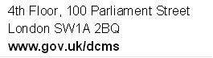

Full definitions of terms are available in Annex B.
Statistical significance tests are applied to all estimates to determine the likelihood that any apparent differences are due to real change, and not due to chance. This is an inherent limitation to using surveys to represent a wider population, in this case all adults in England, compared to carrying out a census, i.e. interviewing all adults in England, which would be prohibitively resource intensive.
DCMS’ input and impact indicators provide information on the delivery and progress towards the Department’s stated outcomes. They reflect the quality and effectiveness of the programmes and priorities set out in our business plan
Full definitions of terms are available in Annex B.
Inspire Mark projects are projects that have been inspired by the Games with the aim of doing something special in local communities and are part of the London 2012 Inspire programme of projects. See the above link for more information.
A significant decrease at the 95% level means that there is less than a 5% (1 in 20) chance that the difference observed within the sampled respondents is representative of the English population as a whole.
A significant increase at the 95% level means that there is less than a 5% (1 in 20) chance that the difference observed within the sampled respondents is not representative of the English population as a whole.
A classification of residential neighbourhoods is a geo-demographic information system categorising some United Kingdom postcodes into various types based upon census data and other information such as lifestyle surveys.
In July 2011, this statement became part of a response list. From July 2005 - June 2011, it was asked as a single question. For this reason, this estimate cannot be compared with previous year’s estimates.
Percentages will not total to 100% as some people may have visited a museum or gallery for more than one reason. Visits to museum and galleries for voluntary work have also not been included.
A significant increase at the 95% level means that there is less than a 5% (1 in 20) chance that the difference observed within the sampled respondents is not representative of the English population as a whole.
A significant decrease at the 95% level means that there is less than a 5% (1 in 20) chance that the difference observed within the sampled respondents is not representative of the English population as a whole.
A significant increase at the 95% level means that there is less than a 5% (1 in 20) chance that the difference observed within the sampled respondents is not representative of the English population as a whole.
An index measures change over time from a chosen starting point. It is expressed as a per cent of a base value, which always equals 100. In this example we are comparing each year’s figures with 2005/06. The values for 2005/06 equal 100 since this is the base year. An index of 110 in a subsequent year means that there has been a 10 per cent increase since 2005/06, whilst an index of 90 signifies a 10 per cent decrease since 2005/06.
Prior to July 2011 the question asked whether the respondent had visited “Theatre/ concert websites or other websites about art”. Since July 2011 the question was changed to ask whether they had visited “Arts websites (including music, theatre, dance, visual arts and literature)”.
A significant decrease at the 95% level means that there is less than a 5% (1 in 20) chance that the difference observed within the sampled respondents is not representative of the English population as a whole.
Percentages will not total to 100% as some people may have visited an archive for more than one reason.
A significant increase at the 95% level means that there is less than a 5% (1 in 20) chance that the difference observed within the sampled respondents is not representative of the English population as a whole.
Actions include, contact a local radio station, TV station or paper; talk to / written to a sporting or cultural facility, contact the council, contact a local councillor or MP, join a local group or attend a neighbourhood forum, attend a protest meeting or joined a campaign group, or help organise a petition.
A significant difference at the 95% level means that there is less than a 5% (1 in 20) chance that the difference observed within the sampled respondents is not representative of the English population as a whole.
Design factors are a calculated to correct for imperfect sample design. For example, Taking Part uses a clustered sample, rather than a random sample and this may affect the results for particular demographic groups – design factors are used to correct for this bias.

