Process Name & Jurisdiction | Register a Non-compliant Appeal -Social Security & Child Support Tribunals | No. Process Steps
Aim of the process | To register a Non-compliant appeal on GAPS2 | Total National Task Time | N/A
Customer Expectations | Information provided by the appellant is accurately transcribed | Total Local Task Time | N/A

Key Point Visuals (KPV)
PL Policy/ Legislation Requirement RC Risk Control G Other Guidance Available LP Lean Practice P Performance Measure
Key Steps | KPV | Explanation and examples | Task Time
1. Collect Non Compliant appeal from Registration cabinet.
All non compliant appeals will be placed in the Non compliant tray in the Registration team cabinet by the courier team.
There will be three trays for Non compliant appeals. There are,
- Non Complaint,
- Non Compliant No MRN
- Non Compliant - Complex
Collect the non compliant appeal from the cabinet and update the stats accordingly.
2. What type of Non compliant appeal do you have?
Is the appeal,
- Non Compliant – No MRN? If so, please proceed to step 3.
- Non Compliant? If so, please proceed to step 4.
- Non Compliant – Complex? If so, please proceed to step 4.
3. Non Compliant appeal – No MRN
If the appeal does not contain a MRN, then there will be a companying coversheet labelled as, ’Appeals received with No MRN’. Any appeal that has been received without an MRN has not been through the compliance team.
In these circumstances the registration clerk will be required to perform a one time check on the appeal documents. This check is to see if the appellant has made any reference to either,
- Not being issued an MRN,
- Not being entitled to an MRN,
- Losing both copies of their MRN.
If the appeal makes no reference to the above, please proceed to step 4 of this SOP.
If the appeal does make reference to any of the above, please seek advice from a member of the compliance team, as the compliance team may need to make the appeal complex.
If the appeal is to be complex, please leave the appeal with the compliance team.
4. Check the Notice of appeal, Compliance Checksheet, Letter Registration sheet
Check that the below documents,  - SSCS1 form,  - Compliance Checksheet, (if applicable)  - Letter Registration sheet,  All have the minimum details required for registration of the appeal on GAPS. |  | If the appeal is on a SSCS1 form, data may be transcribed directly from the form.  A compliance Checksheet will be completed on all appeals that contain an MRN.  If the appeal is on letter form, the person who vets the appeal will prepare a Letter Registration sheet to show what data must be transcribed onto GAPS.
If any information is missing, query this with the person who vetted the appeal.  If the appeal has been received in letter format with no MRN, the appeal will not have been through compliance and no Letter Registration sheet will have been produced.  In this circumstance only, the registration clerk can search for the name and address on the letter. If however the information is not easily accessible or the Registration Clerk needs assistance, this can be raised with a member of the compliance team to complete a Letter Registration sheet. |  | All appeals that have a Mandatory Reconsideration Notice will contain a coversheet that will be signed and dated by a member of the compliance team.
2. Update the registration screen
Open the appeal registration screen on GAPS by clicking on the square ‘A‘ icon on the front screen.  There are two ‘A’ icons, please select the lower ‘A’ icon immediately above ‘Clear’, or ‘Search’ button. |  | 
Enter the holding case code.  For Personal Independence Payment appeals this is 002DD, for Universal Credit it is 001DD. |  | All Direct Lodgement appeals will have the case code that ends in DD.  The appeal type is found on the Mandatory Reconsideration Notice.
Click on the yellow ‘Z’ button.
This will open a new window showing what the benefit type is.
If this is correct, press the green tick. |  | 
Enter the appellant’s National insurance number.  If no National Insurance number has been provided, tick the box, ‘Organisation / No National Insurance Number’. |  | 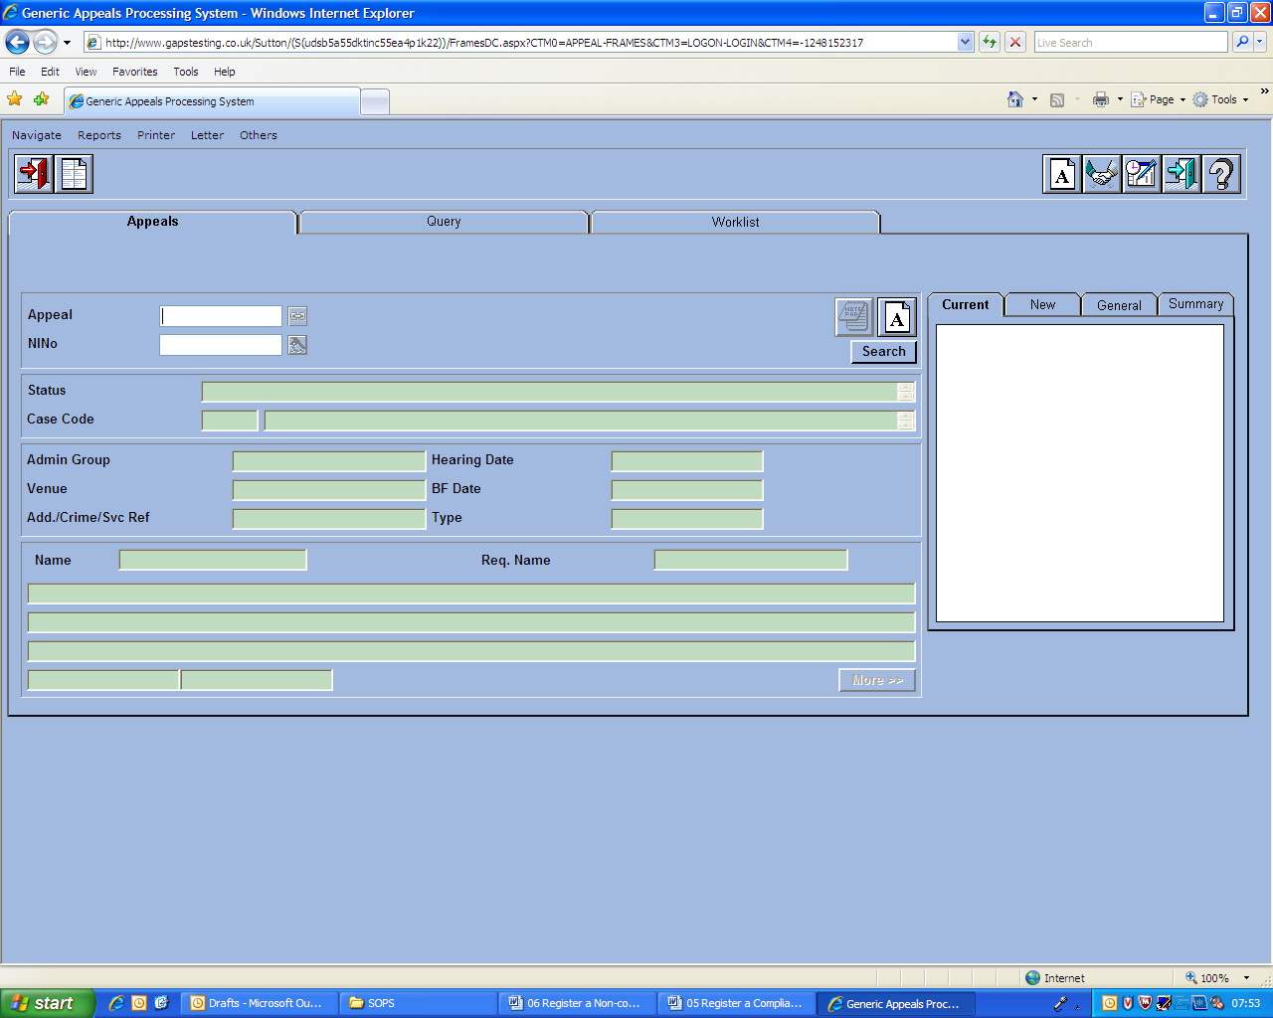
Select the appeal type. This will be,  - DL – Non Compliant |  | DL – Non Compliant = Appeals that have been marked as Non Compliant.
Enter the appellants postcode.
Click on the green tick. |  | If a case code with DD is entered on registration, then GAPS will automatically go to the Direct Lodgement screen after the registration screen has been populated.  If an appeal has been registered previously for the same National Insurance number, a warning notification will be appear. Please check to ensure that this is not a duplicate appeal that has been previously registered or a live appeal which needs linking to the appeal. If the appeal is a linked, take a screenshot of the front screen of the appeal and attach to the front of the jacket later on.  If you wish to continue, click ‘ok’.
GAPS will automatically open the registration screen.  All of the fields with a red arrow next to them are the mandatory fields that need to be completed. |  | Any fields that are marked as white are not mandatory but we need to fill these in if applicable. Any fields that are marked in green, (with the exception of the Appellant’s Address and Appointee for Child) we are not able to be edit these at this stage.
Enter the Date DLC Received.  Type the date in format DD/MM/YYYY or by clicking on the calendar icon, and selecting the date from there. |  | This is the date that the appeal was date stamped at the DLC.
Select the Appeal Format. From the dropdown menu select the format that the appeal was received in,
- Letter
- Form
Select the Receipt Format. From the dropdown menu select how the appeal was received.  - Post,  - Fax,  - Email. |  | At this stage appellants are not able to email their appeal. We are only able to accept appeals that have been sent to the Direct Lodgement Centre via Post or Fax.
Click on the Appellant ‘Address’ button.

This will open a new screen.
Complete all fields that are marked with a red arrow.  - Title,  - Initials,  - Surname,  - DOB (if provided),  - Gender (if provided),  - Correspondence Type – Always ‘Letter’,  - Appellants address (Please note that when completing the appellants address. If you first enter the appellants post code and then click the find button. This will auto populate the rest of the appellants address)  - Phone Number (if provided).  Click on the green tick.  You may receive a message that says, ‘Appellant exists for this postcode, do you want to continue?’ If this message appears, please click on the ‘Ok’ button.  GAPS will take you back to the Registration screen. |  | If the appellant has no NINO, you will need to check that the appellant has no appeals in their name when the message shows up. If there is one for the appellant, print screen the message and attach to the jacket of the file later on at the jacketing stage.
Select the ‘Tribunal Type’. Please select if the appellant has requested an Oral or Paper hearing. |  | If the appellant has not requested either an Oral or Paper hearing, this should be left as paper.
Moving to the bottom right of the screen, please enter the ‘Date Hearing Preference received’. |  | If the appeal was submitted on a form, please enter the date the appeal form was date stamped at the Direct Lodgement Centre.  If the appeal was submitted on a letter, please leave this blank.
From the ‘Oral hearing required’ dropdown box, please select if an oral hearing is required. |  | If the appellant has requested an Oral hearing, please mark this as ‘Yes. Otherwise mark as ‘No’.
If an Oral hearing has been requested, please click on the ‘Requesting Party’ dropdown box and select ‘Appellant.’
If the appeal is to be heard on the paper, this field can be left blank.
Click on the green tick. GAPS will now move to the Direct Lodgement Screen.
From the ‘FTA Reconsideration Enclosed’ dropdown box, please select ‘Yes’/‘No’, if the Mandatory Reconsideration Notice has been received. |  | FTA Reconsideration Enclosed’ is the Mandatory reconsideration Notice.
In the field ‘FTA Reconsideration Date’, please enter the date of the Mandatory Reconsideration Notice.  If no MRN was received, please leave this box blank. |  | This is the date the Mandatory reconsideration Notice was sent to the appellant.
From the ‘Admissable/Complaint’ dropdown, please select ‘No’ as the appeal is non compliant. |  | Is the appeal compliant, No?
From the ‘Further Evidence’ dropdown, please select if further evidence has been attached.
Please check the compliance Checksheet to see if further evidence has been submitted.
In the field ‘Complex’, please select ‘No’.
Moving to the right hand side of the screen there is a box labelled ‘Inadmissible / Non Compliant Reasons’. Below this box, please click on the add reason button. |  | 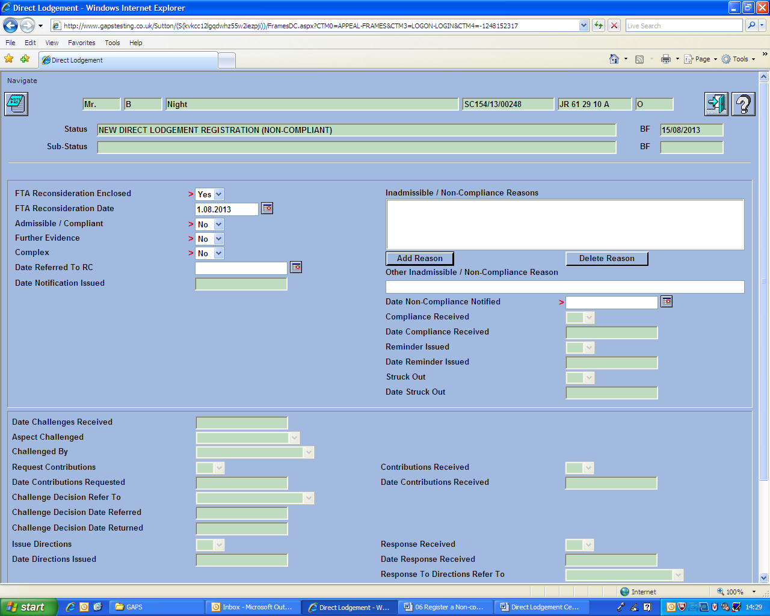
From the non compliant list, please select the reason why the appeal is non compliant.
Click on the green tick.
If the reason for Non compliance is not listed, please click on the red cross.
If the appeal is non compliant for more than one reason, please repeat the above step.
If the appeal is missing the Mandatory Reconsideration Notice, please type, ‘No MRN’ into the blank box under ‘Other Inadmissible / Non Compliant Reasons
If you need to remove a non compliant reason, click on the non compliant reason, and then click on the delete button.
Date Non Compliance Notified. This is the date that the appellant will be notified of the appeal. Please enter the today’s date.
Scroll down to the bottom of the screen.
Click on the green tick to update GAPS
A new window will open for the appellants GAPS letter. Please select Local Print, and click Ok.
Scroll to the top of the screen.  Click on the blue door at the top of the screen to exit. |  | 
4. Update the BF Date
On the right side of the screen, click on the General Tab |  | 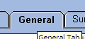
Again on the right side of the screen, click on the Amend BF link. This is approx half way down the list. This will take you to the Amend BF screen. |  | 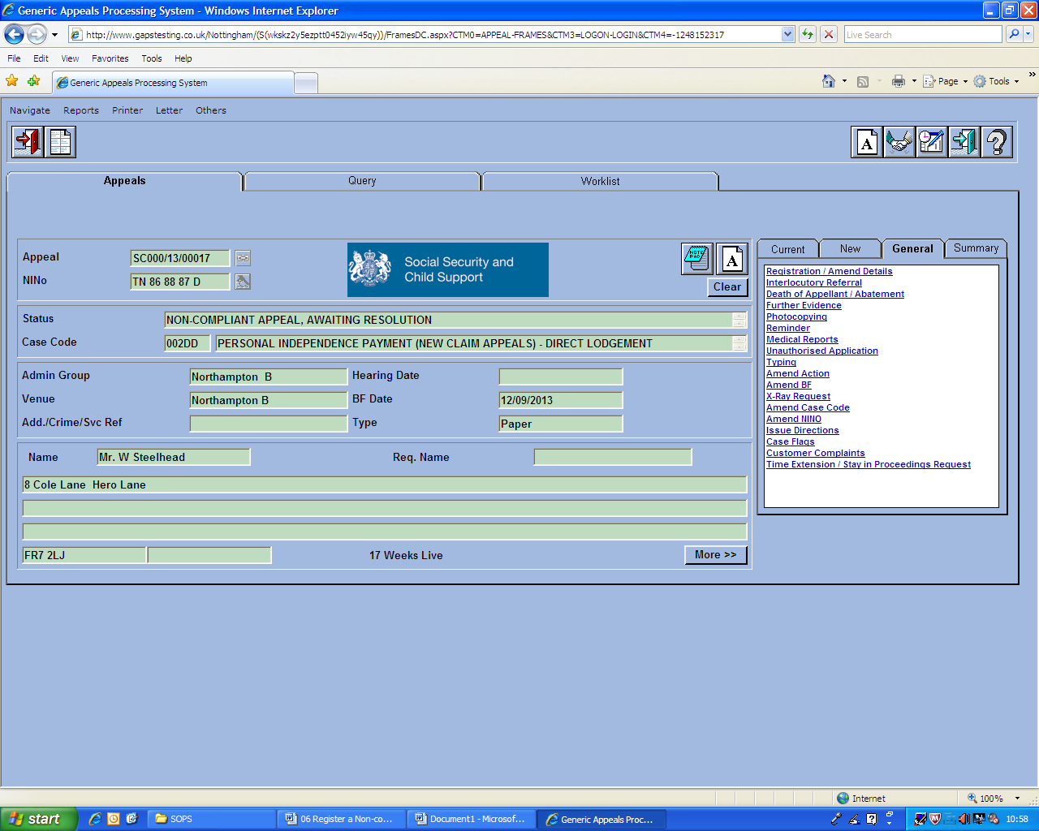
Amend the Major BF date, so that it matches the Minor BF date. |  | With non compliant appeals, the appellant is given 21 days to re-submit their appeal. On the 22nd day, the DLC will run a report to send a reminder to the appellant. The Major BF is automatically set to the same day the appeal is registered on GAPS. If we do not change this date to match the Minor BF date, the report will not pick up the appellants that we need to chase.
Green Tick to confirm the change to the date is correct.
Click on the blue door to exit to the Gaps home screen
5. Link appellant appeal documents.
Notifications that will be sent to the appellant are,  - Non compliance notification letter,  - All other appeals papers received by the Direct Lodgement Centre.  From the appeal documents please remove,  - Compliance Checklist,  - Letter Registration sheet.  Both of these documents are for internal office use only and will not be sent back to the appellant. |  | For non compliant appeals, the non compliance letter and the appellants appeal will be returned to the appellant.
Staple the non compliance letter to the original appeal documents.
6. Return appeal documents to the appellant.
Place the appeal documents and non compliance letter in a C5 (1st class) envelope. Please include a return envelope.
7. Closing action
Place the envelope in out tray ready for posting. |  | For non compliant appeals we do not create a case file. Only action is to send the appeal papers and GAPS letter to the appellant.
Note Missing Files on the File Request Sheet
40

