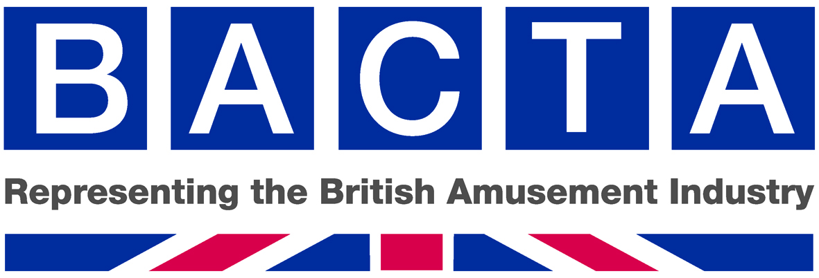

8 April 2013
Gambling Act 2005: Triennial Review of Gaming Machine Stake and Prize Limits (The Triennial Consultation)
We refer to the Triennial Consultation and provide BACTA’s submission which is summarised below. The review of stakes and prizes will assist thousands of small family businesses, many of which represent an important part of coastal tourism, machine suppliers, manufacturing, bingo, sporting and working men’s clubs, pubs, LBO’s and the casino sectors. We believe these measures provide a lifeline to a legitimate industry that provides fun and entertainment while striking the right balance to deliver social responsibility best practice.
Executive summary

BACTA, representing the British amusement industry, supports Package 3 which is the industry’s proposal summarised below. The review of stakes and prizes should continue on a triennial basis because of the timeframe required for development of games, industry investment and the legislative process.

Category B1 – We support the NCIF recommendation of £5 / £10,000. While we support exploring effective measures to underpin social responsibility we do not believe that sufficient is known about player monitoring technology and look forward to working closely with DCMS, the Gambling Commission and Stakeholders to investigate international best practice in this area, address serious issues regarding privacy and civil liberties and determine how it might relate to the UK.
Category B2 - The government has called for evidence of why they should apply the precautionary principle and change the current provision of B2 machines. BACTA submits that all adult premises should be immediately entitled to offer B2 machines and the siting of B2 machines in LBOs, AGCs, bingo clubs and casinos should be reviewed in the context of the Category B research being undertaken by the RGT.
Category B3 –BACTA believes there is a strong case for an increase in the prize to £1,000.
Category B3A - £2 /£500. We agree with the government’s proposal for B3A and B4 which will greatly assist a range of clubs, including sports clubs, cricket clubs etc which will form a focus for activities that underpin the legacy of the UK Olympics.
Category B4 - £2 / £400 (see above)
Category C - £1 / £100. This will assist manufacturing and all sectors that offer Category C machines.
Category D (non-monetary prize - cranes) - £2 /£100 (or £75) non cash. This will allow the offering of fashionable prizes such as Kindles, Tablets, games consoles, sat navs and mobile phones.
Category D (pushers) - 20p /£20 (combined cash and non-cash where limit is £10 cash)
Category D (monetary prize) - 20p / £10 cash. We do not believe that there is any evidence that such an increase would give cause for concern, particularly as these games are played in a supervised family environment. Category D product should be benchmarked against other activities undertaken by youth both in terms of social protection and customer value. Any reasonable consumer would expect the £5 prize to increase at least by inflation since it was frozen in 1997 which would produce a prize of approximately £9. The government’s proposal of £6 is of no value to the customer or the industry. If £10 is granted the industry will agree not to seek a further increase for a 10 year period and to participate in benchmarking research regarding the playing of Category D machines.
Category D (combined monetary and non-monetary prize (other than coin pusher or penny falls) – eg reel based machine paying out a combined monetary and non-monetary prize eg a voucher -20p / £16 (of which £10 maximum cash). In the pre-consultation to this Triennial Review, a subsection of Category D was excluded in error. We therefore submit that this category should also be reviewed in order to assist the arcade sector, particularly those small family businesses at the seaside.
Taxation - It must be noted that the above submissions are on the basis that the taxation rates applying to each machine category will remain unchanged by ensuring that appropriate amendments are made to the Finance Act. If increases in stake and prize result in a product being subject to a higher tax rate because of the failure to amend existing taxation bands, the intended benefits will be entirely vitiated.
Social Responsibility – Enhanced code to underpin stake and prize increases in the 2013 review
BACTA is proud of its record on social responsibility and will continue to explore ways in which it can work in partnership with other stakeholders within the gambling industry, the Gambling Commission and Government to be a world leader in evidence-based social responsibility best practice. Without making representations on behalf of any other trade association, BACTA proposes to work with the other associations to develop improved social responsibility that demonstrates the industry’s real commitment to the social responsibility agenda. In the context of the industry’s 2013 stake and prize requests this improved social responsibility would be based upon the following principles:
- That the changes to stakes and prizes for gaming machines will be connected with improved social responsibility and the introduction of tough new measures which support the Gambling Act 2005 Licensing Objectives which are to keep crime out of gambling, to ensure that gambling is conducted in a fair and open way and to protect children and the vulnerable from harm arising from gambling.
The Gambling Act 2005 introduced Licence Conditions and Codes of Practice (LCCP) which were developed by the Gambling Commission to underpin the Licensing Objectives. The gambling industry will propose new measures not currently contained in the existing LCCP which will form part of a social responsibility code applying to premises to which the LCCP applies. This code will greatly strengthen social responsibility best practice and will include measures to promote more effective customer interaction, self-exclusion and checking for underage customers.
This new social responsibility code promoted by trade associations representing relevant sectors of the industry will reflect new measures referred to above and include the following:
- all adult only premises that offer gaming machines are subject to a rolling programme of test purchasing to determine that adequate and effective controls are in place to prevent under age gambling.
- trade associations representing sectors of the industry will regularly meet with the Gambling Commission to discuss the detailed results of the test purchasing programme and how they plan to secure the further improvements needed.
- industry associations will monitor compliance and take action against any members not implementing the code. Adherence to the code will be a condition of membership for industry associations.
- in addition the industry will review ways of enhancing staff training to include the new social responsibility code.

This will ensure greater protections for those using gaming machines to ensure that the licensing objectives including protection of children and the vulnerable are strengthened.
Gambling Act 2005: Triennial Review of Gaming Machine Stake and Prize Limits (The Triennial Consultation)
BACTA is pleased to respond to the Triennial Consultation as set out below. We would value an opportunity to meet with DCMS officials as soon as possible in order to discuss the submission and provide any assistance to the Department in finalising the consultation process. BACTA represents over 500 members and we therefore make these representations not only on behalf of the trade association, but also of each individual BACTA member. Please therefore ensure that the consultation summary of responses acknowledges representation from each member, details of which can be provided under separate cover.
Process:
Question 1: How often should government schedule these reviews? Please explain the reasons for any timeframes put forward for consideration.

Answer: We submit that the government should schedule these reviews to return to a three year cycle. The Triennial review system that was adopted prior to the 2005 Act appeared to have served the industry and the government well. A three year period is required in order to take into consideration (1) the time required for development and testing of new games following a stake and prize review (2) to allow those purchasing machines to plan for investment and amortise the cost over a realistic period in order to make purchasing of new games a viable commercial proposition and (3) the legislative process.

The process for development and testing of games varies depending upon whether they consist of terminal based content or reel based traditional amusement product. Each stake and prize combination requires extensive and costly periods of software development and testing by specialist gaming software experts with many years of experience in development of complex algorithms to produce games which are attractive to players and are commercially viable to those who provide them.

We submit that the traditional market must be taken into consideration as their business models are less able to adapt and therefore more relied upon the development and buying cycle which has historically been applied to this sector. Typically the process of development of a new game, initial testing, commercial testing, revisions and final entry into the market in an established form, taking into consideration the Gambling Commission’s machine testing strategy, can take between 8 and 12 months. For a traditional cabinet based machine the process might be described as follows:

- Designing a new game – 6 – 8 weeks
- Software and graphics – 12 weeks
- Build test machine – 2 weeks
- Primary test (high tech to retailers, low tech to arcades) – 4 – 6 weeks
- Analysis of feedback – income reliability and test player satisfaction
- Secondary test – larger batch of machines to wider audience – 6 – 8 weeks
- Analysis of feedback
- Approval by retailers and potential purchasers
- Production lead time – 3 – 4 weeks

These periods might be increased in the primary and secondary test phases depending upon the feedback and requirements to redesign software and carry out additional testing. For server based games the development time might decrease by 6 – 8 weeks as much of the analysis and amendment will take place in the primary test phase.

This work cannot commence until the stake and prize levels have been confirmed by Parliament and therefore there can be a substantial time-lag between Parliamentary approval and machines being available for purchase.

Investment, budget planning and amortisation requires a 3 year period for the traditional market which includes the vast majority of small and medium enterprises (SMEs). Those who are purchasing machines are required to budget for years in advance in order to take advantages in increases in stake and prize levels. The commercial profile of purchasing machines can vary widely depending on the type and location of premises or business which will utilise the machines. A small family business might only purchase 10 to 20 new machines of one category type in a three year period, while a machine supplier might be required to invest millions of pounds in new machinery in order to satisfy demand of players in a pub environment requiring new games to refresh the entertainment experience.

It is common industry practice to amortise the purchase of gaming machines, depending upon their type and location, over an average of a 3 year period but this will again vary widely depending upon the machine type. For example a Category C machine in a single site might have a replacement cycle of 12 – 18 months before those machines are moved to a secondary market, however, in an arcade environment machines might be amortised between a 3 – 5 year period depending upon the success of the game and its location. A pusher might be amortised over a period of over 10 – 12 years and a crane over a period of 8 - 10 years but again this will vary widely depending in the machine mix and location.

The legislative process requires a minimum of an 18 month period which includes taking initial soundings from the stakeholders regarding the scope of the review, the preparation of consultation documentation, including internal departmental approvals, the obtaining of approval for releasing consultations by reference to the regulatory policy committee guidelines. The initial phase also requires the gathering of data and preparation of regulatory impact assessments for the pre consultation phase, a three month consultation period in compliance with Cabinet Office guidance, review of responses and consultation with the regulator. Following consultation time is required for the preparation of government response, the drafting of applicable orders and notification to Europe to commence a three month ‘standstill period’ in accordance with EU Directive 98(34). Finally, there is the laying of the order following the ‘standstill period’ upon receiving ministerial clearance.

We submit that the current legislative process appears to be unnecessarily bureaucratic and requires a great deal of resource both from government and the industry. We would value the opportunity to discuss with officials how the industry might work with DCMS to use the current process as a benchmarking exercise and explore how future Triennial Reviews might be streamlined. This includes discussion in addressing challenges of meeting requirements of the regulatory policy committee by clearly identifying data needs at the beginning of the process and considering whether the EU notification process is strictly necessary or of benefit to either government or stakeholders.

Question 2: The government would like to hear about any types of consumer protection measures that have been trialled internationally, which have been found to be most effective and whether there is any consensus in international research as to the most effective forms of machine-based interventions. The government would also like to hear views about any potential issues around data protection and how these might be addressed.
Answer: The industry has a long history of commitment to social responsibility which currently includes interventions in appropriate circumstances. The amusement machine industry is eager to work with government and stakeholders to ensure that UK policy is informed by international research. The issue of consumer protection measures related to gambling has been the subject of consultation in other jurisdictions, notably Australia. We submit however that it would be wrong to simply read across research from other jurisdictions where the gambling environment and culture might be structurally different from the UK.
The tracking of individual citizen’s behaviours with the purpose of restriction or intervention raises more general concerns that apply to all areas of potential harm beyond gambling and cannot be addressed in isolation. These include data protection, privacy, analysis of personal data being used to deal with individuals in a discriminatory way and requiring employees to undertake interventions based upon incomplete and subjective data giving rise to additional duties of care and potential corporate and employer liability. We look forward to exploring with the Department and other stakeholders how these matters might be resolved, while ensuring that measures do not unnecessarily undermine important democratic freedoms.
In the UK the Gambling Commission’s Licence Conditions and Codes of Practice currently contain strict licence conditions that require policies and procedures that include monitoring player’s behaviour on the premises and consideration of whether player interaction/intervention is required. It is noted that these licence conditions and codes of practice were reviewed in 2011 and industry continues to work with the Commission to identify practices that can enhance social responsibility, such as self-exclusion.
It is important to be clear, however, about our objectives and to ensure that they are congruent with civil rights in a democratic society. We are focused upon prevention of gambling related harm, not simply customer disappointment where they have not won a game. It must be recognised that when customers participate in the activity of gambling they are exercising their freedom to take the risk of losing their stake in order to gain an opportunity to enjoy the experience of winning.
Society allows individuals to engage in a range of activities which can result in satisfaction or disappointment. This is distinguished from activities which can result in harm if individuals do not and cannot themselves exercise responsible judgement. Care must be taken when removing individual freedoms and dictating or redefining where choice is to be denied by either those providing a product or services, or by government on the grounds of ‘protection’. Finding the right balance is not confined to gambling, but an enormous range of other activities including consumption of food and alcohol, driving, shopping and financial services. It is important to acknowledge that what represents gambling related harm varies from player to player and currently we are unaware of any jurisdiction which has identified a financial metric to successfully identify harm and use specific financial player patterns as the basis for suppliers of gambling services to remove individual freedoms. We are committed to ensuring that gambling is undertaken in a responsible way and therefore we submit that the right approach is for the Gambling Commission, in co-operation with the RGSB, to commission desktop research of the work that has been undertaken in this area internationally and follow this with a strategy paper to explore how that report might inform UK policy.
Question 3: The government would like to hear from gambling businesses, including operators, manufacturers and suppliers as to whether they would be prepared to in the future develop tracking technology in order to better utilise customer information for player protection purposes in exchange for potentially greater freedoms around stake and prize limits.

Answer: While we support further research regarding ways in which technology can be used to enhance social responsibility and note that the industry will be working with the Responsible Gambling Trust (RGT) regarding the research into Category B machines, we believe that more work needs to be done before any substantive decisions can be taken regarding the best way of proceeding in this area. It is also critical to correctly identify the objective of intervention and find the right balance that protects fundamental democratic freedoms. We also note that changes could have a commercial cost which could distort the market particularly for SMEs without materially improving social responsibility. Businesses in the sector have a diverse technological profile from server-based technologies in bookmakers and casinos to traditional low tech machines in small family arcades.

Package 1: Do nothing (i.e. retention of the status quo)

Question 4: Do you agree that the government is right to reject Package 1? If not, why not?

Answer: Yes.

Package 2: An uplift to stake and prize limits to cover inflation from 2007

Question 5: Do you agree that the government is right to reject Package 2? If not, why not?

Answer: Yes. Note, however, that in relation to Category D complex there has not been an inflationary calculation benchmarked against the last change in 1997. An inflationary increase in relation to the stake for Category D complex would produce a prize level of approximately £9.

Package 3: Proposals by the gambling industry

Question 6: Do you agree with the government’s assessment of the proposals put forward by the industry (Package 3)? If not, please provide evidence to support your view.

Answer: The government’s assessment of proposals is summarised as follows with the applicable comment in relation to each machine set out under the relevant machine category.

B1 Government seek additional assurances about consumer protection.

Comment

We agree with the government’s proposal to increase the stake to £5 but submit that the preferred maximum prize should be £10,000 from the perspective of gaming machine manufacturers. As a general matter we urge government to ensure that gambling regulation is consistent and therefore the issue of linking of games and ability to offer remote technologies should apply to all adult premises in a non-discriminatory fashion provided that adult premises are able to demonstrate that they have equivalent social responsibility measures in place.

B2 Government acknowledges widespread concern from other sectors about B2 machines.

Comment

We support the work that is being undertaken by the RGT in conjunction with the RGSB concerning research into Category B machines and we look forward to co-operating with all stakeholders to ensure that machine play is conducted responsibly. We refer to our answer in Q13 but make the following observations.

The Gambling Act 2005 allowed bookmakers the ability to site B2 machines while denying other adult premises the ability to offer these machines. We submit that rather than this representing the ‘will of parliament’ after considered evidence-based debate, this was the result of political lobbying during the ‘wash-up period’ at the time of the passage of the Bill. There is no evidence to suggest that LBOs present a different risk profile from those of adult gaming centres.

It is self-evident that adult gaming centres have relied upon gaming machines as their primary source of income and activity, unlike LBOs which have traditionally offered betting products, rather than machine gaming, to customers. It is therefore discriminatory and unreasonable that those premises which have relied upon the making of machines available for adult play, should be denied gaming machines which can be offered by LBOs.

BACTA and the members we represent take social responsibility extremely seriously. We will take every reasonable measure to ensure that licensing objectives are pursued, particularly protection of the vulnerable from gambling related harm. We do not believe that any sector should make games available if there is evidence that they undermine the licensing objectives. We submit that if the government believes that there is no cause for the precautionary principle to be applied to B2 machines with immediate effect, that B2 machines should also be made available to all adult premises at the conclusion of this consultation and the provision of B2 machines in adult premises including adult gaming centres and LBOs should be the subject of review in the context of the Category B research which is to be undertaken by the RGT referred to above.

B3 Government does not believe the rationale is credible to justify why the maximum prize for B3s should be higher than the maximum prize for B2s and would risk changing the nature of the B3 product. Government submits there is not sufficient data to allow a proper assessment on what the wider effect might have across the industry as a whole and there has been no analysis of the impact of the changes so far.

Comment

We submit that there is sufficient data to justify a higher maximum prize for B3 and there is no evidence of risk of changing the nature of the B3 product. The Department should obtain data from the Gambling Commission’s Regulatory Returns and the Treasury gambling industry model which has been developed to inform Treasury fiscal policy, using input from the Gambling Commission and other sources in order to assist to verify the effect of the B3 changes to date. Whist the industry bodies can provide anecdotal evidence that there has been some uplift in B3 product, specific industry wide data is not currently available due to both confidentiality concerns and structural changes to the industry.

If a joint industry and Departmental model was developed, as has been done in the tobacco sector, the industry would be able to sense check and comment upon assumptions made regarding the impact of change. It is also difficult to provide data regarding the B3 changes because there have been other factors affecting the market such as the fundamental replacement of the tax structure which make it problematic to isolate precisely where a change has occurred due to the change in stake or machine numbers. We request that the government undertake robust research to demonstrate that the increase in stake has not had a detrimental effect on customers playing responsibly. The government receives substantial tax revenues from the gambling industry and we therefore submit that the government should bear part of the responsibility for and cost of understanding and predicting consequential changes.

B3A/B4 Despite a lack of contextual data these machines are important to members of commercial clubs and because of limitations on siting these machines the potential impact of change is reduced.

Comment

We agree with the government’s proposal which will greatly assist a range of clubs, including sports clubs, cricket clubs etc which will form a focus for activities that underpin the legacy of the UK Olympics.

The B3A product employed a £2 stake prior to the 2005 Act and therefore the proposal is no more than a return to the stake which was previously played. B3A and B4 machines are only able to be sited in clubs and therefore the effect of these changes, while of enormous importance to these premises, will not impact other sectors.

Gaming machines invariably provide the second largest income source for a club after the bar takings; as such the revenue is vital. Clubs exist at the very heart of their community and are run by a committee of members for the benefit of the community in which they are located. They are non-profit making social, entertainment and sporting venues and the revenue from the machines goes back into the community. To many clubs the income from their jackpot machines is the difference between success and failure and helps to subsidise their charitable, social and community sports activities. Anecdotal evidence suggests B4 machines generate between £200 to £500 per week for club funds.

There are circa 8,000 clubs in the UK that have registered for Machine Games Duty (MGD) each with a maximum entitlement of three machines, however this regulatory maximum is rarely utilised and typically clubs will have only one or two machines. The clubs registered are a mixture of working men’s clubs, politically affiliated clubs, sports and social clubs, Royal British Legions and community sports clubs - as such they cater to a wide cross section of the population covering all geographical areas of the UK.

It must be noted that clubs which site these machines are often staffed by secretaries who act on a voluntary basis with many responsibilities to ensure that the clubs continue to provide a valuable community asset to their members. Much of the administration concerning gaming machines has been undertaken by suppliers of those machines to the clubs. There is therefore very limited resource for the club sector to obtain an aggregate data, however, we will be happy to explore how we can assist the Department in future triennials to obtain this data including a shared treasury Department industry model.

C Government is minded to take forward the industry’s proposals acknowledging the serious concerns about the performance of this machine category and the importance to the gaming machine market overall.

Comment

We agree with the government’s proposal and refer to evidence contained in our answer to Question 23.

D Government’s primary concern is potential social impact of any changes which need to be adequately considered or addressed by the industry. In particular crane grabs the government does not think it is right that the maximum prize level of a machine designed to be played by children should match that of a Category D gaming machine which is restricted to adults only (ie £100 is the recommendation is approved). Category D complex (reel based) – these are the most sensitive area for government as they remain gaming machines that can be played by children. It was parliament’s intention that the value of cash prizes for these types of machines should be lower than for other types of Category D machines such as pushers and mixed cash and non-cash Category D games. The government believes that there is a clear distinction between machines played for amusement and for gambling and the distinction should be maintained.

Comment
We do not agree with the government’s assessment and believe there is a strong case for a change in stakes and prizes for both cash and non-cash Category D products. While we will respond under the headings for individual categories below, we make general observations regarding flaws in the government’s assessment. The industry understands and supports the need to ensure that potential social impacts of any changes are fully addressed and currently observes strict social responsibility practices. It should be acknowledged that Category D machines are played in a supervised family environment where there is a much greater level of parental scrutiny than in many other activities which are a normal part of the life of a young person in the 21st Century. Concerns regarding children playing Category D machines were raised during the passage of the Bill, however, parliament determined that there was no evidence of harm. The attitudes of families to the Category D product as harmless entertainment was also supported by the Brand Driver consumer study.
The playing of Category D products should also be placed in context of the activities and entertainments which compete for leisure spend of children and young people. The failure to allow the stakes and prizes of Category D machines to be increased to continue to provide value and entertainment to players of all ages, threatens to cause this product to wither as increasing competition for time and discretionary spend comes from other sectors, including music, technology, computer games, social media, fashion and popular culture.
If Category D stakes and prizes are not increased as set out below it will place into jeopardy many SMEs, particularly at the seaside, who have experienced exponential increases in cost and taxation without the ability to respond commercially. These increases will therefore assist to boost coastal tourism at a time of unprecedented closures.
Recognising, however, sensitivities regarding Category D complex machines we propose that if stakes and prizes are increased to 20p / £10 we will offer an enhanced social responsibility code, assist to take forward benchmarking research in relation to children playing these machines and not seek a further increase for a period of a minimum of 10 years during which time research will have been undertaken. We firmly believe that this research will underpin the common sense view of generations of families which have enjoyed playing Category D games as a normal part of their family entertainment. If stakes and prizes do not keep pace with customer expectation, this family entertainment will disappear.
Concerns regarding Category D machines were fully rehearsed in the passage of the Gambling Act 2005, in particular in the Parliamentary debate in the House of Lords in March 2005 regarding the playing of Category D machines by children, Lady Buscombe, after having initially argued strongly for the introduction of restrictions on children playing Category D machines, withdrew this suggestion, acknowledging that such restrictive action affecting the playing of category D machines would need to be based upon ‘serious evidence’. She went on to note that ‘we are talking about destroying an industry—yes, it is an industry—that has existed for many years and, as my noble friend Lord Ullswater said, provided a huge amount of enjoyment for young people—including me, when I was a child …. Children have been playing those machines for many years. To deprive them of that enjoyment—because it is fun—must require a huge amount of serious research and further thought’.
Lord Pendry noted that the Government commissioned Lancaster University to review the available research on the very question of gambling for youngsters. It concluded that, "the current evidence is insufficient to make definitive judgments" about the prevalence of patterns of problem gambling among young people …. I think that we would be very foolish to deny young people the opportunity to have the kind of fun they have had when there is no evidence to say that gambling is doing any great harm to them.
The overwhelming attitude of the majority of the public is that Category D products to not represent risk and are harmless entertainment for children. Customer research by Brand Driver (extracts of which are attached as Annex A) which was presented to DCMS officials showed that parents were content for children to play upon these low stake and prize entertainments as they were considered to be a harmless leisure activity which had formed part of the childhood experience of generations of British families, particularly at the seaside. When it was recognised that seaside businesses were in need of support, the non-cash Category D stakes and prizes were reviewed and increased demonstrating that their social profile was not one that should give rise to concern, but an increase could be justified on the basis of retaining the commercial viability for these amusement businesses.
The industry has demonstrated that it strictly adheres to the rigorous regulatory regime that was introduced with the Gambling Act 2005, including supervision and staff training. Although changes to non-cash Category D were welcome, reel based Category D machines continued to play a fundamental part in the business models for family entertainment centres, particularly at the seaside. It must be noted that there is normally a great deal of family supervision in the playing of these games as they are played in the context of a family day out. Parents will normally be responsible for providing the stakes directly to the young person who is playing the game, being fully aware of the game which is being played and the amount of money which has been spent. These Category D games have always been played in this way with arguably more parental supervision than other activities which have developed over the last 20 years and compete with Category D product. Category D remains a harmless and fun family activity but its value has been eroded both to the customer and those providing these games.
Cranes

In relation to cranes we believe that the concerns of the government that the prize levels should not be equivalent to a Category C machine, ie £100, are not valid as the profile of Category D non-monetary prize machines is fundamentally different to that of Category C machines. The attitude of the consumer to non-monetary prize cranes was demonstrated in the Brand Driver research referred to above, simply as a harmless form of entertainment. That entertainment value, however, can only continue if the product is able to continue to keep pace with consumer expectations and not be eroded when compared with other sources of entertainment with which these products are competing.

Whilst it continues to be our belief that there is a strong argument that the prize level should be increased to £100, if this is not permitted, we submit that the next three years the maximum non cash prize for a Category D crane shall be increased from £50 to £75 (see response to package 4). This will allow the offering of attractive prizes which could not be offered if £60 was the maximum limit. These include Kindle Wi Fi 6” Display, Tablets, gaming consoles eg Sony PSP, Tom Tom Sat Nav, Samsung Galaxy Y mobile phone, all of which are currently fashionable and popular with consumers in 2013.

Category D complex - reel based

We strongly submit that an increase in reel based amusement machines from £5 to £10 prize can be justified on the basis that there is no evidence that this will give cause for regulatory concern, as referred to in the parliamentary debate referred to above, but rather protects a harmless genre of fun activity by allowing it to remain attractive to players who are children. Further details are set out below and in the response to the question under package 4.

Category D machine prizes being eroded in the context of teenager consumer patterns

The erosion of value which particularly applies to Category D complex games because of the immediate ability to quantify the stake prize ratio for consumers, is equally applicable to all types of Category D product. Prabhakar, Rajiv (2009). Teen and tweeneconomics: a study into the teenage and tweenage pound in Britain: - report into youth spending, looked at spending habits of 7-15 years olds across the UK. It showed that spending by young people has continued to rise despite drops in parental disposable income. For the first time, the spending power of Britain’s young people has increased during a recession. The average young person will spend over £6,000 between the ages of seven and fifteen, which equates to spending of £10.27 per week for seven to ten year-olds and an average of £15.25 per week for those aged between 11 and 15.

The spending power of young people has continued to increase significantly beyond the rate of inflation, meaning that in real terms, young people are wealthier now than they ever have been. In 1987, the average young person received £1.18 per week and this contrasts with £6.84 in 2009, an increase of 500 per cent. This demonstrates that the comparative value of a cash prize for Category D which has remained unchanged has eroded against teenager’s income which by contrast has increased by 500%. However the spending power young people have on a weekly basis goes significantly beyond pocket money.

Whilst their income is £6.84 per week, across the age groups, the same average spending figure is £13.10 – meaning that young people are accessing an additional £6.34 through part-time work, gifts from family or additional household chores to increase their spending power. This has further diminished the attraction of the £5 cash prize for reel based Category D machines.

At the same time there is increasing competition for the leisure time of teenagers particularly from mobile devices according to the latest annual survey of young people's media habits, carried out by the British media regulator, Ofcom.

The survey found that 12 to 15 year olds spent equal amounts of time watching TV and going online - 17 hours a week on average for each medium. And asked which media device they most valued, teenagers rated their mobile phone above the family TV set. Smart phone ownership among teenagers was found to have doubled in just 12 months.

The survey paints a picture of an increasingly tech savvy younger generation, with even very young children confident about, and familiar with, a wide variety of digital devices which compete with the Category D product for leisure time of young people. The survey says the take up of digital technologies is faster among teenagers than the general population.

It also comments on changes in the way in which technology is used present challenges to make traditional gaming machines retain their entertainment value. For example, the report showed the popularity of text messaging, especially among girls. Teenage girls typically send 30 or more text messages a day, 35% more than boys do. Category D games which are normally played in a family environment must be permitted to develop and represent entertainment value to boys and girls who spend time sending messages on mobile devices without parental supervision.

The perception of value erosion applies to all aspects of the Category D prize. BACTA has previously highlighted the need to benchmark the non-cash prize for cranes which is currently limited to £50 against consumer goods which appeal to teenagers. A £75 limit would permit the offering of fashionable prizes such as Kindles which would not be permitted with a £60 maximum limit.
The average adolescent lifestyle now requires a staggering £9,000 a year to service as set out in the most recent AAT report on spending trends for children and teenagers in the UK.
The report indicates that children spend more than £1,000 a year on mobile phones, MP3 players and music downloads alone.
Add £240 for haircuts and £300 for trainers and the average 17-year-old now spends 12 times more than his or her 1975 counterpart, according to a household spending survey by the Office for National Statistics. Over nearly all of this period the prizes for Category D machines have remained unchanged.
Aspirations and expectations are higher than they have ever been, analysis of the figures by the accountancy trade body AAT found.
Its report highlights a marked change in teenage activities and spending habits over a generation.
While a games console or stereo is significantly cheaper now than it was 30 years ago, these items are now regarded as ‘essentials’, rather than luxuries.
The cost of buying an Atari 2600 games console in 1975 was the equivalent of £1,200 in today’s money.
The cost of other activities has also risen disproportionately. A trip to the cinema costs £7 today, compared with the equivalent of £4.80 in 1975. With increasing competition for discretionary spend and time we strongly contend that the Category D product must be permitted to increase its stake and prize limits in order to be a viable entertainment form. This is consistent with the Brand Driver research referred to above.
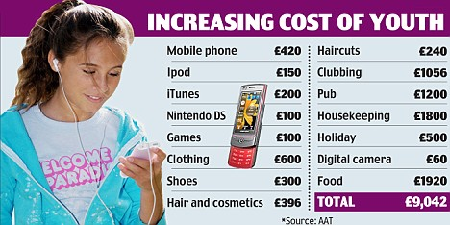
Category D and social responsibility
We acknowledge that concerns have been raised in relation to children playing Category D product but refer the Department to the parliamentary debate referred to above. It should be noted that children are permitted to participate in an ever increasing range of activities and entertainments. It is important that the playing of Category D games is benchmarked against these other forms of activity and entertainment, noting that Category D games are normally played in the context of a family experience unlike certain other activities that can be enjoyed by children, such as use of mobile technologies.
Children on average from the age of 8 years old have their own mobile devices. Playing by children in family entertainment centres is viewed as a family activity as indicated by the research referred to above. There are a multitude of regulatory social responsibility safeguards which have been developed in the course of extensive parliamentary debate and are now enshrined in the Gambling Act 2005 and the Gambling Commission Licence Conditions and Codes of Practice.
We believe that evidence will underpin the common sense view of generations of families which have played Category D games as a normal part of family entertainment. If, however, Category D games are allowed to wither because they do not keep pace with customer expectation, they will disappear. Should there be any evidence of concern regarding the new stakes and prizes the Gambling Act 2005 allows for great flexibility to immediately respond using the many safeguards and checks and balances which underpin the UK gambling regime.
Package 4: Category B1
Question 7: Do you agree with the government’s proposal for adjusting the maximum stake limit to £5 on category B1 gaming machines? If not, why not?

Answer: Yes, however, we believe that further work needs to be done in understanding how monitoring technologies might benefit social responsibility. We do not agree that there is current evidence regarding the benefits of use of tracking technology to monitor patters of problem play. We submit that this should be a matter of further research as referred to in Question 2 above. We look forward to working with DCMS and other stakeholders to address concerns in this area.

Question 8: Do you consider that this increase will provide sufficient benefit to the casino and manufacturing and supply sectors, whilst also remaining consistent with the licensing objectives of the Gambling Act?

Answer: Yes, we agree that the maximum prize limit on B1 machines should be increased to £10,000 to provide a beneficial outcome to the casino sector and the manufacturing and supply sectors in terms of reinvigorating the B1 offer. We refer to the preliminary industry submission in this regard which estimated that consumer demand would drive manufacturing by 10% should the prize level increase to £10,000.

Question 9: Do you agree with the government’s proposal for adjusting the maximum prize limit on B1 gaming machines?

Answer: Yes, we submit that an increase to the maximum prize will assist manufacturers to develop product to meet consumer demand.

Question 10: If so, which limit would provide the most practical benefit to casino and machine manufacturers without negatively impacting on the licensing objectives of the Gambling Act?

Answer: £10,000 is the preferred increase and we refer to the response from NCIF in this regard.

Question 11: Are there any other options that should be considered?

Answer: No other options should be considered and we refer to the NCIF response

Question 12: The government would also like to hear from the casino industry and other interested parties about what types of consumer protection measures have been trialled internationally, which have been found to be most effective and whether there is any consensus in international research as to the most effective forms of machine-based interventions.

Answer: We refer to the answer to Question 2 above and believe this should be the subject of a separate research project.

Package 4: Category B2 Government’s preferred options.

Question 13: The government is calling for evidence on the following points:
a) Does the overall stake and prize limit for B2 machines, in particular the very wide range of staking behaviour that a £100 stake allows, give rise to or encourage a particular risk of harm to people who cannot manage their gambling behaviour effectively?

Answer: We refer to our comments in Question 6 above.

- The government must act consistently and in a non-discriminatory way towards venues that are permitted to offer games to customers and towards customers playing those games.
- The amusement industry is proud of its record for responsible gambling and there is no reason why all adult premises should not be entitled to offer customers the same machines as are offered in bookmakers. The Gambling Act 2005 allowed bookmakers and casinos the ability to site B2 machines while denying other adult premises the ability to offer these machines. We submit that this was the result of political lobbying during the ‘wash-up period’ at the time of the passage of the Bill, rather than any evidence-based analysis which could credibly suggest that LBOs presented a different risk profile from those of adult arcades. It is self-evident that adult gaming centres have relied upon gaming machines as their primary source of income and activity, unlike LBOs which have traditionally offered betting products, rather than machine gaming, to customers. It is therefore discriminatory and unreasonable that those premises which have relied upon the making of machines available for adult play, should be denied gaming machines which can be offered by LBOs.
- BACTA and the members we represent take social responsibility extremely seriously. We will take every reasonable measure to ensure that licensing objectives are pursued, particularly protection of the vulnerable from gambling related harm. We do not believe that any sector should make games available if there is evidence that they undermine the licensing objectives.
- The government has asked if there is a plausible risk of gambling related harm from B2 machines in which case it will apply the ‘precautionary principle’.
- BACTA makes no comment on whether there is evidence of a plausible risk, however, if the government does not believe that the precautionary principle should be applied, all adult premises must be entitled to offer B2 machines to customers immediately in order to be consistent.
- The siting of B2 machines on all adult premises ie including LBOs and AGCs can then be reviewed in the process of the Category B research project which is to be undertaken by RGT.

b) If so, in what way?

Answer: No comment.

c) Who stakes where, what are the proportions, what is the average stake?

Answer: No comment

d) What characteristics or behaviours might distinguish between high spending players and those who are really at risk?

Answer: No comment

e) If there is evidence to support a reduction in the stake and/or prize limits for B2 machines, what would an appropriate level to achieve the most proportionate balance between risk of harm and responsible enjoyment of this form of gambling?

Answer: Government must be consistent and there should be parity of treatment both for premises wishing to offer B2 machines to adult players and for adult players wishing to play B2 games.

f) What impact would this have in terms of risks to problem gambling?

Answer: No comment.

g) What impact (positive and negative) would there be in terms of high street betting shops?

Answer: We make no comment on the business model of high street betting shops. However, it should be noted that the primary activity that has historically underpinned the commercial activity of a betting shop is betting rather than the playing of gaming machines. By contrast the primary activity which has historically underpinned amusement centres is the playing of gaming machines. Consideration should be had to the uneven playing field which has been created which denies amusement centres the ability to offer gaming machines which are permitted in LBOs. We therefore submit that the commercial impact upon other adult premises on the high street should be taken into consideration if an uneven playing field continues.

Question 14:

a) Are there other harm mitigation measures that might offer a better targeted and more effective response to evidence of harm than reductions in stake and/or prize for B2 machines?

Answer: Government must be consistent and there should be parity of treatment both for premises wishing to offer B2 machines to adult players and for adult players wishing to play B2 games. If any harm mitigation measures are required they can be adopted in all adult premises offering B2 games.

b) If so, what is the evidence for this and how would it be implemented?

Answer: We refer to our answer to Question 2 above. We do not currently believe there is sufficient evidence in relation to harm mitigation measures to inform government policy and we will fully support research in this area.

c) Are there any other options that should be considered?

Answer: Government must be consistent and there should be parity of treatment both for premises wishing to offer B2 machines to adult players and for adult players wishing to play B2 games.

Package 4: Category B3

Question 15: Do you agree with the government’s proposal to retain the current maximum stake and prize limits on category B3 gaming machines? If not, why not?

Answer: We believe that there is a strong commercial case for an increase in the prize level to £1,000 in the context of this review. We request that the government note that we will seek to ensure that the RGT Category B research explore whether in the future B3 could be increased to a £5 stake and £1,000 prize in the context of a future triennial review.

Question 16: Are there any other options that should be considered?

Answer: Refer to answer in Question 15 above.

Package 4: Category B3A

Question 17: Do you agree with the government’s proposal for adjusting the maximum stake limit to £2 on category B3A gaming machines? If not, why not?

Answer: Yes. We refer to our answer in Question 6 above. Revenue from these machines is vital for the viability of clubs and an increase in the maximum stake limit is likely to provide benefit without any detriment to other sectors.

Question 18: Do you consider that this increase will provide sufficient benefit to members’ and commercial clubs, whilst also remaining consistent with the licensing objectives of the Gambling Act?

Answer: Yes. We refer to our answer in Question 6 above and will seek to work with DCMS and the Commission to develop a shared industry model which will allow us to streamline future triennial processes and to provide a more robust data set for future stake and prize increases.

Question 19: Are there any other options that should be considered?

Answer: No.

Package 4: Category B4

Question 20: Do you agree with the government’s proposal for adjusting the maximum stake to £2 and maximum prize to £400 for category B4 machines? If not, why not?

Answer: Yes. We refer to our answer in Question 6 above. An increase in the maximum stake and prize levels would benefit clubs and would be unlikely to be detrimental to other sectors of the industry.

Question 21: Do you consider that this increase will provide sufficient benefit to members’ and commercial clubs and other relevant sectors, whilst also remaining consistent with the licensing objectives of the Gambling Act?

Answer: Yes. We refer to our answer in Question 6 above and will seek to work with DCMS and the Commission to develop a shared industry model which will allow us to streamline future triennial processes and to provide a more robust data set for future stake and prize increases.

Question 22: Are there any other options that should be considered?

Answer: No.

Package 4: Category C

Question 23: Do you agree with the government’s proposal to increase the maximum prize to £100 for category C machines?

Answer: Yes, while the previous increase in 2009 did give some short term benefit to the arcade and pub sectors, the £1 / £70 increase was a government imposed compromise and the industry put forward a strong case for the £1 / £100 stake ratio. An increase in the maximum prize limit to £100 would delivery significant benefits to the arcade and pub sectors. Category C machines also remain an important element to the manufacturer / supply sector and would also benefit greatly from such a change.

In October 2008 BACTA commissioned Brand Driver to undertake a series of surveys to examine attitudes towards and demand for a range of stakes and prizes. Extracts of this survey are attached as Annex B. The aim of the research was to understand whether there was legitimate scope to increase the maximum prices to play and jackpots – in particular for Category C and D machines. This research was presented to DCMS in the context of the review of stakes and prizes for Category C and D machines in 2008. This research remains relevant in the context of this consultation and therefore we extract pertinent findings below.

Having considered all the data across the various studies conducted, Brand Driver were confident to recommend that introducing £1/ £100 maximum stake to prize option for Category Cs would serve the AGC industry and its customers to the highest satisfaction. The research found that the £1/£100 option had the greatest potential in terms being accepted by AGC customers and the greatest demand out of the options tested. The increase in prize is necessary to maintain variety and choice, which the research demonstrated as extremely important to a majority of machine players.

We recognise the need to be constantly reviewing and improving social responsibility best practice and we refer to our further submission regarding an enhanced social responsibility code set out below. We also submit that further increases in the stake for Category C should be considered in future stake and prize increases on the basis that an increase in the stake for Category C would provide manufactures with greater flexibility to create more entertaining and varied games in this critical market sector.

Question 24: Do you consider that this increase will provide sufficient benefit to industry sectors, whilst also remaining consistent with the licensing objectives of the Gambling Act?

Answer: Yes

Package 4: Category D

Question 25: Do you agree with the government’s proposal to increase the maximum stake to £2 and the maximum prize to £60 for category D crane grab machines? If not, why not?

Answer: We refer to our answer in Question 6 above. While we agree that the maximum stake should be raised to £2, we do not believe that the maximum prize should be limited to £60 for Category D crane grab machines. The £50 prize level for a non cash prize is being constantly eroded as referred to above and urgently needs to be reviewed in order to continue to be commercially viable. We submit that there is a strong argument that the non-cash prize could be increased to £100 without any negative impact upon the licensing objectives and refer to our answer in Question 6 above. If, however, the government is un-persuaded by these arguments, we submit that in the context of evidence regarding consumer expectations and customer value referred to above, a £60 prize would not be considered by the player to be of value and would therefore represent no benefit either to the player or operator. We therefore propose that the maximum prize be increased from £50 to £75 for the purposes of this review with the objective to increase the prize to £100 when the next review takes place. This would allow operators to offer popular consumer items such as Kindles, tablets, games consoles, mobile phones and sat navs.

Question 26: Do you agree with the government’s proposal to increase the maximum stake to 20p and the maximum prize to £6 for category D complex (reel based) machines? If not, why not?
Answer: We refer to our answer in Question 6 above in relation to Category D complex. We also refer to and support the arguments raised by BALPPA in their submission in relation to Category D. While we agree that the maximum stake should increase to 20p we strongly submit that the maximum prize levels should be increased from £5 to £10 on the basis that this will preserve the game as harmless entertainment representing value to players in an increasingly competitive youth and family market.
We are further advised by manufacturers that it is not possible to create a game based upon the stake to prize ratio of 20p / £6 that will be appealing to players and provide sufficient entertainment experience to be commercially viable. Specialist machine game software developers advise that the algorithms which are required to be employed in the context of software creation for Category D complex machines prevent 20p / £6 from being entertaining or compelling. As a consequence such games are not commercially viable and can also not be promoted as a credible customer offer by retail premises in the context of value to the player. It is therefore pointless to consider reviewing this product to 20p / £6 as this will be of no benefit either to the customer or the industry. We are also advised that it is only the 20p / £10 ratio which can allow manufacturers to produce a sustainable product which will continue to provide harmless entertainment to customers.
We also note that this increase will assist primarily seaside businesses which have experienced more than 300 closures since 2007. The British coastal towns almost invariably include a traditional British amusement arcade which forms an essential part of the commercial and retain attraction model, yet has struggled against increased prices and the inability to change the stakes and prizes of one of its most important entertainment products. Year on year costs have increased while the Category D complex game has not been increased for approximately 20 years. VAT has now increased by 20%. Since the last increase in Category D complex costs such as Gambling Commission operating licences and local authority premises licences have effectively escalated bottom-line expenses by more than ten-fold which cannot be passed on to customers. Any reasonable consumer would expect the £5 prize to increase at least by inflation since it was frozen in 1997 which would produce a prize of approximately £9.

Apart from inflationary costs there have also been increases in minimum wage levels and staff pensions which cannot be offset against increases in prices to the consumer because of the unique restrictions which bind seaside family businesses. For this reason, in order to support coastal tourism and small family business we urge the government to increase Category D complex to 20p / £10.
Recognising sensitivities regarding this machine category, while submitting that any concerns have been fully addressed as set out above, we propose that on condition that the stake and prize of Category D complex machines be increased to 20p / £10, the industry will not seek a further increase in the stake and prize for this category of machine for a period of 10 years. During that 10 year period, the industry will co-operate and actively engage with the RGSB in a benchmarking study regarding the playing of low stake and prize machines by children and to better understand and monitor the effect of playing those machines in order to inform future reviews of stakes and prizes.
Question 27: Do you agree with the government’s proposal to increase the maximum stake to 20p and the maximum prize to £20 (of which no more than £10 may be a money prize) for Category D coin pusher machines? If not, why not?

Answer: Yes.

Question 28: Do you consider that the increases will provide sufficient benefit to the arcade sector, whilst also remaining consistent with the licensing objectives of the Gambling Act?

Answer: Yes.

Question 29: Are there any other options that should be considered?

Answer: In the pre consultation to this Triennial Review, a sub-section of Category D was excluded in error and for the reasons stated above in relation to the importance of Category D product, we request that this important sub-section of Category D product be reviewed. That category is Category D combined monetary and non-monetary (currently 10p / £8 of which £5 may be cash). We therefore submit that this category should also be reviewed in order to assist the arcade sector, particularly those small family businesses at the seaside. We recommend that the stake and prize levels be reviewed to 20p / £16 (of which £10 maximum cash).

Costs and benefits:

Question 30: Do you agree with the methodology used in the impact assessment to assess the costs and benefits of the proposed measures? If not, why not? (Please provide evidence to support your answer)

Answer: Yes.

Question 31: Do you agree with the government’s approach to monitoring and evaluating the impact of changes to inform future reviews? If not, why not? (Please provide evidence to support your answer)

Answer: No. The periodical prevalence survey should be continued in order to provide credible data against which valid comparisons can be made.
Question 32: What other evidence would stakeholders be able to provide to help monitoring and evaluation?

Answer: It would be helpful to ensure that there was a shared model which included the model and assumption base used by Treasury in relation to the industry. We strongly recommend that Treasury be encouraged to transparently share its assumptions in relation to the industry as these are fundamental to development of tax policy.

Prize gaming:

Question 33: Are there other sectors in addition to bingo that currently provide gaming under prize gaming rules?

Answer: Yes. Prize gaming is offered in bingo clubs and AGCs/FECs and has a long history in these premises. Before the 1968 Gaming Act was implemented, there were few restrictions on which games could take place in which premises, meaning that most games could be found across a range of premises including casinos, bingo clubs and arcades. The Act sought to regulate the market by creating a physical separation between gambling types, restricting them to certain premises. Section 21 of the Gaming Act retained the limited ability for bingo clubs and AGCs/FECs to play games that were not games of chance, subject to certain monetary limits (at this point, most games played in clubs were subject to monetary limit restrictions).
Beyond this narrow provision, the 1968 Act restricted bingo clubs to games of chance: in effect, bingo. AGCs and FECs also played prize gaming under Section 16, along similar lines but separate monetary limits. It is often cited as an important and valuable part of the product mix, particularly because for bingo it provides the opportunity to innovate and develop new products. For this reason the principles behind Sections 16 and 21 were retained in Sections 288-294 of the Gambling Act 2005 under the “prize gaming” provisions.
The prize gaming provisions are set out in Part 13 of the Act (Section 288 to 294). Prize gaming is defined as gaming where neither the nature nor the size of the game played is determined by reference to (a) the number of persons playing or (b) the amount paid for or raised by the gaming. Section 290 provides that a person does not commit an offence by providing prize gaming without a permit if it is provided in an AGC or a licensed or unlicensed FEC and the conditions or prize gaming defined in section 293 are satisfied.
Section 291 sets out an equivalent right in relation to bingo halls but also contains the ability to attach a condition to an operating licence to prevent such facilities being offered. Section 293 provides four conditions for prize gaming (1) compliance with prescribed limits regarding participation fees (2) all chances to participate must be allocated on one day and in the place where the game is played, the game must be played entirely on that day and the results made public in the place where the game is played and on the day it is played (3) a prize or the aggregate of the prizes for which a game is played must not exceed the prescribed amount (4) participation in the game does not entitle the player to participate in other gambling.
Prize gaming, as its name suggests, traditionally offered a prize other than cash to players in the game. This could be white goods (eg a washing machine) or connected to a particular event (e.g. a Christmas hamper, a giant Easter egg). Players would judge whether they wanted to play based on the price to play and the value they placed on the prize on offer. It also has the ability to offer a cash prize, which is limited by statute. Bingo games that offer cash prizes are not subject to any limits: the size of the prize is generally determined by the number of people playing. The larger the pool of players, the higher the prize. For prize gaming, the operator is forbidden by statute from using the number of players to determine the prize, whether it be a prize or cash. The prize is set in advance of the game, and cannot be varied.
Traditional prize bingo is played on large bingo rigs as a pari-mutuel game. These games are typically played on shutter card type pads, but with developments in technology, could also be played on terminals or hand held tablets with the same principles. The Gambling Commission developed a very clear set of guidelines which allows the playing of bingo games on machines or terminals, however, the current stake and prize levels for prize gaming are too low to make investment in developing similar applications using equivalent technology. As such modernisation of the product is being hampered by the restrictions.
In bingo clubs prize gaming is an interval activity (one that takes place between the main bingo sessions). These games are regarded as important by the industry, as they offer customers the chance to remain in the club, taking advantage of a range of activities on offer: mechanised cash bingo, prize gaming, gaming machines, or food and drink. They enable the club to provide products that appeal to the widest possible range of player profile.
Bingo operators and those who would wish to increase the product mix in FECs and AGCs by using prize gaming argue that current stake and prize limits are stifling their ability to offer prize gaming in a way which is appealing to customers: without a sufficiently high total aggregate stake, they contend that any game, however innovative, will not appeal to players because their ability to take part is so limited. The limits work in several ways: they limit the individual stake per “chance” that can be charged, the maximum amount of prize in cash which may be offered; the maximum total amount in stake money which may be taken in any one game; and the maximum total amount in prize value which may be given away in any one game.
As an example, in a bingo club (over 18s only) if the cost to play is £1 per chance, then a maximum of 500 chances can be sold for that game. The cash prize offered cannot exceed £100. The value of any prize offered cannot exceed £500. This is further complicated by the fact that bingo players routinely buy 6 chances at a time. This is because a single page of 6 tickets contains one of each number 1-90, making marking during the game much simpler as the player knows they must have each number, and only once. In a game where every player buys a book of 6 tickets, only 83 players would be able to take part. Operators point out that in a large bingo club there can be in excess of 2000 people playing at any one time, leading to player frustration and making the game less attractive.
Although prize gaming was traditionally a valuable part of a mixed product offer in bingo clubs and FECs and AGCs, the current limits on stakes and prizes have limited the attractiveness of this product. The bingo industry argues that the current limits, in particular the maximum limits on stake and prize are therefore acting to limit the viability of prize gaming in clubs. In AGCs and FECs, prize gaming has all but disappeared. The sectors which have traditionally offered prize gaming, eg bingo clubs, FECs and AGCs, argue that the stated objective of retaining prize gaming provisions in the 2005 Act – the ability for the industry to innovate with games that are not of equal chance – cannot be achieved under limits which so severely limit the number of participants in any game.
Individual stake levels for prize gaming were increased to £1 in 2008, from 50p (set in 2002).
At that time the industry had argued that in combination with the £1 stake, the aggregate value of prizes (cash and non-cash) and total money staked should rise from £500 to £1000, and the maximum cash prize to £100.
The Government chose only to increase individual stake levels and maximum cash prize. Maximum aggregate stake and maximum aggregate prize have therefore not increased since 1998.
The industry states that piecemeal increases, which make no connection between individual stake levels and maximum aggregate stake, severely limit the benefit of any change, and are perceived by players as poor value. It argues that for the £1 stake to be effective, a corresponding increase to £1,000 in maximum aggregate stake (equating to 166 players) was essential. The impact of increasing the individual stake without a proportionate increase in the maximum aggregate stake was to halve the number of players who were able to take part. It argues that individual stake now needs to increase to £2: this will enable games offered at a stake lower than this maximum to increase the number of participants. In conjunction with this, it argues that there should be an increase in maximum aggregate stake (and maximum aggregate prize) to £2000 in order to bring levels to where they should be, had the increase to £1000 been implemented in 2008.
There is evidence that prize gaming has declined over the period in question, set out in the table below.
 | 2008 | 2009 | 2010
Revenue (total stake, less prize paid out, before costs) | 77.6m | £73.1m | £60.4m
Contribution to total revenue | 9.4% | 8.5% | 7.3%
Source: Bingo Industry Survey, 2008, 2009, 2010, HCHLV/RSM
The industry also points to the fact that prize gaming has historically been more popular in smaller, traditional clubs. It argues that the limit on player numbers created by the action of the maximum aggregate stake limit acts to disadvantage many of these small businesses. For traditional clubs with less than 1,000 admissions per week, on a per club basis the average contribution of prize gaming to total revenues decreased from 9.8% in 2008 to 7.2% in 2009, then recovered to 9.7% in 2010. With admissions at this very low level, the limit on maximum aggregate stake has less impact. However, for traditional clubs with 1-2,000 admissions per week (still regarded as a small club), the contribution has declined steadily from 9.8% in 2008 to 9% in 2009, then to 8.4% in 2010.
An increase in the prize gaming stake and prize limits would also allow arcades, particularly those at coastal tourist locations, greater flexibility in offering a range of entertainments to customers and therefore this increase would be a manner in which government can support coastal tourism and their communities. The existing variation in limits applying to different premises will be maintained. Bingo clubs that do not admit under 18s will continue to be permitted a higher stake and maximum cash prize than other premises, reflecting the fact that these limits are achieved through an operating licence condition, significantly more onerous in regulatory terms than for other premises. Government proposes that the maximum cash prize available for all other premises offering prize gaming, and bingo premises which admit under 18s, increase but to a lower level.
The industry calculates that the likely benefit of increased stake and prize levels will be an increase in the number of games offered, leading to an increase in turnover. It projects that if the ratio of individual stake and total maximum aggregate stake returns to pre-2008, an uplift of at least 10% is realistic. It also anticipates that there will be a wider benefit derived from the introduction of a greater variety of games that are not bingo.
Question 34: Were the Government to change the stake and prize limits (including aggregate limits), would this encourage more operators to offer prize gaming?

Answer: Yes, see comments in Question 33 above.

Question 35: What type of products would the industry look to offer as a result of the proposals
Answer: See comments in Question 33 above. The types of products will depend upon further investment in development which could create new forms of entertainment to supplement the existing product mix in bingo, AGCs and FECs.
Annex A
Attitudes of families to children playing in amusement centres

It should be noted that consumer research conducted by Brand Driver in 2007 which has been presented to DCMS indicated that consumers believe that seaside family entertainment centres represent family entertainment and not gambling. The research found:

Families enjoy visiting seaside arcades

- 92% of those who have visited them in the last year enjoyed their experience
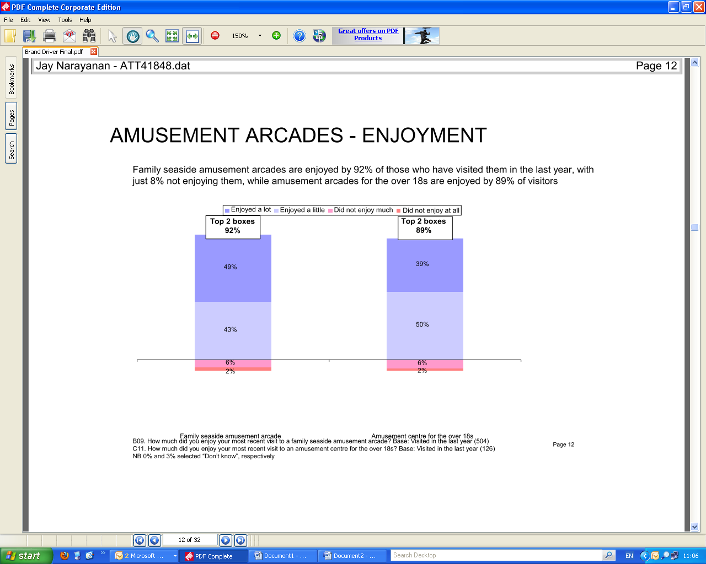

Seaside Arcades – family entertainment, not gambling

- 73% of respondents indicated that they visited seaside arcades as part of a family activity.

Playing Category D machines does not harm children

- 78% of those interviewed confirmed that playing low stake and prize reel based machines as a child did not cause harm but was a part of a child’s family experience for a day out at the seaside.
- 72% of respondents confirmed they would allow their children to play reel based machines.
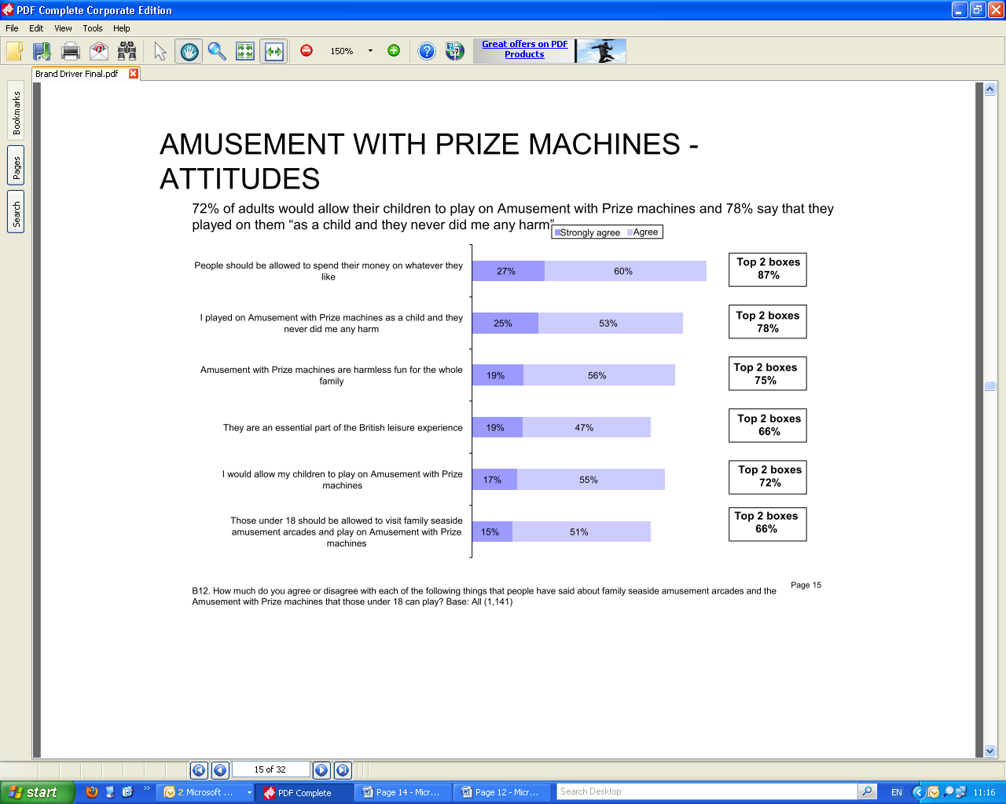

Causes of problem gambling cannot be attributed to reel based machines in FECs

- 78% of people believe that gambling problems later on in life develop from more complex issues than having visited a seaside arcade before the age of 18.

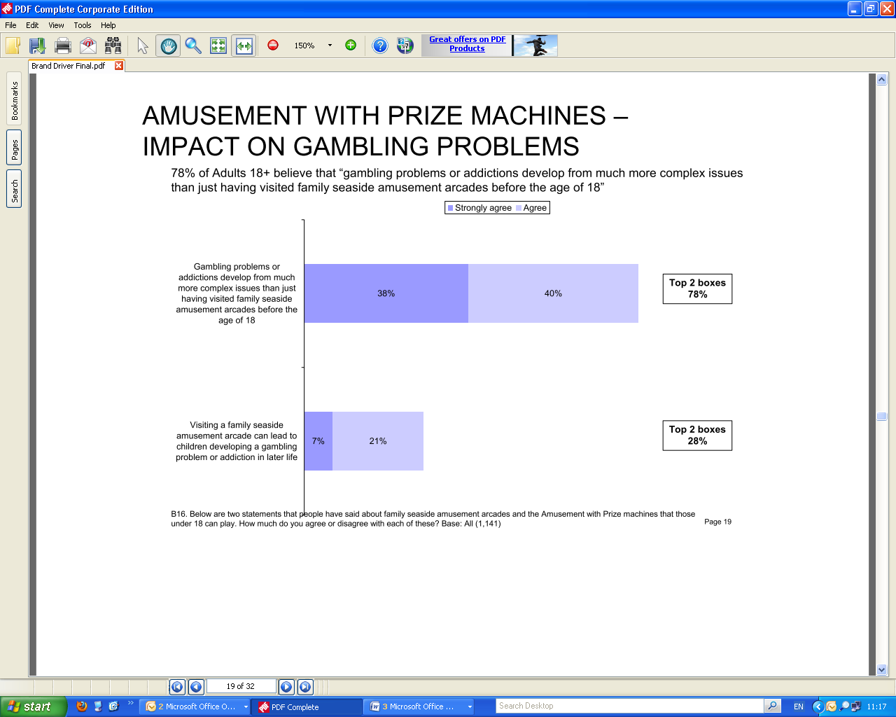

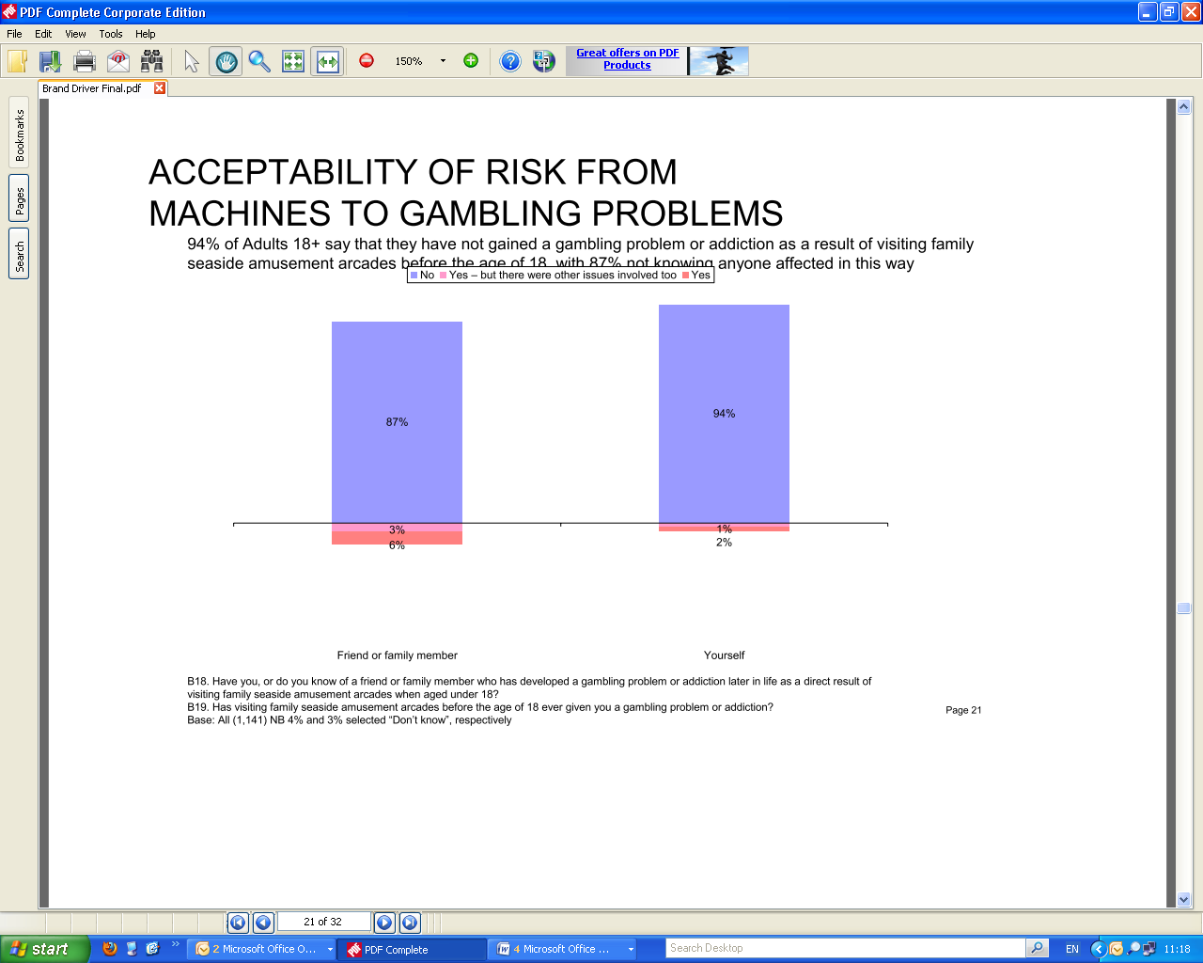

Annex B- extract from Brand Driver survey

Whilst the result of the 2008 consultation for Category C was £1/£70 it was less popular with consumers overall as set out below.

AGC players also preferred the £1/£100 option and it provided a significant trade-down option to Category B either for variety or to alleviate the problem of their usual stake to play and prize machines being busy.

Reaction to stakes to play vs prizes

As would be anticipated the research indicated that consumer is more interested in the greater jackpot to the stake that they play.

In particular higher stake players (50p+) customers are most motivated by a ratio of 1:100 and above

For these higher stake players the jackpot of £100 demonstrates a landmark for the consumer. The interest in playing to the stake increases significantly.

Reaction to stakes vs prizes within the DCMS consultation - £1 / £100 was significantly of more interest

Amongst AGC customers the interest in playing each of the options was as follows:

- £1/£70 = 20%
- £1/£100 = 34%

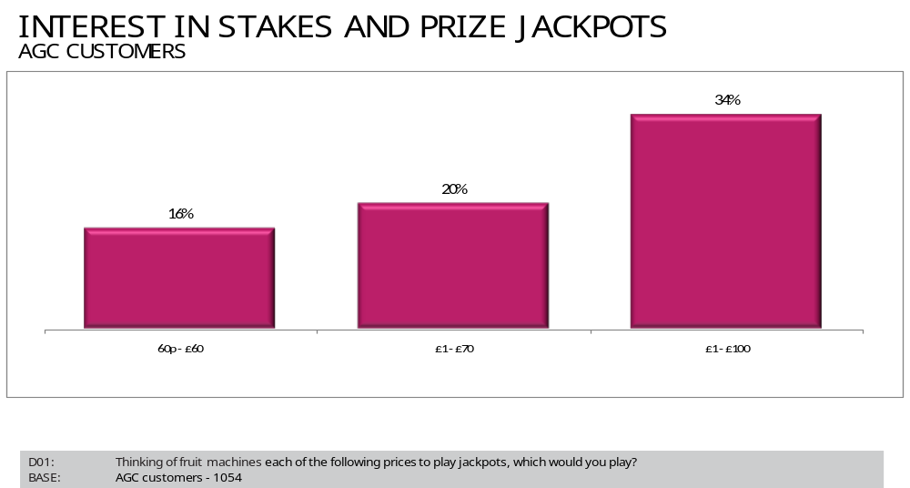

The above demonstrates the familiarity in playing the then current Category C maximum price to play and jackpot.

£1/£100 not only offered an option for 50p AGC players, but also those playing the £1 machines who are prepared to trade-down the jackpot size for more frequent wins:

The preference for the £1/£100 combination was consistent amongst pub players. Their propensity to play on the key options was:

- £1/£70 = 32%
- £1/£100 = 44%

The Category B users interest in playing the stakes and prizes combinations was:

- £1/£70 = 48%
- £1/£100 = 65%

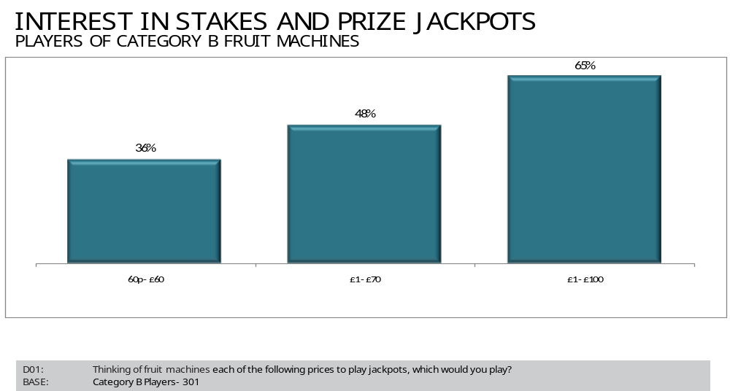

The research showed that the increase in Category C machines to a £1 stake and £100 maximum jackpot would therefore provide the Category B user an additional choice to play as well as provide relief for AGCs at busy periods, when all or most Category B machines are already being used.

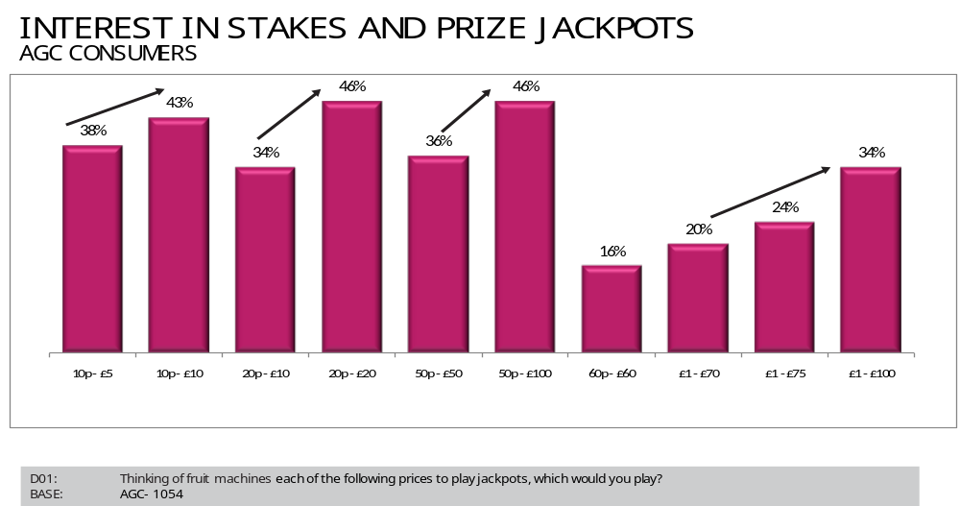

The above chart highlights that there is greater interest in stakes as prizes increase (particularly once the ratio is 1:100+).

