UK-India Workshop on ‘Future Cities’
The UK-India Workshop on ‘Future Cities’, organised by the UK Science and Innovation Network (SIN) in partnership with Indian Ministry of Human Resources and Development (MHRD), IIT-Roorkee and the Research Councils UK India (RCUK-I) was held in New Delhi on 24-25th February 2014.
The workshop aimed to –

- Convene diverse stakeholders – government officials, policy makers, academics and experts - and provide an interactive platform to facilitate exchange of ideas.

- Enable deliberation on the future course of action to build smart and sustainable cities in India.

- Form a UK-India Research and Innovation network on ‘Future Cities’ to take forward the agreed actions.

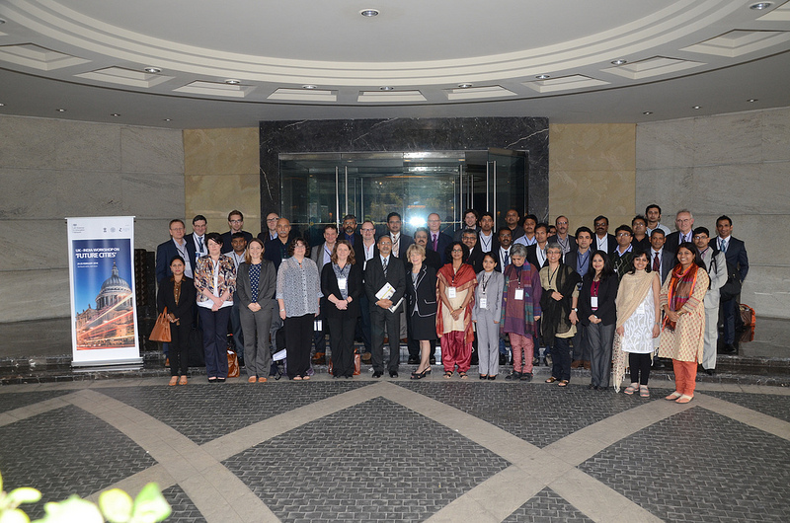

This document captures the ideas presented and discussed at the UK-India Future Cities Workshop. The presentations from the Workshop are at https://www.gov.uk/government/publications/uk-india-future-cities-workshop

Day 1 – Inaugural Session and Thematic Discussions
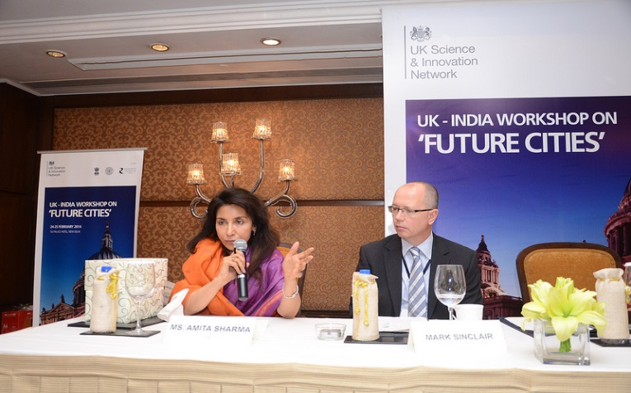
The inaugural session included speeches and presentations from Mr Mark Sinclair, Head, SIN-India, Ms Amita Sharma, Additional Secretary, MHRD, Dr Simon Buckle, Policy Director, Imperial College, Dr Jagan Shah, Director, National Institute of Urban Affairs, Mr Abhijit Ray, DFID-India with a special address by Mr Amitabh Kant, CEO, Delhi Mumbai Industrial Corridor Development Corporation Ltd.
The inaugural session was followed by break-out sessions on the following themes –
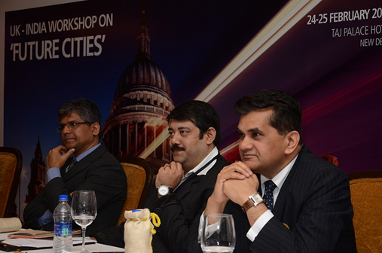
Theme 1 | Leadership and social innovation in urban design and planning
Theme 2 | Towards resilient and sustainable urban infrastructure – Energy, Water, Sewage and Transport
Theme 3 | Reducing energy demand from new and existing urban habitat - problems and issues in UK and India
Theme 4 | Tangible and intangible heritage of cities and their preservation – problems and issues in UK and India
For each theme, there were pre-assigned UK and Indian theme leader who delivered a perspective of the research challenge in their host country. The presentations were followed by a facilitated discussion on –
- What are the research questions to be tackled in this theme?
- What UK and Indian research expertise can contribute to this theme?
- How can the UK and India work together to address the research challenges identified?
- What mechanisms of collaboration are needed?
- What other individuals/ companies/ policy makers/ expertise/disciplines are needed to address these challenges?

Theme 1: Leadership and social innovation in urban design and planning

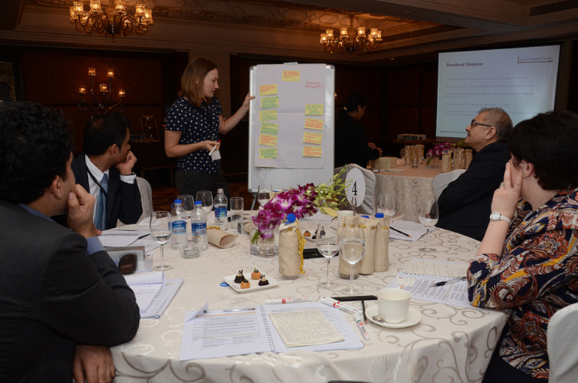
The theme leaders for this theme were Mr Jon Price, CEO, Centre for Low Carbon Futures and Professor Chetan Vaidya, Director, School of Planning and Architecture, New Delhi.

Key research questions -
- Reactive questions concerning the information gaps that exist i.e. what do we need to know to address current and anticipated problems?
- Proactive questions that we need to answer to improve the planning process, particularly with regards to the participation process. The group highlighted that this is not a desirable attribute of the urban design and planning process, but an urgent priority.
This is not an exhaustive list, but some issues that were raised by the group included-
- Understanding environmental stress, risk and sustainability. This also includes an awareness of urban citizens and their (lack of) attachment to the environment.
- Concepts of ‘liveable’ and ‘desirable’ cities – future cities are not just about what we have to do, but also what we want to do. They should not be seen as machines for living but desirable places to live.
- Recognising differences between short-term and long-term issues
- Relationships across spaces – urban-peri-urban; rural-urban; big city-small town.
But: These are all questions addressing the ‘what’ and not the ‘how’. We also need to understand processes and mechanisms that will lead to better outcomes in the future. This leads us to the proactive questions.

Proactive questions:
These all focus on the importance of balancing a formal planning process with the needs of all groups of citizens.
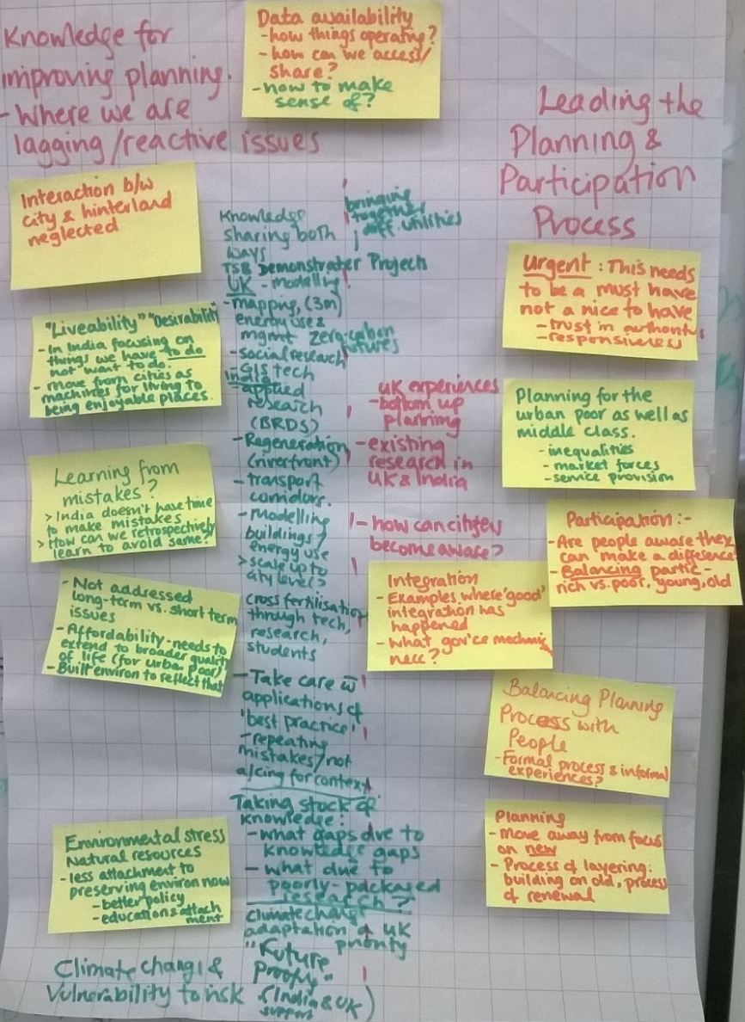
- How to balance planning with knowledge of people and places? We have talked about the centrality of people to towns and cities but often this is neglected in planning.
- How to reconcile formal process of planning with the informal experiences that dominate in social and economic life?
- Participation – but how to integrate the poor as well as the rich and middle class who find it easier to capture political spaces? And this also needs to recognise diversity across gender, age (a special focus on youth too). Broader participation will ensure that i) all citizens are more likely to ‘buy’ into the planning process (building trust in process) and ii) that all citizens are more likely to benefit.
- The need to recognise planning as a process of layering – not just a focus on the new but also about building on (and protecting) the old.
- How do we recognise and incorporate both bottom-up and top-down approaches in the planning processs?

What (and how) can we learn from?
Here the group discussed that it is not about reinventing the wheel but building on existing knowledge and experience first. This requires we take stock of existing knowledge and data to uncover to what extent:
- Are gaps in knowledge due to a lack of knowledge?
- Are gaps in knowledge due to poor packaging by knowledge producers (i.e. research not accessible to policy makers)
- Are gaps in knowledge due to poor listening to knowledge-holders (i.e. overlooking the wealth of local knowledge in poor communities).
We can learn from:
- Shared experiences across Indian and UK cities (e.g examples of riverfront regeneration and transport corridors across both countries; ‘Future proofing’ project.
- Shared skills and technologies (e.g. GIS, modelling, mapping)
- Applied research (e.g. what examples of good integrated governance exist and what mechanisms enabled its successes? What barriers were there?)
- Cross-fertilisation could take place through research, experts, students, technologies.
BUT, the group concluded that India doesn’t have time to make and learn from its mistakes, these issues are too urgent. Instead we all have to be innovative and to retrospectively learn from other countries’ experiences to avoid the same mistakes.
The group highlighted the dangers of transferring ‘best practices’ without attention to context (people, culture, economy, politics), and that out of this complexity arises the need for collaboration.

What mechanisms of collaboration are necessary and among whom?
Stakeholders involved: local communities; local, municipal and national governments; academic research (across ALL disciplines); private sector; other ‘experts’; bi- and multi-laterals.
Crucially, all of these have their own needs, interests and priorities. They also, of course, have different power and integration into the decision-making / planning process given their position in social and political hierarchies. How can we bring convergence to this diversity through collaboration?
Priorities - We discussed the need for bridge-building and ‘translation’:
- Community knowledge to be translated to policymakers and there is a role for communities, NGOs, CSOs, and researchers in this.
- Academic knowledge to be translated into policy relevant and accessible information for policy makers - and there is a role for researchers, funders and policy makers in this.
- Policy makers to make aware their information needs in this area - and there is a role for policymakers, researchers and funders in this.
- Bringing together diverse stakeholders in forums such as this workshop is one means of facilitating these exchanges and there is a role for networks, researchers, policy makers, NGOs and CSOs, bi- and multi-laterals, in this.
- Training and capacity building across all stakeholders, and there is a role for universities (in training new generations of professionals), development consultants, bi- and multi-laterals in this.
Theme 2 - Towards resilient and sustainable urban infrastructure – Energy, Water, Sewage and Transport
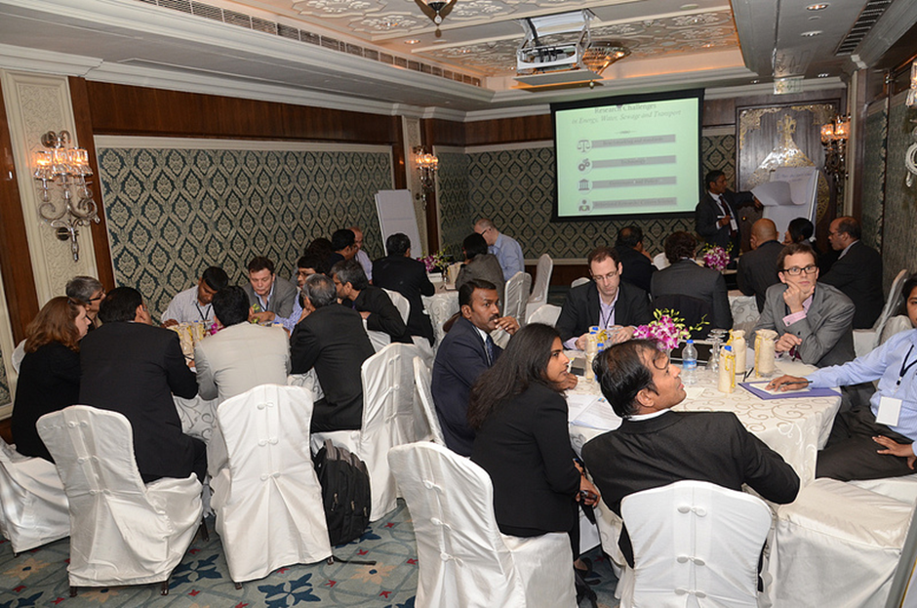
The UK and Indian theme leaders for this theme were Professor Cedo Maksimovic, Imperial College and Professor Krithi Ramamritham, IIT Bombay.

Professor Ramamithram considered that the outputs from the RCUK Roundtable on Sustainable Cities and Rapid Urbanisation, which took place in November 2013, were a useful starting point for this discussion on potential areas for UK-India collaboration. At that event, a breakout group on the urban infrastructure had identified the following top 5 areas for potential UK-India collaboration:
  - Resource efficiency in critical infrastructure.
  - Waste management and recycling.
  - ICT capability development to integrate data from critical infrastructure.
  - Citizen engagement on infrastructure development.
  - Efficient use of water ways for transportation and energy generation.
He proposed that we should brainstorm on the research challenges in energy, water, sewage and transport under the following 4 themes:
- Benchmarking and Standards
- Technology
- Governance and Policy
- Behavioural Research/ Citizen Science

Benchmarking and Standards
It was felt that benchmarking and standards for technologies utilised in urban infrastructure were currently defined top down and often globally. As a result, they were not context specific and inappropriate to developing country with issues of extreme poverty. Affordability and access was not often a consideration in setting standards. In a country like India, geospatial variations in benchmarks and standards, reflecting different social, economic and environmental conditions were important.
Indigenous knowledge and technology is not valued and this is reflected in ‘official’ benchmarking and standards. We need to take better account of the ability of communities to build and manage their own environment and resources. For example, we should look more closely at the lessons learnt from the work of Himanshu Parikh on water and sanitation in low-income settlements and try to extend it.
Benchmarks and standards for urban infrastructure are often expressed in terms per unit area. A positive development would be to transform these into per person standards that are specific in time and space.
More work is required on mapping resource movement/transmission, especially water and power, in time and space to gauge losses en-route. This, along with auditing and measuring real and specific consumption would provide valuable baseline information, which can be used to improve services. This would provide better information than the usual standards employed by utilities.
Affordability is an important criterion to bear in mind in understanding resource utilisation in ‘informal city’ development. In this regard, we need to better understand the interaction between various resources (energy, water, transport) including their transferability and future costs.

Technology
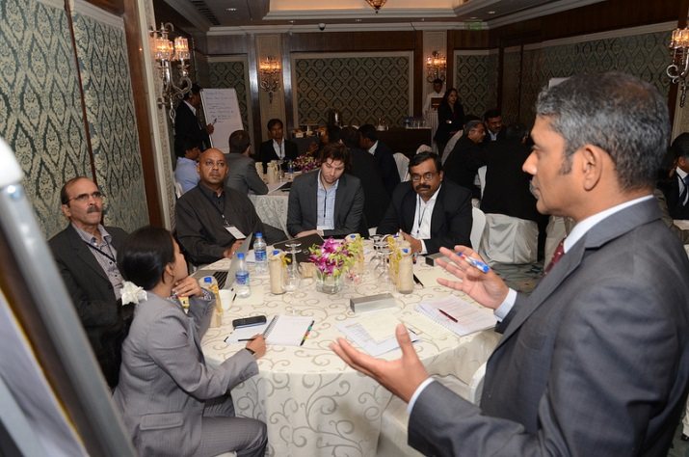
The focus of the discussion around appropriate technologies for water, sanitation, housing, energy and transport was on how these services could be delivered efficiently to people and especially to the urban poor. It was considered that more could be done to exploit rapid (but resilient) construction technologies to provide services to poor communities. This may, in part, be achieved through exploitation of traditional/indigenous technologies known to local communities and supported by innovation.
In respect of urban transport, much more could be done to manage demand and supply of transportation in real time through better integration of different modes of transport. It was noted that in many metro projects in Indian cities, there is currently little connectivity between different modes of transport. In addition, to reduce dependence on fossil fuels and reduce levels of atmospheric pollution, more should be done on alternatives e.g. hydrogen.
The group felt that there was an opportunity to roll out arrays of sensors and other ICT technologies both above and below ground in Indian cities and develop analytics for improving city management and efficiently delivering services to people.
Integrating environmental and human well being concerns should be key criteria in choosing from a range of different technologies for addressing a given infrastructure issue. This would serve to create a connection between the societal needs and technology. The group considered that we needed to establish interdisciplinary problem focused action learning projects that would bring together technical modelling with social and political analysis to optimise technological solutions.

Governance and Policy
The group considered that there are currently gaps in governance and policy framework at the national and state and/or local level where there is uncertainty on who is responsible and/or accountable. These should be identified and the uncertainties addressed. We should also promote city leadership, build capacity at the local level and incentivise achieving long-term outcomes. We need to identify the right indicators for measuring policy impact, which recognise, amongst other things, the political economy drivers.
More needs to be done to create mechanisms for implementation and enforcement of regulations on infrastructure development. In addition, at the moment there are few mechanisms for collaboration across departments. As a consequence, different departments responsible for different aspects of urban infrastructure work independently resulting in uncoordinated development and extra costs.

Behavioural Research/Citizen Science
The group first considered the question - why do city authorities want information from its citizens? They concluded that local authorities seek information from citizens to get a better understanding of the ‘pain points’ i.e. where there are gaps in the delivery of services or where there is a localised problem with the infrastructure. The group felt that city planners and utility providers would benefit from more systematic and constructive engagement with citizens in providing information on the delivery of energy, sanitation, water and transport services.
The group next considered the question on how should citizens engage in knowledge provision? This could be done through the deployment of smart meters for energy and water; citizen surveys; SMS/mobile phone apps; internet portal; crowd sourcing solutions for local issues; and engaging with schools and colleges.
Finally, the group addressed the question of how the information provided by citizens should be used? It suggested that information from citizens could be used to: identify hotspots; develop opportunities to raise awareness; take urgent remedial measures (e.g. water leakage) etc.
It was felt that greater citizen engagement in the management of urban infrastructure could empower citizens and also reinforce positive behaviour. Therefore, steps should be taken to enhance citizens in the design, development and management of urban infrastructure.

Theme 3 - Reducing energy demand from new and existing urban habitat - problems and issues in UK and India
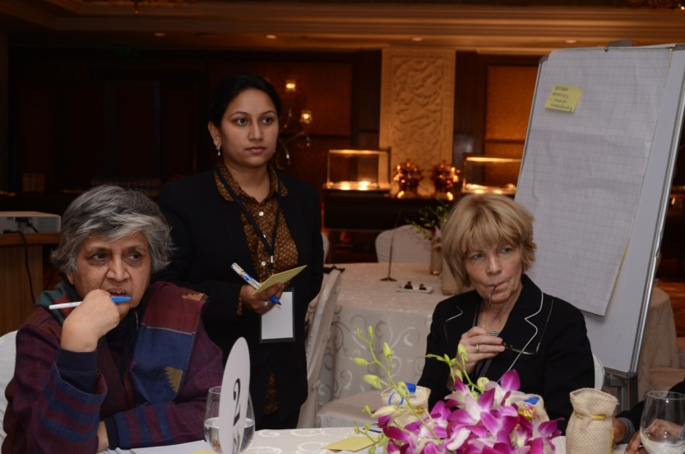
The theme leaders for this theme were Mr Martin Mayfield, Head of the Urban Institute at the University of Sheffield and Professor Uday Desai, Director IIT Hyderabad.
The group thought that Whole Chain Analysis and embodied energy should be considered. Urbanisation will undoubtedly increase demand for resources and the question needs to be asked whether the world has enough metals to achieve the ambitious plans in India and other developing countries.
Further research is needed on City Design using systems thinking bringing together technological, social and economic dimensions. The outputs of this research then need to be embedded into the planning process so that it can offer strategic direction as well as purporting to offer definitive solutions. For example, the group felt that there is a need for a better understanding of the land-use-transport interactions for future planning of city development. There should also be more use made of pilot demonstration projects and dissemination of specific stories of successes and failures so that there is a constant reflexive learning process.
As energy usage in India will continue to increase with the growing economy, the group felt that that the ECBC (Energy Conservation Building Code) needs to be kept under review to drive enhancement of standards for commercial buildings – and enforced. This should be accompanied by substitution, wherever possible, with clean energy. Low energy buildings have to be at the heart of design for future cities with retrofit as a solid option for older buildings. In addition, energy demand reduction in the wider non-domestic sector has to be prioritised.
The group felt that more is needed to improve baseline information on where energy is used in a city. Improved data collections systems are needed to achieve this end. The analysis and use of the data from such an exercise should bring together architects, planners, data scientists, utility providers, innovators, SMEs and consumers. Sharing of exemplars at the right scale will help with building consumer understanding of resource/energy use before applying controls (e.g. cost).
Theme 4 Tangible and intangible heritage of cities and their preservation – problems and issues in UK and India

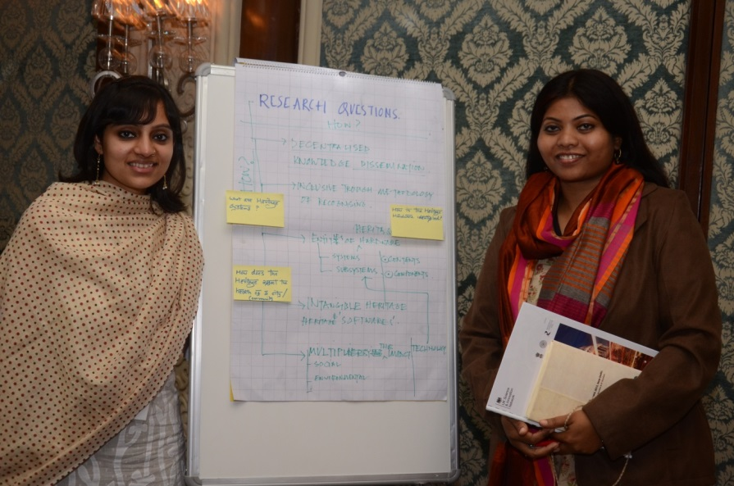
The pre-assigned UK and Indian theme leaders for this theme were Ms Julie McLaren ESRC, Dr Nafees Meah, RCUK India and Professor Ajay Khare, School of Planning and Architecture, Bhopal.

After a discussion of the importance of built, natural and intangible heritage to the individual character of Indian cities, the group considered that there was an importance task to balance modernisation/importance with preservation. However, a major issue was the lack of awareness amongst city planners as well as the general population.
The RCUK Roundtable on Sustainable Cities and Rapid Urbanisation, which took place in November 2013, had identified potential areas for collaborative research as: information and cities i.e. developing databases (e.g. of architectural heritage) and information systems; understanding needs of communities and getting their engagement in urbanisation; environmentally sustainable city development and how to retain culturally and environmentally appropriate knowledge in modern cities; comparative research on sharing historical knowledge of urbanisation; legislative and policy framework for urban planning within conservation areas and local community participation in planning process and research into economic incentives/models for successful conservation based development in urban areas.
The group here identified the key research issues as:
- Value and use of legal frameworks
- Mapping components of heritage – hardware and software
- Community level, city level, building level research to define a particular city’s cultural and historical unique selling point
- Linking heritage with local economic development
- Attributing economic value to tangible and intangible heritage
- Ethnographic approaches to research intangible heritage
The group considered that UK and Indian experts have much to contribute in developing planning frameworks that are sensitive to the preservation of tangible and intangible heritage. In particular, many Indian professionals were trained in the UK. There was also long experience of applying science and technology to the preservation of tangible heritage (e.g. EPSRC/AHRC Science and Heritage Programme). Both countries have old cities with narrow streets that throw up a host of access issues. The group considered that the natural assets (lakes, tanks, rivers parks, open spaces) as well as the built environment should be within scope. Digitisation of tangible heritage was also a potential area for collaboration. Finally, the group felt that there was much that could be learned from the UK experience of incentivising the preservation of cultural heritage.
There were various mechanisms that could be developed to facilitate UK-India collaboration in this area. These include setting up a small number of demonstration projects; developing on-line forums; and setting up UK-India networks, which would include higher education and research institutions, civil society groups, private sector and public sector (in particular, planning professionals).
The group concluded that that UK-India collaboration in this space should engage with local communities, businesses, city planners, civil society groups and central and state Government Departments.

Key Note Address – Professor Sandy Thomas and Dr Isher Judge Ahluwalia

In the evening of day 1, there was a networking reception and dinner with two keynote speakers - Professor Sandy Thomas, Head, Foresight presented her organisation’s work on future proofing cities and Dr Isher Judge Ahluwalia, Chair, Indian Council for Research on International Economic Relations (ICRIER) raised the issues and challenges of urbanization in India.
Day 2 - Case Studies and UK-India Joint Centre of Excellence – Future Cities Platform
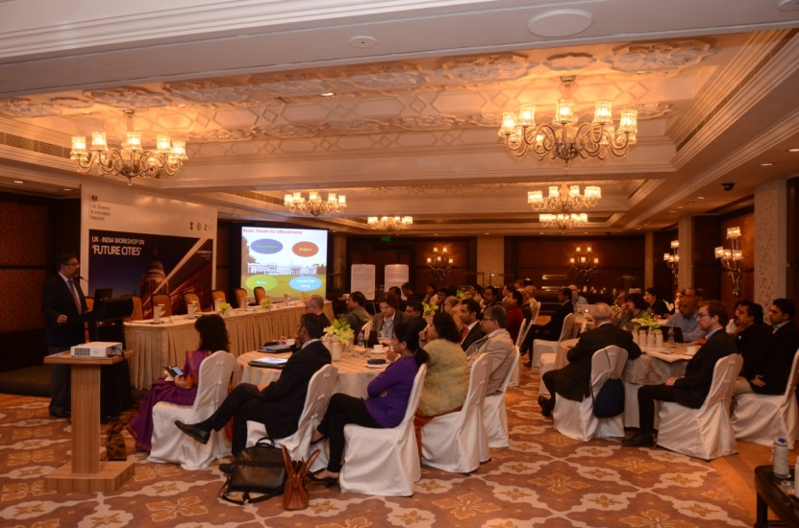
On day 2, there were presentations on case studies/ live programmes from Varanasi, Uttarakhand and Mumbai (Ajanta caves) – by representatives from IITs and on London by the Future Cities Catapult. By then, an interesting research agenda was emerging out of all the discussions and we seemed to get good coverage across a breadth of future cities topics.

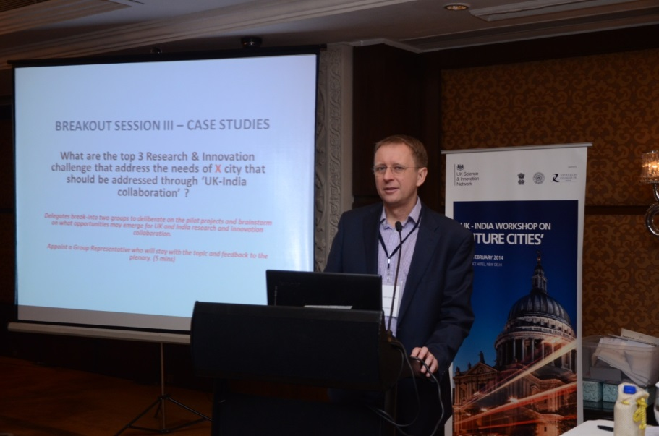
To take the joint work forward, we then facilitated a group discussion on UK-India Joint Centre(s) of Excellence – Future Cities Platform – what does it look like? How will it achieve knowledge to delivery?
The workshop participants were asked to work on a pictorial representation of the UK-India Joint Centre(s) of Excellence based on the following questions:

- Engage and understand user needs
- Promote leadership and social innovation
- Engage with industry
- Transfer knowledge and skills
- Identify candidate cities
There was a lot of commonality in the outputs from the breakout groups. Not surprisingly, there was a strong appetite for establishing a UK-India Joint Centre of Excellence on a Future Cities Platform. Most of the breakout groups considered that the Centre should be interdisciplinary and have a strong socio-economic and behavioural research component. In addition, there should be strong engagement with user groups (government, local authorities, planners, communities, businesses and civil society groups) – both to help co-define the research questions as well as engage on translating the outputs from the Platform into practical outcomes in society. It was felt that a Platform would operate best if there were a lead UK and lead Indian partner who would provide the co-ordination across and between the countries. It was also strongly recommended that the Platform should focus its activities on a small number of pilot cities in India and set up demonstration projects. Finally, all the breakout groups felt that there should be a strong capacity building component with routine exchange of scholars and post-graduate students. A synthesis of the outputs is presented below:

Build on existing collaborations
Workshops
Secondments/ student exchange

Community engagement and multiple level participatory processes

Sustainable urban systems challenge
Inter disciplinary across scale
Socio-economic/behavioural
research
Process & new technology development & customisation

User forum
- Local policy
- National policy
- Community
- NGO’s
- Business

Pilot cities and hinterland
UK and India Network leads

Event feedback
The event was agreed to be informative and useful. The sharing of frank views and best practice was important to achieve the symposium’s aims and objectives. Participants were encouraged to think beyond disciplinary boundaries, and to forge new links with their counterparts in the other countries. A number of participants indicated that they had established links with potential collaborators, and in some cases had already begun to discuss joint projects, seminars and other collaborations.
A selection of feedback comments:
“To have representatives from almost all the premier institutes of India like the IITs and SPAs all under one roof was just brilliant.”
“It was interesting to hear some of the breadth of research interaction between the UK and India and to hear some of the specific experiences of both UK and Indian participants.”
“.....high calibre participants from UK and India...”
“.... really stimulating........such high quality participation from the Indian and UK sides”
“I found the break-out sessions very useful. The workshop was organised in a very good way”
