Fuel Duty Stabiliser – Final Report
Prepared for the Federation of Small Businesses

17 February 2012

Contents
1 Executive summary 1
2 Introduction 2
2.1 Background to the study 2
2.2 Key inputs and terminology 2
3 Fuel Stabiliser Model Results 4
3.1 Fiscal neutrality of an adjusted duty 4
3.2 Reducing pump price volatility 5
3.3 Comparison of forecast pump prices 8

Appendices
A Methodology for Adjusted duty rates 9
B Inputs to the Model and Assumptions 10

- Executive summary
The volatility of crude oil prices can be attributed to factors such as demand-supply dynamics, market speculation and production costs. In the recent period, crude oil prices have fluctuated due to economic turmoil and political unrest in various economies. However, since crude oil is traded globally, the trade prices are comparable across economies and the price paid by consumers largely reflects the national pricing policy.
Fuel cost in the UK is made up of the product price and taxation. Product price is composed of crude oil cost, processing & refining cost, and distribution & retailing cost. Taxation is a result of fuel duty and Value Added Tax (VAT) – fuel duty is levied on the product price before VAT. Taxation makes up the largest portion of cost of fuel in UK – in November 2011, the pump price for petrol was 133.7 pence of which 80.2 pence was taxation cost (57.9 pence was duty rate and 22.3 pence was VAT value) and the remaining 53.5 pence accounted for the product price. Between 2008 and 2011, taxation accounted for 57% - 73% of the pump prices for petrol.
To help reduce the impact of high fuel costs, the Government passed the Fair Fuel Duty Stabiliser in the 2011 budget, replacing the Fuel Duty Escalator with the Fair Fuel Duty Stabiliser. The fuel duty rate was cut by 1 penny per litre and the fuel duty rise would increase only by RPI as long as the crude oil prices remained high. The fuel duty price rise would be revised to increase by RPI plus 1 penny if the crude oil prices fell below a pre-determined trigger price. The Government proposes to set the trigger price at $75 per barrel.
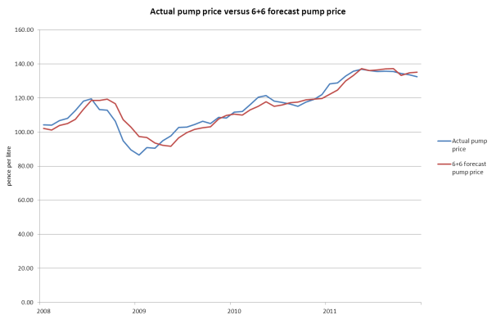
Rise in fuel duty and uncertainty over fuel prices have a significant impact on businesses, making overhead costs and budgeting forecasts unpredictable. This report discusses a different approach to fuel duty adjustments - by basing the Fuel Duty Stabiliser on the crude oil price cycle, the level of fuel duty could be calculated against a trend price for oil. The duty rate would then be adjusted in regular intervals following the changes in the crude oil price cycle. This would result in a more predictable pump rate for fuel, as illustrated in the chart above, and allow for better budgeting for smaller businesses in the short-term. With a Fuel Duty Stabiliser, the revenues realised by the Treasury from adjusted duty revenues are marginally lower than the actual revenues realised.
The fuel duty stabiliser impacts upon fuel prices as illustrated below.
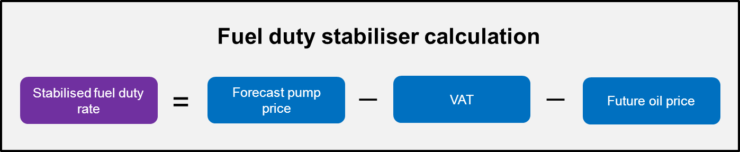

- Introduction
  - Background to the study
Grant Thornton ("GT") were engaged by the Federation of Small Businesses ("FSB") to build an excel-based quantitative "Fuel Duty Stabiliser Model" ("the Model"). The objective was to illustrate the potential impact of a fuel stabiliser on pump price should fuel duty be adjusted and the fiscal neutrality of the adjusted duty rates. The Model estimates adjusted duty rates based on the "forecasted" pump price and compares it to the existing fuel pricing structure.
The theory being tested is whether the use of a fuel price stabiliser will flatten out the peaks and troughs currently seen in fuel prices, hence allowing for better budgeting for small business, whilst remaining fiscally neutral for the Treasury.
This report discusses the results of the Model and further elaborates on the methodology, inputs and assumptions on which it was developed in Appendices A and B.
The Model has been developed for two fuel types – petrol and diesel, and estimates the adjusted duty rates for both fuel types. In the context of this report, we discuss the impact of the Fuel Duty Stabiliser on petrol prices and corresponding duty rates.

  - Key inputs and terminology
The actual petrol pump price (hereinafter referred to as "actual pump price") is made up of three main components:
- Actual duty rate – as specified by HMRC
- Value added tax (VAT) – as specified by HMRC
- Oil price is calculated as pump price less actual duty and VAT. For the purposes of this report, it is assumed that actual oil price includes overheads such as refining costs, distribution costs and profit margin within the supply chain. These overheads have been included in the oil price as it has not been possible to obtain adequate and specific information relating to them.
Crude oil prices relate to Brent prices. Actual Brent prices are taken from the BP website, with the 1, 2 and 3 month future prices taken from Thomson Reuters DataStream.

In order to calculate a stabilised rate of fuel duty, we need to forecast pump prices based on future spot oil prices. The Model estimates forecast pump price under three scenarios:
- 6+6 forecast pump price - The actual pump price is forecasted based on a 6 month historic and 6 month forecast average. Appendix A details the methodology used to calculate the 6+6 forecast pump price.
- 12+3 forecast pump price - The actual pump price is forecasted based on a 12 month historic and 3 month forecast average.
- 12 month forecast pump price - The actual pump price is forecasted using a 12 month historic moving average.
The adjusted duty rates are derived from the forecasted pump price, after accounting for oil price and VAT, under each scenario:
- 6+6 adjusted duty rate - The adjusted duty rate is estimated from 6+6 forecasted pump price after accounting for VAT and estimated oil price.
- 12+3 adjusted duty rate - The adjusted duty rate is estimated from 12+3 forecasted pump price after accounting for VAT and estimated oil price.
- 12 month adjusted duty rate - The adjusted duty rate is estimated from 12 month forecasted pump price after accounting for oil price and VAT.

- Fuel Stabiliser Model Results
  - Fiscal neutrality of an adjusted duty
The Model estimates the adjusted duty rate for the 6+6, 12+3 and 12 month forecasted pump price respectively and then compares the total duty revenues realised under the three scenarios to the actual duty revenues. The objective is to find the optimal scenario under which the revenue realised by the Treasury is least deviated from the actual duty revenue.
Table 1 compares the fiscal neutrality of the revenues realised from the adjusted duty rates under the three scenarios to the revenues realised from actual duty rates.
The actual duty is calculated based on the fuel duty per litre of fuel for each month from January 2008 to December 2011.

Table 1 - Total duty revenues realised from January 2008 to December 2011
 | Actual duty | 6+6 adjusted duty | 12+3 adjusted duty | 12 month adjusted duty
 | £ | £ | £ | £
Cumulative duty revenue | 26.41 | 25.91 | 24.49 | 23.94
Difference between actual and adjusted duty revenue |  | 0.50 | 1.92 | 2.47
Difference as a % of total actual duty revenue |  | 1.88% | 7.25% | 9.35%

From Table 1, a comparison of the three scenarios shows that the 6+6 adjusted duty rate results in the lowest deviation of 1.88% from the total duty revenues realised from actual duty rates. The results from the Model, as illustrated above, support the hypothesis that the use of a Fuel Duty Stabiliser does not substantially affecting revenue to the government. Based on the comparison of adjusted duty revenues under the three scenarios to actual duty revenues, the Model suggests the 6+6 forecasted pump price as the preferred option.
Further, the duty revenues are compared over a 4 year horizon (January 2008 – December 2011), including 2008 and 2009, when the oil prices were highly volatile. This suggests that the Fuel Duty Stabiliser can be applied under volatile market conditions to achieve more predictable pump prices.

  - Reducing pump price volatility
The smoothing of pump price volatility is the key objective in order to allow businesses to better plan their overheads. The accuracy of the forecasted pump prices will prove important as this would result in a lower variation of actual overheads from budgeted estimates.
The 6+6 approach helps smooth pump price volatility, as illustrated in Chart 1. As shown in the chart, the 6+6 forecast pump price dampens the peaks and troughs of the actual pump price but with a slight time-lag. This is because 6+6 forecast pump price uses the estimated 1, 2 and 3 month future spot oil prices which capture the crude oil volatility in the short-term.

Chart 1 – Actual pump price versus 6+6 forecast pump price
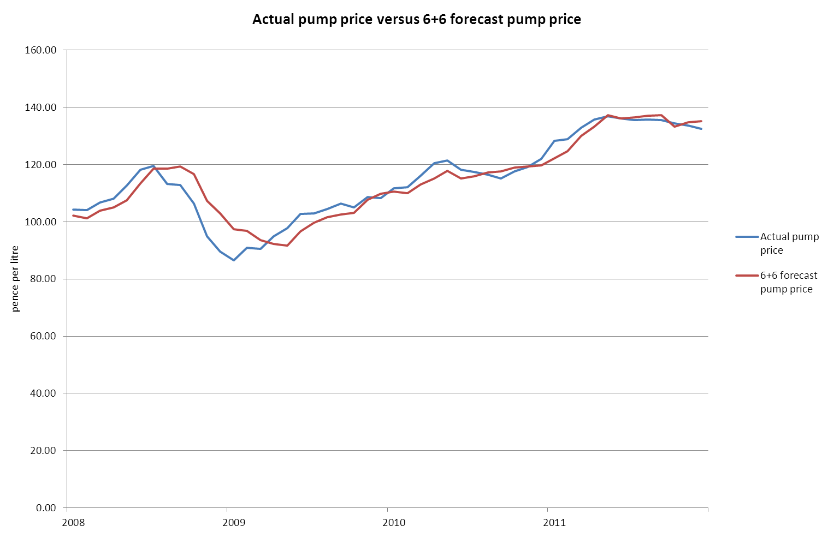

Further, the table in section 3.1 also shows that the 6+6 adjusted duty rate results in the lowest deviation of duty revenues from actuals.

The composition of actual and 6+6 forecast pump prices (charts 2 and 3) show that the adjusted duty and VAT values change as a result of the forecast pump price.
Chart 2 – Composition of actual pump prices
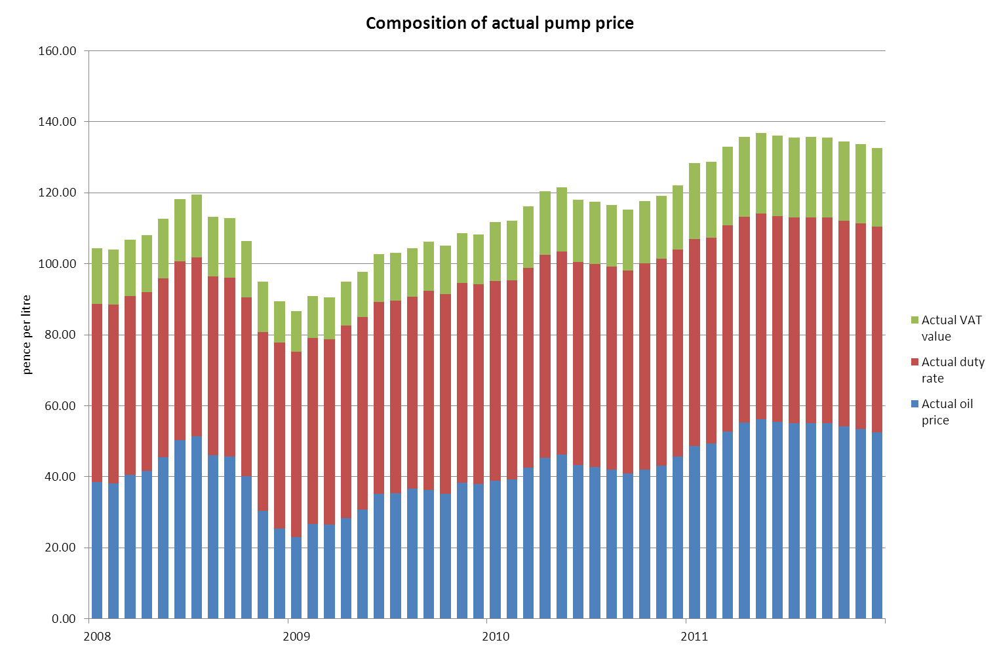
Chart 3 – Composition of 6+6 forecast pump prices
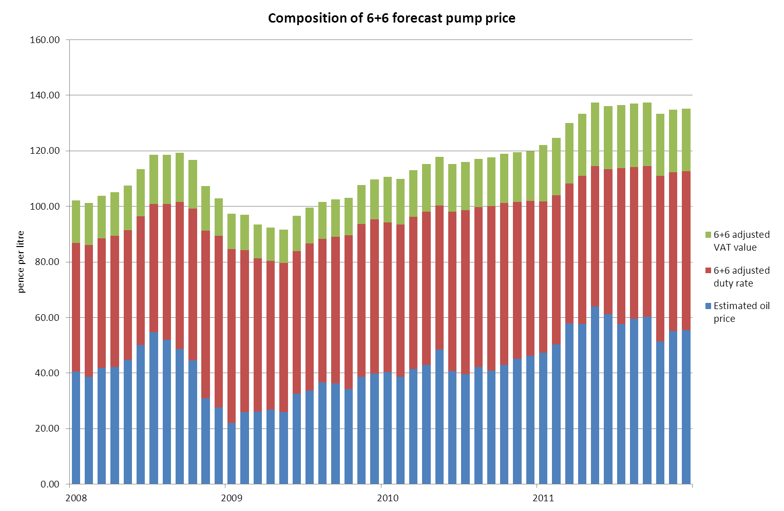

Chart 4 – Comparison of actual pump price to forecast pump price
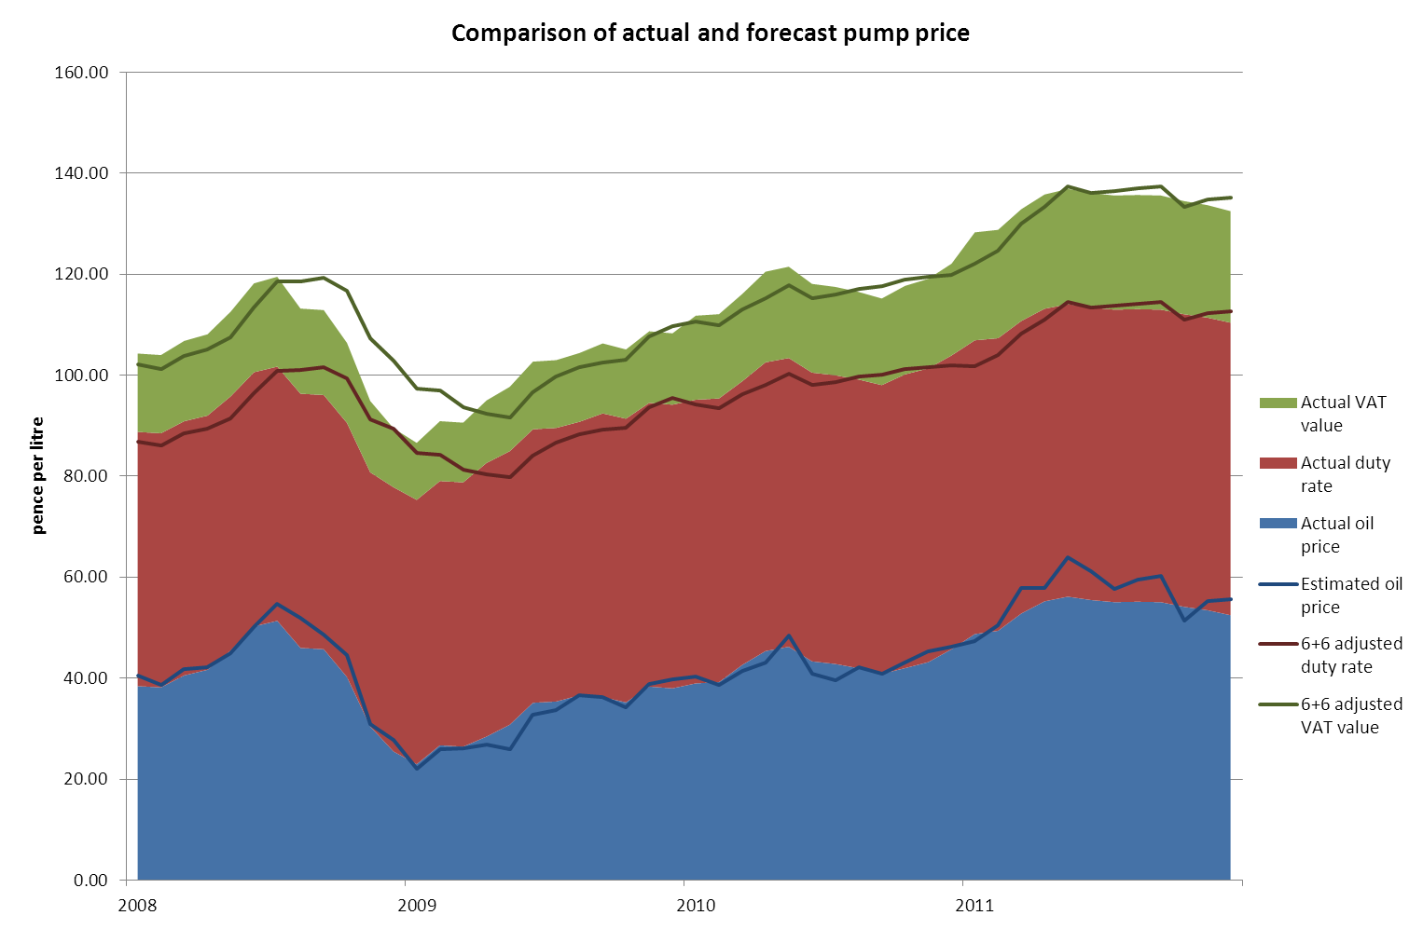

The smoothing of volatility in pump prices can be clearly seen from the above chart, as the adjusted duty rates stabilise the volatile oil prices.

  - Comparison of forecast pump prices
The Model forecasts pump prices under the three scenarios as illustrated in Chart 5.

Chart 5 – Actual pump price versus 6+6, 12+3 and 12 month forecast pump price
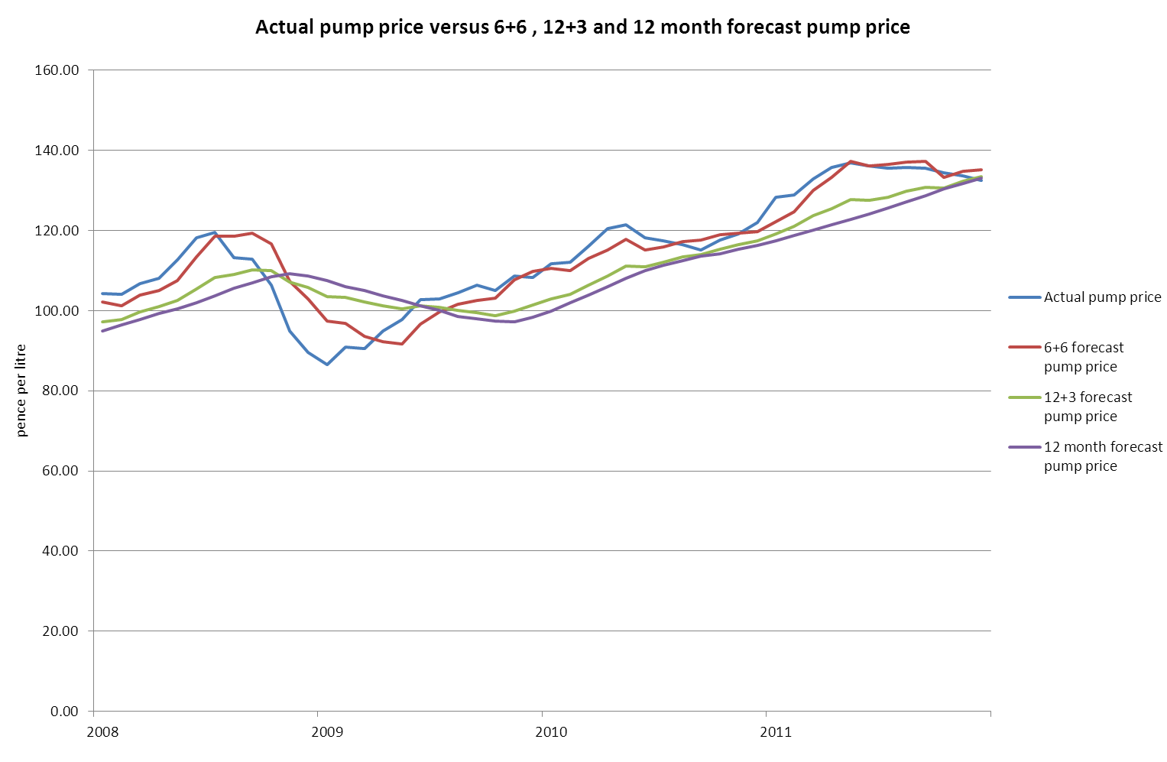
Comparison of the three forecasted pump prices to the actual pump price reveals that the 12 month forecast pump price results in a smoother pump price. However, since this forecast is only based on historic data, the resulting forecast pump price has a higher degree of variance to the actual pump price. This effectively means that though the peaks and troughs of the actual pump price are flattened, the forecast pump prices are not predictable with a high degree of accuracy. The 12+3 forecast pump price is based on 12 month historic prices and 3 month forecasted prices, but even this has a high variance to the actual pump price.
Further, the fiscal impact of the corresponding adjusted duty rates under 12+3 and 12 month scenarios were discussed in section 3.1, and show substantial variations from the actual duty revenues.
The 6+6 forecast pump price has the least variance to actual pump prices, resulting in higher degree of accuracy for pump price predictions. Further, the 6+6 adjusted duty rates calculated from 6+6 forecast pump price also result in the lowest deviation of 1.88% from the total actual duty revenues realised by the Treasury.
This illustrates the trade-off between a smooth pump price and fiscal neutrality.

- Methodology for Adjusted duty rates
The approach and methodology applied to achieve the stabilised fuel price forecasts is shown in the chart below. The key inputs to the Model are crude oil prices, actual pump prices, duty rates and VAT.
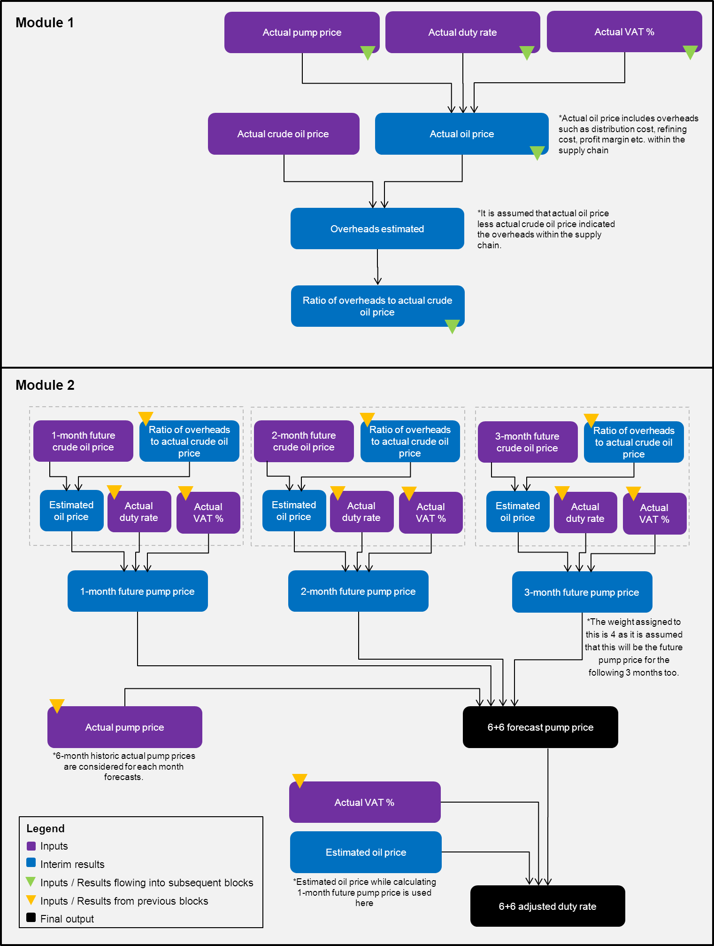
Forecast pump price is calculated as the weighted average of 1, 2 and 3-month future oil prices. The Model assigns a weighting of '4' to the 3 month future oil price as it is assumed that future oil prices in months 4 to 6 would be same as the 3-month future price.

- Inputs to the Model and Assumptions
- Crude oil prices: Historic crude oil prices contained within the model refer to Brent prices and have been taken from the BP website.
- Future oil prices have been taken from Thomson Reuters DataStream.
- The $:£ exchange rate has been taken from OANDA.com.
- Petrol and Diesel prices have been taken from the monthly reports published on the AA website. Future projections have been estimated based on the methodology detailed in Appendix A.
- Duty rates have been taken from HMRC documentation available on their website.

 | Duty rate (pence per litre)
Oct 2007 - Nov 2008 | 50.35
Dec 2008 - Mar 2009 | 52.35
Apr 2009 - Aug 2009 | 54.19
Sep 2009 - Mar 2010 | 56.19
Apr 2010 - Sep 2010 | 57.19
Oct 2010 - Jan 2011 | 58.19
Feb 2011 – Dec 2011 | 57.95
- The VAT rate has been taken from the HMRC documentation available on their website.

 | VAT %
Jan 2007 – Nov 2008 | 17.50%
Dec 2008 – Dec 2009 | 15.00%
Jan 2010 – Dec 2010 | 17.50%
Jan 2011 – Present | 20.00%

Sources
Fuel Price Information - http://www.theaa.com/motoring_advice/fuel/
Oil Price Information - http://production.investis.com/bp2/download/brent_oil/

