This document was archived because it is no longer current.
Using science and engineering to support the achievement of students with social, emotional and mental health difficulties: The Observatory School

URN: 127715
Region: North West
Remit: Schools

Provider background
The Observatory School is a special school for boys and girls aged 11 to 16 who have social, emotional and mental health difficulties. All students have a statement of special educational needs. The school is situated on the Wirral, close to Birkenhead.

Brief description
This example explains The Observatory School’s enterprising approach to science and engineering that is making a significant contribution to transforming the attitudes towards learning of boys and girls who are unable to cope with or learn within mainstream schools. It shows how students’ enthusiasm for science and engineering can be harnessed to support their learning in literacy and open doors to the world of work in their future.

The good practice in detail
The school added engineering to the science curriculum as a response to a single student’s interest in that subject. The school tries to offer a bespoke curriculum for its students that is adapted to their learning needs and interests. Enrichment activities are an important extension to work within lessons.
The engineering course is being implemented with boldness and imagination through a concept of ‘extreme classrooms’. For example, in the ‘world’s wettest classroom’, students learn about science, mathematics and engineering on board a racing yacht moored in Liverpool Marina. Overcoming the logistical and safety issues and the necessary risk assessments in taking students off-site was a considerable challenge for staff, but the gains in motivation and enthusiasm for learning for students, both boys and girls, have been huge.
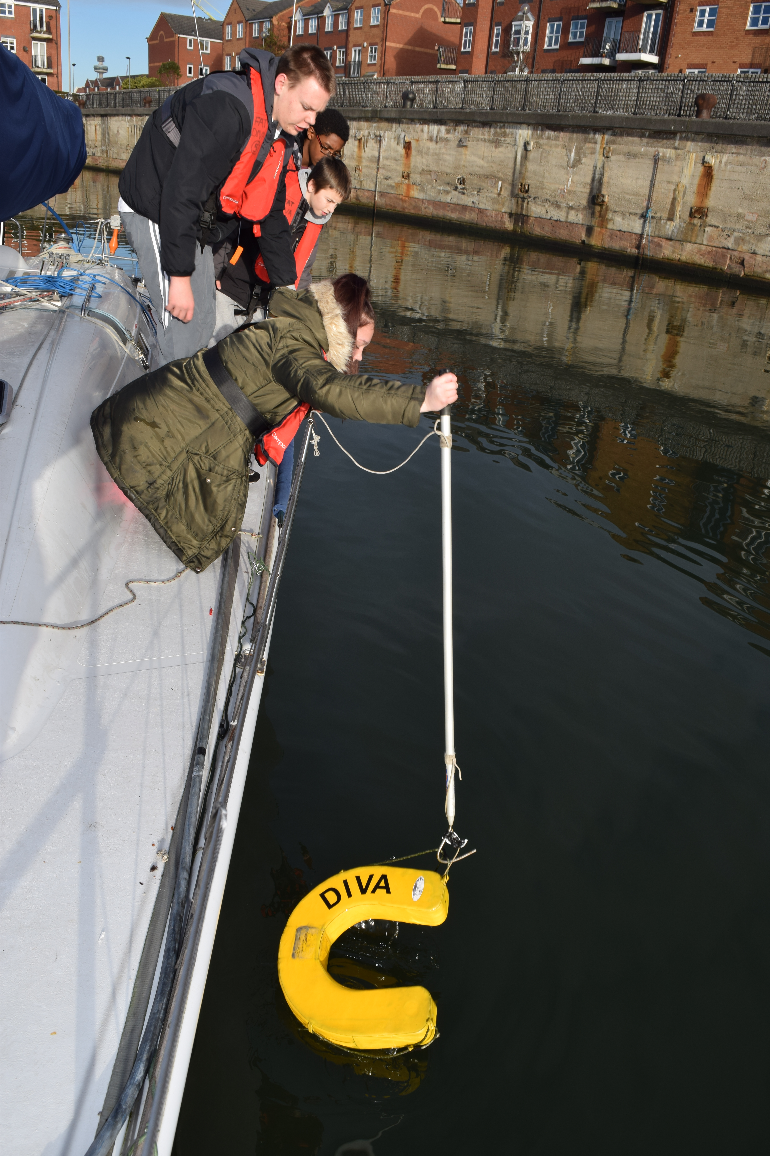
Staff have advanced plans to develop the ‘world’s fastest classroom’ and the ‘world’s highest classroom’. The highest classroom will be based on a cliff and will involve mountaineering technology, while the fastest classroom will attempt to break the water speed record for a jet-propelled model boat. Students are already experimenting with a model turbojet constructed from a kit.
The science and engineering curriculum developed by the school is firmly rooted in the industrial and commercial heritage of the area. Seafaring and marine engineering have been continuous threads throughout Merseyside and Wirral for centuries.
The level of commitment of staff to the students is very high. It shows in their willingness to share their own personal interests in science and engineering with students and to undertake enrichment activities that take place outside of the school day.
The school is enterprising in its funding of engineering within science. As well as working closely with work-related learning collaborative partnerships, it actively seeks sponsorship from local engineering firms. Winning regional engineering competitions and sponsorship have allowed further investment in modern engineering machine tools and equipment that are in a specialist room linked to the science room. The school has bought cutting edge computer-aided design tools, such as a 3D printer, which it uses for complex designs and constructions, such as boat exteriors. This technology allows students to develop these complex products very quickly, which reinforces their motivation and interest.
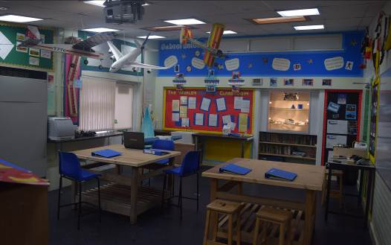
Engaging in projects outside of school is benefiting students beyond learning in science and engineering. Students are developing a knowledge and understanding of commerce, business and enterprise, of entering bids and speaking in public. These skills and knowledge are improving students’ self-esteem and confidence considerably. Feedback from work experience placements is highly positive and students from the school, with whom engineering is increasingly popular, have now begun attracting the interest of employers as future engineering apprentices within the local economy.
The school links literacy and numeracy closely with science and engineering. The more obvious links with mathematics were recognised in the school’s latest inspection report. In an English lesson, for example, material for the study of parts of speech was based on visual images from science and engineering that the students were familiar with. Students are required to write formal letters of application to argue what personal qualities and skills they would contribute towards science and engineering projects and why they should be included. Because students are highly motivated to be part of the engineering projects, they work hard to improve their writing and are making considerable progress.
The school’s examination results are rising across all subjects, not just in science and engineering, as the students’ confidence grows. Each year since the new leadership took over in 2011, the students’ average points scores in English and mathematics at GCSE have risen by large percentages: they were 27% higher in English and 23% higher in mathematics in 2014. The school recorded students’ first A grades in BTEC science and ICT in 2014. This represents a major difference in students’ achievements in obtaining qualifications and accreditations, led, originally by the motivation to gain qualifications in science in 2011.
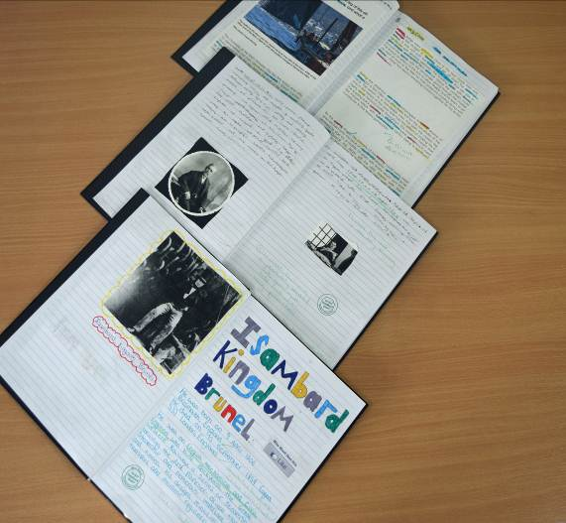
Only a few years previously, students showed little interest in or respect for school. One Year 11 boy said that the school was then little more than a ‘youth club’. Now he felt it was a ‘proper school’ with a uniform, where students show respect, learn and gain qualifications. The experiences students are now enjoying in science and engineering contribute to their growing pride in their school. Moreover, they know that many opportunities they have - for example to learn about velocity from the deck of a yacht - are rarely open to students in mainstream schools. Rather than wanting to return to mainstream school, this special school is becoming their school of choice.
It is important to recognise that, although the innovative approach to science and engineering has been the key driver of improvement, the increasing success of its students is not exclusively the result of gains in knowledge, understanding and skills. The gains in students’ self-confidence, self-esteem and resilience are of an even greater importance. When asked what the most significant improvement in the school was, Year 11 students said it was in their trust in the staff. They feel they can discuss any issues with staff, know that they will be listened to and know their concerns will be acted on. In the 2012 inspection report, students’ spiritual, moral, social and cultural development was rated outstanding.
A student’s story
‘When I came to The Observatory School, it was like a youth club and if it had carried on that way, I probably would have stopped coming into school and I definitely wouldn’t have any GCSEs. When we got the new headteacher, everything changed. We got new school rules like no smoking, detentions, no swearing, being respectful to staff, and calling the teachers Miss/Sir. We started to have proper lessons where we actually learned things and didn’t just mess around all day. We got a school uniform and that made us feel like we were in a proper secondary school, not a primary school. There were loads of good changes around the school and it became much safer to be there. The biggest change for me was when we started to do engineering. I always enjoyed taking things apart, looking at mechanics and finding out how things worked. I asked Mrs Idris (the headteacher) if we could introduce engineering to the school and she told me to write a letter to her explaining why I wanted to do it.
‘I was so excited to start that I asked my mum to order me my own overalls with my name on them. When we started the lessons, it was so good and it was the most I had ever enjoyed myself in school. I then knew that this was what I wanted to do with my life. The lessons were interesting, insightful and enjoyable. I am now studying Vehicle Maintenance at Wirral Met College. If it wasn’t for The Observatory School, the changes that Mrs Idris made and the engineering course ran by Mr Chiswell, I wouldn’t have been able to pursue my dream of becoming a qualified mechanic. Without the support of all the staff at the Observatory school, even the volunteers, I wouldn’t have been able to succeed in lessons and wouldn’t have ended up with the life opportunities that I have now.’

The good practice case studies that Ofsted publishes highlight specific examples of practice that providers of education, learning and children’s services have used to achieve successful outcomes.
For education, the case studies do not recommend a single particular approach to teaching and learning. Ofsted has no preferred lesson structure or teaching style. We showcase and share a wide range of approaches that providers have found work well for them in achieving good outcomes for children, young people and learners.
Are you thinking of putting these ideas into practice; or already doing something similar that could help other providers; or just interested? We'd welcome your views and ideas. Complete our survey here.
Click here to see other good practice examples.
If you would like a copy of this document in a different format, such as large print or Braille, please telephone 0300 123 1231, or email enquiries@ofsted.gov.uk.

