

24th June 2021

Greenhouse gas mitigation practices – Farm Practices Survey England 2021

This release contains the results from the February 2021 Farm Practices Survey which focused on practices relating to greenhouse gas mitigation.

Key findings
- Nutrient Management – 56% of holdings have a nutrient management plan.
- Anaerobic digestion – 8.9% of farmers process waste by anaerobic digestion.
- Emissions – 56% of farmers are currently taking action to reduce GHG emissions from their farm.
- Fertiliser, manure and slurry spreaders – 79% of holdings spread manure or slurry on grass or arable land.
- Manure and slurry storage – 72% of livestock farmers store solid manure in temporary heaps in fields.
- Farm health planning and biosecurity – 71% of livestock farmers have a Farm Health Plan.
- Grassland and grazing – 76% of livestock holdings sow some or all their temporary grassland with a clover mix.
- Livestock feeding regimes and breeding practices – 69% of holdings with livestock use a ration formulation programme or nutritional advice.

Contents

What you need to know about this release 3
National Statistics Status 3
Section 1 – Nutrient management 4
Section 2 – Anaerobic digestion 14
Section 3 – Emissions 15
Section 4 – Fertiliser, manure and slurry spreaders 20
Section 5 – Manure and slurry storage 23
Section 6 – Farm health planning and biosecurity 27
Section 7 – Grassland and grazing 30
Section 8 – Livestock feeding regimes and breeding practices 33
Section 9 – About these statistics 39

What you need to know about this release

The Farm Practices Survey (FPS) – Greenhouse Gas Mitigation edition is usually run annually and collects information on a diverse range of topics usually related to the impact of farming practices on the environment. This release contains the results from the February 2021 Farm Practices Survey which focused on practices relating to greenhouse gas mitigation. Note: The results in section 5 to 8 relate to only holdings with livestock.
Contact details
Responsible statistician: Sarah Thompson
Team: Farming Statistics - Department for Environment, Food and Rural Affairs.
Email: farming-statistics@defra.gov.uk
Tel: 03000 600 170

National Statistics Status
National Statistics status means that our statistics meet the highest standards of trustworthiness, quality and public value, and it is our responsibility to maintain compliance with these standards.
The continued designation of these statistics as National Statistics was confirmed in 2014 following a full assessment by the UK Statistics Authority against the Code of Practice for Statistics.
Since the last review of these statistics in 2014, we have continued to comply with the Code of Practice for Statistics, and have made improvements including:
- Improvements to the commentary to aid user interpretation
- Providing a helpful summary of the ways in which the results are used by government and other users

For general enquiries about National Statistics, contact the National Statistics Public Enquiry Service:
Tel: 0845 601 3034
Email: info@statistics.gov.uk.
You can find National Statistics on the internet on the Gov.uk website.

Section 1 – Nutrient management
Effective nutrient management provides sufficient nutrients to meet the growth requirements of crops and grassland whilst managing environmental impacts; it can help minimise GHG emissions, reduce the incidence of diffuse water pollution and increase productivity by reducing input costs. Here we consider how farmers manage the application of fertilisers and manures, the use of nutrient management plans and how nutrient requirements are calculated and monitored.
Key findings
- In 2021, 56% of holdings had a nutrient management plan which is almost unchanged from 2020. These holdings accounted for 74% of the farmed area covered by this survey.
- The largest proportion of nutrient management plans were created by farmers themselves either with the help of a professional (37%) or without advice (28%). The remaining 35% were created by an adviser or contractor.
- In 2021, 69% of farmers have a programme of soil testing for nutrient indices and 73% for pH. Of these holdings, almost all were tested on at least some of their fields every five years.
- Some 71% of holdings have a manure management plan for their farm, up from 65% in 2020.
- 38% of farmers keep track of soil organic matter and 63% of farmers know the soil types for each field on their farm.
- 30% of farms have calculated a whole farm nutrient balance every year.

Figure 1.1 Proportion of holdings with a nutrient management plan: 2011 – 2021
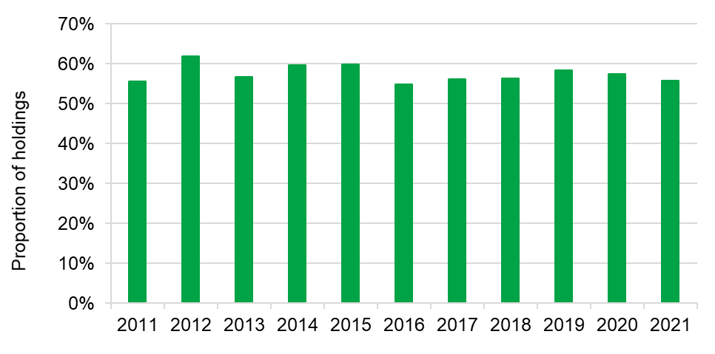

The proportion of farms with a nutrient management plan (NMP) was 56% in 2021, almost unchanged from 2020 (see Figure 1.1). In 2021, those holdings with nutrient management plans accounted for 74% of the farmed area covered by this survey.
Around 12% of holdings (accounting for 5% of the farmed area) indicated that a NMP is not applicable. This figure varied by farm type with 33% of pig/poultry farms, 18% of lowland grazing livestock farms and 21% of LFA grazing livestock farms indicating that a NMP was not applicable compared to 4% of cereal farms, 4% of other general cropping farms and 1% of dairy farms.
Figure 1.2 Preparation of nutrient management plans: 2021
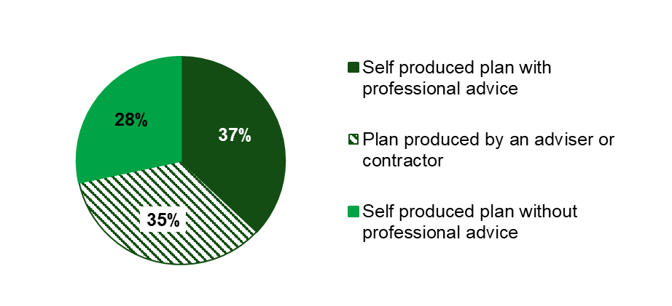

In 2021, 28% of those with a nutrient management plan completed the plan on their own without advice, whilst a further 37% created it themselves with the help of an adviser (see Figure 1.2). The remaining 35% had the plan produced by a contractor or adviser.
Of those that sought professional advice, the majority (79%) did so from fertiliser advisers or agronomists (see Table 1.3). Most of those with a nutrient management plan update it every year (70%) and almost all (94%) refer to it at least once each year (see Tables 1.4 and 1.5).

Figure 1.3 Methods used to create nutrient management plans: 2018 - 2021
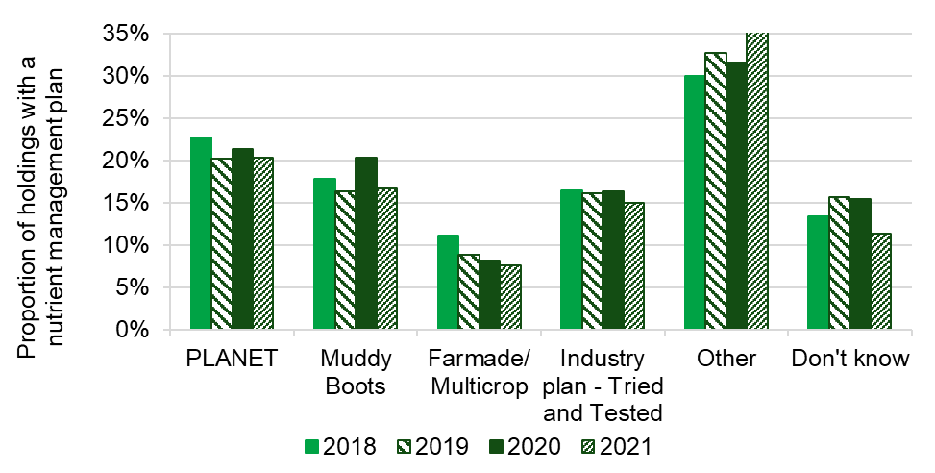
PLANET, Muddy Boots, Farmade/Multicrop and Tried & Tested are methods for creating nutrient management plans. PLANET has remained the most popular of these four methods (see Figure 1.3), although in each of the last five years the largest proportion of farmers (38% in 2021) have used other methods not listed on the survey form to create their plans (see Table 1.6). ‘Defra recommendations (RB209)’ was the most commonly reported source of nutrient recommendations for plans (see Table 1.7).
The percentage of farmers undertaking some form of nutrient testing on soil has remained similar between 2010 and 2021. Results for the past three years can be found in table 1.8. Approximately 71% of farms have a manure management plan in 2021, an increase compared to 65% in 2020. The majority of farmers (87%) use nutrient recommendations for manure management plans from Defra recommendations (RB209, CoGAP).
Over half of farms (61%) have calculated a whole farm nutrient balance for nitrogen, phosphorus or potassium. In 2021, 30% of farms have calculated the balance every year, 8% every 2 years, and 23% every 3 or more years. When testing for other metals, the majority of farms (70%) have never tested their soils for levels of arsenic, cadmium, chromium, copper, lead or zinc. A further 4% had tested in every field, 22% in some fields and the remaining 3% in one field.
Soil Monitoring looks at the use of soil organic matter and whether this is being recorded. Organic matter helps to retain nutrients and water in soil. Benefits include reduced compaction and surface crusting, plus improved water infiltration into the soil. In 2021, 38% of farmers kept track of soil organic matter on their farm. Of those not keeping track 36% provided the main reason as not important enough to test for (see Table 1.15 and 1.16).
Figure 1.4 Reasons preventing monitoring soil organic matter: 2020 – 2021
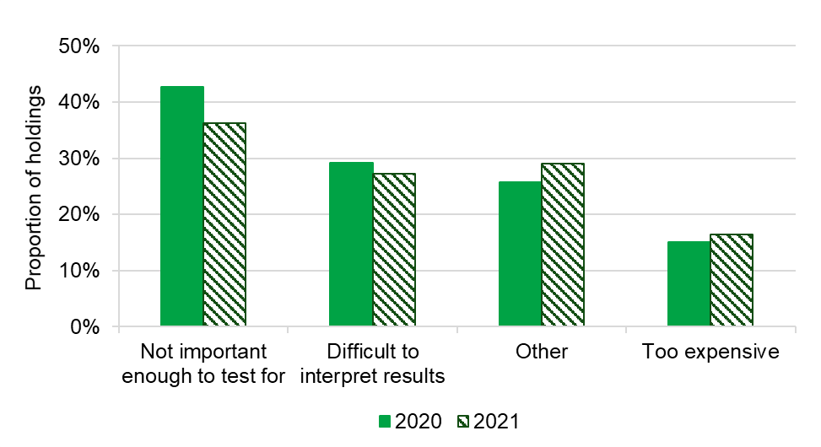

Table 1.1 Uptake of nutrient management plans: 2019 - 2021 (proportion of holdings and farmed area)
 | 2019 |  | 2020 |  | 2021
 | % | 95% CI | % | 95% CI | % | 95% CI
% of holdings
Yes | 58 | ±2 | 57 | ±2 | 56 | ±2
No | 31 | ±2 | 32 | ±2 | 32 | ±2
Not applicable | 11 | ±2 | 11 | ±1 | 12 | ±2
% of farmed area
Yes | 73 | ±2 | 75 | ±2 | 74 | ±3
No | 20 | ±2 | 21 | ±2 | 21 | ±2
Not applicable | 6 | ±2 | 4 | ±1 | 5 | ±1
Based on 2,176 responses in 2019, 2,340 in 2020 and 1,939 in 2021 from holdings with a nutrient management plan.
Source: Farm Practices Survey – Greenhouse gas mitigation

Table 1.2 Use of advisers/professional advice to create nutrient management plans: 2019 - 2021 (proportion of farmers with nutrient management plans)
 | 2019 |  | 2020 |  | 2021
 | % of holdings | 95% CI | % of holdings | 95% CI | % of holdings | 95% CI
Self-produced plan without professional advice | 25 | ±2 | 22 | ±2 | 28 | ±5
Self-produced plan with professional advice | 43 | ±3 | 44 | ±3 | 37 | ±4
Plan produced by an adviser or contractor | 32 | ±3 | 33 | ±3 | 35 | ±4
Based on 1,445 responses in 2019, 1,535 in 2020 and 1,198 in 2021 from holdings with a nutrient management plan.
Source: Farm Practices Survey – Greenhouse gas mitigation

Table 1.3 Use of advisers and contractors for completion of nutrient management plans: 2021
 | Those who sought an adviser’s help to create the plan themselves (a) |  | Those whose plan was created by an adviser or contractor(b)
Type of adviser | % of holdings | 95% CI | % of holdings | 95% CI
Fertiliser adviser / agronomist | 79 | ±10 | 79 | ±7
Animal nutritionist | 15 | ±9 | 5 | ±7
FWAG (c) | 2 | ±2 | 2 | ±1
Other | 11 | ±8 | 19 | ±7
Footnotes:
(a) Based on 491 responses from those who created the nutrient management plan themselves with advice.
(b) Based on 449 responses from those whose nutrient management plan was created by an adviser or contractor.
(c) FWAG: Farming and Wildlife Advisory Group.
Source: Farm Practices Survey – Greenhouse gas mitigation

Table 1.4 Frequency with which the nutrient management plan is updated: 2019 – 2021
 | 2019 |  | 2020 |  | 2021
Frequency of update | % of holdings | 95% CI | % of holdings | 95% CI | % of holdings | 95% CI
Every year | 76 | ±2 | 73 | ±2 | 70 | ±5
Every 2 years | 11 | ±2 | 12 | ±2 | 11 | ±3
Every 3 years or longer | 13 | ±2 | 16 | ±2 | 19 | ±4
Based on 1,444 responses in 2019, 1,535 in 2020 and 1,189 in 2021 from holdings with a nutrient management plan.
Source: Farm Practices Survey – Greenhouse gas mitigation

Table 1.5 Frequency with which the nutrient management plan is referred to in a year: 2019 - 2021
 | 2019 |  | 2020 |  | 2021
Frequency of use per year | % of holdings | 95% CI | % of holdings | 95% CI | % of holdings | 95% CI
More than 10 times | 8 | ±1 | 9 | ±2 | 7 | ±2
5 to 10 times | 17 | ±2 | 19 | ±2 | 15 | ±3
Less than 5 times | 68 | ±3 | 64 | ±3 | 71 | ±4
Never | 6 | ±1 | 7 | ±1 | 6 | ±2
Based on 1,441 responses in 2019, 1,536 in 2020 and 1,188 in 2021 from holdings with a nutrient management plan.
Source: Farm Practices Survey – Greenhouse gas mitigation

Table 1.6 Methods used to create nutrient management plans: 2019 – 2021
 | 2019 |  | 2020 |  | 2021
Method | % of holdings | 95% CI | % of holdings | 95% CI | % of holdings | 95% CI
PLANET | 20 | ±2 | 21 | ±2 | 20 | ±4
Muddy Boots | 16 | ±2 | 20 | ±2 | 17 | ±3
Farmade / Multicrop | 9 | ±2 | 8 | ±1 | 8 | ±2
Industry plan – ‘Tried and Tested’ | 16 | ±2 | 16 | ±2 | 15 | ±3
Other | 33 | ±3 | 31 | ±3 | 38 | ±5
Don’t know | 16 | ±2 | 15 | ±2 | 11 | ±3
Based on 1,438 in 2019, 1,513 in 2020 and 1,063 in 2021 from holdings with a nutrient management plan.
Source: Farm Practices Survey – Greenhouse gas mitigation
Table 1.7 Sources of nutrient recommendations for nutrient management plans: 2019 - 2021
 | 2019 |  | 2020 |  | 2021
Source | % of holdings | 95% CI | % of holdings | 95% CI | % of holdings | 95% CI
Defra recommendations / manual (RB209) | 66 | ±3 | 68 | ±3 | 64 | ±5
An adviser’s or industry note | 32 | ±3 | 35 | ±3 | 32 | ±4
Personal experience | 41 | ±3 | 36 | ±3 | 39 | ±4
Other | 3 | ±1 | 4 | ±1 | 6 | ±3
Don’t know | 3 | ±1 | 2 | ±1 | 3 | ±2
Based on 1,442 in 2019, 1,535 in 2020 and 1,171 in 2021 from holdings with a nutrient management plan.
Source: Farm Practices Survey – Greenhouse gas mitigation

Table 1.8 Nutrient testing of soil: 2019 - 2021
 |  | 2019 |  | 2020 |  | 2021
 |  | Proportion | 95% CI | Proportion | 95% CI | Proportion | 95% CI
Testing the nutrient content (indices) of soil | % of holdings | 70 | ±2 | 71 | ±2 | 69 | ±2
Testing the nutrient content (indices) of soil | % of farmed area | 82 | ±2 | 84 | ±2 | 84 | ±2
Testing the pH of soil | % of holdings | 74 | ±2 | 75 | ±2 | 73 | ±2
Testing the pH of soil | % of farmed area | 84 | ±2 | 86 | ±2 | 86 | ±2
Based on responses from holdings considering the questions applicable. Minimum numbers of responses used: 2,052 in 2019, 2,196 in 2020 and 1,762 in 2021.
Source: Farm Practices Survey – Greenhouse gas mitigation

Table 1.9 Nutrient testing of soil by proportion of fields: 2021
 |  | All fields |  | Some fields |  | None of the fields
 |  | Proportion | 95% CI | Proportion | 95% CI | Proportion | 95% CI
Testing the nutrient content (indices) of soil at least every 5 years | % of holdings | 55 | ±4 | 44 | ±4 | 1 | ±1
 | % of farmed area | 62 | ±4 | 38 | ±4 | 0.4 | ±0.5
Testing the pH of soil at least every 5 years | % of holdings | 54 | ±3 | 45 | ±3 | 0.6 | ±0.8
Testing the pH of soil at least every 5 years | % of farmed area | 60 | ±4 | 40 | ±4 | 0.4 | ±0.5
Based on responses from holdings with a programme of soil testing for either nutrient indices or pH. Minimum numbers of responses used: 1,352 in 2021.
Source: Farm Practices Survey – Greenhouse gas mitigation

Table 1.10 Calculation of whole farm nutrient balance for N (nitrogen) or P (phosphorus) or k (potassium): 2020-2021
 | 2020 |  | 2021
Frequency | % of holdings | 95% CI | % of holdings | 95% CI
Every year | 30 | ±2 | 30 | ±2
Every 2 years | 7 | ±1 | 8 | ±1
Every 3 years or more | 22 | ±2 | 23 | ±2
Never | 42 | ±2 | 39 | ±2
Based on 2,330 responses in 2020 and 1,852 responses in 2021
Source: Farm Practices Survey – Greenhouse gas mitigation

Table 1.11 Testing of soils for levels of Arsenic, Cadmium, Chromium, Copper, Lead or Zinc: 2020-2021
 | 2020 |  | 2021
Frequency | % of holdings | 95% CI | % of holdings | 95% CI
In every field | 4 | ±1 | 4 | ±1
In some fields | 20 | ±2 | 22 | ±2
In one field | 3 | ±1 | 3 | ±1
Never | 73 | ±2 | 70 | ±2
Based on 2,335 responses in 2020 and 1,857 responses in 2021
Source: Farm Practices Survey – Greenhouse gas mitigation

Table 1.12 Nutrient testing of manure: 2020 - 2021
 | 2020 |  | 2021
Methods of testing/assessing/calculating nutrient content of manure | % of holdings | 95% CI | % of holdings | 95% CI
Sampling and lab analysis | 14 | ±2 | 14 | ±2
Sampling and on-farm testing | 4 | ±1 | 3 | ±1
Based on published tables | 36 | ±2 | 37 | ±3
No testing done | 49 | ±2 | 47 | ±3
Based on 1,886 responses in 2020 and 1,505 in 2021 from holdings without a manure management plan.
Source: Farm Practices Survey – Greenhouse gas mitigation

Table 1.13 Uptake of manure management plans: 2019 - 2021
 | 2019 |  | 2020 |  | 2021
 | % | 95% CI | % | 95% CI | % | 95% CI
% of holdings | 64 | ±2 | 65 | ±2 | 71 | ±3
% of farmed area | 77 | ±3 | 82 | ±2 | 82 | ±3
Based on 1,901 responses in 2019, 2,034 in 2020 and 1,492 in 2021 from holdings for which the question was applicable.
Source: Farm Practices Survey – Greenhouse gas mitigation

Table 1.14 Source of nutrient recommendations for manure management plans: 2019 - 2021
 | 2019 |  | 2020 |  | 2021
 | % of holdings | 95% CI | % of holdings | 95% CI | % of holdings | 95% CI
Defra recommendations / manual (RB209), CoGAP | 87 | ±2 | 91 | ±2 | 87 | ±3
Other | 14 | ±2 | 10 | ±2 | 14 | ±3
Based on 1,368 responses in 2019, 1,454 in 2020 and 1,143 in 2021 from holdings with a manure management plan.
Source: Farm Practices Survey – Greenhouse gas mitigation

Table 1.15 Soil organic matter and awareness of soil types: 2020 - 2021
 | 2020 |  | 2021
Methods of testing/assessing/calculating nutrient content of manure | % of holdings | 95% CI | % of holdings | 95% CI
Holdings keeping track of soil organic matter | 32 | ±2 | 38 | ±2
Holdings who know the soil type(a) for each field on the farm | 64 | ±2 | 63 | ±2
Based on no less than 2,167 in 2020 and 1,771 in 2021.
(a) as described in Nutrient Management Guide (RB209).
Source: Farm Practices Survey – Greenhouse gas mitigation

Table 1.16 Reasons preventing farmers keeping track of soil organic matter: 2020 -2021
 | 2020 |  | 2021
Methods of testing/assessing/calculating nutrient content of manure | % of holdings | 95% CI | % of holdings | 95% CI
Too expensive | 15 | ±2 | 16 | ±2
Not important enough to test for | 43 | ±3 | 36 | ±3
Difficult to interpret results | 29 | ±3 | 27 | ±3
Other | 26 | ±2 | 29 | ±3
Based on 1,386 responses in 2020 and 1,033 in 2021 from holdings that do not keep track of soil organic matter
Source: Farm Practices Survey – Greenhouse gas mitigation

Section 2 – Anaerobic digestion
Anaerobic digestion is a natural process in which plant and animal materials are broken down by micro-organisms in the absence of oxygen, producing a biogas that can be used to generate electricity and heat. The process allows more efficient capture and treatment of the nutrients and greenhouse gas emissions from animal slurries and manures than can be achieved by spreading directly onto land. The remaining digestate is rich in nutrients and can be used as fertiliser. This section looks at the proportion of farmers who are currently processing any waste or crop feedstocks in this way.
Key findings
- In 2021, 8.9% of farmers said they process waste by anaerobic digestion, an increase from 6.6% in 2020.
- The proportion of farms processing waste by anaerobic digestion varied across farm types with 15% of pig and poultry farms doing so, followed by 11% of cereal farms.
- Slurries and manures were the most common material type being processed, with 5.5% of farmers choosing this option. Crops were the next most popular option processed by 4.9% of farmers.
The majority of farms do not currently process slurries, crops or other feedstocks by anaerobic digestion, with just 8.9% of holdings doing so in 2021 (see Table 2.1). Prior to 2015, the number of farmers processing by anaerobic digestion had remained stable at approximately 1.5% or below.
Table 2.1 Proportion of holdings processing waste by anaerobic digestion: 2019 -2021
 | % of holdings |  |  | 95% CI
Waste type | 2019 | 2020 | 2021 | 2021
Slurries | 3.1 | 3.8 | 5.5 | ±1.1
Crops | 2.9 | 4.3 | 4.9 | ±1.1
Other feedstocks from the holding | 1.0 | 0.9 | 1.2 | ±0.5
Other feedstocks from outside the holding | 1.3 | 1.0 | 1.9 | ±0.7
Any of the above | 5.2 | 6.6 | 8.9 | ±1.4
Based on 2,187 responses in 2019, 2,364 in 2020 and 1,833 in 2021 from all holdings.
Source: Farm Practices Survey – Greenhouse gas mitigation

Section 3 – Emissions
This section looks at the importance farmers place on greenhouse gas (GHG) emissions when making decisions about their farms. It also focuses on the actions that farmers are currently taking to reduce emissions and their motivations for doing so. In contrast we also look at the reasons that prevent farmers from taking action.
Key findings
- The proportion of farmers considering greenhouse gases (GHG) to be either fairly or very important when taking decisions about their land, crops and livestock is 67% in 2021.
- In 2021, 56% of farmers reported that they were currently taking action to reduce greenhouse gas emissions from their farm.
- The most common actions taken to reduce GHG emissions on farms were recycling of waste materials from the farm (83%), improving energy efficiency (79%) and improving nitrogen fertiliser application accuracy (62%).
- The most common motivation for taking any action was that it was considered good business practice to do so (80%). This has been the case for the past nine years.
- For those not taking action to reduce GHG emissions, the most common reasons given were that they were unsure what to do as there are too many conflicting views on the issue (41%) and it was not necessary because the farm did not produce many emissions (35%).
Figure 3.1 Importance placed on GHGs by farmers when taking decisions about their land, crops and livestock: 2020-2021
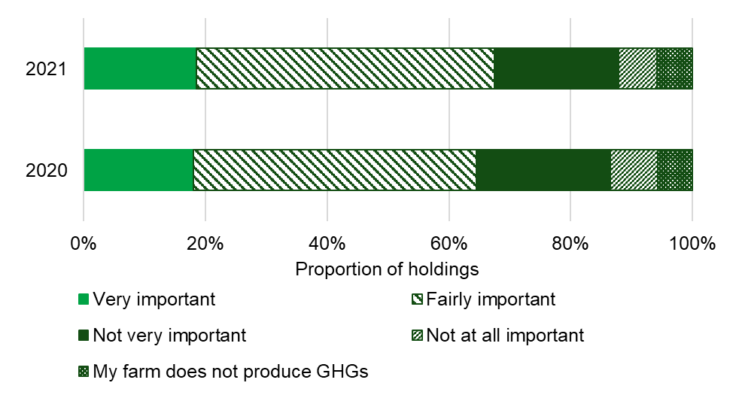
The proportion of farmers considering greenhouse gases to be either fairly or very important when taking decisions about their land, crops and livestock is 67% in 2021, an increase from 65% in 2020 (see Figure 3.1). There were 6% of farms where greenhouse gases were considered to be “not at all important” and 6% that believed their farm did not produce any GHGs.
In 2021, 56% of farmers said that they were currently taking action to reduce GHG emissions from their farm. Of those taking action (see Figure 3.2 and Table 3.3) the three most common actions are recycling waste materials from the farm (83%), improving energy efficiency (79%) and improving nitrogen fertiliser application accuracy (62%). The largest change in actions seen between 2013 when these questions were first asked and 2020 was an increase in the number of farmers improving efficiency of their manure & slurry management and application. This has risen from 28% of holdings in 2013 to 51% in 2021.
Figure 3.2 Actions taken to reduce GHG emissions from the farm: 2019-2021(a)
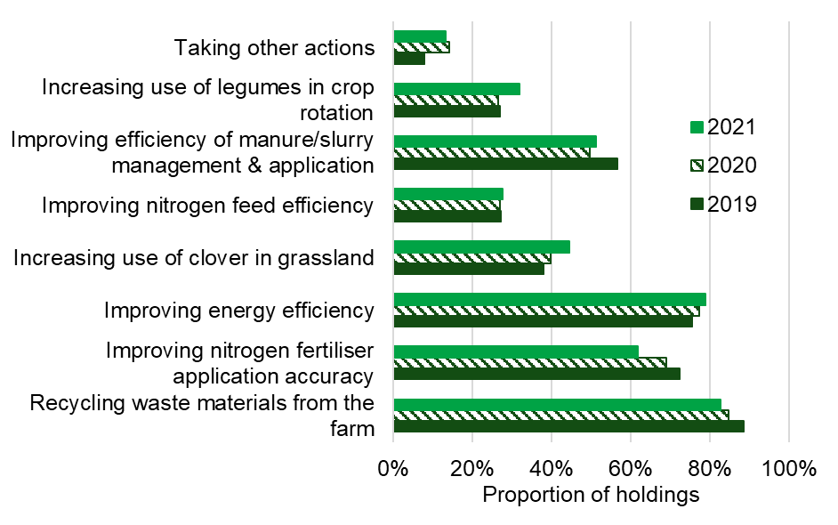
(a) Figures relate only to those holdings currently taking action to reduce GHG emissions from their farm.
For those farmers currently taking action to reduce their farm’s GHG emissions the most common motivation for doing so was that it was considered to be good business practice (selected by 80% of holdings) followed by concern for the environment (selected by 75%) (see Table 3.4).

Figure 3.3 Reasons preventing farmers taking action to reduce GHG emissions: 2021
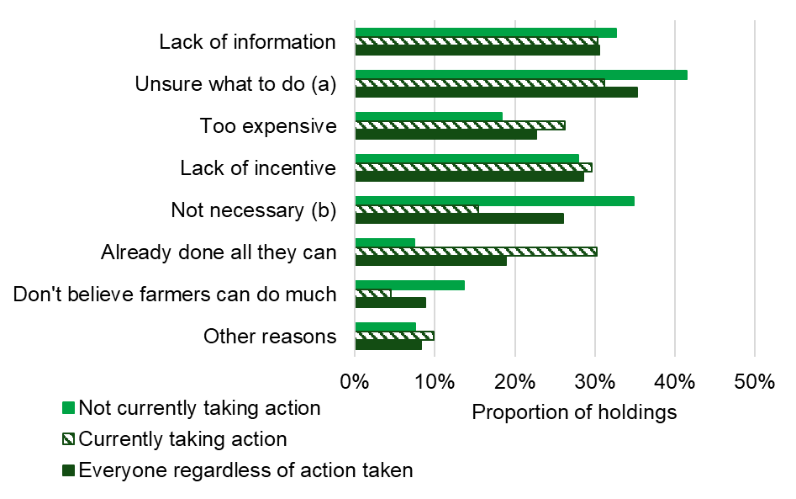
(a) Unsure what to do - too many conflicting views on the issue
(b) Not necessary - don't believe farm produces many emissions
The reasons that prevent people from taking action to reduce GHG emissions vary depending on whether farmers were currently taking action or not (see Figure 3.3). For those not currently taking action, the most commonly quoted reasons were that farmers are unsure what to do as too many conflicting views on the issue (41%) and they did not think it was necessary to do so as the farm did not produce many emissions (35%). For those who were already taking action, unsure what to do due to too many conflicting views was the most quoted reason (31%), followed by lack of information (30%) and already done all they can (30%).
Table 3.1: Importance placed on GHGs by farmers when taking decisions about their land, crops and livestock: 2019 – 2021
 | % of holdings |  |  | 95% CI
 | 2019 | 2020 | 2021 | 2021
Very important | 13 | 18 | 19 | ±2
Fairly important | 42 | 46 | 49 | ±2
Not very important | 29 | 22 | 20 | ±2
Not at all important | 8 | 8 | 6 | ±1
Do not believe farm produces GHGs | 8 | 6 | 6 | ±1
Based on 2,169 responses in 2019, 2,331 in 2020 and 1,815 in 2021.
Source: Farm Practices Survey – Greenhouse gas mitigation
Table 3.2: Belief that reducing GHG emissions from the farm will contribute to improving the overall profitability: 2019 – 2021
 | % of holdings |  |  | 95% CI
 | 2019 | 2020 | 2021 | 2021
Strongly agree | 4 | 6 | 6 | ±1
Agree | 37 | 40 | 41 | ±2
Disagree | 49 | 45 | 45 | ±3
Strongly disagree | 9 | 9 | 8 | ±1
Based on responses from 2,163 in 2019, 2,313 in 2020 and 1,806 in 2021.
Source: Farm Practices Survey – Greenhouse gas mitigation

Table 3.3: Actions being taken to reduce GHG emissions from farms: 2019 – 2021
 | % of holdings |  |  | 95% CI
 | 2019 | 2020 | 2021 | 2021
Taking action(a) | 61 | 66 | 56 | ±2
Of those taking action, the actions were(b):
Recycling of waste materials from the farm (e.g. tyres, plastics) | 89 | 85 | 83 | ±3
Improving nitrogen fertiliser application accuracy | 72 | 69 | 62 | ±3
Improving energy efficiency (e.g. reducing electricity use, using reduced tillage) | 75 | 77 | 79 | ±3
Increasing use of clover in grassland | 38 | 40 | 44 | ±3
Improving nitrogen feed efficiency, livestock diets | 27 | 27 | 28 | ±3
Improving efficiency in manure and slurry management and application | 57 | 50 | 51 | ±3
Increasing use of legumes in arable rotation | 27 | 26 | 32 | ±3
Other actions | 8 | 14 | 13 | ±2
(a) Based on responses from 2,157 holdings in 2019, 2,335 in 2020 and 1,813 in 2021.
(b) Based on responses from 1,413 holdings in 2019, 1,640 in 2020 and 1,092 in 2021 who are taking action to reduce GHG emissions.
Source: Farm Practices Survey – Greenhouse gas mitigation

Table 3.4: Main motivations for those taking action to reduce GHG emissions: 2019 – 2021
 | % of holdings |  |  | 95% CI
Motivations | 2019 | 2020 | 2021 | 2021
Consider it good business practice | 84 | 85 | 80 | ±3
Concern for the environment | 71 | 73 | 75 | ±3
To improve profitability | 55 | 46 | 47 | ±4
Regulation | 41 | 35 | 30 | ±3
To meet market demands | 19 | 24 | 22 | ±3
Other motivation | 3 | 5 | 5 | ±2
Based on 1,408 responses in 2019, 1,636 in 2020 and 1,088 in 2021 from holdings who are taking action to reduce GHG emissions.
Source: Farm Practices Survey – Greenhouse gas mitigation

Table 3.5: Reasons preventing farmers from taking action to reduce GHG emissions from their farm: 2021
 | For those not taking action(a) |  | For those already taking action(b) |  | For all holdings(c)
 | % of holdings | 95% CI | % of holdings | 95% CI | % of holdings | 95% CI
Lack of information | 33 | ±4 | 30 | ±4 | 31 | ±2
Too expensive | 18 | ±3 | 26 | ±3 | 23 | ±2
Lack of incentive | 28 | ±3 | 30 | ±4 | 29 | ±2
Already done all they can | 7 | ±2 | 30 | ±4 | 19 | ±2
Don’t believe farmers can do much | 14 | ±3 | 4 | ±2 | 9 | ±2
Not necessary – don’t believe farm produces many emissions | 35 | ±4 | 15 | ±3 | 26 | ±2
Unsure what to do - too many conflicting views on the issue | 41 | ±4 | 31 | ±4 | 35 | ±3
Other reasons | 8 | ±2 | 10 | ±3 | 8 | ±1
(a) Based on responses from 705 holdings in 2021 who are not taking action to reduce GHG emissions.
(b) Based on responses from 860 holdings in 2021 who are currently taking action to reduce GHG emissions.
(c) Based on responses from 1,570 holdings in 2021 regardless of whether or not they are taking action to reduce GHG emissions.
Source: Farm Practices Survey – Greenhouse gas mitigation

Section 4 – Fertiliser, manure and slurry spreaders
Calibrating fertiliser, manure and slurry spreaders can help to improve input efficiency and reduce GHG emissions. This section focuses specifically on farmers who spread manure, slurry and fertiliser.
More details on nitrogen fertiliser spreading practices are available in the British Survey of Fertiliser Practice.
Key findings
- Just over three quarters of holdings (79%) spread manure or slurry on their grass or arable land in 2021 and 84% spread fertilisers.
- On 43% of holdings where the farmer spreads at least some manure or slurry themselves, the manure or slurry spreader is never calibrated.
Figure 4.1: Proportion of holdings spreading manure and slurry on grassland and arable land by farm type: 2021
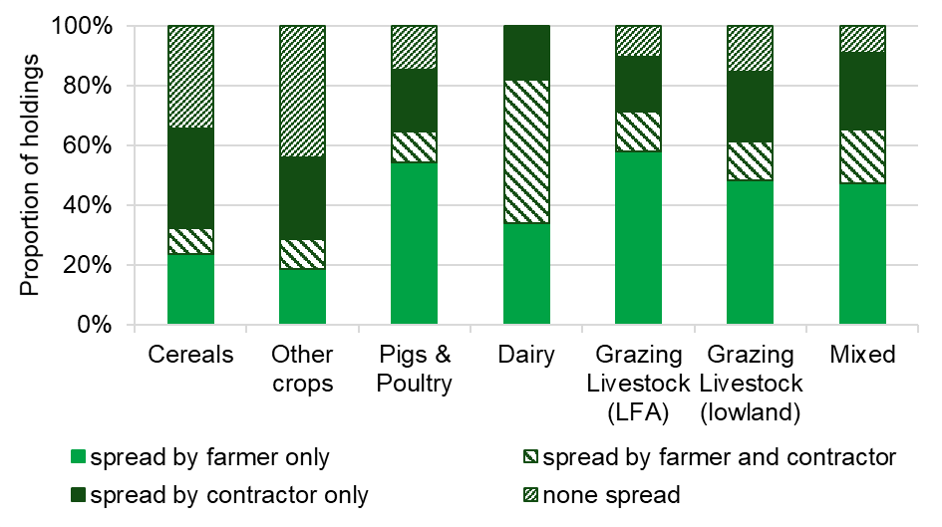
In 2021, 79% of holdings spread manure or slurry on their grass and arable land. There was considerable variation between farm types. Almost all dairy farms spread manures or slurries and these farms are more likely to use contractors to spread at least some of the manure and slurry than other farm types. The majority (58%) of LFA grazing livestock farmers spread manure/slurry themselves only (see Figure 4.1).
Fertiliser was spread either by the farmer or a contractor on 98% of cereal farms, 95% of other cropping farms and 90% of dairy farms. On all three of these farm types the largest proportion of holdings said the fertiliser was spread solely by the farmer, however cereal and other cropping farms were more likely to use a contractor than dairy farms (see Figure 4.2).
Figure 4.2: Proportion of holdings spreading fertiliser on grassland and arable land by farm type: 2021
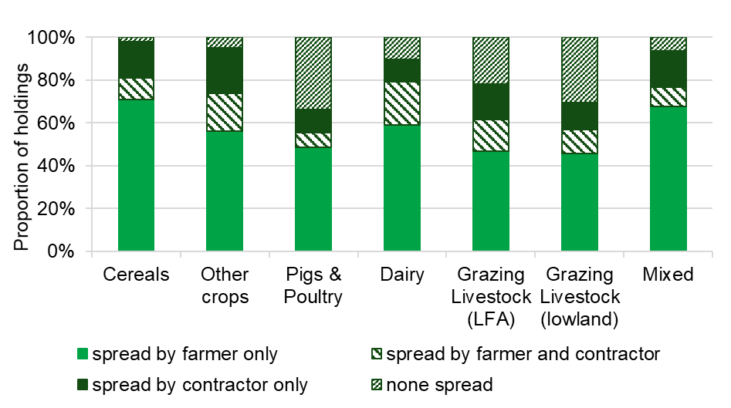
Table 4.1: Spreading of manure and slurry on grassland or arable land: 2019 – 2021
 | 2019 |  | 2020 |  | 2021
 | % of holdings | 95% CI | % of holdings | 95% CI | % of holdings | 95% CI
Spread by farmer only | 41 | ±3 | 38 | ±2 | 39 | ±3
Spread by farmer and also contractor | 14 | ±2 | 17 | ±2 | 15 | ±2
Spread by contractor only | 23 | ±2 | 20 | ±2 | 25 | ±3
None spread | 22 | ±2 | 24 | ±2 | 21 | ±2
Based on 1,887 responses in 2019, 2,010 in 2020 and 1,511 in 2021.
Source: Farm Practices Survey – Greenhouse gas mitigation

Table 4.2: Spreading of fertiliser on grassland or arable land: 2019 – 2021
 | 2019 |  | 2020 |  | 2021
 | % of holdings | 95% CI | % of holdings | 95% CI | % of holdings | 95% CI
Spread by farmer only | 59 | ±3 | 57 | ±3 | 57 | ±3
Spread by farmer and also contractor | 11 | ±2 | 11 | ±1 | 12 | ±2
Spread by contractor only | 15 | ±2 | 16 | ±2 | 15 | ±2
None spread | 14 | ±2 | 16 | ±2 | 16 | ±2
Based on 1,899 responses in 2019 and 2,028 in 2020 and 1,525 in 2021.
Source: Farm Practices Survey – Greenhouse gas mitigation
Table 4.3: Frequency with which farmers calibrate their manure or slurry spreader(s): 2019 – 2021
 | 2019 |  | 2020 |  | 2021
Frequency of check | % of holdings | 95% CI | % of holdings | 95% CI | % of holdings | 95% CI
Never | 47 | ±4 | 49 | ±3 | 43 | ±4
Whenever there is significant change in manure or slurry characteristics | 22 | ±3 | 19 | ±3 | 15 | ±3
Whenever manure or slurry is tested | 2 | ±1 | 2 | ±1 | 3 | ±2
Every year | 19 | ±3 | 18 | ±3 | 24 | ±4
Less often than every year | 7 | ±2 | 8 | ±2 | 6 | ±2
Other frequency | 4 | ±2 | 3 | ±1 | 9 | ±3
Based on 871 responses in 2019, 909 in 2020 and 785 in 2021 on holdings where the farmer spreads some or all of the manure/slurry.
Source: Farm Practices Survey – Greenhouse gas mitigation
Note: The results in section 5 to 8 relate to only holdings with livestock.

Section 5 – Manure and slurry storage
The system of manure and slurry management is relevant to the control of environmental risks to water and air. It prevents the loss of ammonia to the air, at the same time retaining the nitrogen for use as an organic fertiliser, reducing the need for manufactured nitrogen fertiliser inputs.
This section looks at the types of stores that livestock farmers have, whether or not they are covered, and whether the farmer has any plans to upgrade their current facilities. It also looks at whether the farmer has a slurry separator. Separating the suspended solids from slurry allows the two manure streams to be handled separately. The solid fraction can be stored on a concrete pad or in a field heap, while the liquid fraction can be stored and transported/pumped to fields for land application. Separation can reduce storage space and improve the efficiency with which nitrogen is applied to land which has the potential to reduce emissions.
Key findings
- Temporary heaps remain the most common form of storage for solid manure, with just over two thirds (72%) of the farmers having this kind of store.
- Around one fifth of farmers (22%) store slurry in a tank, whilst 13% store slurry in lagoons without a strainer.
- In 2021, 20% of livestock farmers with storage facilities intend to enlarge or upgrade their manure or slurry storage compared to 16% in 2020.

Figure 5.1: Proportion of livestock holdings with manure or slurry storage facilities: 2019 - 2021
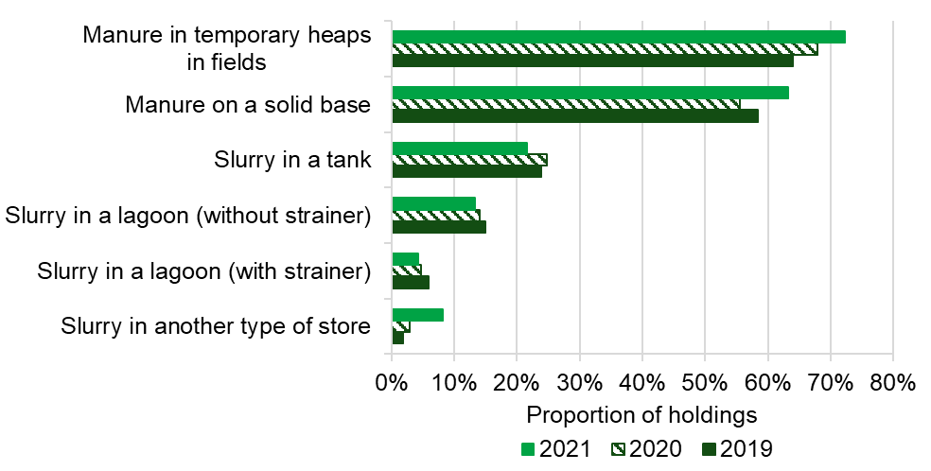

The most common storage facility for solid manure continues to be temporary heaps in fields (see Figure 5.1). The most common facilities for slurry storage are tanks (22% of farms) followed by lagoons without a strainer (13%). Slurry in a tank is far more likely to have a cover than any other type of store (see Table 5.2).
In 2021, 20% of livestock farmers planned to make changes to their manure or slurry storage facilities. Of these, 23% planned to make the changes within the next year and a further 49% in the next 1 to 3 years (see Table 5.3).
Figure 5.2: Proportion of holdings with storage facilities for slurry by number of months of storage capacity: 2017 - 2021
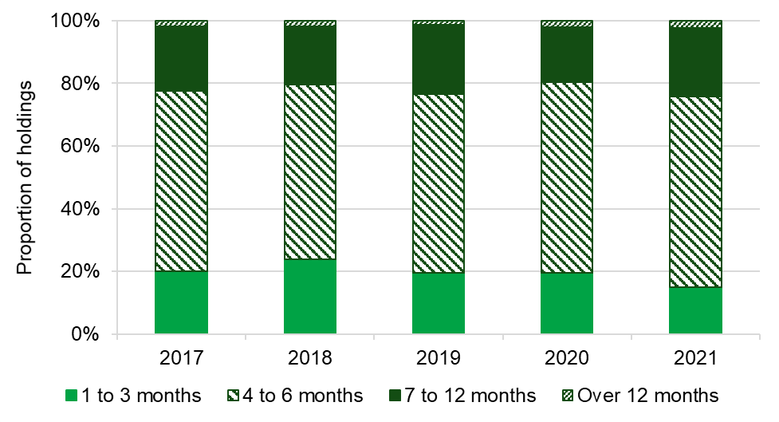
The proportion of holdings that have up to 6 months’ storage capacity for slurry has decreased slightly to 76%. Almost all of the remaining holdings had between 7 and 12 months capacity with only very few people having more than 12 months storage (see Figure 5.2 and Table 5.4).

Table 5.1: Proportion of holdings with storage facilities for manure and/or slurry: 2019 – 2021 storage
 | 2019 |  | 2020 |  | 2021
Storage facility | % of holdings | 95% CI | % of holdings | 95% CI | % of holdings | 95% CI
Solid manure stored in heaps on a solid base | 58 | ±3 | 55 | ±3 | 63 | ±4
Solid manure stored in temporary heaps in fields | 64 | ±3 | 68 | ±3 | 72 | ±3
Slurry in a tank | 24 | ±3 | 25 | ±3 | 22 | ±4
Slurry in a lagoon without strainer | 15 | ±2 | 14 | ±2 | 13 | ±3
Storage with strainer facility | 6 | ±1 | 5 | ±1 | 4 | ±1
Slurry in another type of store | 2 | ±1 | 3 | ±1 | 8 | ±2
Based on no fewer than 1,352 responses in 2019, 1,445 in 2020 and 1,075 in 2021 from livestock holdings.
Source: Farm Practices Survey – Greenhouse gas mitigation

Table 5.2: Proportion of holdings having storage facilities for manure and/or slurry where the store is covered: 2019 – 2021
 | 2019 |  | 2020 |  | 2021
Storage facility | % of holdings | 95% CI | % of holdings | 95% CI | % of holdings | 95% CI
Solid manure stored in heaps on a solid base | 19 | ±3 | 16 | ±3 | 14 | ±3
Solid manure stored in temporary heaps in fields | 1 | ±1 | 1 | ±1 | 1 | ±1
Slurry in a tank | 30 | ±6 | 24 | ±5 | 25 | ±13
Slurry in a lagoon without strainer | 5 | ±3 | 3 | ±3 | 3 | ±3
Storage with strainer facility | 13 | ±11 | 8 | ±6 | 4 | ±3
Slurry in another type of store | 5 | ±5 | 5 | ±4 | 3 | ±5
Based on no fewer than 86 responses in 2019, 68 in 2020 and 67 in 2021 from livestock holdings that have the storage facilities in question.
Source: Farm Practices Survey – Greenhouse gas mitigation

Table 5.3: Proportion of holdings planning to enlarge, upgrade or reconstruct their manure and slurry storage facilities: 2019 – 2021
 | 2019 |  | 2020 |  | 2021
 | % of holdings | 95% CI | % of holdings | 95% CI | % of holdings | 95% CI
Holdings planning to make changes to their current facilities (a) | 14 | ±2 | 16 | ±2 | 20 | ±3
Of those planning to make changes, the changes will be made: (b)
In 0 to 6 months | 9 | ±4 | 9 | ±4 | 13 | ±6
In 7 to 11 months | 13 | ±5 | 14 | ±4 | 11 | ±6
In 1 to less than 3 years | 46 | ±7 | 43 | ±6 | 49 | ±10
In 3 to less than 5 years | 19 | ±6 | 17 | ±5 | 18 | ±8
In 5 years or more | 12 | ±5 | 18 | ±4 | 10 | ±5
(a) Based on 1,339 in 2019, 1,435 in 2020 and 1,066 in 2021 from livestock holdings that have manure or slurry storage facilities.
(b) Based on 216 responses in 2019, 261 in 2020 and 265 in 2021 from livestock holdings that are planning to make changes.
Source: Farm Practices Survey – Greenhouse gas mitigation

Table 5.4: Proportion of holdings with slurry stores by storage capacity: 2019 – 2021
 |  | 2019 |  | 2020 |  | 2021
Storage capacity |  | % of holdings | 95% CI | % of holdings | 95% CI | % of holdings | 95% CI
1 to 3 months |  | 20 | ±4 | 19 | ±4 | 15 | ±7
4 to 6 months |  | 57 | ±4 | 61 | ±4 | 61 | ±10
7 to 12 months |  | 22 | ±4 | 17 | ±3 | 22 | ±9
Over 12 months |  | 1 | ±1 | 2 | ±1 | 2 | ±2
Based on 518 responses in 2019, 525 in 2020 and 429 in 2021 from livestock holdings that have slurry storage facilities.
Source: Farm Practices Survey – Greenhouse gas mitigation

Table 5.5: Proportion of holdings that have a slurry separator: 2019 - 2021
 | 2019 |  | 2020 |  | 2021
 | % of holdings | 95% CI | % of holdings | 95% CI | % of holdings | 95% CI
Holdings who have a slurry separator | 10 | ±3 | 9 | ±2 | 8 | ±5
Based on 532 responses in 2019, 542 in 2020 and 445 in 2021 from livestock holdings.
Source: Farm Practices Survey – Greenhouse gas mitigation

Section 6 – Farm health planning and biosecurity
Farm health planning is a Defra initiative which benefits farmers by helping to prevent disease and improve the performance of their livestock. This can help to reduce GHG emissions over the course of an animal’s lifetime by, for example, reaching finishing weights earlier and achieving higher feed conversion rates. Farm health planning is about farmers working closely with their vets or other advisers to set targets for their animals’ health and welfare and take steps to measure, manage and monitor productivity.
Key findings
- The number of livestock farmers with a Farm Health Plan (FHP) decreased to 71% in 2021, compared with 75% in 2020.
- In 2021, over half (57%) of farmers with a FHP used it on a routine basis to inform disease management decisions.
- The number of FHPs completed with the help of a vet or adviser has decreased from 91% in 2020 to 87% in 2021.

In 2021, 71% of livestock farms had a Farm Health Plan. This is a decrease when compared with 75% in 2020. The majority of livestock farmers (60%) have a written or recorded plan a decrease from 66% in 2020. Livestock farmers with a plan that was not recorded (11%) saw an increase in 2021, from 9% in 2020 (see Figure 6.1). Of those holdings with a FHP in 2021, 87% had created the plan with assistance from a vet or advisor (see Table 6.2). The proportion using a vet or adviser has risen steadily from 60% in 2009 when we first asked the question.
Figure 6.1: Proportion of livestock holdings with a farm health plan: 2017 – 2021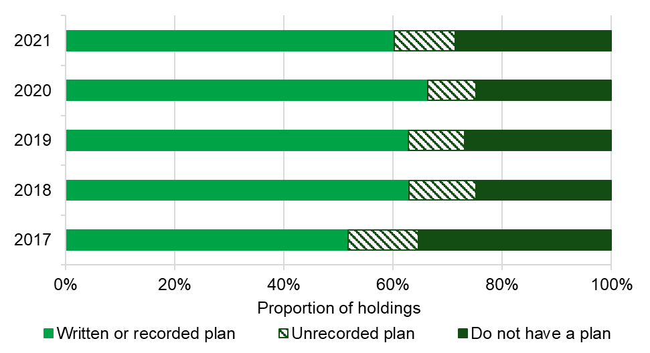
Of those with a Farm Health Plan in 2021, 89% were using it either routinely or when they could to inform disease management decisions and a further 5% felt that they should be doing so. The remaining 6% did not feel it was necessary to use the plan (see Figure 6.2).
Figure 6.2: Proportion of livestock holdings using their farm health plan to inform disease management decisions by frequency: 2017 - 2021
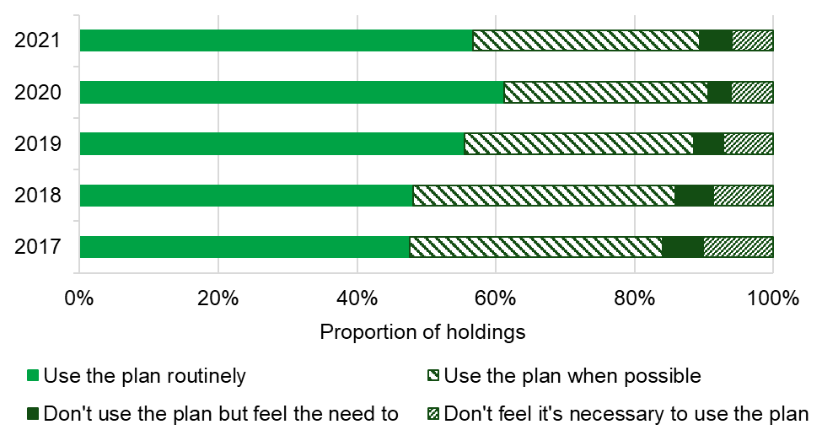
The number of livestock farmers who undertake training for animal health and welfare and disease management either routinely or when they can fell to 61% in 2021, compared with 65% in 2020. A further 11% said that although they did not undertake training, they felt that they should and the remaining 29% did not feel training was necessary (see Table 6.4).

Table 6.1: Proportion of livestock holdings with a farm health plan: 2019 – 2021
 | % of holdings |  |  | 95% CI
 | 2019 | 2020 | 2021 | 2021
Written or recorded plan | 63 | 66 | 60 | ±3
Unrecorded plan | 10 | 9 | 11 | ±2
No plan | 27 | 25 | 29 | ±3
Based on 1,601 in 2019, 1,740 in 2020 and 1,377 in 2021 from livestock holdings.
Source: Farm Practices Survey – Greenhouse gas mitigation

Table 6.2: Proportion of holdings who completed their farm health plan with the assistance of a vet or adviser: 2019 – 2021
 |  |  |  | % of holdings |  |  | 95% CI
 |  |  |  | 2019 | 2020 | 2021 | 2021
Assistance from vet / adviser |  |  |  | 84 | 91 | 87 | ±3
Based on 1,248 responses in 2019, 1,365 in 2020 and 1,053 in 2021 from holdings with livestock.
Source: Farm Practices Survey – Greenhouse gas mitigation

Table 6.3: Proportion of holdings using their farm health plan to inform disease management decisions by frequency of use: 2019 – 2021
 | 2019 |  | 2020 |  | 2021
Frequency of use | % of holdings | 95% CI | % of holdings | 95% CI | % of holdings | 95% CI
Use plan routinely | 55 | ±3 | 61 | ±3 | 57 | ±4
Use plan when possible | 33 | ±3 | 29 | ±3 | 33 | ±4
Don’t use plan but feel the need to | 4 | ±1 | 3 | ±1 | 5 | ±2
Don’t feel it’s necessary to use plan | 7 | ±2 | 6 | ±1 | 6 | ±2
Based on 1,255 responses in 2019, 1,378 in 2020 and 1,059 in 2021 from livestock holdings with a farm health plan.
Source: Farm Practices Survey – Greenhouse gas mitigation
Table 6.4: Proportion of holdings undertaking animal health and welfare and disease management training by frequency of training: 2019 – 2021
 | 2019 |  | 2020 |  | 2021
Frequency of training | % of holdings | 95% CI | % of holdings | 95% CI | % of holdings | 95% CI
Undertake training routinely | 22 | ±2 | 24 | ±2 | 25 | ±3
Undertake training when possible | 38 | ±3 | 41 | ±2 | 36 | ±3
Don’t undertake training but feel the need to | 10 | ±2 | 10 | ±2 | 11 | ±2
Don’t feel training is necessary | 30 | ±3 | 25 | ±2 | 29 | ±3
Based on 1,588 responses in 2019, 1,709 in 2020 and 1,350 in 2021 from livestock holdings.
Source: Farm Practices Survey – Greenhouse gas mitigation

Section 7 – Grassland and grazing
In some situations sowing temporary grassland with a clover mix or high sugar grasses can be a cost effective method of increasing production and improving environmental protection. For example, clover’s nitrogen fixing properties (although not suitable for all soil types) can reduce the amount of nitrogen applied and improve grassland yields. High sugar grasses can help to improve the efficiency of animal production (for example, improved milk yields and faster live weight gain) which can in turn reduce GHG emissions.
Land and soil management mitigation methods can help to preserve good soil structure preventing erosion and compaction, both of which can lead to GHG emissions. Mitigation methods relating to this include keeping livestock away from water courses and reducing stocking rates when conditions are excessively wet.
Key findings
- In 2021, 76% of livestock holdings indicated that a proportion of their temporary grassland had been sown with a clover mix: 20% had sown all of their temporary grassland with a clover mix.
- High sugar grasses were sown on 65% of livestock holdings with temporary grassland.
- The most common frequency for reseeding clover or high sugar grass swards in 2021 was 3 to 5 years.
- Approximately 77% of livestock farmers always take action to reduce stocking rates when fields are excessively wet.
- 63% of livestock farmers routinely try to keep livestock out of water courses.

Table 7.1: Proportion of livestock holdings that have sown their temporary grassland with a clover mix by proportion of grassland: 2019 – 2021
 | 2019 |  | 2020 |  | 2021
Proportion of temporary grassland (%) | % of holdings | 95% CI | % of holdings | 95% CI | % of holdings | 95% CI
100 | 27 | ±3 | 13 | ±2 | 20 | ±5
81-99 | 6 | ±2 | 3 | ±1 | 3 | ±2
61-80 | 7 | ±2 | 7 | ±2 | 3 | ±2
41-60 | 9 | ±2 | 22 | ±3 | 19 | ±4
21-40 | 10 | ±2 | 12 | ±2 | 12 | ±4
1-20 | 17 | ±3 | 17 | ±3 | 18 | ±5
0 | 25 | ±3 | 25 | ±3 | 24 | ±5
Based on 817 responses in 2019, 878 in 2020 and 654 in 2021 from livestock holdings with temporary grass.
Source: Farm Practices Survey – Greenhouse gas mitigation

Table 7.2: Proportion of livestock holdings that have sown their temporary grassland with high sugar grasses by proportion of grassland: 2019 – 2021
 | 2019 |  | 2020 |  | 2021
Proportion of temporary grassland (%) | % of holdings | 95% CI | % of holdings | 95% CI | % of holdings | 95% CI
100 | 19 | ±3 | 8 | ±2 | 12 | ±4
81-99 | 6 | ±2 | 4 | ±1 | 2 | ±1
61-80 | 7 | ±2 | 4 | ±1 | 5 | ±2
41-60 | 10 | ±2 | 22 | ±3 | 17 | ±4
21-40 | 9 | ±2 | 11 | ±2 | 14 | ±4
1-20 | 9 | ±2 | 11 | ±2 | 14 | ±4
0 | 41 | ±4 | 39 | ±3 | 35 | ±6
Based on 814 responses in 2019, 875 in 2020 and 641 in 2021 from livestock holdings with temporary grass.
Source: Farm Practices Survey – Greenhouse gas mitigation

Table 7.3: Proportion of holdings by the frequency with which holders reseed their clover sward: 2019 – 2021
 | 2019 |  | 2020 |  | 2021
Frequency of reseeding | % of holdings | 95% CI | % of holdings | 95% CI | % of holdings | 95% CI
1 to 12 months | 1 | ±1 | 2 | ±1 | 1 | ±2
1 to 2 years | 4 | ±2 | 7 | ±2 | 6 | ±3
2 to 3 years | 8 | ±2 | 8 | ±2 | 9 | ±4
3 to 5 years | 34 | ±4 | 27 | ±4 | 32 | ±6
5 to 10 years | 23 | ±4 | 24 | ±4 | 19 | ±5
10 years and over | 1 | ±1 | 1 | ±1 | 3 | ±2
Never/Do not reseed | 30 | ±4 | 31 | ±4 | 30 | ±6
Based on 594 responses in 2019, 594 in 2020 and 450 in 2021 from livestock holdings with temporary grass.
Source: Farm Practices Survey – Greenhouse gas mitigation

Table 7.4: Proportion of holdings by the frequency with which holders reseed their high sugar grass sward: 2019 – 2021
 | 2019 |  | 2020 |  | 2021
Frequency of reseeding | % of holdings | 95% CI | % of holdings | 95% CI | % of holdings | 95% CI
1 to 12 months | 1 | ±1 | 1 | ±1 | 0 | ±0
1 to 2 years | 6 | ±2 | 6 | ±2 | 10 | ±4
2 to 3 years | 12 | ±3 | 16 | ±3 | 11 | ±5
3 to 5 years | 35 | ±5 | 34 | ±4 | 36 | ±6
5 to 10 years | 27 | ±4 | 22 | ±4 | 18 | ±5
10 years and over | 1 | ±1 | 1 | ±1 | 3 | ±3
Never/ Do not reseed | 19 | ±4 | 21 | ±4 | 21 | ±5
Based on 492 responses in 2019, 513 in 2020 and 427 in 2021 from livestock holdings with temporary grass.
Source: Farm Practices Survey – Greenhouse gas mitigation

Table 7.5: Frequency with which livestock holdings take action to reduce stocking rates when fields are excessively wet: 2020 – 2021
 | 2020 |  | 2021
Frequency | % of holdings | 95% CI | % of holdings | 95% CI
Always | 76 | ±2 | 77 | ±3
Some of the time | 22 | ±2 | 21 | ±3
Never | 2 | ±1 | 2 | ±1
Based on 1,598 responses in 2020 and 1,258 in 2021 from holdings with livestock.
Source: Farm Practices Survey – Greenhouse gas mitigation

Table 7.6: Frequency with which livestock holdings take action to keep livestock out of water courses: 2020 – 2021
 | 2020 |  | 2021
Frequency | % of holdings | 95% CI | % of holdings | 95% CI
Routinely | 62 | ±3 | 63 | ±3
Some of the time | 28 | ±2 | 25 | ±3
Never | 9 | ±2 | 12 | ±2
Based on 1,433 responses in 2020 and 1,141 in 2021 from holdings with livestock.
Source: Farm Practices Survey – Greenhouse gas mitigation

Section 8 – Livestock feeding regimes and breeding practices
Cattle and sheep breeding practices are another area which can contribute to herd and flock productivity and efficiency which in turn can reduce GHG emissions. A Profitable Lifetime Index (PLI) is a scoring system to identify cattle with the best ‘genetic merit’ used when choosing bulls to breed with dairy cattle. The PLI uses a combination of attributes including life expectancy, health, fertility and milk production. Estimated Breeding Values (EBV) estimate the genetic worth of animals using desirable traits such as meat production. In addition to playing an important role in productivity and efficiency, livestock feeding practices such as intake and type of feed, can have an impact on GHG emissions.
Key findings
- In 2021, 69% of livestock holdings used a ration formulation programme or nutritional advice.
- Whole-crop silage and maize were the most common alternative forages (other than grazed or conserved grass) offered to cattle and sheep by 13% and 9% of farmers respectively.
- In 2021, 11% of holdings breeding dairy cows always used bulls with a high Profitable Lifetime Index (PLI).
- Bulls and rams with high Estimated Breeding Values (EBV) were always used by 16% of holdings breeding beef cattle and 11% of those breeding lambs in 2020.

In 2021 over half (54%) of livestock holdings used a ration formulation programme or expert nutritional advice when planning the feeding regime of their cattle and sheep at least some of the time and a further 15% do so rarely (see Figure 8.1).
Figure 8.1: Proportion of holdings using a ration formulation program or expert nutritional advice when planning livestock feeding regimes: 2017 - 2021
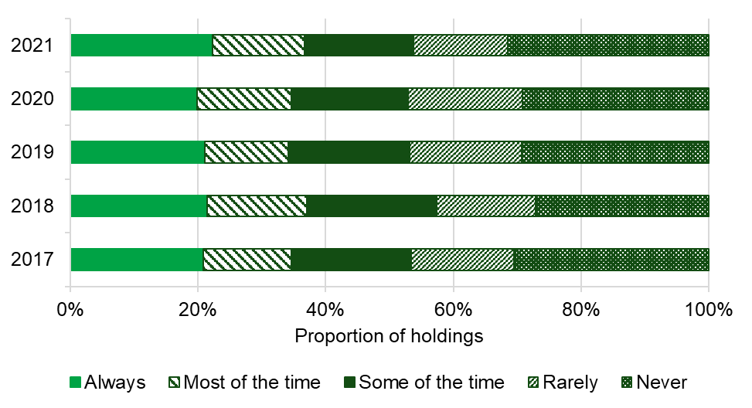
Almost a quarter (23%) of farmers offered alternative forages (other than grazed or conserved grass) to their cattle and sheep in 2021. This figure varies depending on farm type and dairy farmers are most likely to offer their livestock alternative forages (see Figure 8.2).
Figure 8.2: Proportion of holdings offering alternative forage crops to cattle and sheep by farm type: 2021(a)
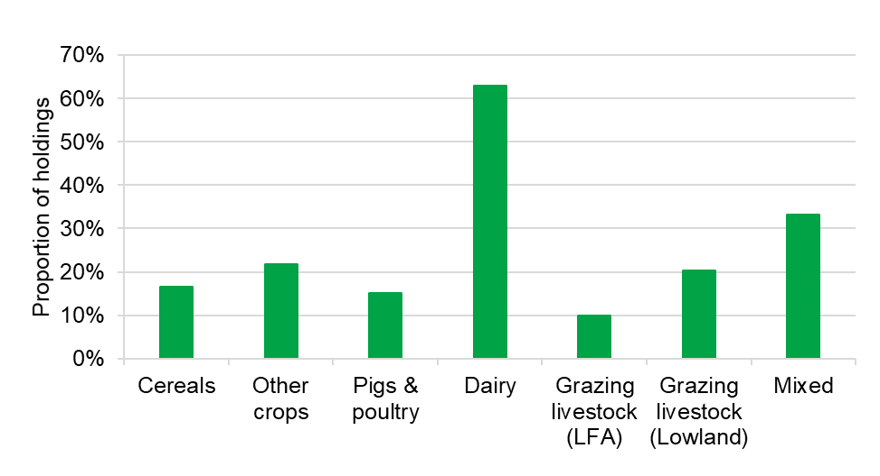
(a) For holdings with cattle and/or sheep
The most common of these forage crops were whole-crop silage and maize which were offered by 13% and 9% of farmers respectively.
Figure 8.3: Proportion of holdings using bulls with a high PLI when breeding dairy cows by frequency of use: 2017 - 2021 (a)
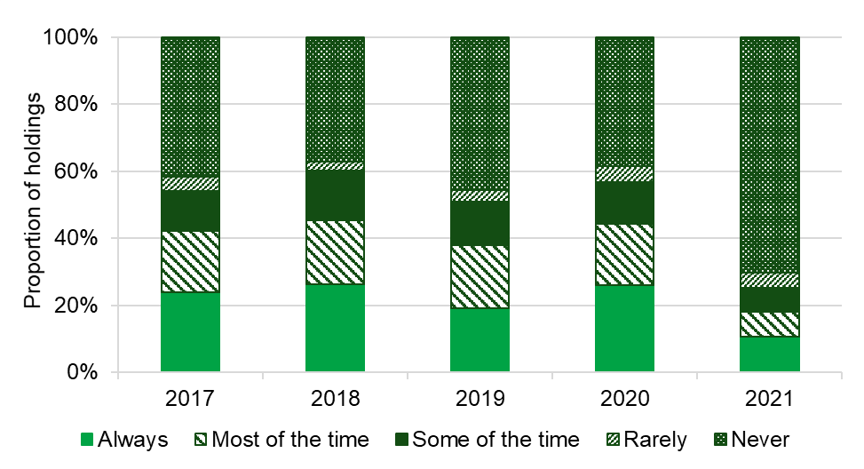
(a) For holdings with dairy cattle
In 2021, 11% of livestock holdings always used bulls with a high Profitable Lifetime Index (PLI) when breeding dairy cows. This was a decrease from 26% in 2020.
Figure 8.4: Proportion of holdings using bulls with high EBVs when breeding beef cattle by frequency of use: 2017 - 2021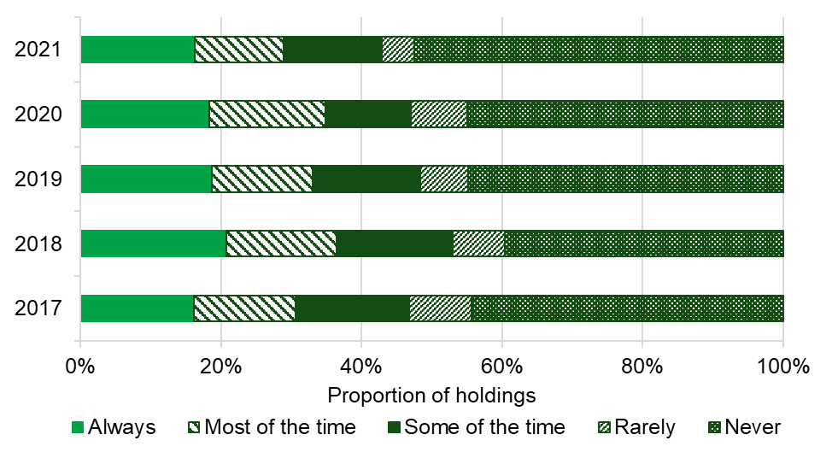
(a) For holdings with beef cattle
Estimated Breeding Values (EBV) estimate the genetic worth of animals using desirable traits such as meat production. Just under half (43%) of holdings used bulls with a high EBV at least some of the time when breeding beef cattle in 2021 (see Figure 8.4). The equivalent proportion of holdings using rams with a high EBV at least some of the time when breeding lambs was 48% (see Figure 8.5).
Figure 8.5: Proportion of holdings using rams with high EBVs when breeding lambs by frequency of use: 2017 - 2021 (a)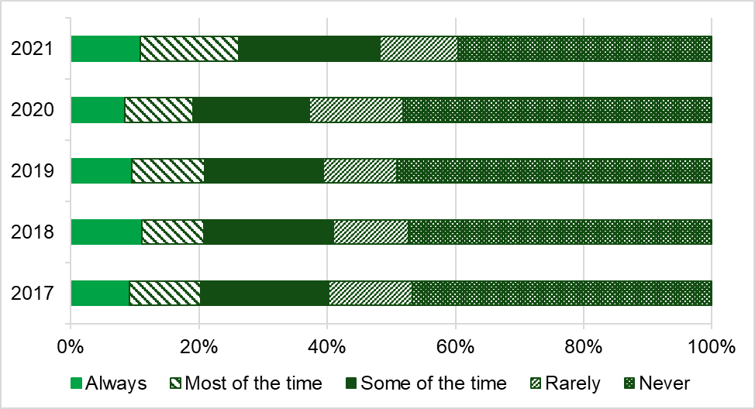 (a) For holdings with lambs
In addition to the proportion of holdings using bulls and rams with high EBVs (see Table 8.4 and 8.5) the proportion of beef cattle and lambs that this figure relates to has also been calculated (see Tables 8.6 and 8.7). By using responses from the 2019 June survey, we can give an indication of the proportion of animals that are covered by this practice. In 2021, the holdings using bulls and rams with high EBVs at least some of the time accounted for 56% of beef cattle and 55% of lambs at June 2019.
Table 8.1: Proportion of holdings using a ration formulation programme when planning cattle and sheep feeding regimes by frequency of use: 2019 – 2021
 | 2019 |  | 2020 |  | 2021
Frequency of use | % of holdings | 95% CI | % of holdings | 95% CI | % of holdings | 95% CI
Always | 21 | ±2 | 20 | ±2 | 22 | ±4
Most of the time | 13 | ±2 | 15 | ±2 | 14 | ±3
Some of the time | 19 | ±2 | 18 | ±2 | 17 | ±3
Rarely | 18 | ±2 | 18 | ±2 | 15 | ±3
Never | 29 | ±3 | 29 | ±2 | 31 | ±4
Based on 1,435 responses in 2019, 1,552 in 2020 and 1,207 in 2021 from holdings with cattle or sheep.
Source: Farm Practices Survey – Greenhouse gas mitigation

Table 8.2: Proportion of holdings offering alternative forages to cattle and sheep: 2020 – 2021

 | 2020 |  | 2021
Alternative forage crop | % of holdings | 95% CI | % of holdings | 95% CI
Whole-crop silage | 13 | ± 2 | 13 | ±3
Maize | 11 | ±1 | 9 | ±2
Red clover | 6 | ±1 | 7 | ±2
Lucerne | 2 | ±1 | 2 | ±1
Triticale | 1 | ±0 | 1 | ±0
Any of the above | 24 | ±2 | 23 | ±3
None of these | 76 | ±2 | 77 | ±3
Based on 1,538 responses in 2020 and 1,184 in 2021 from holdings with cattle and sheep.
Source: Farm Practices Survey – Greenhouse gas mitigation

Table 8.3: Proportion of holdings using bulls with a high Profitable Lifetime Index (PLI) when breeding dairy cows by frequency of use: 2019 – 2021
 | 2019 |  | 2020 |  | 2021
Frequency of use | % of holdings | 95% CI | % of holdings | 95% CI | % of holdings | 95% CI
Always | 19 | ±3 | 26 | ±3 | 11 | ±4
Most of the time | 19 | ±3 | 18 | ±3 | 7 | ±4
Some of the time | 13 | ±3 | 12 | ±3 | 7 | ±5
Rarely | 3 | ±1 | 5 | ±2 | 5 | ±5
Never | 46 | ±4 | 39 | ±4 | 70 | ±8
Based on 543 responses in 2019, 518 in 2020 and 379 in 2021 from holdings with cattle or sheep.
Source: Farm Practices Survey – Greenhouse gas mitigation

Table 8.4: Proportion of holdings using bulls with a high Estimated Breeding Value (EBV) when breeding beef cattle by frequency of use: 2019 – 2021
 | 2019 |  | 2020 |  | 2021
Frequency of use | % of holdings | 95% CI | % of holdings | 95% CI | % of holdings | 95% CI
Always | 19 | ±3 | 18 | ±2 | 16 | ±3
Most of the time | 14 | ±2 | 17 | ±2 | 13 | ±3
Some of the time | 15 | ±2 | 12 | ±2 | 14 | ±3
Rarely | 7 | ±2 | 8 | ±2 | 5 | ±1
Never | 45 | ±3 | 45 | ±3 | 53 | ±4
Based on 1,031 responses in 2019, 1,102 in 2020 and 779 in 2021 from holdings with beef cattle.
Source: Farm Practices Survey – Greenhouse gas mitigation

Table 8.5: Proportion of holdings using rams with a high Estimated Breeding Value (EBV) when breeding lambs by frequency of use: 2019 – 2021
 | 2019 |  | 2020 |  | 2021
Frequency of use | % of holdings | 95% CI | % of holdings | 95% CI | % of holdings | 95% CI
Always | 10 | ±2 | 8 | ±2 | 11 | ±3
Most of the time | 11 | ±2 | 11 | ±2 | 15 | ±6
Some of the time | 19 | ±3 | 18 | ±3 | 22 | ±6
Rarely | 12 | ±3 | 15 | ±3 | 12 | ±3
Never | 49 | ±4 | 48 | ±4 | 40 | ±7
Based on 769 in 2019, 830 in 2020 and 642 in 2021 from holdings with lambs.
Source: Farm Practices Survey – Greenhouse gas mitigation
Table 8.6: Proportion of beef cattle on holdings using bulls with a high Estimated Breeding Value (EBV) by frequency of use: 2019 – 2021
 | 2019 |  | 2020 |  | 2021
Frequency of use | % of beef cattle | 95% CI | % of beef cattle | 95% CI | % of beef cattle | 95% CI
Always | 25 | ±4 | 28 | ±4 | 21 | ±5
Most of the time | 15 | ±3 | 19 | ±3 | 19 | ±6
Some of the time | 17 | ±3 | 14 | ±3 | 15 | ±4
Rarely | 6 | ±2 | 8 | ±2 | 6 | ±3
Never | 37 | ±4 | 32 | ±4 | 38 | ±5
Based on 1,031 responses in 2019, 1,102 in 2020 and 779 in 2021 from holdings with beef cattle.
Source: Farm Practices Survey – Greenhouse gas mitigation

Table 8.7: Proportion of lambs on holdings using rams with a high Estimated Breeding Value (EBV) by frequency of use: 2019 - 2021
 | 2019 |  | 2020 |  | 2021
Frequency of use | % of lambs | 95% CI | % of lambs | 95% CI | % of lambs | 95% CI
Always | 12 | ±4 | 11 | ±3 | 13 | ±4
Most of the time | 15 | ±4 | 14 | ±4 | 16 | ±7
Some of the time | 24 | ±4 | 21 | ±4 | 25 | ±6
Rarely | 10 | ±3 | 13 | ±3 | 14 | ±5
Never | 39 | ±5 | 41 | ±5 | 31 | ±6
Based on 769 responses in 2019, 830 in 2020 and 642 in 2021 from holdings with lambs.
Source: Farm Practices Survey – Greenhouse gas mitigation

Section 9 – About these statistics
Survey methodology
The Farm Practices Survey (FPS) – Greenhouse Gas Mitigation edition is usually run annually and collects information on a diverse range of topics usually related to the impact of farming practices on the environment. Each year, stakeholders are invited to request new questions to help inform policy decisions and provide evidence on progress towards agricultural and environmental sustainability.
This release includes the results from the FPS run in February 2021. The survey largely focused on practices relating to greenhouse gas mitigation, similar in content to FPS surveys run in February over the previous nine years. Topics covered include nutrient and manure management, anaerobic digestion, emissions, fertiliser, manure and slurry spreaders and storage, farm health planning, grassland and grazing and livestock breeding and feeding practices. Where comparisons with earlier years are possible, the results are displayed alongside those from previous years.
The results provided in this release are based on questions sent to approximately 7,000 holdings in England. These holdings were targeted by farm type and size to ensure a representative sample. The survey was voluntary and the response rate was approximately 30%. Thank you to all of the farmers who completed a survey form.
Thresholds were applied to ensure that very small holdings with little agricultural activity were not included in the survey. To be included in the main sample, holdings had to have at least 50 cattle, 100 sheep, 100 pigs, 1,000 poultry or 20 hectares of arable crops or orchards. Therefore, all results given in this statistical release reflect almost 60 thousand holdings that exceed these thresholds out of the total English population of almost 106 thousand commercial holdings.
A breakdown of the number of holdings within the population and the sample are shown in Table 9.1.
Table 9.1 Sample design
Farm type | Number of eligible holdings in England | Number of holdings sampled | Response rate (%)
Cereals | 15,087 | 1,487 | 33
Other crops | 5,881 | 961 | 29
Pigs & poultry | 3,563 | 572 | 22
Dairy | 5,635 | 1,017 | 30
Grazing livestock (LFA) | 8,130 | 861 | 33
Grazing livestock (lowland) | 15,481 | 1,486 | 27
Mixed | 5,424 | 640 | 33
All Farms | 59,201 | 7,024 | 30

Data analysis
Results have been analysed using a standard methodology for stratified random surveys to produce national estimates. With this method, all the data are weighted according to the inverse sampling fraction.

Accuracy and reliability of the results
We show 95% confidence intervals against the results. These show the range of values that may apply to the figures. They mean that we are 95% confident that this range contains the true value. They are calculated as the standard errors (se) multiplied by 1.96 to give the 95% confidence interval (95% CI). The standard errors only give an indication of the sampling error. They do not reflect any other sources of survey errors, such as non-response bias.
Definitions
Where reference is made to the type of farm in this document, this refers to the ‘robust type’, which is a standardised farm classification system. Farm sizes are based on the estimated labour requirements for the holding, rather than its land area. The farm size bands used within the detailed results tables which accompany this publication are shown in the table below. Standard Labour Requirement (SLR) is defined as the theoretical number of workers required each year to run a holding, based on its cropping and livestock activities.
Farm size | Definition
Small | Less than 2 SLR
Medium | 2 to less than 3 SLR
Large | 3 or more SLR

Availability of results
This release contains headline results for each section. The full breakdown of results, by region, farm type and farm size can be found at the Farm Practices Survey.
Other Defra statistical notices can be viewed on the Defra website.
Data uses
The Farm Practices survey is used to investigate the impact of farming on the environment and to provide up-to-date agri-environment information on current issues to help inform policy decisions. The survey has a wide customer base both internal and external to Defra including Natural England, English Heritage, ADAS, the Environment Agency and the NFU.
Data from the Farm Practices Survey are used in Defra’s greenhouse gas (GHG) indicator framework. The framework, initially developed as part of the 2012 review of progress in reducing GHG emissions from English agriculture, consists of ten key indicators covering farmer attitudes and knowledge, the uptake of mitigation methods and the GHG emission intensity of production (GHG produced per tonne of crop or litre of milk or kilogramme of meat produced) in key agricultural sectors. Information from the survey also feeds into the Defra publication, Agricultural Statistics and Climate Change which provides background context to the current understanding of agriculture and GHG emissions.
In partnership with the Devolved Administrations, the Government invested over £12 million, over a four and a half year period, on the development of an improved GHG inventory to strengthen understanding of on farm emissions. Information from the Farm Practices Survey fed into this project which should enable greater precision in reporting GHG emissions from the sector, so that, going forward, changes made to farming practices to reduce GHG emissions will be properly recognised in the inventory.
Additional information
For more information on how the data was collected you can view the questions asked on our survey form in Annex I over the page.
Finally, we are keen to hear your thoughts on this statistical release. If you found the data useful or if you have any other comments please let us know. You can contact us via the phone number on the front page or alternatively email us at farming-statistics@defra.gov.uk.

