Application Decision
by Richard Holland
Appointed by the Secretary of State for Environment, Food and Rural Affairs
Decision date: 09 June 2021

Application Ref: COM/3266791
Stroud Green, Berkshire
Register Unit No: CL 10
Commons Registration Authority: West Berkshire District Council
- The application, dated 4 January 2021, is made under Section 38 of the Commons Act 2006 (the 2006 Act) for consent to construct works on common land.
- The application is made by West Berkshire Council.
- The works comprise the installation of approximately 100 m² of rubber mulch safety surfacing and around 10 pieces of outdoor adult gym equipment occupying an area of approximately 400 m² of the common.

Decision
  - Consent is granted for the works in accordance with the application dated 4 January 2021 and the plans submitted with it subject to the following conditions:
      - the works shall begin no later than three years from the date of this decision;
      - the exercise equipment shall be grey or black in colour; and
      - if the exercise equipment is removed the common shall be reinstated to grass within one month from the date of removal.
  - For the purposes of identification only the location of the works is shown in outlined in red on the attached plan.

Preliminary Matters

  - I have had regard to Defra’s Common Land Consents Policy Guidance in determining this application under section 38, which has been published for the guidance of both the Planning Inspectorate and applicants. However, every application will be considered on its merits and a determination will depart from the guidance if it appears appropriate to do so. In such cases, the decision will explain why it has departed from the guidance.

  - This application has been determined solely on the basis of written evidence. The applicant is unable to specify exactly what the equipment will look like until the tender process for the works has been completed. However, the applicant has provided an illustration of the sort of equipment it requires and I have taken this into account in deciding the application.

  - I have taken account of the representations made by the Open Spaces Society (OSS) and Rebecca MacPhee.
  - I am required by section 39 of the 2006 Act to have regard to the following in determining this application:-
- the interests of persons having rights in relation to, or occupying, the land (and in particular persons exercising rights of common over it);
- the interests of the neighbourhood;
- the public interest; and
- any other matter considered to be relevant.

Reasons

The interests of those occupying or having rights over the land
  - The owner of the common is the applicant. The applicant confirms that the rights registered over the common are not exercised and the common has been managed as an open recreational space. I am satisfied that the works will not harm the interests of those occupying or having rights over the land.

The interests of the neighbourhood and the protection of public rights of access
  - The interests of the neighbourhood test relates to whether the works will impact on the way the common land is used by local people. The applicant explains that it has been shown that outdoor gyms help promote fitness and well-being. The types of equipment proposed include a spinning bicycle, elliptical trainer, rowing machine and equipment to develop upper body and arm strength such as chin up machine and bench presser. The common is on the edge of a known ‘pocket of deprivation’ and the aim is to encourage greater physical activity amongst older youths and adults. The works are the result of discussions between the local community and local ward member. No fencing is proposed. Given that each piece of equipment is relatively small and that the works will occupy only a small proportion of the common as a whole, I am satisfied that the proposal will not seriously interfere with public access.
  - In response to concerns about health and safety, the applicant advises that the equipment is designed for outdoor open spaces, use by families and adults and safety features are part of the design and construction. The project includes safety surfacing and small children should not be left unsupervised on the equipment. The applicant explains that there has been a vast increase in the numbers of people visiting open spaces. The works will provide a facility for older users of the common who make up a sizeable proportion of visitors. The applicant agrees to a condition suggested by the OSS to remove the equipment at the end of its useful life and return to grass open space. However, and as the applicant points out, this would not preclude a further similar Section 38 application.
  - I note that the works have local support. I consider that, overall, the works are likely to increase and improve opportunities for recreation and use of the common by local people without materially affecting access. I conclude that the works will benefit the interests of the neighbourhood by improving the way the common is currently used for recreation.

Nature conservation
  - I am satisfied that there is no evidence before me to indicate that the works will harm nature conservation interests.

Conservation of the landscape
  - The applicant explains that the common is a large urban open space which lends itself to greater recreational use and the addition of the proposed equipment is not out of keeping with an urban location. The small area the equipment occupies will be set behind existing trees which will hide the equipment to some extent and the works are not of a scale to be imposing.
  - The common has no special landscape designation. The pieces of equipment are relatively small and unobtrusive and I agree that the works are not out of keeping with the common’s urban location. However, I consider that a condition stipulating that the exercise equipment is either grey or black in colour is appropriate to mitigate any visual impact; bright colours would be intrusive. I am satisfied that, subject to the condition, the works will conserve the landscape.

Archaeological remains and features of historic interest
  - The applicant has submitted comments from West Berkshire Archaeology advising that there are no known archaeological features in the area or any significant archaeological implications. I am satisfied that there is no evidence before me to indicate that the works will harm archaeological remains and features of historic interests.

Conclusion
  - I conclude that the works will enhance local people’s recreational enjoyment of the common and will not harm the other interests set out in paragraph 6 above. Consent for the works is granted subject to the conditions set out at paragraph 1.

Richard Holland

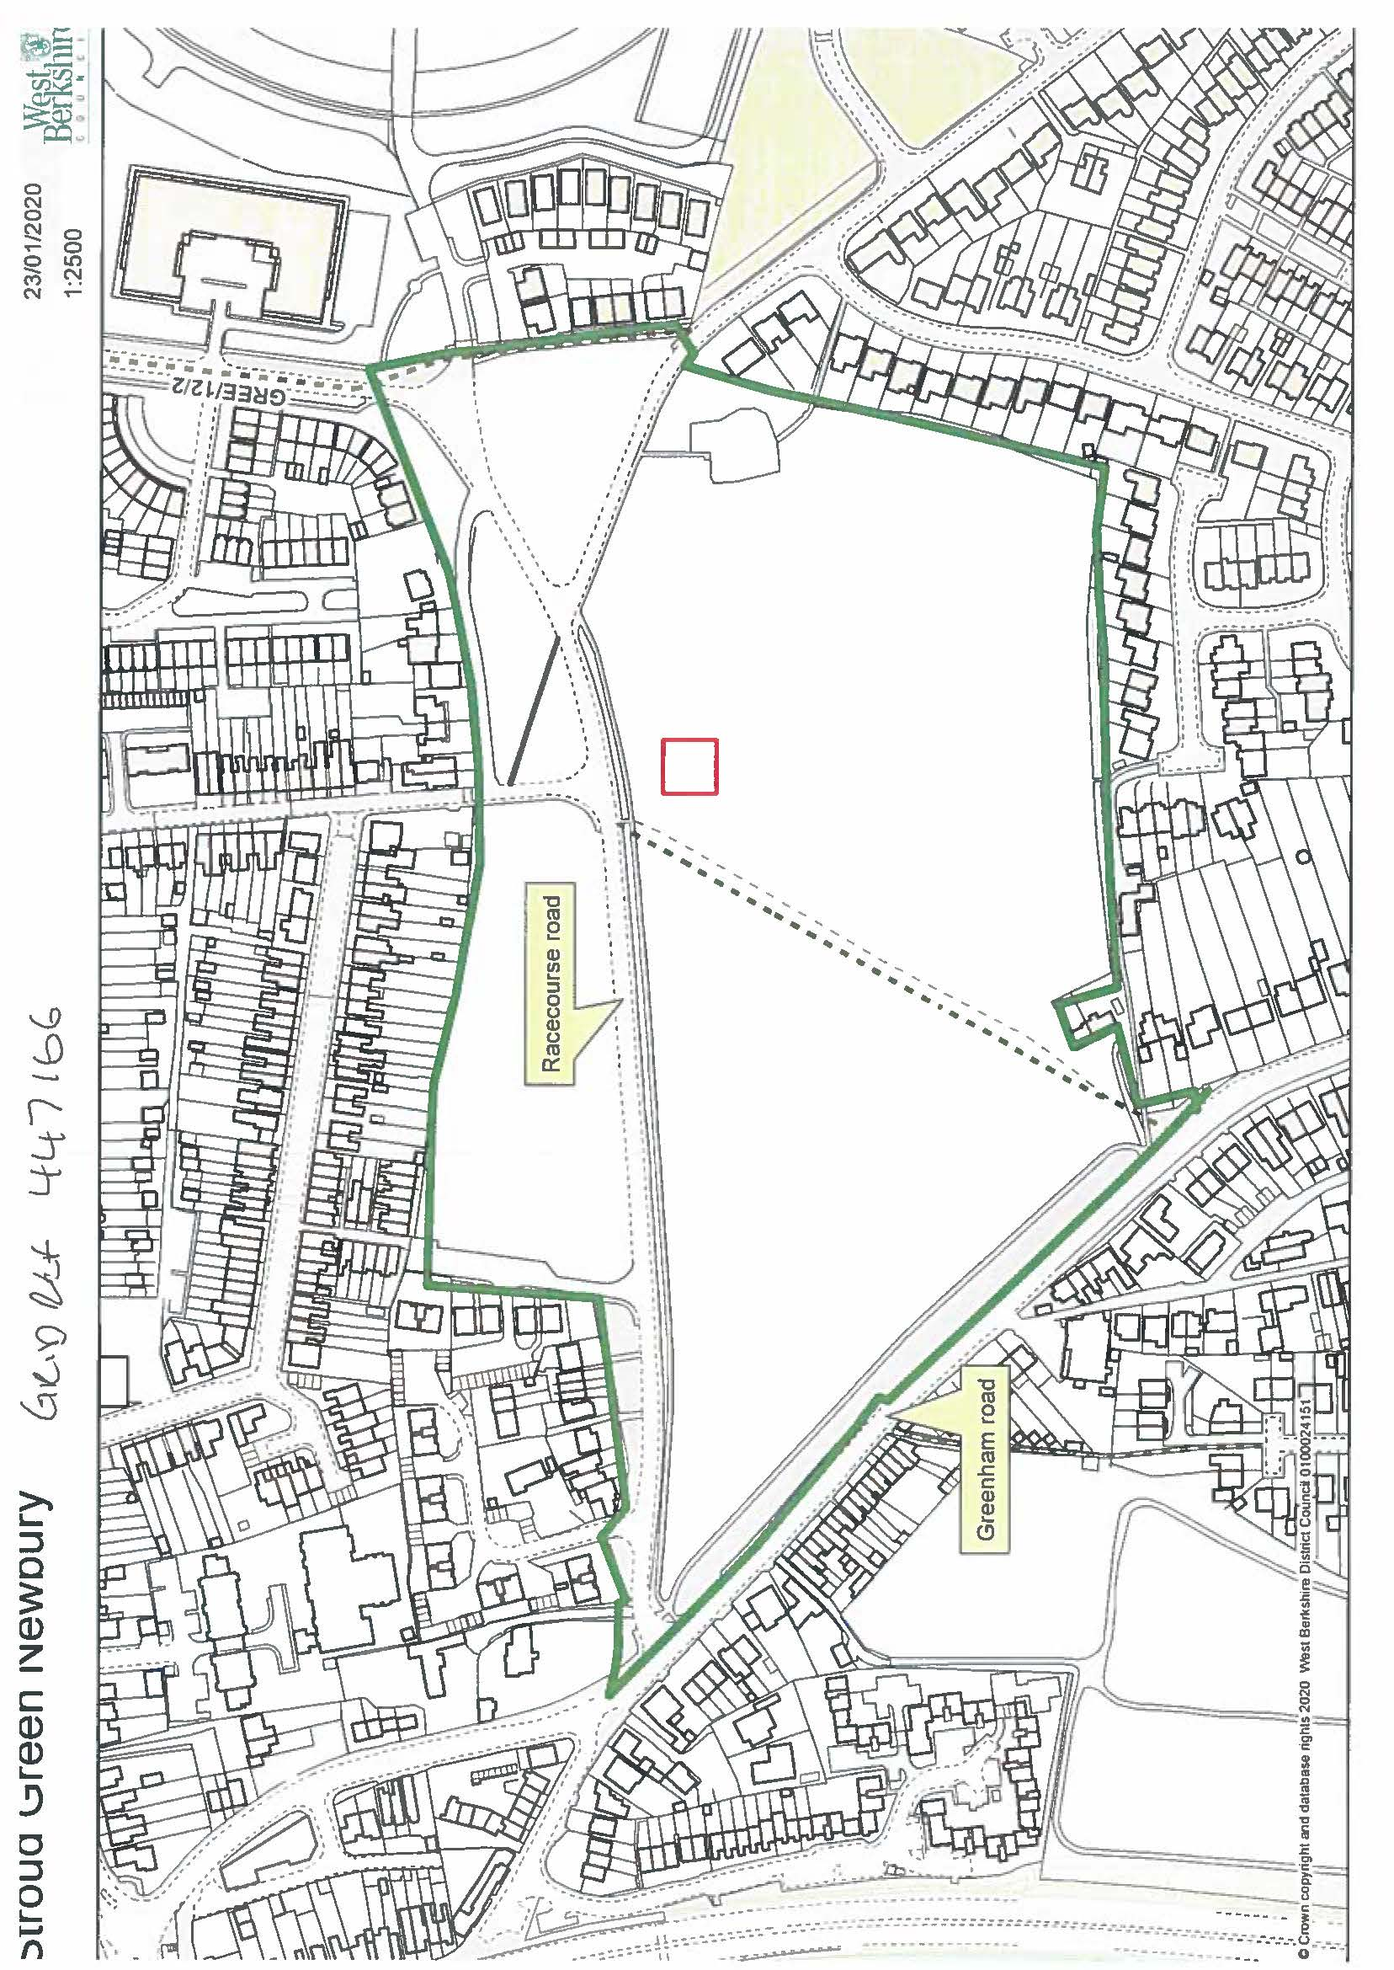

Common Land Consents Policy Guidance (Defra November 2015)
Section 39(2) of the 2006 Act provides that the public interest includes the public interest in; nature conservation; the conservation of the landscape; the protection of public rights of access to any area of land; and the protection of archaeological remains and features of historic interest.

