Application Decision
by Richard Holland
Appointed by the Secretary of State for Environment, Food and Rural Affairs
Decision date: 29 April 2021

Application Ref: COM 3262579
Grassington Moor, North Yorkshire
Register Unit No: CL77
Commons Registration Authority: North Yorkshire County Council.
- The application, dated 23 October 2020, is made under Section 38 of Commons Act 2006 (the 2006 Act) for consent to carry out restricted works on common land.
- The application is made by The Grassington Mines Appreciation Group.
- The works comprise the permanent placing of 1.2m high post and rail stocknet safety fencing around 15 mineshafts. The works will enclose 1 area of 7m x 8m (56m²) and 14 areas each of no more than 3.6m x 3.6m (12.96m²).

Decision
  - Consent is granted for the works in accordance with the application dated 23 October 2020 and accompanying plan, subject to the following conditions:-
  - the works shall begin no later than three years from the date of this decision; and
  - the common shall be restored within one month of the completion of the works.
  - For the purposes of identification only the locations of the works are shown as red dots on the attached plan.
Preliminary Matters

- I have had regard to Defra’s Common Land Consents Policy in determining this application under section 38, which has been published for the guidance of both the Planning Inspectorate and applicants. However, every application will be considered on its merits and a determination will depart from the policy if it appears appropriate to do so. In such cases, the decision will explain why it has departed from the policy.

- This application has been determined solely on the basis of written evidence. I have taken account of the representations from the Open Spaces Society (OSS), which does not object to the proposed works.
- I am required by section 39 of the 2006 Act to have regard to the following in determining this application:-
- the interests of persons having rights in relation to, or occupying, the land (and in particular persons exercising rights of common over it);
- the interests of the neighbourhood;
- the public interest; and
- any other matter considered to be relevant.

Reasons

The interests of those occupying or having rights over the land
- The common land has no known owner. The Commons Commissioner recorded in his decision of 14 April 1988 (Ref 268/U/302) that he was not satisfied that any person is the owner of the land and it will therefore remain subject to (local authority) protection under section 9 of the Commons Registration Act 1965. The applicant confirms that North Yorkshire County Council, in its capacity as commons registration authority, advised that it had no official comments to make regarding the proposed works.
- The common land register records extensive grazing rights and also rights of turbary, estovers, pannage and sporting rights. The applicant advises that grazing and sporting rights are exercised daily. The applicant further advises that all the active commoners are members of the Grassington Moor Management Association, which was consulted about the application but has not commented. I am satisfied that the proposed works will not harm the interests of those occupying or having rights in relation to the land. Indeed, one of the stated reasons for the works is to protect animals from injury or death, which I conclude to be in the interests of those who graze animals over the land.

The interests of the neighbourhood and the protection of public rights of access
- The interests of the neighbourhood test relates to how the works will impact on the way the land is used by local people and is closely related to public rights of access. The area is remote but lies within the Yorkshire Dales National Park (YDNP) so is likely to attract recreational visitors. The application plan shows a number of tracks running through the area, some of which are very close to the mineshafts proposed to be enclosed.
- The purpose of the proposed fencing is to make the area safe for people and animals by excluding access over the shafts. The applicant advises that the 15 mineshafts have been mostly capped with railway sleepers and spoil heaps but they have been covered in such a way that the shafts are not easily visible and the wooden sleepers have begun to rot away, presenting a danger to members of the public as they cross the moor. I conclude that the proposed works to prevent users of the common from walking over the shafts will be of significant health and safety benefit and are in the interests of the neighbourhood and public rights of access.
- The proposed fencing will permanently exclude the public from up to 243m² of the common, which equates to approximately 0.003% of the common as a whole. I conclude that the fencing will only negligibly reduce the land available for public access.

Nature conservation and conservation of the landscape
- There is no evidence before me to indicate that the proposed works will harm nature conservation interests.
- The applicant advises that the proposed fencing is in keeping with other fences across the moor, including some already in place around uncapped mineshafts, and is of a type used widely throughout the YDNP so would not look out of place. Nevertheless, I consider that 15 new areas of permanent fencing, albeit very small, are bound to have some detrimental visual affect. However, I consider that the harm to the landscape will not be unacceptable and that the benefit to the neighbourhood outweighs any such harm. I am satisfied that the amount of fencing proposed is the minimum required to protect the safety of the public and grazing animals and that the proposals will help to ensure that the natural beauty of the YDNP is conserved.

Archaeological remains and features of historic interest
- Due to its lead mining history the majority of Grassington Moor is classed as a Scheduled Ancient Monument (SAM). The applicant wishes to preserve the mines across the moor without making unnecessary modifications to existing features. The applicant believes that capping the shafts with concrete or other intrusive methods would not be reasonable or acceptable and that the proposed fencing is the least intrusive and most effective way of ensuring that the mines are preserved and the safety of the public and animals is maintained. I am satisfied that this is the case and that the proposed works are in the interests of preserving the historic mineshafts.
- Historic England has granted Secretary of State Scheduled Monument Consent for the fencing works and I am satisfied that adherence to conditions attached to that consent will ensure that the above interests are not harmed.

Conclusion
- I conclude that for reasons of health and safety the proposed works are in the interests of the public and those exercising rights of common. They are also in the interests of preserving the SAM and will not unduly harm the other interests set out in paragraph 5 above. Consent is therefore granted for the works subject to the conditions set out in paragraph 1.

Richard Holland

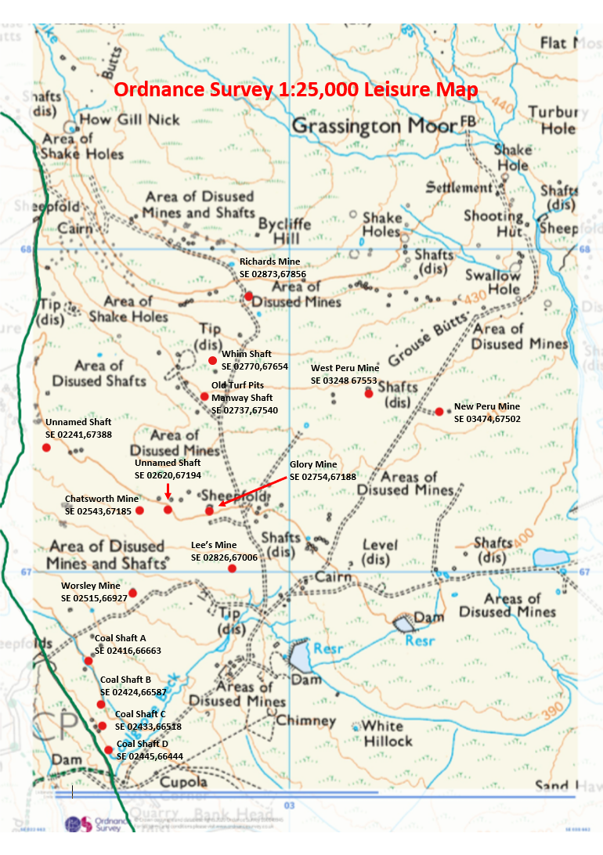

Common Land Consents Policy (Defra November 2015)
Section 39(2) of the 2006 Act provides that the public interest includes the public interest in; nature conservation; the conservation of the landscape; the protection of public rights of access to any area of land; and the protection of archaeological remains and features of historic interest.

