Application Decision
by Richard Holland
Appointed by the Secretary of State for Environment, Food and Rural Affairs
Decision date: 05 May 2021

Application Ref: COM/3268499
The Green, Ashley Green, Buckinghamshire
Register Unit No: CL29
Commons Registration Authority: Buckinghamshire Council

- The application, dated 5 February 2021, is made under Section 38 of the Commons Act 2006 (the 2006 Act) for consent to carry out restricted works on common land.
- The application is made by Ashley Green Parish Council.
- The works comprise the erection of a 21 m² timber WC and coffee kiosk lean-to building (8.5 m long x 2.47 m deep x 3 m high) and associated area of grey sandstone paving (50 m² on the common) to the rear of the Memorial Hall.

Decision
  - Consent is granted for the works in accordance with the application dated 5 February 2021 and the plan submitted with it, subject to the following conditions:-

(i) the works shall begin no later than three years from the date of this decision;

(ii) the common shall be restored within one month from the completion of the works.
  - For the purposes of identification only the location of the works is shown outlined in red on the attached plan.

Preliminary Matters
  - I have had regard to Defra’s Common Land consents policy in determining this application under section 38, which has been published for the guidance of both the Planning Inspectorate and applicants. However, every application will be considered on its merits and a determination will depart from the policy if it appears appropriate to do so. In such cases, the decision will explain why it has departed from the policy.

  - This application has been determined solely on the basis of written evidence.

  - I have taken account of the representation made by the Open Spaces Society (OSS).
  - I am required by section 39 of the Commons Act 2006 to have regard to the following in determining applications under Article 12 of the 1967 Act:-
- the interests of persons having rights in relation to, or occupying, the land (and in particular persons exercising rights of common over it);
- the interests of the neighbourhood;
- the public interest; and
- any other matter considered to be relevant.

Reasons

The interests of those occupying or having rights over the land
  - The landowner, Buckinghamshire Council has been consulted and has not objected to the application. The applicant advises that the landowner is supportive of the community’s proposals. There are no registered rights over the common. I consider therefore that the works will not harm the interests of those occupying the land and the interests of those having rights is not at issue.

The interests of the neighbourhood and the protection of public rights of access
  - The interests of the neighbourhood test relates to whether the works will impact on the way the common land is used by local people and is closely linked with interests of public access. The works form part of a well-being facility funded by Chiltern District Council’s 2019-20 Large Project Fund, to improve the community’s experience and enjoyment of the common. The applicant explains that it is working in conjunction with The Ashley Green Community Association, who lease the Memorial Hall and associated surrounding land, to deliver the scheme. The works have community support and there are no similar or competing facilities or services in the village. The hard paving is required to provide access to an accessible toilet, the coffee kiosk and will link to a larger children’s playground and adult exercise area off the common. Planning permission has been granted for the works (PL/21/0243/FA).
  - The works are located on a small section of common to the rear of the existing Memorial Hall. Due to its relatively small size and location, the site has little recreational value and I do not consider that the works will seriously harm public access. The works are supported by the local community and are likely to provide a valuable amenity for those wishing to enjoy the common. I conclude that the works will benefit the interests of the neighbourhood by improving use of the common for recreation and will not seriously impinge on public rights of access.

Nature conservation
  - There is no evidence before me to indicate that the works will harm any statutorily protected sites or other nature conservation interests.

Conservation of the landscape
  - The proposed building is timber framed and weatherboarded to match the extended Memorial Hall. Consent was given for the extension in 2013 (COM/416). The applicant explains that the works are considered a suitable, subtle and modest extension, providing a greater positive impact positioned alongside the well-being facility, than a more prominent structure to the front of the Memorial Hall. The OSS does not object to the works provided, where applicable, the common is restored to its former state after works are completed. The applicant confirms that the works area will be made good and restored for public use.
  - The works represent a minor extension to the existing Memorial Hall, infilling a small area to the rear of the building. I consider that as the works are relatively small scale, are screened from the rest of the common and are in keeping with the Memorial Hall and surroundings, they will conserve the landscape.

Archaeological remains and features of historic interest
  - There is no evidence before me to suggest that the works are likely to harm any archaeological remains at the site.

Conclusion
- I conclude that the works will enhance people’s enjoyment of the common and will not harm the other interests set out in paragraph 6 above. Consent is therefore granted for the works subject to the conditions set out in paragraph 1.

Richard Holland

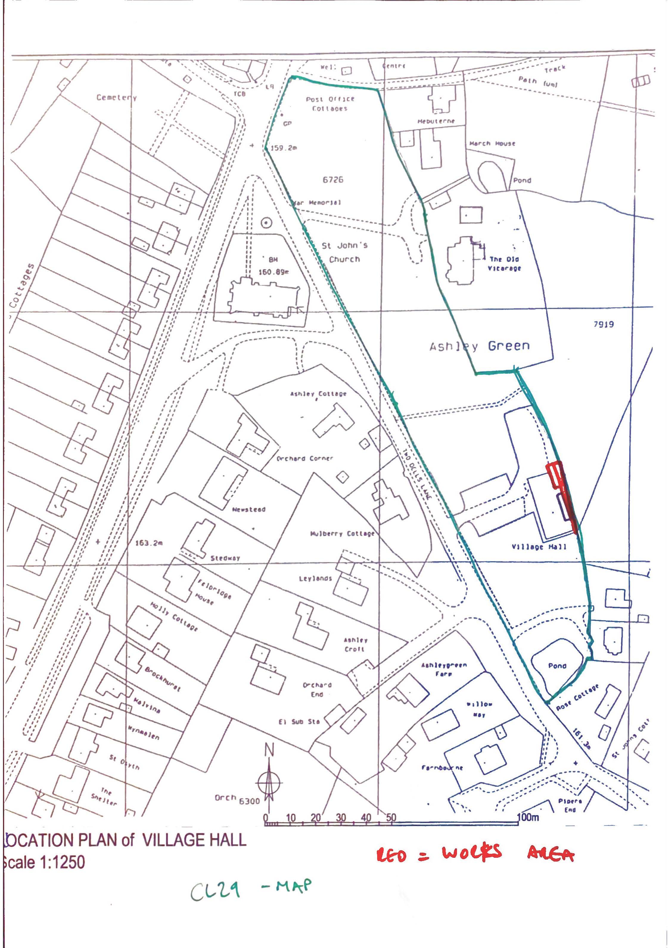

Common Land consents policy (Defra November 2015)
Section 39(2) of the 2006 Act provides that the public interest includes the public interest in; nature conservation; the conservation of the landscape; the protection of public rights of access to any area of land; and the protection of archaeological remains and features of historic interest.

