Application Decision
by Richard Holland
Appointed by the Secretary of State for Environment, Food and Rural Affairs
Decision date: April 2021

Application Ref: COM/3267846
GREEN STREET COMMON, LONDON BOROUGH OF BROMLEY
Register Unit No: CL 84
Commons Registration Authority: London Borough of Bromley
- The application, dated 27 January 2021, is made under Article 12 of the Ministry of Housing and Local Government Provisional Order Confirmation (Greater London Parks and Open Spaces) Act 1967 for consent to construct works on common land.
- The application is made by the London Borough of Bromley.
- The works comprise 19m by 6m soil scrape, followed by the potential addition of chalk as well as wildflower seeds in order to create an area of suitable habitat offering landscape connectivity for specialist butterfly species.

Decision
  - Consent is granted for the works in accordance with the application dated 27 January 2021 and the plan submitted with it subject to the condition that the works shall begin no later than three years from the date of this decision.
  - For the purposes of identification only the location of the works is shown outlined in red on the attached plan.

Preliminary Matters
  - Although the application is made under section 38 of the 2006 Act, the legislation relating to applications for consent to carry out works on a common controlled and managed by a London Borough is Article 12 of the Ministry of Housing and Local Government Provisional Order Confirmation (Greater London Parks and Open Spaces) Act 1967.
  - I have had regard to Defra’s Common Land Consents Policy Guidance in determining this application, which has been published for the guidance of both the Planning Inspectorate and applicants. However, every application will be considered on its merits and a determination will depart from the guidance if it appears appropriate to do so. In such cases, the decision will explain why it has departed from the guidance.

  - This application has been determined solely on the basis of written evidence.

  - I have taken account of the representation made by Katie Hargreaves.
  - I am required by section 39 of the 2006 Act to have regard to the following in determining applications under Article 12 of the 1967 Act:-
- the interests of persons having rights in relation to, or occupying, the land (and in particular persons exercising rights of common over it);
- the interests of the neighbourhood;
- the public interest; and
- any other matter considered to be relevant.

Reasons

The interests of those occupying or having rights over the land
  - The common is owned and managed by the applicant. There are no rights of common registered. I am satisfied that the works will not harm the interests of those occupying the land and the interests of those having rights is not at issue.

The interests of the neighbourhood and the protection of public rights of access
  - The interests of the neighbourhood test relates to whether the works will impact the way the common land is used by local people. The applicant confirms that the works will not impede the current public right of way. Although the works will not prevent access, to avoid damaging wildflowers it is likely that those using the common will not wish to walk across the application site in any event. By enhancing biodiversity (as dealt with at paragraphs 10 and 11 below) the works will make the common a more attractive place for visitors. I conclude that the works will benefit the interests of the neighbourhood and protect public rights of access.

Conservation of the landscape and nature conservation interests
  - The applicant explains that the works are intended to enhance biodiversity to create landscape connectively for rare and declining butterfly species as part of the Brilliant Butterflies project. The works, once completed and the wildflowers established, will be floristically diverse and visually appealing.
  - I am satisfied that the works are likely to benefit nature conservation interests and enhance the landscape value of the common.

Archaeological remains and features of historic interest
  - I am satisfied that there is no evidence before me to indicate that the works will harm archaeological remains and features of historic interests.

Conclusion
  - I conclude that the works are likely to benefit landscape, nature conservation and neighbourhood interests and will not impact the other interests set out in paragraph 7 above. Consent for the works is therefore granted subject to the condition set out at paragraph 1.

Richard Holland

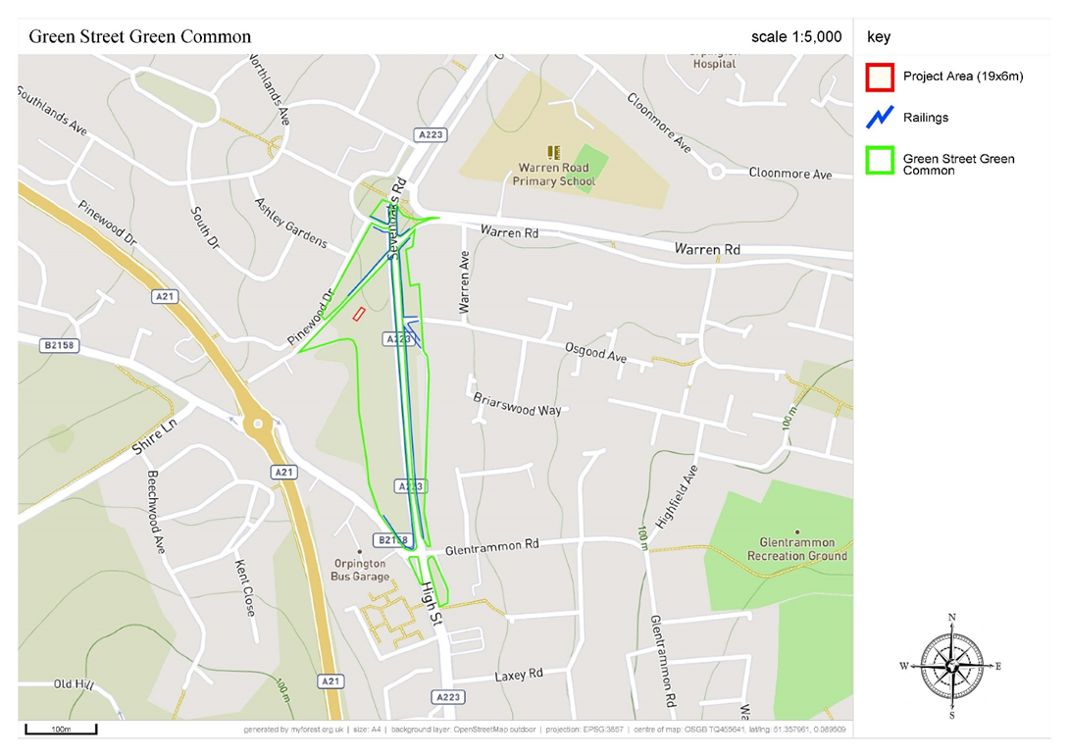

Common Land Consents Policy Guidance (Defra November 2015)
Section 39(2) of the 2006 Act provides that the public interest includes the public interest in; nature conservation; the conservation of the landscape; the protection of public rights of access to any area of land; and the protection of archaeological remains and features of historic interest.

