Application Decision
by Richard Holland
Appointed by the Secretary of State for Environment, Food and Rural Affairs
Decision date: 20 April 2021

Application Ref: COM 3266161
Southampton Common
Register Unit No: CL1
Commons Registration Authority: Southampton City Council.
- The application, dated 19 November 2020, is made under Section 38 of Commons Act 2006 (the 2006 Act) for consent to carry out restricted works on common land.
- The application is made by Southampton City Council.
- The works of approximately six months duration to deliver the Southampton Cycle Network along The Avenue comprise:
- installation of permanent hard surfacing on existing highway (carriageway and footway) and on 8 small parcels of existing highway verge;
- installation of permanent highway and traffic related structures comprising cycle land segregators, signage, lighting upgrades, dropped kerb crossings and traffic signals; and
- temporary erection of fencing for health and safety purposes to facilitate i) and ii) above as well as to facilitate the removal of unnecessary hard surfacing from the highway and the relaying of grass turf.

Decision
  - Consent is granted for the works in accordance with the application dated 19 November 2020 and accompanying plans, subject to the following conditions:-
  - the works shall begin no later than three years from the date of this decision; and
  - all temporary fencing shall be removed and the common shall be restored within one month from the completion of the works.
  - For the purposes of identification only the location of the works is shown in red on the attached plan.
Preliminary Matters

- I have had regard to Defra’s Common Land Consents Policy in determining this application under section 38, which has been published for the guidance of both the Planning Inspectorate and applicants. However, every application will be considered on its merits and a determination will depart from the policy if it appears appropriate to do so. In such cases, the decision will explain why it has departed from the policy.
- This application has been determined solely on the basis of written evidence. I have taken account of the representations from the Open Spaces Society (OSS), Southampton Commons and Parks Protection Society (SCAPPS), Southampton Common Forum (SCF), Oakmount Triangle Residents Association (OTRA) and Mr Godfrey Doyle.
- I am required by section 39 of the 2006 Act to have regard to the following in determining this application:-
- the interests of persons having rights in relation to, or occupying, the land (and in particular persons exercising rights of common over it);
- the interests of the neighbourhood;
- the public interest; and
- any other matter considered to be relevant.

Reasons

The interests of those occupying or having rights over the land
- The land is owned by the applicant, Southampton City Council (SCC), which proposes to carry out the works in accordance with its published ‘Cycling Southampton’ strategy for 2017-2027. The common land register records no rights of common over the land. I am satisfied that the proposed works will not harm the interests of those occupying or having rights in relation to the land.

The interests of the neighbourhood and the protection of public rights of access
- The works proposed are spread out along an approximate 1.5km section of the A33 road known as The Avenue, which forms part of the registered common and runs north to south through it, effectively separating the common into two sections. All the proposed works fall within the highway or land immediately next to it.
- The interests of the neighbourhood test relates to how the works will impact on the way the common land is used by local people and is closely related to rights of public access. SCC considers that the application land provides no discernible benefit to users of the common beyond its use as a highway. I consider that this is likely to be the case and although there may be significant disruption and inconvenience to pedestrians using pavements along The Avenue and adjoining roads during the works period, I am satisfied that it will be limited to highway land and that the works will not unacceptably harm local and public use of recreational areas of the common.
- SCC says the proposed works are necessary to enable the delivery of The Avenue cycle corridor phase of the cycle strategy, which is intended to provide cyclists with an alternative to using footpaths on the common either side of the road. I consider that this will allow separation of cyclists wishing to pass quickly through the common from recreational users of the common and will be of benefit to both.
- The proposals include a new toucan crossing on The Avenue just north of the Winn Road junction where SCC says there is a clear desire line to the children’s playground and the Cowherds public house. I consider that the proposed crossing will improve public access from one section of the common to the other at this location.
- I am satisfied that the works, while benefiting cyclists, will also add to people’s enjoyment of the common.

Nature conservation
- Much of the common abutting the west side of The Avenue forms the Southampton Common Site of Special Scientific Interest (SSSI), which supports a range of species including endangered bats and newts. NE was consulted by SCC about the proposed works but has not commented.
- SCC confirms that none of the works will extend into the hedgerow beyond the highway boundary and that there will be no loss of trees. Works close to tree roots will be ‘no dig’ construction and cellweb root protection will be installed. The bat species present are sensitive to nocturnal light levels so the proposed lighting has been designed to avoid illumination of vegetation. Whilst it is proposed to improve/upgrade lighting along the corridor there will be no increase in lighting levels in recognition of its potential impact on wildlife. The majority of the works will be carried out during the winter months when the endangered species of newts and bats are in hibernation and all construction workers will be briefed on environmental impacts and mitigations.

- Whilst some of the proposed works will be very close to the SSSI boundary I am satisfied that they are unlikely to unacceptably harm nature conservation interests.

Conservation of the landscape
- Whilst The Avenue is an A class road within a city, it runs through a sizable area of common land and is largely lined with trees on each side with grass verges between the road and the pavement in places. This offers a pleasant verdant setting for those walking on the common and for those travelling along The Avenue.
- The works include re-surfacing and changes/increases to street furniture, structures and signage, which I consider are likely to urbanise the common to some extent. Whilst the works include removal of some unnecessary hardstanding and the laying of grass turf in its place, I consider it unlikely that such measures will fully compensate for the urbanising effect of the other works. I conclude that on balance the proposed works are likely to be of some harm to landscape interests but that the harm, in itself, will not be serious enough to prevent the granting of consent.

Archaeological remains and features of historic interest
- There is no evidence before me to suggest that any such remains and features are present. SCC advises that if any archaeological discovery is made on site works will be stopped and the relevant body will be informed and asked to investigate. I am satisfied that such action will ensure that no harm comes to any archaeological remains or features of historic interest that may be present.

Other matters
- Most of those to have made representations expressed concerns that the application includes no proposals for the roadside section of The Avenue between Winn Road and Westwood Road, where cyclists will have to continue to share pathways with pedestrians. SCAPPS additionally is concerned that there are no proposals to improve the Lovers Walk path, which begins at the Winn Road junction. SCC advises that plans to improve the Winn Road to Westwood Road section with a gravel surface will not need section 38 consent and that a separate application for re-surfacing of Lovers Walk may follow in due course subject to other necessary approvals. Whilst I recognise these concerns, I can only have regard to the works applied for in determining the application before me. Similarly, the concerns expressed about highway safety and the perceived inadequacy of the scope of the works in terms of SCC’s cycling strategy are not matters for my consideration.

Conclusion
- I conclude that the proposed works will help to separate recreational users of the common from cyclist through-traffic. This, together with the provision of a toucan crossing, will enhance people’s enjoyment of the common. The works will not unduly harm the other interests set out in paragraph 5 above. Consent is therefore granted for the works subject to the conditions set out in paragraph 1.

Richard Holland

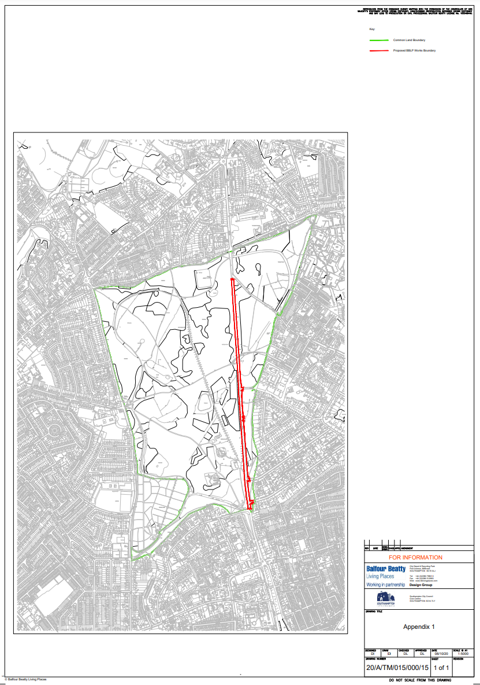

Common Land Consents Policy (Defra November 2015)
Section 39(2) of the 2006 Act provides that the public interest includes the public interest in; nature conservation; the conservation of the landscape; the protection of public rights of access to any area of land; and the protection of archaeological remains and features of historic interest.

