Application Decision
by Richard Holland
Appointed by the Secretary of State for Environment, Food and Rural Affairs
Decision date: 12 February 2021

Application Ref: COM 3262574
Central Parks, Southampton
Register Unit No: CL3
Commons Registration Authority: Southampton City Council.
- The application, dated 15 October 2020, is made under Section 38 of Commons Act 2006 (the 2006 Act) for consent to carry out restricted works on common land.
- The application is made by the Police and Crime Commissioner’s Office, Hampshire, Isle of Wight, Portsmouth & Southampton.
- The works in the Hoglands Park area of Central Parks comprise:
- installation of a permanent 5m high prefabricated modular building (9.6m x 12m) on a weight distributed pad;
- a temporary tracker mat for site delivery vehicle use; and
- a temporary works area surrounding the site enclosing up to 424m² of land with 85.5m of 3m high hoarding type fencing for approximately five weeks.

Decision
  - Consent is granted for the works in accordance with the application dated 15 October 2020 and accompanying plan, subject to the following conditions:-
  - the works shall begin no later than three years from the date of this decision; and
  - all temporary fencing and mats shall be removed and the common shall be restored within one month of the completion of the works.
  - For the purposes of identification only the location of the works is shown on the attached plan.
Preliminary Matters

- I have had regard to Defra’s Common Land Consents Policy in determining this application under section 38, which has been published for the guidance of both the Planning Inspectorate and applicants. However, every application will be considered on its merits and a determination will depart from the policy if it appears appropriate to do so. In such cases, the decision will explain why it has departed from the policy.

- The published application notice describes the permanent works as a modular building, the application form describes it as a modular community building and the application plan describes it as a pavilion. I am satisfied that it is sufficiently clear from the application what the building is for and I refer to it in this Application Decision as ‘the new building’. The application form and application plan also refer to a temporary tracker mat to be laid on the common for approximately 4 hours to protect the green space during delivery of the new building to the site. Whilst the mat is not referred to in the application notice, I am satisfied that it forms part of the proposed works and, as such, can be considered in this Application Decision.
- This application has been determined solely on the basis of written evidence. I have taken account of the representations from the Open Spaces Society (OSS), Southampton Commons and Parks Protection Society (SCAPPS) and The Gardens Trust/Hampshire Gardens Trust (GT/HGT).
- I am required by section 39 of the 2006 Act to have regard to the following in determining this application:-
- the interests of persons having rights in relation to, or occupying, the land (and in particular persons exercising rights of common over it);
- the interests of the neighbourhood;
- the public interest; and
- any other matter considered to be relevant.

Reasons

The interests of those occupying or having rights over the land
- The land is owned by Southampton City Council (SCC), which has not commented on the proposals. However, the applicant has advised that SCC will be funding and managing the installation of the building and I have no reason to believe otherwise. There is one right of common in favour of Hampshire County Council to dig marl over part of the land comprised in this register unit. The County Council has confirmed that whilst this right is still exercisable, it is not its intention to exercise it. I am satisfied that the proposed works will not harm the interests of those occupying or having rights in relation to the land.

The interests of the neighbourhood and the protection of public rights of access
- The interests of the neighbourhood test relates to how the works will impact on the way the land is used by local people and is closely related to rights of public access. Central Parks comprises five interconnected parks, of which the eastern most is Hoglands. SCAPPS has advised that Hoglands was intended to be used for organised team sports, with the others laid out as ornamental gardens. For well over a century Hoglands was used for team cricket matches but that has diminished over recent decades, to be replaced by informal casual recreation.
- Two buildings sit on a hard surface in the centre of Hoglands. Both were once used in connection with the playing of cricket but no longer serve that purpose. One is in poor condition but remains in some use and is to be retained. The other is derelict and includes a toilet block that has been out of use for 15 years. It is described by the applicant as unattractive and structurally unsafe and is to be demolished. It is also described as a crime generator in an area with disproportionately high crime rates, which I take to mean it is seen as a magnet for anti-social and criminal behaviour, although no evidence has been provided to support this assertion. The new building is proposed to replace the existing building on a slightly smaller footprint and will have a gross internal floor area (GIFA) of 104m².
- The applicant says the new building will be used as a community space to optimize the public experience of the park, particularly for those regularly using it for sports and skating (there is a skatepark at Hoglands) and to give family and friends a hub whilst games are in play. More specifically, the applicant envisages that the space could be used by an active local music group, which already makes use of the other building, or as a facility to support clubs, for example a tea room, changing facilities or storage space. The charity Active Nation apparently hopes to reignite grass roots cricket at Hoglands.
- It is proposed to erect hoarding style temporary fencing around the new building during its installation. This will create a works compound enclosure of up to 424m² which will exclude public access during the five week period of works. I am satisfied that excluding the public from the work site in this way is necessary for health and safety reasons and that the extent of the compound does not exceed what is reasonable. I consider that the temporary enclosure of land and the placing of a tracker mat, which will only be in place for 4 hours, will not significantly harm public access interests in the long term.
- I conclude that the proposed works will encourage legitimate recreational use of the land and help to bring Hoglands back into traditional use as a place for organised team sports. Whilst the old and new buildings are not the same shape, their footprints are similar and I am satisfied that the new building will present no new impediment to public access over the land.

Nature conservation, archaeological remains and features of historic interest and
conservation of the landscape
- There is no evidence before me to indicate that the proposed works will harm nature conservation interests or harm any archaeological remains or features of historic interest.
- SCAPPS and GT/HGT raised some concerns that the design of the new building, which will sit in the centre of the Grade II listed parkland, is unexciting and pedestrian. GT/HGT was also concerned that the footprint would encroach into the path layout, which is one of the features leading to the listing. However, both accepted that the design is the product of funding and time constraints and welcomed the investment in the park.
- I agree that the new building, which is constructed from modern materials, is somewhat functional in appearance but it will be visually preferable to the existing derelict and unsightly building and will not harm the traditional landscape of the park. A condition can be attached to the consent to ensure that the land affected by the temporary hoarding and tracker mat will be restored to its original state.

Conclusion
- I conclude that the proposed works will help to promote legitimate and traditional recreational use of the common and will not unduly harm the other interests set out in paragraph 6 above. Consent is therefore granted for the works subject to the conditions set out in paragraph 1.

Richard Holland

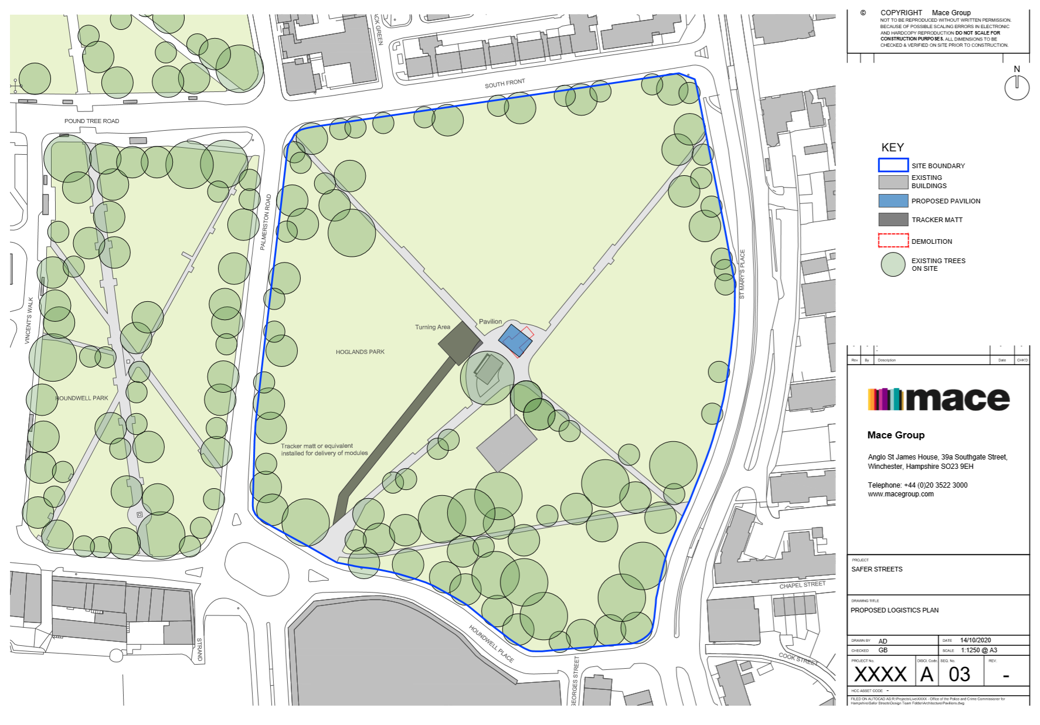

Common Land Consents Policy (Defra November 2015)
Section 39(2) of the 2006 Act provides that the public interest includes the public interest in; nature conservation; the conservation of the landscape; the protection of public rights of access to any area of land; and the protection of archaeological remains and features of historic interest.

