Application Decision
by Richard Holland
Appointed by the Secretary of State for Environment, Food and Rural Affairs
Decision date: April 2021

Application Ref: COM/3263012
Cranswick Village Green, East Yorkshire
Register Unit No: VG18
Commons Registration Authority: East Riding of Yorkshire Council
- The application, dated 10 November 2020, is made under Section 38 of the Commons Act 2006 (the 2006 Act) for consent to carry out restricted works on a village green.
- The application is made by Hutton Cranswick Parish Council.
- The works comprise a 30 m zip line, a climber with scramble net traverse rope, safety surfacing improvements and realignment/additional 24 m of boundary fencing.

Decision
  - Consent is granted for the works in accordance with the application dated 10 November 2020 and accompanying plan, subject to the condition that the works shall begin no later than three years from the date of this decision.
  - For the purposes of identification only the location of the works are shown in red on the attached plan.
Preliminary Matters

- Cranswick Village Green (‘the green’) is subject to a scheme of management made under the Commons Act 1899 and is therefore land to which section 38 of the 2006 Act applies.

- I have had regard to Defra’s Common Land Consents Policy in determining this application under section 38, which has been published for the guidance of both the Planning Inspectorate and applicants. However, every application will be considered on its merits and a determination will depart from the policy if it appears appropriate to do so. In such cases, the decision will explain why it has departed from the policy.

- This application has been determined solely on the basis of written evidence.

- I have taken account of the representations made by the Open Spaces Society (OSS), Historic England (HE), M J and C A Setterington and P A Waddington.
- I am required by section 39 of the 2006 Act to have regard to the following in determining this application:-
- the interests of persons having rights in relation to, or occupying, the land (and in particular persons exercising rights of common over it);
- the interests of the neighbourhood;
- the public interest; and
- any other matter considered to be relevant.

Reasons

The interests of those occupying or having rights over the land
- The applicant is the landowner. There are no rights of common registered over the green. I am satisfied that the works will benefit the interests of those occupying the land and the interest of those having rights over the land is not at issue.

The interests of the neighbourhood and the protection of public rights of access
- The interests of the neighbourhood test relates to whether the works will impact on the way the land is used by local people. The applicant explains that the installation of two new pieces of play equipment is needed to give children an opportunity to learn, be challenged and improve physical development and the additional fencing will maintain the safety of the children using the play area. The works have been granted planning permission (21/00255/PLF).
- In response to representations, the applicant comments that the works were discussed at parish council meetings, the minutes of which are included in a bulletin sent to every village household and published online. Positive feedback has been received from key groups within the village, including the nearby school. The growing village population and increased school intake has led to overcrowding and overuse of the existing play area, resulting in a high proportion of the council’s budget spent on maintenance and repair of the play items. Feedback also indicated that the variety of play equipment is limited; the new climbing equipment is lower in height and safer to use. The zip line is a popular, modern addition. The increase in the footprint of the play area is minimal (149 m² of the 26300 m² green), as much of the existing play area will be used for the works, and needed to retain well used picnic benches, maintain safety and protect the green. The applicant adds that many residents in the village have complained that the green is not used often enough.
- I note that the works are intended to improve recreational opportunities on the green for an increasing village population and are in response to local feedback and concerns of overcrowding and lack of variety of play items. While the works will make use of the existing play area, an increase to both boundary fencing and the overall footprint of the play area is required to accommodate the additional play items. I consider that the very modest increase (less than 0.6% of the green) to the play area and boundary fencing is unlikely to impinge significantly on access or interfere with the way the common is currently used. I am satisfied that, overall, the neighbourhood will benefit from the improvement to recreational facilities that the works will bring about and public rights of access will be protected.

Nature conservation
- There is no evidence before me to indicate that the proposed works will harm nature conservation interests.

Conservation of the landscape
- Those raising concerns about the application point out that the play area was enlarged in 2011 to include larger items of play equipment and the green forms part of, and is central to, a designated conservation area. The East Riding of Yorkshire Council’s Cranswick Conservation Area Appraisal dated July 2006, also submitted by the applicant with the application, considers that an existing pond and the play area have, to some extent, intruded into the landscape setting and the further introduction of non-green elements would be a retrograde step. Further concerns raised include poor drainage, the impact on nearby mature trees, a street lamp, power supply and footpath. In response the applicant explains that the works have been designed to fit within the existing tree line to minimise any visual impact. Materials sympathetic to the green such as wood and grass lock matting will be used. The distance of the works from residential properties has been correctly considered and the ground conditions scrutinised.
- In conclusion, the works will be sited next to an existing play area, they will match the current play equipment and realign and extend existing paled timber fencing. Although the works will have some visual impact, I consider that this will be mitigated by the use of natural materials in keeping with the existing play area. The works will, to some extent, be screened by surrounding trees, especially during the summer. The zip line will remain unfenced. I conclude that overall, the works are sympathetic to the green and any limited visual impact is outweighed by the benefits to the neighbourhood from improvements to recreational opportunities. The effect of the works on the living conditions of nearby residents is a matter for the planning system and is not something which carries weight in my determination of the application.

Archaeological remains and features of historic interest
- HE advise that the applicant contact the relevant local authority and check the Historic Environment Record (HER) for the area. The applicant has confirmed that the Humber Archaeological Partnership has been consulted about the application; it has not commented on the proposal. I am satisfied that there is no evidence before me to indicate that the works will harm archaeological remains and features of historic interest.

Other matters
- The OSS question whether consent is needed as the applicant may have powers to undertake the works under the scheme of management. However, applicants should satisfy themselves that commons consent is needed for the works. In this case, an application for consent has been made and it has been decided on its merits.

Conclusion
- I conclude that any limited impact the proposed works have on the landscape is outweighed by the benefits to the interests of the neighbourhood. The works will not adversely impact the other interests set out in paragraph 7 above. Consent is therefore granted for the works subject to the condition set out in paragraph 1.

Richard Holland

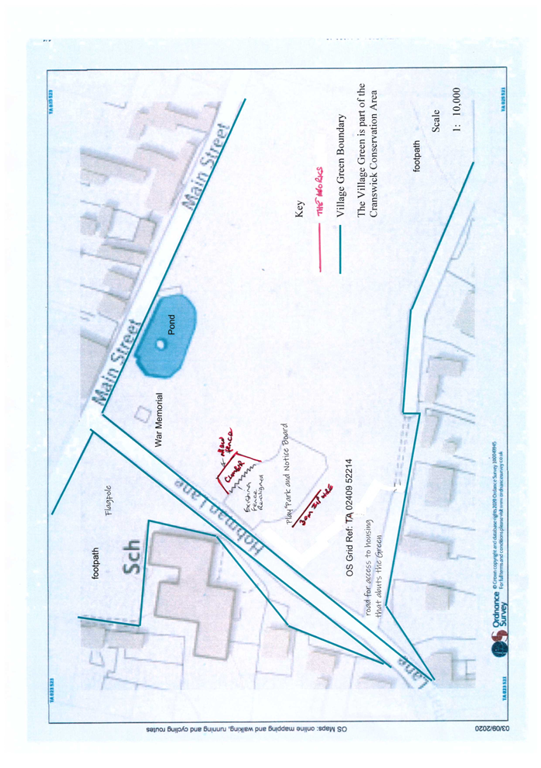

Common Land Consents Policy (Defra November 2015)
Section 39(2) of the 2006 Act provides that the public interest includes the public interest in; nature conservation; the conservation of the landscape; the protection of public rights of access to any area of land; and the protection of archaeological remains and features of historic interest. `

