Application Decision
by Richard Holland
Appointed by the Secretary of State for Environment, Food and Rural Affairs
Decision date: 21 January 2021
Application Ref: COM/3259689
Knodishall Common, Suffolk
Register Unit No: CL19 and CL133
Commons Registration Authority: Suffolk County Council

- The application, dated 10 July 2020, is made under Section 38 of the Commons Act 2006 (the 2006 Act) for consent to carry out restricted works on common land.
- The application is made by Savills (UK) Ltd for UK Power Networks.
- The works of up to approximately 4 weeks duration comprise:
- underground installation by open trench of approximately 100m of new low voltage electricity cables;
- removal of approximately 115m of overhead line; and
- temporary 1m high (approx.) plastic safety barriers as necessary during the period of works.

Decision

1. Consent is granted for the works in accordance with the application dated 10 July 2020 and the plans submitted with it subject to the following conditions:
- the works shall begin no later than 3 years from the date of this decision; and
- all safety barriers shall be removed, and the land shall be fully reinstated, within one month from the completion of the works.

2. For the purposes of identification only, the location of the proposed works is shown on the attached plan.
Preliminary Matters

3. I have had regard to Defra’s Common Land consents policy in determining this application under section 38, which has been published for the guidance of both the Planning Inspectorate and applicants. However, every application will be considered on its merits and a determination will depart from the policy if it appears appropriate to do so. In such cases, the decision will explain why it has departed from the policy.

4. This application has been determined solely on the basis of written evidence. I have taken account of the representation made by the Open Spaces Society (OSS), which does not object to the application.

5. I am required by section 39 of the 2006 Act to have regard to the following in determining this application:-
- the interests of persons having rights in relation to, or occupying, the land (and in particular persons exercising rights of common over it);
- the interests of the neighbourhood;
- the public interest; and
- any other matter considered to be relevant.

Reasons

The interests of those occupying or having rights over the land

6. The application land straddles two separate common land register units.

7. The common land register for CL19 records Charles Alfred Smith and Georgina Eveline Ransby of Myrtle Cottage as owners of part of the register unit, as instructed by Commons Commissioner Decision 34/U/45 of 24 February 1975. Following discussion with Ms Ransby’s husband, the applicant believes that there is no known owner of the area of land the subject of the application. The rights section of the register records rights of common in favour of Myrtle Cottage and the property known as Cosy Cot, which the applicant has advised are not exercised.

8. The common land register for CL133 records that it has no known owner and Commons Commissioner Decision 34/U/46 of 24 February 1975 instructs that it is subject to the protection of the local authority. The rights section of the register records no rights.

9. There is no evidence to suggest that the works are likely to harm the interests of those occupying or having rights over the land (and in particular persons exercising rights of common over it).

The interests of the neighbourhood and public rights of access

10. The application plan shows that most of the overhead line to be removed oversails residential properties abutting the commons. Planning permission has been granted to erect a taller dwelling at one of the properties, which will infringe on safety clearances such that the line needs to be diverted. Diverting the line underground is preferred by the applicant from a maintenance perspective as underground cables rarely fault, whereas overhead lines may be affected by adverse weather conditions or falling objects such as tree branches. The underground cables are proposed to be laid inside the common land boundary around and between the oversailed properties.

11. The interests of the neighbourhood test relates to whether the works will impact on the way the common land is used by local people and is closely linked with interests of public access on foot. The line of the underground cable begins outside the property known as The Mill House and runs north along roadside verge at the side of Mill Road. It then turns west along a narrow footpath, roughly following the boundary of the property known as The Forge, into a more open area of common land where the cable will reconnect to another overhead line. I consider it likely that the route described above is used by the local community and the public to access the commons from Mill Road or as a short-cut from Mill Road to Post Office Road. The narrow path section takes up the middle third of the proposed route.

12. The applicant has advised that the narrow footpath will have to be closed for about a week whilst the works take place, which will prevent its use and impact on anyone wishing to access the commons from Mill Road. However, the applicant has confirmed that there is an alternative footpath onto the commons approximately 40m further along Mill Road, which I do not consider to be an unreasonable distance for a short-term diversion. The applicant has also advised that the main point of access to the common land from Mill Road appears to be via a car park, although this is significantly further away and is unlikely to be used by persons accustomed to accessing the commons via the narrow path.

13. I consider that the closure of the narrow path for a week will not seriously harm public rights of access as there is an alternative access point onto the commons within a reasonable distance. I am satisfied that the trench works and safety barriers at the remaining two sections of the route will not interfere significantly with public access over the commons.

14. I conclude that public access over the commons will be maintained as far as is practically possible during the works. As the permanent works will be entirely underground and all safety barriers will be removed once the works are completed, which is expected to be within 4 weeks, I further conclude that the works will not have an unacceptable or lasting impact on local and public access rights over the commons.

The public interest

Nature Conservation, Archaeological remains and features of historic interest

15. Natural England and Historic England were consulted about the application but did not comment. There is no evidence before me that leads me to think the works will harm any statutorily protected sites or other nature conservation interests or any archaeological remains or features of historic interest.

Conservation of the landscape

16. The landscape will be improved by the removal of a visually intrusive overhead electrical line, which will be made possible by the laying of new underground cables. Whilst the trenches and safety barrier fencing will cause some visual harm, it will be short term and the land will be re-instated upon completion of the works, which can be ensured by attaching a suitable condition to the consent.

Conclusion

17. I conclude that the proposed works will not significantly harm the interests set out in paragraph 5 above; indeed, the undergrounding of the overhead line will improve the landscape and allow the safe development of a new dwelling, which would otherwise interfere with above ground electricity cables. Consent is therefore granted for the works subject to the conditions set out in paragraph 1.

Richard Holland

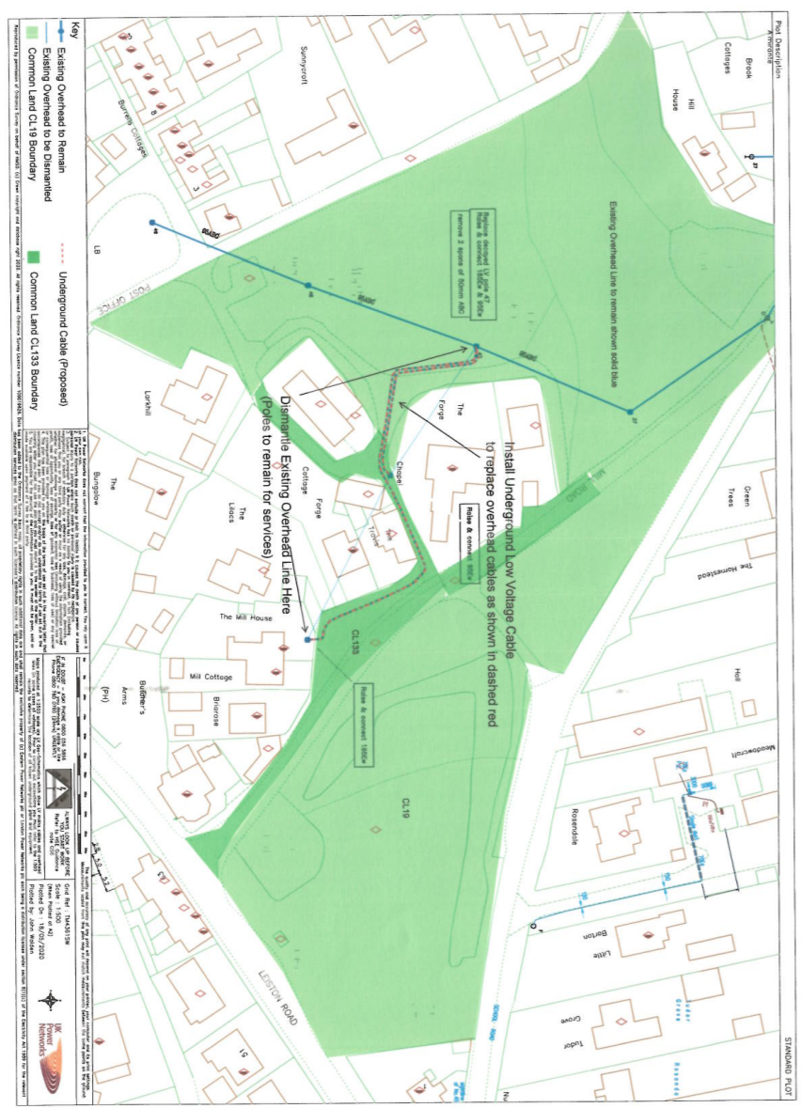

Common Land consents policy (Defra November 2015)
Section 39(2) of the 2006 Act provides that the public interest includes the public interest in; nature conservation; the conservation of the landscape; the protection of public rights of access to any area of land; and the protection of archaeological remains and features of historic interest.

