Application Decision
by Richard Holland
Appointed by the Secretary of State for Environment, Food and Rural Affairs
Decision date: 18 February 2021

Application Ref: COM/3254796
Baulking Common, Farringdon, Oxfordshire
Register Unit No: CL59
Commons Registration Authority: Oxfordshire County Council
- The application, dated 10 June 2020, is made under Section 38 of the Commons Act 2006 (the 2006 Act) for consent to carry out restricted works on common land.
- The application is made by Miss Jessica Reid.
- The works comprise a vehicular access way with a permeable Teram geotextile base and Type 1 (porous stone) surfaced finish covering 244.2 square metres (66 metres long, 3.7m wide) to serve a new development of two semi-detached cottages at Middle Green Farm from Baulking Lane.

Decision
- Consent is granted for the works in accordance with the application dated 10 June 2020 and the plan submitted with it subject to the following conditions:
- the works shall begin no later than 3 years from the date of this decision; and
- the land shall be fully reinstated within one month of completion of the works.
- For the purposes of identification only the location of the works is shown in red on the attached plan.
Preliminary Matters
- I have had regard to Defra’s Common Land consents policy in determining this application under section 38, which has been published for the guidance of both the Planning Inspectorate and applicants. However, every application will be considered on its merits and a determination will depart from the policy if it appears appropriate to do so. In such cases, the decision will explain why it has departed from the policy.
- Planning permission has been granted by Vale of White Horse District Council for the erection of two dwellings at Middle Green Farm, Baulking (Planning Decision PV18/V0721/FUL of 23 August 2018). Permission is conditional upon a new vehicular access and parking area being constructed and provided in accordance with the details shown in drawing number J0014572P01D (Condition 10). This drawing has been submitted in support of the application before me and shows the position of the proposed vehicular access over the common land.
- This application has been determined solely on the basis of written evidence. I have taken account of the representations made by Historic England (HE) and the Open Spaces Society (OSS). OSS objects to the application.
- I am required by section 39 of the 2006 Act to have regard to the following in determining this application:-
- the interests of persons having rights in relation to, or occupying, the land (and in particular persons exercising rights of common over it);
- the interests of the neighbourhood;
- the public interest; and
- any other matter considered to be relevant.

Reasons

The interests of those occupying or having rights over the land
- The land is owned by The Lonsdale Estate, which was consulted about the application but has not commented. The common land register records four rights to graze over the land. One of the rights holders, Mr Jim Matthews, exercises his right to graze cattle each year from 13 May to 20 December and was consulted by the applicant but did not comment. The applicant states that construction will only take place when there are no cattle on the land and with the agreement of the grazier. Whilst the proposed works will lead to the loss of 244.2 square metres of grazing land, this represents only 0.27% of the total area of the common, which I do not consider to be significant.
- I am satisfied that the works are unlikely to harm the interests of those having rights in relation to, or occupying, the land.

The interests of the neighbourhood and the protection of public rights of access
- The applicant seeks a new surfaced vehicular access way from Baulking Lane over the common to serve two new dwellings at Middle Green Farm (the development site). The interests of the neighbourhood test relates to whether the works will affect the way the common land is used by local people and is closely linked with public rights of access.
- The affected common land is a wide roadside verge with a footpath running through the centre parallel to Baulking Lane. The verge would not appear to be used for any purpose other than general access. The applicant says the footpath will be uninterrupted by construction but as the access way will cross the footpath it is likely that public access will be interrupted during the works for anyone wishing to use the footpath or accessing the common across the route of the access way. However, the works are expected to last no more than 4 days and I conclude that once constructed the proposed access way will have a negligible impact on the interests of the neighbourhood and public rights of access as local people and the wider public will be able to walk over it should they wish to.

Nature conservation and conservation of the landscape
- NE was consulted by the applicant but has not commented. There is no evidence before me to suggest that the works will harm nature conservation interests.
- The application land is described by the applicant as down to pasture and photographs she has submitted show that it sits within a rural setting. OSS describes Baulking Common as an attractive broad common running alongside Baulking Lane and is integral to the setting of the village. OSS considers that a track across the common would be an eyesore and would suburbanise it.
- There are a number of similar tracks serving nearby properties on Baulking Lane. The proposed access way would sit amongst these tracks and would have a surface in keeping with them. The common has no special landscape value and I do not consider that the proposed works would introduce an alien feature into the landscape or have an unduly urbanising effect on the common.
- The applicant confirms that any interruption to the surrounding ground will be restored to its original state, which can be secured by attaching a suitable condition to the consent. Whilst a new hard surface will cause some visual harm to landscape interests, I am satisfied that such harm will not be serious.

Archaeological remains and features of historic interest
- HE advised that the proposals will not harm any highly designated assets in the vicinity and it therefore has no objections. The applicant confirms that she will organise an archaeological watching brief in accordance with Condition 8 of the planning permission. I am satisfied that suitable measures to ensure against any harm to the above interests will be put in place.

Other relevant matters
- In response to an OSS request for clarification, the applicant says the proposed surface is not sealed and therefore does not require ‘additional consent’. However, an application for consent for the works has been made and it has been decided on its merits.
- In deciding the application I have considered OSS’ contention that it is not necessary to construct an access way over the common in order to provide vehicular access to the development site as it is within the applicant’s power to provide an internal connection from Middle Green Farm, which already has vehicular access from Baulking Lane. However, the applicant has said that she does not own the land over which such an access would run. The applicant had considered constructing an access way from Cottage Lane but the local planning authority advised against it as it would not meet highway standards and, in any case, it would only have marginally reduced the length of the access way over the common.
- Defra’s policy advises that ‘…where it is proposed to construct or improve a vehicular way across a common… such an application may be consistent with the continuing use of the land as common land, even where the vehicular way is entirely for private benefit, because the construction will not in itself prevent public access or access for commoners’ animals… The Secretary of State takes the view that, in some circumstances, a paved vehicular way may be the only practical means of achieving access to land adjacent to the common’. I am satisfied that the proposed works are consistent with Defra’s policy objectives.

Conclusion
- I conclude that the works are likely to be the only practical means of providing an access to the development site but, in any case, they will not unacceptably harm the interests set out in paragraph 6 above. Consent for the works is therefore granted subject to the conditions in paragraph 1.

Richard Holland

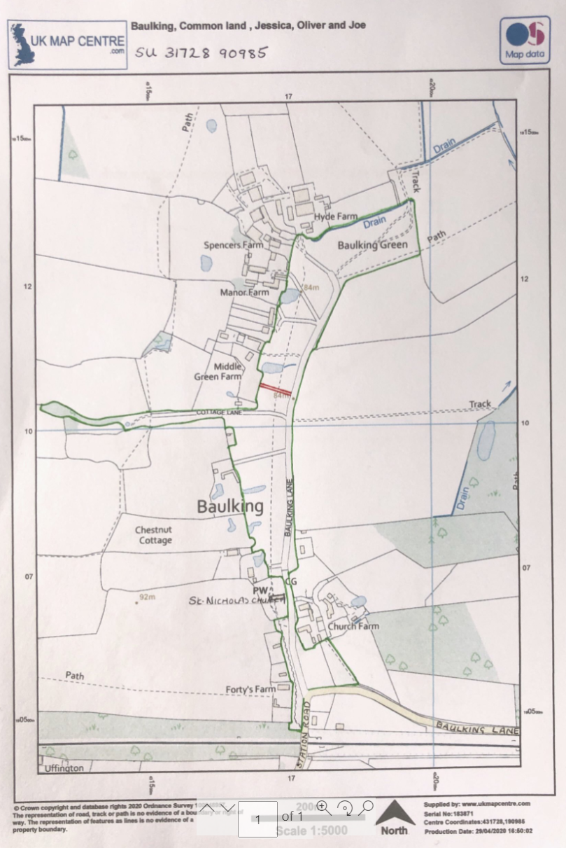

Common Land Consents policy (Defra November 2015)
Section 39(2) of the 2006 Act provides that the public interest includes the public interest in; nature conservation; the conservation of the landscape; the protection of public rights of access to any area of land; and the protection of archaeological remains and features of historic interest.

