Immunisation Division
For completion by UKHSA
VIP reference: VIP/
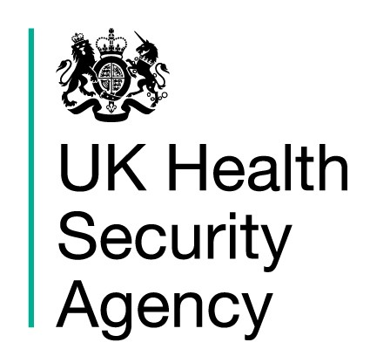

Surveillance of MMR, chickenpox or shingles vaccination in pregnancy

This form is for reporting MMR (measles, mumps, rubella), chickenpox or shingles vaccination of women who are pregnant or in the weeks prior to becoming pregnant. Please provide as much information as possible. Follow up will be with the GP practice.

Patient:

First Name | Surname | Date of birth | NHS/ CHI no

Notifying healthcare professional:

First Name | Surname | Profession | Telephone no | Contact email

The patient’s GP details (or alternative Health Professional for follow up):

Name | Practice Address | Practice email | Profession

Date pregnancy was confirmed (if known): | / /
Last menstrual period: | / /
Estimated date of delivery: | / /
Details of vaccine/s administered in, or shortly before, pregnancy (please complete this information for the vaccine/s concerned):

 | Vaccine and dose | Date of vaccination |  | Batch number | Brand name/ manufacturer
☐ | MMR dose 1 | / /
☐ | MMR dose 2 | / /
☐ | MMR dose uncertain | / /
☐ | Chickenpox vaccine | / /
☐ | Shingles vaccine* | / /
*Please ensure you provide additional information overleaf

Are you aware of any problems with the pregnancy to date? yes no not known

If yes, please briefly describe: __________________________________________________________________________________________________________________________________________________________________________________________________________

Reason for vaccination (MMR or chickenpox vaccine only):

seronegative healthcare worker, contact with case of: chicken pox measles mumps rubella

seronegative in antenatal screening pregnancy planning

other, please state:

For women given shingles vaccine please indicate why this vaccine was administered:
- In error, flu vaccine in pregnancy was indicated
- In error, pertussis vaccine in pregnancy was indicated
- Other reason, please specify ___________________________________________________________

Based on her medical history, was this lady considered immune to varicella-zoster virus?
No review was conducted
Yes, she was considered immune. This was due to prior history of chickenpox or shingles disease
Yes, she was considered immune. This was due to 2 documented doses of chickenpox vaccine
No, she was not considered immune. An urgent varicella antibody test (VZV IgG) has not been performed
No, she was not considered immune. An urgent varicella antibody test (VZV IgG) has been/ is being performed
- The result is not yet available
- The result indicated this lady was: VZV IgG negative VZV IgG positive OR VZV IgG equivocal

If this lady was not immune please indicate whether she was offered VZIG

- VZIG was administered on please provide date
 |  | / |  |  | /
- VZIG was offered but the offer was not accepted
- It was too late to administer VZIG

Signature |  |  |  | Name
 | Signature of the person submitting this form |  |  |  | Name of the person submitting this form (print)
Date of signature |  | / /

Please email completed form to: phe.vip@nhs.net Alternatively, forms can be sent to: Helen Campbell, Vaccination in Pregnancy Surveillance, Immunisation and Vaccine Preventable Diseases Division, UKHSA, 61 Colindale Avenue, London NW9 5EQ. Contact: 0208 327 7150

For summary safety information please see below but please consult the UKHSA website for further details. Further information and an initial survey form will usually be sent to the woman’s GP (unless otherwise specified).

For information

Vaccines containing varicella-zoster virus, rubella and MMR vaccines have been given inadvertently to pregnant women with no ill effects observed. Women should be reassured that in general, live virus vaccines are contraindicated for pregnant women because of the theoretical risk of transmission of the vaccine virus to the fetus. There has never been a case of congenital rubella syndrome or congenital varicella syndrome associated with a rubella vaccine virus or varicella-zoster vaccine virus respectively.

Most women of child-bearing age in the UK will be immune to chickenpox. If a pregnant woman has an uncertain history to chickenpox, or is not known to be immune, and receives shingles vaccine (Zostavax) whilst pregnant she should be offered testing to establish her immunity as early as possible. If a woman with an uncertain or negative history of chickenpox is found susceptible (VZV IgG negative): contact the duty doctor at Colindale as soon as you have the result, to discuss the individual case. The immunisation team may recommend varicella-zoster immunoglobulin, given within 10 days of the Zostavax immunisation.

