Same-Sex Marriage at the British Embassy Phnom Penh

To have a same-sex marriage ceremony at a British Embassy, at least one party must be British. As the Cambodian government does not legally recognise same-sex marriages, we regret to inform that we cannot perform a same-sex marriage if one party is Cambodian.

We will need to see a Single Status Certificate from any non-British party from their Consulate/Embassy.

If either party has been married or in a Civil Partnership (CP) previously, we will need to see evidence that you are now free to register (i.e. Decree Absolute, Dissolution of CP or Death Certificate).

There are two parts to the same-sex marriage process:

The Notice and the Ceremony

Part 1 - The Notice
- You will need to submit documentation and complete a Notice.
- Each need to complete an affidavit or affirmation form.
- Both you and your partner must sign your declarations before a Registration Officer, so you will need to make an appointment before you visit us. The link to book an appointment is found below:
https://www.book-consular-appointment.service.gov.uk/TimeSelection?location=135&service=13

Documents to bring with you:

- Both of your passports as evidence of nationality and identity.
- We will need to take copies of the relevant pages.
- Evidence that each of you has resided in Cambodia for at least seven days before the date of the notice.
- The method of computing the minimum time of “residence” before Notice of Marriage can be posted is: 1st day, beginning of residence; 2nd to 8th day inclusive is 7 clear days’ residence; 9th day, giving notice; 10th to 23rd day inclusive is the 14 clear day notice period; Affidavit/Affirmation can be made and the Marriage Ceremony can go ahead on the 24th day onwards.

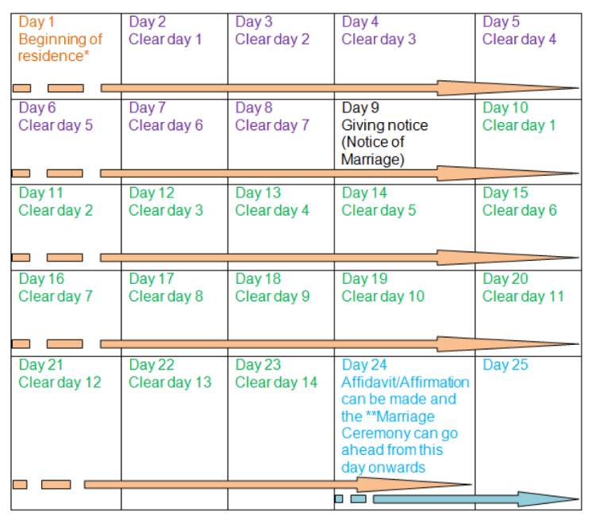
- For the purpose of consular marriage, “residence” means that the couple have been physically present in the district for 7 days before they post Notice of Marriage and have either had their home in the consular district for 21 days or, for visitors, have been physically present in the consular district for 21 days before the Marriage Ceremony takes place. The couple's immigration status locally is not relevant. (i.e. must remain in Cambodia)
- The Marriage Ceremony must take place within 3 months from the day of giving notice (Notice of Marriage). From Day 24 onwards, the couple can leave the country and return for the Marriage Ceremony at a later date if they so wish, as long as it is within the 3 months period as stated above. We will also need to take a fee before you give notice and further fees for the affidavits/affirmation and on your marriage date, for the ceremony and the certificate. The fees must be paid in USD cash or by card.

Part 2 - The Marriage Ceremony

The Marriage Ceremony must take place between 15 days (i.e. Day 24 as illustrated above) and three months after you lodge your notice - so please arrange to give notice no more than three months before the date you wish to marry.

A consular marriage must take place in the presence of two or more witnesses both of whom must be provided by you. On the day of your ceremony, you will need to bring two witnesses. Witnesses must: be aged 16 or over; know the couple; speak English; understand what is happening. There is no nationality requirement to act as witness. Witnesses must also bring proof of identification. We will ask to see each of your photo ID (e.g. drivers licence or passport), as we need to include both of your details on the register and marriage certificate.

Please arrive 15 minutes before the ceremony due to start so we can complete all the necessary documentation and begin the ceremony on time. Ceremonies take place in the Embassy and can accommodate around 6 guests.

Updated on 02/03/2022

