INDEPENDENT RECONFIGURATION PANEL

MEMBERSHIP

All Panel members are public appointees.

Chairman
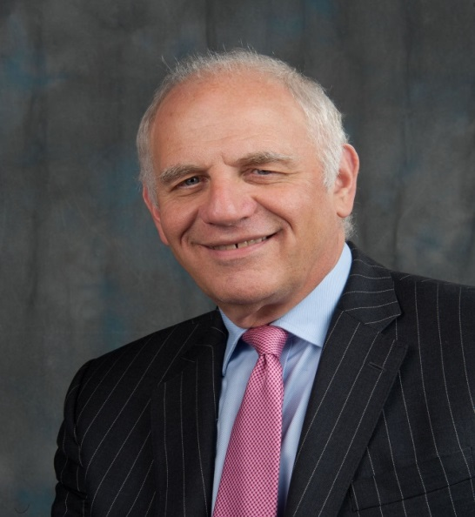 |  | Norman Williams is a former Professor of Surgery at Barts and The London and President of the Royal College of Surgeons of England. Between 2015-18, he was an independent clinical advisor to the Secretary of State for Health, led an independent commission on Education and Training for Patient Safety for Health Education England and chaired the Rapid Review of Gross Negligence Manslaughter in Healthcare. As a past Director of the National Centre for Bowel Research and Surgical Innovation, he retains a close interest in the subject and is President of Bowel & Cancer Research, a registered charity that supports patients by funding innovative research.

Members
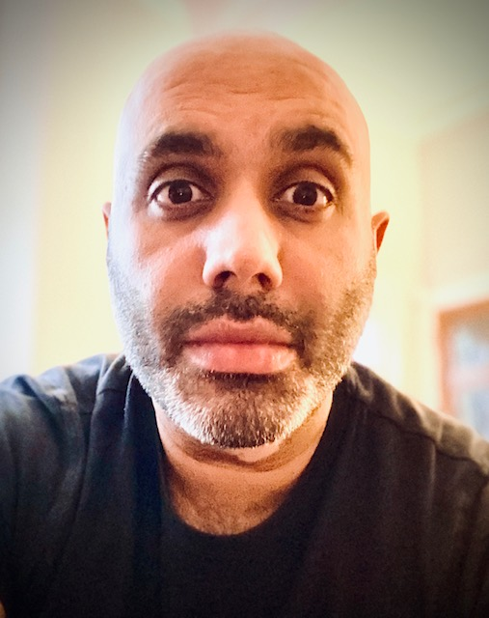 |  | Irfan Chaudry is a consultant in critical care medicine and anaesthesia and Divisional Medical Director at Lancashire Teaching Hospitals NHS Foundation Trust. He is an honorary senior clinical lecturer at Manchester University. He sits as a member for the Faculty of Intensive Care Professional Affairs and Standards Committee at the Royal College of Anaesthetists and as a member of the Greater Manchester Lancashire and South Cumbria clinical senate. Irfan is a clinical member of the Panel.
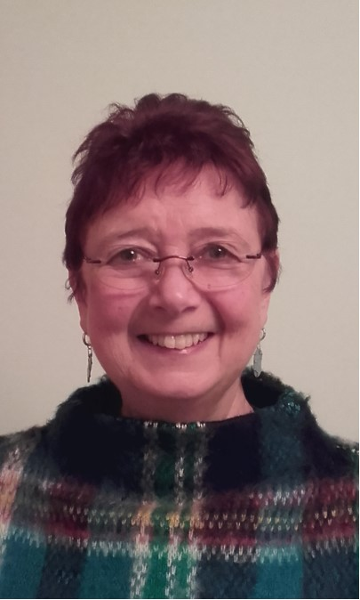 |  | Diane Davies worked in senior management posts in the NHS before leaving to care for members of her family living with complex medical conditions, disabilities and mental health issues. She now works as an “expert by experience”, supporting Care Quality Commission inspections. She is an “experience of care” volunteer with the NHS Leadership Academy and with local health and social care initiatives in Sheffield. She is also a patient representative with the General Pharmaceutical Council and a lay member for a NICE Committee. Diane is a lay member of the Panel.
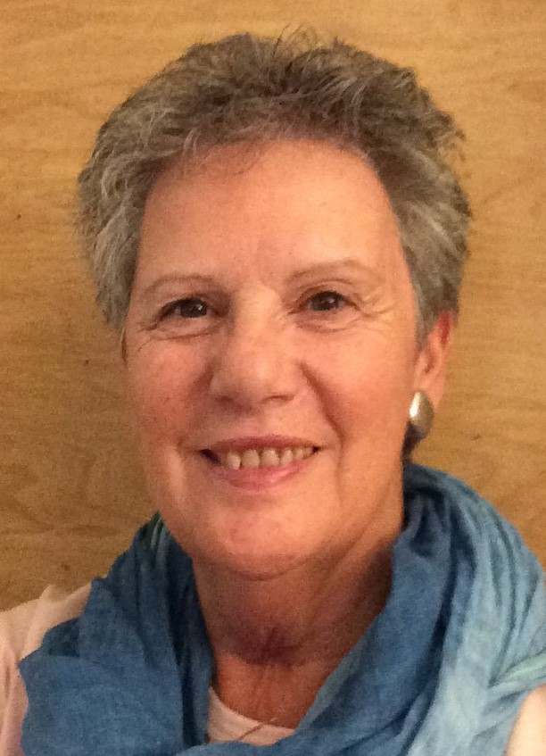 |  | Tansi Harper has a background in education having been principal of two colleges teaching 16-18 year olds. She has represented patients and the public on NHS boards for 20 years and was the first Chair of the Northamptonshire STP. She remains on the Board as it transitions to ICS and chairs its Collaborative Stakeholder Forum. With a particular interest in mental health, she has been Chair of a probation trust and of a charity helping clients with substance misuse challenges. She has most recently become a director of St Andrew’s Healthcare Trust which specialises in meeting the needs of patients with complex mental health conditions. Tansi is a lay member of the Panel.
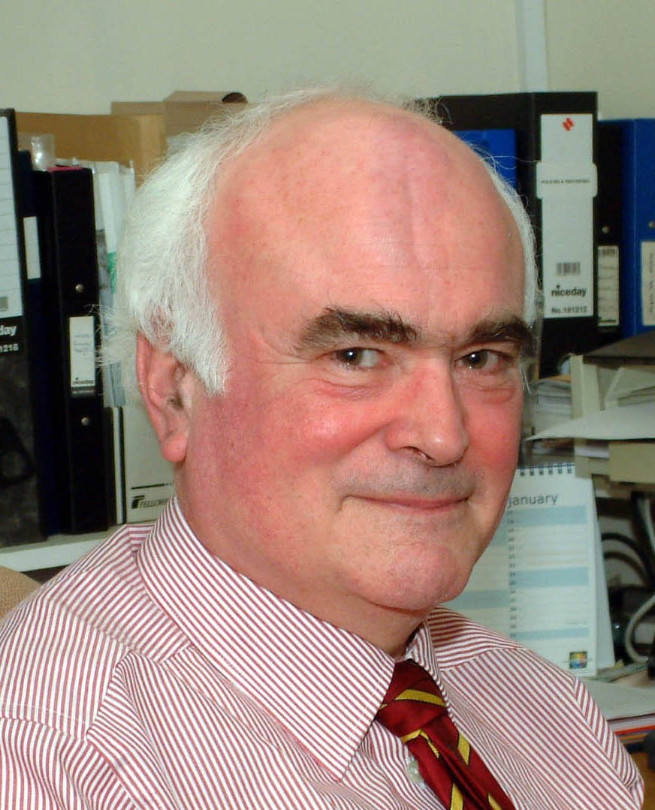 |  | Graham Jagger is an independent consultant experienced in representing the public and patient perspective on healthcare services including as Director of Healthwatch Cambridgeshire and Peterborough, PPV Partner and lay member of Health Education England’s national Patient Advisory Forum, Lead Governor at Royal Papworth NHSFT and as a General Medical Council Lay Associate. He served as a member of the NHS Pay Review Body for six years and currently chairs the East of England Advisory Committee on Consultant Clinical Excellence Awards. Graham is a lay member of the Panel.
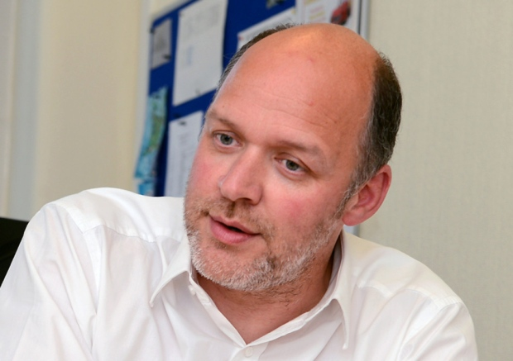 |  | Simon Morritt is Chief Executive of York Teaching Hospital NHS Foundation Trust. Simon joined the NHS in 1989 and held posts in Manchester, Wakefield and Doncaster before becoming Chief Executive of Doncaster PCT in 2000. He became Director of Performance at West Yorkshire Strategic Health Authority before taking up chief executive posts at Bradford and Airedale Teaching PCT, Sheffield Children’s NHS Foundation Trust and Chesterfield Royal NHS Foundation Trust. Simon is a managerial member of the Panel.
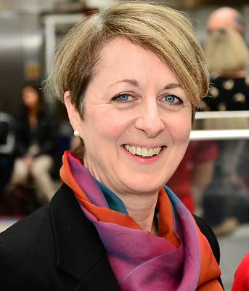 |  | Zoe Penn leads on professional standards with NHS E&I, London. She is a consultant obstetrician and former executive Medical Director of Chelsea and Westminster Hospital NHS Foundation Trust. She served on the expert panel for the Kings Fund report Safer Births and with the National Clinical Governance Support team. She sits on the London Clinical Senate and North West London Clinical Board. Zoe is a managerial member of the Panel.
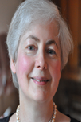 |  | Linn Phipps is an independent consultant with a specialist interest in patient and public engagement, effective health scrutiny by local government and addressing health inequalities. She is a patient and public voice representative with NHS X also sits on their Empower the Person Board, Strategy Board and Remote Monitoring Board. She serves on two NICE committees and has 20 years’ experience as a NED/Chair/Advisory Member in NHS primary, secondary and tertiary care services. Linn is a lay member of the Panel
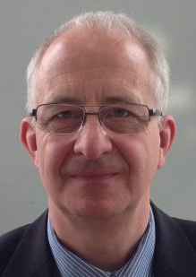 |  | Nick Relph is a former NHS chief executive with 40 years’ experience of working in the NHS having been a finance director before taking up chief executive roles at district and strategic authority level in the Thames Valley and with CCGs in west London. He has been a non-executive director (NED) of an NHS trust and Chair of Gloucestershire Integrated Care System. Nick also has private sector experience as a NED of a private healthcare company and worked with the independent sector on the development of new elective hospitals and capacity in the south west. He currently Chairs the Gloucestershire Carers Board and the Oxford Centre for Triple Value Healthcare. He is a qualified accountant. Nick is a managerial member of the Panel.
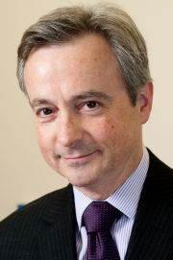 |  | Anthony Schapira is a consultant neurologist and Head of the Department of Clinical and Movement Neurosciences at University College London (UCL). He is Professor of Neurology at the National Hospital for Neurology and Neurosurgery and at the Royal Free London Hospital. He is Vice Dean of UCL and the Director of the Royal Free Campus as well as leading a large programme of research into Parkinson’s disease. Anthony is a clinical member of the Panel.
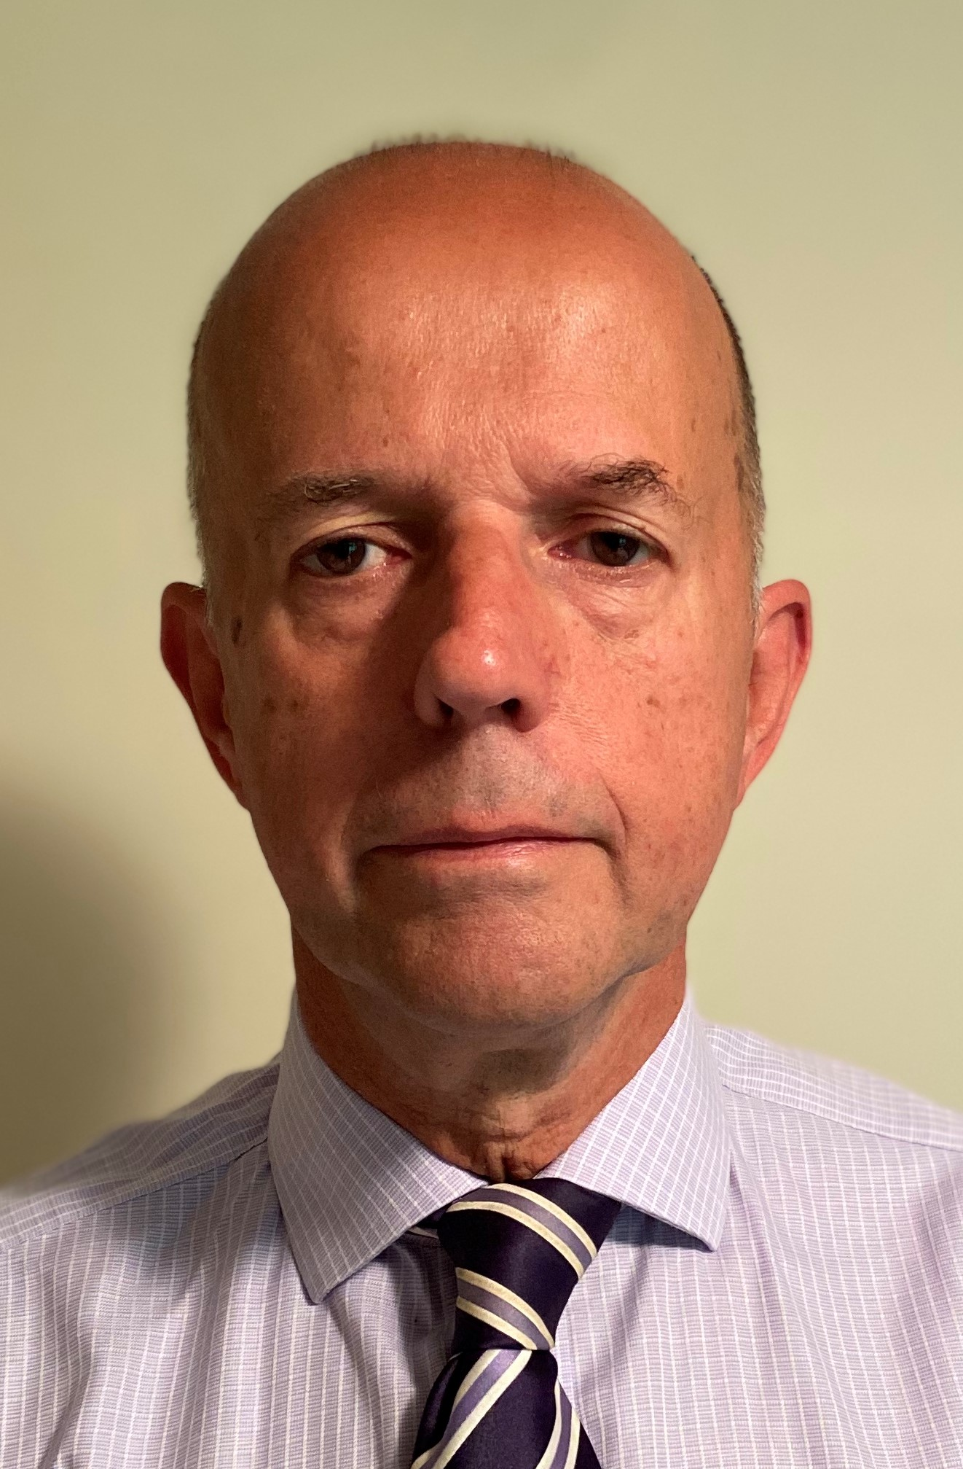 |  | Michael Scott is a former NHS chief executive with over twenty years’ experience of working in the NHS including in acute, community, mental health and learning disability settings. He played a key role in the successful reconfiguration of health services in Derby and in north west London helped deliver a new pattern of stroke and major trauma services. Now living in rural Norfolk, he understands the challenges posed by geography for service change. He is a qualified social worker and is a passionate advocate of greater health and social care integration. Michael is a managerial member of the Panel.
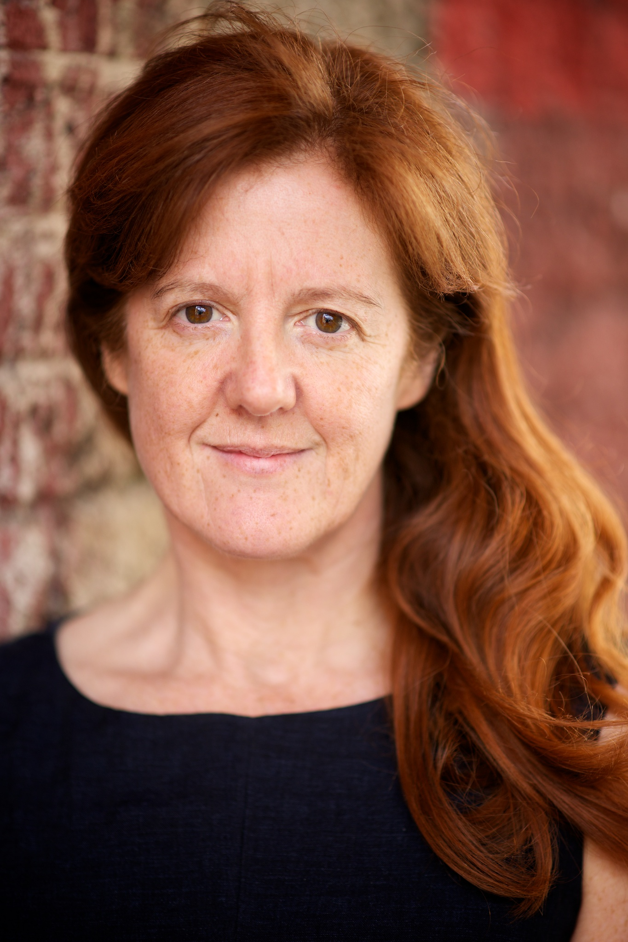 |  | Suzanne Shale is an independent consultant in healthcare ethics, patient safety and healthcare leadership. She has many years of experience presenting lay views about priorities for healthcare having worked with a number of prominent medical bodies including NHS England, the Academy of Medical Royal Colleges and the General Medical Council. She chairs the leading national patient charity Action Against Medical Accidents, is a member of the Advisory Panel of the Healthcare Safety Investigation Branch and is a non-executive director of Oxleas NHS Foundation Trust. Suzanne is a lay member of the Panel.
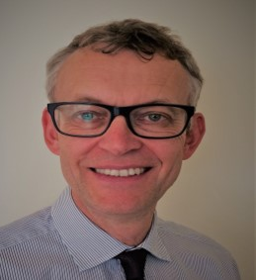 |  | Mark Taylor works as a management consultant and coach to the NHS and as a non-executive director of North Norfolk Primary Care. He previously worked in a range of senior leadership roles in the NHS for over 30 years including spells as PCT chief executive and chief officer of a CCG. Mark is a managerial member of the Panel.
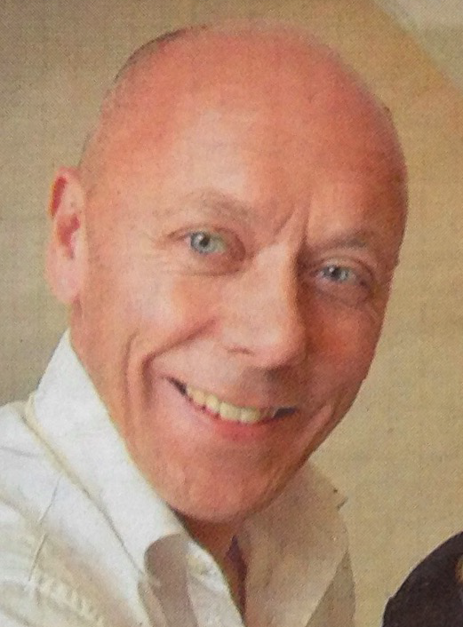 |  | Miles Wagstaff is a consultant paediatrician and neonatologist at Gloucestershire Hospitals NHS Foundation Trust where he was Clinical Director and then Specialty Director for Children’s Services for five years. He is a member of the NICE Expert Advisors Panel and of NICE Guideline Development Groups. He is also a member of the South West Clinical Senate and of the executive board for the South West Neonatal Network. Miles is a clinical member of the Panel.

Appointed through an open process of advertisement, sifting, interview and Ministerial approval in line with the Commissioner of Public Appointments code of practice and Cabinet Office guidelines.

