Data Ethics Framework: capture your work

This editable template is designed to help users of the Data Ethics Framework capture their answers to the questions posed as part of the process and share learnings, progress, challenges, and achievements. This document can be kept with project records, published alongside other key documents, or shared with the Data Ethics Team (email to data-ethics@digital.cabinet-office.gov.uk) in order to help us gather case studies and measure the impact of the Framework.

Project name
Project team
Department(s)
Project objectives
Project timeline

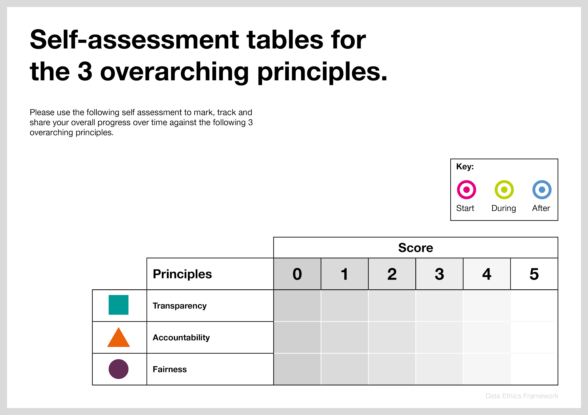
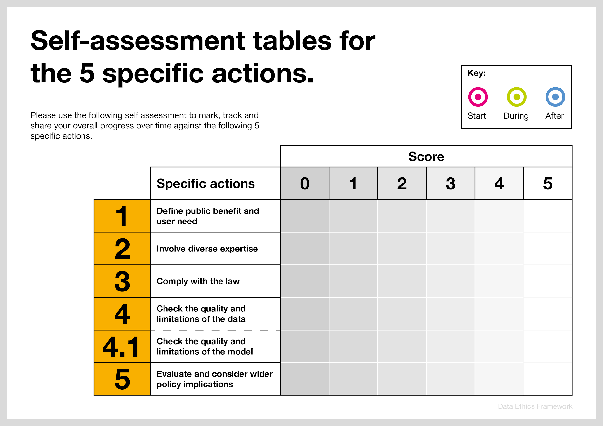

1. Define and understand public benefit and user need
When starting a public sector data project, you must have a clear articulation of its purpose. This includes having clarity on what public benefit the project is trying to achieve and what are the needs of the people who will be using the service or will be most directly affected by it.

Questions | Answers
1.1 Understand the wider public benefit
- What are direct benefits for individuals in this project? (e.g. saving time when applying for a government service)
- How does the project deliver positive social outcomes for the wider public?
- How can you measure and communicate the benefits of this project to the public?
- What are the groups that would be disadvantaged by the project/ that would not benefit from the project? What can you do about this?
1.2 Understand unintended consequences of your project (fairness)
- What would be the harm in not using data? What social outcomes might not be met?
- What are the potential risks or negative consequences of the project versus the risk in not proceeding with the project?
- Could the misuse of the data/algorithm or poor design of the project contribute to reinforcing social and ethical problems and inequalities?
- What kind of mechanisms can you put in place to prevent this from happening?
- What specific groups benefit from the project? What groups can be denied opportunities/face negative consequences because of the project?
1.3 Human rights considerations (fairness)
- How does the design and implementation of the project/ algorithm respect human rights and democratic values?
- How does the project/algorithm work towards advancing human capabilities, advancing inclusion of underrepresented populations, reducing economic, social, gender, racial, and other inequalities?
- What are the environmental implications of the project? How could they be mitigated?
1.4 Justify the benefit for the taxpayers and appropriate use of public resources in your project (accountability)
- How can you demonstrate the value for money of your project?
- Is there effective governance and decision-making oversight to ensure success of the project?
- Do you have evidence to demonstrate all of the above?
1.5 Make your user need and public benefit transparent (transparency)
- Where can you publish information on how the project delivers positive social outcomes for the public?
- How have you shared your understanding of the user need with the user?

User need

Questions | Answers
1.6 Understand the user need
‘User needs’ are the needs that a user has of a service, and which that service must satisfy for the user to get the right outcome for them. For more information about the user need, consult the GDS Service Manual

Example:
- running and improving services
- building new services
- trialling new processes for internal operations
- testing existing and new policies

1.7 Ensure there is a clear articulation of the problem before you start the project.

Describe the user need in your project:

- As a …
- I need/want/expect to… [what does the user want to do?]
- So that… [why does the user want to do this?]

Example 1: the Register to vote service’s user need:

- As a UK resident
- I want to get my details on the online electoral register
- So that I can vote

Example 2: user need when building a platform for fire safety checks:
- As a data analyst working in a fire and rescue service
- I need to identify homes which are likely to not have a smoke alarm fitted
- So that I can advise how to prioritise fire safety checks

For various user needs, using data can:
- help you identify themes in large volumes of text
- predict what will happen
- automatically categorise stuff
- spot something unusual
- show you how things are connected to each other
- spot patterns in large volumes of data
- spot geographic patterns in services or data
1.8 Check if everyone in your team understands the user need and how using data can help.
Does everyone in your team understand the user need?
- Often projects involving data analysis are requested by non-practitioners - people with an ill-defined problem they would like to understand better. Reframing their request as a user need will help you understand what they’re asking for and why, or expose what you don’t know yet.
1.9 Repeatedly revisit your user need throughout the project.
Consider these questions as the project evolves:

- What is the overall problem you’re trying to solve?
- Who are the users of this data process or analysis?
- What needs do they have?

Involve diverse expertise

Working in diverse, multidisciplinary teams with wide ranging skill sets contributes to the success of any data or tech project. If you do not have the sufficient skills or experience, you should involve others from your team or wider network with the right expertise

Questions | Answers
2.1 Get the right expertise
- Beyond data scientists, who are the relevant policy experts and practitioners in your team?
- What other disciplines and subject matter experts need to be involved? What steps have been taken to involve them?
- What should their roles be? Have you defined who does what in the project?
- Ask your team and experts if you have the right data for your research questions. Get their help in matching the dataset to the problem.
2.2 Ensure diversity within your team (fairness)
- How have you ensured diversity in your team? Having a diverse team helps prevent biases and encourages more creativity and diversity of thought.
- Avoid forming homogenous teams, embrace diversity of lived experiences of people from different backgrounds. If you find yourself in a homogenous team, challenge it.
2.3 Involve external stakeholders
- How have you engaged external domain experts in your project (e.g. academics, ethicists, researchers)?
- Have you consulted the relevant civil society organisations?
- What is the impact that external engagement/consultations have had on the project?
- Have you considered consulting the target audience or the users of your project? This could be done through a range of deliberative processes and consultations.
2.4 Effective governance structures with experts (accountability)
- What senior/external oversight is there for your project?
- What are the governance mechanisms that enable domain experts to challenge your project?
- Who are the external experts/consultants who could review and assess the progress and ethical considerations of your project? How will you involve them?
- What is the termination mechanism if the project stops being ethical?
2.5 Transparency
- Wherever appropriate, publish information on expert consultations and the project team structure

3. Comply with the law

You must have an understanding of the relevant laws and codes of practice that relate to the use of data. When in doubt, you must consult relevant experts.

Questions | Answers
3.1 Get legal advice
- Have you spoken to a legal adviser within your organisation?
- Have you spoken to your information assurance team?
- Have you consulted your organisation’s Data Protection Officer when doing a DPIA?
- What legal advice have you received?
3.2 It is your duty and obligation to obey the law in any data projects. You must ensure the project’s compliance with GDPR and DPA 2018 (accountability)

If you are using personal data, you must comply with the principles of the EU General Data Protection Regulation (GDPR) and Data Protection Act 2018 (DPA 2018) which implements aspects of the GDPR and transposes the Law Enforcement Directive into UK law. It also provides separate processing regimes for activities which fall outside the scope of EU law.

Personal data is defined in Section 3(2) DPA 2018 (a wider explanation is detailed in Article 4 of the GDPR).
3.3 Data protection by design and DPIA
Data protection by design and by default is a legal requirement under the GDPR (see Article 25).

It is a legal obligation under Article 35 of the GDPR to complete a data protection impact assessments (DPIA) (also known as privacy impact assessments) when there’s likely to be high risk to people’s rights, particularly when using new technologies. It is good practice to do a DPIA for any use of personal data.
3.4 Accountability
An important aspect of complying with data protection law, is being able to demonstrate what measures you are taking to ensure everything is documented, as seen in Article 5(2) of the GDPR (the accountability principle) and Article 30 on keeping records of processing activities.
Your organisation and information assurance teams will be responsible for this at a high level including ensuring policies and training are in place. However, it is essential to show how you are doing this at an individual level, through thorough documentation of things like Data Protection Impact Assessments.
3.5 Transparency
Publish your DPIA and other related documents.
3.6 Ensure the project’s compliance with the Equality Act 2010 (fairness)
Data analysis or automated decision making must not result in outcomes that lead to discrimination as defined in the Equality Act 2010.

- How can you demonstrate that your project meets the Public Sector Equality Duty?
- What was the result of the Equality Impact Assessment of the project?
3.7 Ensure effective governance of your data
Organisations have a responsibility to keep both personal data and non-personal data secure.
- How have you ensured that the project is compliant with data governance policies within your organisation?
3.8 Ensure your project’s compliance with any additional regulations
Consider additional relevant legislation and codes of practice.

4. Review the quality and limitations of the data

Insights from new technology are only as good as the data and practices used to create them. You must ensure that the data for the project is accurate, representative, proportionally used, of good quality, and that you are able to explain its limitations.

Questions | Answers
4.1 Data source
- What data source(s) is being used?
- Are individuals and/or organisations providing the data aware of how it will be used? If the user is repurposing data for analysis without individual consent, how have you ensured that the new purpose is compatible with the original reason for collection (Article 6 (4) GDPR)?
- Are all metadata and field names clearly understood?
  - Do you understand how the data for the project is generated? Remember that depending on where the data came from, the field may not represent what the field name/metadata indicates.
- What processes do you have in place to ensure and maintain data integrity?
- What are the caveats? How will the caveats be taken into account for any future policy or service which uses this work as an evidence base?
● Would using synthetic data be appropriate for the project? Synthetic data is entirely fabricated or abstracted from real data through various processes, e.g. anonymisation or record switching. It is often created with specific features to test or train an algorithm.

4.2 Determining proportionality
You must use the minimum data necessary to achieve your desired outcome (Article 5(1)(c) of the GDPR). Personal data should be adequate, relevant and limited to what is necessary in relation to the purposes for which they are processed.

- How can you meet the project aim using the minimum personal data possible?
- Is there a way to achieve the same aim with less identifiable data, e.g. pseudonymised data?
- If using personal data identifying individuals, what measures are in place to control access?
- Is the input data suitable and necessary to achieve the aim?
- Would the proposed use of data be deemed inappropriate by those who provided the data (individuals and/or organisations)?
- Would the proposed use of data for secondary purposes make it less likely that people would want to give that data again for the primary purpose it was collected for?

● How can you explain why you need to use this data to members of the public?
● Does this use of data interfere with the rights of individuals? If yes, is there a less intrusive way of achieving the objective?

4.3 Bias in data (fairness)
- How has the data being used to train a model been assessed for potential bias? You should consider:
  - Whether the data might (accurately) reflect biased historical practice that you do not want to replicate in the model (historical bias)
  - The data might be a biased misrepresentation of historical practice, e.g. because only certain categories of data were properly recorded in a format accessible to the project (selection bias)
- If using data about people, is it possible that your model or analysis may be identifying proxy variables for protected characteristics which could lead to a discriminatory outcome? Such proxy variables can potentially be a cause of indirect discrimination; you should consider whether the use of these variables is appropriate in the context of your service (i.e. is there a reasonable causal link between the proxy variable and the outcome you’re trying to measure?; do you assess this to be a proportionate means to achieve a legitimate aim in accordance with the Equality Act 2010?)
- What measures have you taken to mitigate bias?
4.4 Data anonymisation
If you plan to anonymise or pseudonymise personal data before linking or analysis, make sure you follow the ICO’s Anonymisation: managing data protection risk code of practice and document your methods. You can find more technical advice in the UK Anonymisation Networks anonymisation guidance.

If the assumption is that data in the project is anonymised, consider the following:
- How can you demonstrate that the data has been de-identified to the greatest degree possible?
- Can the data be matched to any other datasets that will make individuals easily identifiable? What measures have you taken to mitigate this? Have you considered any determined intruder testing?
4.5 Robust practices (accountability)
- If necessary, how can you (or external scrutiny) validate that the algorithm is achieving the correct output decision when new data is added?
- How can you demonstrate that you have designed the project for reproducibility?
  - Could another analyst repeat your procedure based on your documentation? Have they tried?
  - Have you followed the 3 requirements for reproducibility? (Applying the same logic (code, model or process), to the same data, in the same environment).
  - How have you ensured that high quality documentation will be kept?
  - Have you considered Reproducible Analytical Pipelines? (RAP)

- How confident are you that the algorithm is robust, and that any assumptions are met?
- What is the quality of the model outputs, and how does this stack up against the project objectives?
4.6 Make your data open and shareable whenever possible (transparency)

If data is non-sensitive, non-personal, and if Data Sharing Agreements with the supplier allow it, you should make the data open and assign it a digital object identifier (DOI). For example, scientists share data when publishing a paper on Figshare and Datadryad. This gives others access to the data and the code, so the analysis can be reproduced. You can also publish data on Find open data and the UK Data Archive.
4.7 Share your models - developed data science tools should be made available for scrutiny wherever possible (transparency)

Can you openly publish your methodology, metadata about your model, and/or the model itself e.g. on Github?

There are 2 main types of algorithms used in data science.

The first is the algorithmic methodology used to train a model. It’s often more useful and clear to share a document describing the analytical process than the code.

The second is the trained model itself (the result of applying the methodology to the dataset). Releasing this model allows others to scrutinise and test it, and may highlight issues that you can fix as part of your continual improvement.

When sharing models it’s important that it does not endanger either the:
- privacy of those whose data was used to train it
- integrity of the task being undertaken.

4.8 How to ensure transparency of sensitive models? (transparency)

- How are you planning to inform the public about the model?
- Even if the model cannot be released publicly, you may be able to release metadata about the model on a continual basis, like its performance on certain datasets.
- If your data science application is very sensitive, you could arrange for selected external bodies, approved by your organisation, to examine the model itself in a controlled context to provide feedback. This could be expertise from another government department, academia or public body.
4.9 Explainability (transparency)

Explainability is the extent to which the workings in a machine learning algorithm can be explained in human terms. It means expanding on the transparency of what variables are used to provide information on how the algorithm came to give an output, and how changing the inputs can change the output.

- Explain what your project does and how it was designed in plain language to a non-expert audience.
- Describe the process and the aim of your algorithm, as well as what variables are used for what outcomes without using technical terms.
- Make this explanation publicly available (e.g. on GitHub, blogs, or gov.uk).

5. Evaluate and consider wider policy implications

It is essential that there is a plan to continuously evaluate if insights from data are used responsibly. This means that both development and implementation teams understand how findings and data models should be used and monitored with a robust evaluation plan and effective accountability mechanisms.

Questions | Answers
5.1 Evaluate the project
Continuous evaluation - ask yourself and the team:
  - At the beginning of the project: ‘are we doing the right thing?’
  - During the project: ‘have we designed it well?’
  - After the project: ‘is it still doing the right thing we designed it for?’

- How have you evaluated the project? Evaluation techniques you might use include holding retrospective roundtables at the end of the project; inviting an external expert or a ‘critical friend’ from a different team to observe and evaluate the project; request external consultations or audits
5.2 Repeatedly revisit the user need and public benefit throughout the project
- How has the user need changed?
- Is the project still benefiting the public?
- Has there been a change of circumstances that might have affected the initial understanding of the public benefit in the project? If so, how can you adjust it?
- How sufficient is the current human oversight of the automated project?
- If any unanticipated harms emerged during the project, how have they been mitigated?
5.3 Check how your project influences policy
- How accurately are the insights from the project used in the practical policy context?
- How have you ensured if policymakers and secondary users of the tool fully understand its purpose and structure?
5.4 Ensure there are skills, training, maintenance for longevity of the project
- How have you ensured that the users have the appropriate support and training to maintain the new technology?
- What is the longevity of the project?
- How have you checked if the users understand the software they need to maintain the project? Have they been appropriately trained?
5.5 Accountability structures
- What are the governance structures in place to ensure a safe and sustainable implementation of the project?
- How often will you update the board/governing bodies?
5.6 Public scrutiny
- Do members of the public/ end users of the project have the ability to raise concerns and place complaints about the project? If yes, how? If not, why?
- What channels have you established for public engagement and scrutiny throughout the duration of the project?
5.7 Share your learnings
- How have you documented and shared the progress and case studies from your project with peers and stakeholders?

Next steps: if you have scored a 3 or less in any of the principles, this could indicate the need for additional checks and potential changes to make your project more ethical. Please explain the reason for the score and consult the outcome with your team leader/organisational ethics board/data ethics lead to advise on the specific next steps to improve the ethical standards of your project.

