# 5G mobile technology: a guide

## 5G is the latest mobile technology. It brings greater speed, capacity and functionality to mobile services, opening up new opportunities for consumers, businesses and public services.

Companies have been rolling out 5G in the UK since 2019. However, some people have raised concerns that the introduction of 5G could affect people’s health and have even linked it to the coronavirus pandemic.

These claims are completely unfounded and should not be used as a basis to block or delay 5G rollout.

This guide explains the facts about 5G to help you deal with queries from the public and to combat the disinformation that is spreading online.

### What is 5G?

5G is the new, fifth generation of mobile technology. Like previous mobile generations, including 3G and 4G, 5G uses the radio spectrum. The radio spectrum supports all of the wireless services used by people and businesses every day – including making a mobile phone call, listening to the radio or going online using Wi-Fi.

### What are the differences between 5G and 3G and 4G?

There is nothing fundamentally different about the physical characteristics of the radio signals that will be produced by 5G compared to previous technologies like 3G and 4G.

Compared to previous generations of mobile services, 5G offers faster internet speeds and the ability to connect thousands of different devices in a small area. This means it could help create new ‘smart’ services for people in public spaces – providing real-time information to them about the local area and availability of services. It can also be used in healthcare, agriculture and other industries – for example, connecting machinery in factories to make production more efficient.

5G also makes use of certain advances in technology which are described further in this guide.

### Which radiowaves does 5G use?

5G is re-using spectrum that has previously been used to deliver services such as TV broadcasting, wireless broadband and other types of transmissions that have been in the environment for many years.

Initially, mobile phone companies have deployed 5G in frequency bands which are close to those already used for previous generations of mobile technology (sometimes called low- and mid-frequency spectrum). 5G can also make use of higher frequency spectrum, and some 5G trials have already taken place in these frequencies.

All frequencies that are currently and will in future be used for 5G fall within the part of the electromagnetic spectrum that includes radiation which is classed as ‘non-ionising’. This means that these radio waves do not carry enough energy to directly damage cells. This is different from ‘ionising’ radiation, which is generally considered to be hazardous to humans and includes gamma (nuclear) radiation as well as x-rays, which occur at the higher frequency end of the electromagnetic spectrum.

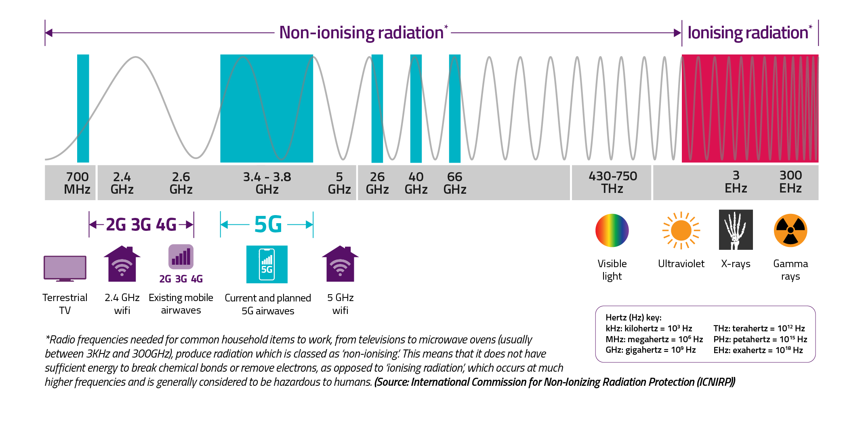

Figure : The Electromagnetic Spectrum

### What do health experts say about 5G?

Health experts have studied the effects of radio waves on health for many years.

In the UK, Public Health England (PHE)[1] takes the lead on public health matters associated with electromagnetic fields, or radio waves, and has a statutory duty to provide advice to the UK Government on any health effects that may be caused by exposure to electromagnetic fields, including radio wave emissions.

PHE endorses the international guidelines for limiting exposure to radio waves, published by the International Commission for Non-Ionising Radiation Protection (ICNIRP). These guidelines cover many uses of radio frequencies, including Wi-Fi, Bluetooth and mobile technologies. The guidelines were updated in March 2020 and take full account of 5G operating at higher frequencies.

In relation to 5G, PHE have said that “the overall exposure is expected to remain low relative to guidelines and, as such, there should be no consequences for public health”.

Mobile companies are also required to ensure that their signals do not exceed the limits set out in the ICNIRP guidelines for the protection of the general public.

### Have 5G masts been tested to ensure they are safe?

Ofcom carries out measurements to confirm transmitter base stations do not exceed the restrictions set out in the ICNIRP guidelines. Over the past few months, [Ofcom has measured radio wave emission levels at 5G sites in 10 UK towns and cities](https://www.ofcom.org.uk/spectrum/information/mobile-operational-enquiries/mobile-base-station-audits/2020) and, in all cases, the levels recorded are a small fraction of those in the ICNIRP guidelines.

The maximum measured at any mobile site was approximately 1.5% of the guideline levels – including signals from other mobile technologies such as 3G and 4G. The highest level from 5G signals specifically was 0.039% of the maximum set out in the guidelines.

Ofcom will continue to monitor 5G signal levels as 5G becomes more widely adopted.

### Will the technological advances of 5G result in increased risks for the general public?

***Use of higher frequencies (millimetre wave)***

At the moment, all mobile phone companies in the UK are operating mobile services in frequencies between 700 MHz and 3.8 GHz. This includes 2G, 3G and 4G as well as all current 5G deployments. These frequencies are at the lower end of the microwave frequency range (microwaves are generally considered to encompass frequencies between 300 MHz and 300 GHz)[2].

5G can also make use of higher frequency spectrum, and some 5G trials have already taken place in these frequencies. Higher frequency bands that could be used for 5G include the 26 GHz, 40 GHz and 66 GHz frequency bands (as illustrated in Figure A above). The term millimetre wave or mmWave is often used to describe these higher frequencies. The advantage of these frequencies is that they can deliver very high speeds and high capacity with very low latency (the time between instructing a wireless device to perform an action and that action being completed).

At these frequencies, the signals do not travel as far and do not carry through walls or objects as easily as low- and mid-frequency spectrum, so they are not suited to providing wide-area mobile coverage. They are instead most likely to be used in areas with the highest demand from mobile phone users - so-called ‘hotspots’.

The use of these frequencies is not new – they have been used for many years for other radio services, including point-to-point links, satellite earth stations and radio astronomy. The ICNIRP guidelines cover all frequencies that will be used for 5G, including mmWave, and all operators are required to comply with these guidelines. The latest version of these guidelines, published in March 2020, contains some additional restrictions for use at these higher frequencies.

***Advanced antenna technology (massive MIMO and beamforming)***

New advanced ‘massive MIMO’ (multiple input, multiple output) and ‘beamforming’ antenna technology mean that antennas used in mobile networks will be able to direct signals only to where they are needed – for example, directly to your mobile handset. This technology is already used in 4G to some extent but will be used more widely in 5G.

The antennas themselves are not ‘massive’ in size – in fact, they are similar in size to the antennas used in previous generations of mobile technology. Rather, they are massive in that they are made up of a larger number of smaller antennas than antennas used for previous generations.

This technology means 5G transmissions will be more efficient as they will not be transmitting in directions where the signal is not needed, tending to reduce incidental radio wave exposure levels in the environment. Even so, operators will still need to ensure that the emission levels from these new antennas are compliant with the restrictions in the ICNIRP guidelines.

***Small cells***

At the moment, 5G equipment is generally being added to existing mobile phone masts. However, over time, more smaller transmitters (known as “small cells”) may be used to provide capacity in specific locations.

While more small cells might be needed, they will operate at much lower powers than existing mobile masts as the signals do not need to travel as far. In addition, use of small cells will have the benefit of enabling mobile phones to operate at lower powers. This means that, in general, small cells will be unlikely to cause any increase to the overall radio wave exposure levels experienced by a mobile phone user, and may cause a decrease.

However, a significant increase in the number of small cells is not expected immediately as operators are concentrating on adding 5G technology to their existing sites.

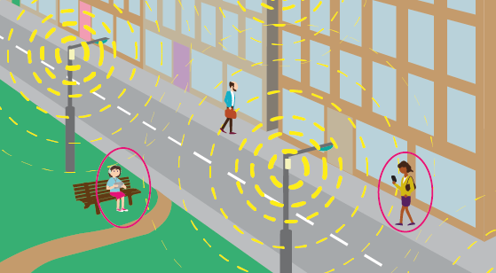

Figure : Small cell deployment in a city centre

### 5G and Coronavirus

Recently, conspiracy theories have been shared online that claim 5G mobile is connected to the spread of the coronavirus. This is wrong. There is no scientific basis or credible evidence for these claims.

Some areas of the country have seen mobile phone masts vandalised because of these incorrect claims. Engineers from the mobile phone operators have also been threatened in the street while they work. These types of incidents put lives at risk. If a mobile phone mast stops working, either because it has been vandalised or because engineers can’t carry out vital maintenance, people in that area can’t call the emergency services, dial the NHS on 111 or contact their friends or family.

Mobile phones have been used by volunteers to organise support for their local communities to collect medicines and get food for those who cannot go out during the Covid-19 crisis. People’s safety and wellbeing can be put at risk if the mobile phone network isn’t available.

### Which organisations are responsible for public safety relating to 5G?

The **UK Government’s** priority is to promote investment and innovation in 5G, to ensure that services and applications are widely available for the benefit of UK consumers and businesses, to drive economic growth and boost productivity. The UK Government has published guidance in respect of [5G and coronavirus (COVID-19)](https://www.gov.uk/guidance/5g-and-coronavirus-covid-19), and the [sharing of false information](https://sharechecklist.gov.uk/).

**Planning law** and policy requires that planning applications for electronic communications development should be accompanied by a statement or declaration that certifies that when operational, equipment will be compliant with the ICNIRP guidelines for limiting exposure to electromagnetic fields[3].

**Public Health England (PHE)** takes the lead on public health matters associated with electromagnetic fields, or radio waves, and has a statutory duty to provide advice to Government on any health effects that may be caused by exposure to electromagnetic field emissions. PHE has published advice on exposure to radio waves at the following link: <https://www.gov.uk/government/collections/electromagnetic-fields#radio-waves>

**Ofcom** is responsible for managing use of the radio spectrum in the UK. Ofcom regularly carries out radio frequency electromagnetic field (EMF) measurements near mobile phone base stations to test whether EMF levels are within ICNIRP guidelines. Further information on Ofcom’s work in relation to EMF is available at the following link: <https://www.ofcom.org.uk/manage-your-licence/radiocommunication-licences/mobile-wireless-broadband/exposure-electro-magnetic-fields>.

1. On 18 August 2020, the Government created the National Institute for Health Protection. This brings together Public Health England, NHS Test and Trace and the analytical capability of the Joint Biosecurity Centre under a single leadership team. The organisation will be formalised and be operating from spring 2021.
2. Note, the use of the term ‘microwaves’ here should not be confused with ‘microwave ovens’ - these use a very specific set of frequencies which, incidentally, are also widely used for Wi-Fi, albeit at much lower power levels.
3. Planning law is a devolved matter. Please see: The Town and Country Planning (General Permitted Development) (England) Order 2015 (as amended); The Town and Country Planning (General Permitted Development) (Scotland) Order 1992 (as amended); The Town and Country Planning (General

   Permitted Development) (Wales) Order 1995 (as amended); The Planning (General Permitted Development) Order (Northern Ireland) 2015.