Explanatory Memorandum on the Agreement between the Government of the United Kingdom of Great Britain and Northern Ireland and the
Government of the Kingdom of the Netherlands concerning border controls on rail traffic between the Netherlands and the United Kingdom using the Channel Fixed Link

Title of the agreement
Agreement between the Government of the United Kingdom of Great Britain and Northern Ireland and the Government of the Kingdom of the Netherlands concerning border controls on rail traffic between the Netherlands and the United Kingdom using the Channel Fixed Link.
Command Paper Number CP 254
- Introduction
1.1 This explanatory memorandum has been prepared by the Home Office and is laid before Parliament by Command of Her Majesty.
2. Subject Matter and purpose of the Treaty
2.1 This Agreement makes provision for:
- UK border controls to be conducted in the Netherlands in respect of passengers using a Channel Fixed Link train service whose destination is the UK; and
- Dutch border controls to be conducted in the UK in respect of passengers using a Channel Fixed Link train service whose destination is the Netherlands.

3. Background
3.1 The UK Border Force currently conducts border controls in France and Belgium on passengers destined for the UK using the Channel Fixed Link. This is a reciprocal arrangement, with French Police aux Frontiéres officers completing Schengen border controls on passengers destined for continental Europe. Border Force officers currently conduct border controls at juxtaposed controls in Paris Gare du Nord, Lille Europe, Calais Fréthun and Brussels Midi Stations. Police aux Frontiéres currently undertake Schengen border controls on behalf of France, Belgium and the Netherlands at juxtaposed controls in London St Pancras International, Ebbsfleet International and Ashford International Stations.
3.2 In April 2018, Eurostar commenced operating services between the UK and the Netherlands. As there are no juxtaposed controls in the Netherlands, these services only operate on a direct basis from London to the Netherlands, with Schengen border controls carried out before departure in the UK. Return services require a 'hub-stop' in Brussels Midi Station. Passengers embarking in the Netherlands are required to disembark at Brussels Midi Station to clear Schengen exit and UK entry border controls, before re-boarding the train and completing the remainder of their journey to the UK. This process is required until UK immigration checks can be carried out at Rotterdam Centraal and Amsterdam Centraal Stations for UK-bound services.
3.3 The legal framework for current border controls is provided for in the Agreement between the Government of the United Kingdom of Great Britain and Northern Ireland, the Government of the Kingdom of Belgium and the Government of the French Republic concerning Rail Traffic between Belgium and the United Kingdom using the Channel Fixed Link with Protocol, done at Brussels on 15 December 1993 (the "Tripartite Agreement").
3.4 The parties to the Tripartite Agreement and the Netherlands have agreed to amend and supplement the Tripartite Agreement through a new treaty (the "Quadripartite Agreement") adding the Netherlands as a contracting party and updating the legal framework for the exercise of border controls on all rail passengers travelling via the Channel Fixed Link between the UK, the Netherlands and Belgium, including UK-bound rail traffic from international rail terminals in the Netherlands. The Quadripartite Agreement is subject to a separate Command Paper and Explanatory Memorandum.
3.5 This Agreement contains several provisions specific to the operation of border controls in respect of Netherlands — UK rail traffic using the Channel Fixed Link, which will continue in force once the Quadripartite Agreement has entered into force. It also contains other provisions which will allow for the temporary exercise of juxtaposed border controls in the Netherlands pending the entry into force of the Quadripartite Agreement.
- Implementation
  - The Agreement will be implemented by means of a statutory instrument, namely the Channel Tunnel (Arrangements with the Kingdom of the Netherlands) Order 2020, made under section 11 of the Channel Tunnel Act
1987.
- Territorial Application
  - The territorial application of this Arrangement is metropolitan United Kingdom only.

6. Financial
6.1 Implementing juxtaposed immigration controls in the Netherlands will be cost neutral to the UK as Eurostar is meeting the costs of both the infrastructure and staffing costs of the border controls in the Netherlands.

- Human Rights
7.1 This Arrangement does not raise any human rights implications.

8. Reservations and Declarations
8.1 No reservations or declarations have been made in relation to this Agreement.

9. Consultations
9.1 Consultation has taken place with Eurostar International Limited, as well as with officials from the Governments of France, Belgium and the Netherlands. All parties involved in these discussions have been positive and are in favour of extending the service and the associated treaty arrangements.

10. Provisional Application
10.1 Article 21 of the Agreement provides that either contracting party may notify the other contracting party in writing that it will provisionally apply the Agreement, in whole or part, pending its entry into force. Provisional application can be terminated by mutual agreement or by either contracting party giving two months' written notice.
10.2 A direct service between the UK and the Netherlands is scheduled to commence towards the end of 2020. In order to ensure this service can commence on time, the UK and the Netherlands intend to provisionally apply, wholly or in part, the Agreement pending its entry into force.

11. Entry into Force
11.1 The Agreement will enter into force on the date of receipt of the later contracting party's notification of the completion of their internal procedures, in accordance with Article 20 of the Agreement.
- Ministerial Responsibility
  - The Secretary of State for the Home Department has Ministerial responsibility for policy matters relating to immigration law and for this Agreement.
  - The Secretary of State for Foreign and Commonwealth Affairs has overall responsibility for UK policy relating to the UK's relations with the Netherlands.
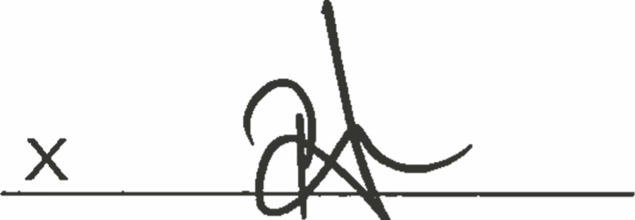

Priti Patel
Home Office
Secretary of State for the Home Department

