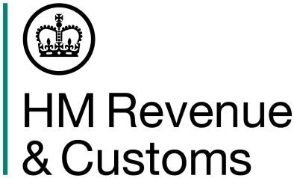
Submitting your Corporation Tax return example

Your company prepares its annual accounts to 31 December each year.
In the 12 months to 31 December 2020, the company made a profit from the UK property business of £450,000. In the previous 12 months, company’s profits were £400,000.
The company’s 2019/2020 Non-resident Company Income Tax return will show profits from the UK property business for the period from 6 April 2019 to 5 April 2020 calculated as follows:
For the period from 6 April 2019 to 31 December 2019
£400,000 x 270/365 = £295,890
For the period from 1 January 2020 to 5 April 2020
£450,000 x 96/366 = £118,033
Total for the tax year 6 April 2019 to 5 April 2020
£295,890 + £118,033= £413,923
From 6 April 2020, the company will be chargeable to Corporation Tax on its UK property profits. The company’s first Company Tax Return should include the profits from the UK property business for the period from 6 April 2020 to 31 December 2020:
6 April 2020 – 31 December 2020
£450,000 x 270/366 = £331,967

In the following 12 months (year ended 31 December 2021), the company makes a profit of £500,000. The Company Tax Return will show profits for the period from 1 January 2021 to 31 December 2021, which is £500,000.

