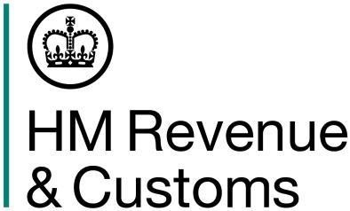

Loan losses referable to a period prior to 6 April 2020 example

A company has raised funds under a fixed rate bond for a UK property business. The bond is ‘out-of-the-money’ immediately prior to 1 April 2020 because it carries a high rate of interest compared with current market rates.
Immediately following the transition into Corporation Tax regime on 1 April 2020 the company buys-back the bond, in respect of which it pays a premium of £100,000.
The premium would have been considered as a capital loss and would not have been allowed as a deduction under the Income Tax rules.
The loss on buying back the bond is therefore not deductible for Corporation Tax purposes as it is attributable to the Income Tax period and would have been not deductible under Income Tax rules.

