Dear Click here to enter text.
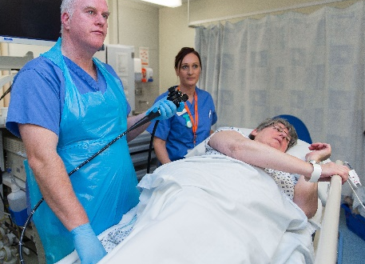 | We are inviting you to come into hospital for a test called bowel scope screening.  This test looks inside your bowel to check it is healthy.
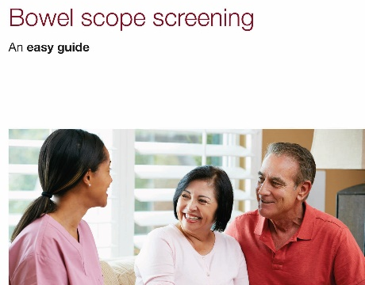 | There is an easy guide leaflet with this letter that tells you about bowel scope screening.  Withdrawn January 2021  The leaflet can help you decide if you want to do the test.
Let us know if you would like bowel scope screening by calling our helpline on
0800 707 6060.

Or fill in the reply form and post it. You can ask someone to help you do this.
If you do not want bowel scope screening then we will not invite you again.

You can change your mind before you are 60 years old. You can call the helpline on 0800 707 6060 to make an appointment.
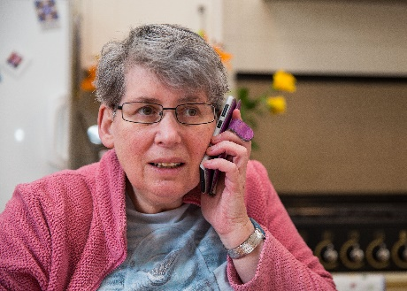 | For help or more information, speak to:  - our helpline on 0800 707 6060  - your learning disability team or doctor  - your screening centre on Click here to enter text.

