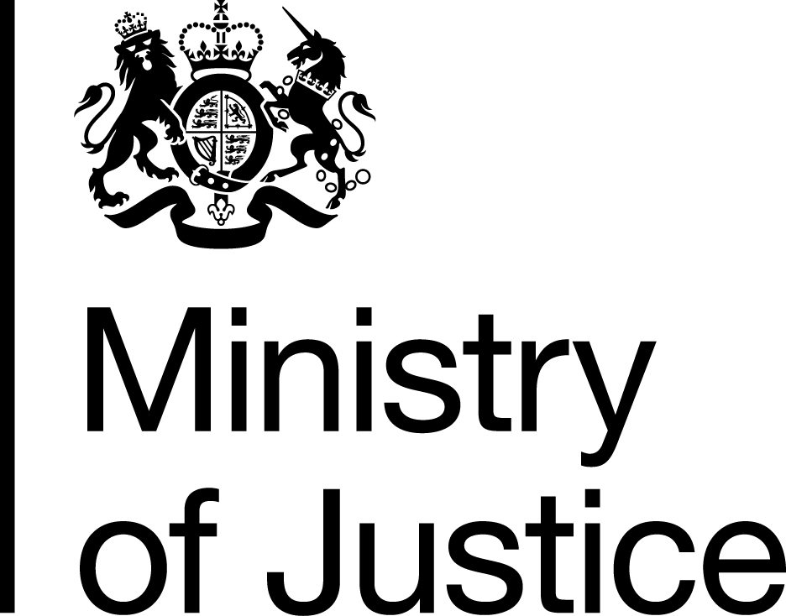 | April 2019

Freedom of Information Act (FOIA) Request – 190327026

Thank you for your request in which you asked for the following information from the Ministry of Justice (MoJ):

Please may you provide the name, category and 2017 mid-year population, broken down into the age and gender bands listed below, of each prison in England, Scotland and Wales. Please may this information be provided in an electronic table format, with the following column headers: - Prison Name - Category (Male, Female, YOI) - Total Population - M0to4 - M5to9 - M10to14 - M15 - M16to19 - M20to24 - M25to29 - M30to34 - M35to39 - M40to44 - M45to49 - M50to54 - M55to59 - M60to64 - M65to69 - M70to74 - M75to79 - M80to84 - M85to89 - M90andover - F0to4 - F5to9 - F10to14 - F15 - F16to19 - F20to24 - F25to29 - F30to34 - F35to39 - F40to44 - F45to49 - F50to54 - F55to59 - F60to64 - F65to69 - F70to74 - F75to79 - F80to84 - F85to89 - F90andover

Your request has been handled under the FOIA.

I can confirm that the MoJ holds some of the information that you have requested and I have provided it in the attached tables:

- Table 1 shows the prison population by gender, establishments, and age bands, at the 30 June 2017, England and Wales, and

- Table 2 shows the Population of children and young people in Secure Childrens’ Homes (SCHs) and Secure Training Centres (STCs), by age, gender and establishment, 30 June 2017.

Please be aware that information in relation to prisons and prisoners in Scotland is a matter for the Scottish Government. You may wish to contact them directly as follows:

Scottish Prison Service Headquarters
Communications Branch,
Room 338 Calton House,
5 Redheughs Rigg,
Edinburgh,
EH12 9HW

Email: gaolinfo@sps.pnn.gov.uk

