

British Embassy Dubai
British Embassy
PO Box 65
Dubai
United Arab Emirates

Tel: 00971 (4) 309 4444

Information Note
British National sponsoring a non-British relative of transferring visa

To whom it may concern

The British Embassy has no objection to any British national sponsoring their non British spouse. We also have no objection to any British nationals sponsoring their family members e.g. parents, children, stepchildren and grandchildren, or any individuals who are unrelated to them in the United Arab Emirates and so we will no longer issue this letter on an individual basis.

All nationals married to a British national that require a visa to enter the UK must satisfy the immigration rules at the time of their application and if they meet these requirements there would be no objection for them to travel to the UK.

The British Embassy also has no objection to British nationals transferring their visas, issued by another country to or from a British passport.
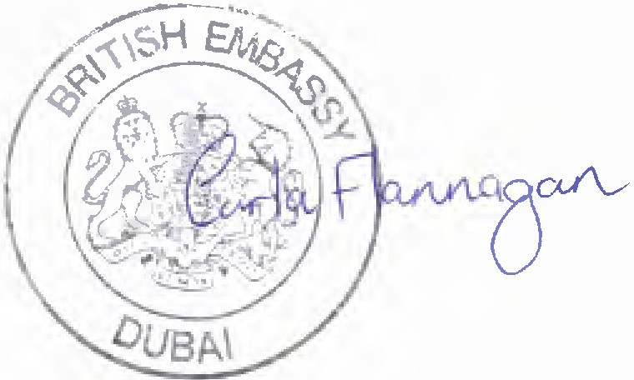

Carla Flannagan
Head of Consular Operations United Arab Emirates

