In June 2019, Dame Sally Davies, Chief Medical Officer (CMO) for England, visited Dublin to receive an Honorary Doctorate from the Royal College of Surgeons Ireland. As part of her visit, SIN Ireland organised a visit programme focussed around Genomics, Clinical Trials and in particular Anti-Microbial Resistance (AMR).
If not tackled AMR could have a devastating impact – by 2050 the death toll could be 1 person every 3 seconds – but it is also a complex challenge which needs innovation and local, national and global action. CMO Dame Sally Davies delivered a keynote address at an AMR workshop organised by SIN Ireland with researchers, clinicians, policy makers and industry leaders from across the island of Ireland in attendance.
The workshop displayed the work on both sides of the border to tackle AMR across humans, animals and the environment. Dame Sally welcomed the action taken in both NI and Ireland, noting that Ireland and the UK were the only two countries to have placed AMR on their national risk registry. Recognising that AMR does not respect borders, she called for a multi-agency and multi-sectoral approach. Co-operation on surveillance and better mapping of AMR cases across the island of Ireland were identified as areas for further work.
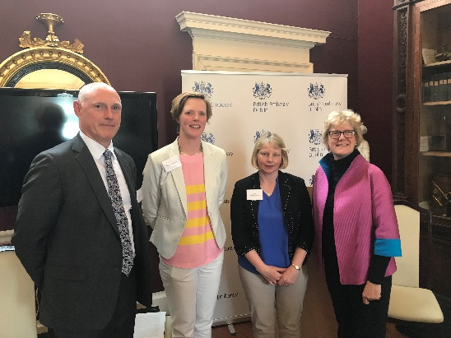
At a follow up discussion with the Northern Irish CMO and Chief Veterinary Officer (CVO) as well as the Irish CVO and deputy CMO and the Environmental Protection Authority the need for greater North-South cooperation was recognised and committed to. All parties agreed to begin regular formal meetings to discuss AMR activity and a collaborative approach to surveillance, an important step forward in the fight against AMR.
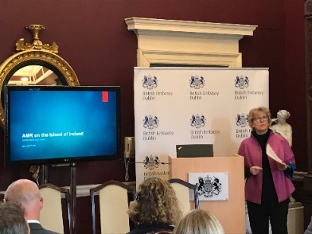
During her visit, Dame Sally also visited Genomics Medicine Ireland (GMI) to learn about their expansion plans and gave GMI the opportunity to gain further insight into the UK’s 100,000 genomes project. At a breakfast with senior Irish figures from research and public health Dame Sally heard about shared health services for patients in Northern Ireland and Ireland and cooperation on clinical research both North-South and East-West. Participants stressed the importance of retaining existing all-island services in areas such as paediatrics and radiotherapy after the UK leaves the EU, and were keen to receive guidance on how best to collaborate with the UK on issues such as cancer research, clinical trials, genomics and AMR to further develop and support shared interests.

