UK Science and Innovation Network Case Study

UK-Russia Science & Cocktails series of lectures
In 2018, SIN Russia together with DIT Russia launched the Science & Cocktails series of lectures. The programme has been set to attract young generations to science career and communicate scientific discoveries that change our life.
Rising to the Challenge
In August 2018, we piloted a concept of mixing science in a social setting. As a first theme, we chose holography, the technology invented by the UK based scientist Dennis Gabor at Imperial College. The event was very successful as the format allowed for a small focused celebration with our scientific partners, students, and experts.
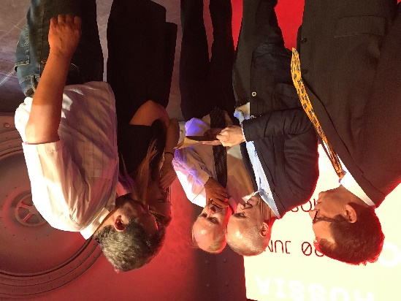
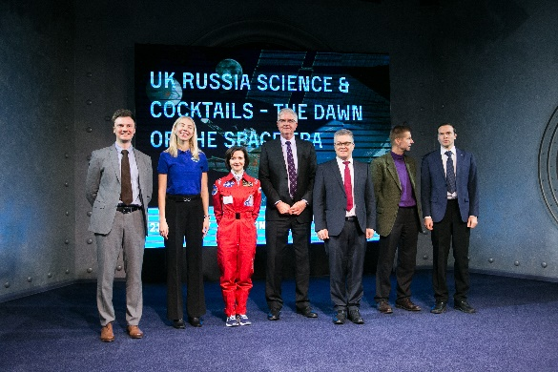
From the beginning, it was clear that this could not be a one-way street of showcasing UK innovation and expertise. We needed to invite Russian speakers alongside British scientists to give opportunities for both side to share their knowledge and for partnerships to bloom. For our second Science & Cocktails, we invited the crew of young researchers from IMBP – the Russian institute that organises space simulation flights, such as the famous MARS500, and ESA Head Russia. We have been joined by Doug Millard, Deputy Keeper and Coordinator of the famous “The Cosmonauts” exhibition at the Science Museum London, and science journalist Andrei Vaganov, who had just published his book “Isaac Newton and Russian Science”, for our third event to talk on space chemistry.
From left: Matthew Lownds (British Embassy Moscow), Andrew Vaganov (Nezavisimaya Gazeta, Moscow), Doug Millard (Science Museum London), Alexandra Smirnova (SML), Prof Alexander Lutovinov (IKI, Moscow)

A Cross Embassy Approach
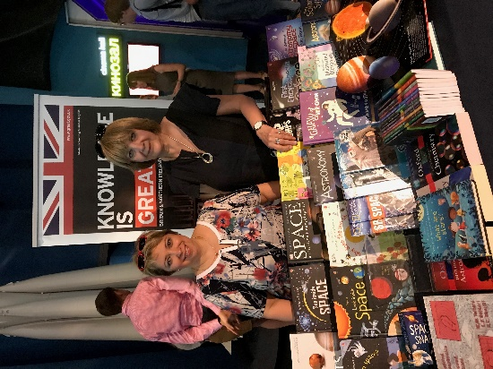
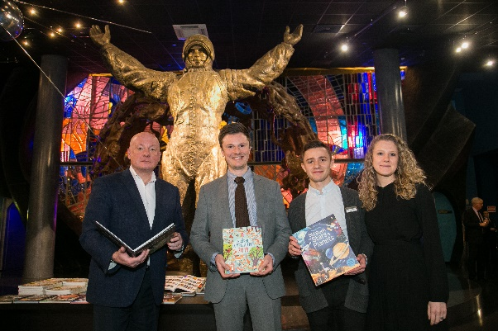
At all our Science & Cocktails, our colleagues in DIT were our good partners. We worked closely with them on a Science-themed Book Exhibitions and the very popular Innovative Cocktails events to add to our list of lectures. The collaboration showed that there was opportunity to deliver against broader objectives in the Embassy. Without their enthusiasm and access to their local customers – distributors of the UK products – we would
Oxford University Press and other British books and Prof Yulia Gorbunova (IYPT-Russia), Dr Lubov Strelnikova (Chemistry and Life Magazine)
Usborne books at our partner’s Cosmonautics Museum. From left: Vyacheslav Klimentov, (The Cosmonautics Museum, Moscow), Igor Nikonenko (Usborne Books rep, Moscow), Alfred Vardazaryan and Daria Chudnaya (both Cosmonautics Museum)
not have achieved the outcome we did. Our DIT colleagues attracted Usborne and Oxford University Press.

Impact
At a challenging time in the UK/Russia relationship, we have been able to generate a positive and engaging environment that has allowed our contacts to focus on what matters – the science.
We shaped public and expert opinions about excellence of UK science and education. We deepened relations with researchers and next generation scientists. We facilitated co-operation between UK and Russian partners, and agree about next joint projects.
Feedback has been universally positive and we’ve even taught a few people things with quotes like “Oh, I did not know anything about Sir Norman Lockyer and his helium discovery”; “I need to visit the Science Museum London as soon as possible!; “Never thought they had been celebrated the Periodic table since 1960s” and; “My dreams of further destination for education are more concrete now”.

Key lessons
Firstly, you need to choose the theme that is relevant and exciting. You need to appreciate what is interesting, where our science overlaps and understand the local and UK science community to find the right theme.
Second, you have to choose charismatic speakers and a good venue. For this, you need to have a great expert network and good friends in science and science journalism.
Third, always consider which other parts of the embassy team could benefit with partnering, whether that’s DIT, British Council, Visit Britain or even the political team. Engage them early and encourage them to generate ideas too.
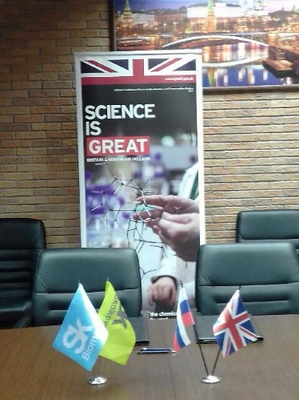
….
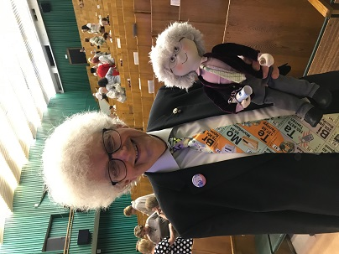
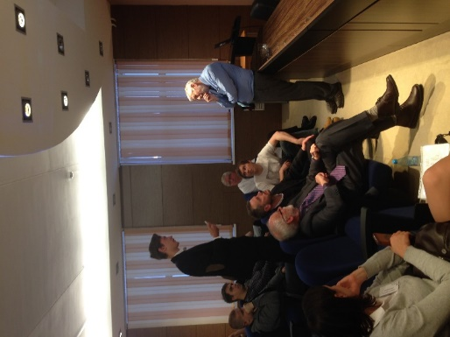
Prof

Martyn Poliakoff in Dubna Prof Graham Hutchings in Krasnoyarsk

Sin Russia Contact: Marina.Sokolova@fco.gov.uk

